Rush to Flush-User Guide

By Aicha, Eunwon, Hai, Robert & Spencer

Contents

Introduction 3

Instructions 4

Glossary 5

Trouble Shooting 6

# Introduction

Welcome to Rush to Flush, an online HTML5 game developed to help you to train your brain. Rush To Flush targets your short term memory retention and information processing speed. The basic idea of the game is to show you the solution to a maze, which you then have to memorize. The solution, as well as the walls of the maze disappear, and you have to trace the correct path to the end. If you stray off the path, time is deducted. You have 3 minutes to complete as many levels as you can, and you compete against yourself to beat your highest score. The more mistakes you make, the lower your score. This game is available to play on both mobile devices and computers (desktop or laptop).

This game was developed over 5 weeks in our BCIT projects course (COMP2910).

# Instructions

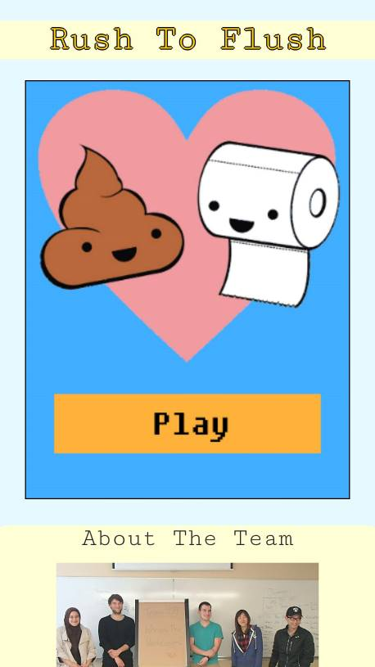

Are you ready to begin? Press the play button to start the game. The leaderboards and information about the team are located underneath the game.

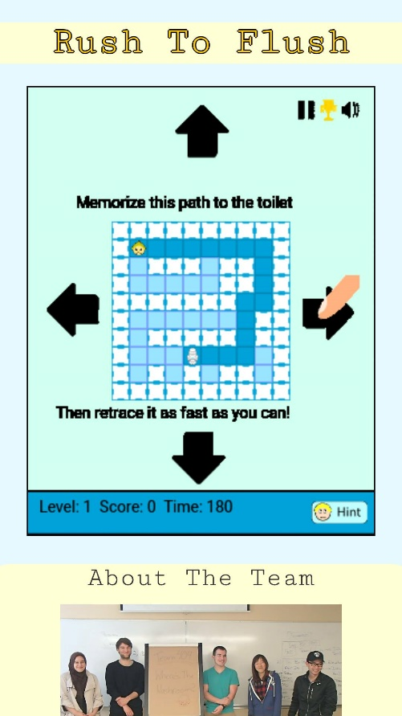

This is how the game starts. The solution is shown at the center of the screen. Under the maze you will find the level, score, timer and the hint button. Pressing this hint button will show you the solution while deducting 30 seconds from your total time. Memorize the solution shown to you, and click on the arrows to move. After your first click, the solution will disappear.

As you can see, your field of vision is now completely restricted to the blocks immediately around you. Follow the path that was shown to you, but be careful! If you stray off the proper path, you will be transported back to the start of the maze. Reach the toilet in the shortest amount of time in order to get a high score.

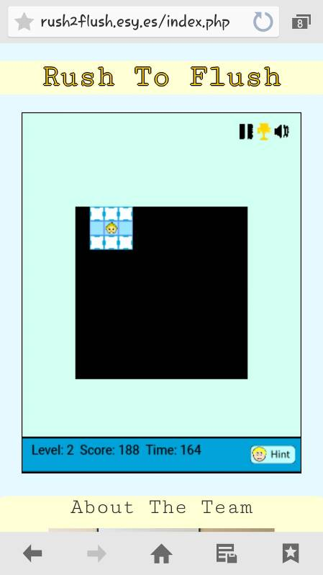

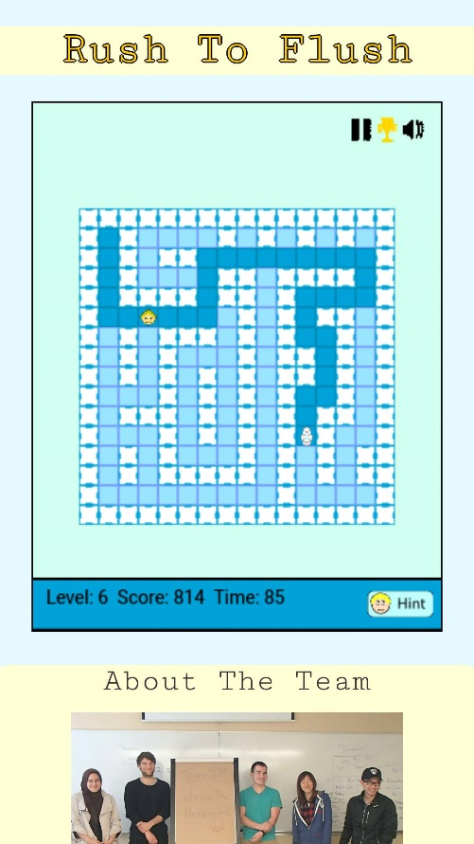As the game progresses, you can easily lose track of what the solution looks like. To help you out we’ve added a hint button. This will show you the solution to the current map for as long as you need, however, by clicking the button your overall time is deducted, and the timer will continue while you are looking at the solution so don’t look for too long!

Included in the game is also a pause button. 3 minutes can be a long time, and a lot needs to be done in our lives that just can’t wait, but by pressing the pause button on the game you can easily take a break and attend to anything you need to without losing your high score streak.

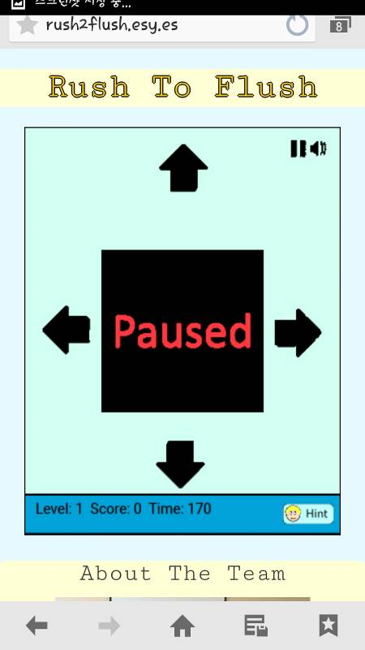

Also in the game, there are achievements throughout. As you play try and make it onto the leaderboards, but also try to finish all of the achievements given. This will add some extra competition to the game. Complete all if you can!

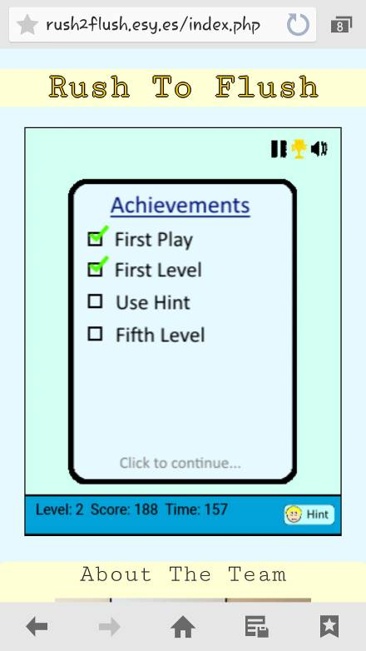

After the game is over you can input your name or put an alias, and enter our high score leaderboards. We show our top players for the day, listed by score and by level. Also we show our overall top leaders on the scoreboard to give you the best of the best.

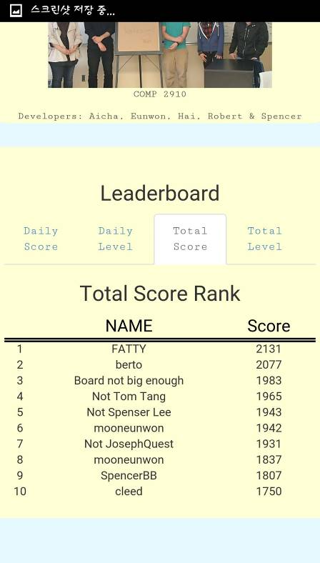

# Trouble Shooting

No Internet Connection

Be sure you are connected to the internet to play the game. Because this is run on HTML and PHP, you cannot play the game.

First check if Wi-Fi is on and connected to your router on either your phone or computer.

If you are running an Ethernet connection on your computer, check to make sure the cord is both plugged in fully to the computer and to the router.

Be sure that your router is turned on and has an internet connection.

Slow Game

Close extra tabs in your browser and extra applications that are running in background on either your phone or computer.

If it’s still running slow, see that people on the network aren’t downloading heavy games or videos as this can slow down the network.

Otherwise, restart your router as a last resort and see if that can help your internet connection.