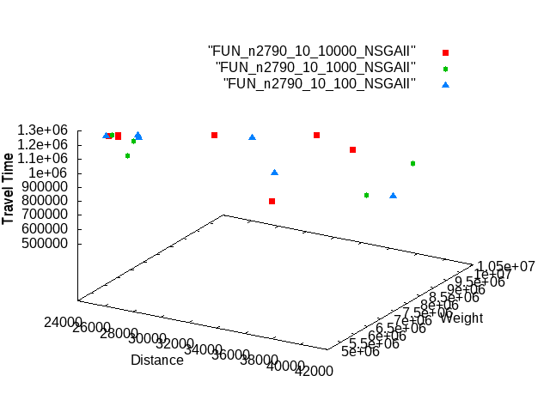
a280_n2790 – population 10, generations 10000, 1000, 100

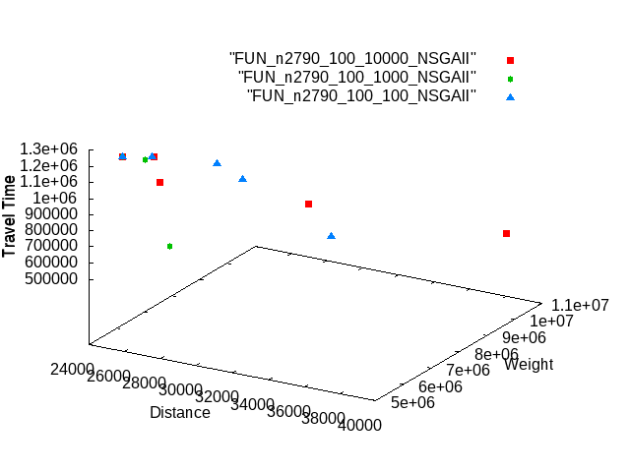
a280_n2790 – population 100, generations 10000, 1000, 100
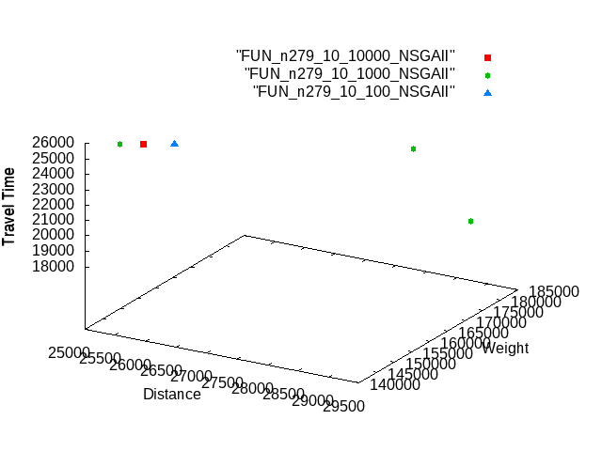
a280_n2790 – population 10, generations 10000, 1000, 100

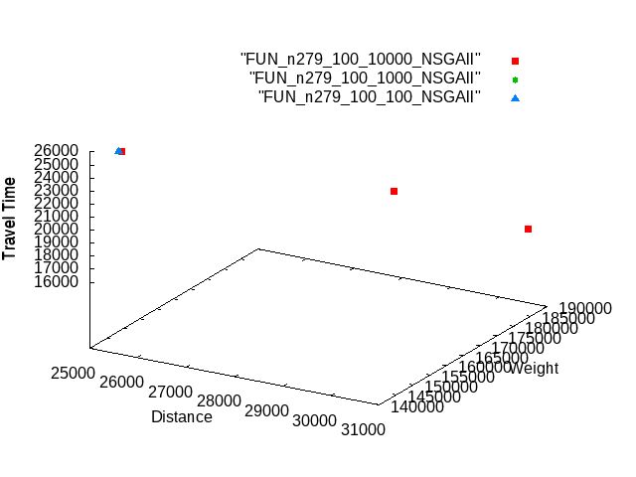
a280_n279 – population 100, generations 10000, 1000, 100
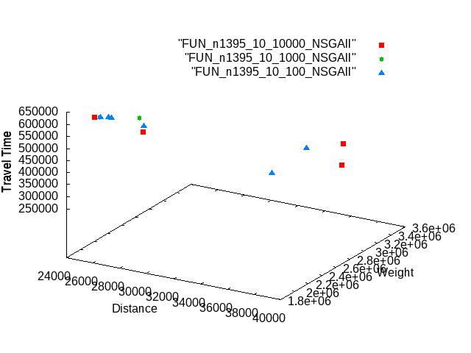
a280_n1395– population 10, generations 10000, 1000, 100

a280_n1395– population 100, generations 10000, 1000, 100
