**CT -Assignment 3**

Simulations Report:

1. M(t) = Am*cos(2*pi*fm*t) where fm = 1000 and Am = 1.

C(t) = Ac* cos(2*pi*fc*t ) where fc = 10000 and Ac = 10.

Ufm(t) = Ac* cos(2*pi*fc*t + phi(t))

Kf =50 . We have taken the time scale to be [-1,1] in step of 1/fs where fs = 1001.

Now the plot of message, carrier and FM modulated signal is:

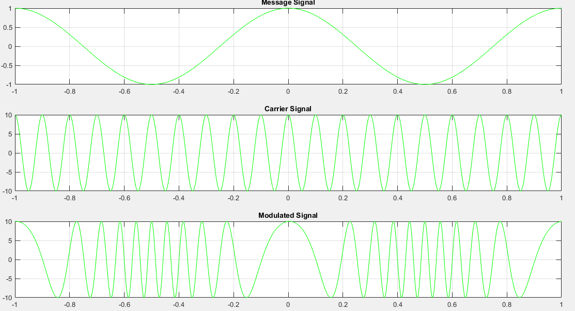

1. We demodulate the above obtained Ufm signal by passing it through a differentiator , a envelop detector and then a DC block.

For differentiation we use the command **diff(x)**, and to find the envelope we used the command **envelope(x)**.

The plot of the rectified FM and the recovered message signal are:

Fs = 1001

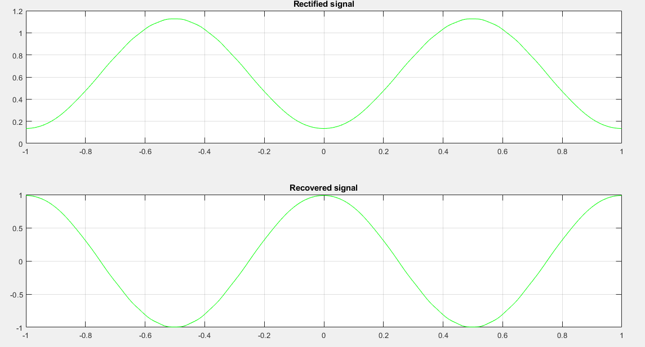

1. Now we plot the spectrum of all the signals we have above by using the commands **fft(x)** and **fftshift(y)**. The plots are below :

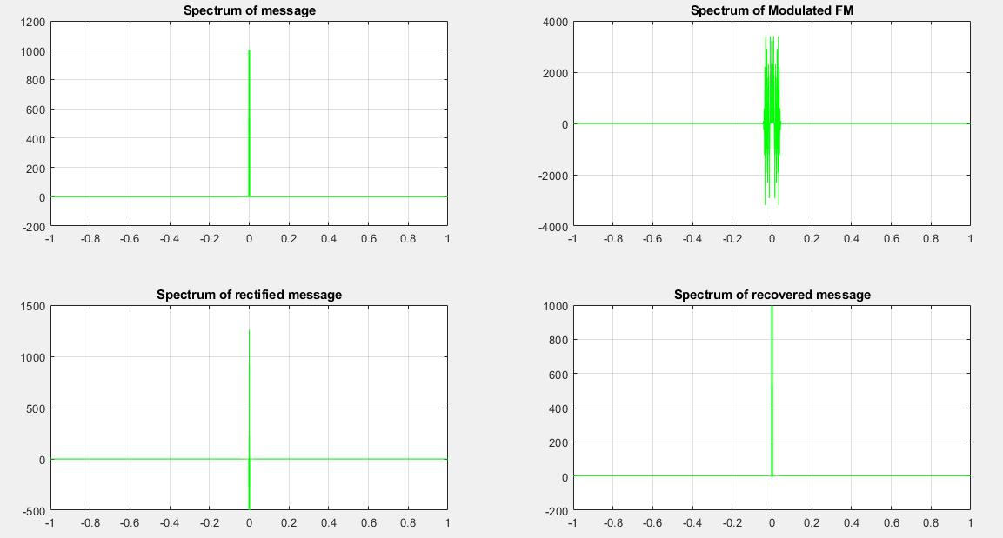

1. Now we have the message signal to be a triangular wave given as

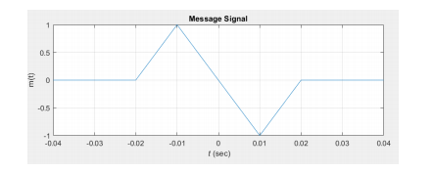

Now we perform the above FM modulation and demodulation to this signal. The modulated signal has small rumbles .

