**NAME: SRESTHA DAS**

**2MAECO**

**2237058**

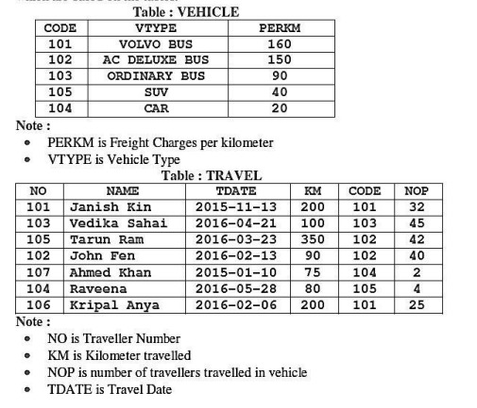

**1. Write command to create the above database Vehicle and Travel.**

mysql> create table Vehicle (Code INT, VTYPE VARCHAR (20), PERKM INT);

mysql> insert into Vehicle values (101, 'VOLVO BUS', 160);

Query OK, 1 row affected (0.05 sec)

mysql> insert into Vehicle values (102, 'AC DELUXE BUS', 150);

Query OK, 1 row affected (0.01 sec)

mysql> create table TRAVEL (NO INT, NAME VARCHAR (20), TDATE DATE, KM INT, CODE INT, NOP INT);

mysql> insert into TRAVEL values (101, 'JANISH KIN', '2015-11-13', 200, 101, 32);

Query OK, 1 row affected (0.02 sec)

mysql> insert into TRAVEL values (103, 'VEDIKA SAHAI', '2016-04-21', 100, 103, 45);

Query OK, 1 row affected (0.01 sec)

**QUERY 1**

**To display total fare paid by every traveller.**

mysql> Select PERKM*KM*NOP as "Total Fare" from VEHICLE, TRAVEL where TRAVEL.CODE=VEHICLE.CODE;

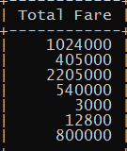

**QUERY 2**

**To display all details of a traveller of table travel whose no is 101, 102, 106, 107.**

mysql> Select * from TRAVEL where NO IN (101,102,106,107);

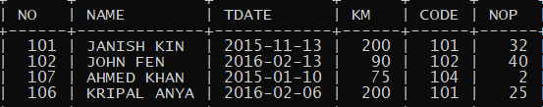

**QUERY 3**

**CALCULATE TOTAL KM TRAVEL BY EACH VEHICLE IN YEAR 2016.**

mysql> Select CODE,SUM(KM) from TRAVEL group by CODE;

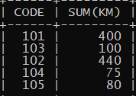

**QUERY 4**

**To display NO,NAME,TDATE from the table TRAVEL in descending order of NO.**

mysql> Select NO, NAME, TDATE from TRAVEL ORDER BY NO DESC;

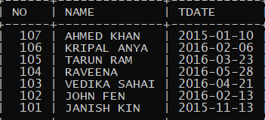

**QUERY 5**

**Update data of per km whose vehicle type is any type of bus and km is more than 150.**

mysql> Update VEHICLE set PERKM=PERKM+20 where VTYPE LIKE '%BUS' and PERKM>150;

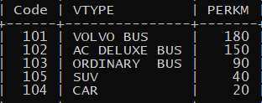

**JOINS**

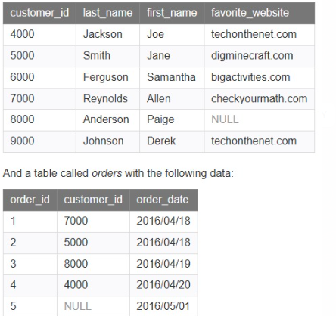

**INNER JOIN**

mysql> select customer.customer_id,order_customer.order_id,order_customer.order_date from customer **inner join** order_customer on customer.customer_id=order_customer.customer_id order by customer.customer_id;

**LEFT JOIN**

mysql> select customer.customer_id,order_customer.order_id,order_customer.order_date from customer left join order_customer on customer.customer_id=order_customer.customer_id order by customer.customer_id;

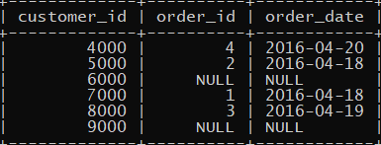

**RIGHT JOIN**

mysql> select customer.customer_id,order_customer.order_id,order_customer.order_date from customer right join order_customer on customer.customer_id=order_customer.customer_id order by customer.customer_id;

**FULL/OUTER JOIN**

mysql> select * from customer left join order_customer on customer.customer_id=order_customer.customer_id union select * from customer right join order_customer on customer.customer_id=order_customer.customer_id;

**CARTESIAN JOIN**

mysql> select customer.customer_id,first_name,last_name,order_date from customer, order_customer;

