PART C : Resolution times of various DNS resolvers.

|  |  |  |  |
| --- | --- | --- | --- |
| SITE | My DNS resolver  (time in ms) | Local DNS resolver  (time in ms) | Google’s DNS resolver  (time in ms) |
| Google.com | 150 | 15 | 18 |
| Youtube.com | *185* | *60* | *71* |
| Tmall.com | 104 | 60 | 41 |
| Baidu.com | 300 | 15 | 12 |
| Qq.com | 350 | 47 | 128 |
| Sohu.com | 290 | 20 | 90 |
| Facebook.com | 150 | 15 | 20 |
| Taobao.com | 165 | 15 | 60 |
| Login.Tmall.com | 350 | 16 | 250 |
| Wikipedia.org | 250 | 180 | 150 |
| Yahoo.com | 270 | 100 | 90 |
| 360.cn | 285 | 102 | 170 |
| Jd.com | 1700 | 3500 | 330 |
| Amazon.com | 700 | 120 | 150 |
| Sina.com.cn | 602 | 4000 | 250 |
| Weibo.com | 420 | 80 | 70 |
| Pages.tmall.com | 200 | 109 | 87 |
| Live.com | 310 | 231 | 77 |
| Reddit.com | 344 | 80 | 150 |
| Vk.com | 1000 | 200 | 80 |
| Netflix.com | 180 | 75 | 82 |
| Blogspot.com | 340 | 150 | 153 |
| Alipay.com | 8000 | 500 | 100 |
| Office.com | 400 | 126 | 90 |
| Okezone.com | 588 | 90 | 100 |

CDF of resolution times for various resolvers.

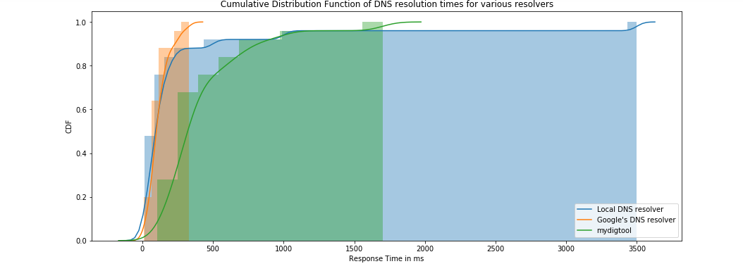

**OBSERVATIONS**

* From analyzing the graph, it can be observed that,
* Google’s DNS resolver is the fastest resolver, with 100% of the websites being resolved within 330ms. We can also infer that the area under the curve is the least for Google’s resolver, which means it is the best performing.
* While the local DNS resolver takes a little more time, almost 95% of the websites have been resolved before 1000ms. The part of the graph that has been extended above 2000 ms, must relate to the couple of websites that have taken 3000ms. The area of under the graph shows that it is the second-best performing resolver.
* Mydig tool has almost 90% of the websites resolved under around 1000ms, but there are a couple of websites that take between 1500 to 4000 ms, extending the area under the CDF.
* The comparatively modest performance of Mydig tool could be associated with factors like - it does not implement caching, whereas the other two resolvers do.