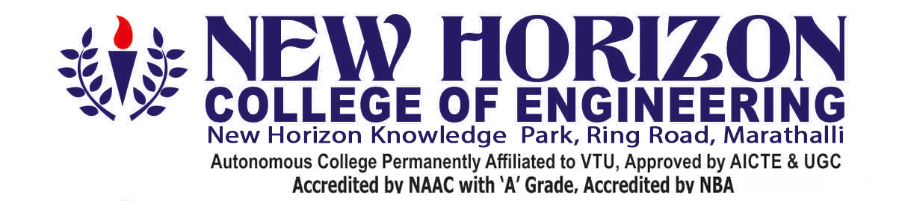

|  |  |  |  |  |  |  |  |
| --- | --- | --- | --- | --- | --- | --- | --- |
| **Branch**:  **Computer Science and Engineering** | | **USN**:  **1NH19CS149** | | | | | |
| **Course Code**:  **19CSE48** | | **Course Name**:  **Mini Project in Java** | | | | | |
| **Semester**:  **IV** | | **Date:**  **17/ 08/ 2021** | | | | | |
|  | | **Candidate Signature**: | | | | | |
| **PROJECT VIVA – VOCE**   1. **Project Work: 40% of Maximum Marks= 20** 2. **Presentation: 30% of Maximum Marks= 15** 3. **Viva Voce : 30%of Maximum Marks=15** | | **TITLE OF THE PROJECT** | | | | | |
| **MOVIE BOOKING** | | | | | |
| **Max Marks** | **Marks Awarded** | | | | **Total** |
| **20** | **15** | | **15** | **50** |
| **50** |  |  | |  |  |
| **Marks Awarded** | | | | | | | |
| **Total Marks Allocated**:  **Marks In Words**: | | | | | | | |
| **Internal Examiner** | | **External Examiner** | | | | | |
| **Digital Signature:** |  | **Digital Signature:** | | |  | | |
| **Name & Affiliation** |  | **Name & Affiliation** | | |  | | |