1. 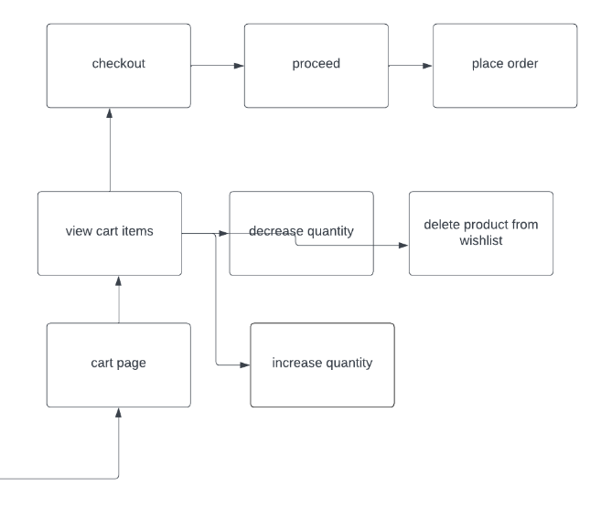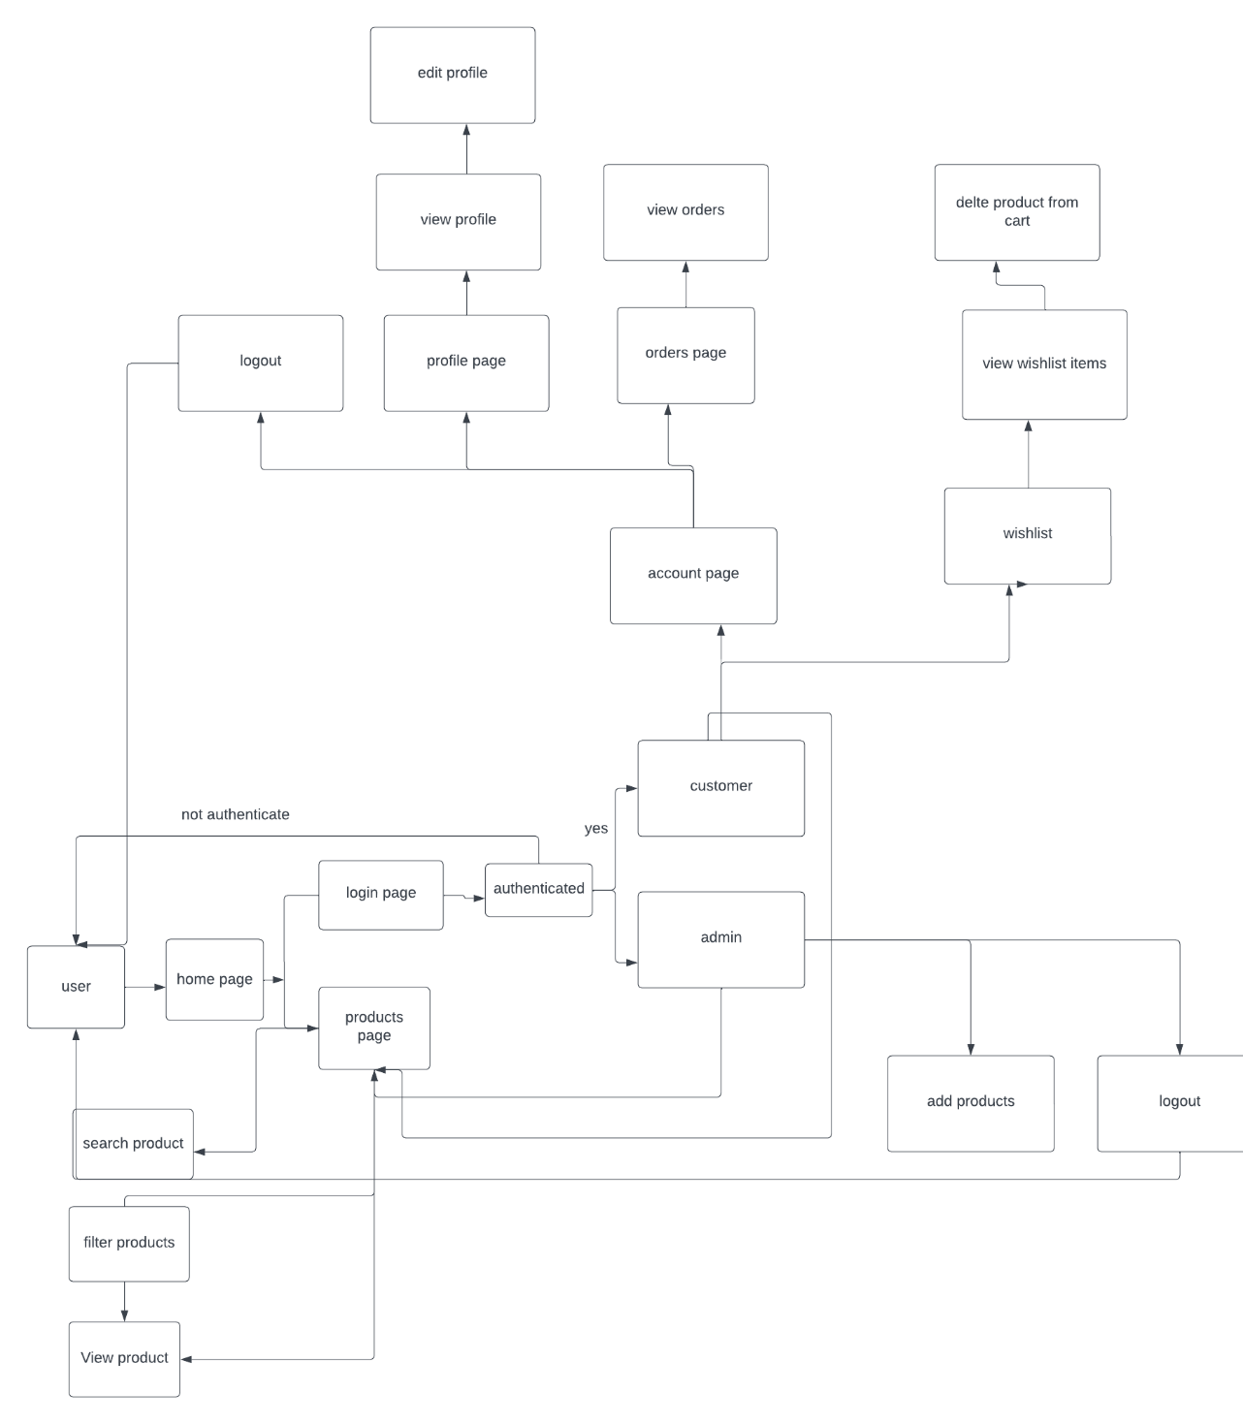UML class diagram

2.UML use case diagram

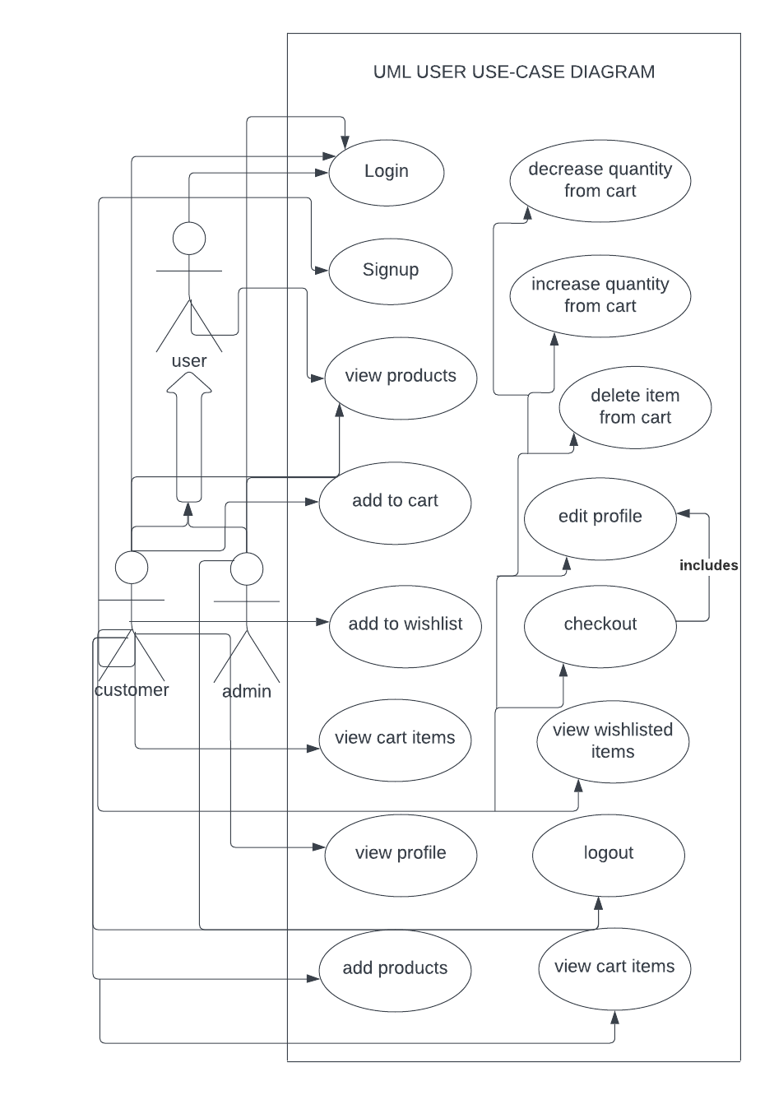

3.UML sequence diagram

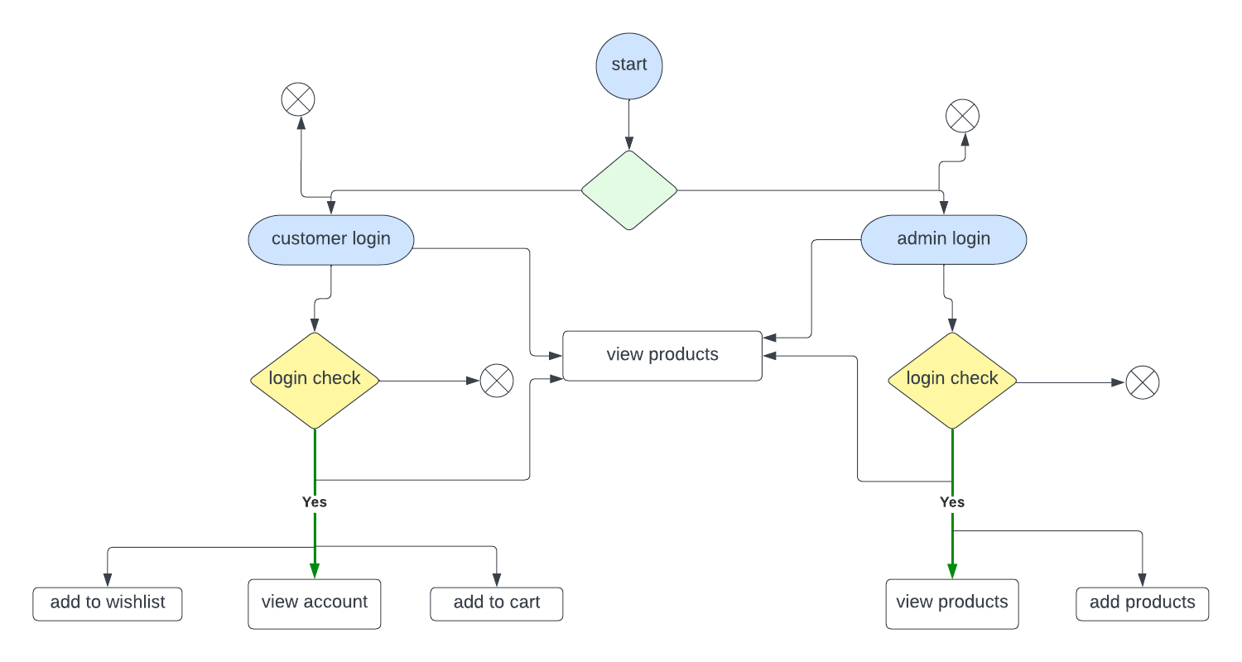

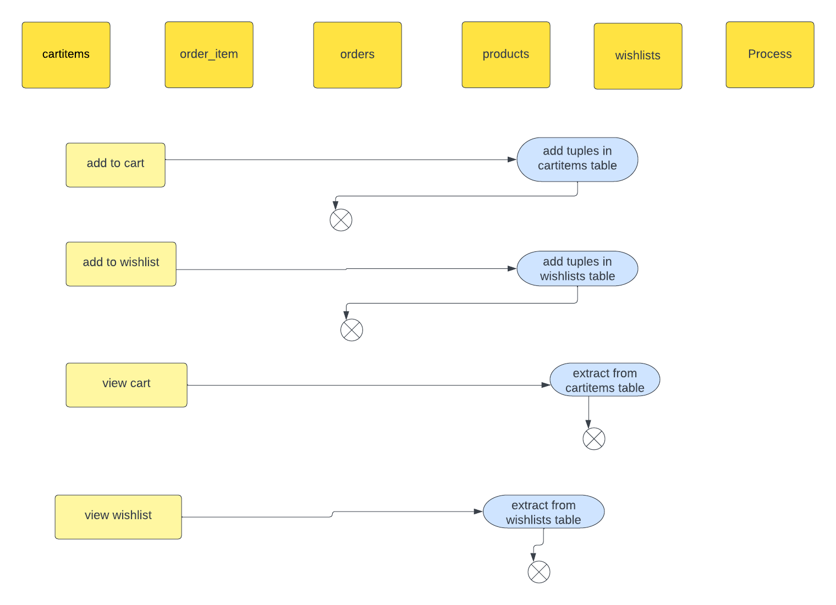

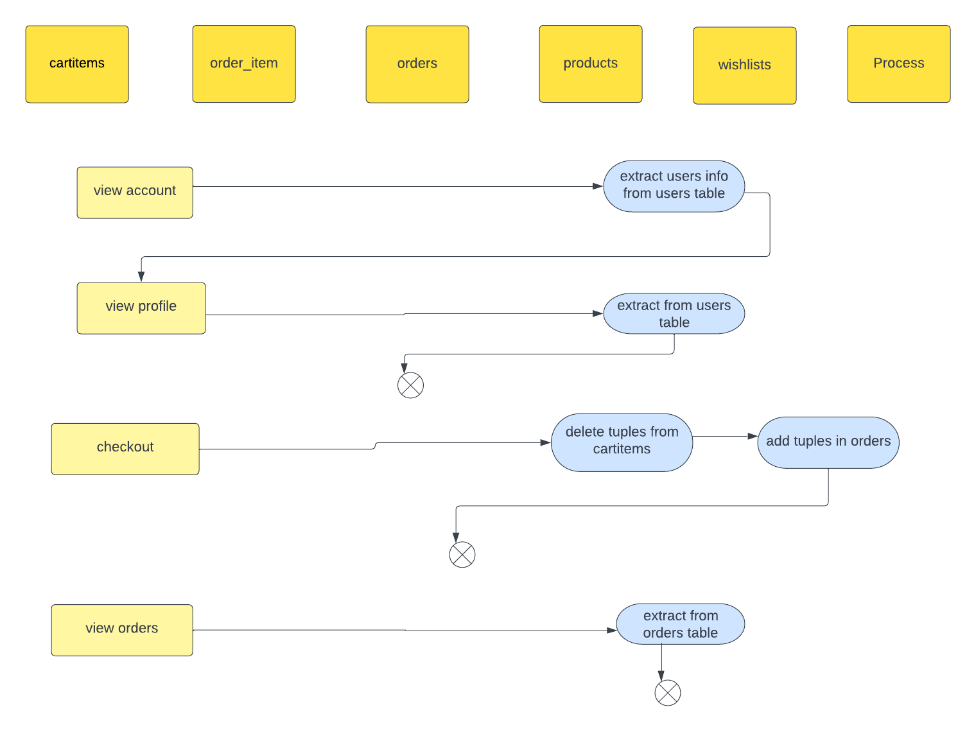

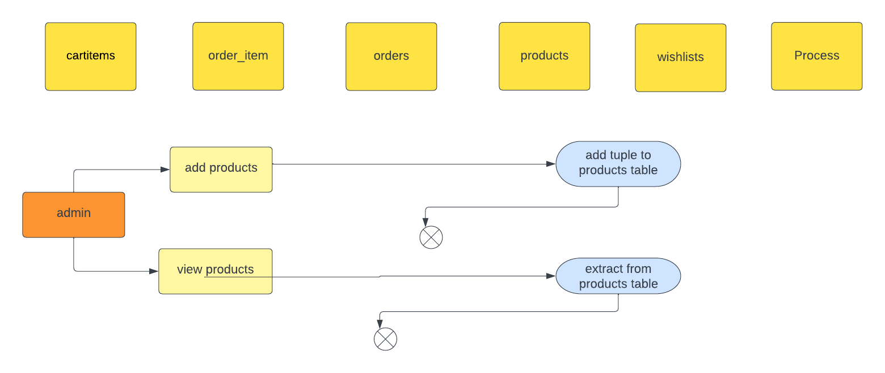

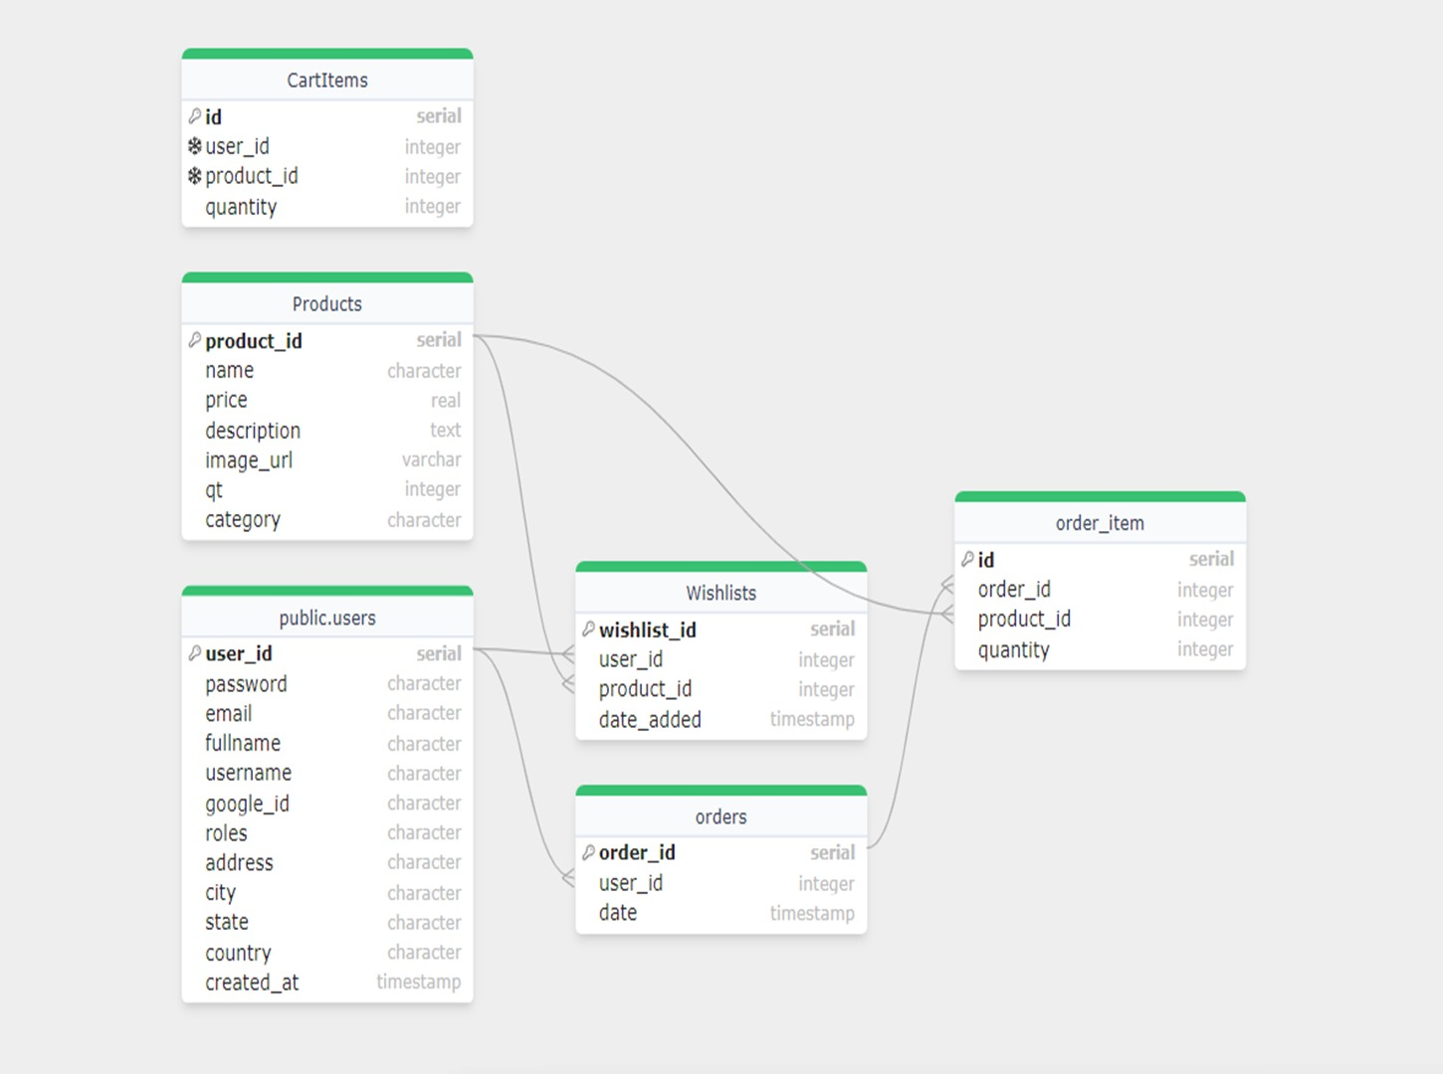4. Database ER Diagram

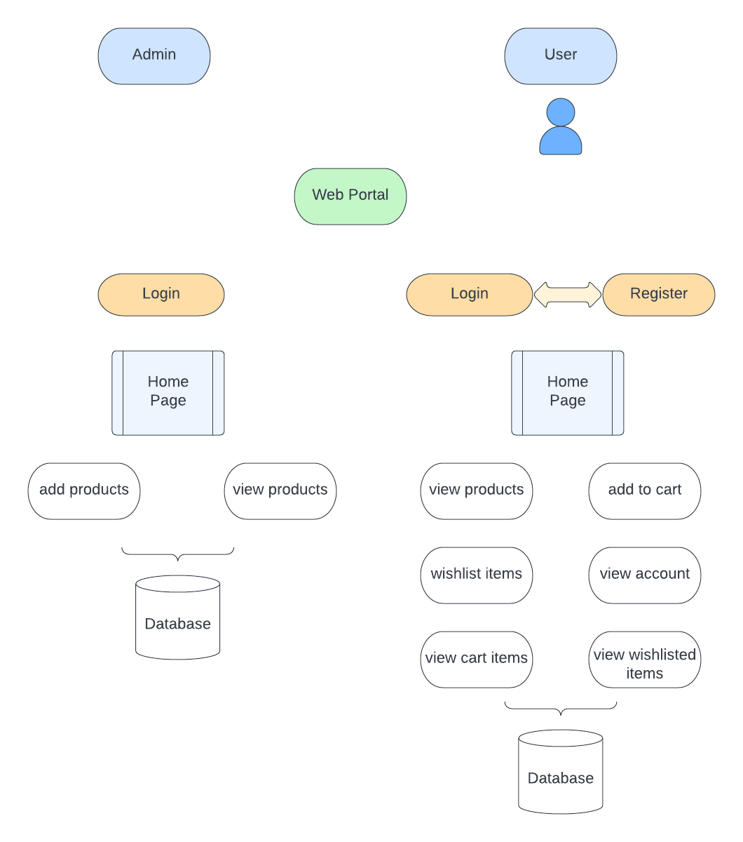5. Logical Architecture of the system

6. Technology Architecture of the system.

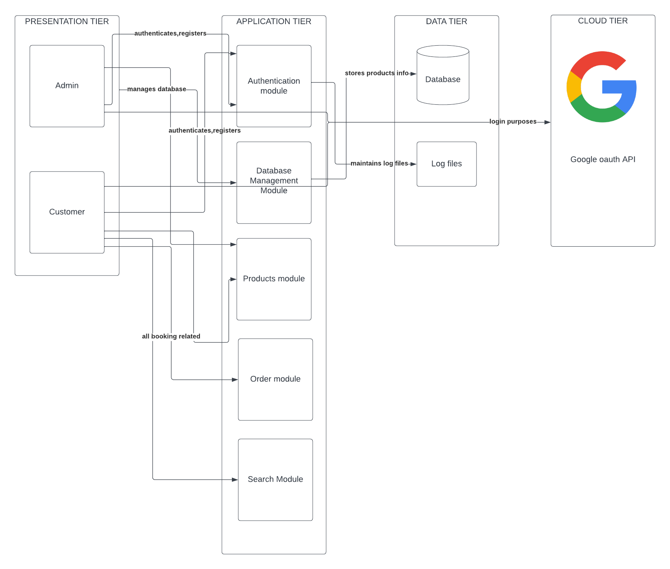

7.Project description.

SmartStore retail management Application will be a platform where Admin/seller will be able to add products in the website and users will be able to buy those products. Orders history and quantity of the products will be managed by the application to make shopping and selling easy for the customers and the seller.

Following Features will be provided by our website: -

* Login
* Users will be able to log in to the app after signup
* Website also allow users to login using google.
* view all the product available for purchase.
  + Users can view all the products and see the details of each product.
  + User can search of the product and filter the products with categories.
  + Users can view the products they have ordered from the past orders history. Users can view details of the products from Cart and Wishlist.
* Add to cart.
  + User can add product to the cart.
* While adding products to the cart, user cannot add the more than the quantity of the products available and after each order the product available quantity will be decreased by the order quantity
* Whenever user adds a product in the cart, he can see the number of items in the current cart on the top of cart icon in the navbar.
* Checkout
* When user want to order the product, the user can checkout and edit the address of delivery.
* User can view total summary of the order, total cost, and cost of each product.
* He can chode the payment method and place order.
* Add to Wishlist
* User can add the products to the Wishlist for the future purchases.
* When whenever the product is in the Wishlist, user can see red heart on the products and if not a white heart.
* Orders
* User can see the details of every past order and details of each product in the order.
* User can view total cost, cost of product at the time of order and keep track of their purchase.
* A web-based Admin Portal will be implemented where Admin will be able to add new products.