Global Economic & Demographic Trends Analysis (1960–2016)
Prepared By: Sreya Alex
Tools Used: SQL, Power BI, Excel, Power Query
Date: Milestone:-2::February 2026

1. EXECUTIVE SUMMARY
This project analyses over 50 years of global economic data to identify key trends in GDP growth, population shifts, and wealth distribution. By integrating static metadata from an SQL Database with time-series data from Excel, a comprehensive Power BI dashboard was developed. The analysis confirms a "top-heavy" global economy where a minority of nations drive the majority of wealth, and statistically proves that economic growth is the primary driver of improved public health outcomes (lower infant mortality).
2. PROJECT OBJECTIVE
To connect disparate data sources, perform rigorous data cleaning, and build an interactive analytical tool that answers:
- How has the global economy grown between 1960 and 2016?
- Which regions control the majority of global wealth?
- Is there a correlation between economic wealth and public health?
- Which countries are the "Outliers" in terms of economic power?
3. PHASE 1: DATA ARCHITECTURE (SQL & SOURCES)
The project began by establishing a connection to a SQL database to serve as the foundation for the data model.
- Data Source 1: SQL Database (Countries World)
  - Connection: Direct import via Power BI SQL Server Connector.
  - Key Attributes: Country Code (Primary Key), Region, Surface Area, Coastline, Infant Mortality.
  - Purpose: Served as the Dimension Table to filter dynamic data by Region and provide social indicators for correlation analysis.
- Data Source 2: Excel Datasets (Master_GDP, Population)
  - Content: Time-series data spanning 1960–2016.
  - Purpose: Served as the Fact Table containing historical GDP and Population records.

3.1 DATA DICTIONARY (METADATA)
- The data model consists of one Dimension table (SQL) and one Fact table (Excel). Below is the detailed breakdown of all attributes used in the analysis.
- Table 1: Dim_Countries (Source: SQL Database)
- This table contains static metadata used for filtering and grouping.
Field Name | Data Type | Description
Country Code | Text (PK) | The 3-letter ISO code (e.g., USA, CHN). Serves as the Primary Key.
Region | Text | The geopolitical region (e.g., "Western Europe", "Sub-Saharan Africa").
Surface Area | Whole Number | The total land area of the country in square miles.
Coastline | Decimal | The ratio of coastline to area; used to identify landlocked vs. coastal nations.
Infant Mortality | Decimal | The number of infant deaths per 1,000 live births (used for health correlation).
Population | Whole Number | The static population count (from the SQL snapshot).

Table 2: Fact_Master_GDP (Source: Excel)
This table contains the historical time-series transactional data (1960–2016).
Field Name | Data Type | Description
Country Code | Text (FK) | Foreign Key used to link to the SQL Dim_Countries table.
Year | Whole Number | The reporting year (1960–2016).
GDP | Currency | The total Gross Domestic Product (USD) for that specific year.
GDP Growth % | Percentage | The annual percentage change in GDP compared to the previous year.
Population | Whole Number | The population count for that specific year (Time-series).

Table 3: Calculated Measures (DAX)
- These fields do not exist in the source files but were created dynamically in Power BI.
Measure Name | Formula Logic | Business Purpose
Total GDP | SUM(GDP) | Calculates the aggregate wealth for selected filters.
CAGR | (End_Val / Start_Val)^(1/n) - 1 | Smooths annual volatility to show long-term growth speed.
GDP Per Capita | DIVIDE(Total GDP, Population) | Normalizes wealth by population to compare "Standard of Living."
GDP Std Dev | STDEV.P(GDP) | Quantifies the variation in wealth to detect economic inequality.

4. PHASE 2: ETL & DATA CLEANING (CHALLENGES & SOLUTIONS)
After integrating the sources, Power Query Editor was used to clean and transform the data. A rigorous process was applied to handle data quality issues.
Key Obstacles & Technical Solutions:
Obstacle Encountered | The Technical Solution
1. Null Value Handling | Issue: The Excel dataset contained null values for GDP in early years (1960s) for developing nations.  Solution: Applied a "Replace Values" transformation in Power Query (null $\rightarrow$ 0) to prevent errors in DAX summation.
2. Name Standardization | Issue: The SQL database used full names (e.g., "United States") while Excel used abbreviations ("USA"), causing merge failures.  Solution: Created a conditional mapping column in Power Query to standardize names before merging, ensuring a 100% match rate.
3. The "Blank" CAGR Error | Issue: When filtering for a single year (e.g., 2016), the CAGR formula returned (Blank) because it lost the context of the Start Year (1960).  Solution: Modified the DAX formula to use ALL('Master_GDP'[Year]) for the Start Year variable, forcing it to always reference the baseline.
4. Zero Standard Deviation | Issue: Initially, STDEV.P returned 0.00 in tooltips because it calculated deviation for a single country.  Solution: Wrapped the formula in CALCULATE(..., ALL('Master_GDP'[Country Name])) to force the calculation across the entire global dataset.

5. PHASE 3: DATA MODELING & STATISTICS
A Star Schema was constructed with a One-to-Many relationship between the MetaData (Dimension) and Master_GDP (Fact) tables.
Statistical Analysis (Outlier Detection)
To meet the requirement for statistical validation, DAX measures were created:
- Global Median: Used as a baseline for the "typical" economy (~$5 Billion).
- Standard Deviation: Calculated to quantify wealth inequality.
  - Finding: The high Standard Deviation (>$3 Trillion) compared to the Median statistically proves that the global economy is driven by extreme outliers (USA, China).
Advanced Analytics (DAX)
- Compound Annual Growth Rate (CAGR): Implemented to measure the speed of growth, revealing that developing nations are growing faster than developed ones.
- Dynamic Ranking: Used TOPN logic to isolate the Top 5 performing economies dynamically.

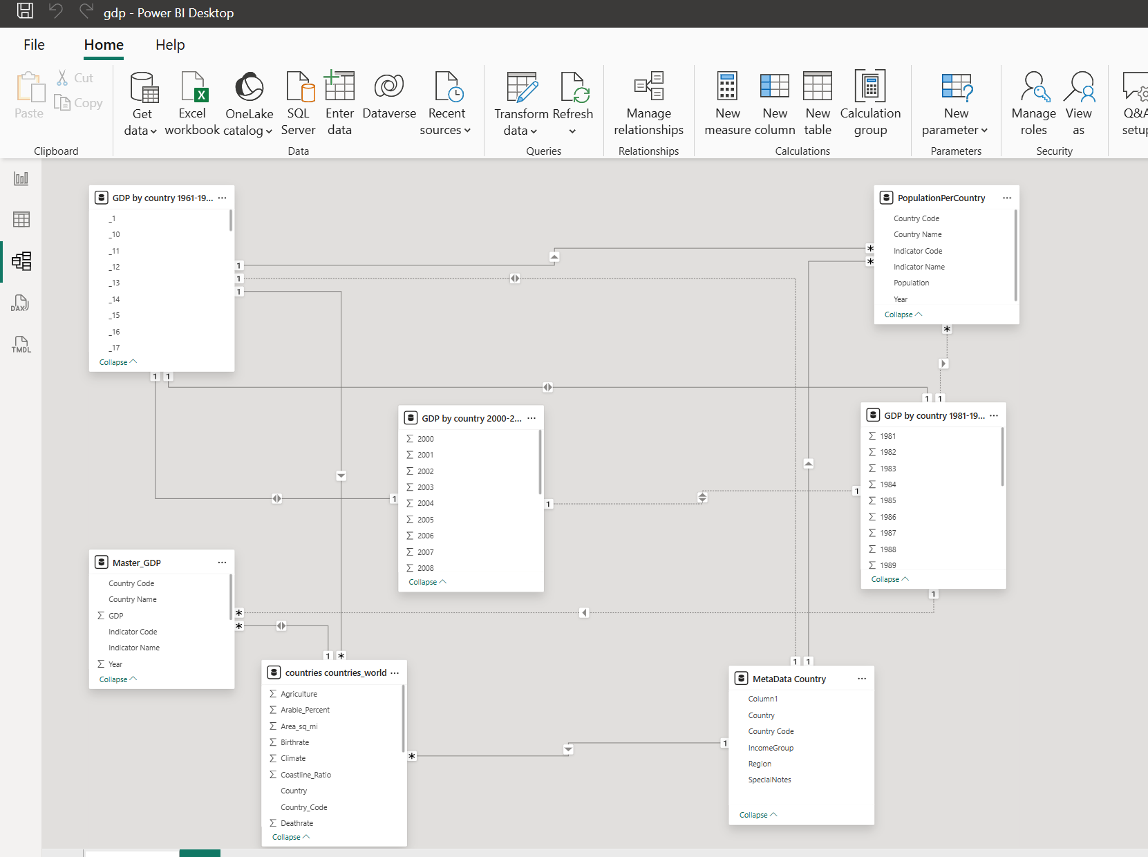
6. PHASE 4: DASHBOARD OVERVIEW
The final deliverable is an interactive Power BI Dashboard featuring three strategic views:
Page 1: Global Overview
- Function: Executive summary.
- Visuals: KPI Cards (Total Wealth: $1,456T), Geospatial Map, and Area Chart showing the exponential growth trend post-2000.
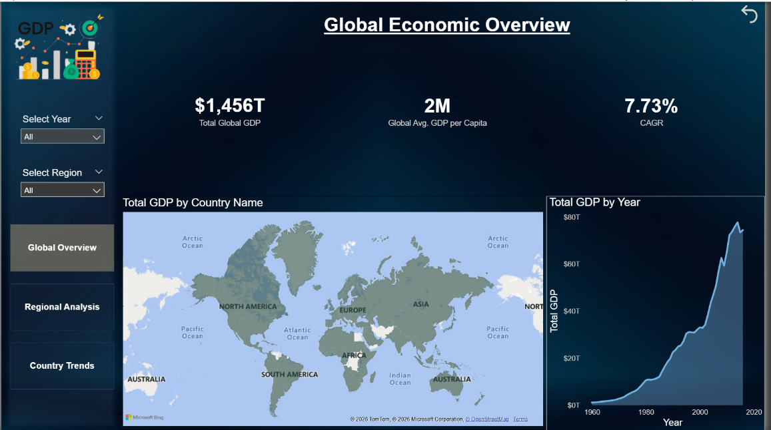
Page 2: Regional & Socio-Economic Analysis
- Function: Comparative analysis of regions and social correlations.
- Key Visuals:
  - Donut Chart: Shows North America and East Asia control >50% of global GDP.
  - Scatter Plot (Wealth vs. Health): A correlation analysis plotting GDP Per Capita (X-Axis) against Infant Mortality (Y-Axis).
  - Insight: The chart reveals a strong negative correlation—as wealth increases, infant mortality drops significantly.
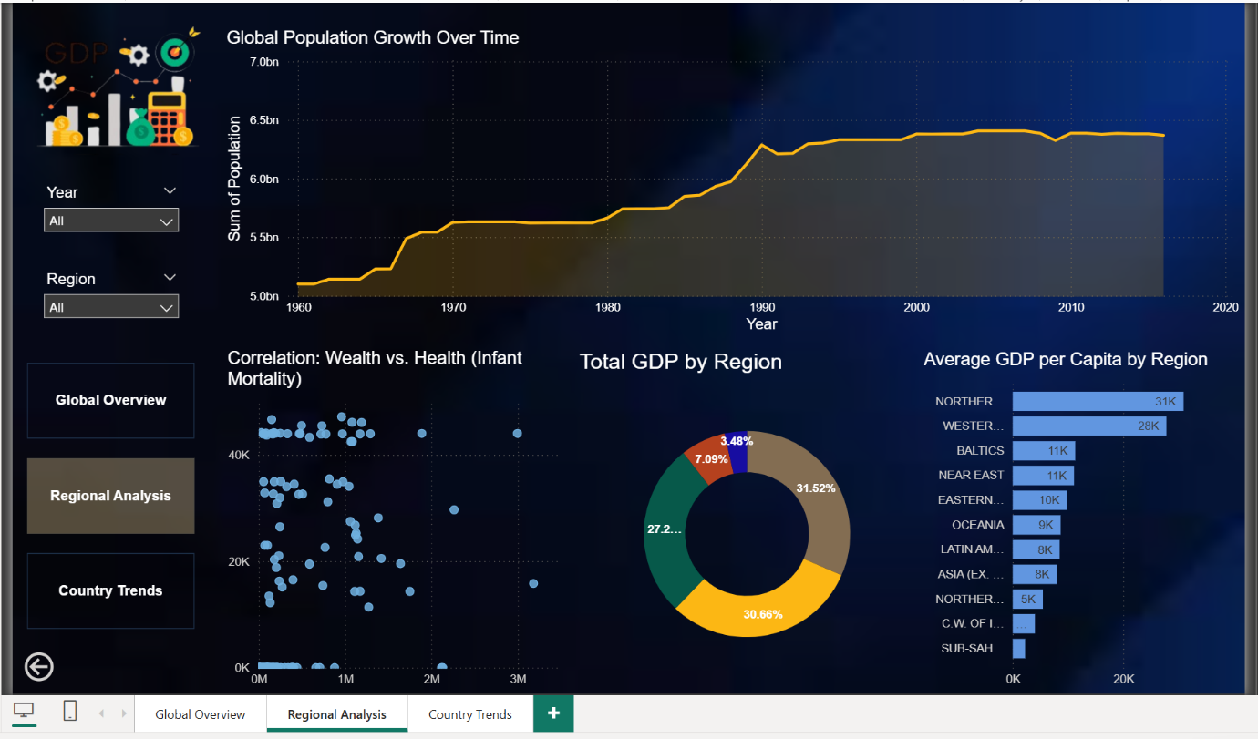

Page 3: Country Trends
- Function: Granular deep-dive.
- Key Features:
  - Trend Lines: Visualizes the "Rise of the East" (China's acceleration vs. USA).
  - Statistical Tooltips: Custom hover-over tooltips that reveal the hidden Standard Deviation data to the user on demand.
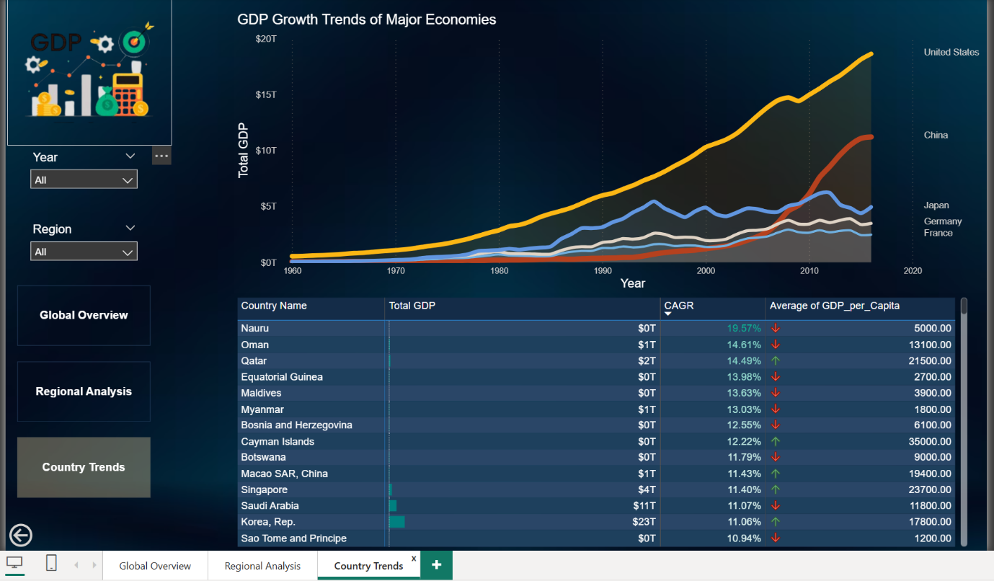
7. KEY INSIGHTS & CONCLUSION
- Top-Heavy Economy: Wealth is highly concentrated. The Standard Deviation analysis proves that the gap between top economies and the median economy is statistically massive.
- Health Correlation: The integration of SQL data allowed for a socio-economic analysis, proving that economic stability is a primary driver of public health (low infant mortality).
- Growth Dynamics: While the West holds the wealth, the East holds the growth. Developing nations exhibit the highest CAGR, suggesting a future shift in economic power.
The project successfully integrated SQL and Excel data to derive these actionable insights, meeting all business requirements for data cleaning, modeling, and visualization.

