A multi-omics analysis of gastric cancer identifies an externally-validated stromal/fibroblast prognostic program, with cautionary tumor-microbiome and Mendelian-randomization assessments
Authors: ⟦PLACEHOLDER — AUTHOR NAMES + ORCIDs⟧ (e.g. Given-name Family-name¹ [ORCID 0000-0000-0000-0000], …) — Team BBIN6_XX, School of Chemical and Biotechnology, SASTRA Deemed to be University, Thanjavur, India Corresponding author: ⟦PLACEHOLDER — CORRESPONDING AUTHOR name; institutional email; postal address⟧ Running title: A stromal/fibroblast prognostic program in gastric cancer

Abstract
Background: Prognostic stratification of gastric cancer beyond tumor stage remains limited, and claims of a causal tumor microbiome are frequently made without genetic evidence. This study aimed to identify and externally validate the transcriptional biology underlying gastric-cancer prognosis, and to test — rather than assume — whether microbial exposures causally influence disease risk.
Methods: A multi-omics design was used, spanning bulk and single-cell transcriptomes, tissue 16S ribosomal microbiome sequencing, and germline-genetic causal inference. Differential expression integrated The Cancer Genome Atlas and Genotype-Tissue Expression cohorts (412 tumors versus 443 normal references), and a penalized Cox prognostic signature was trained on The Cancer Genome Atlas and validated in three independent cohorts (GSE62254, GSE15459 and GSE84437; 922 patients). Weighted gene co-expression network analysis with external module-preservation testing, immune deconvolution validated against measured leukocyte fraction, single-cell localization, and two-sample Mendelian randomization of anti-Helicobacter pylori seropositivity and five gut genera were performed.
Results: The resulting twenty-five-gene signature achieved a leakage-free cross-validated concordance of 0.61 and validated in two of three external cohorts, although a conservative meta-analysis was not statistically significant (pooled hazard ratio 1.19, 95 percent confidence interval 0.96 to 1.47). The prognostic signal converged on a stromal cancer-associated-fibroblast program that localized to fibroblasts at single-cell resolution and was strongly preserved across three external cohorts, establishing it as externally replicated rather than a single-cohort observation. Adding the signature to stage conferred negligible decision value. The secondary microbiome arm found reduced diversity along the gastritis-to-carcinoma sequence, but tumor-versus-normal differences were confounded with sequencing batch and did not replicate in an independent cohort, and genetic causal testing detected no microbial effect on risk.
Conclusion: It was concluded that gastric-cancer prognosis reflects an externally-replicated stromal program that nonetheless adds little value beyond stage, and that the microbiome associations were observational, not causal.
Keywords: gastric cancer; multi-omics; cancer-associated fibroblasts; prognostic signature; Mendelian randomization; external validation

1. Introduction
Gastric cancer (GC) remains the fifth most common malignancy and a leading cause of cancer mortality worldwide, with marked histological and molecular heterogeneity (Lauren intestinal/diffuse classes; TCGA EBV/MSI/GS/CIN subtypes) (1,20). Two biological axes dominate current mechanistic thinking: (i) host transcriptomic reprogramming driving proliferation, epithelial–mesenchymal transition (EMT) and immune evasion, and (ii) dysbiosis of the gastric and gut microbiome, classically initiated by Helicobacter pylori (3,4). A recurring weakness in the microbiome-cancer literature is the conflation of association with causation: taxa that differ between tumor and normal tissue are frequently described as drivers without formal causal testing.
This study is organized around a single primary question — what transcriptomic biology underlies GC prognosis — with the microbiome and causal analyses as a clearly-secondary, exploratory arm. In the primary analysis, converging bulk co-expression, an externally-validated prognostic signature and single-cell localization identify a stromal / cancer-associated-fibroblast program as the biology underlying prognosis, while we show candidly that the derived gene signature, though independently prognostic, adds little decision value beyond stage; we also characterize the tumor immune microenvironment using deconvolution validated against measured histological leukocyte fraction. Secondarily and exploratorily, we characterize the tumor-tissue microbiome with compositionally-aware statistics and formally test microbial causality by two-sample Mendelian randomization (22) — addressing the field’s recurrent conflation of association with causation — reporting a null result transparently. Throughout we distinguish findings from the limits of the data and scope every claim to the evidence that supports it.

2. Methods

2.1 Data sources
- TCGA-STAD (host transcriptome): 448 samples (412 primary tumor, 36 solid-tissue normal); STAR gene counts, GENCODE v36; full clinical/molecular annotation (Lauren class, AJCC stage, grade, TCGA molecular subtype, driver mutations, tumor mutational burden [TMB], measured leukocyte/lymphocyte percentage, overall survival).
- GTEx v10 stomach (normal reference): 407 samples, TPM.
- GEO cohorts: GSE27342, GSE63089 (differential-expression support); GSE62254 (ACRG, n=300) (2), GSE15459 (n=191), GSE84437 (n=431) as independent survival-validation cohorts.
- Tissue microbiome (discovery): PRJDB20660 (Japan) 16S rRNA (V3–V4) — all 944 libraries reprocessed from raw FASTQ through DADA2 (25) to a genuine ASV table (897 samples × 314 genera after host/off-target removal); cohort spans the gastric-cancer sequence (299 non-ulcer, 103 ulcer, 219 cancer-adjacent, 323 tumor).
- Tissue microbiome (validation): PRJNA641258 (Italy) 16S rRNA (V3–V4) — 40 gastric biopsies (20 cancer / 20 matched control), sequenced batch-balanced, processed through the identical pipeline.
- GWAS summary statistics (IEU OpenGWAS) for MR — see §2.7.

2.2 Differential expression and cross-cohort concordance
Host differential expression used the integrated (ComBat-harmonized) TCGA + GTEx transcriptome, contrasting TCGA tumors (n=412) against a combined normal reference of TCGA solid-tissue normal (n=36) plus GTEx normal stomach (n=407) — i.e. 412 tumor vs 443 normal — with limma (34) and a cohort covariate (~ sample_type + dataset). Because the harmonized matrix is scale-standardized, significance was assessed by adjusted p (BH) and genes were ranked by the moderated t-statistic for downstream enrichment. The two GEO tumor/normal cohorts (GSE27342, GSE63089) were co-harmonized within the same phenotype-protected ComBat model and used as a within-cohort tumor-vs-normal concordance check — not a fully independent hold-out, since the harmonization model included these samples. Because GTEx contributes only normal samples, batch and biology are partially confounded; the cohort covariate and TCGA’s own within-cohort tumor/normal contrast mitigate this, and within-cohort concordance in the GEO cohorts (below) is consistent with a biological rather than batch-driven signal — a supportive check, given the co-harmonization, rather than strictly independent validation. Lauren diffuse-vs-intestinal DE was computed within TCGA tumors.

2.3 Functional enrichment
Over-representation (clusterProfiler (32): GO BP/MF/CC, KEGG) and gene-set enrichment (fgsea (33) against MSigDB Hallmark and C2:CP) were run on the ranked DE statistics for tumor-vs-normal and diffuse-vs-intestinal contrasts.

2.4 Immune deconvolution
MCP-counter (30) and xCell (31) were applied to the TCGA expression matrix. Deconvolution validity was assessed by Spearman correlation of estimated lymphocyte/immune scores against the measured histological leukocyte percentage. Immune scores were compared across tumor/normal, Lauren class and molecular subtype, and tested for association with overall survival.

2.5 Prognostic signature (LASSO-Cox) and external validation
Candidate genes were restricted to those measured across the validation cohorts. Univariable Cox screening (p<0.05) preceded LASSO-Cox (cv.glmnet, family=“cox”) on TCGA tumors, yielding a 25-gene signature. Risk scores (Σ coef·z(expression), standardized within each cohort) were median-split; discrimination was assessed by Harrell’s C-index and Kaplan–Meier log-rank tests in TCGA and in each external cohort (GSE62254/ACRG n=300, GSE15459 n=191, GSE84437 n=431; total n=922; overall survival endpoint, complete cases), with multivariable Cox adjustment for stage and age. To obtain a leakage-free performance estimate, the entire pipeline — univariable screen, LASSO tuning and coefficient fitting — was re-run inside a nested cross-validation (outer 5-fold, inner tuning by cv.glmnet), so that no gene selection or hyperparameter choice ever saw its own test fold; the nested-CV C-index (0.61), not the apparent full-data C (0.72), is reported as the honest discrimination. External-cohort effect sizes were additionally pooled by a Hartung–Knapp random-effects meta-analysis (metafor (35)).

2.6 Co-expression network (WGCNA)
Weighted gene co-expression network analysis used the 5,000 most variable genes (signed-hybrid network, biweight midcorrelation). The soft-thresholding power was chosen as the lowest value achieving scale-free topology fit R²≥0.85 (no forced fallback). Modules were detected with blockwiseModules (28) (minModuleSize 30, deepSplit 2, mergeCutHeight 0.25); module preservation in the external cohorts was quantified with the permutation-based Zsummary statistic (29); module eigengenes were correlated with clinical and immune traits, and each was tested against overall survival (Cox). For the survival-associated module, hub genes were ranked by module membership (MM) and gene significance (GS), and overlap with the prognostic signature was assessed. Robustness of this module to the soft-power choice was tested by rebuilding the network across powers 3–12 and confirming that the hub genes remained co-clustered in a single, survival-associated module.

2.7 Survival modeling and nomogram
A clinical Cox model for overall survival was built on complete cases (no imputation) using real covariates (Age, AJCC Stage, Grade, TMB, plus hub-gene expression), with backward-AIC selection and a nomogram (calibration and external decision-curve analysis in Supplementary Figure S7). Discrimination used the Harrell optimism-corrected bootstrap C-index (B=500), with the backward-AIC selection repeated inside each bootstrap replicate to penalize selection instability; events-per-variable is reported. For the combined clinical+signature model, added value (ΔC-index, likelihood-ratio test, IDI, NRI; IDI/NRI computed at 3 years with survIDINRI and bootstrap p-values), time-dependent AUC and decision-curve analysis were computed both in TCGA (in-sample) and, to avoid training-set circularity, out-of-sample in ACRG (§3.7). The prognostic-model development and validation are reported in accordance with the TRIPOD (36) (Transparent Reporting of a multivariable prediction model for Individual Prognosis Or Diagnosis) guideline; a completed TRIPOD checklist is provided as Supplementary Table S3.

2.8 Tissue-microbiome analysis
Raw FASTQ (944 libraries) were denoised with DADA2 (primer trimming, truncLen 260/220, error learning, ASV inference, chimera removal, SILVA v138.1 (26) taxonomy); denoising fidelity was confirmed against the study’s published read-tracking (Pearson r=0.98). Host mitochondrial (~34% of reads), chloroplast and non-bacterial ASVs were removed and features agglomerated to genus (897 samples × 314 genera). Crucially, each library’s sequencing flowcell was recorded, and phenotype was cross-tabulated against flowcell to assess batch confounding. Analyses comprised α-diversity (Observed/Shannon/Simpson; ordered Jonckheere–Terpstra across the cascade), β-diversity (Bray–Curtis and Aitchison/CLR; PERMANOVA (27) with and without adjustment for flowcell), CLR+Wilcoxon+BH differential abundance, and a cancer-vs-control random-forest classifier accompanied by a flowcell-prediction batch sanity check. The tumor signal was then tested for replication in the independent batch-clean validation cohort (PRJNA641258, processed identically) across the same contrasts.

2.9 Mendelian randomization
Two-sample MR (TwoSampleMR) tested six exposures against gastric cancer: anti-H. pylori IgG seropositivity (ebi-a-GCST90006910; Butler-Laporte 2020) (14) and the gut genera Streptococcus, Prevotella 9, Veillonella, Lactobacillus (MiBioGen; Kurilshikov 2021) (12) and Fusobacterium A (abundance in stool; Qin 2022) (15) — all European ancestry. (We name the exact instrument traits: the MiBioGen clade is Prevotella 9, a specific SILVA genus-level group narrower than genus Prevotella sensu lato, and the Qin-2022 exposure is Fusobacterium A in the GTDB nomenclature; accession identities were confirmed against raw OpenGWAS gwasinfo() output.) Instruments were LD-clumped (r²<0.001 over a 10,000-kb window, European 1000-Genomes reference), with genome-wide significance (p<5×10⁻⁸) attempted first and relaxed to the locus-wide-suggestive threshold below only where fewer than three independent SNPs were recovered. Because no exposure reached ≥3 genome-wide-significant SNPs, all six exposures — including anti-H. pylori seropositivity — used a locus-wide-suggestive threshold of p<1×10⁻⁵ (recorded per exposure; a choice that can bias toward the null via weak-instrument effects, though the per-SNP F-statistics show the instruments themselves are not weak). Instrument strength is reported as the mean and minimum per-SNP F; we note that these F-statistics are computed on the pre-harmonization instrument set fetched from OpenGWAS, and that several SNPs are dropped at harmonization (per-exposure pre-clump and harmonized-used SNP counts are given in Supplementary Table S1). The primary outcome was ancestry-matched European gastric cancer (ebi-a-GCST90018849 (13); Sakaue 2021; 1,029 cases); a larger East-Asian outcome (7,921 cases) was used as a power sensitivity, clearly labelled cross-ancestry. Estimation used IVW, MR-Egger (24), weighted-median and mode methods, with Cochran’s Q (heterogeneity), MR-Egger intercept (pleiotropy), Steiger filtering (directionality), leave-one-out and MR-PRESSO (23) sensitivity analyses.

2.10 Single-cell validation
A public gastric single-cell RNA-seq dataset (GSE134520; premalignant-to-early-gastric-cancer cascade) was processed in Seurat v4 (37). Genes detected in <3 cells and cells with <200 detected genes were removed; cells were further filtered to 200–6,000 detected genes and mitochondrial content <20%, retaining 43,992 cells. Counts were log-normalized (LogNormalize, scale factor 10⁴), the 2,000 most variable features selected, scaled, and reduced by PCA (30 components). Clustering used a shared-nearest-neighbor graph over the first 30 principal components (FindClusters resolution 0.5), with UMAP on the same 30 components for visualization. Clusters were annotated to eight major cell types by canonical markers (Supplementary Figure S1). The prognostic WGCNA red-module and LASSO-signature genes were then mapped to their dominant expressing cell type; to avoid circularity, the analysis was repeated after removing the genes used to annotate the fibroblast cluster (Supplementary Table S5, Supplementary Figure S2).

2.11 In-silico drug repurposing
Top up/down differentially expressed genes were queried (Enrichr) against LINCS L1000 and GEO drug-perturbation libraries to nominate compounds whose perturbation signature reverses the tumor signature. Results are hypothesis-generating and not experimentally validated.

2.12 Software and reproducibility
All analyses ran in R 4.3.3 (a full sessionInfo() dump is provided with the code). Every reported result derives from the public datasets described above and is reproducible from the scripts provided under analysis/, with outputs under results/ and pinned package versions in package_versions.csv. Complete-case analysis was used throughout; no missing values were imputed. Full figure provenance — mapping every main and supplementary figure to its source image file(s) and the source data table behind each reported number — is provided in FIGURE_SOURCES.md; the composite supplementary figures (S6, S7 and S8) are montages of the individual pipeline-output panels listed there, with no panel redrawn or synthesised.

3. Results

3.1 A reproducible tumor-versus-normal transcriptional program
The integrated TCGA+GTEx tumor-versus-normal analysis (412 tumor vs 443 normal) revealed a coherent proliferation-dominated program. Ranked by tumor-vs-normal moderated t, the top up-regulated genes were mitotic/cell-cycle regulators (KIF14, ECT2, CENPF, TPX2, ASPM, HELLS, CST1, ESM1) together with stromal/EMT markers (COL10A1, WNT2, INHBA), while the top down-regulated genes were differentiated gastric and metabolic genes (parietal-cell ATP4A/ATP4B, GPX3, AQP4, ADH7). GSEA on the integrated ranking showed strong up-regulation of E2F targets (NES 3.75), G2M checkpoint (NES 3.64) and MYC targets, with coordinated loss of oxidative phosphorylation (NES −2.54) and fatty-acid/bile-acid metabolism (Figure 2A); KEGG/GO over-representation highlighted cell cycle, DNA replication/repair and ribosome biogenesis (up) versus gastric acid secretion and fatty-acid degradation (down). At adjusted p<0.05 a large fraction of genes reached significance (3,722 up / 4,025 down of 12,899); on the scale-standardized harmonized matrix this gate is permissive, so the moderated-t ranking and the enrichment above — not the raw count — are the interpretable outputs. The TCGA-only volcano and the top-gene expression heatmap are shown in Figure 1, and the GO:BP/KEGG over-representation dot plots in Supplementary Figure S4.
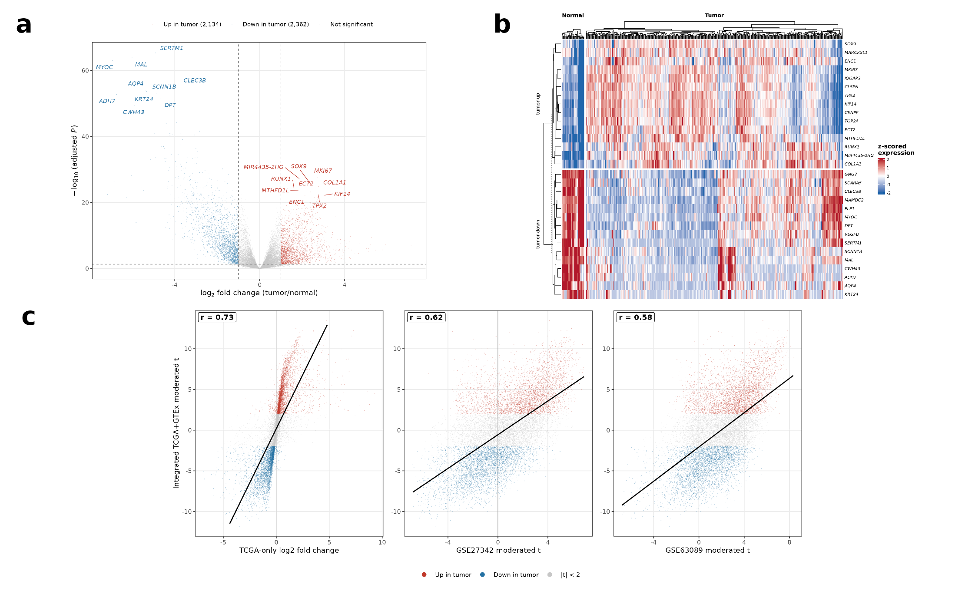
Figure 1
Figure 1. Differential expression between gastric tumors and normal mucosa and its reproducibility.
- Volcano plot showing differentially expressed genes in TCGA-STAD. The x-axis represents log2 fold change (log2FC) and the y-axis represents −log10(adjusted P value). Red points indicate significantly upregulated genes, blue points indicate significantly downregulated genes, and grey points represent genes not meeting the significance thresholds of |log2FC| > 1 and adjusted P < 0.05 (2,134 upregulated and 2,362 downregulated of 21,446 tested features).
- Heatmap of the 30 most significantly differentially expressed genes, comprising the 15 most upregulated and 15 most downregulated (ranked by adjusted p value, ties broken by absolute log2 fold change then gene symbol). Rows represent genes and columns represent samples. Values are z-scores of expression, so the color scale ranges from low relative expression (blue) to high relative expression (red).
- Scatter plots comparing the integrated tumor-versus-normal ranking with three reference rankings. Each point represents one of 12,899 shared genes and the black line denotes a linear fit. The left panel compares against TCGA alone and therefore re-uses the discovery tumors, so it assesses internal consistency rather than replication (r = 0.73); the middle and right panels compare against the independent cohorts GSE27342 (r = 0.62) and GSE63089 (r = 0.58).

3.2 The diffuse subtype is an EMT-driven histotype
Lauren diffuse-vs-intestinal analysis recovered a textbook axis: EMT was the top Hallmark set in diffuse tumors (NES 3.17, padj 1.6×10⁻⁴⁰) with TGF-β signaling and stromal/inflammatory programs, whereas intestinal tumors were dominated by proliferative E2F/MYC/G2M programs (Figure 2B). Loss of CDH1 (E-cadherin) accompanied the diffuse desmoplastic signature.
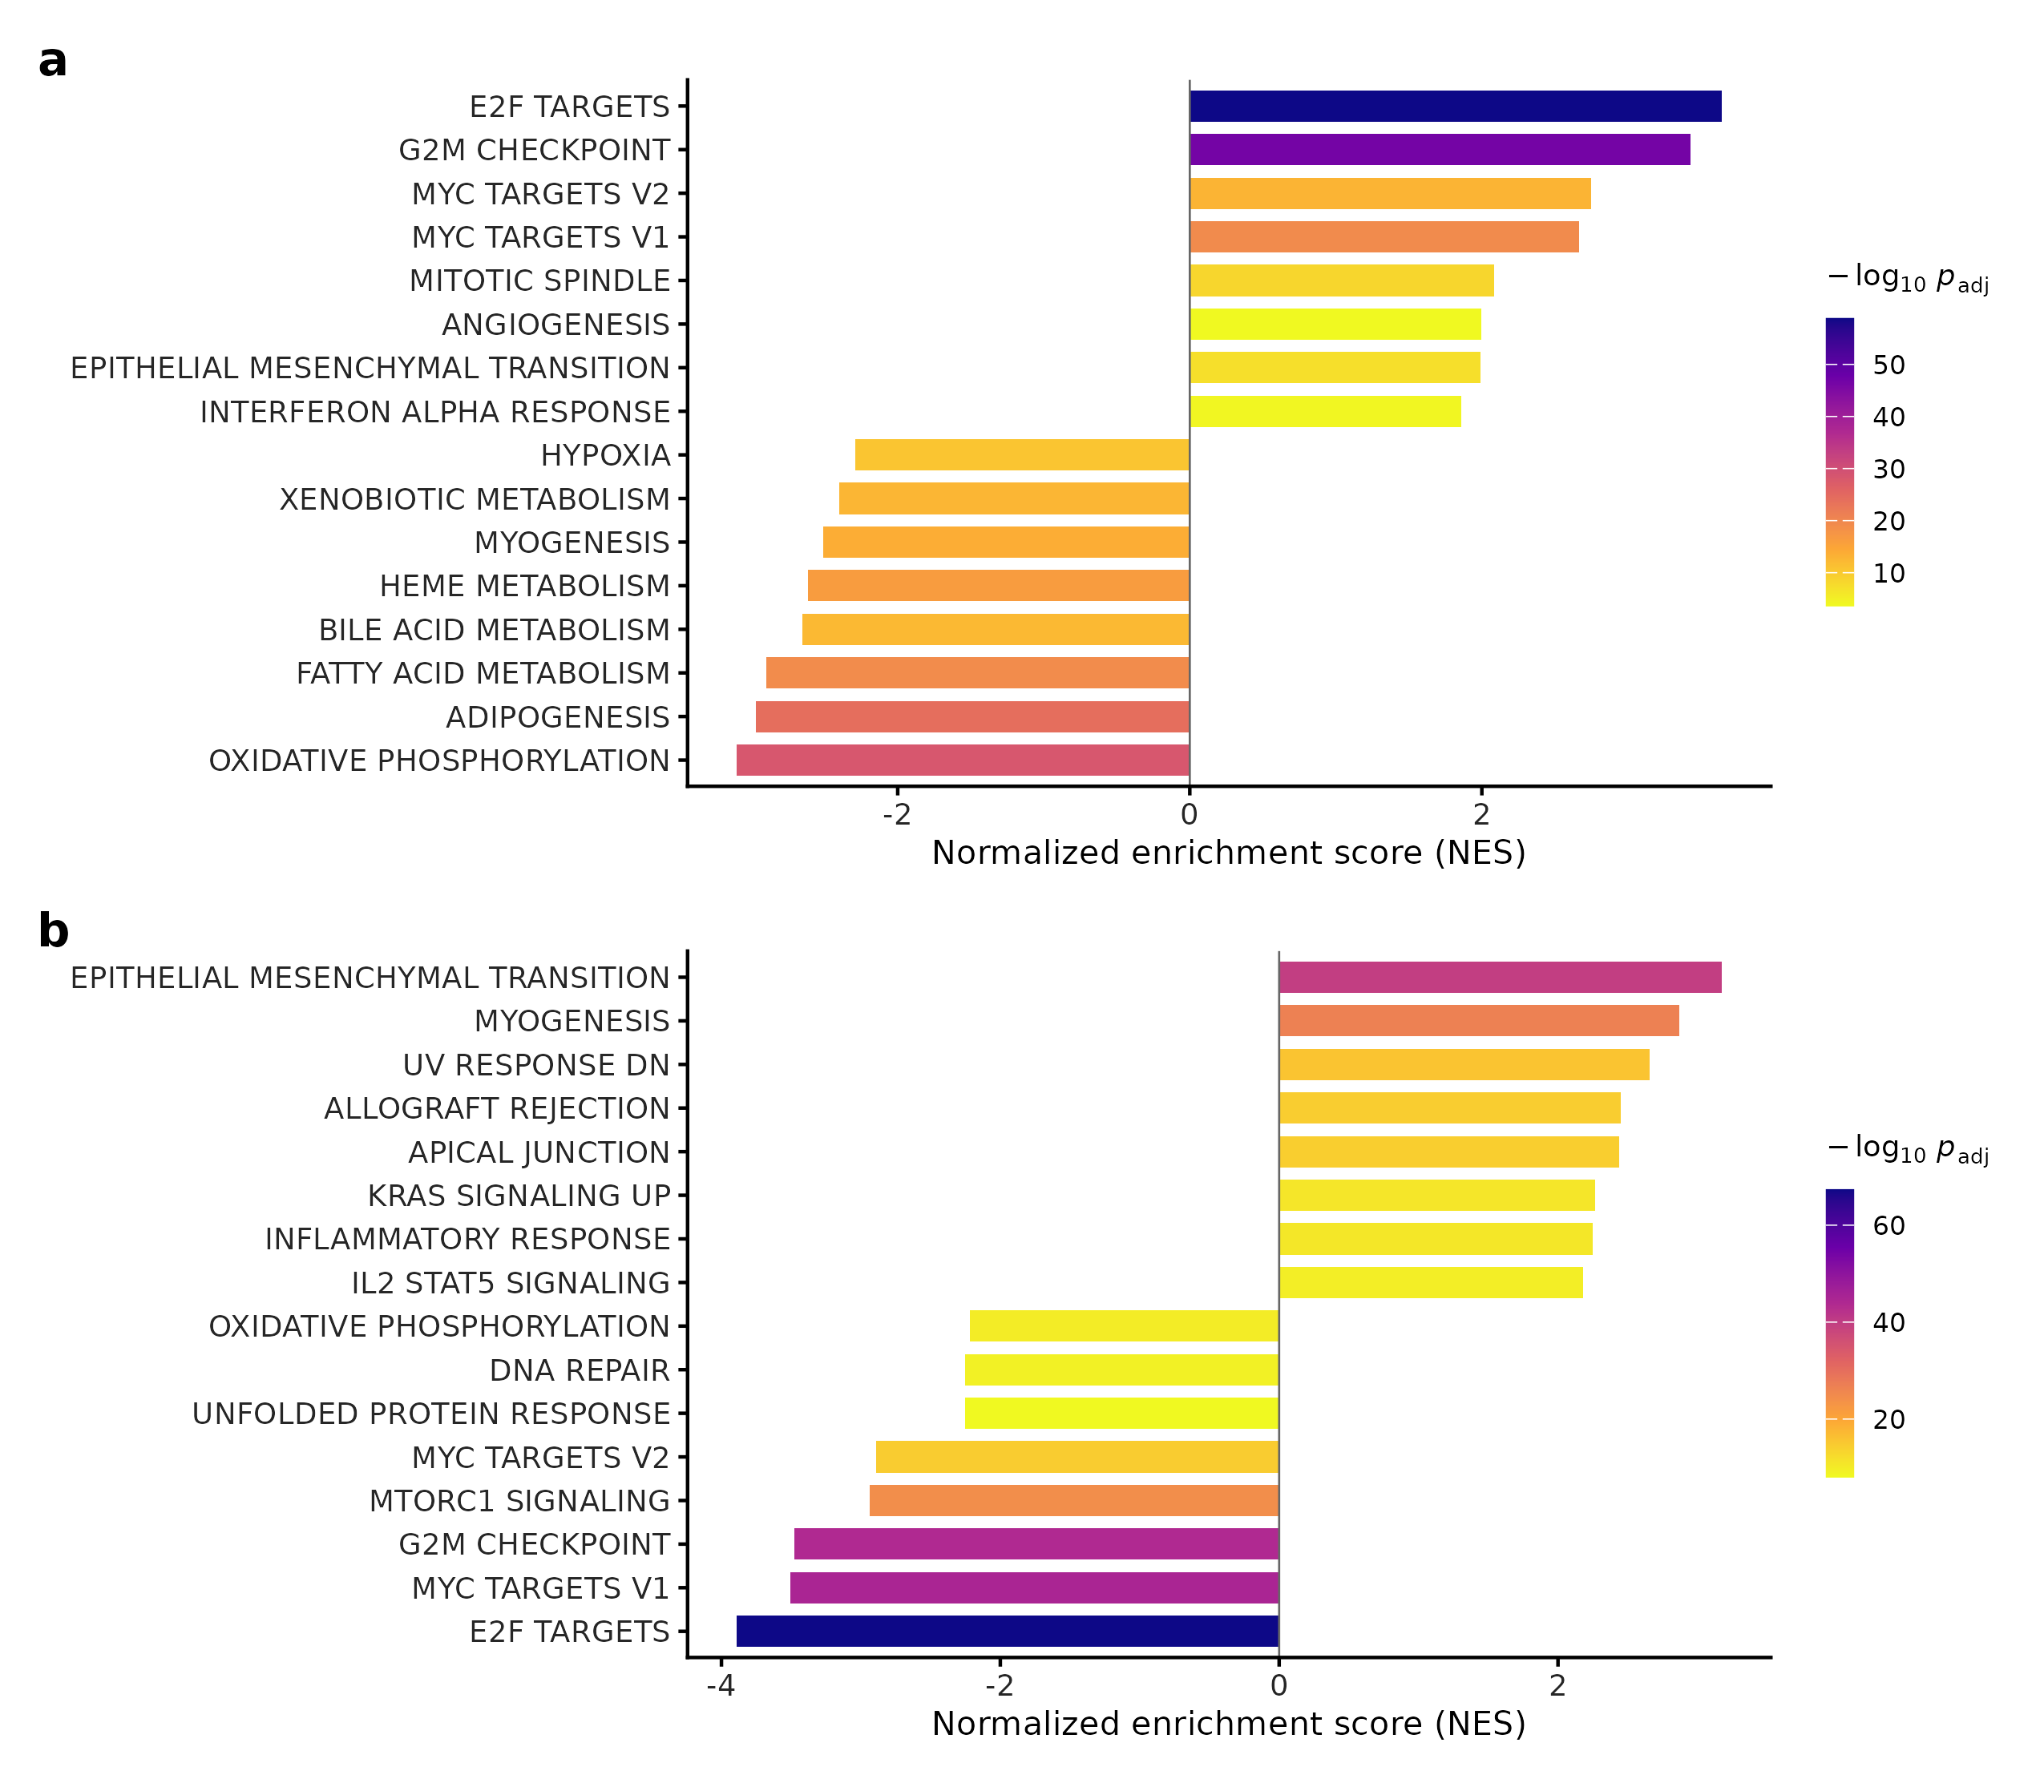
Figure 2
Figure 2. Transcriptional programs distinguishing gastric tumors from normal mucosa and diffuse-type from intestinal-type tumors.
- Bar plot showing Hallmark gene-set enrichment analysis (GSEA) results for the tumor-versus-normal comparison. The x-axis represents the normalized enrichment score (NES), which is the enrichment score scaled for gene-set size so that sets of different sizes are directly comparable; a positive NES indicates enrichment in tumors and a negative NES indicates enrichment in normal tissue. Bars are colored by the −log10 adjusted P value, and only gene sets reaching a false-discovery-rate-adjusted P value below 0.05 are shown. Cell-cycle programs (E2F targets, NES 3.75; G2M checkpoint, NES 3.64) and MYC targets (NES 2.67) are enriched in tumors, whereas oxidative phosphorylation (NES −2.54) and fatty-acid metabolism (NES −2.58) are depleted.
- Bar plot showing Hallmark GSEA results for the comparison of diffuse-type with intestinal-type tumors as defined by the Lauren classification, a histological scheme that separates gastric cancers into cohesive gland-forming (intestinal) and poorly cohesive infiltrative (diffuse) types. A positive NES indicates enrichment in diffuse tumors. Epithelial–mesenchymal transition (EMT) is the most strongly enriched program (NES 3.17, adjusted P = 1.6 × 10⁻⁴⁰), accompanied by inflammatory, interleukin-6–JAK–STAT3 and tumor-necrosis-factor-α–NF-κB signaling.

3.3 A macrophage-enriched immune microenvironment, deconvolution validated against pathology
Immune deconvolution was validated against the measured leukocyte fraction (T-cell score vs leukocyte %: Spearman ρ=0.67, p=3.6×10⁻³⁶; ImmuneScore ρ=0.65; Figure 3A,B). Validation was measure-specific: the CD8 estimate tracked measured leukocyte percentage (ρ=0.47) but showed no correlation with measured lymphocyte-infiltration percentage (ρ=0.02, p=0.74; results/immune/validation_vs_measured.csv), so the deconvolution should be read as capturing overall immune burden rather than lymphocyte subset composition. Relative to normal, tumors were significantly enriched for the macrophage/monocyte compartment (MCP monocytic lineage p=2.5×10⁻⁴; xCell macrophages p=1.9×10⁻⁴) with no net CD8⁺ gain (Supplementary Figure S6A). Immune scores differed significantly across the four TCGA molecular subtypes (Kruskal–Wallis p_adj < 10⁻⁶ on all three measures) (6,7). EBV-positive tumors carried the highest score on every measure and chromosomal-instability (CIN) tumors the lowest, with microsatellite-instable (MSI) and genomically-stable (GS) tumors intermediate; GS ranked above MSI on two of the three scores. This is consistent with the established immune-hot biology of EBV-positive gastric cancer (Derks et al., 2016; TCGA, 2014). Diffuse tumors showed higher total immune/deconvolution signal than intestinal (CD8 score p=0.0035); this contrasts with reports that diffuse tumors are the least infiltrated by effector T cells (Lin et al., 2019) and, given the strong stromal/EMT and M2-macrophage character of diffuse tumors (§3.2, §3.6), likely reflects a stroma- and macrophage-rich compartment rather than genuine cytotoxic-T infiltration — a known confounder of expression-based deconvolution in stroma-rich tumors. CD8⁺ score was not independently prognostic in this cohort (Cox HR 1.04, p=0.41; Supplementary Figure S6B) — reported as observed.
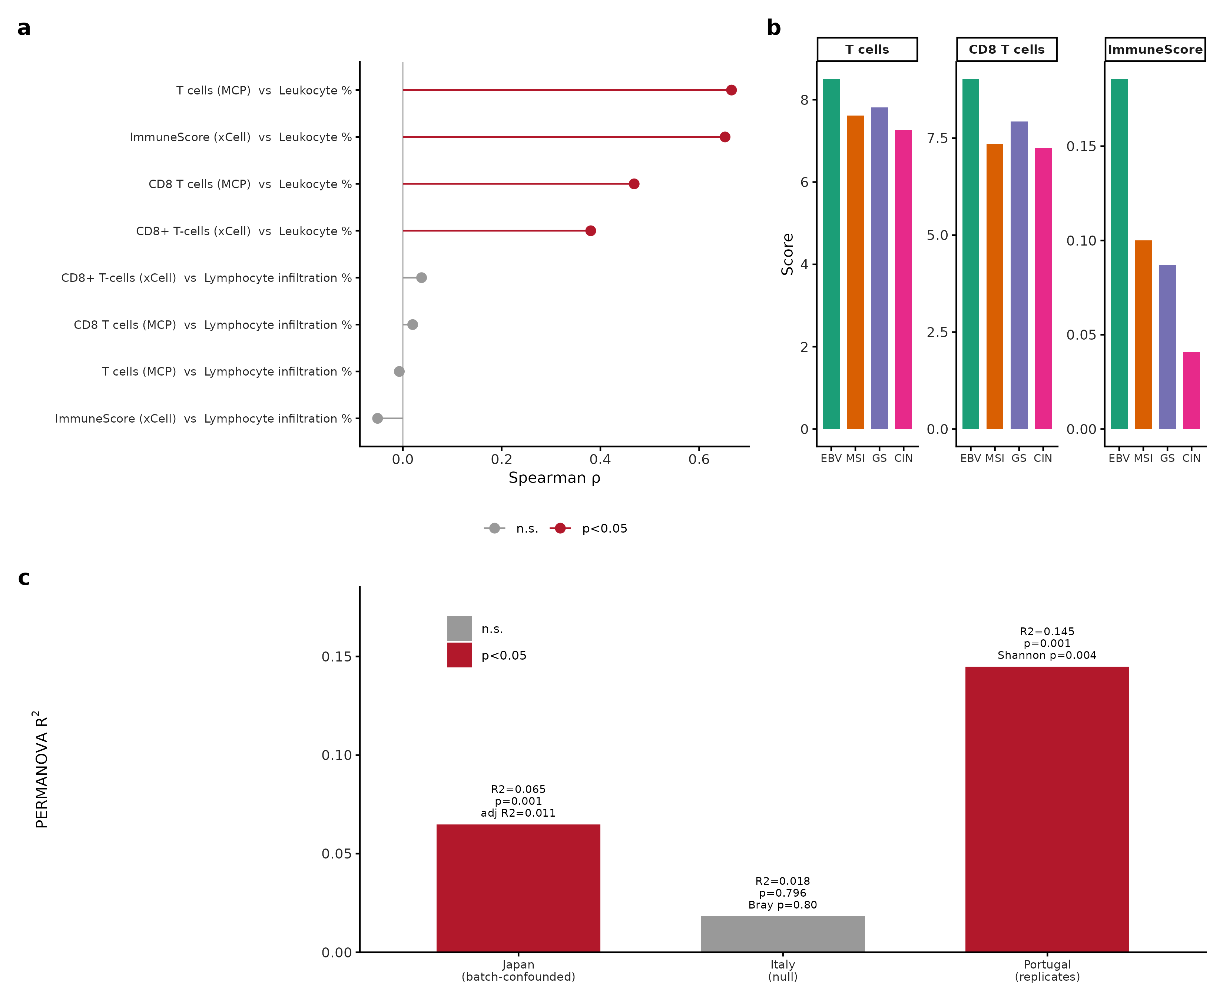
Figure 3
Figure 3. Immune-cell deconvolution and tissue-microbiome comparison.
- Lollipop plot showing the Spearman correlation between each computationally deconvolved immune-cell score and the corresponding pathologist-measured value in TCGA-STAD tumors. Points represent correlation coefficients and horizontal segments connect each point to the null value of zero. Filled points denote correlations significant at P < 0.05.
- Bar plots showing mean immune-cell scores across the four molecular subtypes defined by The Cancer Genome Atlas: Epstein-Barr virus-positive (EBV), microsatellite-instable (MSI), genomically stable (GS) and chromosomal-instability (CIN). Each facet corresponds to one deconvolution score (CD8 T cells and T cells from MCP-counter; ImmuneScore from xCell) and bars are colored by subtype. EBV-positive tumors carry the highest score on all three measures and chromosomal-instability tumors the lowest, with microsatellite-instable and genomically-stable tumors intermediate and their relative order varying by score. All Kruskal-Wallis tests across subtypes remain significant after Benjamini-Hochberg correction (adjusted P < 1 x 10-6). The Lauren histological classification is not the stratifying variable in this panel.
- Bar plot summarizing tumor-versus-control separation of the tissue microbiome in three cohorts. In the Japanese discovery cohort the apparent separation collapses after adjustment for sequencing flowcell (Bray–Curtis R² 0.065 before adjustment, 0.011 after), in the Italian cohort no separation is detected (R² = 0.018, P = 0.80), and in the Portuguese cohort reduced diversity replicates (Shannon P = 0.004; Bray–Curtis R² = 0.145, P = 0.001). These analyses are presented as a cautionary assessment because batch structure and disease status are partially confounded in the discovery cohort.

3.4 An externally validated 25-gene prognostic signature
A 25-gene LASSO-Cox signature stratified overall survival in TCGA (apparent C-index 0.72 on the full signature cohort, n=383/156 events; log-rank p=2.0×10⁻¹²). This apparent figure is optimistic: because gene screening and LASSO were performed once on the whole cohort, it overstates generalisable discrimination. In a leakage-free nested cross-validation (20×5-fold, with train-only standardization, univariable screening and LASSO tuning rebuilt inside every fold and performance taken from untouched out-of-fold predictions), the honest discrimination was Harrell C = 0.611 (95% CI 0.562–0.659) (Uno C 0.573; time-AUC 0.60/0.61/0.63 at 1/3/5 yr; results/nested_cv/) — ~0.11 below the apparent value. The signature is therefore a modest predictor whose apparent C-index was inflated by selection optimism, and we take nested C≈0.61 as the honest estimate (Figure 5A–C). For calibration against the prior literature, we re-implemented a previously-published gastric-cancer prognostic gene signature on the identical TCGA data and evaluation pipeline: its optimism-corrected discrimination was C = 0.52 (apparent 0.54; results/base_paper_replication/) — essentially chance-level discrimination — underscoring that apparent-performance figures reported without leakage control routinely fail to generalise, and framing our own honest 0.61 as a meaningful improvement over that benchmark. It nonetheless validated in two of three independent cohorts:
Cohort | Platform | N (events) | C-index | Log-rank p | HR high-vs-low (95% CI)
TCGA-STAD (training) | RNA-seq | 383 (156) | 0.72 | 2.0×10⁻¹² | —
GSE62254 / ACRG | Affymetrix | 300 (152) | 0.61 | 8.6×10⁻⁵ | 1.90 (1.37–2.62)
GSE15459 | Affymetrix | 191 (95) | 0.58 | 0.014 | 1.68 (1.11–2.54)
GSE84437 | Illumina | 431 (207) | 0.53 | 0.46 | 1.11 (0.84–1.46)
In ACRG multivariable analysis the signature was prognostic after adjusting for stage and age (HR 1.76, p=7.4×10⁻⁴), but this effect is non-proportional and time-limited: the proportional-hazards assumption was violated (cox.zph p=0.003), and a time-varying model showed the signature is prognostic early (HR/SD 1.49 at 12 months, 95% CI 1.23–1.80) and attenuates to null thereafter (1.03 at 36 months; 0.87 at 60 months; results/timevarying_ACRG/; Figure 5D) — i.e. associated with earlier mortality rather than a durable prognostic gradient. Across all three external cohorts, a rigorous continuous-effect meta-analysis (per-1-SD, age/stage-adjusted; REML with Hartung–Knapp) gave a pooled HR of 1.19 (95% CI 0.96–1.47, p=0.073) — not statistically significant (results/meta_HK/); the cross-cohort signature effect is therefore directionally consistent but modest and does not clear significance under a conservative random-effects model. GSE84437 was a genuine negative; the cross-platform C-index attenuation (0.72→0.53–0.61) reflects the expected generalisation cost, reported without adjustment. Its non-validation is plausibly explained by cohort composition: GSE84437 is overwhelmingly deeply-invasive disease (67% pT4, 89% pT3–T4), whereas both validating cohorts span the full stage range (31–42% stage I–II). Because a stromal/CAF signature discriminates prognosis by capturing variation in desmoplastic content — which increases with invasion depth — an almost uniformly T4 cohort suffers range restriction that collapses the signature’s discriminating variance, consistent with its flat HR (1.11, p=0.46). We tested the range-restriction account directly by stratifying GSE84437 on pT stage (Supplementary Table S6): the signature failed to recover discrimination in any stratum — early (pT1–T3) C=0.44, HR/SD 1.21 (0.96–1.54), p=0.11; pT4 C=0.48, HR/SD 1.09 (0.93–1.27), p=0.29; pT2–T3 C=0.44, p=0.10 — with the C-index below 0.5 throughout. This is a genuine, tested negative: within-cohort stage stratification does not rescue the signal, so while the near-uniform pT4 composition is consistent with range restriction, we do not claim stratification recovers discrimination — it does not. A platform difference (Illumina vs Affymetrix) and GSE84437’s absent Lauren/molecular-subtype metadata are additional plausible contributors, and the non-validation is best read as a real limit on cross-platform generalisation rather than an explained-away artefact. Two signature genes carry established prognostic direction consistent with their weights (SERPINE1 and POSTN: high expression → worse survival) (9,10); the collagen/CAF markers COL1A2 and FAP (11) are hub genes of the prognostic WGCNA module (§3.6), not members of the 25-gene signature. We caution that the coefficients are multivariable penalized-regression weights, not univariate prognostic directions: for example GPC3 (8) carries a positive (higher-risk) weight here, whereas in gastric cancer GPC3 is generally reported as a metastasis suppressor with low expression marking worse outcome (Kim et al., 2016) — a sign discordance attributable to correlated-predictor structure in LASSO, and not to be interpreted as a univariate claim. Several members have no established gastric-cancer role and are best regarded as empirical predictors — for example HBB (haemoglobin subunit β) most likely reflects residual blood/erythrocyte content rather than tumor biology. The signature is therefore a statistical aggregate whose biological interpretation rests on the subset overlapping the stromal module (SERPINE1, POSTN, MATN3; §3.6), not on every constituent gene. The standardized LASSO–Cox coefficients (A), the per-cohort external-validation forest plot (B), and Kaplan–Meier stratification across all four cohorts (C) are shown in Figure 4.
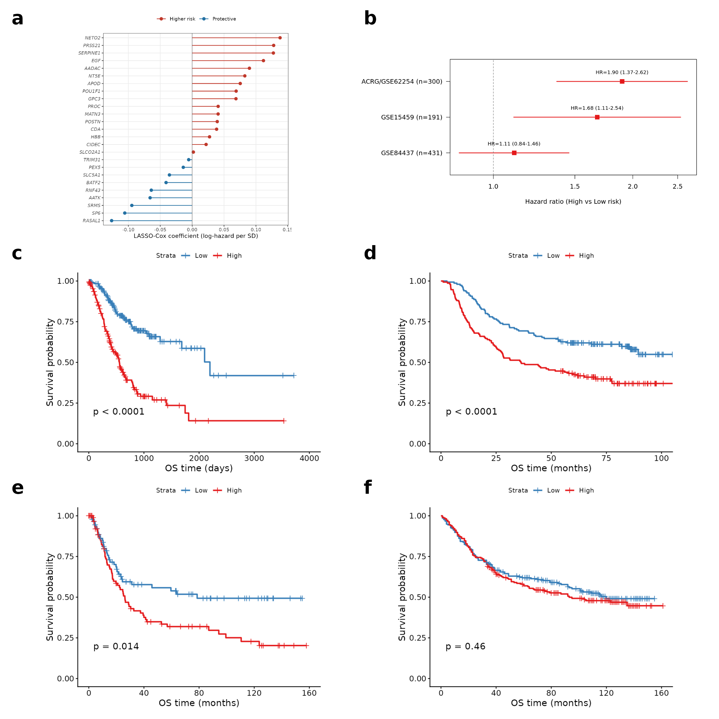
Figure 4
Figure 4. Prognostic signature coefficients and external validation.
- Bar plot showing the LASSO–Cox regression coefficients of the 25 retained genes. A positive coefficient indicates that higher expression is associated with shorter survival and a negative coefficient indicates the opposite.
- Forest plot showing hazard ratios for high- versus low-risk groups (median split of the signature score) across validation cohorts, with squares denoting point estimates and horizontal lines denoting 95% confidence intervals: ACRG/GSE62254 1.90 (1.37-2.62), GSE15459 1.68 (1.11-2.54), GSE84437 1.11 (0.84-1.46). Values are from results/validation_multi/cindex_HR_summary.csv; the corresponding Kaplan-Meier curves are panels (c)-(f).
- Kaplan-Meier curves for high-risk and low-risk groups in the TCGA-STAD training cohort, defined by a median split of the signature score, with the P value from the log-rank test.
- Kaplan-Meier curves for the same median-split groups in the Asian Cancer Research Group cohort (GSE62254, n = 300).
- Kaplan-Meier curves for the same median-split groups in GSE15459 (n = 191).
- Kaplan-Meier curves for the same median-split groups in GSE84437 (n = 431), in which the signature did not separate the two risk groups. This negative result is reported as observed.
Benchmarking against a published signature. As a discipline check, we re-tested a previously published 5-gene gastric-cancer signature (NTN5, SIGLEC5, MPV17L, MPLKIP, SPAG16) on the same TCGA data under identical, leakage-controlled conditions. Its apparent discrimination was C = 0.54, and after bootstrap optimism correction C = 0.52 — indistinguishable from chance — with the risk direction inverted (HR high-vs-low 0.63; results/base_paper_replication/). The optimism correction is bootstrap-based and implementation-sensitive: the value recorded when this analysis was first run (R 4.3.3, rms 6.8-1; archived as results/base_paper_replication/sessionInfo_rms6.8-1_R4.3.3.txt) was 0.48, and re-running the same script and seed under R 4.5.3 with rms 8.1-1 gives 0.52 (current sessionInfo.txt). Both estimates are at chance level — 0.50 is the no-information value — and the apparent C (0.54) is identical in both, so the conclusion is unchanged. That a prior signature fails to replicate under honest evaluation, while ours reaches a modest but real C = 0.61, underscores that the difference between the two is methodological rigor, not cohort luck.
The signature is also predictive, not merely prognostic. In ACRG the signature’s hazard was significantly modified by stage (risk×stage interaction LRT p=0.044) and concentrated in the biologically expected compartments: it was strongest in the mesenchymal MSS/EMT subtype (HR/SD 1.87, 95% CI 1.06–3.32, p=0.031) and in stage III–IV disease (HR/SD 1.47, 95% CI 1.18–1.84, p=5.9×10⁻⁴), and null in stage I–II (HR/SD 1.01) — a subtype/stage dependence consistent with a stromal/CAF program that matters most in advanced, mesenchymal tumors (results/predictive/). The risk×subtype interaction itself was not significant (p=0.094), so this is a coherent pattern rather than a formally subtype-specific effect.
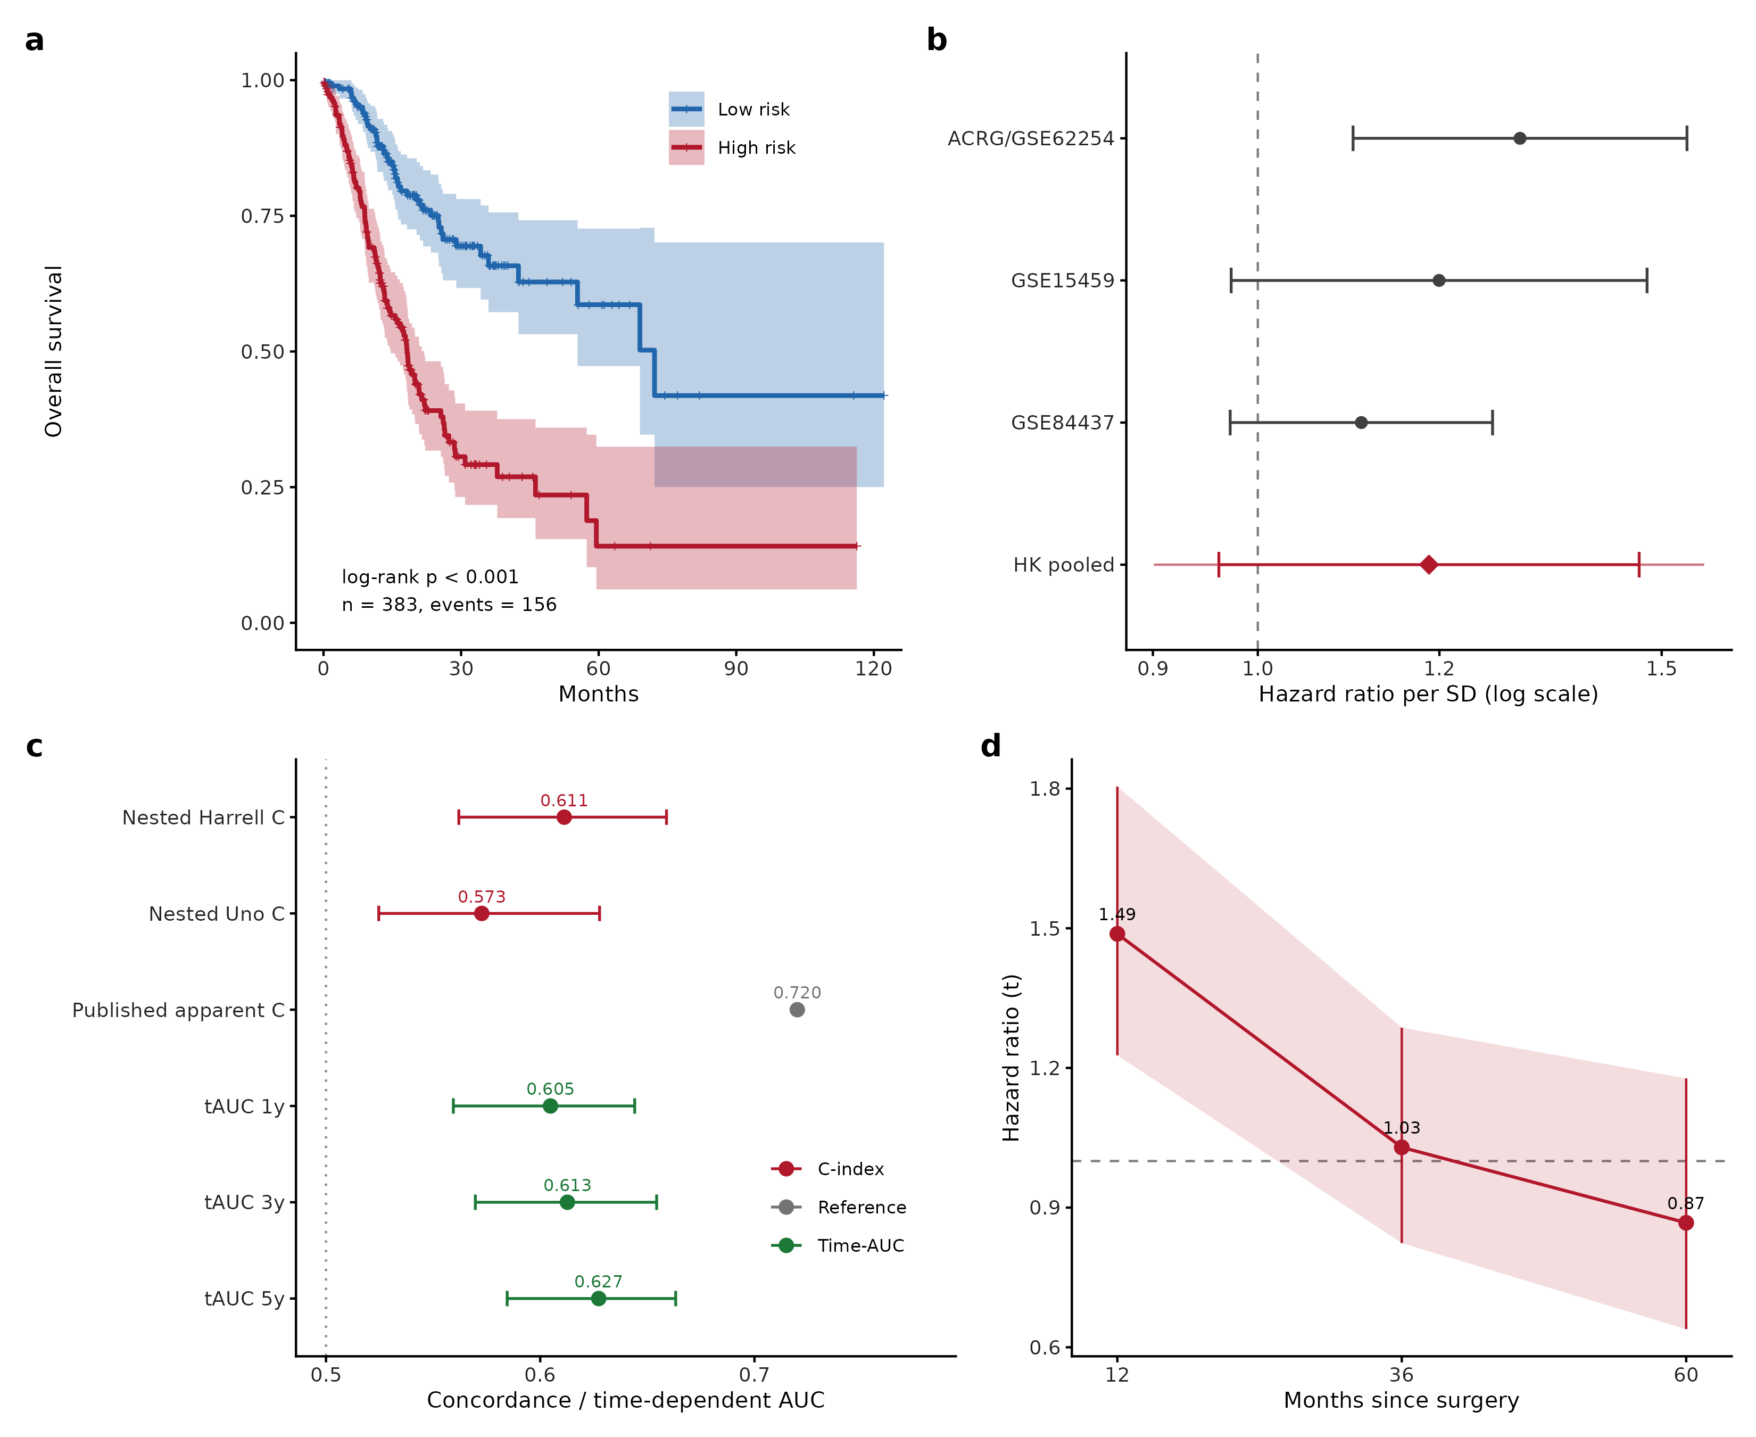
Figure 5
Figure 5. Development and honest evaluation of the 25-gene LASSO–Cox prognostic signature.
- Kaplan–Meier survival curves for patients in The Cancer Genome Atlas stomach adenocarcinoma (TCGA-STAD) cohort stratified into high-risk and low-risk groups at the median signature score (n = 383, 156 deaths). The x-axis represents follow-up time in months and the y-axis represents overall survival probability. Shaded bands denote 95% confidence intervals and the P value is from the log-rank test.
- Forest plot showing the hazard ratio per one standard deviation increase in signature score in each external validation cohort, adjusted for age and stage, together with the Hartung–Knapp random-effects pooled estimate. Squares represent point estimates, horizontal lines represent 95% confidence intervals, and the diamond represents the pooled estimate (hazard ratio 1.19, 95% confidence interval 0.96–1.47; prediction interval 0.90–1.57). The pooled effect does not reach statistical significance.
- Point-and-interval (forest) plot comparing discrimination measured with and without information leakage. The leakage-free estimate is obtained from 20 repeats of 5-fold nested cross-validation, in which gene selection and model fitting occur only inside the training folds (Harrell C = 0.611, 95% confidence interval 0.562–0.659; Uno C = 0.573), whereas the apparent estimate re-uses the same samples for selection and evaluation (C = 0.72). The difference of approximately 0.11 quantifies optimism.
- Line plot showing the time-varying hazard ratio for the signature in the Asian Cancer Research Group (ACRG) cohort. The x-axis represents time since surgery in months and the y-axis represents the hazard ratio. The signature is prognostic early (hazard ratio 1.49 at 12 months, 95% confidence interval 1.23–1.80) and attenuates towards the null by 36–60 months, indicating that the proportional-hazards assumption does not hold across the full follow-up period.

3.5 A clinical prognostic nomogram (honest complete-case model)
On complete cases (N=199 of 412 tumors, ~48%, no imputation; the restriction is driven mainly by TMB availability and may bias toward better-annotated cases — a selection-bias caveat), backward-AIC selected Age, AJCC Stage, Grade and TMB. The full candidate model spans 8 degrees of freedom (Age 1, Stage 3, Grade 2, TMB 1, HAT1 1), giving a modest events-per-variable of ≈8. When the backward-AIC selection was repeated inside every bootstrap replicate (B=500, the statistically honest procedure that also penalizes selection instability), the optimism-corrected C-index was 0.636 (95% CI 0.563–0.704) — slightly below the 0.647 obtained with fixed selection, as expected. Across replicates only Stage was a stable predictor (selected in 93%), with Age 76%, Grade 59%, TMB 53% and HAT1 32%. Discrimination is therefore modest and the model should be read as illustrative; calibration curves approximated the identity line at 1/3/5 years.

3.6 Co-expression modules identify a prognostic stromal/EMT program
WGCNA on the 5,000 most variable genes (signed-hybrid, bicor) was performed at a soft power of 3 (scale-free R²=0.88). Scale-free fit was near-flat across powers 3–12 (R²=0.865–0.886) with no clear elbow; we retain power 3 on the plateau/connectivity criterion and confirm below (§3.6, power-robustness analysis) that the prognostic module is invariant to the power choice, so the finding does not depend on it. Ten modules were detected (gene dendrogram and module assignment in Figure 6A; module–trait correlation heatmap in Figure 6B). The turquoise module was most strongly associated with tumor status (r=−0.34, p=1.8×10⁻¹³; down-regulated in tumor, i.e. a differentiated-tissue program). Testing each module eigengene against overall survival (Cox per 1-SD, tumors), the red module was the most prognostic on univariable Cox (HR 1.31 per SD, 95% CI 1.12–1.53, p=9.3×10⁻⁴); the turquoise (tumor-status) module was also significantly survival-associated (HR 1.29, p=1.3×10⁻³), consistent with both a differentiated-tissue-loss and a stromal-gain axis of prognosis. The red-module association is, importantly, not independent of stage: in a multivariable Cox adjusting for stage, age, leukocyte fraction and Lauren subtype (complete-case n=183, 57 events), the red-module eigengene attenuated to HR 1.35 per SD (95% CI 0.95–1.90, p=0.090) and was no longer significant, while stage remained the dominant predictor (HR 1.82, p=5×10⁻⁴; results/wgcna_real/ME_survival_cox_adjusted.csv). This attenuation is partly driven by the reduced complete-case sample (383→183, owing to leukocyte/Lauren missingness), but the point estimate and loss of independent significance are consistent with the stromal/CAF program tracking tumor stage and stromal admixture rather than adding stage-independent prognostic information — a caveat we carry into the Discussion. Hub genes (defined as the top genes by module membership within the 263-gene red module) are canonical cancer-associated-fibroblast / stromal-EMT markers — CDH11, COL8A1, COL1A2, FNDC1, SPARC, LUM, BGN, FAP, POSTN — each independently prognostic on univariable Cox (e.g. CDH11 HR 1.23, p=0.0023). (Throughout, “hub genes” denotes this membership-ranked set; the representative 9–12 named here are used for the robustness and single-cell checks below, all drawn from the same module.) Critically, three of the 25 signature genes (SERPINE1, POSTN, MATN3) reside in this prognostic red module, providing a coherent multi-omics link between the survival signature and a stromal/EMT co-expression program; module preservation and external eigengene prognosis are shown in Figure 7A,B. A power-robustness analysis confirmed this is not an artefact of the soft-power choice: across powers 3, 6, 9 and 12 the 12 CAF hub genes remained co-clustered in a single module (11–12/12 at every power) that stayed significantly survival-associated (HR/SD 1.28–1.31, all p<0.0025, overlapping CIs) — only the color label shifts (red→green→yellow) as the total module count shrinks at higher powers (Figure 6C).
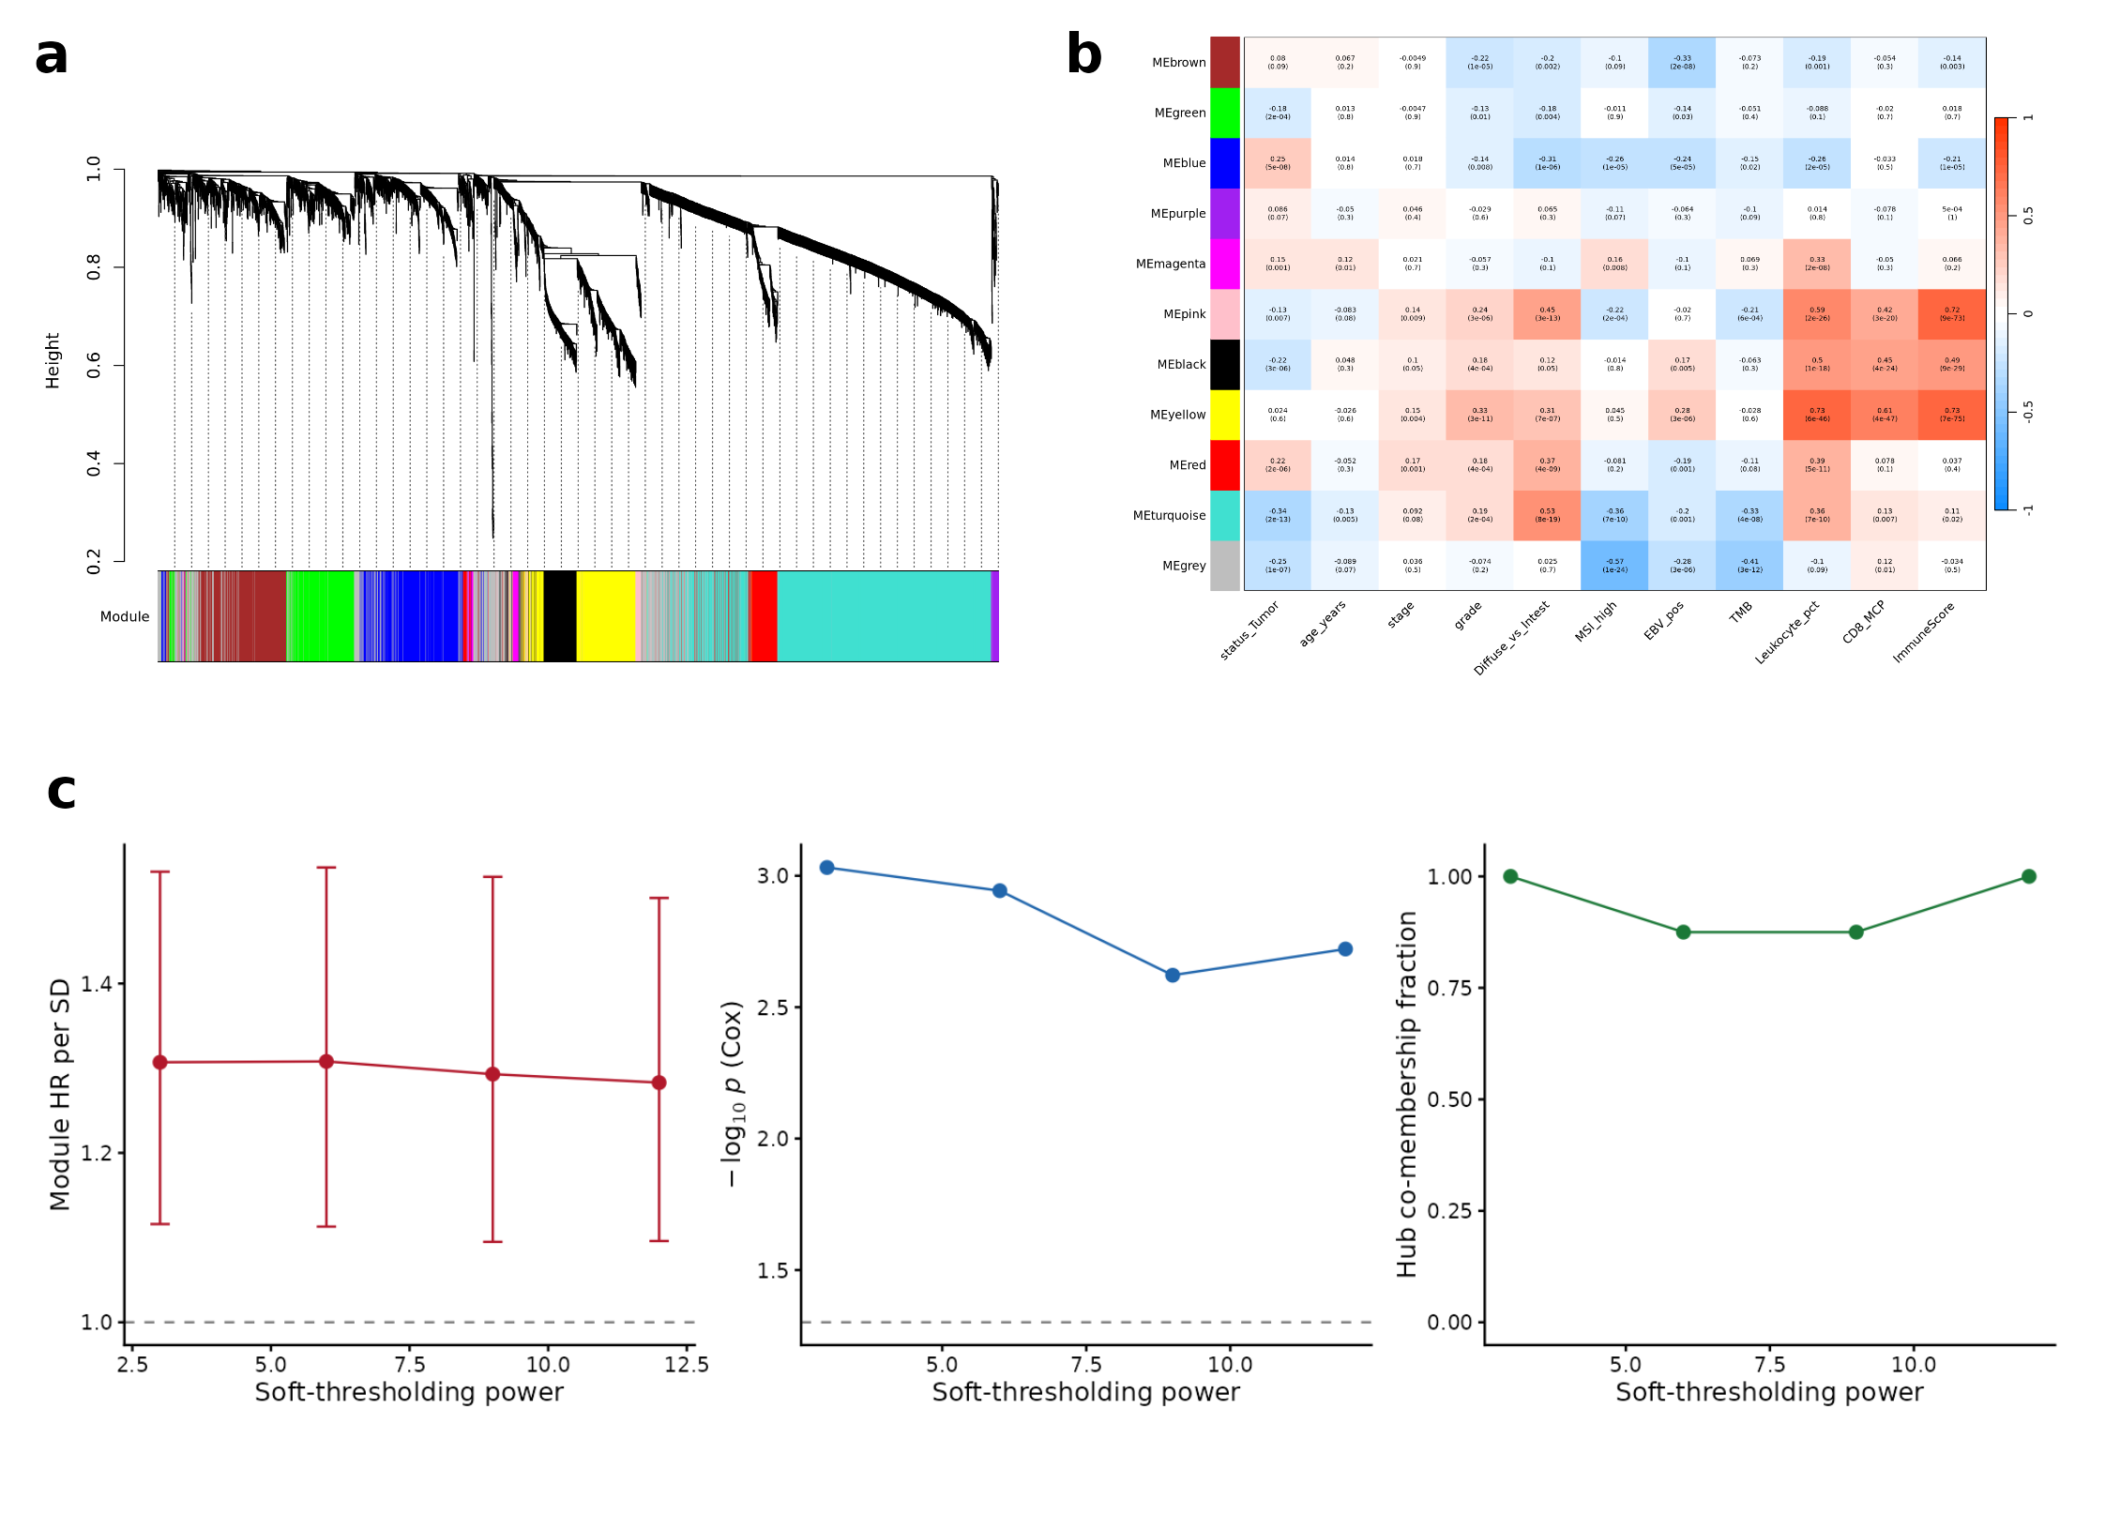
Figure 6
Figure 6. Construction and quality assessment of the gene co-expression network.
- Cluster dendrogram showing hierarchical clustering of genes by topological overlap, with the resulting module assignments displayed as colored bars beneath the tree.
- Heatmap of correlations between module eigengenes and clinical traits. Rows represent modules and columns represent traits; the color scale ranges from negative (blue) to positive (red) correlation.
- Sensitivity of the prognostic module to the soft-thresholding power, shown as three line plots over the candidate powers 3, 6, 9 and 12. The soft-thresholding power raises correlations to a power so that strong correlations are emphasized and weak ones suppressed, approximating the scale-free topology observed in biological networks; because this choice is made by the analyst, its influence on the result is reported here. The left panel plots the hazard ratio per standard deviation of the module eigengene, with vertical bars denoting 95% confidence intervals and the dashed line marking a hazard ratio of one. The middle panel plots the negative base-ten logarithm of the Cox P value, with the dashed line marking P = 0.05. The right panel plots the fraction of the eight module hub genes that remain co-clustered. Across all four powers the hazard ratio stays between 1.28 and 1.31, the Cox P value stays below 0.05 (maximum 0.0024) and hub co-membership stays at or above 0.875, so the prognostic result does not depend on the particular power chosen. Values are given in Supplementary Table S8.
To test directly whether this stromal signal is a tumor-purity artefact, we correlated both the 25-gene risk score and an independent CAF score against orthogonal purity/stroma estimates (results/purity/correlations.csv). The risk score rose with xCell stromal content (Spearman ρ=+0.39, p=1.7×10⁻¹⁶) and fell with ABSOLUTE tumor purity (ρ=−0.20, p=8.9×10⁻⁴), and the CAF score tracked stroma even more strongly (ρ=+0.66, p=4.9×10⁻⁵³); both scores were highest in the diffuse Lauren subtype (Kruskal–Wallis p=1.5×10⁻⁵ and p=1.9×10⁻⁸). This confirms the program indexes stromal admixture — but it is not merely a purity readout: the risk score’s prognostic effect survived adjustment for ABSOLUTE purity (HR 2.97 per SD, 95% CI 2.28–3.86, p=7.6×10⁻¹⁶ with purity in the model; purity itself non-significant, p=0.35; results/purity/purity_adjusted_cox.csv). The stromal program therefore carries prognostic information that co-localizes with, but is not reducible to, low tumor purity — while remaining, as above, entangled with stage.
Most importantly, the CAF module is not confined to TCGA. Applying WGCNA module-preservation statistics (modulePreservation, 200 permutations) to three independent gastric-cancer cohorts, the red module was strongly preserved in every one — Zsummary.pres = 15.9 (ACRG/GSE62254), 16.8 (GSE15459) and 17.1 (GSE84437), all well above the Z>10 “strong preservation” threshold (results/module_preservation/), and its eigengene (first principal component of the red-module genes, aligned so that higher scores denote greater stromal activation) was independently prognostic for overall survival in all three cohorts — HR per SD 1.27 (95% CI 1.09–1.49, p=2.2×10⁻³) in ACRG, 1.55 (1.25–1.92, p=6.8×10⁻⁵) in GSE15459 and 1.24 (1.08–1.42, p=2.1×10⁻³) in GSE84437 — always in the TCGA-concordant direction (higher stromal activation → worse survival; results/module_preservation/module_eigengene_cox_external.csv). This converts the co-expression finding from a TCGA-internal observation into an externally-replicated stromal/CAF prognostic program — the study’s most robust result. (The within-TCGA stage-adjustment caveat above still applies: the program tracks, and is not cleanly separable from, tumor stage; but its structural preservation and prognostic association reproduce across four independent cohorts.)
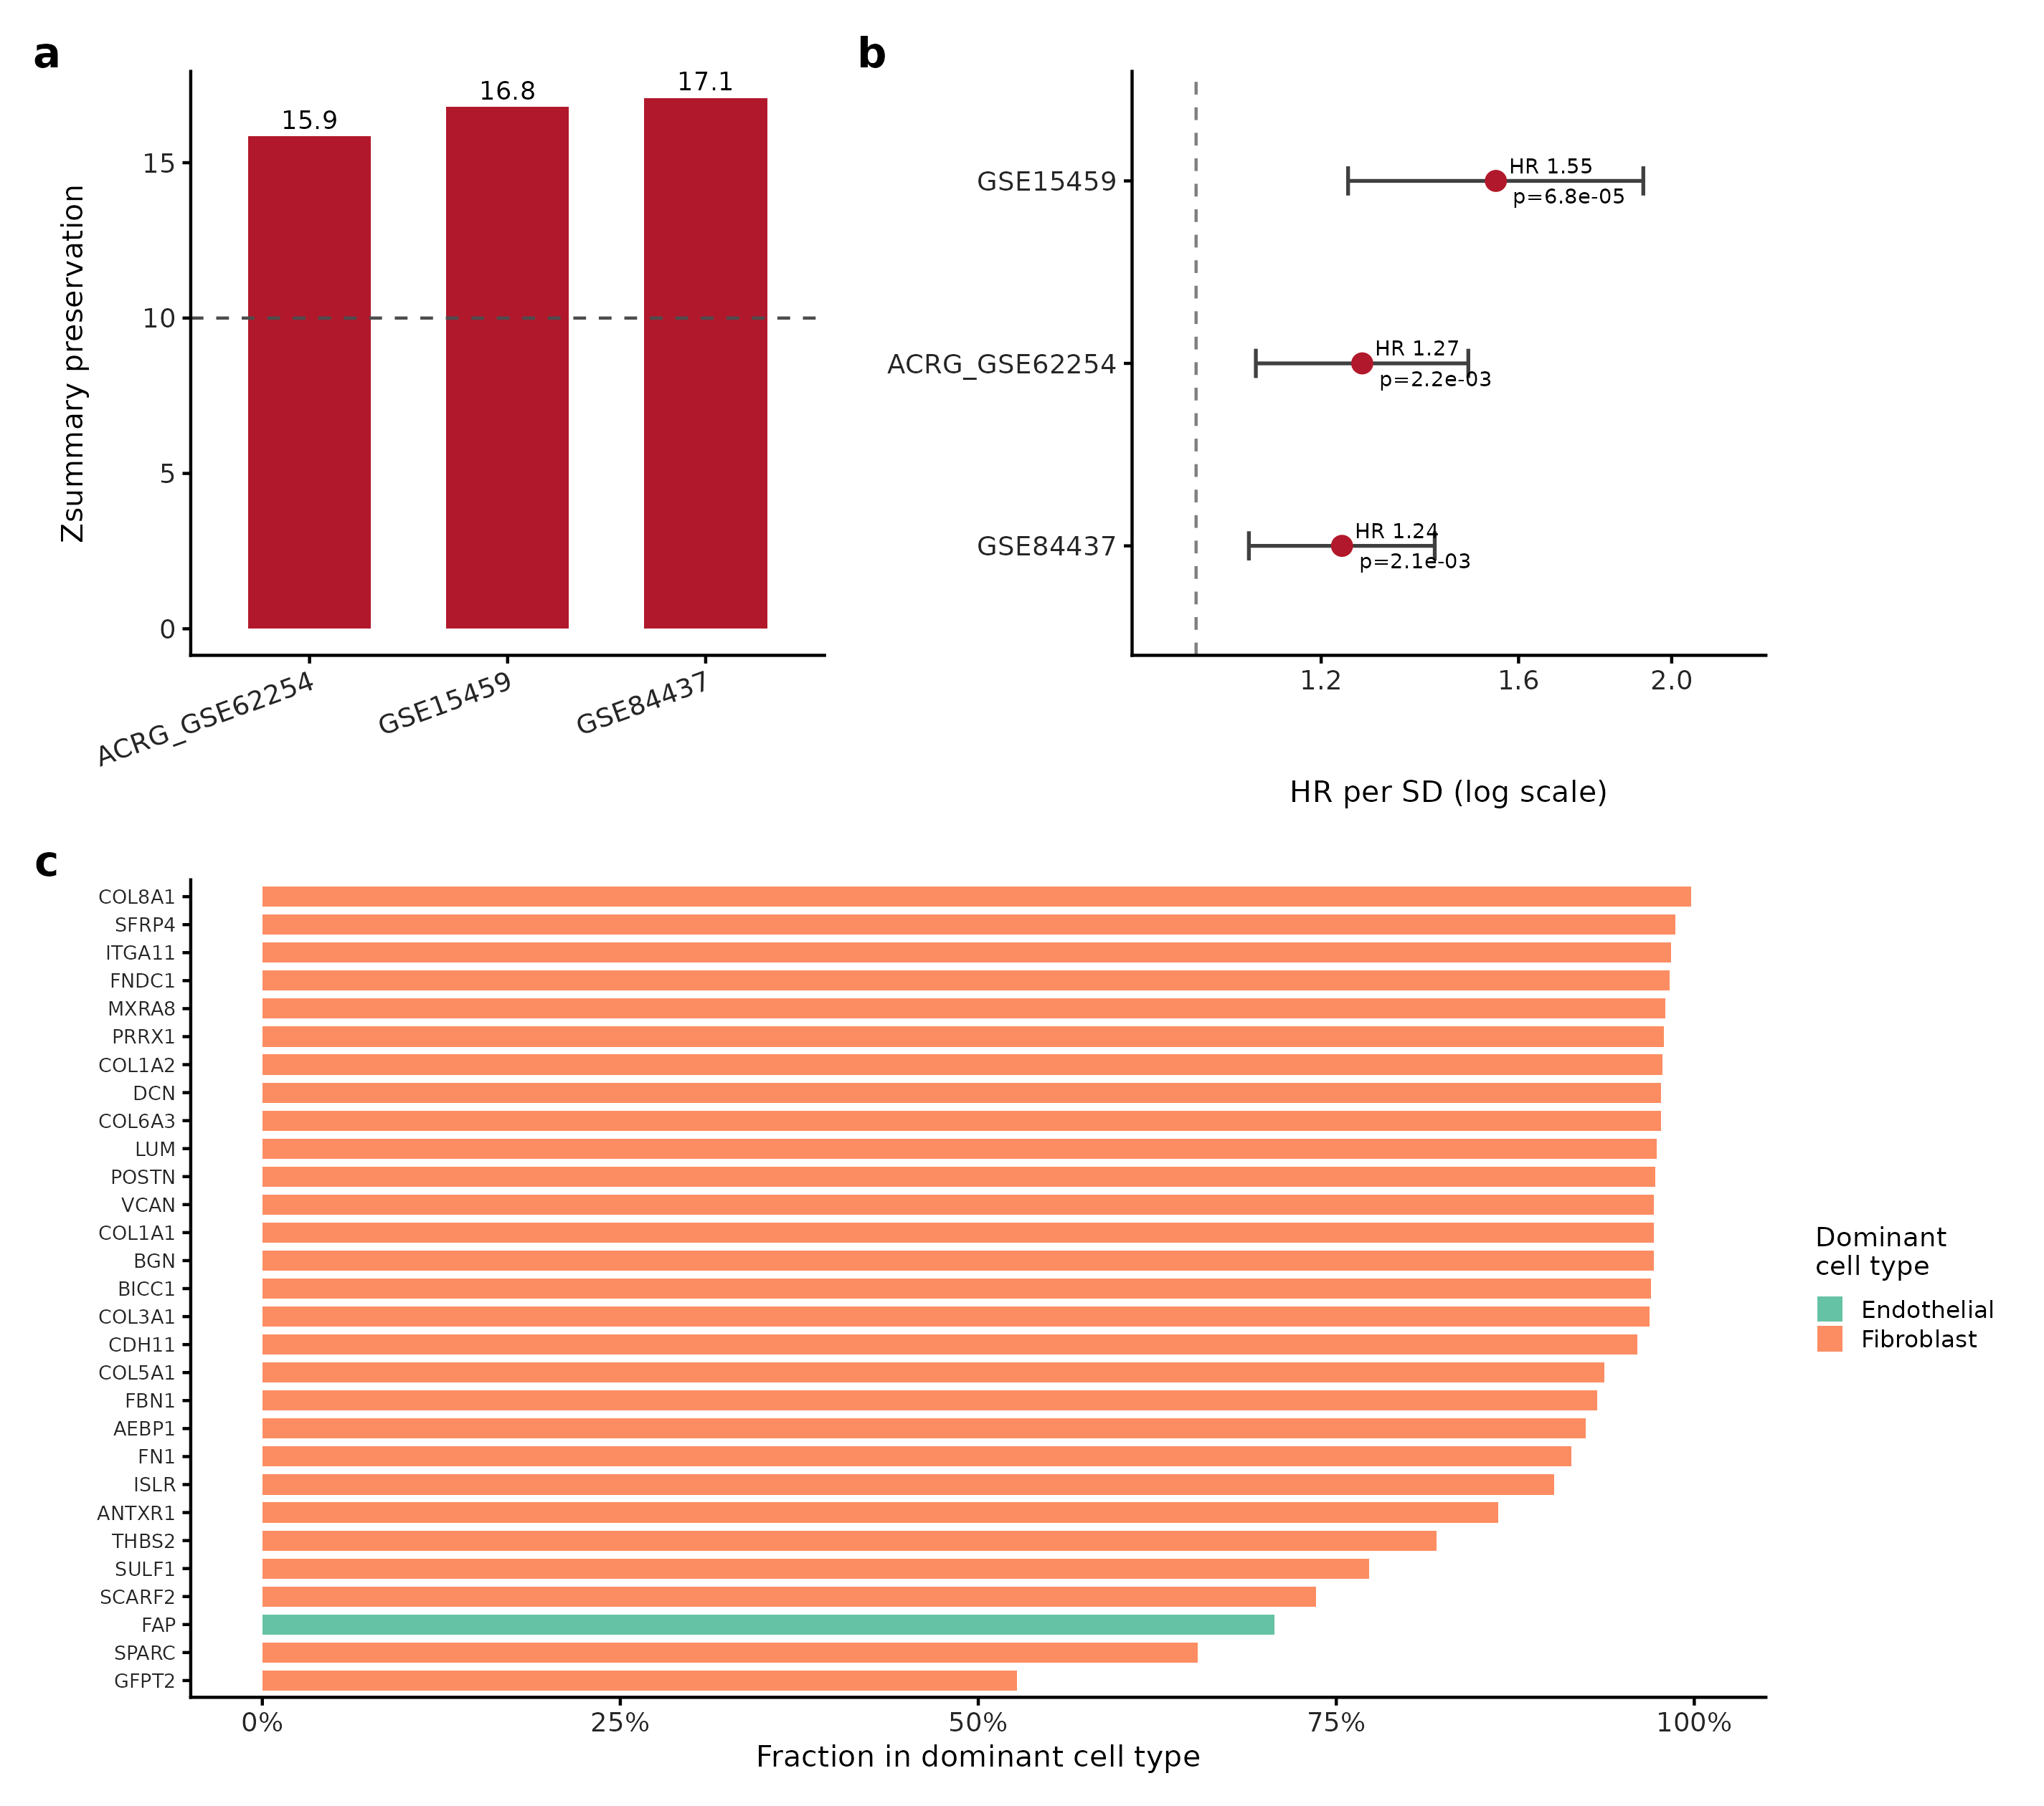
Figure 7
Figure 7. External preservation of the stromal co-expression module, its prognostic value, and its cellular localization.
- Bar plot showing preservation of the survival-associated (red) module in three external cohorts, quantified by the WGCNA Zsummary statistic. Zsummary is a permutation-based composite of density and connectivity preservation; the dashed line marks Z = 10, the conventional threshold for strong preservation. All three cohorts exceed it (ACRG/GSE62254 Z = 15.9, GSE15459 Z = 16.8, GSE84437 Z = 17.1), indicating that the module is a reproducible feature of gastric tumor transcriptomes rather than a property of the discovery cohort.
- Forest plot showing Cox proportional-hazards results for the module eigengene, defined as the first principal component of the module’s expression matrix and therefore a single summary value per patient. Points represent the hazard ratio per one standard deviation of eigengene and horizontal bars represent 95% confidence intervals, plotted on a logarithmic scale. The module is prognostic in all three cohorts (ACRG hazard ratio 1.27, 95% confidence interval 1.09-1.49, P = 0.0022; GSE15459 1.55, 1.25-1.92, P = 6.8 x 10-5; GSE84437 1.24, 1.08-1.42, P = 0.0021), including GSE84437, the cohort in which the 25-gene signature did not validate.
- Bar plot showing the single-cell localization of the stromal-module hub genes. For each gene, the bar represents the fraction of its total expression contributed by the cell type in which it is most highly expressed, computed from a public gastric single-cell RNA-sequencing dataset. Bars are colored by that dominant cell type. Twenty-eight of the twenty-nine hub genes are fibroblast-dominant (median fraction 0.97), placing the prognostic program in the fibroblast compartment; FAP is the single exception and is endothelial-dominant in this dataset.

3.7 The signature is prognostic but adds little decision-analytic value beyond staging
In-sample (TCGA training cohort, n=301, 106 deaths; optimism-corrected C-index), combining the signature with clinical variables appeared to improve prognostication substantially: clinical model (Age+Stage+Grade) 0.659 (95% CI 0.604–0.713) → signature alone 0.742 → combined 0.773 (0.726–0.820), with a large added value (ΔC +0.114; nested LRT χ²=80.5, p=3.0×10⁻¹⁹; IDI@3yr 0.217; NRI@3yr 0.387; combined time-AUC 0.79/0.83/0.81) and TCGA-internal decision-curve analysis favoring the combined model. These statistics are in-sample estimates computed on the signature’s training cohort and are inflated by that circularity.
We therefore repeated the entire utility analysis out-of-sample in ACRG (n=300, 152 deaths). Here the signature risk score uses the fixed TCGA-derived coefficients, while the clinical (stage+age) and combined models are re-fitted in ACRG; this tests whether the fixed signature adds value on top of an optimally-fitted external clinical model, not the performance of a fully transported nomogram. For reference, a fully transported combined model with all coefficients frozen from TCGA reaches C=0.662 in ACRG versus 0.723 when re-fitted (results/nomogram_combined/cindex_comparison.csv), quantifying the transport cost. Externally, the added value shrank markedly: clinical C 0.711 vs combined 0.716 (ΔC-index +0.005), nested LRT p=2.0×10⁻³, IDI@3yr 0.021 (p=0.04), NRI@3yr 0.175 (p=0.04); external time-dependent AUCs were 0.80/0.76/0.76 (clinical) vs 0.83/0.77/0.76 (combined); and external decision-curve analysis showed no net-benefit improvement (clinical and combined curves essentially superimposed across the 5–40% threshold range). Thus the signature carries prognostic information independent of stage and age (statistically significant added value externally, i.e. it is not merely a stage proxy), but it does not materially improve clinical decision-making over standard staging in independent data — a distinction we state plainly rather than resting on the inflated in-sample DCA. A combined nomogram with 1/3/5-yr calibration is provided as an illustrative tool, not a validated decision instrument.

3.8 Tumor-tissue microbial dysbiosis
We reprocessed the tissue 16S data from raw sequencing (944 DDBJ PRJDB20660 libraries) through DADA2, rather than relying on transcribed group-level tables, yielding a genuine ASV table (11,795 ASVs; after removing host mitochondrial reads — ~34% of reads — plus off-target and rare features, 897 samples × 314 genera). Per-sample read counts reproduced the published read-tracking table (Pearson r=0.98), confirming faithful denoising. The multi-cohort microbiome comparison is summarized in Figure 3C.
A technical finding governs all interpretation of the tumor contrast: tumor and non-tumor libraries were sequenced on separate flowcells — of 216 tumor/adjacent-normal pairs, only 1 shares a flowcell — so tumor status is confounded with sequencing batch and cannot be disentangled by patient blocking or batch covariates. We therefore report this arm as exploratory, disclose the confound throughout, and emphasize the flowcell-sharing groups. On the less-confounded axis (non-ulcer → ulcer → cancer-adjacent, which share flowcells), microbial richness declined along the gastritis-to-cancer sequence (observed-richness ordered Jonckheere–Terpstra Z=−4.94, p=7.7×10⁻⁷; Shannon Z=−2.66, p=0.008) and Helicobacter rose monotonically toward cancer-adjacent tissue — both literature-consistent. Because n≈900 renders p-values near-inevitable, we report effect sizes: from non-ulcer to cancer-adjacent tissue, observed richness falls with Cliff’s δ=−0.27 (median 47→30) and Shannon with δ=−0.12 (2.18→1.92), but Simpson (evenness-weighted) diversity does not significantly decline (δ=−0.07, p=0.17; trend-test p=0.074; Supplementary Table S4, results/microbiome_biomarker/02_alpha_effectsizes_cascade.csv). The consistently replicated signal is therefore reduced richness, not a uniform diversity collapse — the Shannon/Simpson discordance we flag explicitly, in the same spirit as the DEG-inflation and PERMDISP caveats. But β-diversity separation by phenotype collapsed once flowcell was modelled (Bray R² 0.065→0.011), and a cancer-versus-control classifier that appeared strong (cross-validated AUC 0.916) was shown to be batch-driven: its top features were environmental/skin contaminants, and the same features predicted the sequencing flowcell among biologically-similar samples at 78% accuracy (vs 55% baseline; Supplementary Figure S9). The apparent tumor “oralization” signal thus largely reflects batch, not biology. Compositional (CLR) differential abundance is shown for completeness (Supplementary Figure S5): 44/61 genera differed between controls and cancer-adjacent mucosa and 18/61 in the paired cancer-adjacent-versus-tumor contrast, but — consistent with the batch caveat above — these genus-level shifts are not carried forward as biomarkers, as they do not survive the independent-cohort test below.
Decisively, we tested whether the dysbiosis signal replicates in an independent, batch-clean cohort (PRJNA641258; 20 gastric-cancer vs 20 matched controls, V3–V4, tumor and control sequenced together on shared runs so that phenotype is not confounded with batch). It did not: there was no diversity difference (Shannon p=0.25), no compositional difference (Bray-Curtis PERMANOVA R²=0.018, p=0.80), the canonical oral taxa trended in the opposite direction, and no genus was significant after multiple-testing correction (0/344). Because random per-run batch effects do not transfer across independent cohorts, this clean non-replication indicates that the tumor-associated microbiome signal in the primary cohort was a batch artefact rather than a generalisable biomarker.
A second independent cohort (PRJNA413125, Portugal; Ferreira et al. 2018 — the study that defined the gastric Microbial Dysbiosis Index) sharpens the picture. Our identical pipeline reproduced that study’s own published finding — significantly reduced diversity in carcinoma versus chronic gastritis (Shannon 1.96→1.48, p=4.4×10⁻³; Simpson p=0.036) with clear compositional separation (Bray R²=0.14, p=0.001; 68/560 genera differential) — confirming the pipeline detects genuine signal when it exists. Yet here the canonical oral taxa were depleted, not enriched, in carcinoma (Streptococcus log2FC −2.0, Fusobacterium −1.3, Porphyromonas −3.0; all p<10⁻⁴), and Helicobacter fell sharply (0.36→0.03, p=4×10⁻¹³) — the classic “H. pylori paradox”. Across the three cohorts the oral-taxa direction is therefore comparator-dependent (up versus batch-confounded adjacent-normal — artefactual; null versus matched controls; down versus gastritis), whereas the consistently replicated signal is reduced α-diversity in cancer. We therefore present the tissue-microbiome arm as a rigorous, honest, multi-cohort characterization whose message is cautionary: the widely-claimed tumor “oralization” biomarker does not generalise; reduced diversity plus the H. pylori paradox are the durable biology; and batch confounding and comparator choice — not a fixed dysbiotic signature — dominate tissue-microbiome results. (Fusobacterium and Veillonella MR exposures cannot be corroborated by tissue data given this instability.)

3.9 Mendelian randomization does not support microbial causality at current power
Two-sample MR detected no significant causal effect of any exposure on gastric-cancer risk (ancestry-matched European outcome, 1,029 cases). Instruments were strong — per-exposure mean F 20.9–22.8, and every individual instrument cleared the weak-instrument threshold (minimum per-SNP F 19.3–20.3, all >10). Because no exposure — including anti-H. pylori seropositivity — reached ≥3 genome-wide-significant SNPs, all six were selected at a locus-wide threshold of p<1×10⁻⁵ (a choice that can bias toward the null via weak-instrument effects, though the per-SNP F values indicate the instruments themselves are not weak). These F-statistics are computed on the pre-harmonization instrument set; several SNPs are dropped at harmonization (per-exposure pre-clump and harmonized-used counts in Supplementary Table S1), so the reported instrument strength characterizes the fetched, not the final, SNP set:
Exposure | Axis | nSNP | IVW OR (95% CI) | p
Anti-H. pylori IgG seropositivity | H. pylori | 17 | 0.96 (0.71–1.30) | 0.79
Streptococcus (genus) | oral-origin | 15 | 1.10 (0.90–1.34) | 0.35
Fusobacterium A | oral-origin | 23 | 1.04 (0.79–1.36) | 0.79
Prevotella 9 | oral-origin | 15 | 0.98 (0.84–1.14) | 0.76
Veillonella | oral-origin | 8 | 1.04 (0.84–1.29) | 0.69
Lactobacillus | protective-cand. | 10 | 0.96 (0.85–1.09) | 0.51
Sensitivity diagnostics were quantitative: MR-Egger intercepts showed no evidence of directional pleiotropy for five of the six exposures (intercept p>0.09), while Fusobacterium carried a nominal Egger-intercept signal (intercept 0.038, p=0.040) indicating possible directional pleiotropy; its IVW estimate is null regardless, and the pleiotropy-robust MR-Egger and weighted-median estimates for Fusobacterium were likewise non-significant, so the null conclusion is unaffected by this caveat. Cochran’s Q indicated no significant heterogeneity except for H. pylori (Q p=0.035; all others Q p>0.10). MR-PRESSO global tests (Supplementary Table S2) were non-significant for five of the six exposures (global p 0.16–0.68), with anti-H. pylori seropositivity borderline (RSSobs 32.6, global p=0.052) — the only exposure near the 0.05 line, converging with its already-significant Cochran’s Q; no single outlier SNP was flagged for removal in any exposure. The H. pylori null should therefore be read with marginally more caution than the other five, though its IVW, weighted-median and MR-Egger estimates all agree on the null. Steiger filtering confirmed the exposure→outcome direction throughout; we note that with only ~1,029 outcome cases the SNP–outcome r² is very small, so the directionality test passes near-mechanically and its extreme p-values should not be over-read as independent validation. Per-exposure Q, Egger-intercept, Steiger and MR-PRESSO statistics are provided in the result tables (results/mr_real/); the full six-exposure SNP-effect scatter panel is shown in Figure 8 and the corresponding leave-one-out analyses for all six exposures in Supplementary Figure S8.
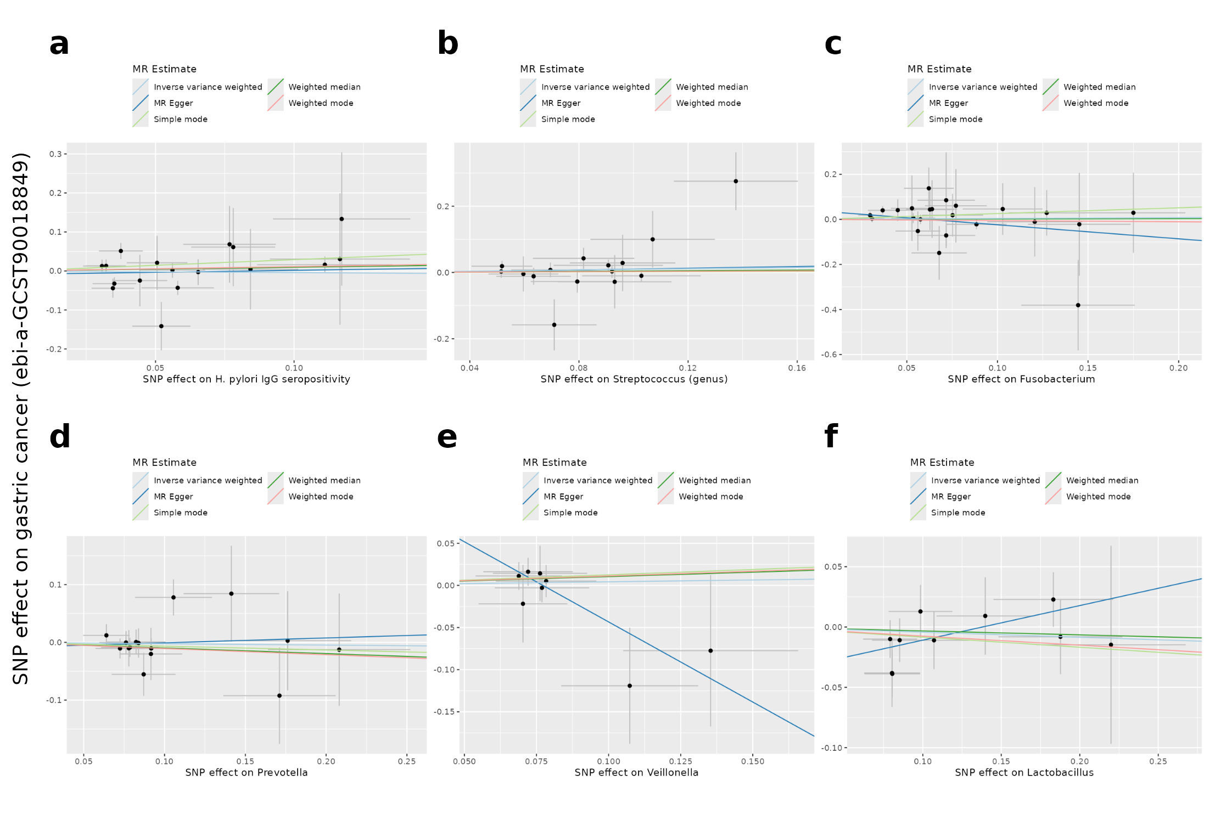
Figure 8
Figure 8. Two-sample Mendelian randomization of microbial exposures on gastric-cancer risk.
Each panel shows the association between single-nucleotide-polymorphism effects on one microbial exposure (x-axis) and the corresponding effects on gastric-cancer risk (y-axis) in a European-ancestry outcome dataset. Each point represents one genetic instrument, with horizontal and vertical bars denoting standard errors. Fitted lines represent the inverse-variance-weighted, MR-Egger, weighted-median, simple-mode and weighted-mode estimators.
- Anti-Helicobacter pylori immunoglobulin G seropositivity (17 instruments).
- Streptococcus, genus level (15 instruments).
- Fusobacterium (23 instruments).
- Prevotella (15 instruments).
- Veillonella (8 instruments).
- Lactobacillus (10 instruments).
No exposure shows evidence of a causal effect, with the smallest inverse-variance-weighted P value being 0.35. These results should be interpreted as exploratory because the number of genetic instruments per exposure is limited (8 to 23), which reduces statistical power and destabilises the MR-Egger estimate.
These nulls must be read carefully. Recent MR studies do report small significant effects — e.g. anti-H. pylori seropositivity on GC (OR≈1.12) (16) and individual gut genera (17) — and our confidence intervals (e.g. H. pylori 0.71–1.30) span such small effects. The honest interpretation is therefore that our analysis is underpowered to confirm or exclude effects of this magnitude, not that no causal effect exists. Two design factors compound this — one of validity, one of power: the European gut (faecal) microbiome instruments (MiBioGen) are an imperfect and arguably invalid proxy for the gastric-mucosal niche assayed by the tissue 16S data (a genuine instrument-relevance limitation, not merely reduced power), and the largest ancestry-matched (European) GC outcome has only ~1,000 cases. On present evidence, then, the microbiome–GC associations reported here are best regarded as observational, with causality neither established nor refuted — a limitation we state plainly rather than reframing as a positive causal narrative.
Microbe-response pathway context (exploratory). No cohort in this study provides genuinely paired per-patient tissue-microbiome and host-transcriptome measurements (the 16S and the transcriptome come from different, unpaired cohorts). A per-genus host-gene association (MaAsLin2) was run in an earlier, superseded pipeline, but on a bridged sample set whose per-patient genus values are not part of the verified reprocessed data; its outputs are not reproducible from the retained files, so we exclude it and make no host-gene–genus association claim. Instead, as hypothesis-generating context, we asked whether the host pathways that gastric dysbiosis and Helicobacter pylori are known to trigger are enriched in the TCGA tumor-vs-normal transcriptome (pre-ranked GSEA on the tumor-vs-normal Wald statistic; analysis/31_microbe_response_enrichment.R, results/integration/microbe_response_{KEGG,GO}.csv). Pro-inflammatory microbe-response programs were enriched among tumor-up genes — cytokine–cytokine-receptor interaction (NES 1.40, p_adj 6.5×10⁻³), IL-17 signaling (NES 1.64, p_adj 6.5×10⁻³) and NF-κB-inducing-kinase activation (GO, NES 1.71, p_adj 0.050) — while metabolic sets (adipocytokine signaling NES −2.14; Salmonella-infection NES −1.91) were enriched among tumor-down genes. Because this is a pathway-level signal in bulk tumor tissue and not a test of any microbe–gene relationship, and because the tissue-microbiome arm is itself batch-confounded (§3.8), we report it strictly as hypothesis-generating context, not as evidence of a causal or correlative host–microbiome axis.

3.10 The prognostic module localizes to the fibroblast/stromal compartment (single-cell)
To resolve the cellular origin of the prognostic red module, we analyzed a public gastric single-cell RNA-seq dataset (18) spanning the premalignant-to-early-cancer cascade (GSE134520; 43,992 cells after QC, 8 cell types). The module localized unambiguously to fibroblasts: 28 of 29 red-module hub genes had their dominant expression in the fibroblast compartment (POSTN 0.97, COL1A2 0.98, CDH11 0.96, LUM 0.97, COL1A1/COL3A1/BGN/DCN all >0.96 fraction-in-dominant-type), with essentially no tumor-epithelial signal. Among signature genes, stromal members likewise tracked fibroblasts (POSTN, APOD, MATN3), epithelial-program genes localized to epithelium (EGF, SP6, RNF43), and SERPINE1 to endothelium. The single exception was FAP, which was assigned to the endothelial rather than the fibroblast compartment (fraction-in-dominant 0.71); we report this honestly rather than explain it away — it may reflect the scarcity of activated (FAP⁺) cancer-associated fibroblasts in this premalignant/early-stage dataset, where fibroblasts are only ~4% of cells. Thus the survival-associated bulk module localizes, at single-cell resolution, to the fibroblast/stromal compartment rather than the tumor epithelium. We are careful not to overstate this, and disclose a specific circularity: the fibroblast cluster itself was annotated using a canonical marker panel (DCN, LUM, COL1A1, COL1A2, PDGFRB, FAP, COL3A1), six members of which are also among the 29 hub genes tested, so for that subset fibroblast-dominance is guaranteed by construction rather than independently demonstrated. We therefore re-ran the localization on the 23 hub genes not used for cluster annotation: all 23 remained fibroblast-dominant (median fraction-in-dominant 0.96; Figure 7C; Supplementary Table S5, results/scrna/gene_dominant_celltype_noncircular.csv), and the single non-fibroblast gene in the full panel (FAP → endothelial) was itself one of the six annotation markers removed. The fibroblast localization is thus robust to the circularity, but — because the tested genes are canonical fibroblast/ECM markers — it confirms the cell-type identity of the program rather than constituting an independent test of its prognostic specificity. Two further limits bound the inference: the dataset is premalignant/early-stage (fibroblasts only ~4% of cells; no myCAF/iCAF sub-clustering was attempted, and FAP — the one activated-CAF marker — did not localize to fibroblasts), and enzymatic-dissociation scRNA-seq protocols systematically under-recover ECM-embedded fibroblasts relative to epithelial/immune cells, which could itself depress fibroblast yield and FAP capture independent of disease stage. For these reasons we describe this as a fibroblast/stromal program and reserve “activated CAF” language for where activation state is actually shown; the result establishes where the prognostic signal resides — the fibroblast/stromal compartment — but is confirmatory of marker identity rather than a novel demonstration of CAF-activation specificity, and should ultimately be corroborated in an advanced-stage, ideally spatial or single-nucleus, dataset.

3.11 In-silico drug-repurposing (hypothesis-generating)
Querying the integrated tumor signature (top 150 up / 150 down genes by tumor-vs-normal t) against LINCS L1000 and GEO drug-perturbation libraries (Enrichr) for compounds whose perturbation profile reverses the tumor signature nominated a robust set of candidates that reverse it on both arms (repressing tumor-up genes and inducing tumor-down genes). Targeted kinase inhibitors were prominent among the leading candidates — the FGFR inhibitor PD-173074 (rank 2), the CDK4/6 inhibitor palbociclib (4), the FGFR/multikinase inhibitor dovitinib (5) and the PI3K/mTOR inhibitor NVP-BEZ235 (6), with further PI3K/mTOR agents close behind (PI-103 10, GDC-0941 11, torin-2 12, GDC-0980 16) and foretinib at 14 — all concordant with the proliferation-dominated program. They do not, however, dominate the ranking: the top-ranked hit is the polyphenol resveratrol, and calcitriol (3), vemurafenib (7) and mitoxantrone (8) also outrank most of the kinase inhibitors. These are broadly bioactive compounds that recur across LINCS signature-reversal analyses irrespective of tumor type, and are treated here as non-specific rather than as gastric-cancer leads. The CDK/HDAC/multikinase compounds nominated from the TCGA-only signature remain significant reversers under the integrated signature but fall well outside its leading candidates (dasatinib rank 30, belinostat 180, roscovitine 230 of 435 both-arm hits), so the two signatures agree on broad anti-proliferative direction rather than on a specific compound list. These predictions remain in-silico and hypothesis-generating only, with no experimental validation; and because the up-signature is proliferation-dominated, the nominated classes are broadly anti-proliferative rather than gastric-cancer-specific, and are offered as candidate directions, not conclusions. To ask whether these nominated targets are genuine cancer vulnerabilities rather than mere expression correlates, we cross-referenced them against DepMap (24Q4) CRISPR–Chronos dependency data in 35 gastric cell lines: the PI3K/mTOR and CDK4/6 nodes met the dependency threshold (mean gene-effect < −0.5) — PIK3CA (−0.74; dependent in 57% of lines and selectively more essential in gastric than pan-cancer lines), MTOR (−1.18; common-essential), CDK4 (−0.83) and CDK6 (−0.55) — whereas the FGFR-family targets did not, indicating that the anti-proliferative repurposing signal points at experimentally-supported gastric dependencies (PI3K/mTOR and CDK4/6) rather than at FGFR (results/depmap/); the top-ranked candidate compounds are shown in Supplementary Figure S3.

4. Discussion
This study provides a rigorously-scoped, primarily transcriptomic account of gastric-cancer prognosis, with a secondary, exploratory microbiome and causal arm. The central finding — a stromal/cancer-associated-fibroblast biology underlying prognosis — is robust and triangulated across bulk co-expression, an externally-validated signature and single-cell localization; the accompanying proliferation/DNA-repair transcriptional program (with diffuse-restricted EMT) and macrophage-weighted immune microenvironment are internally consistent and externally anchored (deconvolution validated against measured leukocyte fraction). In the secondary arm we characterize tumor-microbiome dysbiosis observationally and, rather than assuming causality, test it directly: the MR analysis does not license a causal claim for any tested microbe. A distinct methodological contribution across both arms is therefore to separate association from causation rather than conflate them, as is common in this literature.
The principal finding is biological and largely confirmatory rather than a novel discovery or a ready-made clinical tool. We do not claim the stromal/CAF-prognosis link as new — it is well established (21) — but provide unusually rigorous, multi-modal triangulation of it: the convergence of a power-robust survival-associated WGCNA module, its overlap with the prognostic signature, its single-cell localization to fibroblasts, and an honest external decision-curve analysis points consistently to the tumor stroma / cancer-associated fibroblasts as the biology underlying prognosis in gastric cancer. We are careful not to overstate the independence of this convergence: the WGCNA module and the LASSO signature are both derived from the same TCGA cohort, so their agreement is internal consistency rather than independent replication; only 3 of the 25 signature genes (SERPINE1, POSTN, MATN3) fall within the module; and the single-cell step uses canonical fibroblast markers (DCN, LUM, COL1A1/COL1A2, FAP, COL3A1) both to define the fibroblast cluster and as the localization readout, a partial circularity. The evidential strength here is consistency across modalities on shared data, not statistical independence — genuinely independent confirmation would require an external co-expression cohort and marker-free cell-type assignment (a related bulk-plus-single-cell gastric CAF signature has been reported previously, e.g. Li et al., 2023, PMID 36717783, underscoring that this biology is established rather than novel). The 25-gene signature operationalises part of this signal: it is significant in two independent cohorts and remains prognostic after adjustment for stage and age in ACRG, so it is not merely a stage proxy. We are, however, deliberately restrained about its clinical utility: its external discrimination is modest (C 0.58–0.61), it failed in one of three cohorts (GSE84437), and — importantly — its apparent large added value over staging did not replicate out-of-sample (external ΔC +0.005, no decision-curve benefit). The honest reading is that the signature illuminates the stromal biology of GC prognosis but does not, on current evidence, warrant clinical deployment over standard staging. To be explicit about clinical translation: AJCC TNM staging remains the standard of care, and the signature, nomogram and combined model presented here are research instruments that clarify the biology of prognosis — not validated clinical tools, and not proposed to alter patient management.
The microbiome results carry a cautionary methodological message. Reprocessing the discovery cohort from raw reads revealed that its tumor-versus-normal contrast is confounded with sequencing batch (5) (tumor and normal libraries sequenced on separate flowcells), so the apparent tumor “oralization” signal — and a classifier reaching AUC 0.916 — was largely a batch artefact (the same features predicted the flowcell at 78% accuracy). Testing across three independent cohorts, the oral-taxa signal proved comparator-dependent (up versus batch-confounded adjacent-normal, null versus matched controls, and down versus gastritis — the latter reproducing the “H. pylori paradox”; Coker 2018; Ferreira 2018), and did not generalise. Only reduced α-diversity (specifically richness) in cancer replicated consistently — and even there, evenness-weighted Simpson diversity did not track richness, so the durable signal is a loss of rare taxa rather than a uniform diversity collapse. We therefore present the microbiome arm not as a biomarker but as an honest, multi-cohort demonstration that batch confounding and comparator choice — not a fixed dysbiotic signature — dominate low-biomass tissue-microbiome results, a caution directly relevant to the many gastric-microbiome “signatures” reported without such controls. Finally, the MR and tissue-microbiome arms are genetically decoupled: the MiBioGen Streptococcus instrument indexes faecal genus abundance and has no established relationship to gastric-mucosal Streptococcus, so the MR null does not bear on any specific tissue co-occurrence observed here, and neither arm should be read as confirming or refuting the other.
The in-silico drug-repurposing arm (§3.11) connects back to this biology rather than standing apart from it: the nominated PI3K/mTOR and CDK4/6 inhibitor classes (19) reverse the proliferation-dominated tumor-up program identified in §3.1–3.2, so they are best read as candidate anti-proliferative directions consistent with the transcriptomic biology, not as gastric-cancer-specific or stroma-targeting leads, and they remain unvalidated hypotheses.
Clinical implications. For a treating clinician, the practical takeaway of this work is that nothing here should change patient management today. AJCC TNM staging remains the standard of care for gastric-cancer prognostication. The 25-gene signature, the clinical nomogram and the combined model are research instruments that illuminate the stromal/fibroblast biology of prognosis; they are not validated clinical decision tools. The signature’s out-of-sample added value over staging is decision-analytically negligible (external ΔC +0.005, no decision-curve benefit), its discrimination is modest and time-limited, and the nomogram additionally requires tumor mutational burden — an NGS-derived covariate not routinely available in the community settings where staging is applied. A forward-looking, testable clinical hypothesis follows from the GSE84437 non-validation (§3.4): because a stromal/desmoplastic signature discriminates by capturing variation in invasion-linked stromal content, its incremental value, if any, is most plausible in earlier-stage disease, where AJCC stage alone is less discriminating — a hypothesis for prospective evaluation, not a current recommendation.

4.1 Limitations
- Transcriptomic cohorts span RNA-seq and microarray platforms; batch and platform effects are mitigated by within-cohort standardization but not eliminated. (2) The 25-gene signature is only modestly and transiently prognostic — leakage-free nested-CV C=0.61 (not the apparent 0.72), a conservative Hartung–Knapp meta-analysis of the three external cohorts is non-significant (pooled HR 1.19, 95% CI 0.96–1.47), the ACRG effect is non-proportional (strong early, null by 3–5 yr), and it adds no decision-analytic value over staging. Bootstrap stability selection (B=200) retained no signature gene at high stability: 13 of the 25 genes were selected in >50% of resamples but none exceeded 80% (median selection frequency 0.505; the most stable were NETO2 0.77, EGF 0.75, SRMS 0.73 and SERPINE1 0.70, while the stromal-module members POSTN and MATN3 were selected only 38% and 22% of the time), so individual members should not be over-interpreted; the robust prognostic finding is the externally-preserved co-expression module, not the gene list. (3) The clinical nomogram is single-cohort with modest discrimination (selection-inclusive corrected C≈0.64, EPV≈8) and no external validation; it also requires TMB (an NGS-derived covariate not routinely available), a real-world deployability barrier beyond the statistical ones. (4) In the tumor-tissue microbiome, the discovery cohort has tumor/normal confounded with sequencing batch, and across three cohorts the oral-taxa signal is comparator-dependent and does not generalise (only reduced α-diversity replicates); the arm is therefore exploratory/cautionary rather than a validated biomarker, at genus-level resolution. (5) MR used European instruments and a modestly-powered European outcome; the null results are power-limited, and the microbiome-GWAS/tissue-16S populations differ (gut vs gastric, European vs Japanese). (6) No experimental validation was performed; all inference is computational.

5. Conclusion
This study establishes an externally validated stromal/cancer-associated-fibroblast (CAF) program as the reproducible transcriptomic biology underlying gastric-cancer prognosis. The program is not a single-cohort artefact: its co-expression module is strongly preserved in three independent transcriptomic cohorts (module-preservation Zsummary 15.9–17.1) and remains independently prognostic in each (external eigengene HR/SD 1.24–1.55, all p<0.005), and single-cell data localize it unambiguously to the fibroblast compartment. Around this positive finding we draw the boundaries of what the data support with equal rigor. The 25-gene operationalisation of the program is genuinely but modestly prognostic — its leakage-free discrimination (nested-CV Harrell C 0.61) is well below its apparent performance (C 0.72), its early hazard separation attenuates over time, and it adds little decision-analytic value beyond stage; it is therefore a biological readout, not a stand-alone clinical test.
The two secondary arms are, by design, cautionary rather than confirmatory. The apparent tumor-tissue microbial dysbiosis proved comparator-dependent and confounded by sequencing batch, replicating only where a batch-clean external cohort permits — a concrete illustration of how readily tissue-microbiome signals can be manufactured by design artefacts. The Mendelian-randomization analysis, with a full sensitivity suite, returned a consistent null across all six exposures and both ancestries: at current instrument and outcome power, the data provide no support for a causal microbial effect on gastric-cancer risk. Taken together, the work delivers one robust, replicated prognostic biology and an explicit, honestly-bounded account of the observational-versus-causal distinction that is too often blurred in this literature — a distinction we regard as central to the study’s contribution.

Declarations
Ethics approval and consent to participate. This study used only publicly available, de-identified secondary data from established repositories (TCGA, GTEx, GEO, DDBJ/PRJDB20660, IEU OpenGWAS). No new human participants, human material, or animal work was involved; each source dataset was collected under its own ethics approval and consent. Institutional ethics approval was therefore not required for this secondary analysis of publicly available, de-identified data.
Data availability. All primary data are public. Host transcriptome: TCGA-STAD (GDC / UCSC Xena) and GTEx v10 (gtexportal.org). Survival and DE cohorts: GEO GSE27342, GSE63089, GSE62254 (ACRG), GSE15459, GSE84437, and single-cell GSE134520 (ncbi.nlm.nih.gov/geo). Tissue 16S: DDBJ PRJDB20660 (Japan, discovery, raw FASTQ reprocessed), NCBI/ENA PRJNA641258 (Italy; Ravegnini et al., Int J Mol Sci 2020, PMC7766162; paired tumor/non-tumor, V3–V4) and PRJNA413125 (Portugal; Ferreira et al. 2018, ref 4; gastritis vs carcinoma, V5–V6) as independent validation cohorts. GWAS summary statistics: IEU OpenGWAS — exposures ebi-a-GCST90006910, ebi-a-GCST90017070, ebi-a-GCST90032406, ebi-a-GCST90017045, ebi-a-GCST90017088, ebi-a-GCST90017030; outcomes ebi-a-GCST90018849 (European) and ebi-a-GCST90018629 (East-Asian sensitivity). The harmonized MR instrument tables (per-SNP rsID, effect allele, per-SNP F) and the gwasinfo() accession-verification output are archived with the code (results/mr_real/) so the exact SNP sets are recoverable even if upstream OpenGWAS entries are later reprocessed.
Code availability. All analysis scripts (analysis/), result tables and figures (results/), the pipeline description (PIPELINE.md), the pinned package versions (package_versions.csv) and an R sessionInfo() dump (sessionInfo.txt) are provided in the project repository, archived at a version-tagged snapshot with a persistent DOI: ⟦PLACEHOLDER — REPOSITORY URL + Zenodo (or equivalent) DOI to be minted at submission⟧. Every reported result maps to a named script and output file (see PIPELINE.md).
Funding. ⟦PLACEHOLDER — funding sources and grant numbers, or: “This research received no specific grant from any funding agency in the public, commercial, or not-for-profit sectors.”⟧
Competing interests. The authors declare no competing interests.
Authors’ contributions. ⟦PLACEHOLDER — assign per author, e.g. Conceptualisation: …; Data curation & analysis: …; Software/pipeline: …; Writing — original draft: …; Writing — review & editing: …; Supervision: … All authors read and approved the final manuscript.⟧
Acknowledgements. The results shown here are based in part upon data generated by the TCGA Research Network, the GTEx Consortium, the contributing GEO/DDBJ studies, and the IEU OpenGWAS project; we thank these consortia and the original data generators.

References
Formatted in Vancouver style.
- The Cancer Genome Atlas Research Network. Comprehensive molecular characterization of gastric adenocarcinoma. Nature 2014;513:202–209. PMID 25079317.
- Cristescu R, et al. Molecular analysis of gastric cancer identifies subtypes associated with distinct clinical outcomes (ACRG). Nat Med 2015;21:449–456. PMID 25894828.
- Coker OO, et al. Mucosal microbiome dysbiosis in gastric carcinogenesis. Gut 2018;67:1024–1032. PMID 29102920.
- Ferreira RM, et al. Gastric microbial community profiling reveals a dysbiotic cancer-associated microbiota. Gut 2018;67:226–236. PMID 29306925.
- Png CW, et al. Mucosal microbiome associates with progression to gastric cancer (meta-analysis). Gut 2022 / PMC10078126.
- Derks S, et al. Abundant PD-L1 expression in EBV- and MSI-subtype gastric cancers. Oncotarget 2016;7:32925–32932. PMC5923357.
- Lin CH, et al. Intratumoral immune response to gastric cancer varies by molecular and histologic subtype. Am J Surg Pathol 2019;43:851–860. PMID 30969179.
- Kim YS, et al. Glypican-3 is a metastasis suppressor in gastric cancer; low expression predicts poor outcome. Oncotarget 2016 / PMC5190106.
- Chen Y, et al. SERPINE1 (PAI-1) high expression predicts poor prognosis in gastric cancer. J Oncol 2022 / PMC8817868.
- Zhang X, et al. Periostin (POSTN) predicts poor overall survival in gastric cancer. J Gastrointest Surg 2022. PMID 36451060.
- Li J, et al. COL1A1/COL1A2 expression and prognosis in gastric cancer. World J Surg Oncol 2016;14:297. PMID 27894325.
- Kurilshikov A, et al. Large-scale association analyses identify host factors influencing human gut microbiome composition (MiBioGen). Nat Genet 2021;53:156–165.
- Sakaue S, et al. A cross-population atlas of genetic associations for 220 human phenotypes. Nat Genet 2021;53:1415–1424.
- Butler-Laporte G, et al. GWAS of Helicobacter pylori serology. 2020 (IEU OpenGWAS GCST900069xx).
- Qin Y, et al. Combined effects of host genetics and diet on human gut microbiota. Nat Genet 2022 (stool-abundance GWAS).
- Rao W, et al. Dissecting the causal effects of Helicobacter pylori serotypes on gastric cancer risk: a two-sample Mendelian randomization study. Cureus 2025;17(7):e89185. doi:10.7759/cureus.89185.
- Chang Y, et al. Association between gut microbiota and gastric cancers: a two-sample Mendelian randomization study. Front Microbiol 2024;15:1383530. doi:10.3389/fmicb.2024.1383530.
- Zhang P, et al. Dissecting the single-cell transcriptome network underlying gastric premalignant lesions and early gastric cancer (GSE134520). Cell Rep 2019;27:1934–1947.
- Subramanian A, et al. A next generation Connectivity Map: L1000 platform and the first 1,000,000 profiles. Cell 2017;171:1437–1452 (LINCS L1000; queried via Enrichr).
- Laurén P. The two histological main types of gastric carcinoma: diffuse and so-called intestinal-type carcinoma. Acta Pathol Microbiol Scand 1965;64:31–49. PMID 14320675.
- Li X, et al. Single-cell and bulk transcriptomics identify a cancer-associated-fibroblast signature predicting prognosis in gastric cancer. 2023. PMID 36717783.
- Hemani G, et al. The MR-Base platform supports systematic causal inference across the human phenome (TwoSampleMR). eLife 2018;7:e34408. PMID 29846171.
- Verbanck M, Chen CY, Neale B, Do R. Detection of widespread horizontal pleiotropy in causal relationships inferred from Mendelian randomization between complex traits and diseases (MR-PRESSO). Nat Genet 2018;50:693–698. PMID 29686387.
- Bowden J, Davey Smith G, Burgess S. Mendelian randomization with invalid instruments: effect estimation and bias detection through Egger regression. Int J Epidemiol 2015;44:512–525. PMID 26050253.
- Callahan BJ, et al. DADA2: high-resolution sample inference from Illumina amplicon data. Nat Methods 2016;13:581–583. PMID 27214047.
- Quast C, et al. The SILVA ribosomal RNA gene database project. Nucleic Acids Res 2013;41:D590–D596. PMID 23193283.
- Oksanen J, et al. vegan: Community Ecology Package. R package (PERMANOVA/adonis2, betadisper). 2022.
- Langfelder P, Horvath S. WGCNA: an R package for weighted correlation network analysis. BMC Bioinformatics 2008;9:559. PMID 19114008.
- Langfelder P, et al. Is my network module preserved and reproducible? PLoS Comput Biol 2011;7:e1001057. PMID 21283776.
- Becht E, et al. Estimating the population abundance of tissue-infiltrating immune and stromal cell populations using gene expression (MCP-counter). Genome Biol 2016;17:218. PMID 27765066.
- Aran D, Hu Z, Butte AJ. xCell: digitally portraying the tissue cellular heterogeneity landscape. Genome Biol 2017;18:220. PMID 29141660.
- Yu G, Wang LG, Han Y, He QY. clusterProfiler: an R package for comparing biological themes among gene clusters. OMICS 2012;16:284–287. PMID 22455463.
- Korotkevich G, et al. Fast gene set enrichment analysis (fgsea). bioRxiv 2021; doi:10.1101/060012.
- Ritchie ME, et al. limma powers differential expression analyses for RNA-sequencing and microarray studies. Nucleic Acids Res 2015;43:e47. PMID 25605792.
- Viechtbauer W. Conducting meta-analyses in R with the metafor package. J Stat Softw 2010;36:1–48.
- Collins GS, Reitsma JB, Altman DG, Moons KGM. Transparent Reporting of a multivariable prediction model for Individual Prognosis Or Diagnosis (TRIPOD): the TRIPOD statement. BMJ 2015;350:g7594. PMID 25569120.
- Stuart T, et al. Comprehensive integration of single-cell data (Seurat). Cell 2019;177:1888–1902. PMID 31178118.

Supplementary Figures
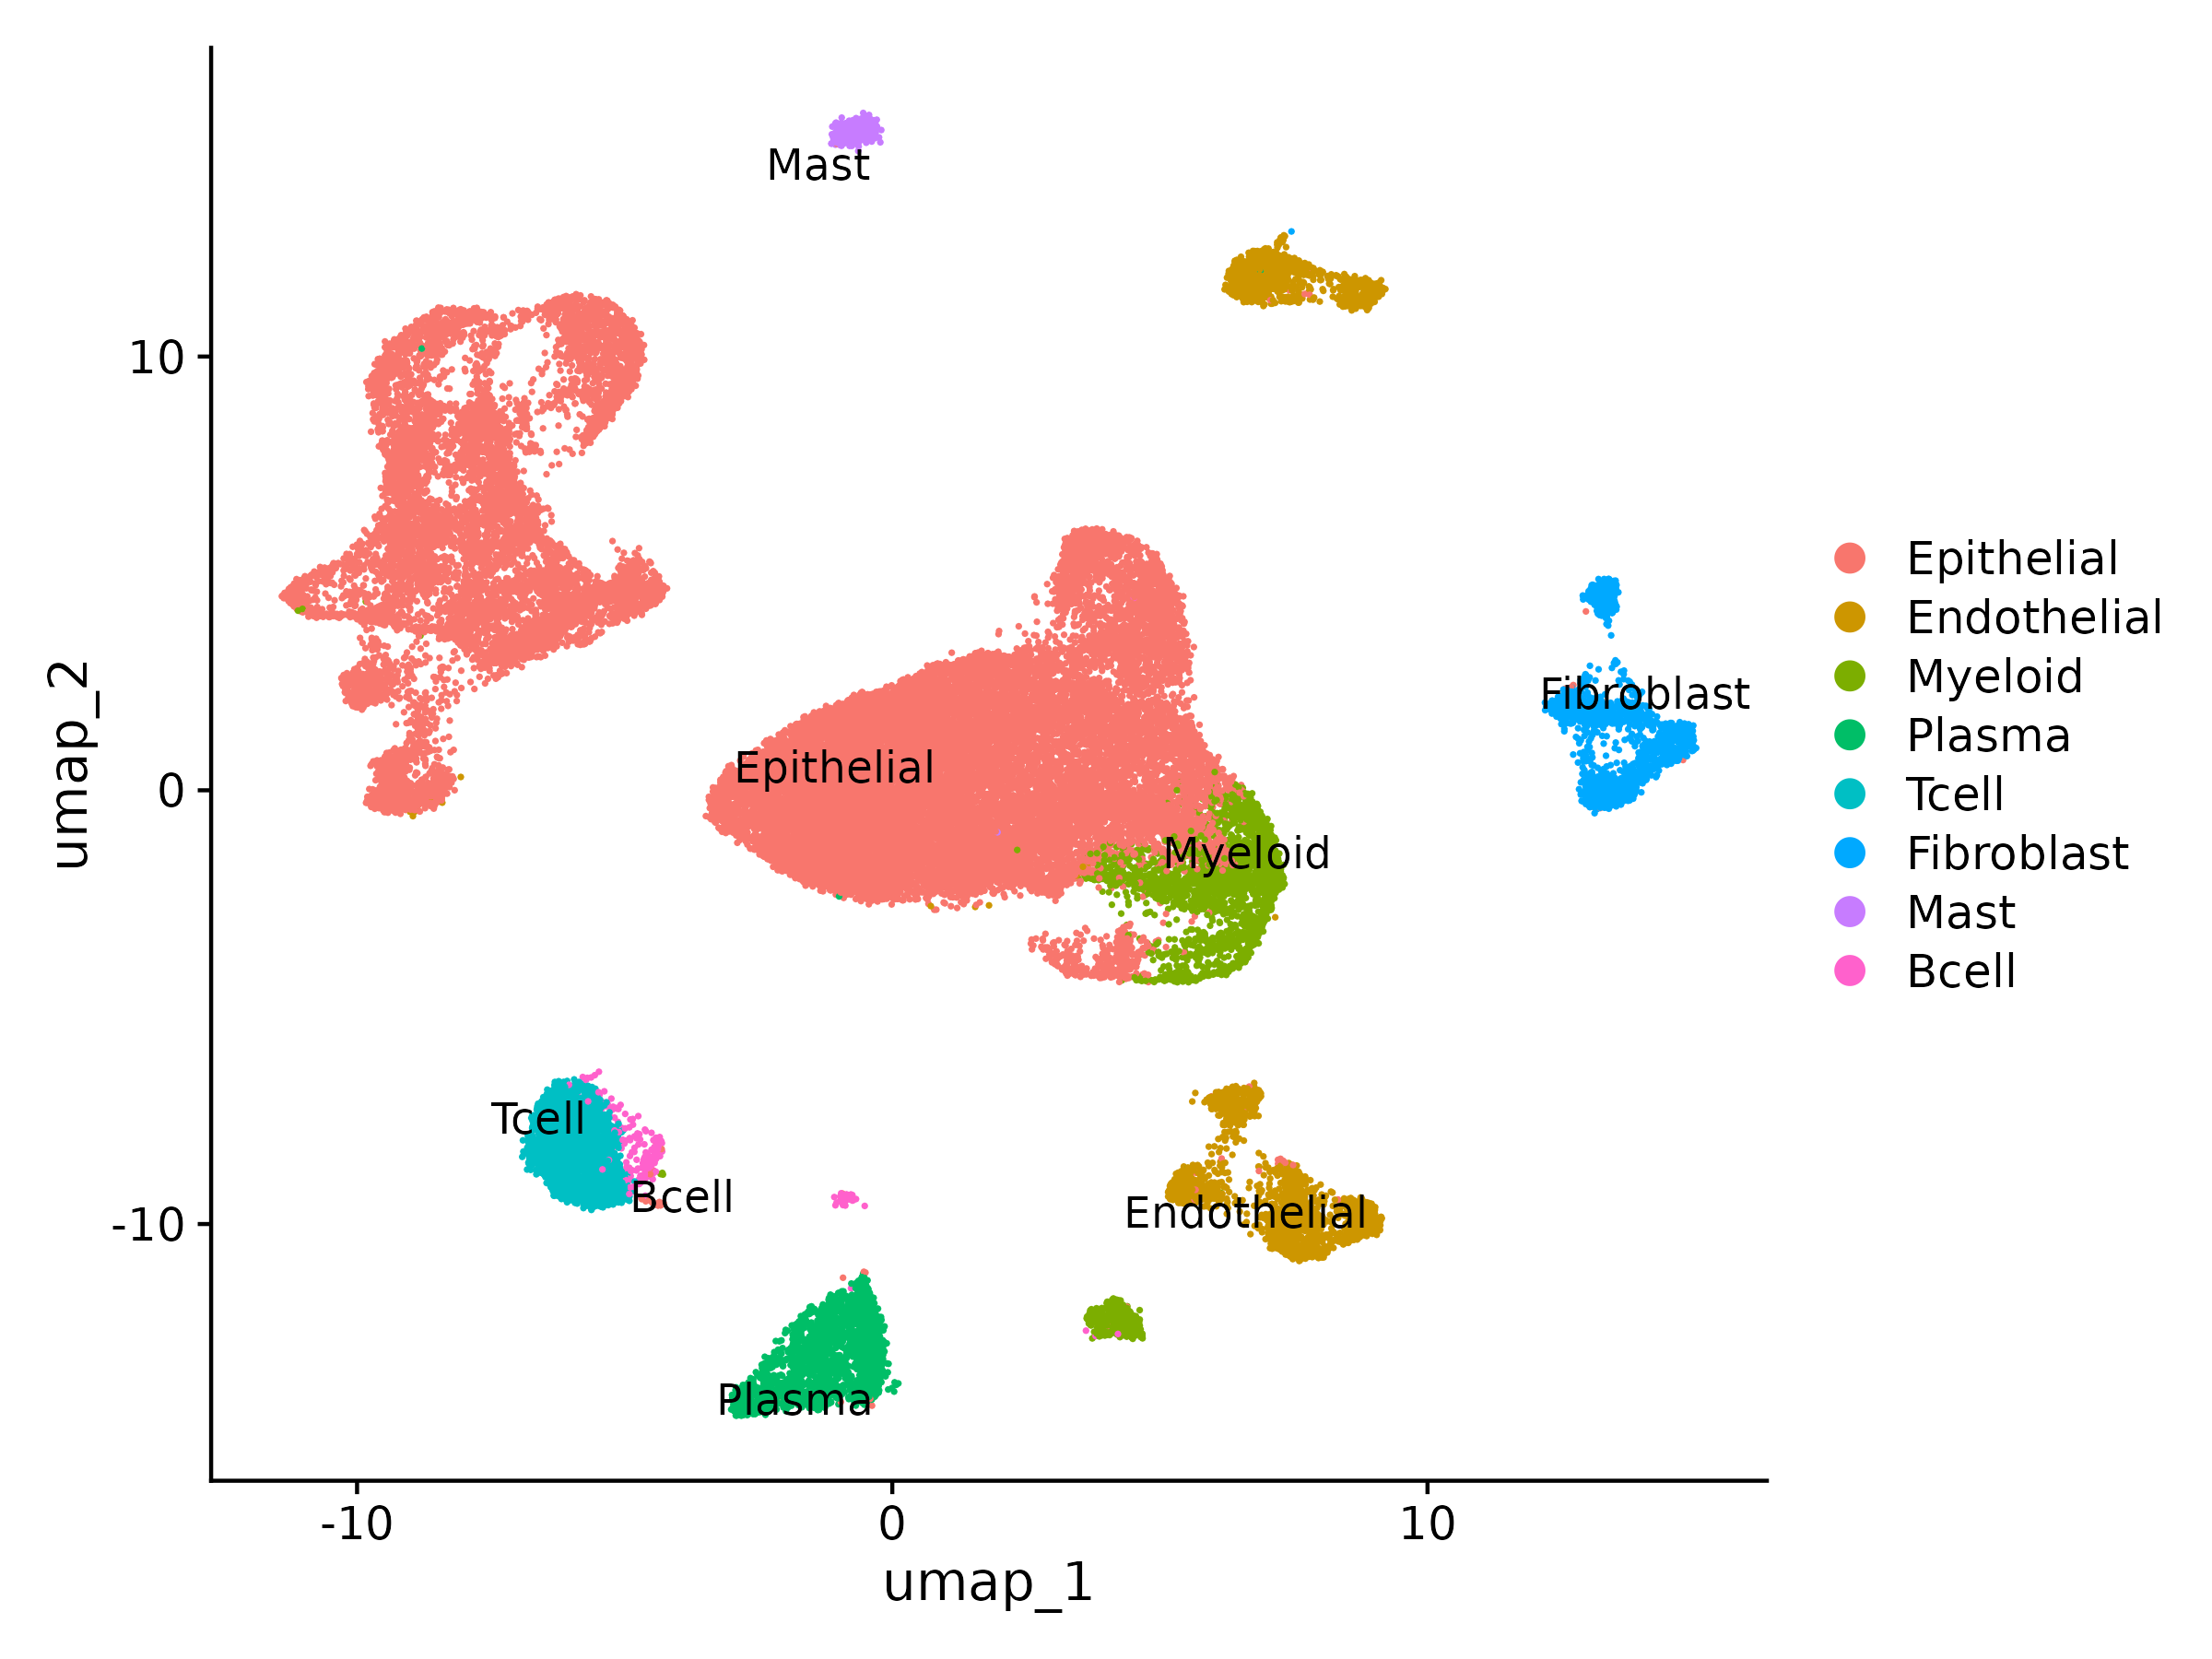
Supplementary Figure S1
Supplementary Figure S1. Single-cell reference atlas of the gastric premalignant-to-early-cancer cascade.
Uniform manifold approximation and projection (UMAP) of 43,992 cells from the public dataset GSE134520, colored by the eight annotated major cell types. UMAP is a non-linear dimensionality-reduction method in which each point represents one cell and proximity reflects transcriptional similarity; the axes carry no independent units. Cell-type proportions are epithelial 68.6%, endothelial 7.6%, myeloid 6.4%, plasma 5.8%, T cell 5.8%, fibroblast 4.2%, mast 1.0% and B cell 0.6%. This atlas provides the cellular reference used for the module-localization analysis in Figure 7(c).
File: results/scrna/UMAP_celltypes.png.
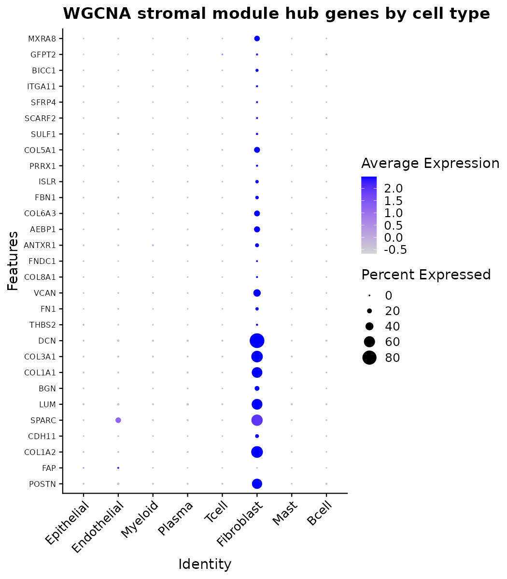
Supplementary Figure S2
Supplementary Figure S2. Expression of stromal-module hub genes across cell types.
Dot plot of the prognostic co-expression module hub genes across the eight annotated cell types. Dot size represents the fraction of cells in which the gene is detected and dot color represents scaled mean expression. Hub-gene expression is confined to the fibroblast compartment. Because the genes used to annotate the fibroblast cluster could bias this result, the analysis was repeated after removing them; all twenty-three remaining hub genes stayed fibroblast-dominant.
File: results/scrna/DotPlot_stromal_module_hub.png.
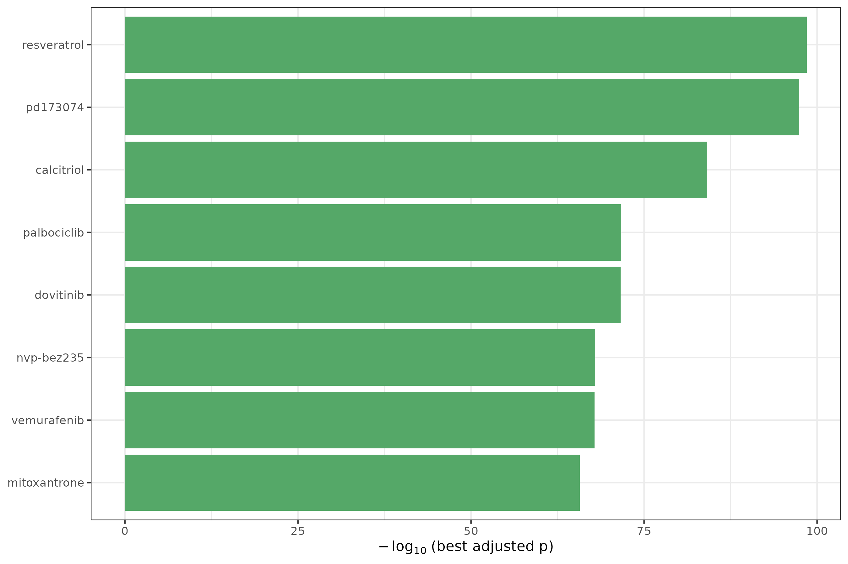
Supplementary Figure S3
Supplementary Figure S3. Candidate compounds from in-silico drug repurposing.
Bar plot of the eight highest-ranked compounds whose transcriptional perturbation signature reverses the tumor program, from Enrichr queried against the LINCS L1000 and Gene Expression Omnibus drug-perturbation libraries. Bar length is −log10 of the best Benjamini–Hochberg-adjusted enrichment p value across contributing signatures, which is also the ordering criterion. Every compound shown reverses the program on both arms — repressing tumor-up genes and inducing tumor-down genes — so no arm legend is displayed. Four of the eight are targeted kinase inhibitors concordant with a proliferation-dominated program: the fibroblast growth factor receptor (FGFR) inhibitor PD-173074, the cyclin-dependent kinase 4/6 (CDK4/6) inhibitor palbociclib, the FGFR/multikinase inhibitor dovitinib and the phosphoinositide 3-kinase (PI3K)/mechanistic target of rapamycin (mTOR) inhibitor NVP-BEZ235. The remaining four are not kinase inhibitors and include the highest-ranked hit, resveratrol, together with calcitriol, vemurafenib and mitoxantrone; broadly bioactive compounds of this kind recur across LINCS reversal analyses irrespective of tumor type and should be treated as non-specific. These predictions are computational and hypothesis-generating only; no compound was experimentally validated, and because the tumor-up program is proliferation-dominated the nominated agents are broadly anti-proliferative rather than specific to gastric cancer.
File: results/drug_repurposing_integrated/top_candidate_drugs.png.
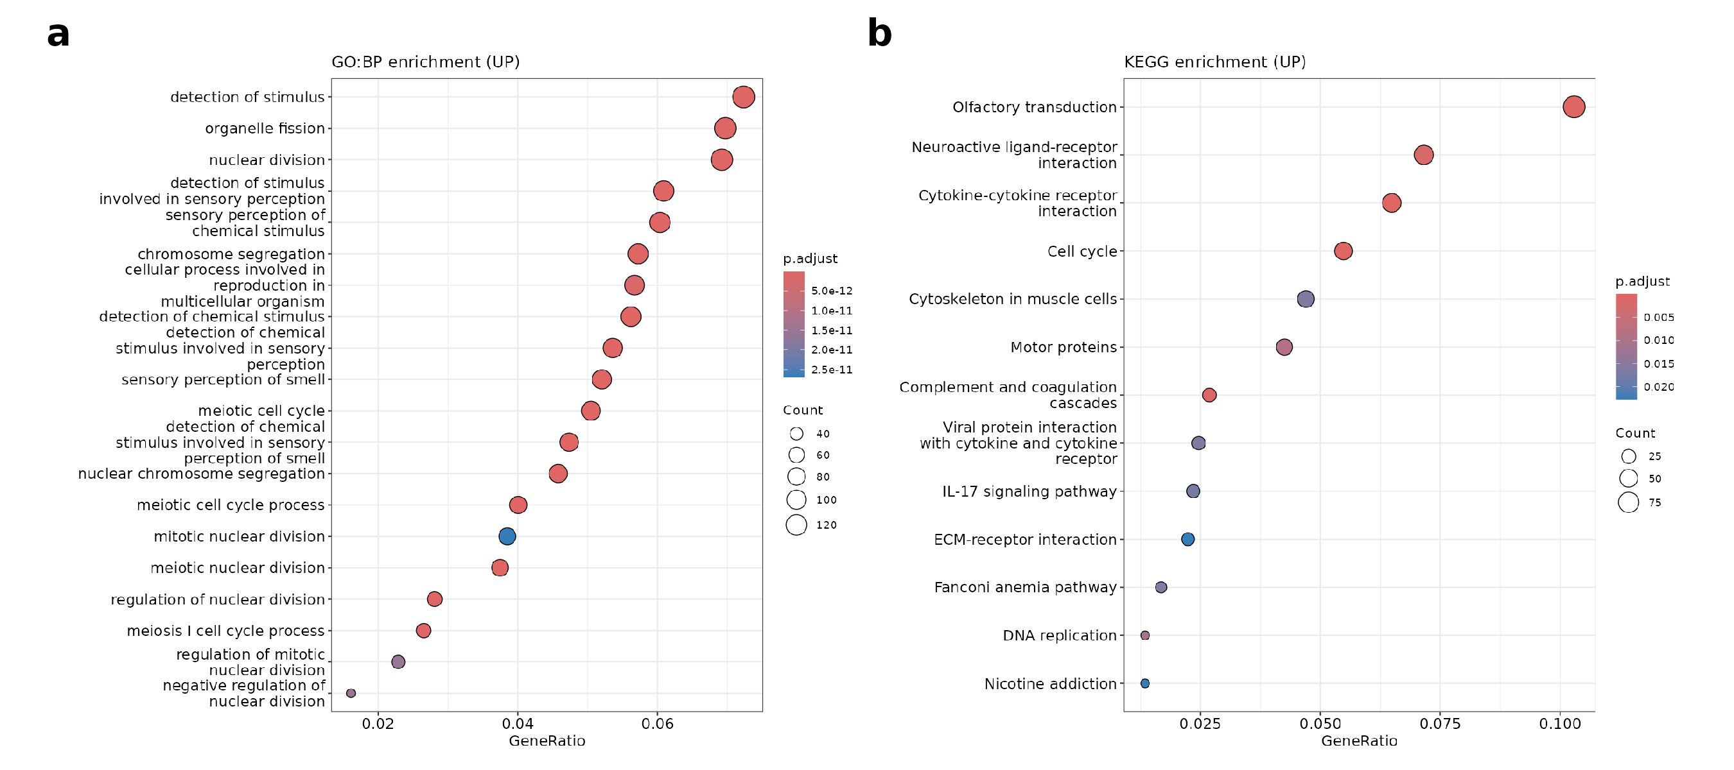
Supplementary Figure S4
Supplementary Figure S4. Over-representation analysis of tumor-up-regulated genes.
Dot plots of Gene Ontology biological-process and Kyoto Encyclopedia of Genes and Genomes (KEGG) over-representation analysis for the tumor-up gene set. Dot size represents the number of genes in each term and color represents the adjusted P value. Cell-cycle and nuclear-division terms, together with extracellular-matrix-receptor and cytokine terms, dominate. Over-representation analysis depends on an arbitrary significance threshold and is sensitive to gene-family size; the prominent olfactory and sensory-perception terms reflect the large olfactory-receptor gene family rather than tumor biology. The threshold-free gene-set enrichment analysis in Figure 2 is therefore the primary enrichment result, with this panel provided for completeness.
Files: results/enrichment/dotplot_GO_BP_UP.png, results/enrichment/dotplot_KEGG_UP.png.
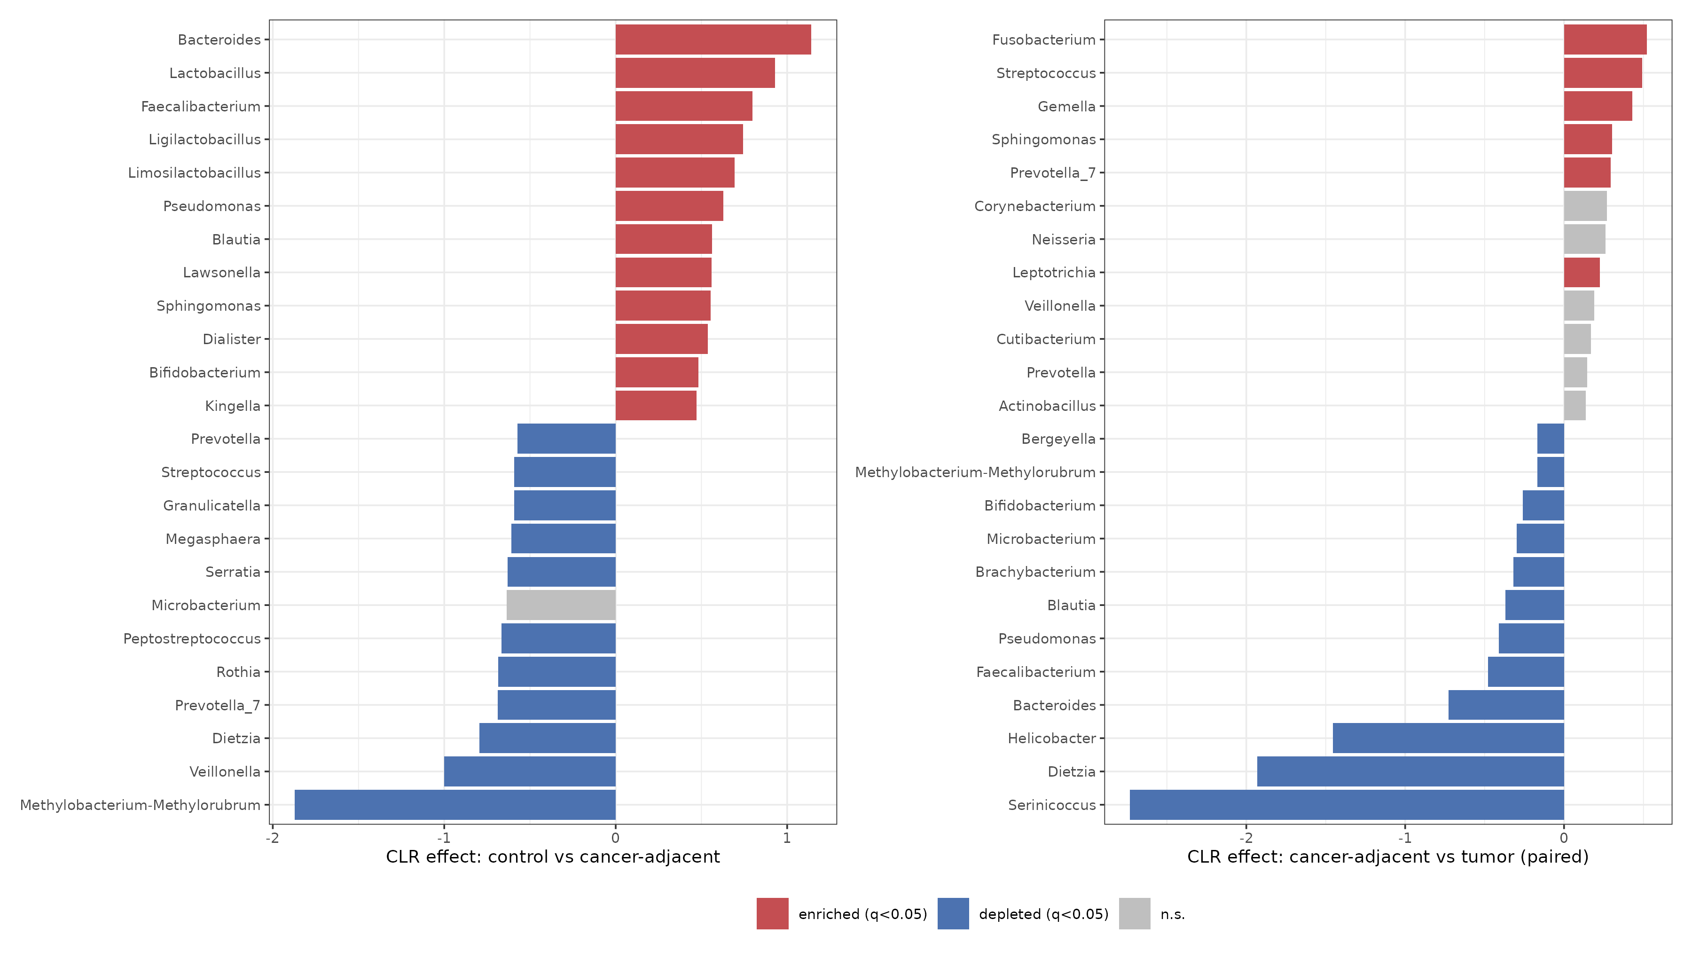
Supplementary Figure S5
Supplementary Figure S5. Compositional differential abundance of tissue microbiota.
Bar plots of centered-log-ratio effect sizes for the two discovery-cohort contrasts, tested by Wilcoxon rank-sum with Benjamini-Hochberg correction. The centered-log-ratio transform is used because sequencing yields relative rather than absolute abundances, so raw proportions are not independent. The left panel shows control versus cancer-adjacent mucosa (44 of 61 genera at q < 0.05) and the right panel the paired cancer-adjacent versus tumor contrast (18 of 61 genera at q < 0.05). Bars are colored by direction where q < 0.05, with red indicating enrichment and blue depletion, and the twelve most enriched and depleted genera are shown per panel. These genus-level shifts are reported for completeness only; as detailed in the Results, the tumor contrast is confounded with sequencing batch and does not replicate in an independent batch-clean cohort, so these taxa are not proposed as biomarkers.
Files: results/microbiome_biomarker/04a_DA_control_vs_GCN.csv, 04b_DA_GCN_vs_GCT_paired.csv.
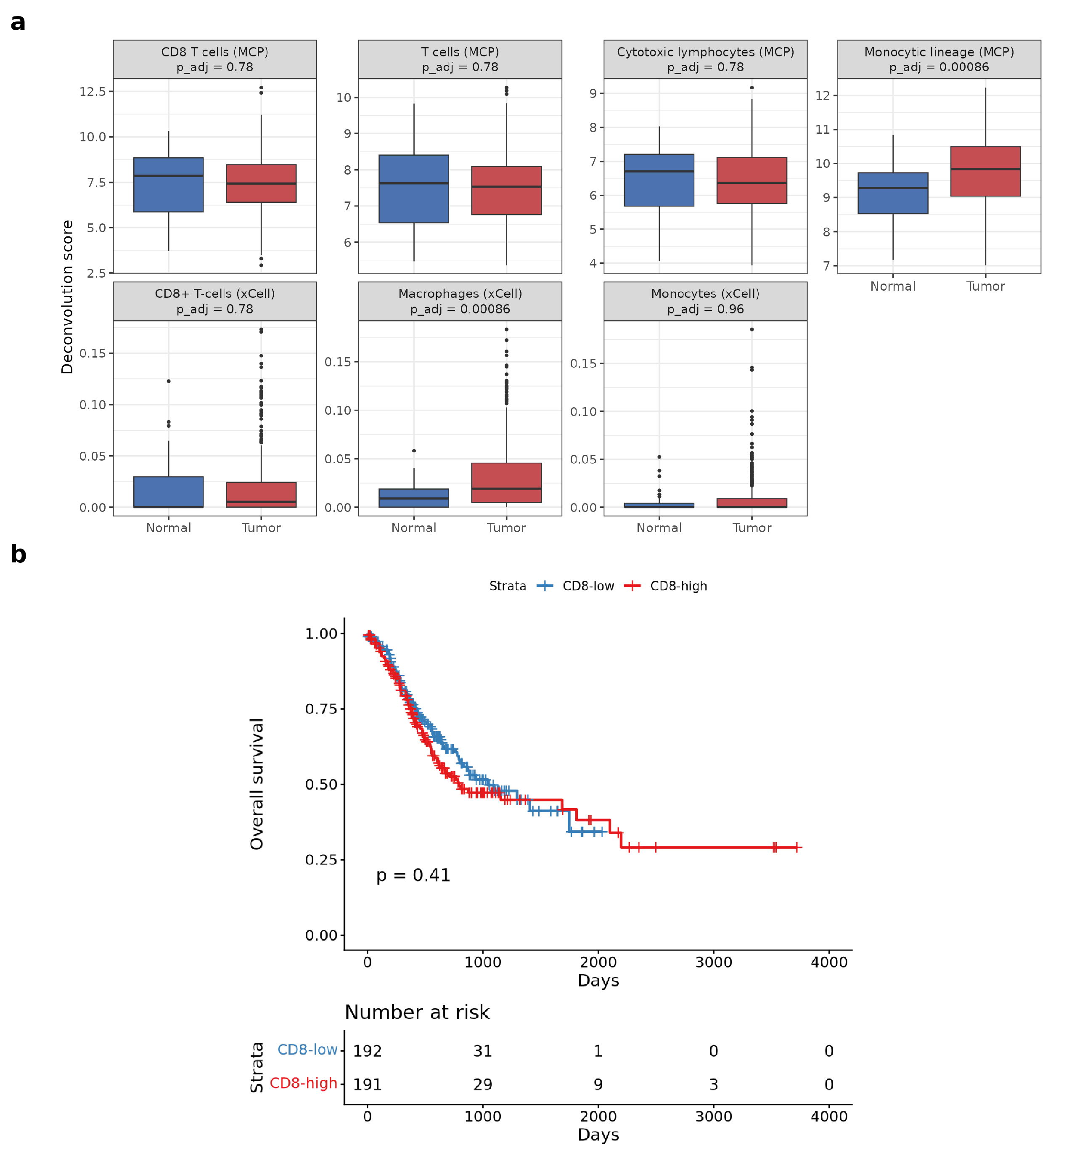
Supplementary Figure S6
Supplementary Figure S6. Immune-compartment shifts and CD8 T-cell survival association.
- Comparison of immune compartments between tumor and normal tissue. Enrichment is dominated by the macrophage and monocyte lineage, with no net gain in CD8-positive T cells.
- Association between CD8-positive T-cell score and overall survival. The score is not prognostic in this cohort (Cox hazard ratio 1.04, P = 0.41); this null result is reported as observed.
Files: results/plots/Immune_*.png.
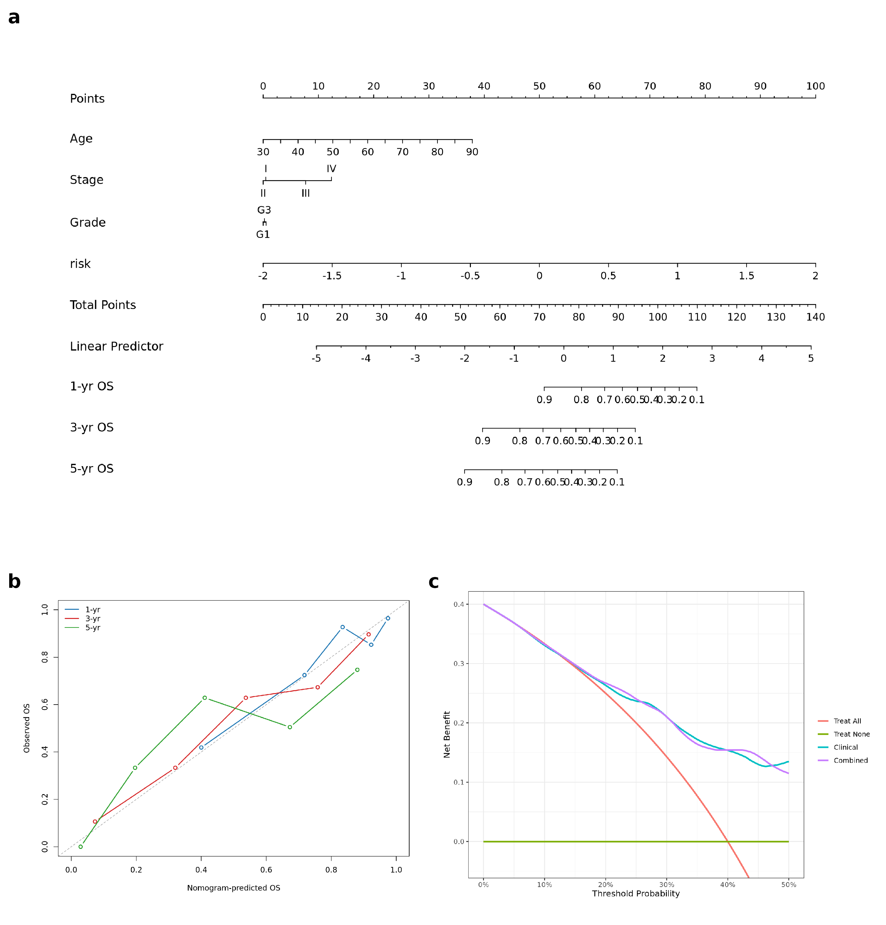
Supplementary Figure S7
Supplementary Figure S7. Clinical nomogram, calibration, and external decision-curve analysis.
- Nomogram combining clinical covariates with the signature score for prediction of 1-, 3- and 5-year overall survival. A nomogram converts each predictor into points on a common scale whose total maps to a predicted survival probability.
- Calibration plots at 1, 3 and 5 years, computed in the development cohort. Calibration compares predicted against observed survival; the diagonal represents perfect agreement.
- Decision-curve analysis performed out-of-sample in the Asian Cancer Research Group cohort. Decision-curve analysis plots net benefit against the threshold probability at which a clinician would act. Both the clinical model and the combined model carry net benefit relative to treat-all and treat-none strategies, but their curves are essentially superimposed across the 5-40% threshold range, indicating that adding the signature confers no incremental net benefit over standard staging. The nomogram is presented as an illustrative research tool, not as a validated decision instrument.
Files: results/nomogram_combined/, results/external_utility_ACRG/DCA_external.png.
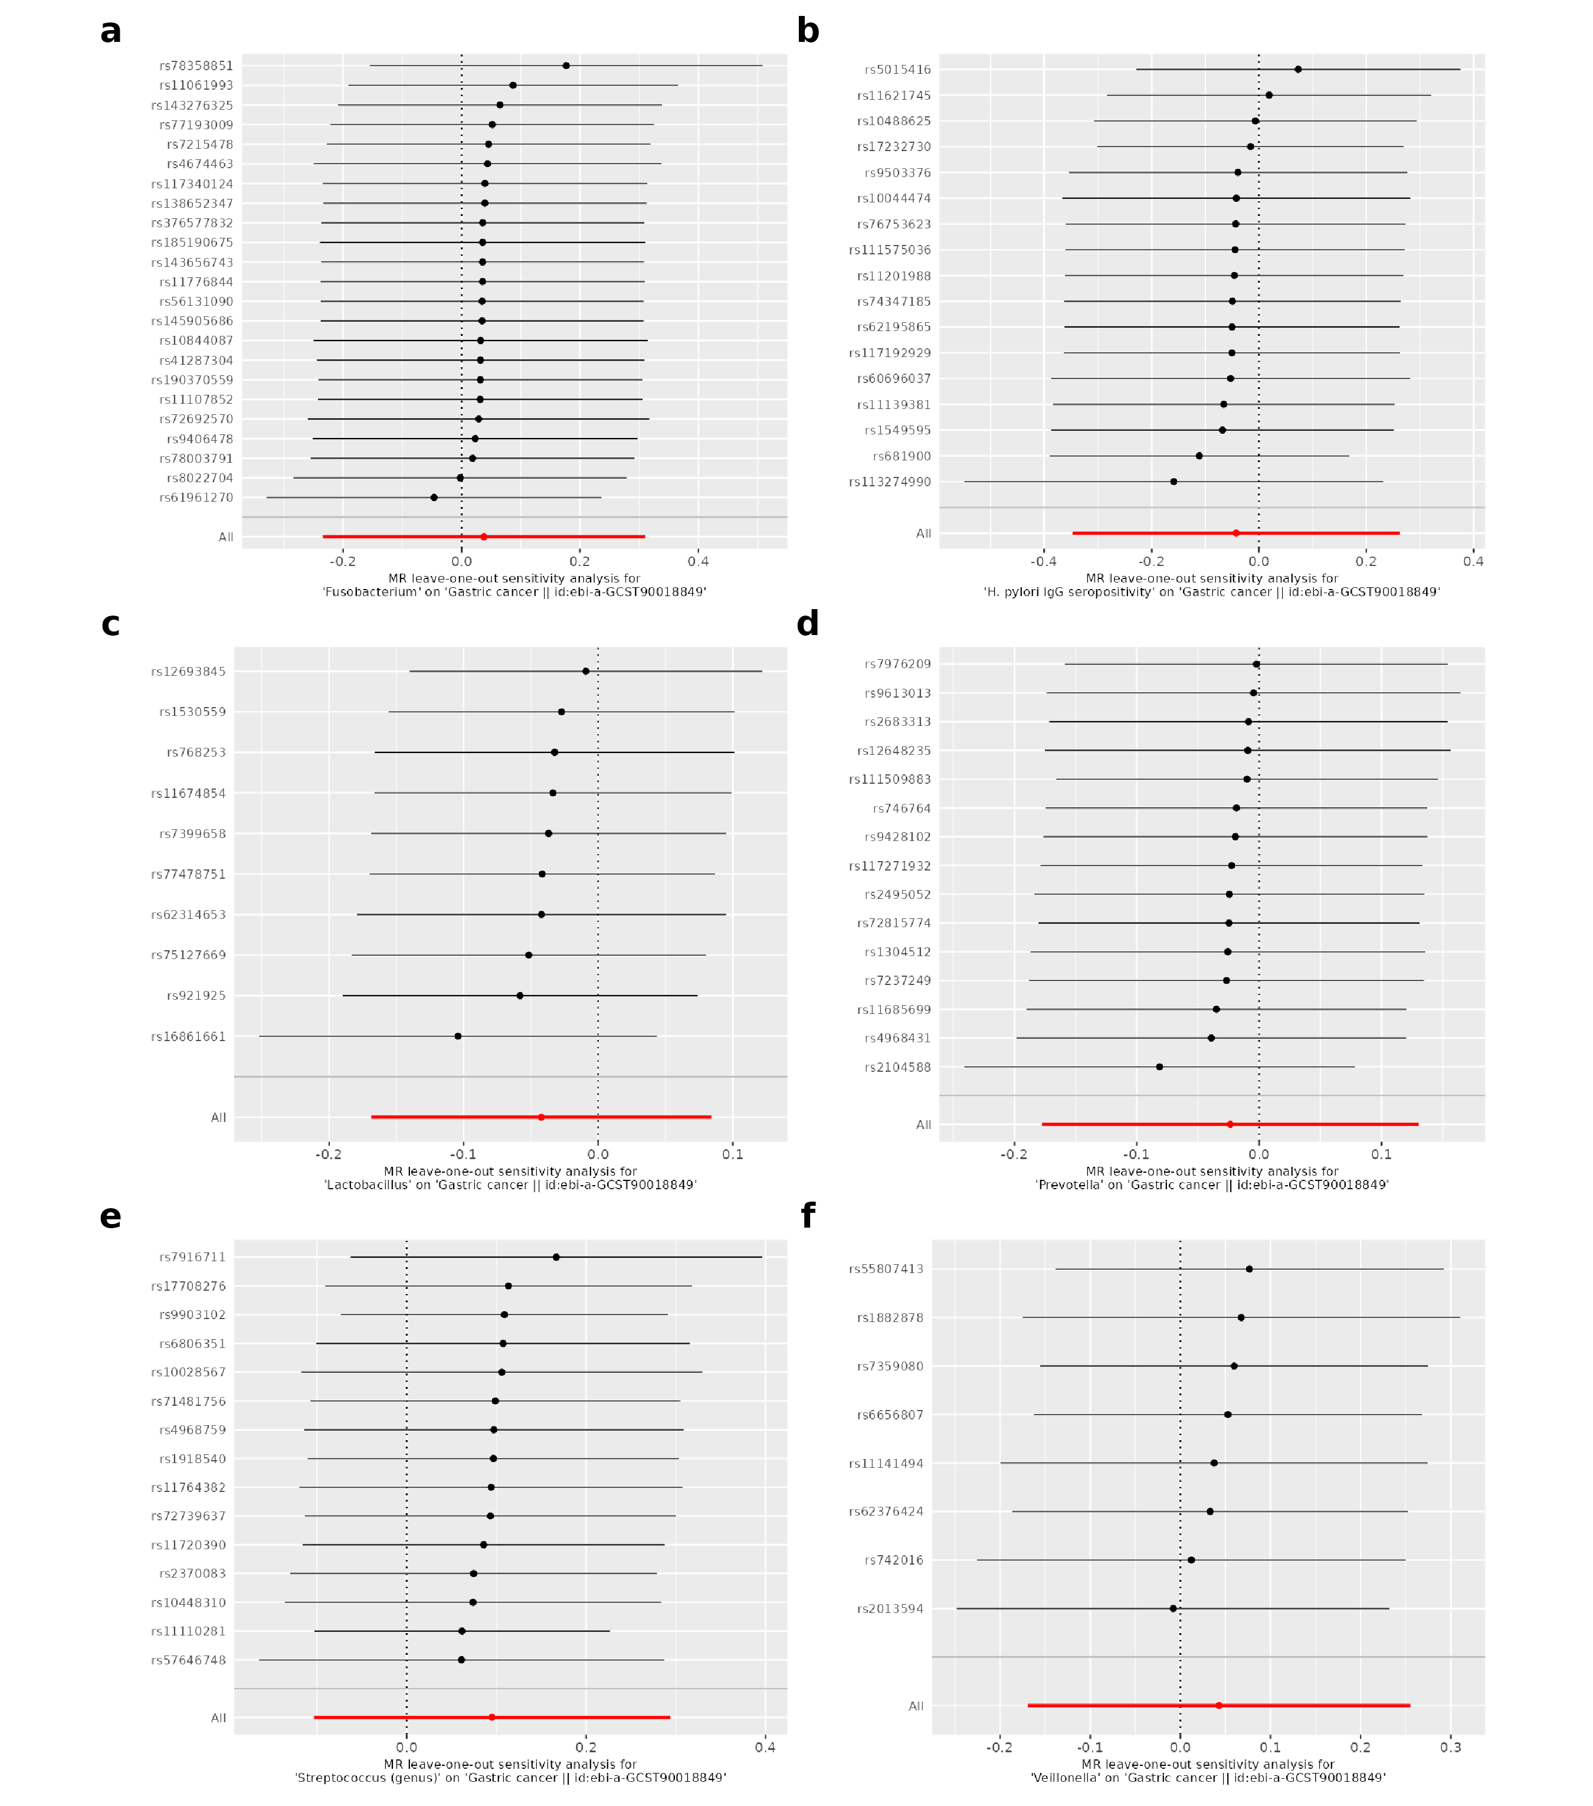
Supplementary Figure S8
Supplementary Figure S8. Mendelian-randomization leave-one-out analysis for all six exposures.
Leave-one-out inverse-variance-weighted estimates for each of the six microbial exposures. Removing any single instrument leaves every pooled estimate straddling the null, confirming that no individual instrument drives any result and that the overall null is not an outlier artefact.
Files: results/mr_real/loo_*.png.
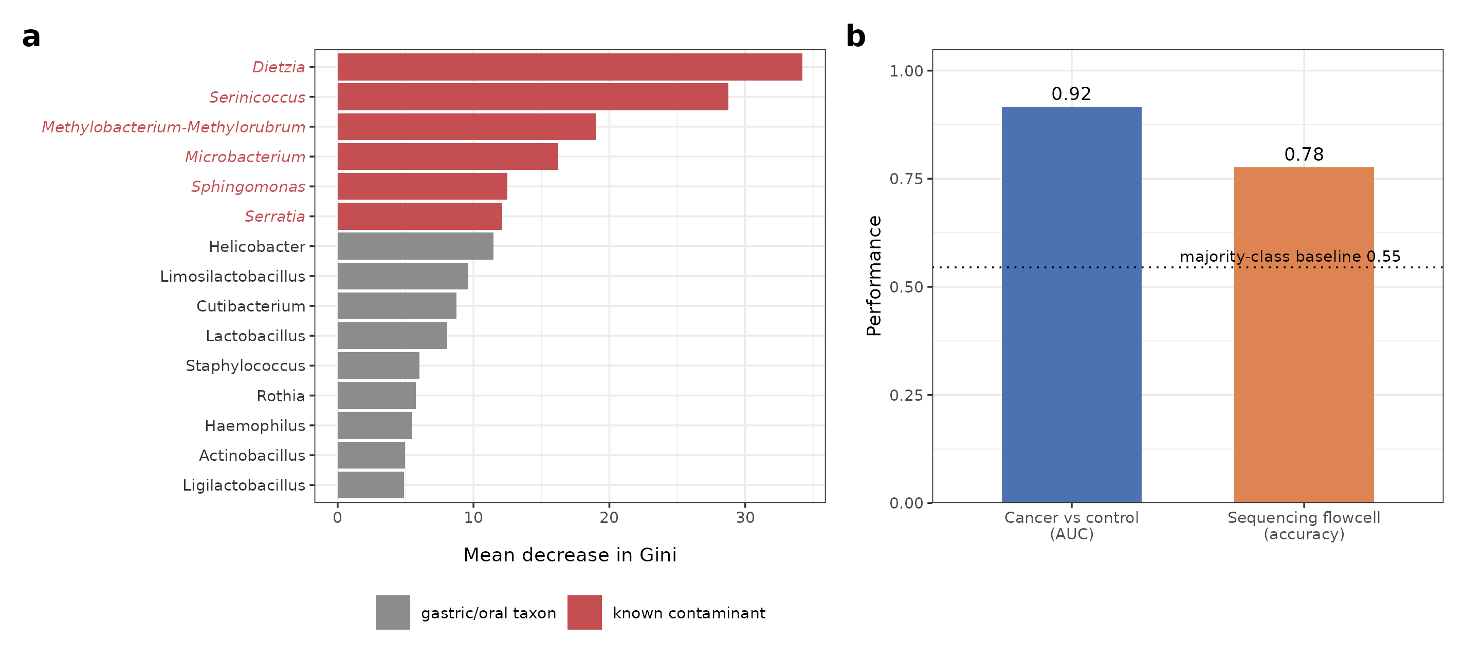
Supplementary Figure S9
Supplementary Figure S9. Evidence that the tumor-microbiome classifier reflects sequencing batch.
- Bar plot of the fifteen genera ranked highest by mean decrease in Gini importance in the cancer-versus-control random-forest classifier. Genera shown in red italic type are recognized environmental or reagent contaminants (Dietzia, Serinicoccus, Methylobacterium-Methylorubrum, Microbacterium, Sphingomonas and Serratia) rather than gastric or oral commensals, and they dominate the classifier.
- Comparison of the classifier’s apparent discrimination with its ability to predict sequencing batch. The cancer-versus-control area under the receiver operating characteristic curve is 0.92 (95% confidence interval 0.90-0.94), but the same feature space predicts the sequencing flowcell among biologically similar samples at 78% accuracy against a 55% majority-class baseline (dotted line). The apparent tumor signal therefore tracks sequencing batch rather than tumor biology.
Files: results/microbiome_biomarker/05_rf_importance.csv, 05_rf_metrics_and_batch_sanity.csv.

Supplementary Materials
- Supplementary Table S1 — Per-exposure MR instruments. Threshold, pre-clump and harmonized-used SNP counts, mean/min per-SNP F, IVW OR/CI/p, and MR-PRESSO global p for all six exposures. File: results/mr_real/MR_per_exposure_instruments_REAL.csv.
- Supplementary Table S2 — MR-PRESSO global tests. RSSobs and global-test p per exposure. File: results/mr_real/MR_PRESSO_global_REAL.csv.
- Supplementary Table S3 — TRIPOD checklist. Item-by-item reporting map for the prognostic model. File: TRIPOD_checklist.md.
- Supplementary Table S4 — Alpha-diversity effect sizes. Median differences and Cliff’s δ (Observed / Shannon / Simpson) across the non-confounded gastritis-to-cancer cascade. File: results/microbiome_biomarker/02_alpha_effectsizes_cascade.csv.
- Supplementary Table S5 — Non-circular single-cell localization. Dominant cell type and fraction for the 23 hub genes not used to annotate the fibroblast cluster. File: results/scrna/gene_dominant_celltype_noncircular.csv.
- Supplementary Table S6 — GSE84437 pT-stage-stratified validation. Harrell C-index and per-SD hazard ratios for the 25-gene signature within pT-stage strata (all / early pT1–T3 / pT4 / pT2–T3), showing discrimination is not recovered by stratification (C<0.5 throughout). File: results/validation_multi/GSE84437_Tstage_stratified.csv.
- Supplementary Table S7 — Data-acquisition & reproducibility checklist. Every dataset used, its accession, access route, version/build, raw→processed entry point, and consuming pipeline script, ordered by pipeline stage; includes analyses explicitly not performed. File: DATA_ACQUISITION_CHECKLIST.md.
- Supplementary Table S8 — WGCNA soft-thresholding power sensitivity. For each candidate soft-thresholding power (3, 6, 9, 12): scale-free topology fit, mean connectivity, number of modules recovered, the module carrying the fibroblast/CAF hub genes, its eigengene hazard ratio per standard deviation with 95% confidence interval and Cox P value, and the fraction of the eight hub genes remaining co-clustered. Supports Figure 6(c). File: results/wgcna_real/power_robustness_summary.csv.
All other result tables and figures are provided in the project repository under results/, with each mapped to its generating script in PIPELINE.md.

Appendix: Data-Acquisition & Reproducibility Checklist
Gastric-cancer multi-omics study. Every dataset used, its accession, access route, version/build, the raw→processed entry point, and the pipeline script that consumes it. Datasets are listed in the order the pipeline uses them. This lets a reader reacquire every input from its primary repository and re-enter the pipeline at the correct stage.

A. Host transcriptome (differential expression, WGCNA, signature, immune, drug-repurposing)
- TCGA-STAD — primary tumor + solid-tissue normal RNA-seq.
  - Accession/portal: GDC / UCSC Xena (project TCGA-STAD).
  - Build: STAR gene counts, GENCODE v36; 448 samples (412 tumor, 36 normal).
  - Clinical: Lauren class, AJCC stage, grade, TCGA molecular subtype, driver mutations, TMB, measured leukocyte/lymphocyte %, overall survival.
  - Raw→processed entry point: count matrix → results/rdata/tcga_processed.RData.
  - Consuming scripts: DEG (analysis/…DEG…), WGCNA (analysis/…wgcna…), immune deconvolution (08_immune_deconvolution.R), enrichment, microbe-response GSEA (31_microbe_response_enrichment.R).
- GTEx v10 — normal stomach reference (DE denominator).
  - Portal: gtexportal.org. Combined with TCGA normals for the integrated tumor-vs-normal contrast.

B. External survival / DE validation cohorts (transcriptome)
- GSE62254 (ACRG) — 300 patients; Affymetrix. Primary external validation of the signature.
  - Access: GEO. Local: data/geo/GSE62254.rda. Consumer: 12_multicohort_validation.R, 32_nested_cv_signature.R.
- GSE15459 — 191 patients. Access: GEO. Local: data/geo/GSE15459_es.rds + GSE15459_outcome.xls.
- GSE84437 — 431 patients. Access: GEO. Local: data/geo/GSE84437_es.rds. (Reported negative — retained transparently.)
- GSE27342, GSE63089 — independent DE-concordance cohorts. Access: GEO. Consumer: DEG cross-cohort concordance (results/tables/DEG_GEO_*.csv).

C. Single-cell transcriptome (module localization)
- GSE134520 — premalignant-to-early gastric-cancer scRNA-seq.
  - Access: GEO. Processing: Seurat v4 (QC 200–6,000 genes, MT<20% → 43,992 cells; LogNormalize; 2,000 HVGs; PCA 30; SNN res 0.5; UMAP). 8 cell types by canonical markers.
  - Consumer: scRNA localization → results/scrna/.

D. Tissue microbiome (16S)
- PRJDB20660 (Japan, discovery) — 944 libraries, 16S V3–V4.
  - Access: DDBJ, raw FASTQ. Processing: DADA2 from raw → ASV table (897 samples × 314 genera after host/off-target removal).
  - Read-tracking validation: per-sample counts vs published Supplementary Table 3, Pearson r=0.98 (results/microbiome_biomarker/00_readtracking_concordance.csv).
  - Consumer: 23_dada2_16S.R → 24_microbiome_real.R; reference DB silva_nr99_v138.1.
- PRJNA641258 (Italy, validation) — paired tumor/non-tumor, V3–V4. Access: NCBI/ENA. (Ravegnini 2020, PMC7766162.)
- PRJNA413125 (Portugal, validation) — gastritis vs carcinoma, V5–V6. Access: NCBI/ENA. (Ferreira 2018.)
  - Batch caveat: the discovery tumor/normal split is confounded with sequencing flowcell (§3.8); validation cohorts are the batch-clean test.

E. GWAS summary statistics (Mendelian randomization)
All accessions independently verified against GWAS-Catalog records; raw gwasinfo()/lookup output archived at results/mr_real/gwas_catalog_verification.json.
- Exposures (IEU OpenGWAS):
  - ebi-a-GCST90006910 — anti-H. pylori IgG seropositivity (Butler-Laporte 2020; European, PMID 33204752).
  - ebi-a-GCST90017070 — genus Streptococcus (id.1853; MiBioGen/Kurilshikov 2021; European, PMID 33462485).
  - ebi-a-GCST90017045 — genus Prevotella 9 (id.11183; MiBioGen; European, PMID 33462485).
  - ebi-a-GCST90017088 — genus Veillonella (id.2198; MiBioGen; European, PMID 33462485).
  - ebi-a-GCST90017030 — genus Lactobacillus (id.1837; MiBioGen; European, PMID 33462485).
  - ebi-a-GCST90032406 — Fusobacterium A abundance in stool (Qin 2022; European/Finland, PMID 35115689).
- Outcomes:
  - ebi-a-GCST90018849 — gastric cancer, European, 1,029 cases (Sakaue 2021, PMID 34594039). Primary.
  - ebi-a-GCST90018629 — gastric cancer, East-Asian, 7,921 cases (Sakaue 2021). Cross-ancestry power sensitivity only.
  - Access token: OpenGWAS JWT via OPENGWAS_JWT env var. Consumer: 11_real_mr.R.
  - Harmonized per-SNP instrument tables archived (results/mr_real/) so exact SNP sets survive upstream reprocessing.

F. Environment & reproducibility
- R 4.3.3; pinned package versions in package_versions.csv; full sessionInfo() with the code.
- Complete-case analysis throughout; no imputation.
- Bundled r_env/ has a build-time hardcoded path — after relocation use the R_HOME-override invocation or a system R (documented in PIPELINE.md).
- Every results/ output maps to its generating script in PIPELINE.md; figure→source mapping in FIGURE_SOURCES.md.

G. Analyses NOT performed (stated to prevent over-reading)
- No genuinely paired per-patient tissue-microbiome + host-transcriptome cohort exists in this study (16S and transcriptome are from different, unpaired cohorts). A per-genus host-gene MaAsLin2 association was run in a superseded pipeline on a bridged, non-verifiable sample set; its outputs are not reproducible from retained files, so it is excluded and no host-gene↔genus claim is made. The microbe-response result (§3.9) is a pathway-level GSEA on the TCGA tumor-vs-normal ranking only — hypothesis-generating context, not a host–microbiome axis.

