WEEK 3 TASK
Advanced Data Analysis and Visualization in Logistics
Hypothetical logistics dataset | Python, Pandas, NumPy and Matplotlib
Prepared as an analytical report

1. Executive Summary
This report analyzes 300 simulated shipments to understand delivery speed, transportation cost, shipment mix, and on-time performance. The overall average delivery time is 4.04 days (median 3.98 days), while the average transportation cost is ₹4,566.46. The on-time rate under the report's illustrative four-day threshold is 50.7%. These results are generated from a hypothetical dataset for learning purposes; they are not real company results.

2. Objectives
- Create and inspect a realistic, hypothetical logistics dataset.
- Measure central tendency, spread, missingness, duplicates and correlations.
- Visualize delivery times, transport-mode mix, costs and on-time performance.
- Translate observed patterns into practical operational recommendations.

3. Dataset Simulation and Variables
The dataset contains 300 shipment records and 8 columns. Each row represents one shipment. Values were simulated using random sampling and simple operational assumptions. Delivery time depends partly on distance, transport mode, region and random delay; cost depends partly on weight, distance and mode.
Variable | Type | Meaning
Shipment_ID | Categorical / ID | Unique shipment reference
Region | Categorical | North, South, East or West
Transport_Mode | Categorical | Road, Rail or Air
Distance_km | Numeric | Shipment distance in kilometres
Shipment_Weight_kg | Numeric | Shipment weight in kilograms
Delivery_Time_days | Numeric | Elapsed delivery time in days
Transport_Cost_INR | Numeric | Estimated transportation cost in Indian rupees
On_Time | Categorical | Yes when delivery time is at most 4 days; otherwise No
Important assumption: the four-day on-time threshold is an illustrative rule chosen for this exercise. In a real logistics operation, the threshold should be based on service-level agreements (SLAs), lane, customer priority and promised delivery date.

4. Methodology and EDA

4.1 Data quality checks
The simulated dataset has 0 missing cell(s) and 0 duplicated row(s). The Shipment_ID column is intended to identify each record. Before analysis in a real project, confirm ID uniqueness, valid ranges, consistent category spelling, and whether costs and delivery durations use consistent units.

4.2 Descriptive statistics
The table below summarizes the numeric variables. Mean is sensitive to extreme values; median is more robust.
Metric | Mean | Median | Std. dev. | Minimum | Maximum
Distance_km | 807.44 | 859.00 | 425.72 | 53.00 | 1497.00
Shipment_Weight_kg | 242.50 | 245.50 | 142.86 | 20.00 | 500.00
Delivery_Time_days | 4.04 | 3.98 | 1.56 | 0.50 | 7.76
Transport_Cost_INR | 4566.46 | 2865.35 | 5446.98 | 100.00 | 33313.59
Delivery time has a mean of 4.04 days and median of 3.98 days. A mean above the median can indicate that a smaller number of slower deliveries pull the average upward. Average transportation cost is ₹4,566.46, compared with a median of ₹2,865.35; the gap suggests that some shipments are more expensive than a typical shipment.

4.3 Distribution of delivery time
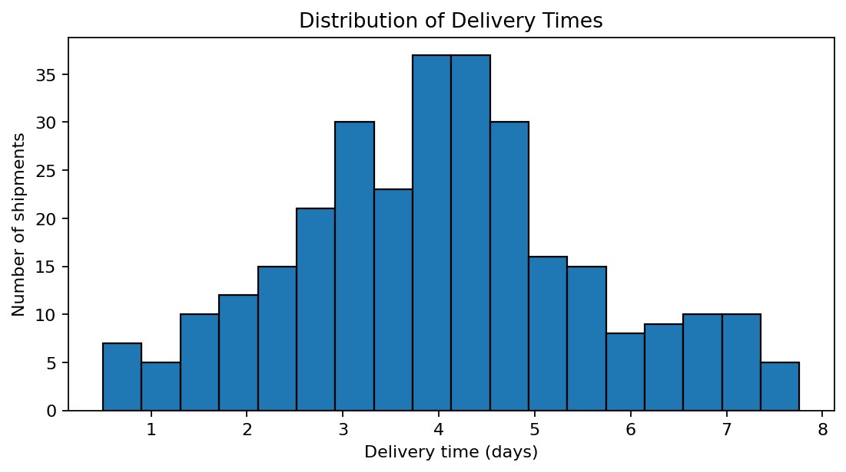
Why this chart: a histogram groups delivery times into bins, making it easier to see the common range, spread and possible long-delivery tail. Operational interpretation: the shape helps planners identify a typical delivery window and whether a smaller group of shipments experiences unusually long transit times. Investigate these cases by route, carrier and delay reason rather than relying only on the average.

4.4 Shipment mix by transport mode
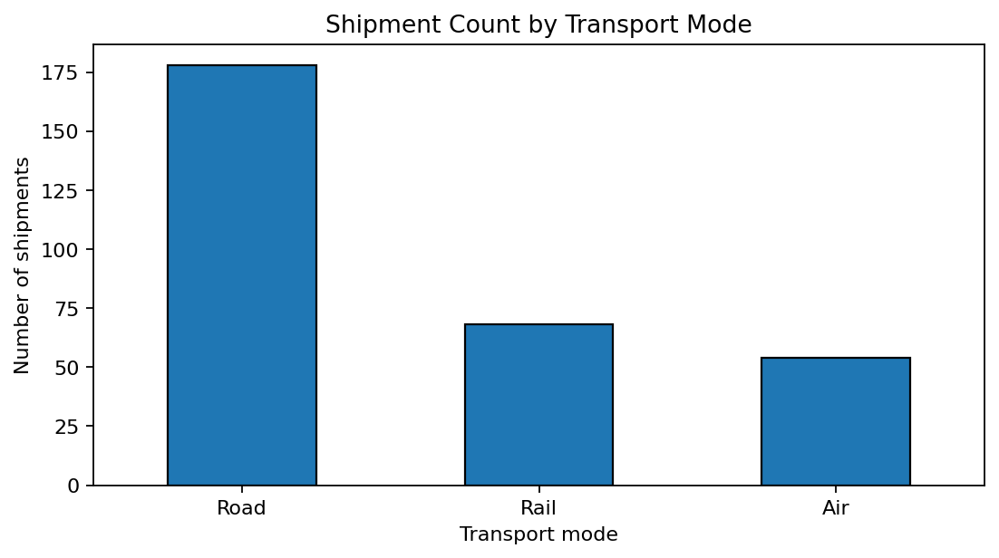
Why this chart: a bar chart compares counts across discrete transport categories. It shows which mode carries the largest share of records and therefore where process improvements may affect the most shipments. Counts alone do not show profitability or service quality, so they should be read alongside cost and delivery metrics.

4.5 Delivery-time comparison by mode
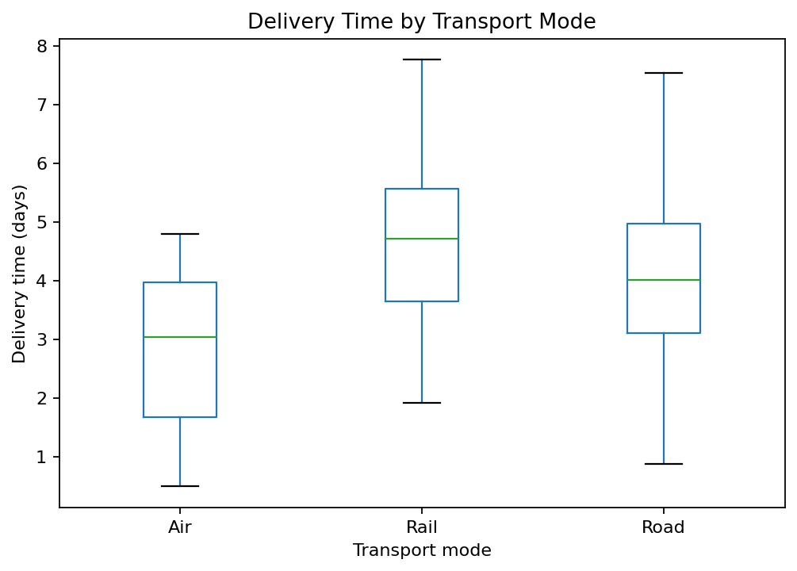
Why this chart: a box plot compares the median, spread and potential outliers for each mode. It is useful because two modes may have similar averages but different reliability. The plot should be interpreted together with shipment distance and route mix; mode comparisons are not automatically causal.

4.6 Distance and transportation cost
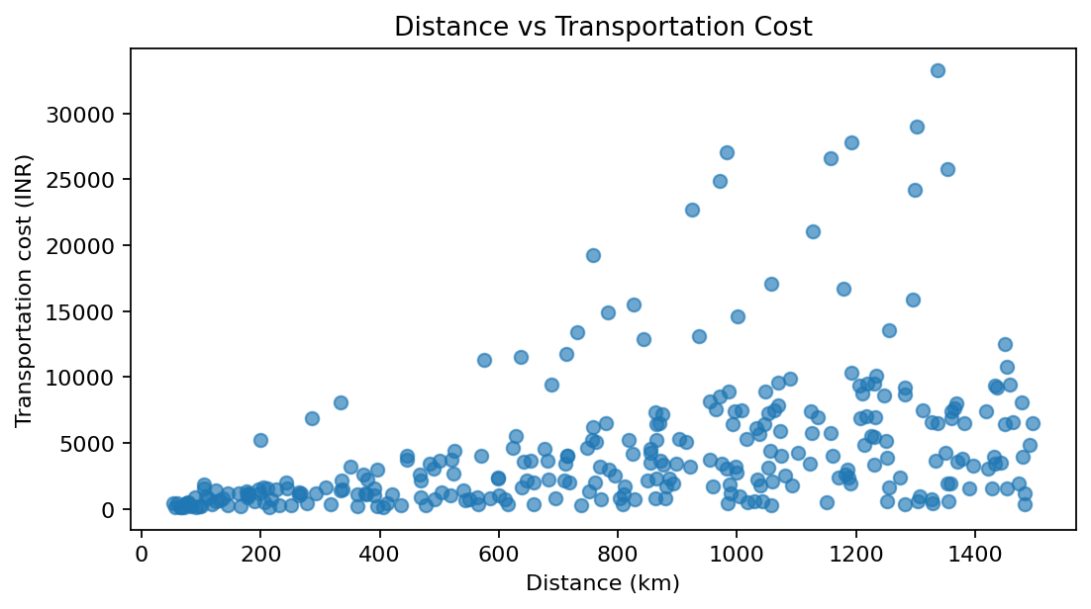
Why this chart: a scatter plot shows the relationship between two numeric variables and reveals clusters or unusual points. The distance-cost correlation is 0.41. A positive association is operationally plausible because longer routes generally require more resources, but weight and transport mode also influence cost. High-cost points should be checked for heavy loads, air transport, special handling or inefficient routing.

4.7 Correlation analysis
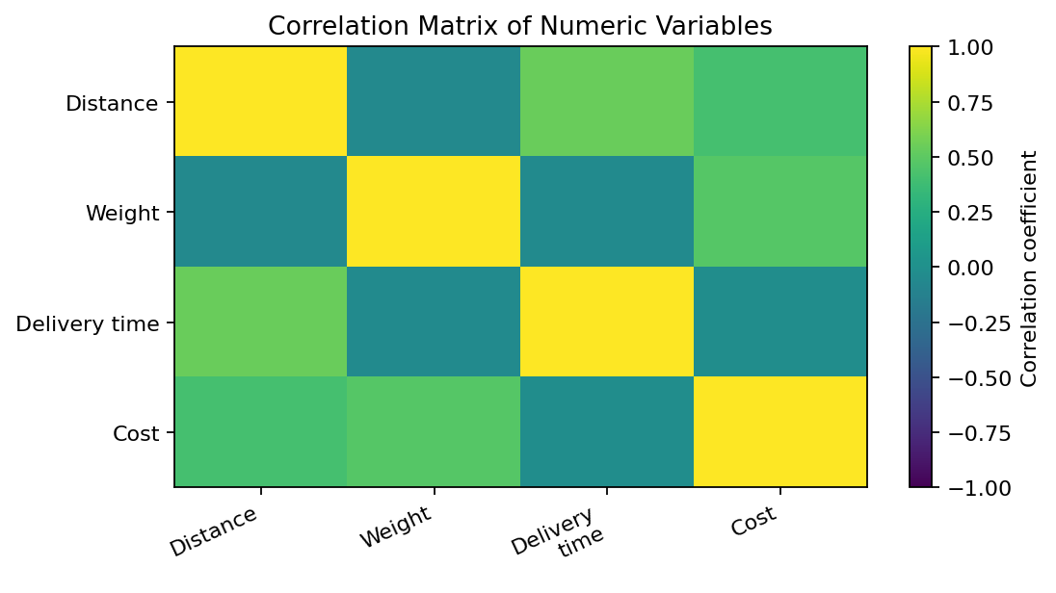
Selected correlations: distance vs cost = 0.41; weight vs cost = 0.47; distance vs delivery time = 0.54. Correlation ranges from -1 to +1. Values near +1 indicate a strong positive linear association; values near -1 indicate a strong negative association; values near 0 indicate a weak linear association. Correlation does not prove causation and may be affected by mode, region and other variables.

4.8 On-time delivery performance
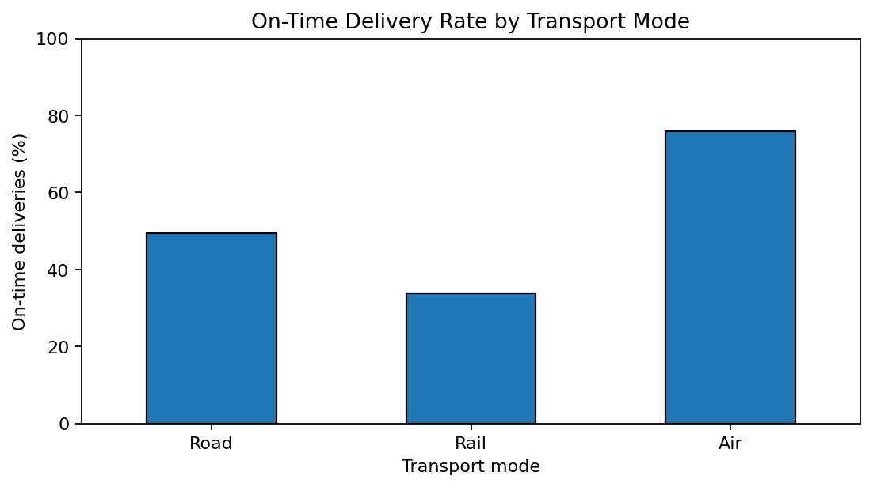
Using the illustrative four-day rule, 50.7% of shipments are on time and 49.3% are not. Why this chart: comparing percentages by transport mode is more informative than comparing raw counts when modes have different shipment volumes. In a real deployment, calculate on-time performance against each shipment's promised delivery date.

5. Grouped Results

5.1 Results by transport mode
Mode | Shipments | Avg. delivery (days) | Avg. cost (₹) | On-time rate (%)
Road | 178 | 4.14 | ₹3,288.17 | 49.4%
Rail | 68 | 4.71 | ₹2,459.84 | 33.8%
Air | 54 | 2.84 | ₹11,432.85 | 75.9%

5.2 Results by region
Region | Shipments | Avg. delivery (days) | Avg. cost (₹) | On-time rate (%)
East | 59 | 4.55 | ₹3,834.85 | 35.6%
North | 80 | 3.81 | ₹5,504.43 | 56.2%
South | 85 | 3.69 | ₹3,902.48 | 61.2%
West | 76 | 4.27 | ₹4,889.69 | 44.7%

6. Key Findings and Operational Interpretation
- Overall service: the on-time rate is 50.7% under the assumed four-day threshold. The remaining 49.3% provides a starting point for delay investigation.
- Cost drivers: distance-cost correlation is 0.41, while weight-cost correlation is 0.47. Review both shipment distance and weight before making cost comparisons.
- Distance and speed: distance-delivery-time correlation is 0.54. Longer routes can require more time, but transport mode, regional conditions and operational delays also matter.
- Transport-mode differences: average delivery time and on-time rate vary by mode (see grouped results). Compare service, cost, capacity and shipment type together before reallocating volume.
- Potential bottlenecks: the upper tail of the delivery-time histogram and points far from the main scatter-plot pattern are candidates for shipment-level investigation.

7. Recommendations
- Track late shipments weekly and classify delay reasons (weather, missed dispatch, warehouse handling, carrier delay, address issue).
- Monitor on-time delivery rate, average and median delivery time, cost per kg-km, and late-shipment count by region and transport mode.
- Review expensive shipments after controlling for distance, weight and mode; investigate exceptions rather than assuming every high cost is avoidable.
- Use route- and customer-specific SLAs instead of a single universal four-day threshold.
- Compare modes on matched routes and similar shipment weights before concluding that one mode is better.
- Improve data quality by validating IDs, dates, weights, distance units, cost currency and missing values at data entry.

8. Python Tools Used
Pandas loads the CSV, checks data quality, calculates summary statistics and groups records. NumPy supports simulation and numeric operations. Matplotlib creates histograms, bar charts, scatter plots and the correlation matrix. The separate Python script contains runnable analysis code. The report's charts were generated from the supplied CSV.
Example code excerpt:
import pandas as pd
import matplotlib.pyplot as plt
df = pd.read_csv("logistics_hypothetical_dataset.csv")
print(df[["Distance_km", "Shipment_Weight_kg",
"Delivery_Time_days", "Transport_Cost_INR"]].describe())
plt.hist(df["Delivery_Time_days"], bins=18, edgecolor="black")
plt.xlabel("Delivery time (days)")
plt.ylabel("Number of shipments")
plt.title("Distribution of Delivery Times")
plt.show()

9. Limitations
This is a simulated dataset, not real operational data. The formulas and distributions are illustrative and may not capture actual carrier pricing, fuel surcharges, customs, traffic, warehouse dwell time, service-level agreements or seasonal effects. The results demonstrate an analytical workflow; business decisions should be validated with verified historical data.

10. Conclusion
The exercise demonstrates how EDA and visualizations can convert shipment-level data into operational questions. Histograms describe delivery-time spread, bar charts compare shipment mix and service rates, box plots compare mode variability, scatter plots reveal cost relationships, and correlation analysis summarizes linear associations. The most useful next step is to replace the hypothetical records with validated real shipment data and investigate late and high-cost shipments at the route level.

Appendix A: Sample dataset preview
Shipment_ID | Region | Transport_Mode | Distance_km | Shipment_Weight_kg | Delivery_Time_days | Transport_Cost_INR | On_Time
SH1001 | South | Road | 1304 | 24 | 4.53 | 614.79 | No
SH1002 | West | Road | 972 | 485 | 3.87 | 8509.24 | Yes
SH1003 | East | Road | 469 | 111 | 4.2 | 887.69 | No
SH1004 | East | Rail | 206 | 189 | 3.51 | 530.66 | Yes
SH1005 | North | Rail | 599 | 336 | 4.4 | 2332.21 | No
SH1006 | North | Air | 1170 | 41 | 4.24 | 2371.52 | No
SH1007 | North | Road | 1070 | 424 | 4.04 | 7840.55 | No
SH1008 | West | Road | 1046 | 345 | 4.64 | 6399.72 | No

