WEEK 4 TASK
Predictive Modeling and Optimization in Logistics Systems
Python | Regression Modeling | Evaluation | Logistics Optimization

1. Executive Summary
This project predicts delivery time in days from shipment distance, weight, transport mode, and region. The hypothetical dataset contains 300 records. The best test-set RMSE among the evaluated models in this run was 1.159 days (Linear Regression); its MAE was 0.879 days and R² was 0.445. These results apply only to this simulated dataset and split.

2. Problem Definition
Delivery delays affect customer satisfaction, inventory availability, dispatch planning, and costs. This is a supervised regression problem: estimate the continuous target Delivery_Time_days from fields available at shipment dispatch.

3. Dataset and Features
The dataset has 300 shipment records. Features are Distance_km, Shipment_Weight_kg, Transport_Mode, and Region. The target is Delivery_Time_days. Transport mode and region are categorical; the remaining inputs are numeric.
Field | Type | Purpose
Distance_km | Numeric | Route length
Shipment_Weight_kg | Numeric | Shipment load
Transport_Mode | Categorical | Road/Rail/Air; one-hot encoded
Region | Categorical | North/South/East/West; one-hot encoded
Delivery_Time_days | Numeric target | Delivery duration to predict

4. Modeling Methodology

4.1 Preprocessing
Missing numeric values are imputed with the median, categorical values with the most frequent category, numeric fields are standardized, and categories are one-hot encoded. These steps are placed in a pipeline to avoid leaking test-set information into training.

4.2 Train-test split
An 80/20 split with random_state=42 creates a training set for fitting and tuning and a held-out test set for final evaluation.

4.3 Model selection
Linear Regression is an interpretable baseline for approximately linear relationships. Random Forest Regression can model nonlinear relationships and interactions by combining decision trees.

4.4 Cross-validation and tuning
Five-fold shuffled cross-validation is performed on the training data. GridSearchCV tests tree counts of 100 and 200, maximum depths of None and 8, and minimum leaf sizes of 1, 2, and 4, selecting by cross-validation RMSE. The test set is kept out of tuning.

5. Evaluation Metrics
- MAE: average absolute error in days; lower is better and easy to interpret.
- RMSE: square root of mean squared error in days; lower is better and larger errors receive more penalty.
- R²: compares the model with a mean-target baseline; values closer to 1 indicate stronger fit, while negative values can indicate poor performance.

6. Results
Metrics below are calculated from the current run on the held-out test set. Cross-validation RMSE is measured on training folds.
Model | MAE (days) | RMSE (days) | R² | CV RMSE (days)
Linear Regression | 0.879 | 1.159 | 0.445 | 1.159
Random Forest | 0.955 | 1.223 | 0.382 | 1.204
Tuned Random Forest | 0.981 | 1.251 | 0.354 | 1.192
The lowest test RMSE in this run was produced by Linear Regression (1.159 days). Model choice should also consider interpretability, stability across validation folds, and the operational cost of underestimating delivery duration.

7.1 Actual versus predicted
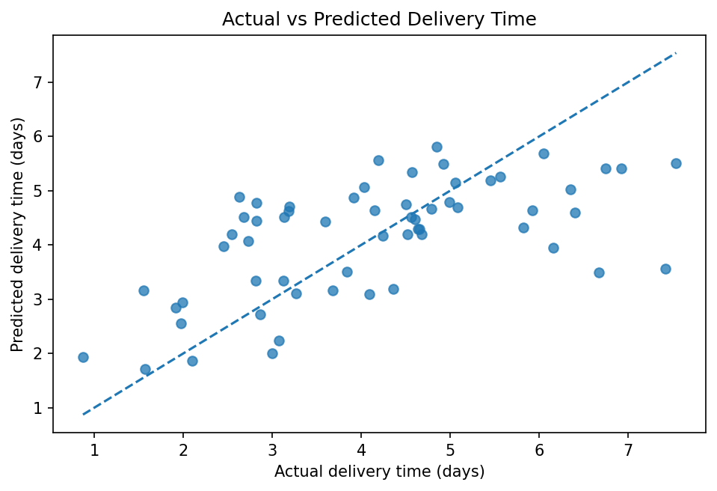
Points closer to the diagonal represent more accurate predictions. Large deviations are candidates for shipment-level investigation.

7.2 Model comparison
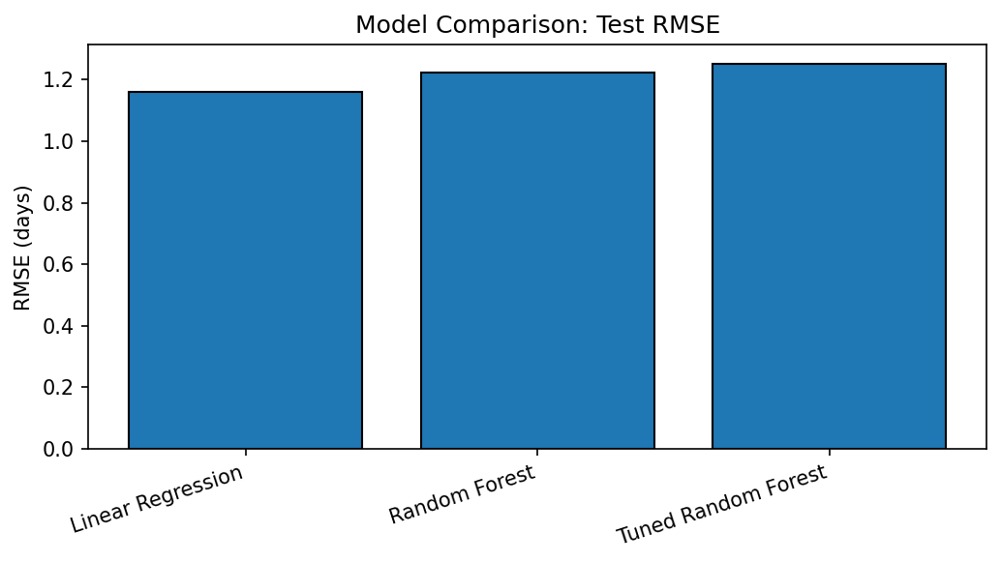
Lower RMSE indicates lower squared-error-based prediction loss on the test set.

7.3 Prediction errors
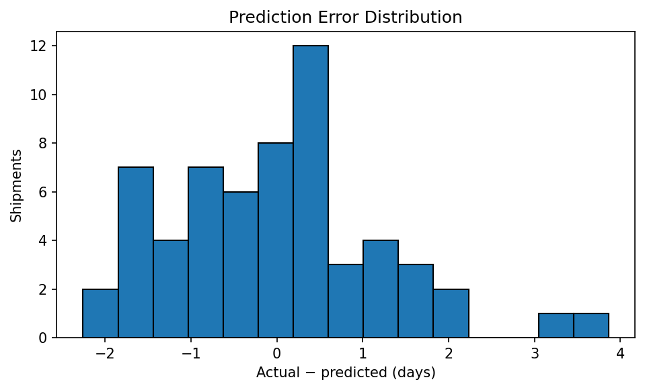
Errors are actual minus predicted duration. Positive errors mean delivery took longer than predicted, which can be important for customer-service risk.

8. Python Code Excerpt
search = GridSearchCV(
rf_pipeline,
param_grid={
"model__n_estimators": [100, 200],
"model__max_depth": [None, 8],
"model__min_samples_leaf": [1, 2, 4],
},
scoring="neg_root_mean_squared_error",
cv=KFold(n_splits=5, shuffle=True, random_state=42),
)
search.fit(X_train, y_train)
predictions = search.predict(X_test)
mae = mean_absolute_error(y_test, predictions)
rmse = np.sqrt(mean_squared_error(y_test, predictions))
r2 = r2_score(y_test, predictions)

9. Optimization Recommendations
- Create an early-warning queue for shipments with high predicted delivery duration; verify route, carrier, and current tracking status before escalating.
- Use predictions to plan dispatch cut-offs and communicate realistic estimated delivery windows. Do not replace confirmed carrier estimates without validation.
- Compare transport modes only for comparable routes, shipment weights, service levels, and costs; faster service may carry higher costs.
- Review high-error shipments to find missing drivers such as weather, traffic, warehouse dwell time, holidays, or carrier reliability. Add these fields when real data is available.
- Use predicted workload by region to support staffing and capacity planning, but add historical daily shipment volume before making volume forecasts.
- Monitor MAE and RMSE monthly, investigate under-predictions, and retrain when operating conditions or carrier performance change.

10. Limitations
The dataset is simulated and may not reflect real carrier pricing, weather, traffic, warehouse handling, holidays, or service-level agreements. Random splitting can overstate performance when predicting future periods; a time-based split is preferable with dated real records. Results should be validated on real historical data before operational use.

11. Conclusion
The workflow demonstrates regression modeling from data preparation through validation, tuning, test-set evaluation, and business recommendations. It can inform early delay warnings and dispatch planning, but real deployment requires richer operational data, route-level validation, and ongoing monitoring.

Appendix: Reproducibility
Install dependencies with `pip install -r requirements.txt`, then run `python logistics_prediction.py` from this project folder. The script saves model metrics, test predictions, and visualizations in `outputs/`.

