**CSE / EEE / ETE 499A (Section 01)**

**Project Proposal (CO1)**

**Project Title: Celebration- Celebrate your event efficiently.**

**Submitted To Dr. Shazzad Hosain (SZZ)**

**Date: 07/03/2021**



**Group no-04**

**Group Members**

|  |  |
| --- | --- |
| **Name** | **id** |
| **Sreyasi Sen** | **1610092642** |
| **Sumaiya Tarannum Noor** | **1721561642** |
| **Iqbal Ahmed Jhimel** | **1631662042** |
| **.Farhana Khan** | **1620542043** |

**1.Introduction**

Festivities have always been an important part of our culture and social life as our society loves to celebrate. Our tradition involves diverse occasions and as our economy is progressing with time, commercial event management is gaining more popularity. Website or application-based event management companies create various types of events and the demand for these companies is very high right now as more people are interested to take service from them for their desired purposes including birthday parties, weddings, and corporate events. These events can happen on a small scale or expand to extravagance especially seen during weddings. Companies in this rapidly growing industry are offering their services at different pricing, and customers approach them with their budget limit and agree with what seems best for them.

**The problem addressed in the project/ The problems of existing systems:**

People face different kinds of problems when they want to plan for an event. Finding a planner, managing location, fixing the price, all of these can be real problems when it comes to planning any event properly. While reviewing other similar systems, we have noticed some different problems.

* Some event management company websites do not provide proper examples of their previous work under the particular company page.
* There are management company websites who are providing a ‘gallery’ section but have only included some random photos without any niche or company name.
* Some websites included a ‘video’ gallery of some random videos. Most of the websites did not include any particular section for essential event items like- speakers, projector, projection screen, microphone, chairs, etc.
* The existing event management websites usually do not disclose their price list and don’t display enough photos of their previous work or have customer review sections for the user to judge by. This seems problematic as someone with a low budget might be missing out on better deals simply for the lack of knowledge.
* There are very few websites who are providing information about convention halls.

**Objective of this proposed project :**

Our objective is to provide a platform for those who want to efficiently plan an event on their own. In this platform, customers will be able to see the reflection of their desired management. The system will not only include the management services but also all other essentials that can make an event lively. On our website, we are willing to keep track of the nearest service providers for the customer. We will include main sections including home, event type, management companies, essentials of event management, about us, contact us, etc. We will also include subsections and features to all these sections. Overall, our target is to meet customers' imagination, choices and expectations as much as possible.

Our approach is to create a web-based platform and eventually build an android application called “Celebration” which can be used by anyone looking for event management related services. Here users can interact with professional event organizers and enjoy a variety of services for a reasonable price.

**Real-World System related to our project:**

**Celebration** is an online portal that provides direct-to-consumer access to event management services.

Some key features:

**Finding event planner/selecting event management companies:** Customers will choose who would be best for them. When a user joins **Celebration**, they will be able to search and choose their wanted deals in their desired price range. With this information, this website will help you to directly contact and book. They also can book an appointment with their desirable event planner or event management companies.

**Text and Audio Messaging:** Customers can send text messages to the event planner/event management company after successful booking.

**Video Session:** The customer can book a schedule to have a live video call with the event planner or event management company.

**Scheduling:** Customers can schedule their event. A calendar will be shown and the customers will be able to see available time slots to manually book hotels/ DJ/ parlour or any other available services. The customer will be asked to select from the uploaded choices including price range, photos and confirm their desired time slot.

**Change planner:** Customers can request to change their booked event planner/management company if they sense lack of compatibility with them. Customers can browse proﬁles belonging to the event planners/event management companies and switch to a new management company/planner of their own choice at any time by clicking the “Change planner” button inside their account. With some additional questions such as why the previous planner wasn’t a ﬁt for them, re-evaluating preferences, and planner expertise, customers can exchange their planner.

**Purchase gifts**: there are lots of events when people want to have the same design clothes such as school/ college rag day t-shirts. In this app we will have a purchase zone where customers can buy things like 'ceremony cloths' and many other things, also they can contact their planner to order their design specifications.

**Hire workers:** customers can hire workers easily, they will have to choose the number and for which work they need a worker.

Giving feedback: all the users can give feedback if they have worked. Any customer can give feedback to their planner, any planner can also give feedback to their customer.

**Upload product photos:** Except customers, all other users can upload photos for their services in their profile. they can use hashtags so that when customers search they will appear on their webpage. With every product price estimation is compulsory.

**To-do cart**: Users can add items to their cart. Booking cart and purchase cart will be different. for booking producers and consumers both have to set and fix their time, for purchase customers can just add, and pay. The booking cart will have three phases such as booking request, verify the request, confirm the request.

**Emergency booking:** for an emergency customer can contact moderators directly, there will be a button to contact us now for an emergency.

**2.Literature Review / Existing Projects**

In [1] the developers have created a website that allows a customer to plan their wedding event. This website is particularly for wedding planning. It has seven sections that include- projects, videos, about, services, careers, and contact. In the project section, they have included all of their previous projects of wedding planning. By clicking on this section, customers can see them elaborately. In the ‘videos’ section, they have included all of their previous customer's wedding videos. In the ‘about’ section they have described their website, services, and all. In the ‘service’ section they included three features- wedding planning, corporate events, and catering service. All these three features include many subsections that will allow a customer to plan an event efficiently. The ‘enlistment’ section includes all the party halls that use their website to get customers. In the ‘carrier’ section, the developers have included the positions where they are hiring people. The ‘contact us’ section allows users to contact them directly.

The developers in [2] have created a website that includes six-section- home, corporate events, Event equipment rental, wedding events, birthday events, and about. It allows the customer to arrange corporate events, wedding events, and birthday events. On their homepage they have described them and shown their previous work on different occasions- Conference, exhibition, product launch, annual meeting, brand activation, virtual conference, artist management, concert, fashion show, roadshow, wedding event, birthday event. They are also showing their ‘popular event items’ on their home page. Customers can click on any item and can get the details about the item and the booking. The website is simple. In the corporate event section, there is only one feature- brand activation. In a wedding, the event section has only a photography feature. The birthday event section doesn’t have any particular feature. There is a small icon that shows the ‘contact us’ section on every page of the website.

In [3] the developers have created a website that allows a customer to plan their wedding event. This website is, particularly for wedding planning. It has seven sections that include- home, about us, wedding, birthday, event management, price & package, other sites, contact. On their homepage, they are allowing the customer to select a month for fast booking through direct contact. They also included a ‘category’ section where everything on this website is shown alphabetically. They also included some samples of their previous work on the home page. In the ‘about us’ section they have given a brief description of them. In the ‘wedding’ section there are features like- pre wedding ritual stages and planning, wedding stage, royal theme wedding stage design, wedding photography. The ‘birthday’ section has a birthday decor theme, birthday photography, birthday games, and activities, these three features. In the event management section, there is only an event set design. The ‘price & package’ section includes the features like- wedding photography price, event photography price, HD video price. The ‘other site’ section allows customers to see three more different websites related to event management- Wedding Planner Bangladesh, Birthday Party Planner Dhaka, Bangladesh, and Event Management Bangladesh. This feature is unique. In the ‘contact us’ section customers can directly contact them.

The developers of [4] have created a website with seven main sections- home, about us, company profile, gallery video gallery, contact us. The ‘home’ page includes a section that allows customers to include the details about them and their event. The ‘about us’ section shows a message from the CEO and Managing Director. The ‘company profile’ section includes the pdf file of the company profile. The ‘gallery’ section shows some random photos of various events. In the ‘video gallery’ section, there are some videos of different events. The ‘contact us’ section helps customers to contact them directly. The ‘river cruise’ section is particularly for a cruise journey on the river. The website is complex yet doesn’t provide enough service for event management.

**3. Business viability of the project**

1. **Novelty of the proposed project**: The novelty of our project is quite new in our local context. as there is currently no platform for event management that would hold each company’s offers and sample photos including their original work with fixed pricing or a price range estimation which would allow users to have the convenience of comparing prices and choosing what’s best for them. There are few websites for event management companies. But in our website/app we are planning to bring all event management companies, event planners, and also event equipment owners into a single platform which will help customers to find producers and vice versa.
2. **Market segments:**

Demographic segmentation: The Demographic segmentation of our customer would be targeted towards age groups: age(25-35) for birthday parties, age(25-45) for weddings, and age(30-40) for office events.

Geographic segmentation: We will target the richest cities in Bangladesh- Dhaka, Chittagong and Sylhet.

c.  **Competitor analysis:** Currently, there are no apps like the one we are planning to build in Bangladesh so we do not have any opponents for that at the moment. However, BD Event Management and Wedding Planners, Event Guide BD are existing event management companies that have websites that do have a list of the different types of the event they cover and have included sample photos but have not mentioned the pricing. There are other companies such as Dhaka Event Planner and Event Consultant BD who have websites but have displayed zero to few sample photos with no price list as well.

d . **Competitive advantages of the project:** Usually, event planners do not disclose their pricing on their websites so our price estimation feature will be a highlight as the companies will include a price range that will allow users to get a better idea about which offers can fit their budget. Furthermore, our convenient app will be another highlight as smartphone-friendly users can find a list of different event management companies, catering, rental services all in one platform. Besides, customers can have more options with their price range, and can easily find their best deals with their budget. Customers can send or receive messages and contact event planners directly, and also they can hire everything on their own.

**e. Success factors: Celebration** will ensure the stable functioning of an event and do everything precisely from the pre-event planning to execution and post-event winding up. It will save time and money. it will help users to find renowned Event management companies and event planners, also owners from whom they will get their deals manually. it will help event management companies, planners, owners, and customers well-connected. Users can negotiate by themselves with hotel owners, venue managers, caterers, and renowned artists & performers, and get the best deal. user can also book a planner, or takes a service from event management companies who will carry the Right from the arrangement of flowers to lighting & audio-visual equipment, they are the ones who will do the networking, running around, and manage the biggest headaches with the team of experienced and skilled professionals who can do the job for you. Whether it is getting the best DJ for your daughter’s wedding party or the best caterer to help satiate the taste buds of the guests, you don’t have to worry when there are such expert organizers. It will help secure permission for the event to proceed. it provides a road map for the event to all stakeholders.it Ensures all relevant angles during planning. it Provides support during the event.it Acts as a key decision-support tool during the event and Provides a solid outline for staff briefing.

The must-haves for our project would be the core features of our platform. Such as

* User Account Information Management
* user{customer, event planner/manager/owner) profile
* online event booking (manually/through event manager/event company)
* Text Messaging
* uploading products photos
* setting price estimation ranges
* Scheduling
* Change event planner
* customer/owner Review/feedback option
* DJ/music, hotels, venue, tickets, car renting, and other things manually booking
* to-do cart system
* direct appointment with the event manager
* progress of work via the online tracking

The optional features that would improve the services even better are

* billing option by Bkash/online banking
* Emergency Calling Service
* Quick workers Calling Service
* search option using API
* video session with the event management company
* purchase gifts

The success of the project will be estimated upon the full implementation of the specifying features in both web-based and Android applications. As the application would work suitably to deliver the user the wanted experience.

f. **Risk factors:** There are some risk factors to online event management such as safety & security breaches. Each event has its nuances and depending on the location, the type, and the size, you’re going to have several different risks to take into accounts such as Staff, and Volunteer Safety, Food safety, Event and Production Equipment. our app will ensure to contact the real management companies, and booking in real-time with real peoples. it will not be liable for any mistakes done by the company or individuals.

With online booking, there is a high chance intruders will try to fraud customers by impersonating them. it’s always recommended to use the latest version of the security software used. Moderators will have to continuously upgrade their technology to prevent security breaches and check authentications, and also take care of every feedback strictly. Another risk factor is unpredictable weather. Also, users can be fraud too, If any unprofessional or unethical event takes place, it must have to be reported. A guideline will be strictly followed and actions will be taken against the offender.

**4. Project analysis :**

**a)Major components of the project:** Our project will be a PHP-based web application and also an Android-based application.

### **Hardware Requirements:**

* Processor: * core i3 *
* Hard Disk: * 80 GB
* Memory: * 1GB RAM

**Software Requirements:**

* Operating System:
* Windows 7/8/10.

**Technologies used :**

1. UML

2. Bootstrap

3. HTML, CSS

4. PHP

5. Laravel

6. JS

7. Mysql

The major functional components for this project are given-

**Functional Requirements:**

1.As a user I want to have a login/out function for users(customer, event planner/manager, owner) Only. So that I can access the portal. The only customer can create their profile, the admin will create other user profiles.

# Confirmation/Acceptance:

• User needs to register to log in.

• Users will be able to log in and log out of the system.

• Upon giving correct information, the user will be redirected to the home page.

• User will remain on the login page and see “incorrect credentials, please try again” for providing wrong credentials

2.As a user I want the system to make profiles so that I can make/update my profile.

online event booking (manually/through event manager/event company)

# Confirmation/Acceptance:

* Users can make their own profile.
* User can update their information

3.As a user(customer) I want the system to make an appointment with an event management company or event planner.

# Confirmation/Acceptance:

### 

• Users must have to fill in the necessary fields.

• Users will be able to see the meeting appointment.

• User can update the appointment schedule

.

4.As a user I want the system to have a Text Messaging option

# Confirmation/Acceptance:

* Customers can send/receive a message to the owner/planner/company.
* planner/owner/company can reply only, they can not give the first message.
* After booking an appointment users can chat together for a given time.

5.As a user(event planner/company/owner) I want the system to uploading products photos

# Confirmation/Acceptance:

* users(company/planner/owner) can upload products/venues/foods/other facilities photos
* customer can view those photos

6.As a user(planner/company/owner) I want to set price estimation ranges

# Confirmation/Acceptance:

* users(company/planner/owner) have to set price/price range before uploading

7.As a user I want the system to time/date Scheduling of my event

# Confirmation/Acceptance:

* after choosing an event, the user will select the date
* user will select a time
* user will see if the date/time is available, if available they will proceed, otherwise, they will redirect to the page and see "try again"

8.As a user I want the system to view the available options and products list on their profile

# Confirmation/Acceptance:

* customer can visit another event planner/owner/management company's profile
* customer can view uploaded photos
* customer can see available offers

9.As a user I want to give my feedback.

# Confirmation/Acceptance:

### 

• User will recommend it if the user feels better from the treatment.

• If the user finds any mistake the user has to click for the review and rate the company/event planner/owner.

10.As a user I want to Change the event planner/company.

# Confirmation/Acceptance:

* the user will change their planner if they do not feel good about their work.
* Users will contact the admin.
* user can remove the old planner and add the new planner

11.As a user I want to have an emergency section.

# Confirmation/Acceptance:

* user can directly send a text message to the admin
* Users can call the given emergency number provided there.

12.As a user(customers) I want to book DJ/music, hotels, venue, tickets, car renting, and other things manually.

# Confirmation/Acceptance:

* user can view any hotels/venue/other things
* user can select their desired options
* user can confirm their booking by clicking confirm button

13.As a user I want to order gifts online through this system

# Confirmation/Acceptance:

* user can view gift items
* user can select any product
* user will choose the number of this selected item
* user will add it to the cart

14.As a user I want the system to have a to-do cart system

# Confirmation/Acceptance:

* after selecting products user can view all those selected items in the cart
* after confirmation of the order, user can check their cart and view updates
* user can see expenses in the cart
* user can confirm payment via cart

15.As a user I want to check the progress of work via online tracking.

# Confirmation/Acceptance:

* user can see their history from their profile history
* they can check the updates about their event which will be made by the event management company/planner/ owner.
* the user can see which task is done, which task is pending, which task is in progress.

16.As a user I want the system to have a billing option and see the expenses by Bkash/online banking.

# Confirmation/Acceptance:

• User has to put additional products into the cart.

• After getting the event booking confirmation user will have to advance via online banking or Bkash.

• If everything is okay, the user will click the expenses button to check his expenses and make payment.

17.As a user I want to have a search option with categories(ex-by price range/event wise)

# Confirmation/Acceptance:

* user can search by event
* user can search by-products
* user can search by price range
* user can search by location

### **Performance Requirement:**

### **Availability:**

The system should be available at all times, meaning the user can access it using the application. In case of a hardware failure or database corruption, a replacement page will be shown. Also, in case of a hardware failure or database corruption, backups of the database should be retrieved from the application data folder and saved by the administrator. It means 24 x 7 availability. Reliability: A better component design for getting better performance at peak time. The flexible service-based architecture will be highly desirable for future extensions.

### 

### 

### 

### **Safety Requirements:**

The necessary data will be stored in a secondary/backup database in case of an emergency. If there is a loss/- damage/harm to the web application, the important data can be found in the secondary/backup database.

### **Security Requirement:**

The system uses SSL (secured socket layer) in all transactions that include any confidential customer information. Securing access to confidential data (user’s details).

**b)Target for 499A and 499B**: Our target is to finish the PHP(framework-laravel) based web application in 499A and then finish the Android part of the project in 499B.

**c)task analysis :**

**Task Analysis (499A)**

|  |  |  |  |  |  |
| --- | --- | --- | --- | --- | --- |
| **Task No** | **Task Description** | **Start Date** | | **End date** | **Dependency** |
| T1 | Proposal | 28/02/21 | | 7/03/21 |  |
| T2 | Project Design Report | 8/03/21 | | 14/03/21 | 1FS |
| T3 | Frontend and Database Design | 15/03/21 | | 21/03/21 |  |
| T4 | Project Impact and Constraint Report | 22/03/21 | | 28/03/21 | 1FS, 2FS |
| T5 | Authentication and User Classes | 29/03/21 | | 4/04/21 | 3FS |
| T6 | User Account Information Management | 5/04/21 | | 11/04/21 | 5FS |
| T7 | Online Event Booking Implementation (through event manager/company) | 12/04/21 | | 18/04/21 | 6FS |
| T8 | Appointment Making and Tracking Progress of Order | 19/04/21 | 25/04/21 | | 7FS |
| T9 | Scheduling, Updating Event and Planner and Review/Feedback | 26/04/21 | 2/05/21 | | 5FS, 6FS |
| T10 | Update Website Information and Chat Implementation | 3/05/21 | 9/05/21 | | 6FS |
| T11 | Payment Implementation and Final Report | 10/05/21 | 23/05/21 | | 1FS, 2FS, 3FS,4FS |

**Task Analysis (499B)**

|  |  |  |  |  |
| --- | --- | --- | --- | --- |
| **Task No** | **Task Description** | **Start Date** | **End date** | **Dependency** |
| T1 | Android Frontend | 6/06/21 | 4/07/21 |  |
| T2 | Android Backend and Database | 5/07/21 | 25/07/21 | 1FS |
| T3 | Backend and Features | 26/07/21 | 19/09/21 | 2FS |
| T4 | Hosting, final paper | 20/09/21 | 10/1021 | 2FS,3FS |

**Activity diagram:**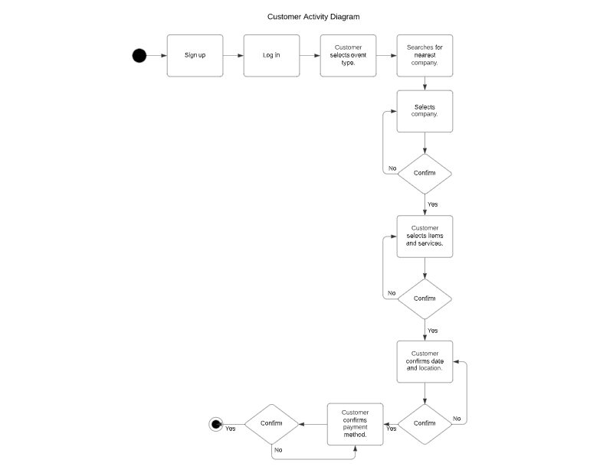

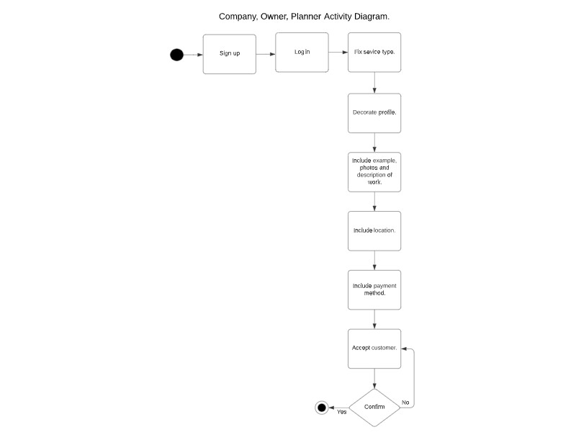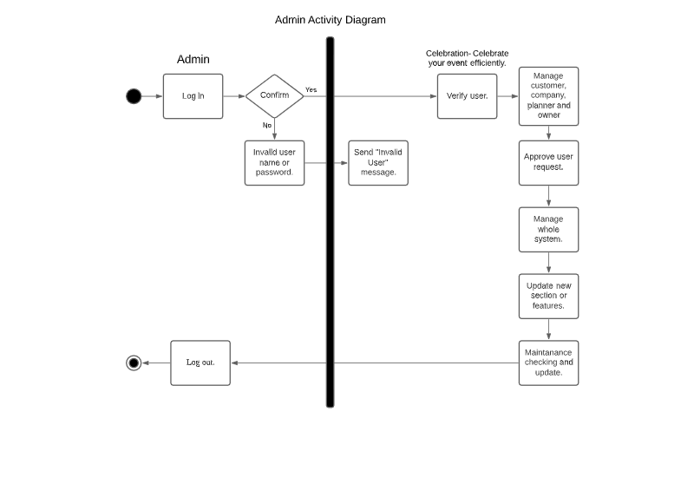

**d)timeline:**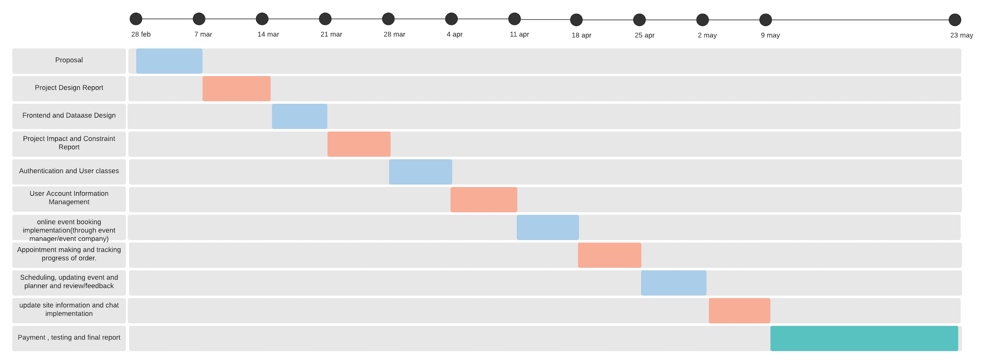

|  |  |  |  |  |  |
| --- | --- | --- | --- | --- | --- |
|  |  |  |  |  |  |

**e) People management:**

* Sreyasi sen- SS
* Sumaiya Tarannum Noor-ST
* Iqbal Ahmed Jhimel - IA
* Farhana Khan -FK

|  |  |  |
| --- | --- | --- |
| Task no | Task name | member |
| 01 | Proposal | ALL |
| 02 | Project design report | ALL |
| 03 | Frontend, database design | SS,ST |
| 04 | Project impact,constraint report | IA,FK |
| 05 | Authentication,user classes | IA,FK |
| 06 | User Account Information Management | SS |
| 07 | Online Event Booking Implementation (through event manager/company) | ST |
| 08 | Appointment Making and Tracking Progress of Order | IA |
| 09 | Scheduling, Updating Event and Planner and Review/Feedback | FK |
| 10 | Update Site Information and Chat Implementation | SS,ST |
| 11 | Payment Implementation and Final Report | ALL |

**f. Cost analysis:**

To develop our website, we will use our personal laptop/desktop. We have downloaded the necessary tools and software for the tasks in hand, from an available platform on the internet. So primarily we don’t need any cost to build this project. As we will update by adding features and enriching our database through collection information about- similar system, convention and party halls, essential event materials then it will cost approximately 2000- 3000 BDT as we will try to include different service providers. For ‘owner’ users, we will primarily need to connect some of the people physically who will be willing to work with us. For this we might need 2000 BDT. Then, we would also need transportation costs, that might be 2000 BDT. To build the system we need an uninterrupted internet connection, which will cost approximately 7000 BDT. Finally, if we want to buy a domain for our website then it will cost 4000 BDT.

**References**

[1] “Creative Wedding Planner”, *Creative Wedding Planner & Event Management,* 2019, [Online]. Available: https://creativeeventsbd.com/

[2] “Dhaka Event Planner”, *Amar Sheba*, 2021, [Online]. Available:<https://dhakaeventplanner.com/>

[3] “BD Event Management & Wedding Planner”, *SKT Themes*, [Online]. Available:<http://www.bdeventmanagement.com/>

[4] “Events Aid Bangladesh”, *Events Aid Bangladesh*, [Online]. Available:<https://eventsaidbd.com/>