test01

test001
PECsw  (all in µg/L) | RAC = 0.523  Scenario | 1.03 | 1.53
Nozzle  reduction | Mitigation  Buffer (m) | 0 m  Single | Multi | 5 m  Single | Multi | 10 m  Single | Multi | 20 m  Single | Multi
Drainage | D6 Ditch | 0.633 | 0.672
None
50 % Drift |  | 0.319 | 0.319 | 0.310
75 % Drift |  | 0.310 | 0.310 | 0.310
90 % Drift |  | 0.310 | 0.310 | 0.310
Runoff | R2 Stream | 0.561 |  | 0.369
50 % Drift |  | 0.369 |  | 0.369
75 % Drift |  | 0.369 |  | 0.369
90 % Drift |  | 0.369 |  | 0.369
PECsw  (all in µg/L) | RAC = 0.523  Scenario | 1.03 | 1.53
Nozzle  reduction | Mitigation  Buffer (m) | 0 m  Single | Multi | 5 m  Single | Multi | 10 m  Single | Multi | 20 m  Single | Multi
Drainage | D6 Ditch | 0.633 | 0.672
None
50 % Drift | Main Entry | 0.319 | 0.319 | 0.310
75 % Drift | Drainage | 0.310 | 0.310 | 0.310
90 % Drift |  | 0.310 | 0.310 | 0.310
Runoff | R2 Stream | 0.561 |  | 0.369
50 % Drift |  | 0.369 |  | 0.369
75 % Drift |  | 0.369 |  | 0.369
90 % Drift |  | 0.369 |  | 0.369
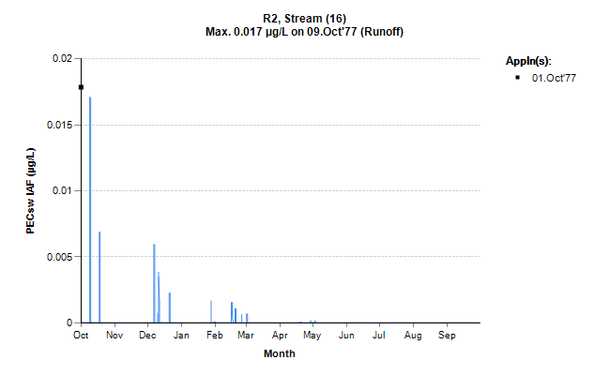

test02

test02
PECsw  (all in µg/L) | RAC = 0.523  Scenario | 1.03 | 1.53
Nozzle  reduction | Mitigation  Buffer (m) | 0 m  Single | Multi | 5 m  Single | Multi | 10 m  Single | Multi | 20 m  Single | Multi
Drainage | D6 Ditch | 0.633 | 0.672
None
50 % Drift | Main Entry | 0.319 | 0.319 | 0.310
75 % Drift | Drainage | 0.310 | 0.310 | 0.310
90 % Drift |  | 0.310 | 0.310 | 0.310
Runoff | R2 Stream | 0.561 |  | 0.369
50 % Drift |  | 0.369 |  | 0.369
75 % Drift |  | 0.369 |  | 0.369
90 % Drift |  | 0.369 |  | 0.369

