DB-C4-S3-THEORY VIEW

This exercise is based on given ONLINE database:

<https://www.w3schools.com/sql/trysql.asp?filename=trysql_select_where>

* Test your queries on the online editor
* Copy / paste your answer for each question on this document

**Q1:** Write a query to create a view for all customers who are coming from France.

SELECT CustomerName FROM Customers WHERE Country = 'France';

CREATE VIEW [CustomerName] AS SELECT CustomerName FROM Customers WHERE Country = 'France';

**Q2:** Write a query to create a view of order quantity more than 50.

SELECT Quantity FROM OrderDetails WHERE Quantity>50;

CREATE VIEW [High quantity] AS SELECT Quantity FROM OrderDetails WHERE Quantity>50;

**Q3**: Write a query to create a view of products with a price between $10 and $30.

SELECT Price FROM Products WHERE Price >10 AND Price<=30;

CREATE VIEW [Price10 or 30] AS SELECT Price FROM Products WHERE Price >10 AND Price<=30;

**Q4**: Write a query to create a view of suppliers coming from Japan and only from Tokyo city.

SELECT SupplierName FROM Suppliers WHERE City ='Tokyo';

CREATE VIEW [Supplier from Tokyo] AS SELECT SupplierName FROM Suppliers WHERE City ='Tokyo';

**Q5:** Write a query to create a view to display product name in each category without any duplicate.

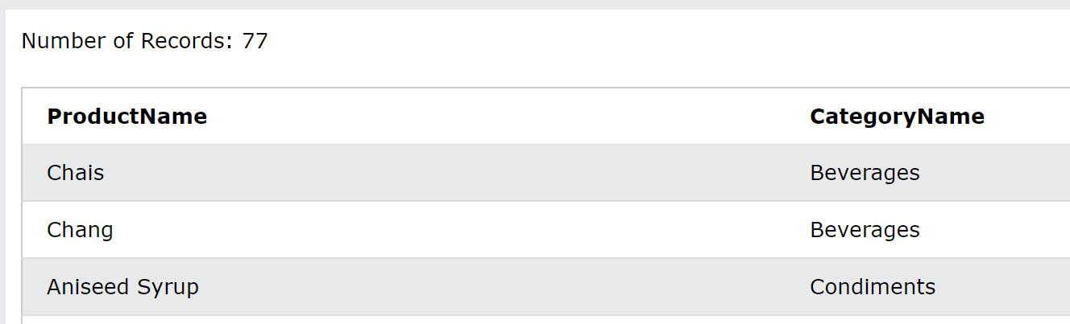

SELECT DISTINCT Products.ProductName, Categories.CategoryName FROM Products

INNER JOIN Categories ON Categories.CategoryID = Products.CategoryID;

CREATE VIEW [ProductName] AS SELECT DISTINCT Products.ProductName, Categories.CategoryName FROM Products

INNER JOIN Categories ON Categories.CategoryID = Products.CategoryID

**Q6:** Write a query to create a view to display all customers and employees as seller

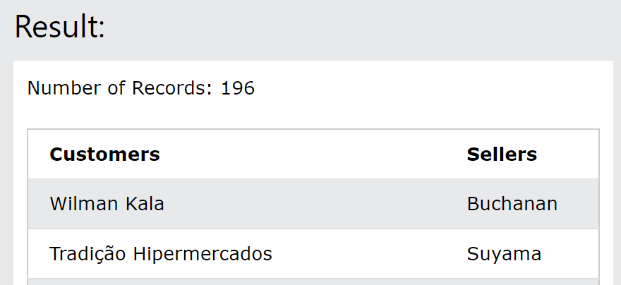

Q7: Write a query to create a view for those salesmen belongs to the city New York.

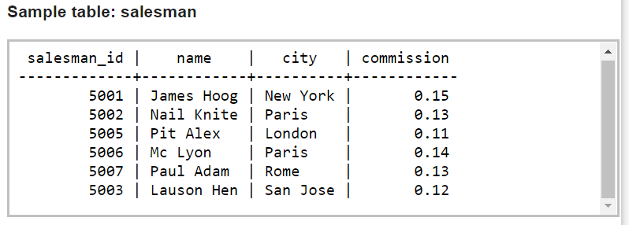

**Q8:** Write a query to find the salesmen of the city New York who achieved the commission more than 13% with the view you just created in Q7.