# C1- S4-PRACTICE

# Exercice 1

Q1 – Complete the **attributes type**s of Book and Read entities (5 points)

Q2 – Complete the **relation** between the Book and Reader entities (5 points)

|  |  |
| --- | --- |
| **Reader** | |
| ReaderID  Name  Class  Address | Numeric  String  String  string |

|  |  |
| --- | --- |
| **Book** | |
| BookID  Title  Publishment date  Language | Numeric  string  date  string |

Many

Many

|  |  |
| --- | --- |
| **Reader** | |
| ReaderID  Name  Address  Date return | Numeric  String  String  date |

|  |  |
| --- | --- |
| **Book** | |
| BookID  Title  Language  Date borrow | Numeric  String  String  date |

Q3 – We have created an **additional Associative table** to manage the previous relation between Book and Reader

* Complete the missing parts!

1

1

|  |  |
| --- | --- |
| **BookBorrow** | |
| BorrowID  Date borrow  Date return  ReaderID  BookID | Pk  Fk  Fk |

Many

Many

# Exercice 2

Q1: complete the missing part of a model diagram below with PK as primary or FK foreign key.

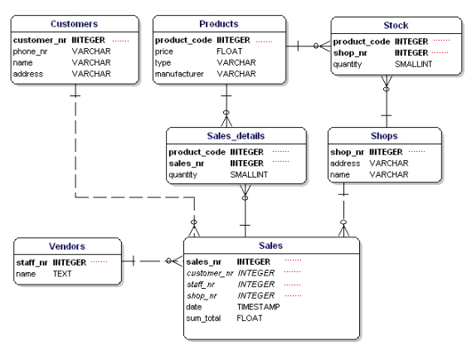

Pk

pk

Pk

Fk

Fk

Pk

Fk

Pk

Fk

Fk

pk

Fk

fk

Fk

# Exercise 3

Q1: Complete the relation between each entity on the database relation model. Take for example the relation between **STUDENTS** and **PROJECTS.**

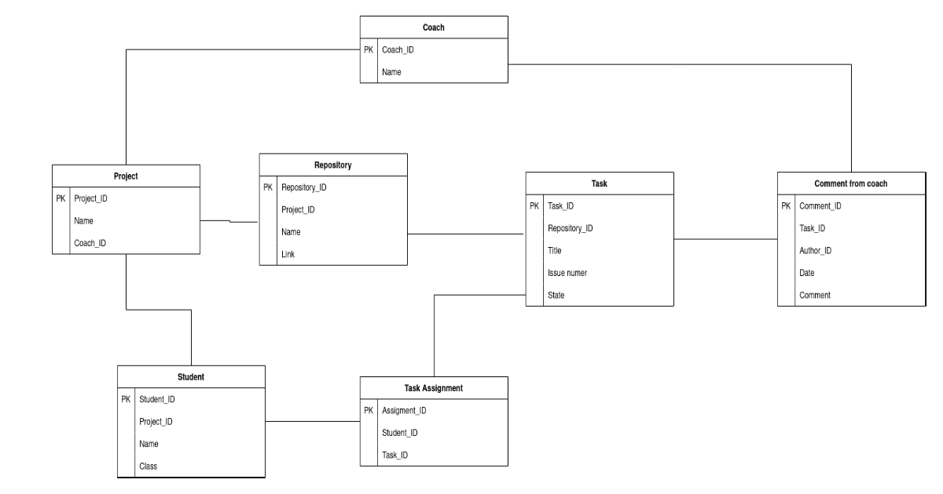

many

Many

Many

Many

M

M

M

1

1

1

M

1

M

M

1

M

# Exercise 4

Google Classroom is the tool used to manage PNC classes, where the teacher can assign homework to the students of different classes.

**Q1**: Complete the attributes types in the following tables

|  |  |
| --- | --- |
| **User** | |
| user ID  email  password  name  role | **Num**  **str**  **str**  **str**  **str** |

|  |  |
| --- | --- |
| **Classroom** | |
| classroom ID  name  section  subject | **Num**  **str**  **str**  **str** |

1 M

|  |  |
| --- | --- |
| **Assignment** | |
| assignment ID  title  description  deadline | **num**  **str**  **str**  **date** |

|  |  |
| --- | --- |
| **Comment** | |
| comment ID  content  user ID  assignment ID | **num**  **str**  **num**  **num** |

M M

Here are some observations that can help us design the Google Classroom database:

* A user can create many classrooms as teacher
* A user can join many classrooms as student
* A classroom can have many teachers
* A classroom can have many students
* A teacher can post many assignments in a classroom, and the same assignment can be posted in several classrooms
* An assignment post can have many comments from students or teachers

**Q2**   **CLASSROOM** and **ASSIGNEMENT**

1. Type of relation: *one to one, one to many, many to many*?

Type of relation 1 to many.

1. Do you need to create an intersection table? Why?

Yes, I do because I no need add new attribute.

1. Create the ERD representing to represent those 2 entities and their relation

1 many 1

|  |  |
| --- | --- |
| **Classroom** | |
| Classroom ID  Name  Section  subject | **num**  **str**  **str**  **date** |

|  |  |
| --- | --- |
| **Classroom_Assignment** | |
| assignment ID  Classroom ID | **Fk**  **Fk** |

|  |  |
| --- | --- |
| **Assignment** | |
| assignment ID  name  description  deadline | **Num**  **str**  **str**  **str** |

**Q4:**   **COMMENT** and **ASSIGNEMENT**

1. Type of relation: *one to one, one to many, many to many*

*Type of relation: Many to many.*

1. Do you need to create an intersection table or not? Why?
2. I need to create an intersection table because I no need add new attribute.
3. Update the previous ERD to represent those 2 entities and their relation

many many many

|  |  |
| --- | --- |
| **Comment** | |
| Comment ID  Name  Section  subject | **num**  **str**  **str**  **date** |

|  |  |
| --- | --- |
| **comment_Assignment** | |
| assignment ID  comment ID | **Fk**  **Fk** |

|  |  |
| --- | --- |
| **Assignment** | |
| assignment ID  name  description  deadline | **Num**  **str**  **str**  **str** |

**Q5:**   **COMMENT** and **USER**

1. Type of relation: *one to one, one to many, many to many?*
2. Do you need to create an intersection table or not? Why?
3. Update the previous ERD to represent those 2 entities and their relation

many many many

|  |  |
| --- | --- |
| **Comment** | |
| Comment ID  Name  Section  subject | **num**  **str**  **str**  **date** |

|  |  |
| --- | --- |
| **Comment_user** | |
| assignment ID  comment ID | **Fk**  **Fk** |

|  |  |
| --- | --- |
| **user** | |
| user ID  email  password  name  role | **Num**  **str**  **str**  **str**  **str** |