# C2- S5 - PRACTICE

*NOTE: check your* ***THEORY slides*** *to answer those questions!*

# EXERCISE 1 – GOOGLE CLASSROOM DATABASE

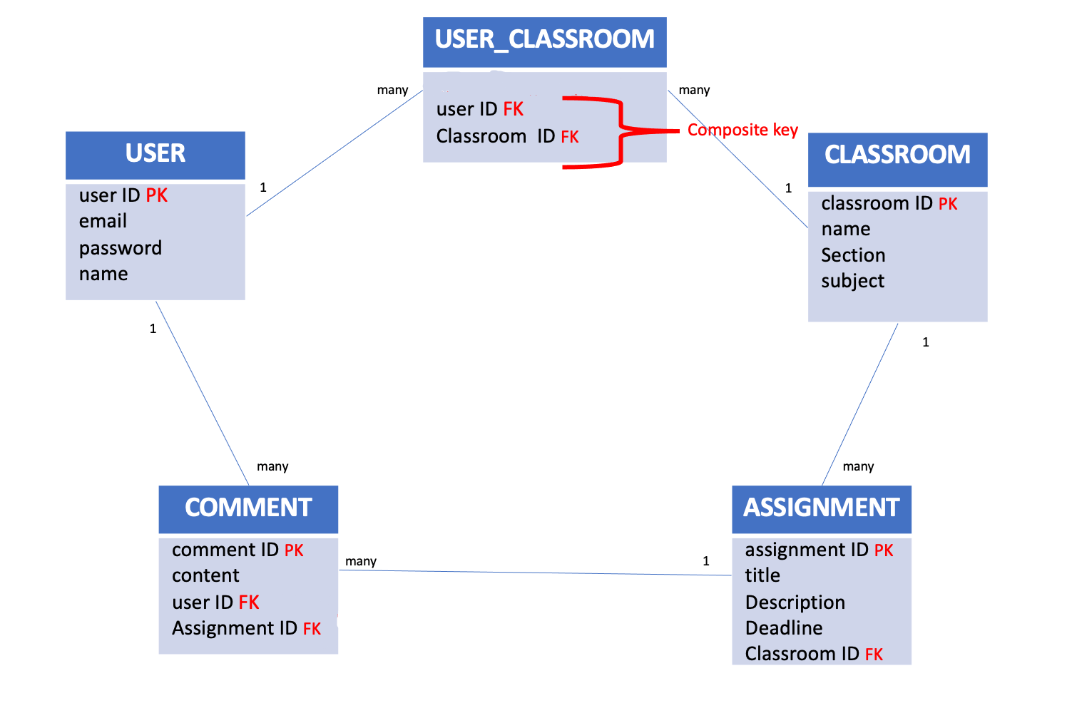

Here is the Entity Relation Diagram of the Google Classroom Database you designed in Chapter 1. You are now going to put it in MySQL!

**Q1 –** Write a statement to create the google classroom database, and to tell MySQL you are now working with it.

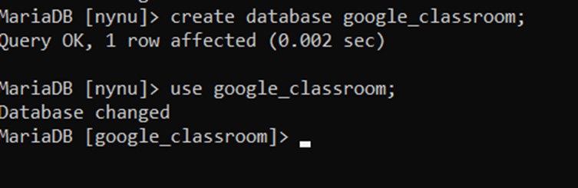

**Q2** – For each table (USER, USER_CLASSROOM, CLASSROOM, ASSIGNMENT, COMMENT), complete the following arrays, by specifying for each attribute:

* + The attribute type (SQL type) and size
  + Can be null or not?
  + Is a primary key or foreign keys?
* **USER TABLE**

|  |  |  |  |
| --- | --- | --- | --- |
| Attribute name | Type / size | Can be Null? | Key |
| User_id | Int | No | PK |
| Name | Varchar(50) | No |  |
| email | Varchar(50) | No |  |
| password | Varchar(50) | No |  |

**USER_CLASSROOM TABLE**

|  |  |  |  |
| --- | --- | --- | --- |
| Attribute name | Type / size | Null? | Key |
| Classroom_id | int | No | fk |
| User_id | int | No | fk |

**CLASSROOM TABLE**

|  |  |  |  |
| --- | --- | --- | --- |
| Attribute name | Type / size | Null? | Key |
| Classroom_id | int | No | pk |
| Name | Varchar(60) | No |  |
| section | Varchar(60) | No |  |
| subject | Varchar(60) | No |  |

**ASSIGNMENT TABLE**

|  |  |  |  |
| --- | --- | --- | --- |
| Attribute name | Type / size | Null? | Key |
| Assignment_id | int | No | pk |
| title | Varchar(65) | No |  |
| description | Varchar(65) | Yes |  |
| deadline | datetime | No |  |
| Classroom_id | int | No | fk |

**COMMENT TABLE**

|  |  |  |  |
| --- | --- | --- | --- |
| Attribute name | Type / size | Null? | Key |
| Comment_id | int | No | pk |
| contant | Varchar(65) | Yes |  |
| User_id | int | No | fk |
| Assignment_id | int | No | fk |

**Q3** – Write the SQL statement to create the 5 tables with appropriate properties.

WARNING: Create the tables in the right order to respect the Foreign Key constraints.

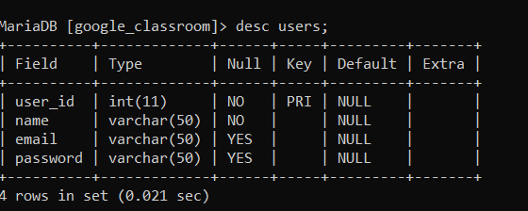

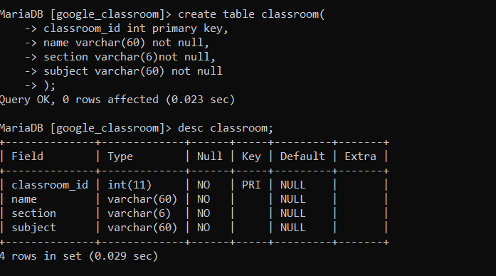

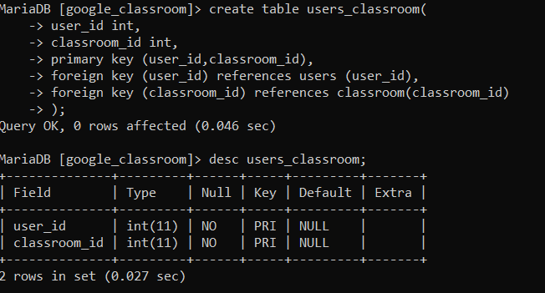

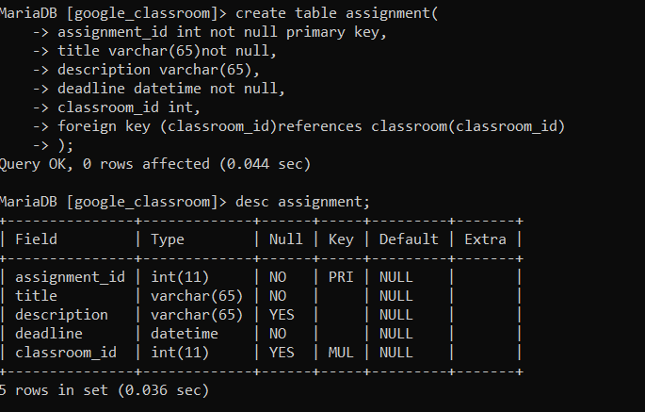

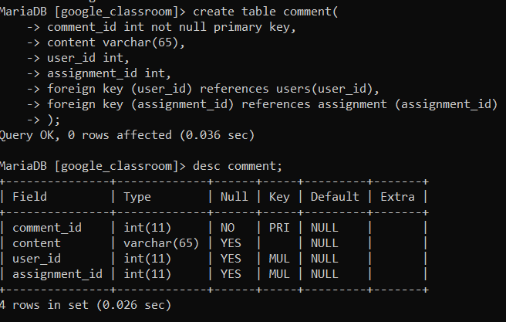

**Q4 –** Write statements to insert at least 3 records in each table.

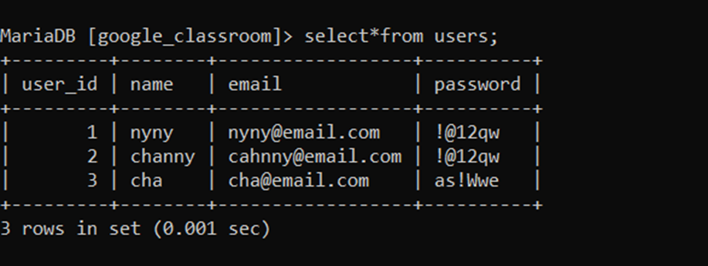

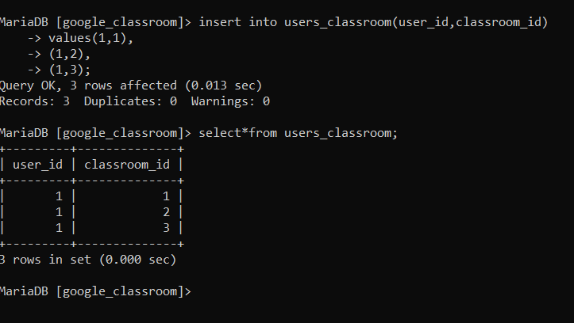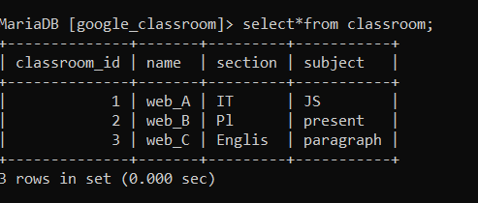

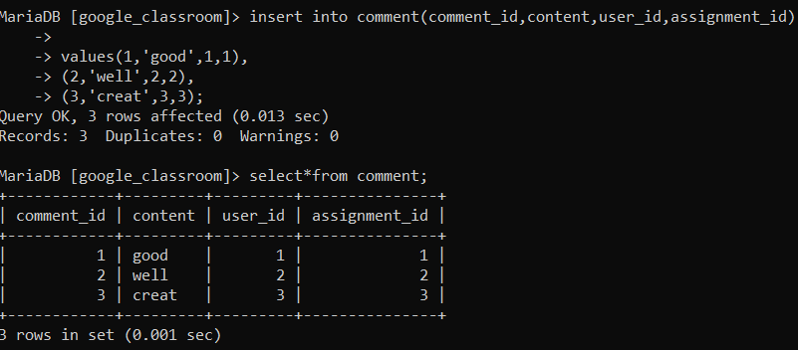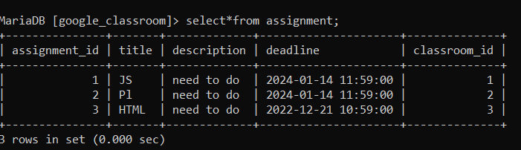

# EXERCISE 2 – FOODPANDA DATABASE

Here is the Entity Relation Diagram of the Foodpanda Database you designed in Chapter 1. You are now going to put it in MySQL!

**Q1 –** Write a statement to create the Foodpanda database, and to tell MySQL you are now working with it.

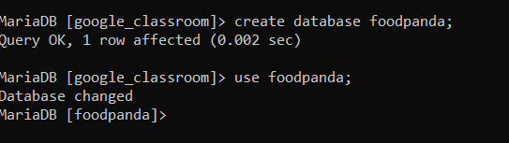

**Q2** – For each table of the database, complete the following array, by specifying for each attribute:

* + The attribute type (SQL type) and size
  + Can be null or not?
  + Is a primary key or foreign keys?

1. Address Table

|  |  |  |  |
| --- | --- | --- | --- |
| Attribute name | Type / size | Null? | Key |
| Address_id | int | No | pk |
| street | Varchar(70) | No |  |
| District | Varchar(70) | Yes |  |
| City | Varchar(70) | Yes |  |

1. Customers Table

|  |  |  |  |
| --- | --- | --- | --- |
| Attribute name | Type / size | Null? | Key |
| Customer_id | int | No | pk |
| Customer_name | Varchar(70) | No |  |
| email | Varchar(70) Unique | No |  |
| Phone number | Varchar(70) Unique | No |  |
| Address_id | int | No | fk |

1. Deliverers Table:

|  |  |  |  |
| --- | --- | --- | --- |
| Attribute name | Type / size | Null? | Key |
| Deliver_id | int | No | pk |
| Phone number | Varchar(60) Unique | No |  |
| vehicle | Varchar(60) | No |  |

1. Restaurants Table:

|  |  |  |  |
| --- | --- | --- | --- |
| Attribute name | Type / size | Null? | Key |
| Restaurant_id | int | No | pk |
| Restaurant_name | Varchar(60) | No |  |
| Address_id | int | No | fk |
| website | Varchar(60) | No |  |
| Phone number | Varchar(60) | No |  |
| category | Varchar(60) | No |  |

1. Food_items Table:

|  |  |  |  |
| --- | --- | --- | --- |
| Attribute name | Type / size | Null? | Key |
| Food_id | int | No | pk |
| Food_name | Varchar(60) | No |  |
| price | Decimal(12,2) | No |  |
| Category | Varchar(60) | No |  |
| Restaurant_id | int | No | fk |

1. Orders Table:

|  |  |  |  |
| --- | --- | --- | --- |
| Attribute name | Type / size | Null? | Key |
| Order_id | int | No | pk |
| Customer_id | int | No | Fk |
| OrderDate | date | No |  |
| Pick up | Varcher(50) | No |  |
| Deliver_id | Int | No | fk |
| Restaurant_id | int | No | fk |

1. Order_food Table:

|  |  |  |  |
| --- | --- | --- | --- |
| Attribute name | Type / size | Null? | Key |
| Food_id | int | No | Fk |
| Order_id | int | No | Fk |
| quautity | int | No |  |

**Q3** – Write the SQL statement to create the tables with appropriate properties.

WARNING: Create the tables in the right order to respect the Foreign Key constraints.

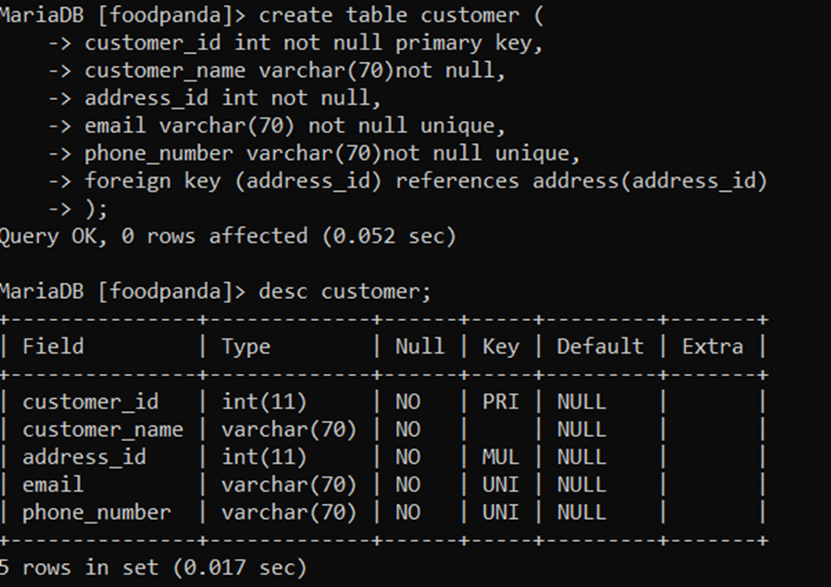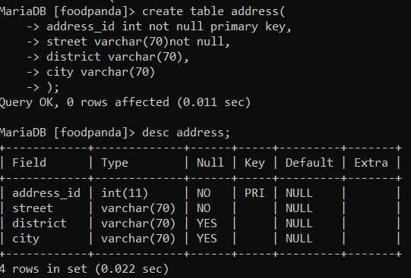

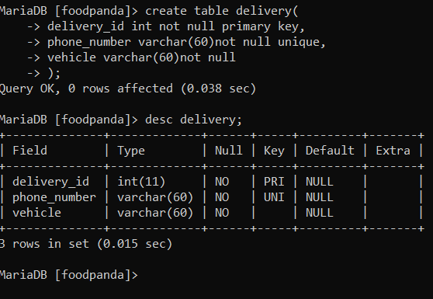

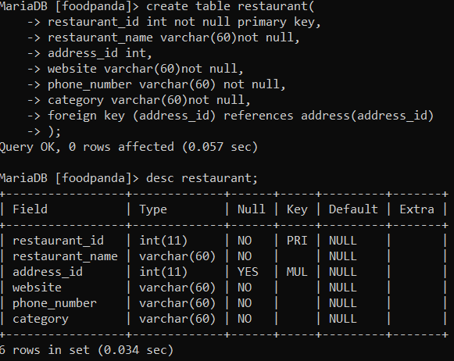

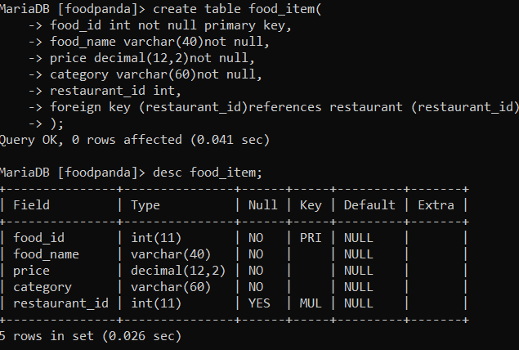

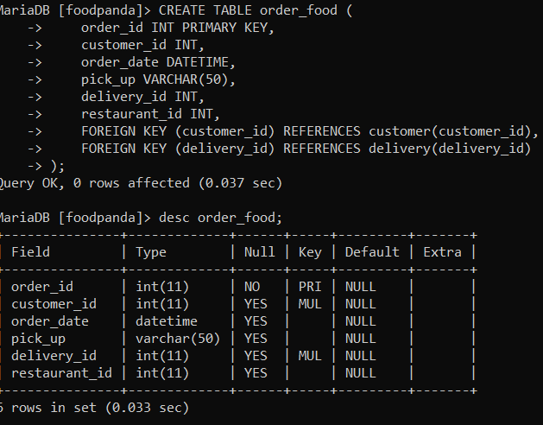

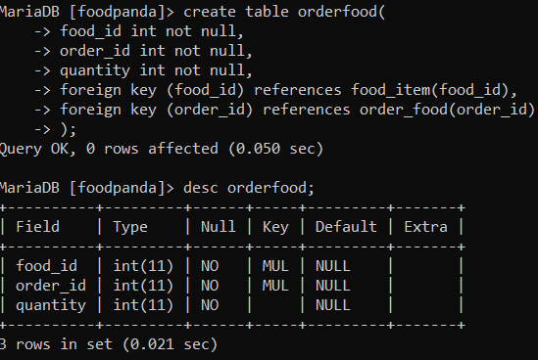

**Q4 –** Write statements to insert between 2 and 4 records in each table.

