C3-S2-PRACTICE

# Instructions: : you can use your favorite SQL editor

**Exercise 1:** [**Databases on W3School**](https://www.w3schools.com/sql/trysql.asp?filename=trysql_select_all) **(on the right side)**

1. **Selecting**

Write statements to extract data from all tables from w3shool order at least one column by ASC and other one by DESC.

* 1. **Customers : select * from customers order by customername DESC;**

**select * from customers order by country ASC;**

**b. Categories : SELECT * FROM Categories order by categoryname DESC;**

**SELECT * FROM Categories order by description ASC;**

**c. Employees : SELECT * FROM Employees order by lastname ASC;**

**SELECT * FROM Employees order by firstname DESC;**

**d. OrderDetails : SELECT * FROM OrderDetails order by orderid DESC;**

**SELECT * FROM OrderDetails order by productid ASC;**

**e. Orders : SELECT * FROM Orders order by employeeid ASC;**

**SELECT * FROM Orders order by shipperid DESC;**

**f. Products : SELECT * FROM Products order by productname ASC;**

**SELECT * FROM Products order by price DESC;**

**g. Shippers : SELECT * FROM Shippers order by shippername DESC;**

**SELECT * FROM Shippers order by shipperid ASC;**

**h. Suppliers : SELECT * FROM Suppliers order by city ASC;**

**SELECT * FROM Suppliers order by contactname DESC;**

1. **Where clause** 
   1. Write a statement to extract all data from products where the price equal to 19.5.

SELECT * FROM Products WHERE Price = 19.5;

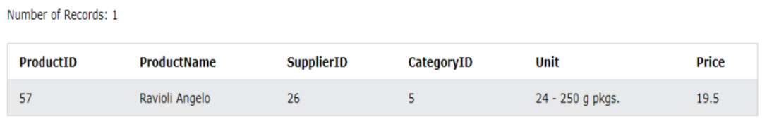

* 1. Write a statement to extract all data from ordereDetail where the Quantity greater than 10.

SELECT * FROM OrderDetails WHERE Quantity > 10;

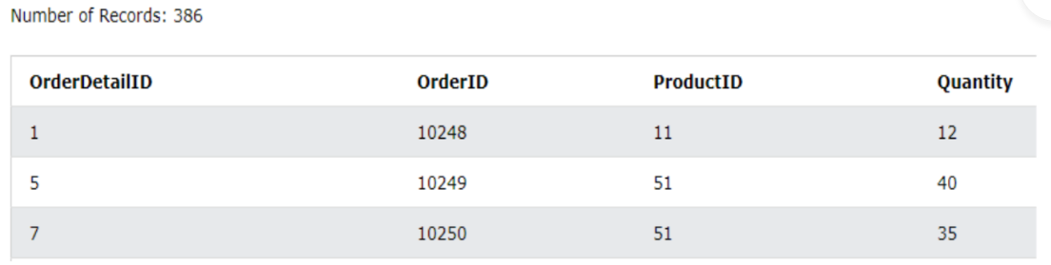

* 1. Write a statement to extract all data from shippers where the shipperid less than 3.

SELECT * FROM Shippers WHERE ShipperID < 3;

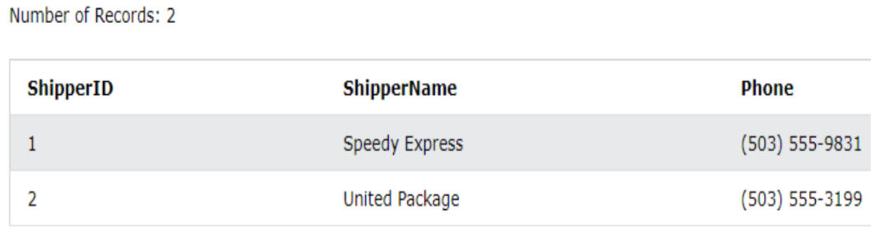

* 1. Write a statement to extract all data from products where the price is Greater than or equal to 40.

SELECT * FROM Products WHERE Price >= 40; 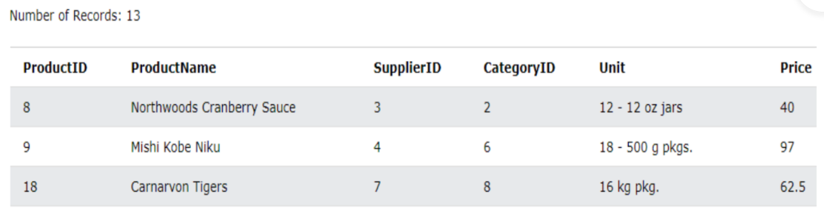

* 1. Write a statement to extract all data from products where SupplierID is Less than or equal to 9.

SELECT * FROM Products WHERE SupplierID <= 9;

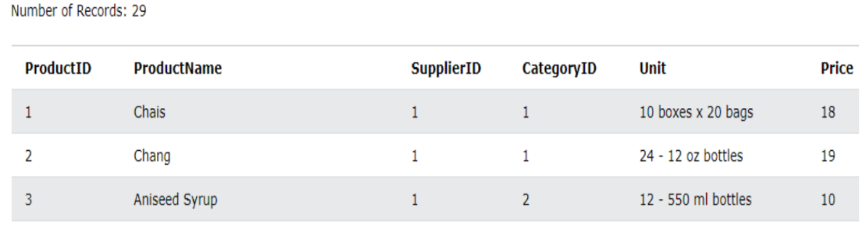

* 1. Write a statement to extract all data from customers except “Canana”.

SELECT * FROM Customers WHERE not Country = "Canada";

Or

select * from customers where country!='Canada';

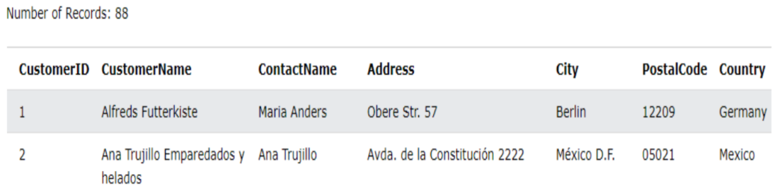

* 1. Write a statement to extract all data from products where the price is between 10 to 30.

SELECT * FROM Products WHERE Price >= 10 and Price <= 30;

OR

SELECT * FROM Products WHERE Price between 10 and 30;

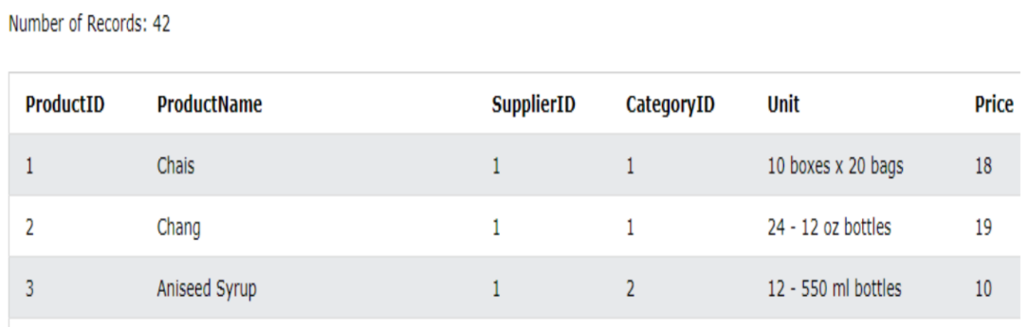

* 1. Write a statement to extract all data from customers where the customername start with letter O.

SELECT * FROM Customers WHERE CustomerName LIKE 'O%';

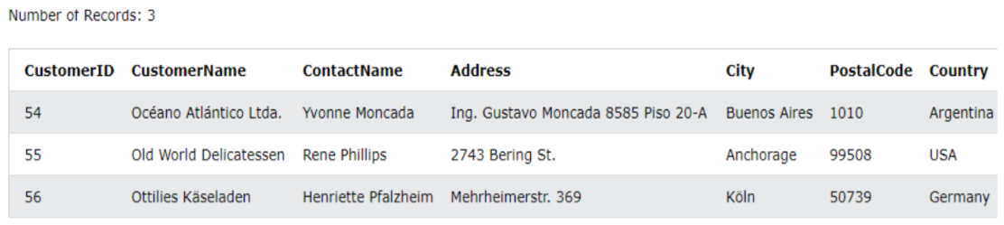

* 1. Write a statement to extract all data from suppliers where the country is in “USA, Italy,France”

SELECT * FROM Suppliers WHERE Country in ("USA", "Italy", "France");

