C4- S2-PRACTICE

# What you will know:

**Combining data** from multiple tables using **JOINS**

This exercise is based on given ONLINE database:

<https://www.w3schools.com/sql/trysql.asp?filename=trysql_select_where>

* Test your queries on the online editor
* Copy / paste your answer for each question on this document

**Q1**

Open the **power point** to edit the database ERD.

* Complete the ERD with the **missing relationships** between the 8 tables of this database

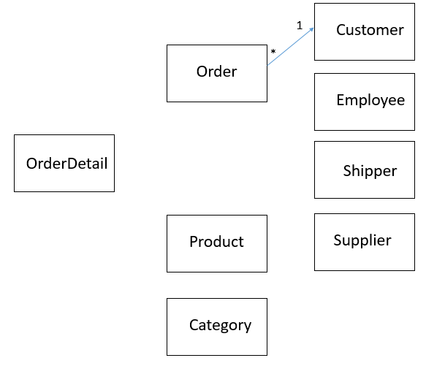

*For now only the relation between Order and Customer table is defined*

**Q2**

Write the query to display for each order ID, the name of the customer

As example:

|  |  |
| --- | --- |
| OrderID | CustomerName |
| 10248 | Wilman Kala |
| 10249 | Tradição Hipermercados |
| 10250 | Hanari Carnes |
| 10251 | Victuailles en stock |
| 10252 | Suprêmes délices |

Your answer:

SELECT Orders.OrderID, Customers.CustomerName

FROM Orders

INNER JOIN Customers

ON Orders.CustomerID=Customers.CustomerID;

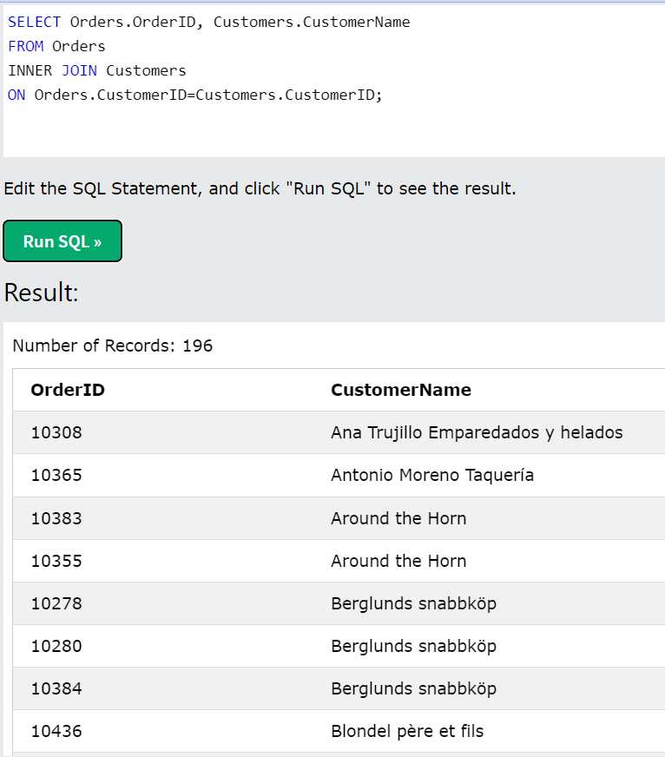

**Q3**

Write the query to display for each **product**, the name of the **supplier**

As example:

|  |  |
| --- | --- |
| ProductName | SupplierName |
| Chais | Exotic Liquid |
| Chang | Exotic Liquid |
| Aniseed Syrup | Exotic Liquid |

Your answer:

SELECT Products.ProductName, Suppliers.SupplierName

FROM Products

INNER JOIN Suppliers

ON Products.SupplierID=Suppliers.SupplierID;

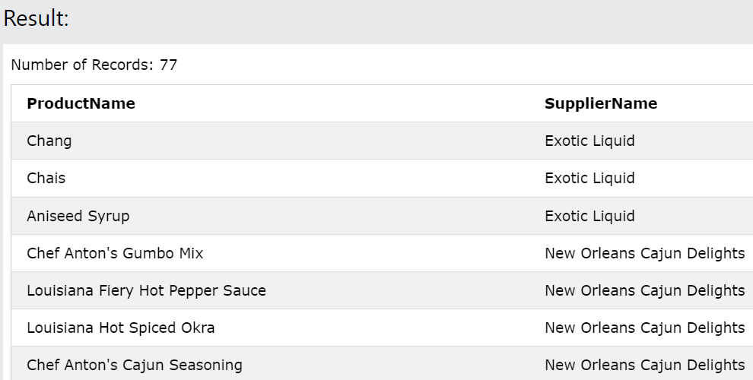

**Q4**

Write the query to display for each **order**, the name of the **customer** and the name of the **supplier**

As example:

|  |  |  |
| --- | --- | --- |
| OrderID | Customer name | Shipper name |
| 10248 | Wilman Kala | Federal Shipping |
| 10249 | Tradição Hipermercados | Speedy Express |
| 10250 | Hanari Carnes | United Package |
| 10251 | Victuailles en stock | Speedy Express |

Your answer:

SELECT Orders.OrderID, Customers.CustomerName, Shippers.ShipperName

FROM (Orders INNER JOIN Customers ON Orders.CustomerID = Customers.CustomerID)

INNER JOIN Shippers ON Orders.ShipperID = Shippers.ShipperID;

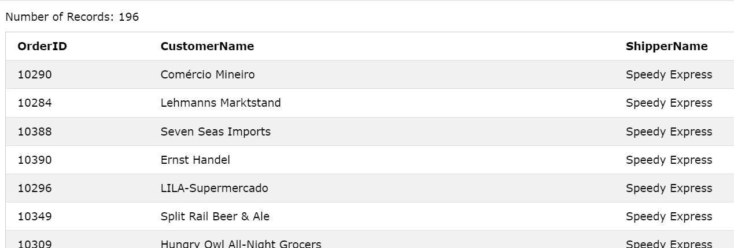

**Q5**

Write the query to display the number of orders sent by each shipper:

As example (the values here are not correct):

|  |  |
| --- | --- |
| ShipperName | NumberOfOrders |
| Federal Shipping | 255 |
| Speedy Express | 249 |
| United Package | 326 |

Your answer:

SELECT Shippers.ShipperName, COUNT(Orders.OrderID) AS NumberOfOrders

FROM Shippers

INNER JOIN Orders ON Shippers.ShipperID = Orders.ShipperID

GROUP BY Shippers.ShipperName;

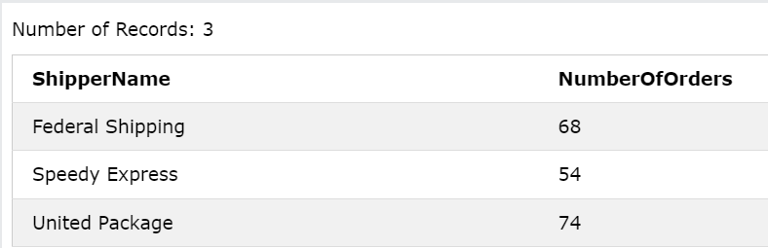

**Q6**

Write the query to display the name of products related to **an order with a quantity of 80 or more**.

*Tips: you should find 8 products!*

As example (the values here are not correct):

|  |
| --- |
| ProductName |
| Pâté chinois |
| Schoggi Schokolade |
| Sirop d'érable |
| Jack's New England Clam Chowder |
| Perth Pasties |
| Chartreuse verte |
| Manjimup Dried Apples |
| Rhönbräu Klosterbier |
| Wimmers gute Semmelknödel |

Your answer: SELECT DISTINCT Products.ProductName FROM Products

INNER JOIN OrderDetails ON Products.ProductID = OrderDetails.ProductID

WHERE OrderDetails.Quantity >= 80;

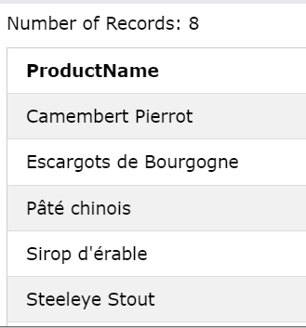

**Q7**

Write the query to display all products whose **supplier is coming from USA**

Example of result

|  |
| --- |
| ProductName |
| Chef Anton's Cajun Seasoning |
| Chef Anton's Gumbo Mix |
| Grandma's Boysenberry Spread |
| Uncle Bob's Organic Dried Pears |
| Northwoods Cranberry Sauce |
| Sasquatch Ale |

Your answer: SELECT DISTINCT Products.ProductName FROM Products

INNER JOIN Suppliers ON Products.SupplierID = Suppliers.SupplierID

WHERE Suppliers.Country='USA';

