**QUIZ CHAPTER 3**

**{2h00}**

|  |  |
| --- | --- |
| **EXERCICES** | **POINTS** |
| EXERCICE-1 | 20 |
| EXERCICE-2 | 80 |

You need to submit on google classroom:

1. Your UML diagrams
2. Your Typescript project

# EXERCICE-1

A house has many chairs

We also want to keep for each chair, to which house it belong to: you need to make the connection between the Chair and the house!

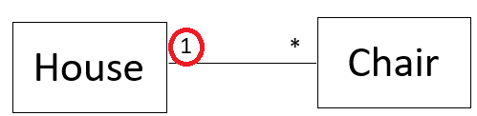

**Q1** Complete the method addChair to:

* Add a new chair to the House
* Set the **House reference** on the new created chair

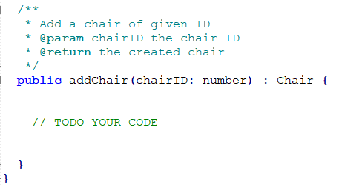

# EXERCICE-2



We describe a library system as follows:

**LIBRARY** has :

* a name
* An address
* Books in the library

**BOOK** has:

* a title
* year of published
* authors, a book can be written by one or many authors
* publisher, a book can have a publisher or not

**PUBLISHER** has:

* a name
* a address

+ **AUTHOR** has:

* name

**Q1** Open file **UML-STUDENT.pttx** and create the class with relationship including the following requirements:

* Visibilities (public/private)
* Multiplicities (has 1, 2, many etc.)

**Q2** From the **UML Diagram** implement the classes and they relationship in **Typescript**

**Q3** Inside class **Book,** create the following methods:

addAuthor(author:Author) // Add an author to the book

setPublisher(publisher:Publisher) // Set publisher of book

**Q4** Inside class **Library,** create the following methods:

addBook(book:Book) // Add a book to the library

**Q4** In the Main.ts**:** createthe following **instances**:

**Author**

|  |
| --- |
| **name** |
| Ronan |
| Him |

**Publisher**

|  |  |
| --- | --- |
| **name** | **address** |
| Sipar | Phnom Penh |
| IBC | Siem Reap |

**Book**

|  |  |  |  |
| --- | --- | --- | --- |
| **Title** | **Year** | **Author** | **Publisher** |
| OOP is the best | 2018 | ronan | sipar |
| Best team ? | 2015 | ronan | sipar |
| The Why not book | 2020 | him |  |

**Library**

|  |  |  |
| --- | --- | --- |
| **Name** | **Address** | **Books** |
| PNC LIBRARY | Phnom Penh | OOP is the best |
| Best team? |
| The Why not book |
|  |

**Q5** Create a method to get all books from a given author

getBooksFrom(author:Author) : Book[]

**Q6** Create a method to get all books from a given publisher

getBooksFrom(publisher:Publisher) : Book[]