

|  |
| --- |
| **EXAM RULE**:   * CLASSROOM DOCUMENTS INCLUDING SLIDES ARE ALLOWED * NO CHAT, TALK OR LOOK TO OTHER STUDENTS. IF SEEN YOU WILL BE FAILED AUTOMATICALLY * ONLY THE FIRST SUBMISSION WILL BE ACCEPTED IN THE CASE OF MISTAKES * REMOVE **Vendors** folder before zip * EXPORT DATABASE, PUT WITH PROJECT * BEFORE SUBMITTING, RENAME YOUR FOLDER: **FIRST-LASTNAME.ZIP** |

# *Scenario for Designing a Laravel API for a Library Application*

# Exam Instructions:

You are required to design and implement a RESTful API for a library application using Laravel. This API should handle the basic operations of managing books and users. Follow best practices for RESTful API design.

# ER Diagram:

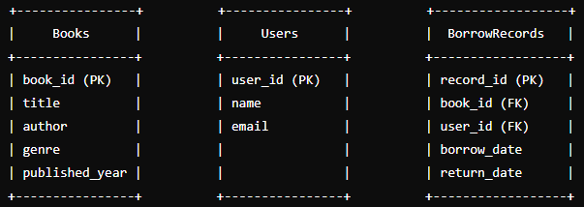

***Task 01:*** Create migration, and insert fake data by using factory or seeder at least 10 records for each table. [10pts]

***Task 02:*** Create endpoint for processing the data such as CREATE, READ, UPDATE and DELETE specific table:

* Books [10pts]
* Users [10pts]

***Task 03:*** Create endpoint for display the list of books that a user has borrowed. [10pts]

***Task 04:*** Create endpoint for display the users and books given by borrow date. [10pts]