1. Install Virtualbox/ VM ware workstation with different flavors of linux or windows OS on top of windows 7 or 8

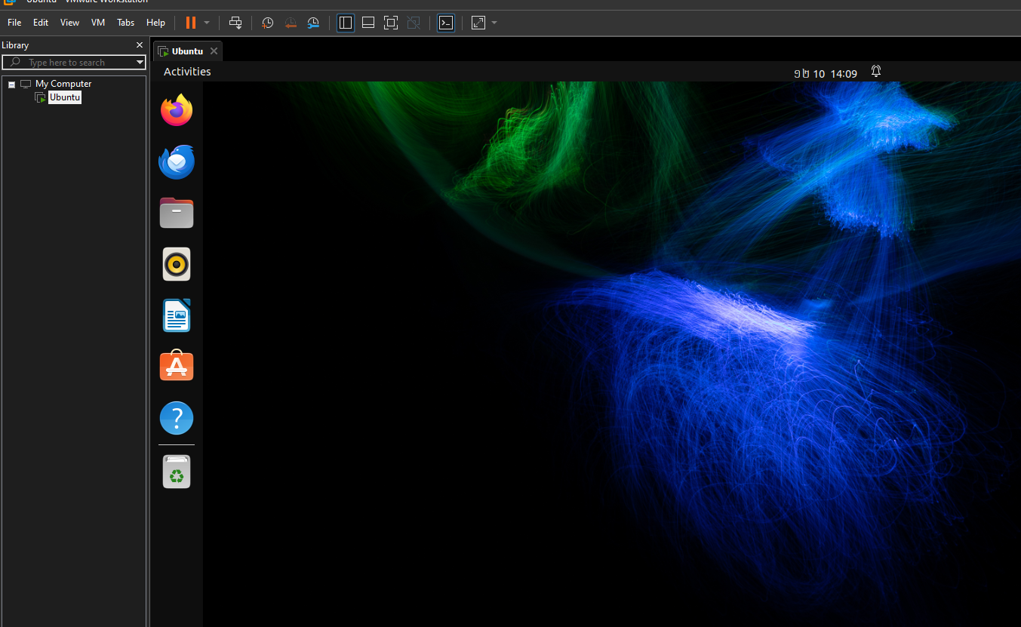

2. Install a C compiler in the virtual machine created using virtual box and execute simple programs

sudo apt update

sudo apt install build-essential

gcc hello.c -o hello.exe

hello.exe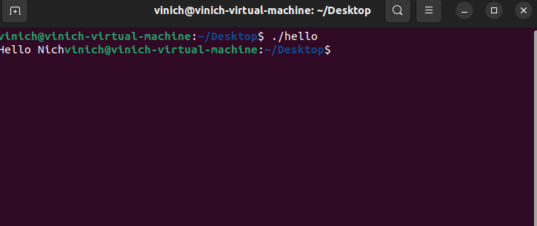

3.Install Google App Engine. Create ***hello Name*** app and other simple web applications using python/java

gcloud init

gcloud app create



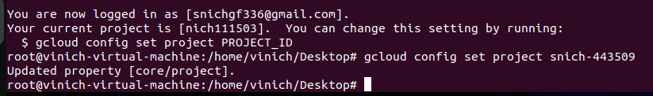

3.Use GAE launch the web applications

gcloud app deploygcloud app browse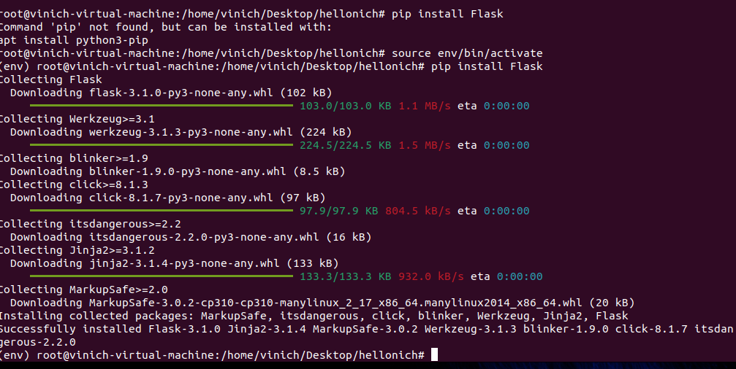

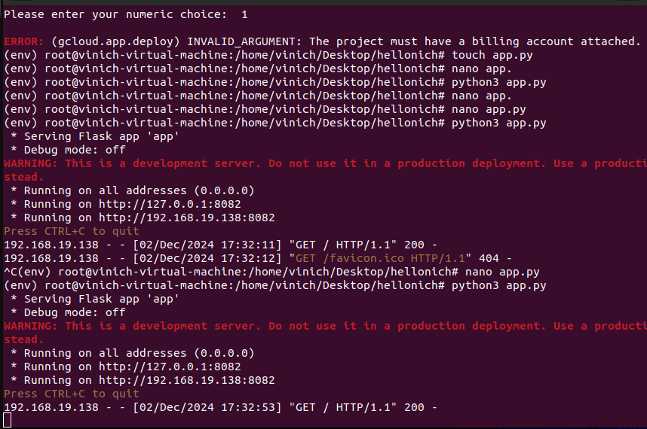

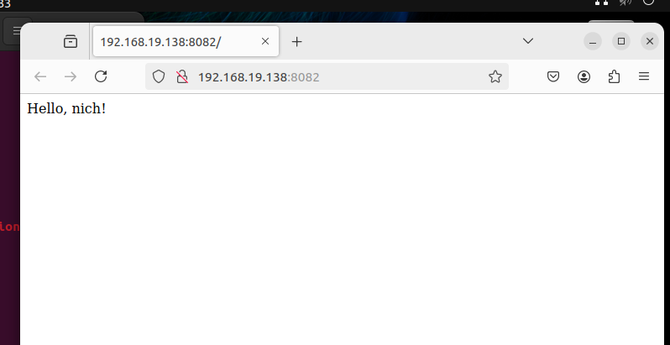

4.Simulate a cloud scenario using Cloudsim and run a scheduling algorithm that is not presenting Cloudsim 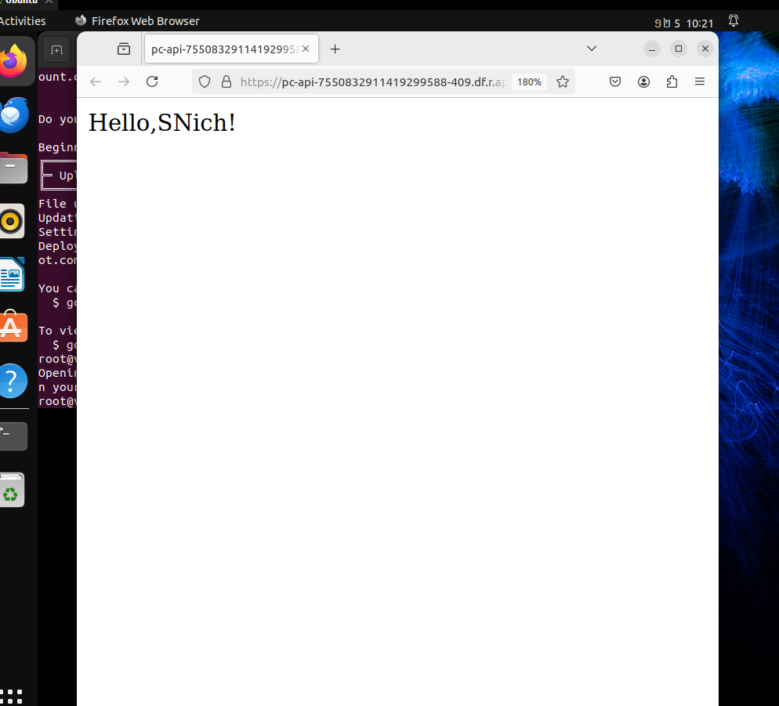

5.Simulate a Cloud Scenario Using CloudSim

