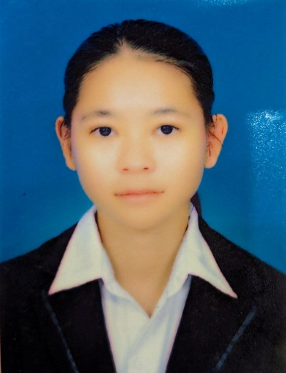

LONG SREYNICH

HELP Research Support Team

2018 - 2021

**High School**

Graduated from Thmor Kol High School

2021 - Present

**University**

Bachalar Degree of Information Technology at National University of Battambang junior

**EDUCATION**



**HARD SKILLS**

* Firebase
* REST APIs
* Laravel
* Basic Website
* Mobile Development (flutter)
* Graphic Design
* Computer Repairing

**SHORT COURSES**

**Computer Training Assistant**

* Volunteered at the Future Leader Center for three months. From december 2, 2023, to Februry 2, 2024, for the Weekend session.

**Completed level 3 English Course at COERR**

* Completed COERR's Level 5 English Course, gaining advanced proficiency, mastering technical grammar, and enhancing communication skills crucial for effective IT collaboration and expression.

**HOBBIE**

* Self Learning:

I always research something new to learn more

* Drawing:

I like to draw any object in 3D

**SOFT SKILLS**

* Socaible
* Teamwork
* Flexibility
* Problem Solving
* Commitment



+855 88 963 6404



Phum Rom Chek Pir, Krong Battambang

Longsreynich231@gmail.com

: Mother Tongue

**KHMER**

: Good

**ENGLISH**

**LANGUAGE**

**PERSONAL INFO**

**Gender**

**Status**

**Date of Birth**

**Place of Birth**

: Female

: Single

: 15 - 11 - 2004

:

Chrorneang Village, Kokmom Commune, Thmor Kol District, Battambang Province

**CONTACT**

**HEIP Research Support Team  
National University of Battambang**

**Dear Mr. Hum Chan,**

I am writing to express my interest in the Mobile Developer Internship under the HEIP Research Proposal program. As a junior mobile developer with a focus on Flutter, I have built several impactful applications, including a rental room app and a weather app, utilizing Flutter and Firebase to deliver efficient, user-friendly solutions.

In my recent Flutter Developer Internship at NUBB, I had the opportunity to lead a team in developing a full-stack lab booking system. This experience sharpened my skills in project management, teamwork, and problem-solving. Along with my academic background in Information Technology, I believe I am well-positioned to contribute effectively to your research initiatives.

I am excited about the opportunity to apply my skills and passion for innovation to your program, and I look forward to discussing how my experience aligns with your goals. Thank you for considering my application.

**Sincerely,  
Ms. Long Sreynich**