Potential effects of flow modifications on long term pallid sturgeon population dynamics in the Missouri River below Fort Peck Dam.

Prepared by

Sara A. Reynolds and Michael E. Colvin

A Draft Report For Discussion Purposes

Submitted to the U.S. Army Corps of Engineers

19 September 2019

Revised 3 October 2019

# Executive summary

This report describes population model analyses done in support of the evaluation of management actions for pallid sturgeon on the Upper Missouri River, from Fort Peck Dam to Lake Sakakawea, using a deterministic population projection matrix. The particular management actions of focus were alternative flow release protocols from Fort Peck Dam. Seven alternative scenarios were considered: No action, Alternative 1, Alternative 1a, Alternative 1b, Alternative 2, Alternative 2a, and Alternative 2b. Additionally, potential effects of temperature are explored. Alternative scenarios were compared in terms of their ability to be fully implemented throughout the period of record (1930-2012), estimated effects on drifting free-embryo retention, and associated long-term growth rates. Sensitivity and elasticity analyses were conducted to evaluate the effects of parameter values, including uncertainties in age-0 survival and probability of spawning in the Missouri River, on long-term population growth rate. Limitations and uncertainties in the modeling, including the availability of information to parameterize the population model, are discussed. Important future directions for the population model, such as incorporating fish passage at Intake in the Yellowstone, are also introduced.

# Introduction

There has been no documented recruitment of natural origin pallid sturgeon in the Missouri River below Fort Peck dam. It is hypothesized that flows and water temperature, when combined with the length of free-flowing river below Fort Peck dam, particularly limit the likelihood that any naturally produced age-0 pallid sturgeon are retained in lotic habitat (Jacobson et al. 2016; Jacobson et al. 2015). Instead free embryos, if produced, drift into unsuitable foraging and rearing conditions in Lake Sakakawea. Science and Adaptive Management Plan (SAMP) hypotheses H3 and H5 postulate that Fort Peck Dam management operations associated with decreased flows and increased water temperatures will decrease drift into Lake Sakakawea, increasing retention in lotic habitat (Fischenich et al. 2018). Alternative flows out of Fort Peck Dam were proposed and evaluated for the potential of drifting free embryos to be retained in lotic habitat given simulated hydraulic and temperature dynamics. Specifically, this analysis simulates the potential response in long term pallid sturgeon population dynamics for 7 alternative hydrographs for flows originating from Fort Peck by linking the probability a free-drifting pallid sturgeon is retained in the Missouri River below Fort Peck Dam and above the headwaters of Lake Sakakawea to potential natural recruitment. The objectives of this analysis were to 1) couple simulated retention probabilities generated by a hydraulic model with the population model, 2) project long term growth rate for a population of pallid sturgeon occupying the Missouri River below Fort Peck Dam, and 3) evaluate 7 alternative hydrographs for Fort Peck in relation to long term population growth.

# Caveats for this report

The results of this report rely on outputs from hydrologic simulations for each of the 7 flow alternatives evaluated, as well as a free-embryo development model. Results of this analysis may change if issues with the underlying hydraulic simulations are found or improvements to the development model are made, and therefore, this report will require updated analysis under these circumstances. The details and results of hydraulic and developmental modeling will be provided in a separate report by Dr. Craig Fischenich.

The population model used to

# Methods

## Modeling Framework Spatial Extent

Seven alternative management scenarios at Fort Peck Dam were considered. Details of the management scenarios: No action, Alternative 1, Alternative 1a, Alternative 1b, Alternative 2, Alternative 2a, and Alternative 2b, are described in a report provided by Craig Fischenich. Alternative management scenarios were only analyzed during years in which they met alternative-specific flow criteria. Flow criteria was two-fold: (1) environmental conditions needed to be such that the given alternative hydrograph could be produced (e.g., enough water available for release), and (2) discharge needed to reach a magnitude greater than 20kcfs is sufficient to produce a spawning cue. For each alternative management scenario and year combination that met flow criteria, long-term population growth rate () was estimated for the population of pallid sturgeon residing within the Upper Missouri River from Fort Peck Dam to Garrison Dam, including the Yellowstone River up to the Intake Diversion Dam (Figure 1). The modeling framework used to calculate long-term population growth relied upon several models, including hydrological modeling in Hydraulic Engineering Center Reservoir system Simulation Model (HEC-ResSim), a spawning model, Hydraulic Engineering Center River Analysis System (HEC-RAS) drift-dispersion modelling coupled with a free-embryo development model, and a pallid sturgeon demographic population model (Figure 2).

## Hydrology, Drift, Development, and Probability of Retention

Hydrological data were generated using HEC-ResSim software implemented for the Missouri River reach between Fort Peck Dam and Lake Sakakawea (see report by Craig Fischenich for HEC-ResSim modeling details). All hydrological runs used for this analysis used historical runoff from the period of record of 1930 to 2012. Reservoir operations were modeled for each alternative scenario assuming the same operation rules were in effect for all years. For each alternative management scenario and year combination that met flow criteria, the probability that a free-embryo develops to a size suitable for settlement prior to reaching the unfavorable conditions of Lake Sakakawea (retention probability) was estimated. The probability of free-embryo retention within the free-flowing Missouri River was computed by integrating a temperature dependent free-embryo development model into HEC-RAS drift simulations, assuming spawning occurs just below Fort Peck dam. The details of the modeling are described in the complementary report by Craig Fischenich. Outputs from this modelling provided summary information about development and retention over time, from which the retention probability could be estimated as detailed below.

The outputs the seven hydrographs evaluated by HEC-RAS were analyzed and coupled to a a pallid sturgeon demographic matrix model in R (R Development Core Team 2010). Outputs from HEC-RES were summarized for each year the given alternative scenario produced the desired hydrograph with a spawning cue discharge greater than 20kcfs (i.e. met flow criteria). The summary information included the amount of cumulative thermal units (CTUs) expected to be absorbed by the free-embryos and the percentage of free-embryos retained in the free-flowing Missouri River at 3 hours intervals. A threshold value of 200 CTUs was assumed to indicate transition of an age-0 pallid sturgeon from drift to settlement (Braaten et al. 2012) . The time interval during which the threshold CTU value was surpassed and estimated the retention probability from was identified from the HEC-RAS outputs. The probability of retention for the year and alternative scenario under consideration, was then computed by interpolation, using the CTU and retention data from the endpoints of the identified interval:

, (1)

where

 is the retention probability for the year and alternative scenario under consideration,

 is the estimated cumulative thermal units absorbed by a drifting free-embryo at time ,

 is the estimated percentage of free-embryos that have been retained in the free-flowing Missouri River at time ,

 is the discrete HEC-RAS time in hours of drift that is associated with the largest CTU value that is less than or equal to 200 CTUs, and

 is the discrete HEC-RAS time in hours of drift that is associated with the smallest CTU value that is greater than 200 (3 hours after ).

In other words, the probability of being retained in the Missouri River below Fort Peck Dam was a function of drift and development time such that pallid sturgeon experiencing slower drift and higher temperatures were more likely to be retained in the Missouri River before reaching the headwaters of Lake Sakakawea.

## Hydrology and Spawning Probability

The probability a reproductively-ready female spawns within the Missouri River instead of spawning in the Yellowstone River or not spawning (atresia) (hereafter referred to as spawning probability) was determined by a spawning model. While there are hypotheses on what factors effect spawning probability, the functional relationship is largely uncertain. The functional relationship used here assumes that if a reproductively ready pallid sturgeon experiences a sufficiently high discharge and temperature conditions are sufficient, then those fish will form spawning aggregation below Fort Peck Dam. As a first approach, the probability a reproductively-ready female spawns in the Missouri River () was modeled in terms of discharge and temperature as a multi-variate step function:

 (2)

where

 is the maximum discharge during April to May in kcfs,

 is the threshold discharge needed to attract and retain spawners up the Missouri River to the vicinity of Fort Peck Dam (in kcfs),

 is the maximum temperature reached below Fort Peck Dam during the end of May to the beginning of July in degrees Celsius,

 is the threshold temperature required for spawning in degrees Celsius,

 is the probability that a reproductively-ready female will spawn in the Missouri River below Fort Peck Dam given favorable flow and temperature conditions, and

 is the probability that a reproductively-ready female will spawn in the Missouri River below Fort Peck Dam given unfavorable conditions.

Baseline values for , , , and  were based on observed cases of female spawning migrations up the Missouri River above the confluence with the Yellowstone (Fuller and Haddix 2013), as well as other spawning data related to temperature (DeLonay et al. 2016b) (Table 1). Outputs from HEC-ResSim provide values for . Since alternative management scenarios were only analyzed in HEC-RAS for years in which they could be implemented and the spawning cue discharge exceeded ,  for the management scenario and year combinations that met flow criteria given . As a first approach, temperature was assumed to exceed its threshold criteria of  during each year a management scenario met flow criteria.

## Demographic Population Model

The demographic pallid sturgeon population model used to calculate long term population growth rate was a prebreeding Leslie matrix model:

 (3)

with

 (4)

where

 is a vector of population sizes by age-class in year ,

 is a Leslie matrix,

 is the expected fertility value of an age- female pallid sturgeon,

 is the probability that a female survives from age- to age-, and

 is the maximum age of a female fish.

Age-specific fertility values are a function of the probability of free-embryo retention () and the probability a reproductively-ready female spawns in the Missouri River () and vary by management alternatives (Figure 2). Details of the model parameterization are described in the following three sections with baseline parameter values listed in Table 1.

### Maximum Age

The baseline maximum age of a female pallid sturgeon was taken to be 60 years old. Braaten et al. (2015) estimated the ages of 11 deceased natural-origin pallid sturgeon from the Upper Missouri River. They determined longevity to be at least 50 years, with individual estimates varying from 37-59 years old.

### Age-Specific Survivals

Age-specific survivals were estimated for pallid sturgeon ages 1 through 9 years old using estimates in Rotella (2017). Survival estimates for this analysis were limited to fingerlings released in RPMA 2 in the Missouri River without fin curl or iridovirus. Fingerlings, released into the river at about 3 months old, were used to estimate age-specific survival with the expectation that having 9 months to acclimate to river conditions would allow for a better estimate of natural age-1 to age-2 survival than yearlings released into the river much closer to their first birthday. Data tables provided in Rotella (2017) for each cohort of fingerlings released into the Missouri River and contained information on the estimated number of fish at the start and end of several consecutive interval after release. Interval periods were not necessarily equal in length, but start and end dates were provided in the tables. Therefore, for each healthy cohort of fingerlings released, we calculated daily survivals from the data provided in the tables as

. (5)

We then used cohort-specific interval daily survivals to compute cohort-specific survivals from age-class to age-class, assuming all fish were born on June 1st. The weighted average of cohort-specific annual survivals was used as an estimated for the age-specific annual survivals:

, (6)

where

 is the age- survival probability for ages ,

 is the probability that a fish in cohort  survives from age- to age-,

 is the expected number of age  fish in cohort  on June 1st, and

 is the set of all healthy cohorts (no iridovirus or fin curl) released into the Missouri River within RPMA 2 as fingerlings.

Adult annual survival () was computed from RPMA 2 wild adult population estimates in 2004 and 2008 (Jaeger et al. 2009; Klungle and Baxter 2005) as

, (7)

and set as the survival probability of all females age-15 and older. Survival probabilities for age-10 to age-14 pallid sturgeon were extrapolated from the probabilities calculated for younger and older fish (Figure 3, Table 1).

### Age-Specific Fertilities

Age-specific fertility values () were broken down into several components:

, (8)

where

 is the proportion of age- females that are reproductively ready to spawn,

 is the fraction of reproductively-ready females that spawn in the Missouri River, often referred to as Missouri River spawning probability or spawning probability,

 is the number of eggs per spawning age- female,

 is the sex ratio (fraction of the eggs that are female),

 is the survival from egg to age-1 given retention within the free-flowing Missouri River, often referred to simply as age-0 survival, and

 is the probability a drifting free-embryo is retained in the free-flowing Missouri River.

Only age-0 survival is considered for those fish retained in the free-flowing Missouri River () because it is assumed that survival in the anoxic conditions of Lake Sakakawea is zero (Guy et al. 2015). For the baseline analysis estimating current conditions, it is assumed that retention probability is 1 in 1,000 and spawning in the Missouri River occurs about once every 100 years (Table 1). Both the retention probability () and the probability a reproductively-ready female spawns within the Missouri River () were assumed to be influenced by temperature and flow. Therefore, they vary with environmental conditions, as well as choice of management action. For the Fort Peck alternative hydrograph analyses,  and  were estimated as outputs of the drift-development and spawning models, respectively, given the particular management alternative scenario and hydrology. The remaining parameter values (, , , and ) were fixed among scenarios, and described below.

### Sex Ratio and Age-0 Survival

The probability a fish is female () and the probability of surviving from egg to age-1 given retention in the Missouri River () are constants, independent of the mother's age. The baseline sex ratio  was computed from a 2008 Upper River (RPMA 2) estimate of 125 wild adults and 40 wild female adults (Jaeger et al. 2009), as

, (9)

but this value is likely higher if hatchery origin pallid sturgeon are included, however at this time, hatchery origin pallid sturgeon have not reached sexual maturity in this section of the Missouri River. Missouri River age-0 survival is uncertain. We set baseline Missouri River age-0 survival at a small probability of 75 in 1,000,000 or . We further examine the sensitivity of model outcomes to changes in  to evaluate the potential effect of this uncertainty on long term population growth. Additionally, Missouri River age-0 survival likely varies with turbidity, and is an area of future consideration for linking management actions to population outcomes and not included in this analysis. The probability a female is reproductively ready to spawn () and the expected number of eggs released per spawning female () are age-specific quantities. Their baseline values were determined using multiple steps, as described first for  and then for  below.

### Probability a Female is Reproductively Ready ()

The proportion of age- females that are reproductively ready is a function of maturation and spawning period:

, (10)

with

, (11)

where

 is the proportion of age- females that are reproductively ready to spawn,

 is the proportion of age- females that just matured, i.e., the probability that the first time a female is reproductively ready to spawn is when she is age-,

 is the probability that the period between being reproductively ready is  years,

 is the minimum age at which a female matures, and

 is the maximum age of a female fish.

The maturation age of female pallid sturgeon has not been well studied and is an area of further informational need (DeLonay et al. 2016b). Age of maturation could also vary by region of the river (George et al. 2012) with observations from the Upper Missouri River suggesting that female pallid sturgeon mature later than those in the Lower Missouri and Mississippi Rivers (M. Webb, USFWS, personal communication). The available published data involves only a few fish from the Lower Missouri and Mississippi Rivers. These females were estimated to have matured between the ages of 8 and 20 years old (George et al. 2012; Keenlyne and Jenkins 1993). Aging of the fish was typically performed by pectoral fin ray analysis, a method that can suffer from low accuracy and precision (Hurley et al. 2004), so there may be some unaccounted for uncertainty due to ageing error.

We used a logistic cumulative distribution model to describe maturation of females with age:

 (12)

where

 is the proportion of age- females that have reached maturity,

 is the age at which half of all females are mature,

 is a scaling parameter that controls the variance of the distribution, and

 is age.

To account for later maturation ages in Upper River females, we assumed that 50% of female pallid sturgeon reach maturity by age 15 (), 5 years later than the expected value used by Wildhaber et al. (2015) for Lower Missouri River females. We also assumed  (corresponding to approximately 5 years representing 3 standard deviations). We converted this unbounded, continuous cumulative maturation distribution to a discrete probability distribution bounded between the ages of 8 and 21 (Figure 4), as follows:

, (13)

where

 is the minimum age at which a female matures,

 is the maximum age at which a female matures, and

 is the cumulative distribution described in equation 12.

The spawning period (i.e., the number of years that pass between two consecutive spawning events) of female pallid sturgeon is likely 2-5 years (DeLonay et al. 2016a), although it has been estimated to be as great as 10 years in past studies using spawning bands (Dryer and Sandvol 1993; Keenlyne and Jenkins 1993). Fuller et al. (2008) and DeLonay et al. (2016a) assessed the reproductive-readiness of 28 female pallid sturgeon. Their data shows that all 28 females had a spawning period greater than 1 year (). Additionally, 8 females had a confirmed spawning period of 2 years with 13 others confirmed as having a spawning period greater than 2 years (). Of the 13 females whose spawning period was greater than 2 years, only the fates of 5 were known beyond this point: 3 females had a confirmed spawning period of 3 years and 2 females had a confirmed spawning period that was greater than 3 years (). Under the following additional assumptions:

1. the maximum reproductively ready period of a female is 5 years, and
2. a female is approximately twice as likely to have a reproductively ready period of 4 years as she is 5 years,

the probabilities from the confirmed data lead to the following distribution for female reproductive-readiness period:

. (14)

With this baseline distribution a female is expected to be reproductively ready, on average, every 2.95 years.

This first approach at generating a probability distribution for years between reproductive readiness was generated from a small data set and must be treated with some caution. While much information could be learned from the combined data of Fuller et al. (2008) and DeLonay et al. (2016a), the exact reproductive readiness period was unknown for 17 of the 28 females. Additionally, our model assumes the amount of time that passes between being reproductively ready is independent of whether a reproductively ready female spawns or reabsorbs her eggs. If it is expected that females to be reabsorbing their eggs is a frequent occurrence, then it may be important to modify how age-specific fertilities are computed.

The baseline parameterization for the age-specific probability that a female is reproductively ready to spawn was computed from equations 13 and 14 with , , , and . No females were reproductively ready until age 8, at which point a very small fraction of the population matures. The fraction of females that are reproductively-ready to spawn increases between ages 8 and 21, sharply at first and then more slowly, leveling out to approximately a third of all age-22+ females being ready to spawn during any given year (Figure 5).

### Expected Number of Eggs ()

The expected number of eggs released by an age- female was determined from the composition of a probabilistic age-length (growth) relationship and a probabilistic length-fecundity relationship. In the case that  (minimum age at maturation), all females of age  have not reached maturity and . In the case of age-classes that could contain mature fish, the general approach was:

1. For each age  (minimum age at maturation) randomly generate 1,000,000 sets of individual von Bertalanffy growth parameters and age-1 lengths from specified distributions and use in the growth model to compute 1,000,000 lengths at age-;
2. For each of the one million lengths, randomly generate the number of eggs produced from a probabilistic length-fecundity relationship;
3. Compute the mean number of eggs produced (across the one million fecundities) and use this as the value for .

In the first step, von Bertalanffy growth parameters for asymptotic length, , and the Brody growth coefficient, , were drawn from a bivariate lognormal distribution:

, (15)

which was truncated to its 90% confidence ellipse. Length at age-1 () was drawn from a truncated normal distribution with a mean value of 200mm and standard deviation of 35mm that was bounded between 50 and 350 mm:

. (16)

The set of randomly drawn parameters , was then used to compute length at age  from a Faben's growth model (derived from von Bertalanffy growth equation) (Smith et al. 1997):

. (17)

Values for the length at age-1 distribution were chosen to roughly approximate observed sizes of age-1 fish. Values for the mean and covariance matrix,

, (18)

which was estimated by fitting equation 17 to individual fish recaptured as part of any monitoring done (e.g., population assessment) in the Missouri River below Fort Peck Dam using a Bayesian approach to account for parameter correlation (M. Colvin unpublished data). We used this process as a first approach for a length-age relationship. Improvements to this approach that account for more recent data and expected correlations between individual length at age-1 and individual growth parameters are recommended as future work.

In the second step, mean fecundity was assumed to be an exponential function of fork length with a negative binomial error distribution. The fecundity value for a given length, , was randomly drawn from a Poisson distribution:

, (19)

with mean value  being drawn from a lognormal distribution to account for overdispersion observed in actual Upper River length-fecundity data:

, (20)

where , , and  were fit in R using a generalized linear mixed effect model (glmer) with a Poisson distribution, log link, and random effects error term, and

 (21)

is a normalization of length (based on the mean and standard deviation of the length data) to aid in the convergence of the model fit. Baseline parameter estimates:

 (22)

were obtained by fitting the model to 25 data points from 24 Upper River female pallid sturgeon.

In the last step, the arithmetic mean value was taken over all fecundity values generated for a given age, resulting in a number of eggs released per spawning female that increases with age (Figure 6).

## Population Model Analyses

### Long-Term Population Growth Rate

Model parameter baseline values (Table 1) were first used to compute a baseline long-term growth rate. Additionally, long-term growth rates were computed for each year a particular alternative Fort Peck flow scenario could be implemented and produce a spawning cue greater than 20kcfs. Retention probability () varied by scenario-year combination and was set to the values computed from the HEC-RAS outputs. As each of these years were expected to cue spawning, the probability that a reproductively-ready female would spawn in the Missouri River () was increased from its baseline value of 0.01 to . At its simplest, this formulation assumes half of the reproductively-ready females spawn in the Missouri River while the other half spawn in the Yellowstone River (given no atresia).

### Sensitivity and Elasticity Analyses

Single entry sensitivity and elasticity analyses were performed using the demogR function in R. As each fertility entry was composed of several components, single variable sensitivity and elasticity values were further computed for the individual parameters that comprised the age-specific fertilities. Sensitivities for age-specific parameters  and  were computed as

, (23)

where

 is the sensitivity of , the age-specific parameter of interest,

 is the sensitivity value for the age- fertility entry,

 is the partial derivative of the fertility entry for age- females with respect to the ,

 is either  or  for a fixed age-, and

 is an admissible age (1 through ).

The parameters , , , and  effect the fertility values across age classes, and therefore, sensitivities for these parameters were computed as

, (24)

where

 is the sensitivity of , the parameter of interest,

 is the sensitivity value for the age- fertility entry,

 is the partial derivative of the fertility entry for age- females with respect to , the parameter of interest, and  is one of , , , or .

Sensitivities express changes in long-term growth rate () in terms of a unit change of a parameter value, while elasticities express changes in the long-term growth rate in relative terms. This can be an additional useful comparison. For example, it is not hard to imagine a female's fecundity increasing by one egg; however, it is impossible for age-0 survival to increase by a whole unit. Instead of unit comparisons, elasticities allow for percentage comparisons—for example, comparing the impact on  of doubling each parameter (while holding the others constant). Parameter elasticities were computed from parameter sensitivities as

, (25)

where

 is the elasticity of , the parameter of interest,

 is the sensitivity of ,

 is the baseline value for the parameter of interest, and

 is the baseline long-term growth rate.

### Long-Term Growth Decline Boundaries

Long-term growth-decline boundaries were computed for the three parameters expected to be effected by management actions: the probability a drifting free-embryo is retained in the free-flowing Missouri River (), the probability a reproductively-ready female spawns in the Missouri River (), and the probability of survival from egg to age-1 given retention in the free-flowing Missouri River (). Management actions that are expected to affect age-0 survival (e.g., turbidity manipulations) have not been considered here and remain for future work.

Age-0 survival is highly uncertain. Considering outcomes across a range of age-0 survival can reveal how important it is to have a good understanding of this parameter value. With the exception of , , and , which were treated as variables (i.e., can vary in value), all other parameters were fixed at their baseline values (Table 1). As , , and  are always found within the model as a product, we first considered the growth-decline boundary of a single variable, . The characteristic equation written in terms of  is described by its associated Euler-Lotka equation. Substituting the baseline values for , , , and  into the Euler-Lotka equation for the Leslie matrix, we obtain a version of the characteristic equation in terms of  and .

If  solves the characteristic equation for a fixed value of , then  is an eigenvalue of the Leslie matrix with the given parameterization. The largest (leading) eigenvalue is the long-term growth rate, and the growth-decline boundary occurs when the largest eigenvalue equals 1 (representing a stable population that is neither growing nor declining). Setting , we solve for  finding that 1 (i.e., a stable population) is an eigenvalue of the population model when . A quick check reveals that, for the computed value of  is in fact the leading eigenvalue of the parameterized Leslie matrix, i.e. . Therefore,  approximates the growth-decline boundary as a surface in 3-dimensional space. To visualize this surface, we consider the contour curves resulting at fixed retention probability () values. Retention probabilities were fixed, either to evenly spaced values between 0 and 1 or at those values computed by HEC-RAS for particular year and flow scenario combinations. Growth-decline curves at the fixed  values were plotted in - space.

### Powerhouse Operations

The population-level impact of utilizing different powerhouse operation strategies was also considered with respect to flows observed in 1985. Except the No Action alternative, which did not meet the 20kcfs spawning cue threshold in 1985, each alternative scenario was implemented using 3 different powerhouse operation strategies: full, standard, and peak times. Full powerhouse operations assume 14kcfs are run through the powerhouse 24 hours a day. During standard powerhouse operations 14kcfs are run through the powerhouse for 12 hours a day with 7kcfs running through the powerhouse the remaining 12 hours. The peak time strategy assumes 7kcfs are regularly run through the powerhouse except during peak times when powerhouse operations switch to running 14kcfs.

# Results

## Baseline Long-Term Growth Rate, Sensitivities, and Elasticities

For the baseline parameterization of the model (Table 1), the long-term growth rate is . With low baseline values for spawning probability, drifting free-embryo retention, and Missouri River age-0 survival, the population is expected to decline, on average, at about 23% per year.

The most sensitive Leslie matrix entries in the model (i.e., the entries for which a unit change in value is expected to have the largest impact on the long-term growth rate) are the fertility values of the largest (i.e., older) fish (, , etc.). Increasing the number of age-1 recruits that are offspring from the oldest fish will have the greatest effect on the long-term growth rate. Increased fecundity for older fish, increased probability of spawning in the Missouri River when reproductively ready, increased free-embryo retention, and increased Missouri River age-0 survival would all increase the number of age-1 recruits. Of these, the model is most sensitive to the smallest baseline parameters: survival from egg to age-1, followed by retention probability and Missouri River spawning probability (Table 2). In relative terms, the highest elasticity value, when rounded to the nearest 6 decimal places, was shared by several parameters: the top 3 most sensitive parameters (, , and ), the sex ratio (), survival probabilities for immature female sturgeon ( to ), and survival probabilities of young, potentially mature female sturgeon (--).

As the elasticity analysis shows, survival of young fish is important to the outcomes of the population model. However, it is important to acknowledge the limitations inherent in increasing survival or any other probability. For example, age-1 survival can at most be increased from 0.64 to 1, or by 56.25% (within biological constraints this number should be smaller). Missouri River age-0 survival, on the other hand, could be increased by 1,000-fold and still would be a valid survival probability (0.075). Mathematically, there is a lot of potential for influencing the population growth rate by making efforts to increase these smaller probabilities with high elasticities, such as age-0 survival, given a large percentage increase is biologically feasible.

### Long-Term Growth Decline Boundaries

The effects that varying Missouri River age-0 survival (), retention probability (), and Missouri River spawning probability given reproductive readiness () are summarized in Figure 7. The choice to manipulate these three variables while holding all others fixed stems both from their relationships to management actions, as well as their expected impacts on long-term growth rate. Management actions related to flows out of Fort Peck Dam will effect discharge and temperature values in the Missouri River, especially those immediately below the dam. In conjunction with the given environmental conditions, this will influence retention probability and the probability a reproductively ready fish spawns in the Missouri River below the dam. Additionally, we expect to see decreasing egg and free-embryo mortality due to predation given increased turbidity below the dam. If management actions are taken to manipulate turbidity, this is expected to effect age-0 survival. All three of the parameters expected to be influenced by alternative hydrographs (, , and ) also were shown to have high sensitivity and elasticity values. As such, increasing these values is expected to have a disproportionate effect on the long-term growth rate when compared with similar increases in other parameters.

The contour curves of Figure 7 represent the boundary value of  for varying levels of retention probabilities (constant across a curve), spawning probabilities, and age-0 survival probabilities. At a long-term growth-rate of  the pallid sturgeon population is neither growing nor declining. Therefore, each curve divides spawning and age-0 survival space (- space) into regions of population decline (below and to the left of the curve) and population growth (above and to the right of the curve) for a fixed retention probability, . For example, if management actions coupled with environmental and hydrological conditions are able to:

1. increase retention probability to 20% and
2. increase the probability a reproductively ready female spawns in the Missouri River below the dam to 0.5,

then given a baseline Missouri River age-0 survival of 75 out of a million, the population growth rate (will increase from baseline  but) is still expected to show an overall declining trend (Figure 8 Panel A, red dot). However, if management actions also influence turbidity, increasing age-0 survival to 25 out of 10,000, then the population is expected to increase in the long-term (Figure 8 Panel A, blue dot). Pine et al. (2001) used an upper estimate of 4 out of 10,000 for age-0 survival of a gulf sturgeon population. Assuming a similar upper estimate for pallid sturgeon age-0 survival (i.e., ), long-term population growth is not expected if the probability of spawning in the Missouri River is less than 0.75 and free-embryo retention probability is at 20% (Figure 8 Panel A, dashed line). If retention probabilities can be further increased to 70%, then population growth would be possible at an age-0 survival value of 0.0004 but only for high spawning probabilities (Figure 8 Panel B, dashed line).

## Fort Peck Alternative Hydrographs

### Long-Term Growth Rates by year

Long-term growth rates (-values) computed from the population model using retention probability inputs from HEC-RAS simulations, a spawning probability of 0.5, and median water temperature conditions varied by management alternative scenario and year (Table 3). Warmer temperatures promote faster development of free-embryos, leading to higher retention probabilities and long-term growth rates. Long-term growth rates () were higher by an average of 0.0063 when temperatures were assumed to be at their upper (95% confidence limit and were lower by an average of 0.0074 when temperatures were assumed to be at their lower 95% confidence limit (Table 4). One year and flow scenario combination, Alternative 1a in 1968, did not follow the general trend (lower long-term growth rate at lower temperatures). Long-term growth rates were nearly the same under median and low water temperatures, with the low water temperatures associated with a  value that was 0.0001 greater than at median temperatures. This slight difference can be attributed to differences in retention probabilities. In 1968 simulations for Alternative 1a, low water temperatures had a slightly higher retention probability than median water temperatures---a difference that is opposite the general trend but can potentially be attributed to non-linearities not accounted for when computing retention probabilities via linear interpolation.

The optimal scenario (i.e., the alternative management flow scenario that produced the maximum long-term growth rate[1]) varied by year and, in some years, by water temperature (Table 5). With the exception of the No Action scenario, all other alternative hydrographs were ranked optimal scenario for at least 3 combinations of year and water temperature in terms of long term population growth. Alternatives 1a and 2 were ranked as the top scenario the fewest numbers of times (Table 5). Alternative 2b was ranked as the top scenario the greatest number of times at 23, or over half of all the temperature and year combinations. While the No Alternative scenario met the flow criteria in 2 out of the 83 years, the long-term growth rate associated with this scenario at all water temperatures was smaller than those computed for all other viable alternative scenarios at the same water temperature.

### Across the Period of Record

Due to environmental conditions and likely other considerations it is not possible to produce the desired hydrograph every year. Additionally, there are some years in which the shape of the desired hydrograph can be achieved, but the magnitude of the peak flows does not surpass 20kcfs, the threshold discharge assumed to cue spawning. The number of years in which a hydrograph with a discharge that surpasses 20kcfs could have been produced throughout the period of record (1930-2012) varies by alternative management scenarios (Table 6). The No Action scenario was the least likely to cue a spawning event, meeting the assumed flow criteria in only 2 of the 83 years on record. Alternative 2 was the most likely to cue a spawning event, meeting the flow criteria in 12 out of 83 years.

Trade-offs can be expected if one alternative is very beneficial to the population (e.g., high long-term growth rate) but can only be implemented rarely. To understand how a fixed alternative strategy would perform across the period of record, average long-term growth rate values were taken. During years in which a hydrograph could not be implemented or did not have peak flows that surpassed 20kcfs (i.e., did not meet flow criteria), it was assumed that no spawning occurred. The long-term growth rate under no spawning conditions will remain less than 1. To account for the reduced population growth rates that would occur during years with no recruitment, we used the minimum annual population growth rate when flow criteria was not met instead of the associated long-term growth rate. Without recruitment to age-1, the population growth rate for a single year would be equivalent to the weighted average of the age-specific survivals (weighted by the number of fish in each age class). The minimum annual growth rate would therefore be equal to the minimum survival rate, or .

Alternative 2b had the largest average long-term growth rate when long-term  values were averaged across all analyzed years for a particular alternative management scenario (Table 7). However, Alternative 2 had the largest period of record average—the growth rate when averaged across the period of record (1930-2012) using an annual growth rate of 0.64 for years in which the alternative scenario was not successfully implemented to cue spawning (did not meet flow criteria). While Alternative 2, had few years in which the long-term population growth rate was the maximum across scenarios (Table 5), it was able to be successfully implemented for more years than any other scenario (Table 6). If information is not available to provide an understanding of which management alternative scenarios can be implemented successfully in a given year, then this type of analysis can be used to evaluate which alternative hydrograph may be the best choice to account for uncertainties in environmental conditions. However, if criteria can be established to determine which management scenarios are options for a given a year, then an adaptive decision making approach could be used. Such an approach would produce a higher period of record average growth rate than any of those given in Table 7.

## Effects of Powerhouse Operations

In general  increases with lower powerhouse operations and higher temperatures (Figure 9). For most alternative hydrographs  does not vary whether the powerhouse is ran under standard or peak time conditions. There are a few exceptions to this result. Cases where switching from standard operation to peak time operations increased  can be seen at low water temperatures for Alternative 1a, at median water temperatures for Alternatives 2 and 2b, and high water temperatures for Alternative 2. Additionally, cases where switching from standard operation to peak time operations decreased  can be seen at median water temperatures for Alternatives 1b and 2a. Theses data only represents one year and these patterns may not be representative of the patterns seen in other years and should be interpreted with caution.

## Long-Term Growth-Decline Boundaries

There is variability in long term population growth among years within the alternative hydrographs (Figure 10). The variability among years can be used to highlight how robust an alternative might be to varying environmental conditions. For example, the space where  is greater than 1 is higher for Alternative 2a versus alternative 1 (i.e., more curves near the lower left hand corner of the graph). In other words, the more space that is above the concave lines the more possible combinations of spawning probability and age-0 survival result in a  of 1 or more. An alternative example is Alternative 2 where the contour lines illustrating the threshold for  is located throughout the possible parameter space for spawning probability and age-0 survival, suggesting a degree of uncertainty.

Similarly, evaluating among alternative hydrographs within year illustrates the potential performance of each alternatives for a range of spawning probabilities and age-0 survival (Figure 10). For example, in 1980 the differences among alternatives was high (i.e., contours distributed throughout the parameter space). Alternatively, contours were stacked closely together for 1987, indicating that each alternative hydrograph may perform similarly in terms of projected effect on long term population growth.

# Discussion

A population could have a long-term growth rate that is less than 1 (population decline), but it could still exhibit natural recruitment. The long term population growth rates presented in this analysis were less than 1, but the long term population growth rates should be viewed relative to each other for each alternative hydrograph. Analysis indicates that given the current understand of pallid sturgeon demographic rates used in this analysis the population may still be in decline but that does not imply that recruitment is not potentially occurring (i.e., low levels of recruitment can lead to decrease in long term population growth) but that there is likely other factors limiting age-0 survival that will need to be evaluated as well.

# Future analysis

Given additional time there are several analytical aspects that can be improved or built on to further inform the potential effect of alternative hydrographs on long term pallid sturgeon population dynamics below Fort Peck Dam in the Missouri River. Below is a partial list of future analyses being considered.

* Analyze a recruitment model to add to the metrics for evaluating alternative management scenarios.
* Improve how temperature is handled and related to  in each alternative scenario-year combination.
* The average  across the period of record analysis would likely be more informative for starting with a particular initial population and iterating through the population model over the period of record.
* Develop analysis to evaluate a similar period average for  analysis under adaptive decision-making (i.e., the optimal hydrograph depends on reservoir and temperature conditions).
* The model is sensitive to fertility values of older fish; these could potentially vary substantially as  likely varies more with age. Therefore some additional analysis to evaluate the effecs of this uncertainty on overall fertility values and incorporating that uncertainty to produce simulation envelopes and understand the range of potential outcomes.

# References

Braaten, P. J., and coauthors. 2015. Age estimations of wild pallid sturgeon (*Scaphirhynchus albus*, Forbes & Richardson 1905) based on pectoral fin spines, otoliths and bomb radiocarbon: Inferences on recruitment in the dam-fragmented Missouri River. Journal of Applied Ichthyology 31(5):821-829.

Braaten, P. J., and coauthors. 2012. An experimental test and models of drift and dispersal processes of pallid sturgeon (*Scaphirhynchus albus*) free embryos in the Missouri River. Environmental Biology of Fishes 93(3):377–392.

DeLonay, A. J., and coauthors. 2016a. Ecological requirements for pallid sturgeon reproduction and recruitment in the Missouri River: A synthesis of science, 2005-2012. U.S. Geological Survey, Scientific Investigations Report 2015-5145.

DeLonay, A. J., and coauthors. 2016b. Ecological requirements for pallid sturgeon reproduction and recruitment in the Missouri River: Annual report 2014. U.S. Geological Survey, Open-File Report 2016–1013.

Dryer, M. P., and A. J. Sandvol. 1993. Recovery Plan for the Pallid Sturgeon (*Scaphirhynchus albus*). U.S. Fish and Wildlife Service.

Fischenich, J. C., and coauthors. 2018. Science and Adaptive Management Plan. U.S. Army Corps of Engineer Research and Development Center.

Fuller, D. B., and T. Haddix. 2013. Examination of pallid sturgeon use, migrations and spawning in Milk River and Missouri River below Fort Peck Dam during 2013. Montana Fish, Wildlife and Parks, Fort Peck, Mont.

Fuller, D. B., M. E. Jaeger, and M. Webb. 2008. Spawning and associated movement patterns of pallid sturgeon in the lower Yellowstone River. Report submitted to the Western Area Power Administration, upper basin pallid sturgeon work group. Montana Fish, Wildlife and Parks.

George, S. G., W. T. Slack, and J. J. Hoover. 2012. A note on the fecundity of pallid sturgeon. Journal of Applied Ichthyology 28(4):512–515.

Guy, C. S., and coauthors. 2015. Broadening the regulated-river management paradigm: A case study of the forgotten dead zone hindering pallid sturgeon recovery. Fisheries 40(1):6–14.

Hurley, K. L., R. J. Sheehan, and R. C. Heidinger. 2004. Accuracy and Precision of Age Estimates for Pallid Sturgeon from Pectoral Fin Rays. North American Journal of Fisheries Management 24(2):715-718.

Jaeger, M., and coauthors. 2009. Pallid sturgeon management and recovery in the Yellowstone River. Pages 311 *in* 2008 annual report. Montana Fish, Wildlife and Parks, Glendive, Mont.

Keenlyne, K. D., and L. G. Jenkins. 1993. Age at sexual maturity of the pallid sturgeon. Transactions of the American Fisheries Society 122(3):393–396.

Klungle, M. M., and M. W. Baxter. 2005. Lower Missouri and Yellowstone Rivers pallid sturgeon study 2004 report. Upper Basin Workgroup, Montana Department of Fish, Wildlife, and Parks, Helena, MT.

Pine, W. E., M. S. Allen, and V. J. Dreitz. 2001. Population viability of the Gulf of Mexico sturgeon: Inferences from capture-recapture and age-structured models. Transactions of the American Fisheries Society 130(6):1164-1174.

R Development Core Team. 2010. R: A language and environment for statistical computing. R Foundation for Statistical Computing, Vienna, Austria.

Rotella, J. 2017. Upper basin pallid sturgeon survival estimation project - 2017 update. Upper basin pallid sturgeon work group, 2010 update.

Smith, E. B., F. M. Williams, and C. R. Fisher. 1997. Effects of intrapopulation variability on von Bertalanffy growth parameter estimates from equal mark-recapture intervals. Canadian Journal of Fisheries and Aquatic Sciences 54(9):2025-2032.

Steffensen, K. D., M. A. Pegg, and G. Mestl. 2013. Population prediction and viability model for pallid sturgeon (*Scaphirhynchus albus* (Forbes and Richardson)) in the Lower Missouri River. Journal of Applied Ichthyology 29(5):984–989.

Wildhaber, M. L., J. L. Albers, N. S. Green, and E. H. Moran. 2015. A fully-stochasticized, age-structured population model for population viability analysis of fish: Lower Missouri River endangered pallid sturgeon example. Ecological Modelling 359:434-448.

# Tables

Table 1: Demographic population model baseline parameter values.

| Parameter | Description | Baseline Value | Source and explanation |
| --- | --- | --- | --- |
|  | discharge (kcfs) | 20 | Fuller and Haddix (2013) |
|  | temperature (C) | 16 | DeLonay et al. (2016a) |
|  | probability a reproductively-ready fish spawns under favorable conditions | 0.5 | Assumes equally likely to choose the Yellowstone |
|  | probability a reproductively-ready fish spawns under unfavorable conditions | 0.009 | based on historical observations |
|  | maximum age of a female pallid sturgeon (years) | 60 | Braaten et al. (2015) |
|  | probability of surviving from age-1 to age-2 | 0.64 | Rotella (2017) |
|  | probability of surviving from age-2 to age-3 | 0.69 | Rotella (2017) |
|  | probability of surviving from age-3 to age-4 | 0.72 | Rotella (2017) |
|  | probability of surviving from age-4 to age-5 | 0.76 | Rotella (2017) |
|  | probability of surviving from age-5 to age-6 | 0.79 | Rotella (2017) |
|  | probability of surviving from age-6 to age-7 | 0.82 | Rotella (2017) |
|  | probability of surviving from age-7 to age-8 | 0.84 | Rotella (2017) |
|  | probability of surviving from age-8 to age-9 | 0.86 | Rotella (2017) |
|  | probability of surviving from age-9 to age-10 | 0.88 | Rotella (2017) |
|  | probability of surviving from age-10 to age-11 | 0.895 | extrapolation |
|  | probability of surviving from age-11 to age-12 | 0.91 | extrapolation |
|  | probability of surviving from age-12 to age-13 | 0.92 | extrapolation |
|  | probability of surviving from age-13 to age-14 | 0.93 | extrapolation |
|  | probability of surviving from age-14 to age-15 | 0.935 | extrapolation |
|  | annual survival probability for age-15+ fish | 0.94 | Klungle and Baxter (2005) and Jaeger et al. (2009) |
|  | probability a pallid sturgeon is female | 0.32 | Jaeger et al. (2009) |
|  | age at which half the female population is mature | 15 | approximation given: Keenlyne and Jenkins (1993) and  Upper River fish mature  later than Lower River fish |
|  | related to the variance in maturation age | 1 |  |
|  | minimum age at maturation | 8 | George et al. (2012) and Steffensen et al. (2013) |
|  | maximum age at which a fish will mature | 21 | Keenlyne and Jenkins (1993) |
| , | probability the period of time between female reproductive readiness is 1 year or greater than 5 years | 0 | DeLonay et al. (2016a) |
|  | probability the period of time between female reproductive readiness is 2 years | 0.38 | DeLonay et al. (2016a) and Fuller et al. (2008). |
|  | probability the period of time between female reproductive readiness is 3 years | 0.37 | DeLonay et al. (2016a) and Fuller et al. (2008). |
|  | probability the period of time between female reproductive readiness is 4 years | 0.17 | DeLonay et al. (2016a) and Fuller et al. (2008). Assumes 4 years is twice as likely as 5 years |
|  | probability the period of time between female reproductive readiness is 5 years | 0.08 | DeLonay et al. (2016a) Fuller et al. (2008). Assumes 4 years is twice as likely as 5 years |
| - | number of eggs released by females ages 1-7 | 0 | minimum maturation age is 8 |
|  | average number of eggs released by age-8 females | 17,858 | see in-text fecundity simulation details |
|  | eggs released by females ages 9--59 |  | number of eggs increases approximately linearly under simulation results (Fig. 6) |
|  | average number of eggs released by age-60 females | 99,151 | see in-text fecundity simulation details |
|  | probability of surviving from egg to age-1 given retention in the free-flowing Missouri River | 0.000075 |  |
|  | free-embryo retention probability | 0.001 |  |
|  | probability a reproductively-ready fish spawns in the Missouri River | 0.01 | approximate geometric mean of  and  from 1930-2012 under the No Action scenario |

Table 2: Top sensitivity values of the baseline model.

|  |  |  |
| --- | --- | --- |
| Parameter | Description | Sensitivity |
|  | survival from egg to age-1 within the free-flowing Missouri River | 183.95 |
|  | probability of free-embryo retention in the free-flowing Missouri River | 13.8 |
|  | probability a reproductively ready female spawns in the Missouri River | 1.38 |
|  | probability a fish is female | 0.04 |
|  | survival from age-1 to age-2 | 0.02 |

Table 3: Long-term growth rates by alternative Fort Peck flow scenario and year given median historical water temperature conditions. Years from the period of record (1930-2012) in which at least one alternative hydrograph could be produced with spawning cue discharges greater than 20kcfs were analyzed in HEC-RAS. Spawning cues surpassing the 20kcfs magnitude were assumed to result in 50% of reproductively-ready females spawning in the Missouri River (vs. spawning in the Yellowstone River or not spawning). Retention probabilities were computed from the HEC-RAS simulations and used to compute *λ* values, i.e., the long-term growth rate. If a long-term growth rate value is absent for a particular year and flow scenario combination, it is because either the hydrograph could not be produce given the environmental conditions of that year or the spawning cue threshold discharge of 20kcfs was not surpassed (and therefore HEC-RAS simulations were not run to calculate a retention probability). NA’s indicate year and scenario combinations for which HEC-RAS outputs are pending.

|  |  |  |  |  |  |  |  |
| --- | --- | --- | --- | --- | --- | --- | --- |
| Year | Alt. 1 | Alt. 1a | Alt.1b | Alt. 2 | Alt. 2a | Alt. 2b | No Action |
| 1947 |  |  |  |  |  | 0.8740 |  |
| 1949 |  |  |  |  |  | 0.9456 |  |
| 1966 |  |  | 0.8474 | 0.8439 | 0.8653 | 0.8791 |  |
| 1968 | 0.8171 | 0.8641 |  | 0.8158 | 0.8433 |  |  |
| 1975 | 0.9070 | 0.8929 | 0.9041 | 0.9034 | 0.9126 | 0.9287 | 0.8831 |
| 1980 | 0.8273 |  | 0.8126 | 0.8189 | 0.8442 | 0.8682 |  |
| 1983 | 0.8642 |  | 0.8945 | 0.8386 | 0.8797 | 0.8891 |  |
| 1984 | 0.8501 |  |  | 0.8523 | 0.8851 |  |  |
| 1985 | 0.8278 | 0.8030 | 0.8961 | 0.8224 | 0.8359 | 0.8548 |  |
| 1986 |  |  |  | 0.8986 |  |  |  |
| 1987 |  |  |  | 0.9035 | 0.9264 | 0.9402 |  |
| 1998 | 0.8218 |  | 0.8373 | 0.8197 | 0.8618 | 0.9142 |  |
| 2000 |  |  |  |  |  |  |  |
| 2011 | 0.8317 | 0.8135 | 0.8416 | 0.8410 | 0.8446 | 0.8425 | 0.8071 |
| 2012 | 0.8648 |  |  | 0.8542 | 0.8469 |  |  |

Table 4: Differences in long-term growth rates, by alternative Fort Peck flow scenario and year, for historically low and high water temperatures as compared with median water temperatures. Retention probabilities were computed from the HEC-RAS simulations and used in the population model to compute long-term growth rates assuming a spawning probability of 0.5. Absent entries represent year and flow scenario combinations for which either the hydrograph could not be produce given the environmental conditions of that year or the spawning cue threshold discharge of 20kcfs was not surpassed. NA’s indicate year and scenario combinations for which HEC-RAS outputs are pending.

|  |  |  |  |  |  |  |  |
| --- | --- | --- | --- | --- | --- | --- | --- |
| Year | Alt. 1 | Alt. 1a | Alt.1b | Alt. 2 | Alt. 2a | Alt. 2b | No Action |
| *Low Water Temperature* | | | | | | | |
| 1947 |  |  |  |  |  | -0.0320 |  |
| 1949 |  |  |  |  |  | -0.0054 |  |
| 1966 |  |  | -0.0028 | -0.0037 | -0.0031 | -0.0038 |  |
| 1968 | -0.0028 | 0.0001 |  | -0.0024 | -0.0022 |  |  |
| 1975 | -0.0081 | -0.0072 | -0.0248 | -0.0075 | -0.0052 | -0.0056 | -0.0098 |
| 1980 | -0.0108 |  | -0.0057 | -0.0053 | -0.0066 | -0.0100 |  |
| 1983 | -0.0060 |  | -0.0300 | -0.0047 | 0.0000 | -0.0021 |  |
| 1984 | -0.0040 |  |  | -0.0046 | -0.0055 |  |  |
| 1985 | -0.0032 | -0.0027 | -0.0070 | -0.0039 | -0.0055 | -0.0032 |  |
| 1986 |  |  |  | -0.0085 |  |  |  |
| 1987 |  |  |  | -0.0023 | -0.0036 | -0.0014 |  |
| 1998 | -0.0060 |  | -0.0040 | -0.0069 | -0.0047 | -0.0057 |  |
| 2000 |  |  |  |  |  |  |  |
| 2011 | -0.0155 | -0.0116 | -0.0157 | -0.0161 | -0.0159 | 0.0000 | -0.0179 |
| 2012 | -0.0053 |  |  | -0.0053 | -0.0058 |  |  |
| *High Water Temperature* | | | | | | | |
| 1947 |  |  |  |  |  | 0.0048 |  |
| 1949 |  |  |  |  |  | 0.0039 |  |
| 1966 |  |  | 0.0053 | 0.0023 | 0.0030 | 0.0039 |  |
| 1968 | 0.0030 | 0.0012 |  | 0.0025 | 0.0032 |  |  |
| 1975 | 0.0065 | 0.0073 | 0.0015 | 0.0061 | 0.0041 | 0.0028 | 0.0080 |
| 1980 | 0.0014 |  | 0.0049 | 0.0044 | 0.0079 | 0.0096 |  |
| 1983 | 0.0057 |  | 0.0059 | 0.0041 | 0.0068 | 0.0070 |  |
| 1984 | 0.0039 |  |  | 0.0045 | 0.0054 |  |  |
| 1985 | 0.0028 | 0.0030 | 0.0059 | 0.0036 | 0.0014 | 0.0030 |  |
| 1986 |  |  |  | 0.0083 |  |  |  |
| 1987 |  |  |  | 0.0023 | 0.0033 | 0.0013 |  |
| 1998 | 0.0056 |  | 0.0123 | 0.0060 | 0.0044 | 0.0092 |  |
| 2000 |  |  |  |  |  |  |  |
| 2011 | 0.0132 | 0.0370 | 0.0132 | 0.0133 | 0.0127 | 0.0122 | 0.0147 |
| 2012 | 0.0063 |  |  | 0.0060 | 0.0062 |  |  |

Table 5: The alternative scenario with the greatest long-term growth rate (value) by year for low, median, and high water temperatures. Entries designated with a * are pending HEC-RAS analyses and were determined by the fact that only a single alternative management flow scenario had the ability to meet the hydrograph requirements, as well as the spawning cue criteria (*>*20kcfs).

Top Scenario

|  |  |  |  |
| --- | --- | --- | --- |
| Year | Low | Median | High |
| 1947 | 2b | 2b | 2b |
| 1949 | 2b | 2b | 2b |
| 1966 | 2b | 2b | 2b |
| 1968 | 1a | 1a | 1a |
| 1975 | 2b | 2b | 2b |
| 1980 | 2b | 2b | 2b |
| 1983 | 2b | 1b | 1b |
| 1984 | 2a | 2a | 2a |
| 1985 | 1b | 1b | 1b |
| 1986 | 2 | 2 | 2 |
| 1987 | 2b | 2b | 2b |
| 1998 | 2b | 2b | 2b |
| 2000 | 1* | 1* | 1* |
| 2011 | 2b | 2a | 2a |
| 2012 | 1 | 1 | 1 |

Table 6: Number of years in the period of record (1930-2012) during which each alternative hydrograph could be implemented and result in flows greater than 20kcfs.

|  |  |
| --- | --- |
| Scenario | Number of Years |
| No Action | 2 |
| Alternative 1 | 10 |
| Alternative 1a | 4 |
| Alternative 1b | 7 |
| Alternative 2 | 12 |
| Alternative 2a | 11 |
| Alternative 2b | 10 |

# Figures

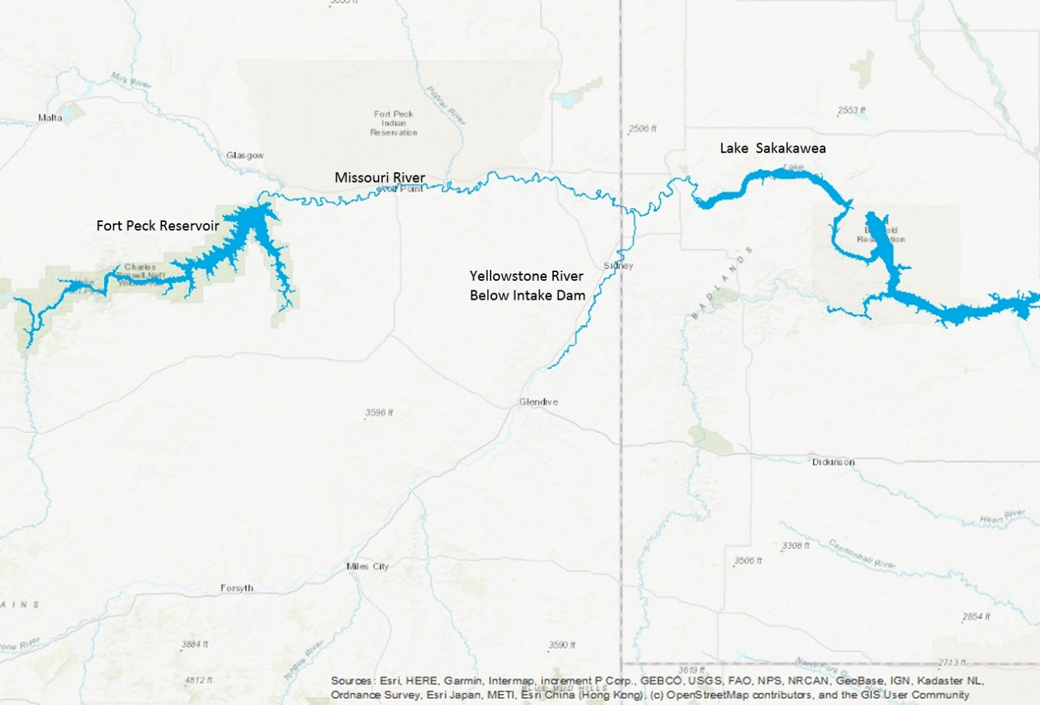

Figure 1: Long-term growth rate was computed for the population of pallid sturgeon residing within the highlighted regions of the Missouri (from Ft. Peck Dam, MT down to Lake Sakakawea impounded by Garrison Dam, ND) and Yellowstone (up to the Intake Diversion Dam, MT) Rivers. Alternative management scenarios at Fort Peck Dam will primarily influence this population of pallid sturgeon.

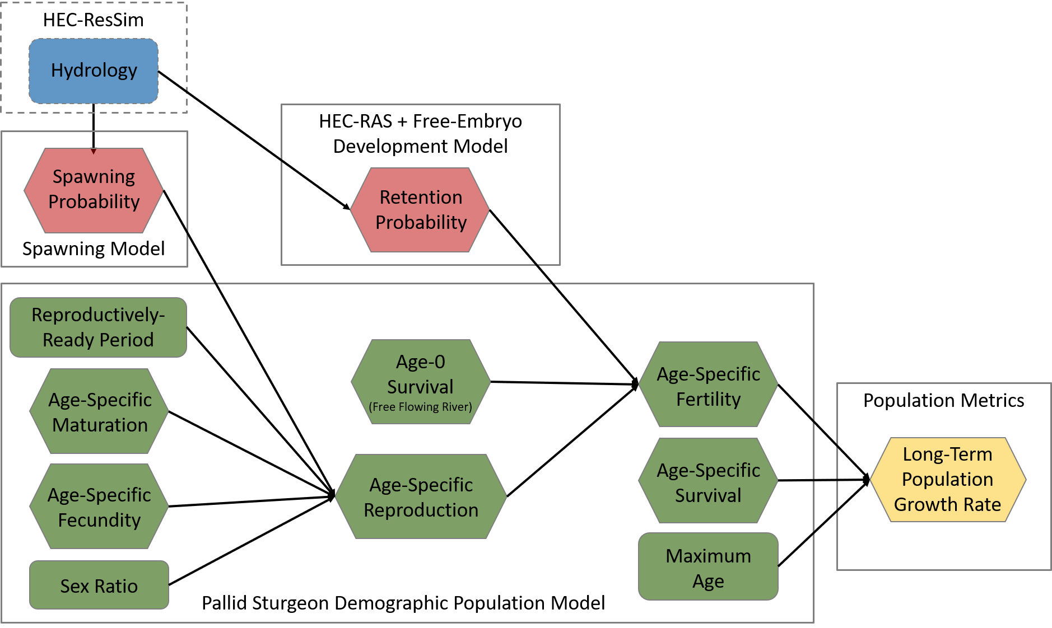

Figure 2: A graphical representation of the framework utilized in modeling the long-term pallid sturgeon population growth rate with respect to the various management alternatives. Colors represent an external model (blue), new models (red), and then the population model (green), and analysis output (yellow). Submodels are represented as boxes outlining the rates (hexagons) and other input values (rounded boxes).

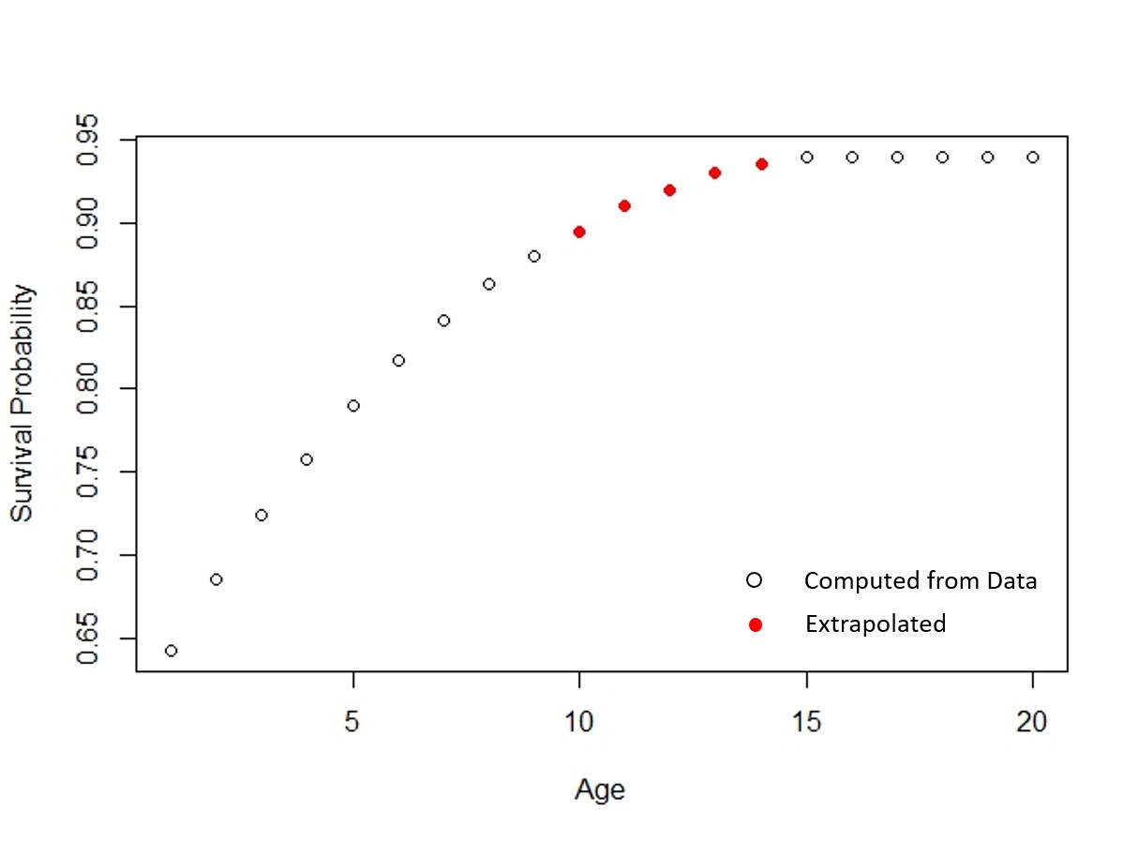

Figure 3: Baseline age-specific survival probabilities (). Values were computed from Rotella (2017) for ages 1-9 and from Klungle and Baxter (2005)and (Jaeger et al. 2009) for ages 15+. Vales for ages 10-14 were extrapolated based on survivals of younger and older fish.

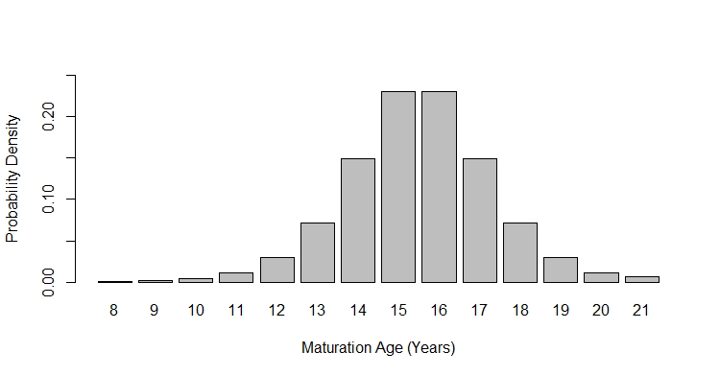

Figure 4: Baseline age-specific maturation probabilities (), indicating the probability that a female matures at a particular age.

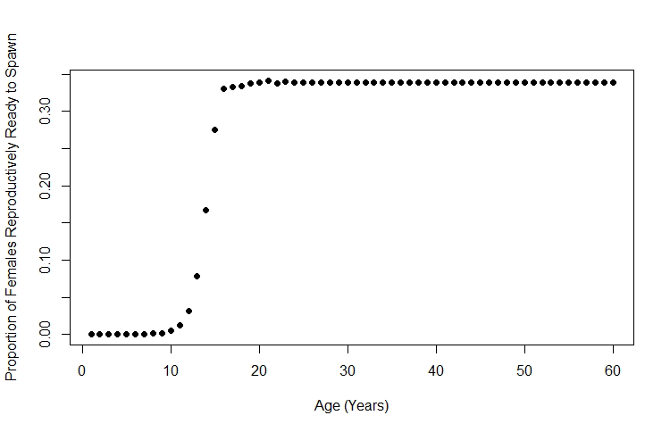

Figure 5: Baseline age-specific reproductive-readiness probabilities (), computed from age- specific maturation probabilities and the distribution of time periods between reproductive readiness.

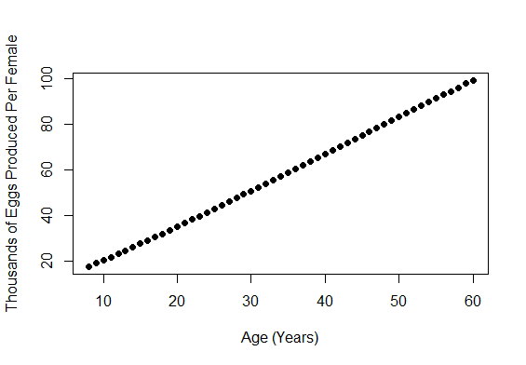

Figure 6: Baseline age-specific expected number of eggs released per spawning female (), computed from combining an age-length and a length-fecundity relationship for female pallid sturgeon.

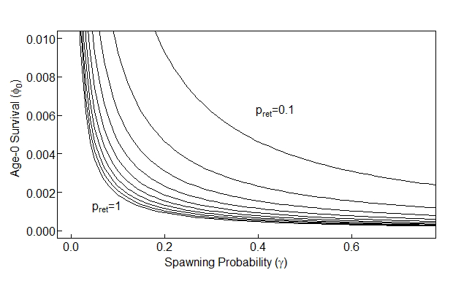

Figure 7: From left to right, the curves are the population growth-decline boundaries (= 1) for retention probabilities =1, 0.9, 0.8, 0.7, 0.6, 0.5, 0.4, 0.3, 0.2, and 0.1. For a given retention probability, a population is expected to grow if spawning and age-0 survival probabilities fall in the space above and to the right of the curve, or, decline if spawning and age-0 survival probabilities fall in the space below and to the left of the curve. Spawning probability () is the probability that a reproductively-ready female spawns in the Missouri River (vs. spawning in the Yellowstone or not spawning and reabsorbing her eggs). Age-0 survival () is the probability of surviving from egg to age-1 given retention in the free-flowing Missouri River. The retention probability () refers to the probability that a drifting free- embryo is retained in the free-flowing Missouri River and does not drift into Lake Sakakawea prior to settlement.

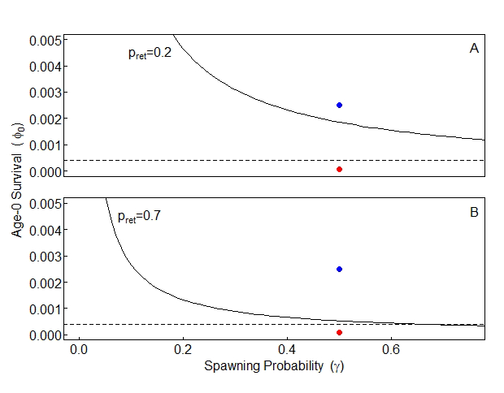

Figure 8: Population growth-decline boundaries (= 1) when retention probability is A) 20% and B) 70%. All dots indicate a population whose reproductively-ready females spawn in the Missouri River 50% of the time, i.e., = 0*.*5. Red dots indicate a population where 75 out of every 1,000,000 eggs are expected to survive to age-1 given retention in the free-flowing Missouri River ( = 0*.*000075), and blue dots indicate a population where 25 out of every 10,000 eggs are expected to survive to age-1 given retention ( = 0*.*0025). Red dots are in a region of decline (below and left of the curve), while blue dots are in a region of growth (above and to the right of the curve). The dashed line indicates Pine et al. (2001) upper estimate of age-0 survival for gulf sturgeon, 0.0004. Population growth at this survival level can occur but only at high spawning and retention probabilities.

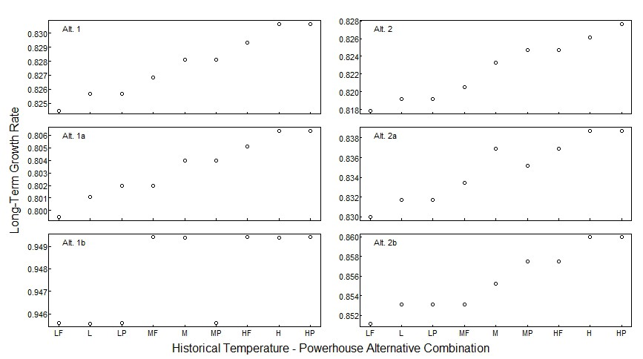

Figure 9: Long-term growth rate () values for six Fort Peck flow scenarios under particular historical temperature and powerhouse operation combinations: LF–low water temperature, full powerhouse operations; L–low water temperature, standard powerhouse operations; LP– low water temperature, peak time powerhouse operations, and similar for M–median water temperature and H–high water temperature. Full powerhouse operations assume 14kcfs are run through the powerhouse 24 hours a day; standard powerhouse operations assume 14kcfs are run through the powerhouse for 12 hours a day with 7kcfs running through the powerhouse the remaining 12 hours; peak time powerhouse operations assume 7kcfs are run through the powerhouse except during peak times when 14kcfs are run through.

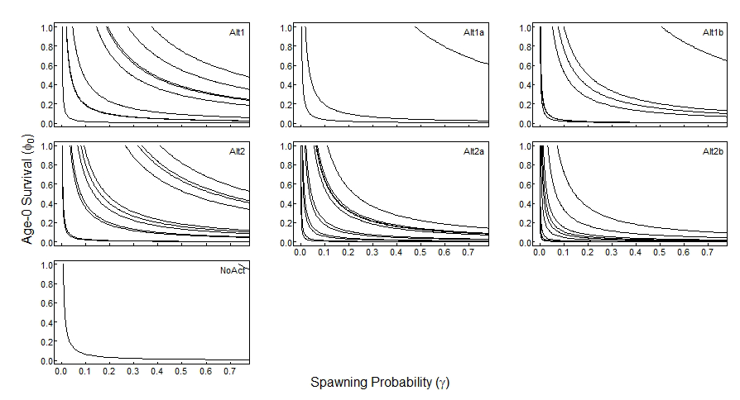

Figure 10: Growth decline boundaries by alternative management scenario. Each contour line has a fixed retention probability that was computed from HEC-RAS outputs and represents a particular year in which the given alternative scenario met the flow criteria. For a given year/retention probability, a population is expected to grow if spawning and age-0 survival probabilities fall in the space above and to the right of the curve, or, decline if spawning and age-0 survival probabilities fall in the space below and to the left of the curve. Spawning probability () is the probability that a reproductively-ready female spawns in the Missouri River (vs. spawning in the Yellowstone or not spawning and reabsorbing her eggs). Age-0 survival () is the probability of surviving from egg to age-1 given retention in the free-flowing Missouri River.

.

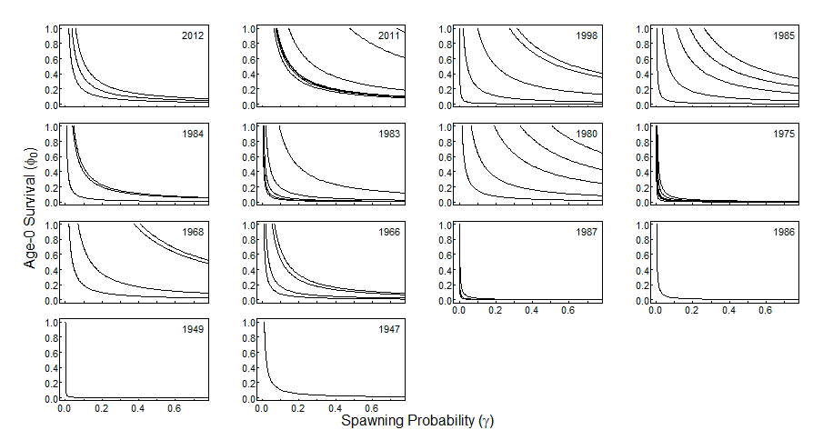

Figure 11: Growth decline boundaries by year. Each contour line has fixed retention probability that was computed form HEC-RAS outputs and represents a particular management scenario that met the flow criteria during the given year. For a given management scenario/retention probability, a population is expected to grow if spawning and age-0 survival probabilities fall in the space above and to the right of the curve, or, decline if spawning and age-0 survival probabilities fall in the space below and to the left of the curve. Spawning probability () is the probability that a reproductively-ready female spawns in the Missouri River (vs. spawning in the Yellowstone or not spawning and reabsorbing her eggs). Age-0 survival () is the probability of surviving from egg to age-1 given retention in the free-flowing Missouri River.

1. Results are presented here in terms of long term population growth and will like change in what is optimal when other considerations are included in a full tradeoff analysis.