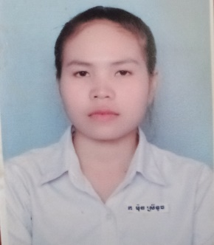**CURRICULUM VITAE**

**Moch sreytouch**

Apply for: Web Developer

|  |
| --- |
| PERSONAL DATA |

Sex : Female

Nationality : Cambodian

Marital status : Single

Date of Birth : 26-March-1998

Place of Birth : Kampong Thom Province

Mobile : 088 400 5497/ 093 830 483

Email : Sreytouch.moch@student.passerellenumeriques.org

Address : St.6, Baray, Baray, Kompong Thom, Cambodia.

|  |
| --- |
| EXPERIENCE |

My name is **Moch sreytouch**  I am a student of a school or an organization called PNC **(Passerellenumeriques.org Cambodia)**, and I am interested in your company **(iCloud & Web Developer )** because I want to work in your company to get experience from your workplace to develop my skills. I promise to work hard to make your company grow.

I have just graduated from school and wish to gain experience in the field of skills, I have learned and I have seen that your company is really good for me to build my skills better. Promise to work at your company to further develop in line with current times and current markets.

If you have questions, or if you want to schedule an interview, please contact me at **088 400 54 97.**  I look forward to meeting you to further discuss employment opportunities with your company **(iCloud & Web Developer)**.

|  |
| --- |
| EDUCATION |

**2019– 20201** bachelor degree in it & wed develop

**August - 2019** Finished High School

**Triel High School**

|  |
| --- |
| WORK HISTORY |

Micrsoft Word/Excel : Good for office use

Internet & Email : Good for communication and research

Photoshop : Basic design skills

volunteer : Good idea to teach young child at iherb organization

|  |
| --- |
| LANGUAGES |

Khmer : Negative

English : Good at Speaking, Listening & writing

Chinese : Good at Speaking, Listening & writing

|  |
| --- |
| INTERESTS |

Free time : Reading books and do something that I like it.

Holiday : Playing sports & sleeping

|  |
| --- |
| REFERENCE |

Mr. Johnson Ms. Alex

Accounting Manager Operation Manager

Finance Company

Soramitsu khmer Web Designer

Tel: 093 XXX XXx Tel: 010 XXX XXX