Sarah Flavin

Introduction to Flask

1. Install Flask by typing “sudo python3 -m pip install Flask”

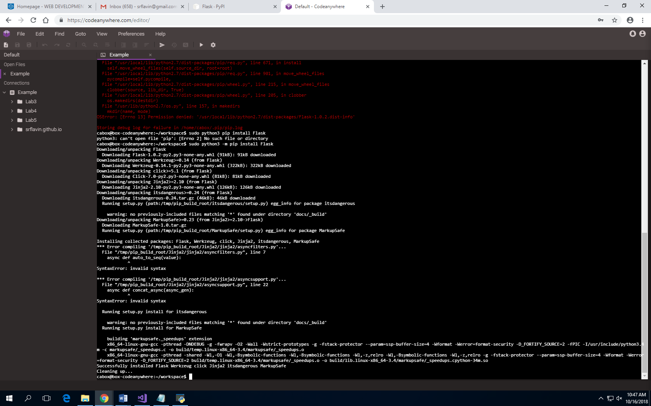

1. First check the version of Flask that was downloaded. Next type “export LC_ALL=C.UTF-8” and enter. Then type “export LANG=C.UTF-8” and enter. This should allow the user to see what type of Flask was downloaded.

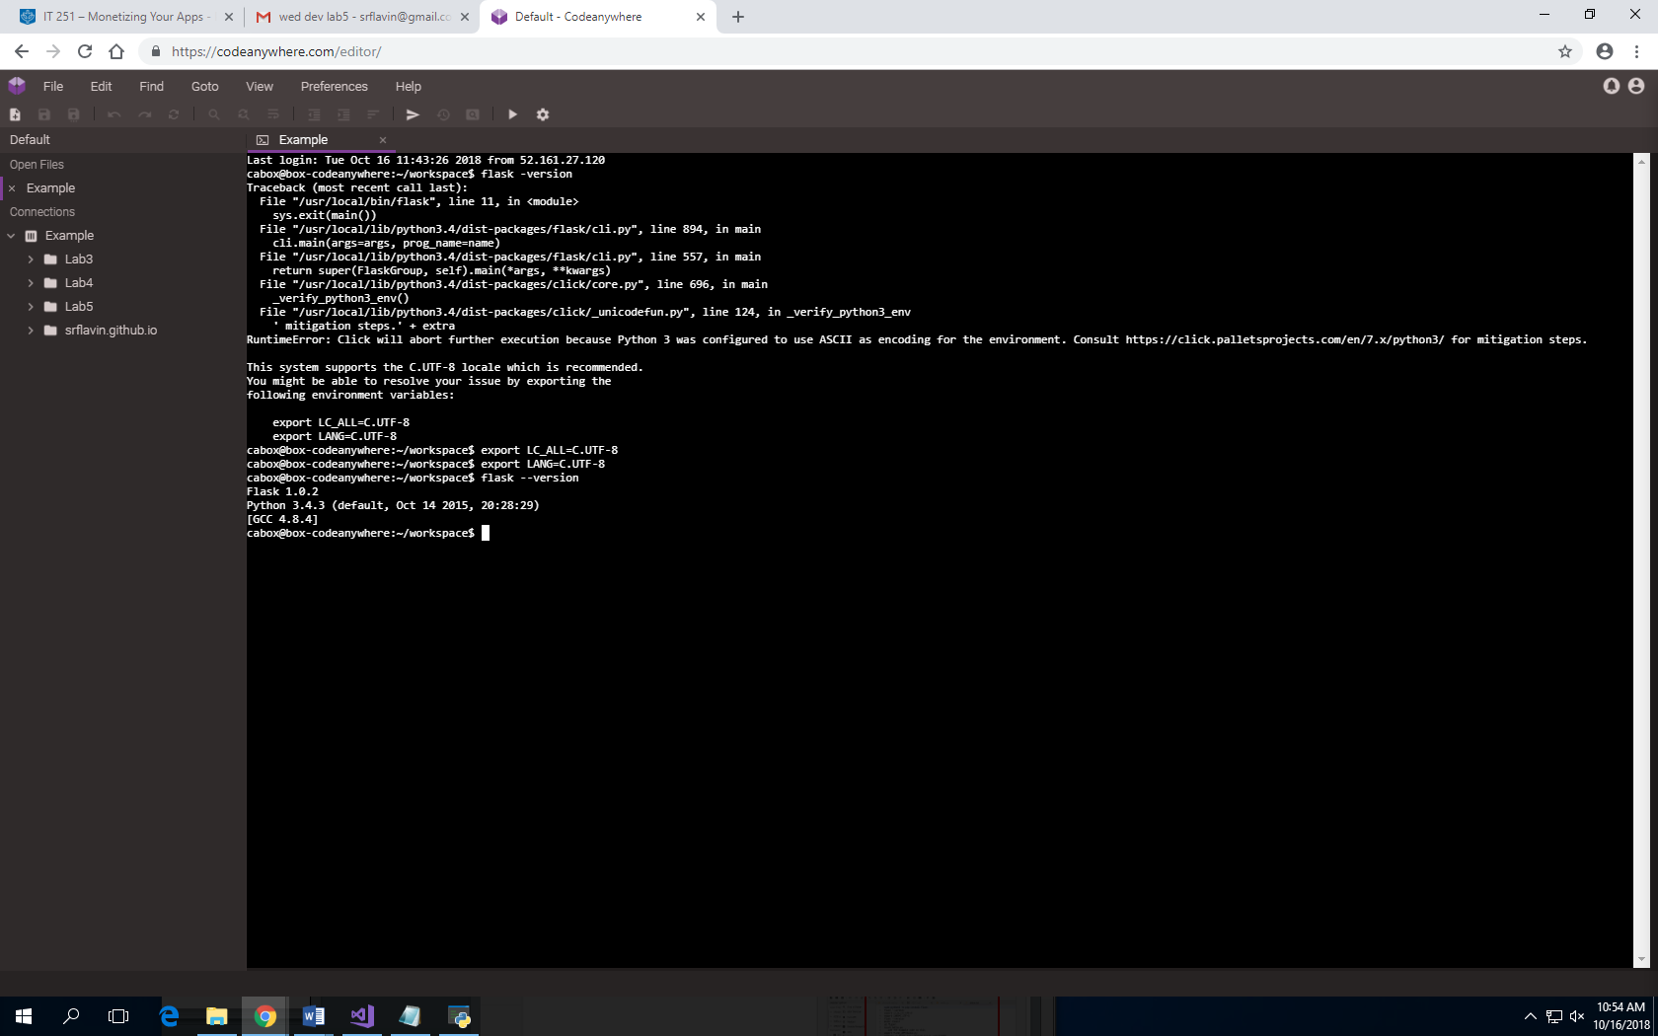

1. Create a new directory.

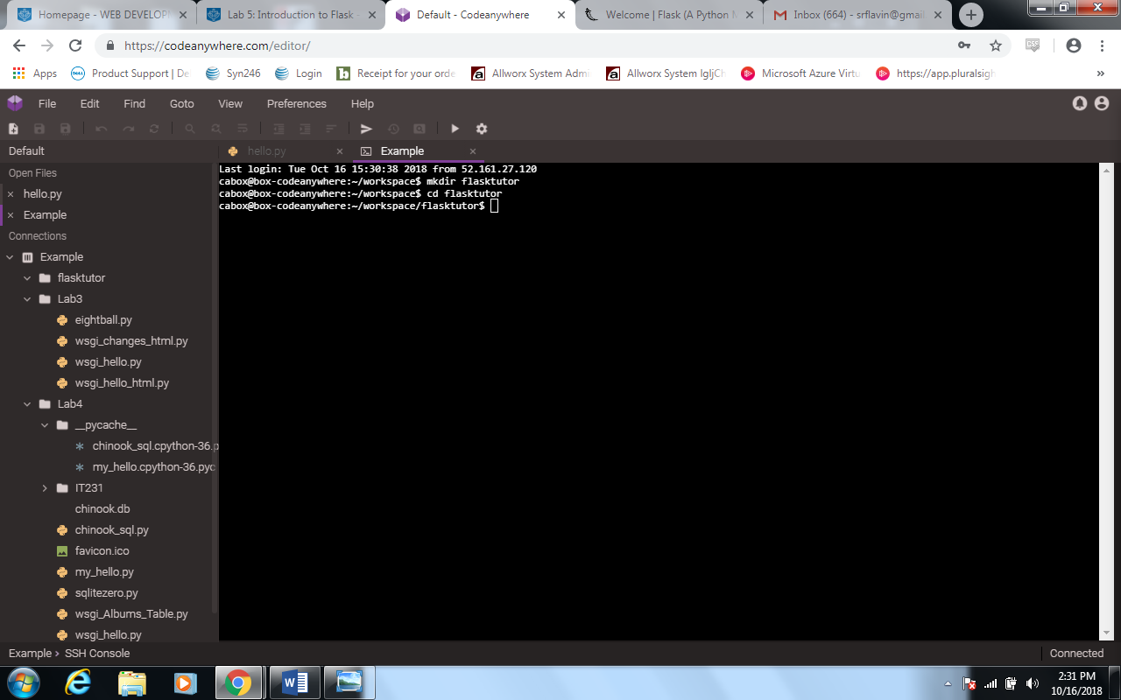

1. Type in “export FLASK_ENV=development”. Create a new folder called Flaskr and then create a new file clicking on the directory and clicking new file. In the name type in “__init__.py”.

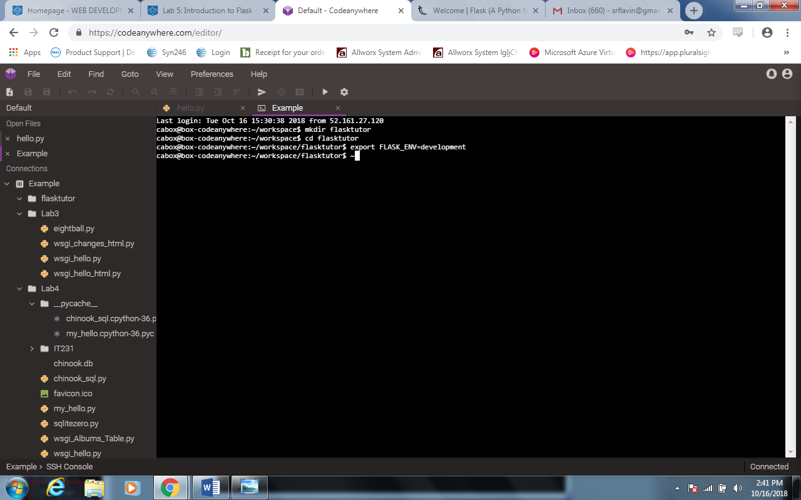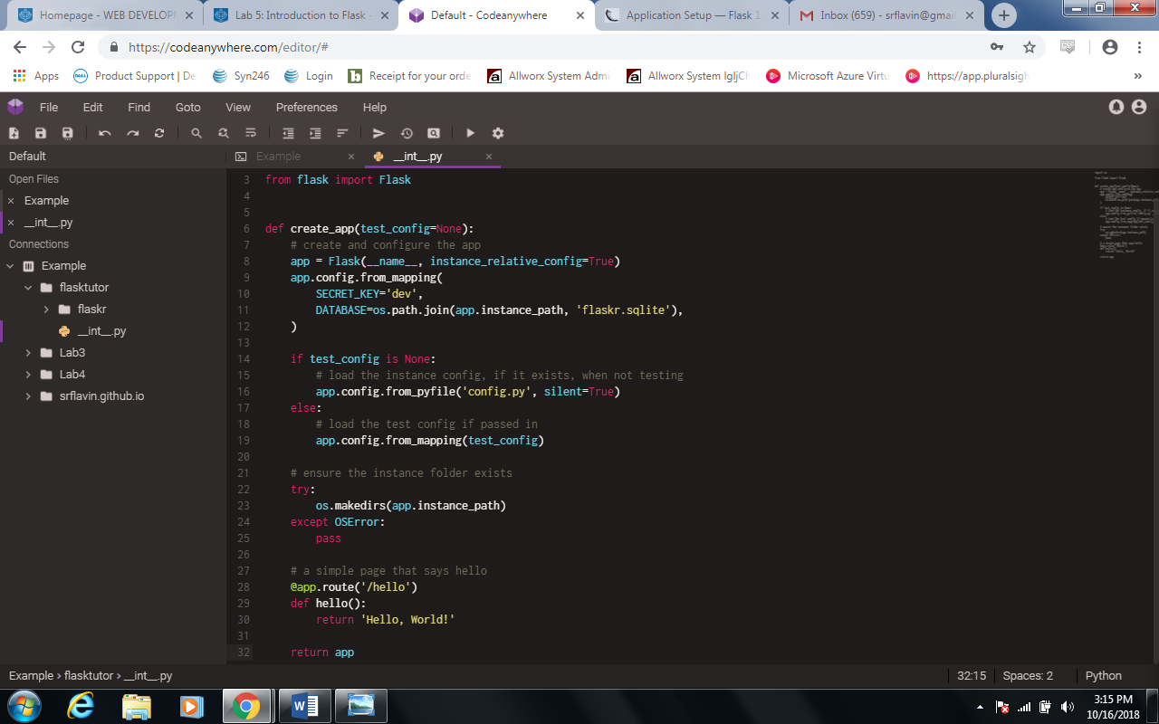

1. Copy the code from website: <http://flask.pocoo.org/docs/1.0/tutorial/factory/> and paste it within the __init__.py

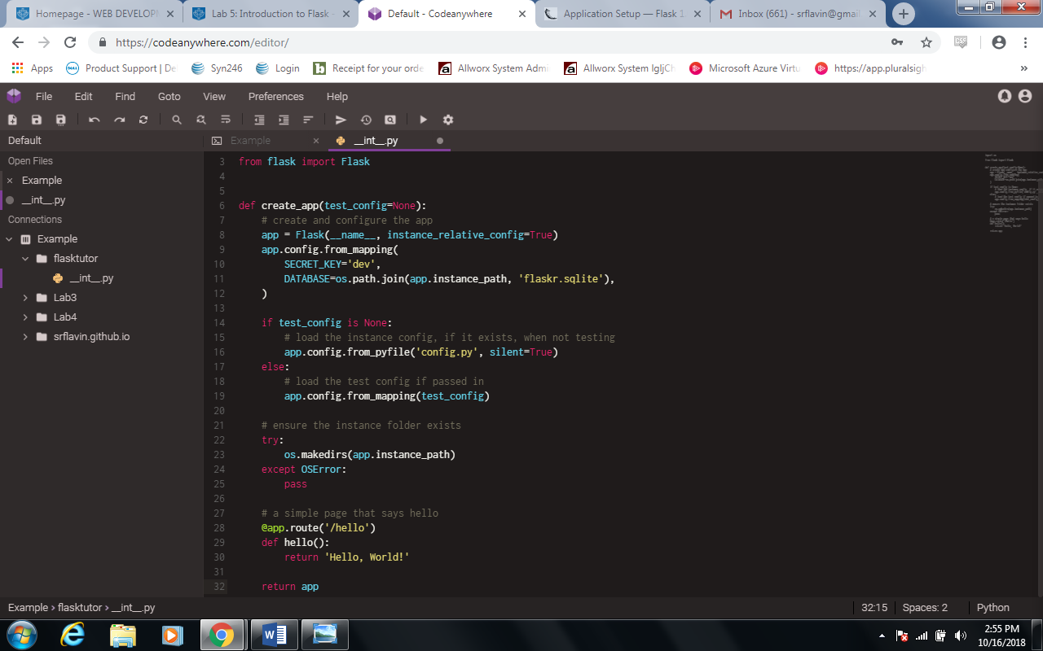

1. Type in flask run –host=0.0.0.0 –port=3000 to run the server.

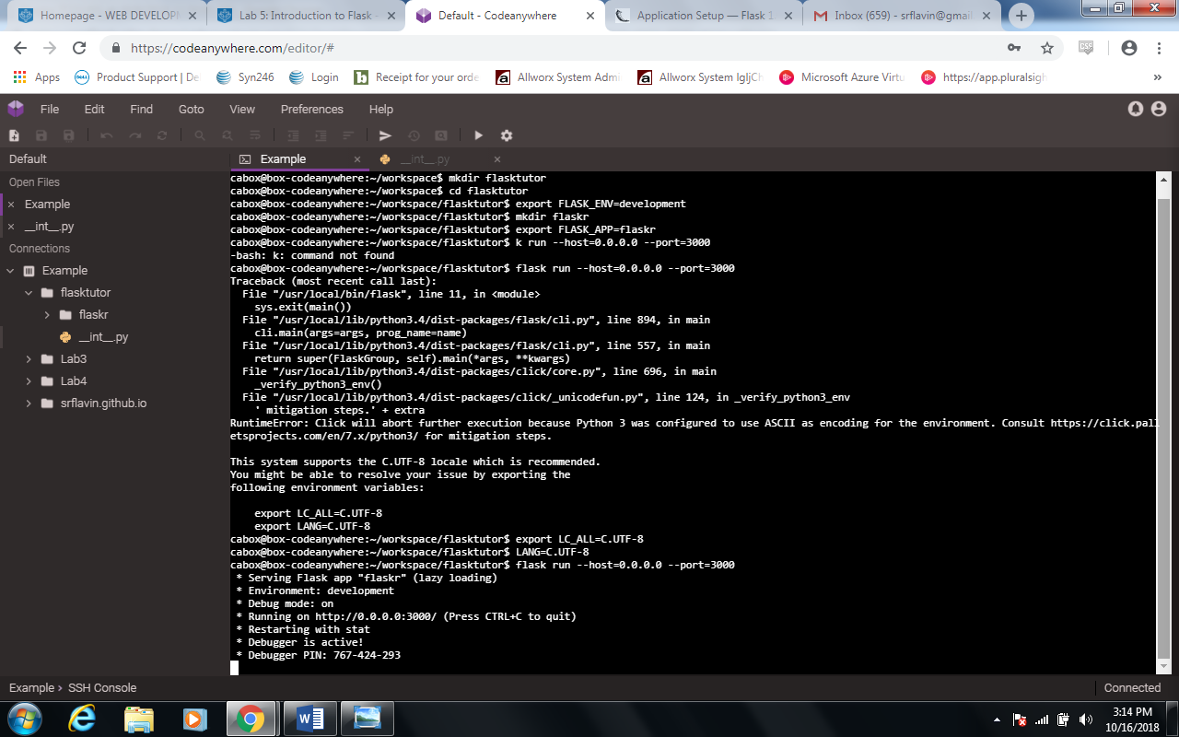

1. In a new tab, type https://example-srflavin698029.codeanyapp.com/

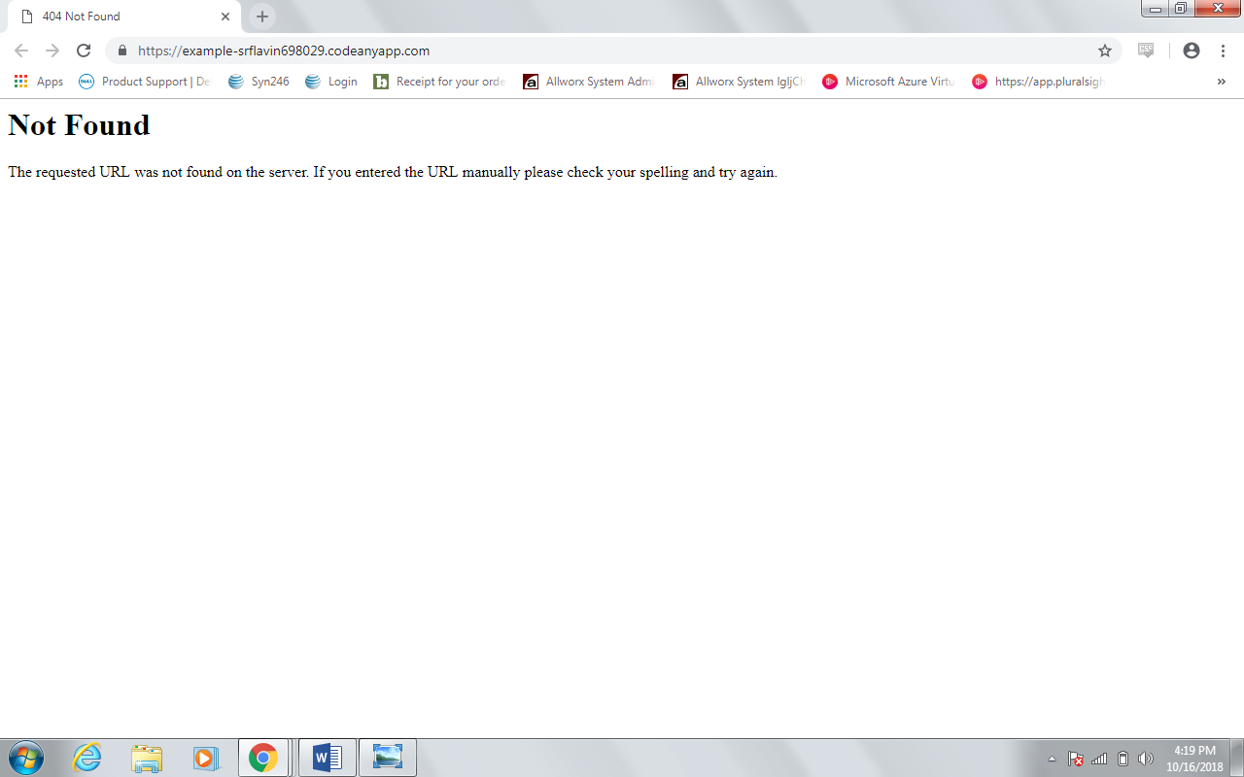

1. To fix the error type <https://example-srflavin698029.codeanyapp.com/hello>

