ImgBeamAnalyzer User’s Guide
Date | Revision | Description | Author
17/01/2007 | 1.0 | Initial Version | J.Malik
Table of contents
1 Applicative goals and main functionalities of the DeviceServer 2
1.1 Introduction 2
1.2 Some vocabulary 2
2 Technical scheme of the application 3
2.1 Architecture 3
2.2 In depth description of the functionalities 4
2.2.1 Conventions 4
2.2.2 Pre-processing 4
2.2.3 Region of Interest 6
2.2.3.1 UserROI setup 6
2.2.3.2 AutoROI algorithms 6
2.2.4 Gamma Correction 7
2.2.5 Histogram 8
2.2.6 Moments 8
2.2.7 Profiles 9
2.2.8 2D Gaussian Fit 10
2.2.9 Pixel to length unit conversion 12
3 TANGO software interfaces 14
3.1 Properties 14
3.1.1 Setup Properties 14
3.1.2 Initialization of attributes 14
3.2 Attributes 14
3.3 Commands 15
4 Software Setup 15
5 Limitations and problems 15

Applicative goals and main functionalities of the DeviceServer

Introduction
This device analyzes an image located on another device.
It provides the following functionalities:
- in preprocessing : rotation/mirroring
- region of interest (user defined and/or automatic)
- gamma correction
- image moments (mean intensity, centroid, variance and skew)
- maximal intensity (to monitor CCD saturation for example)
- histogram of pixel intensity values
- profiles with corresponding gaussian fit
- 2D gaussian fit

The device can read the following types of images: UCHAR, SHORT and USHORT.

Some vocabulary
Vocabulary is explained when necessary in §2.2

Technical scheme of the application

Architecture
The ImgBeamAnalyzer device has two sets of attributes: configuration attributes (the Read/Write attributes) and output attributes (the Read-only attributes). It also has a few set of commands.
The configuration attributes are used to set the parameters of the different algorithms applied on the input image. The output attributes describe the results of the algorithms, and form a set of values that are coherent between them (when read through the read_attributes command, they all correspond to the results of the same image). Moreover, the read values of the configuration attributes correspond to the actual configuration for the processing of the last image (when doing a read_attributes with some configuration attributes and some output attributes, the read values of the configuration attributes are the ones used for computing the values of read output attributes).

The device has two functioning modes:
- ONESHOT: calling the Process command or writing the InputImage attribute launches the computation of output values. These output values stay until the next call to Process or the next writing to InputImage attribute.
- CONTINUOUS: at a user-defined frequency, the device automatically reads the input image on another device and updates its output values (like an internal polling).
N.B.: In ONESHOT mode, it is not mandatory to specify the remote attribute to read the image from. In this case, the Process command is disabled and the only way to interact with the device is to write the InputImage attribute. In CONTINUOUS mode, the initialization of the device fails if the remote image attribute is not specified.

The processing of an image follows this order:
- first the image is preprocessed (rotated/mirrored)
- then the region of interest is applied, if this feature is enabled
- finally the output values (histogram, moments, profiles, gaussian fit) are computed using only the pixels from the region of interest
Each functionality can be enabled or disabled whether it is of interest for the kind of image processed.

In depth description of the functionalities
    - Conventions
The axises of the image are called X and Y and are choosen as the natural axises for a computer-processed image:
X
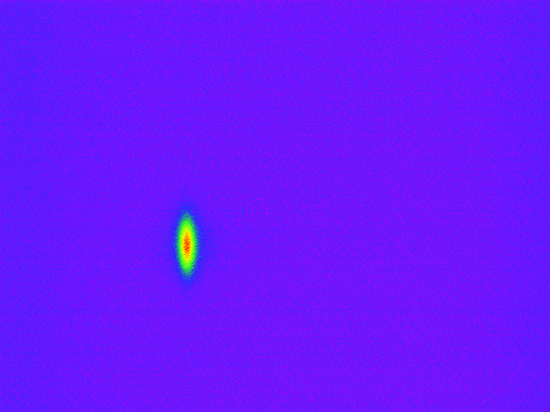
Y

The coordinates of the first pixel of the image are [0,0] (not [1,1] as in MatLab !).

    - Pre-processing

Before any computation, the image is pre-processed.
The current version only supports rotation and mirroring of the input image.

Two parameters handle this functionality: Rotation and HorizontalFlip.
Rotation is used to set the rotation angle in degrees. Only multiples of 90 are allowed (any incoherent value is considered as 0). This transformation is the first to take place.
HorizontalFlip flips the image horizontally. It is done after the rotation.
By combining these two parameters you can do the transformation you want among the 8 possibilities described below.

Important Note : the InputImage attribute represents the preprocessed image. This choice has been made so that it is easier to configure the Region of Interest, because the preprocessing can change the axises of the image. You can test the rotation and mirroring functionalities by setting the Rotation and HorizontalFlip attributes and then directly looking at the InputImage attribute, which will change with respect to them. See the Region of Interest chapter for more detail.

The table below shows the effect of these two parameters:
Original (Rotation : 0° - HorizontalFlip : false) | Rotation : 0° - HorizontalFlip : true
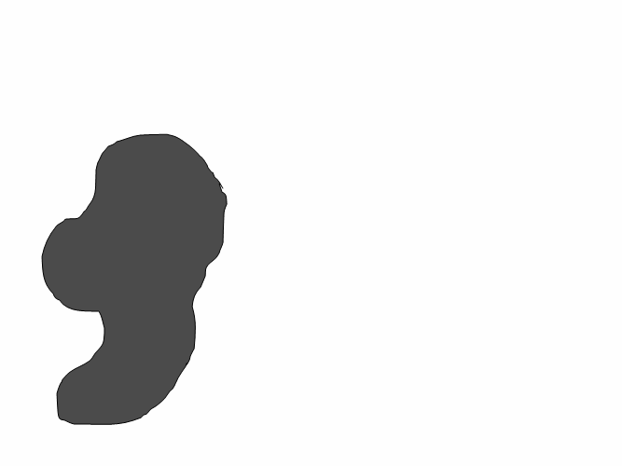 | 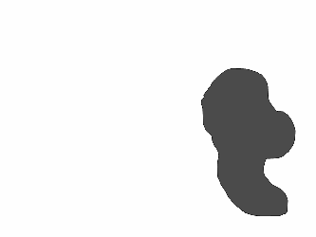
Rotation : 90° - HorizontalFlip : false | Rotation : 90° - HorizontalFlip : true
 | 
Rotation : 180° - HorizontalFlip : false | Rotation : 180° - HorizontalFlip : true
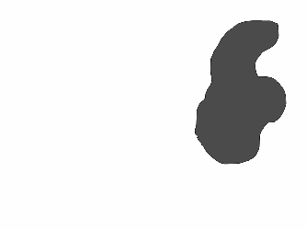 | 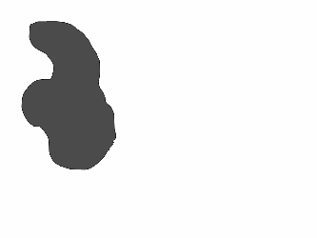
Rotation : 270° - HorizontalFlip : false | Rotation : 270° - HorizontalFlip : true
 | 

    - Region of Interest

A Region of Interest (ROI) can help you select the part of the image you want to focus on. Selecting a ROI will clip the InputImage, and every further processing step (moments, profile fit, histogram…) will be applied on the result of this clipping, called the “ROI Image”.
Two types of ROI can be used, depending on the EnableUserROI and EnableAutoROI attributes:
- User ROI, which is configured by the user (fixed origin, width and height)
- Auto ROI, which is automatically computed on each image.

In case where both EnableUserROI and EnableAutoROI are set, the User ROI is applied first, and the AutoROI is applied on the result of the User ROI.

A ROI is defined by four attributes: the two coordinates of the origin (up left corner), its width and its height.

      - UserROI setup
For the UserROI, these four attributes are of READ/WRITE type : UserROIOriginX, UserROIOriginY, UserROIWidth, UserROIHeight. You must write the four attributes so as the User ROI to be applied: as long as these four attributes define an empty area (width or height is null, or origin x or origin y goes beyond the image size), the whole InputImage is taken and the four attributes are put to ALARM state, meaning that they are not used.

For the AutoROI, these four attributes are READ only, since they are computed automatically:
AutoROIOriginX, AutoROIOriginY, AutoROIWidth, AutoROIHeight.

      - AutoROI algorithms
Two algorithms for automatically computing the ROI are provided by the device:
- The first one is based on Gaussian fit of the profiles of the whole image.
First, profiles of the whole image are computed. Then both profiles are fit to Gaussian functions with background. This defines a center position and the size (sigma) of the beam in both directions.
The AutoROI is then centered on the center position defined by the profiles fits. The size in each direction is defined as a multiple (integer or not) of the sigmas of the profiles.
This method has the advantage of not requiring any user intervention. The method adapts itself to varying beam intensities or size and is based on standard known features (the sigmas of a Gaussian profile). Its disadvantage is that it is bound to analyze Gaussian beam, and may not adapt well to beam of arbitrary shape.
- The second one is based on connected component analysis.
First, the image is thresholded (binarized), using the value of the AutoROIThreshold attribute. Then, the blobs (connected components) are extracted from the binarized image, and the larger one is selected (in terms of area). The bounding rectangle of the selected blob is then taken ad the AutoROI, up to a multiple of its width and height.
The multiples used (in both methods) are set by the AutoROIMagFactorX and AutoROIMagFactorY attributes.
The method used to set the ROI is defined as a property of the device : AutoROIMethod, which can be set to PROFILES or THRESHOLD. Being a property of the device, this setting must be configured via jive and cannot be dynamically changed during runtime.
Examples with the PROFILES method:
The X profile gives a center position of 200 (in pixels) and a sigma of 20 pixels. The Y profile gives a center position of 150 (in pixels) and a sigma of 10 pixels. AutoROIMagFactorX is set to 5 and AutoROIMagFactorY set to 3.5.
This will lead to the following values for the AutoROI :
AutoROIOriginX = 200 – 5 × 20 = 100
AutoROIOriginY = 150 – 3.5 × 10 = 115
AutoROIWidth = 20 × 2 × 5 = 200
AutoROIHeight = 10 × 2 × 3.5 = 70
The values obtained can be non-integer, but they must be converted to integer since it corresponds to number of pixels. Hence, the AutoROIOriginX and AutoROIOriginY values are floored and the AutoROIWidth and AutoROIHeight are ceiled.
Finally, it is possible that an automatic ROI cannot be found. In the PROFILES method, the profiles may not be fitted to Gaussian functions (the fits do not converge), or in the THRESHOLD method, a connected component may not be found (threshold too high for example). In this case, the whole image is taken (in other terms, AutoROI is set to the whole image). The AutoROIFound attribute is a boolean attribute that you can read to monitor the fact that an AutoROI has been found or not by the algorithm.

    - Gamma Correction
It is possible to apply a gamma correction to the image to correct the non linearity of the pixel response to light intensity.
As shown above, if your CCD has a gamma factor of 2.2, it means that low intensities will be represented by a few values, and that high intensities values will be easily distinguishable. On the contrary with a gamma factor of 0.45, different low intensities will be easily distinguishable but different high intensities can lead to the same pixel value.
The plot below shows different transfer functions corresponding to different gamma values. The bit depth is 10, so pixel values goes from 0 to 1023
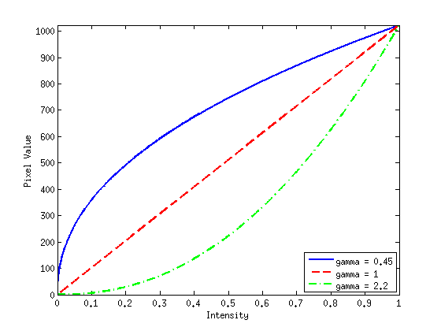
To compensate for this effect you can enter the gamma value of your acquisition device in the GammaCorrection attribute. The BitsPerPixel attribute must be set to the bit depth of your acquisition device (typically 8, 10 or 12).
The following function is applied to each pixel :
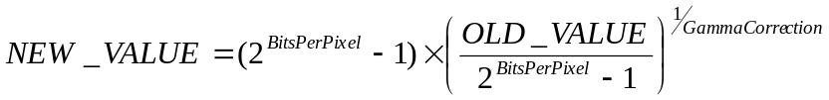

    - Histogram
The histogram of the image is computed if EnableHistogram is set to true.
The histogram gives the number of pixels in the image whose intensity falls inside specified intervals. An interval of intensity value is called a bin.
In the device, the bins have all the same size.
The number of bins is set with the attribute HistogramNbBins. If it is set to 0, the maximum possible number of bins is used: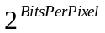.
The HistogramRangeMin and HistogramRangeMax attributes set the minimal and maximal intensity values handled in the histogram.
So each bin in the histogram corresponds to an intensity interval of:
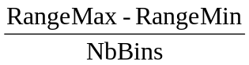

    - Moments
The moments of the image can be computed if EnableImageMoments is true.
In that case, the moments from order 0 to order 3 can be computed. In addition, the maximal intensity value in the image is given. In the following, 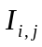 is the intensity of the pixel (i, j) in the image. All moments are scaled by the zero order moment such that these values do not depend on the intensity scale factor. For example, the same image taken with a CCD camera and digitized at 8, 10, or 12 bits will lead to the same value for every moments (except the zero order moment).

MaxIntensity gives the maximal intensity value in the image.
MeanIntensity gives the mean intensity of all pixels in the image (this is the zero-order moment).
CentroidX and CentroidY gives the position of the centroid of the image.
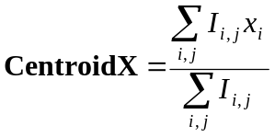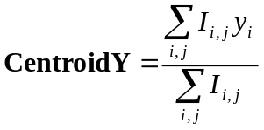
VarianceX, VarianceY and CovarianceXY gives the second order moments:
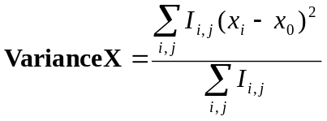
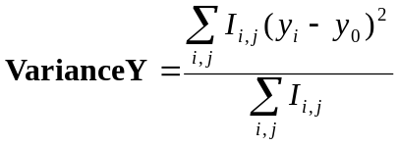
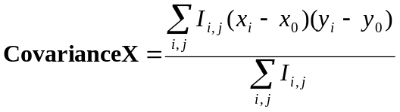
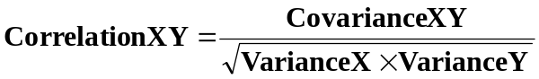
The third order moments (skew) are given by the attributes:
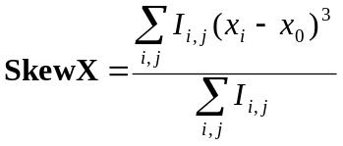
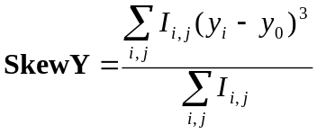
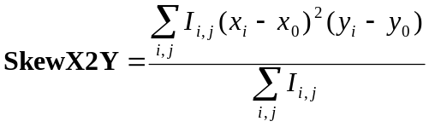
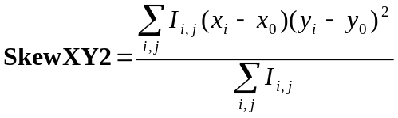

    - Profiles
The profiles of the image are computed if EnableProfile is true.
They are computed as the cumulative sum of rows or colums.
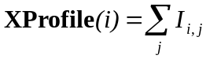, 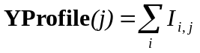
Then, each profile is fitted to a Gaussian function with background through a Levenberg-Marquardt algorithm.
The convergence conditions of the algorithm are controlled by the Fit1DNbIterMax (maximal number of iterations) and Fit1DMaxRelChange (maximal relative change of the 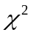function between to iterations). The convergence stops if either one or the other condition is fulfilled.

We define the Gaussian function as:
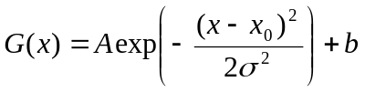

The fitted parameters are:
- , the magnitude of the Gaussian, ProfileMag
- , the center of the Gaussian, ProfileCenter
- , the standard deviation, ProfileSigma
- , a background constant, ProfileBG

For convenience, the full width at half maximum is also given, calculated by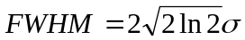, in ProfileFWHM.
Information about convergence are given by :
- ProfileFitConverged : a Boolean indicating if the fit did converge to a stable set of parameters
- ProfileFitted : a spectrum representing the fitted Gaussian function, 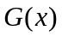
- ProfileError: the difference between and the real values
- ProfileChi2 : the after the last step of the algorithm : 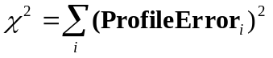
- ProfileNbIter : the number of iteration used to converge to the solution
- ProfileFitRelChange : the relative change in the value between the last two iterations

    - 2D Gaussian Fit

A 2D Gaussian fit of the image can be computed if Enable2DGaussianFit is true.

The parameters of the fit are described by the following function:
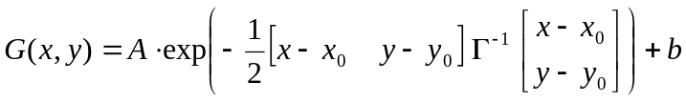
with 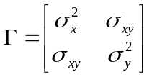

The convergence conditions of the algorithm are controlled by the Fit2DNbIterMax (maximal number of iterations) and Fit2DMaxRelChange (maximal relative change of the function between to iterations). The convergence stops if either one or the other condition is fulfilled.

The fitted parameters are:
- , the magnitude of the Gaussian, GaussianFitMagnitude
- 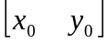, the center of the Gaussian, GaussianFitCenterX and GaussianFitCenterY
- 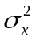,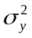 and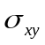 the variance and covariance of the Gaussian, GaussianFitVarianceX, GaussianFitVarianceY, GaussianFitCovarianceXY
- , a background constant, GaussianFitBG

For convenience, several characteristic values computed from the parameters are given :
GaussianFitMajorAxisFWHM, GaussianFitMinorAxisFWHM and GaussianFitTilt are computed from the diagonalization of the covariance matrix :
The major axis is defined by the direction of the eigen vector associated to the greatest eigen value of , the minor axis is orthogonal to the major axis, and the tilt is defined by the angle (in the trigonometric sense) between the major axis and the X axis.
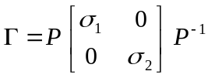 with 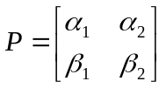
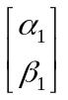 and 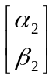 define the major and minor axis, 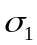 and 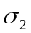 are their associated eigen values.
From these computations, the values returned by the attributes are:
- GaussianFitMajorAxisFWHM = 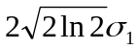
- GaussianFitMajorAxisFWHM = 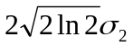
- GaussianFitTilt = 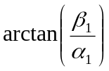
Information about convergence are given by :
- GaussianFitConverged, a Boolean indicating if the fit did converge to a stable set of parameters
- GaussianFitChi2, the after the last step of the algorithm
- GaussianFitNbIter, the number of iteration used to converge to the solution
- GaussianFitRelChange, the relative change in the value between the last two iterations
- GaussianFitParameterCovariance, the covariance matrix of the final parameters, computed from the Jacobian matrix of the minimized function by 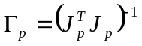, where 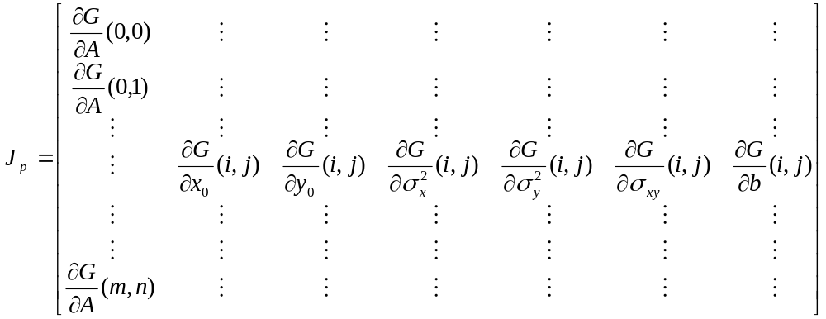
The diagonal elements of 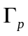give error bounds for each parameters, assuming a unitary measurement error for each pixel value.

    - Pixel to length unit conversion
Finally, the device allows you to set unit conversion values that will be used to scale each attribute value where it makes sense to express it in real unit.
- PixelSizeX : the horizontal size of the pixels of the CCD in µm per pixel
- PixelSizeY : the vertical size of the pixels of the CCD in µm per pixel
- OpticalMagnificationFactor : the magnification factor of your optical system (no unit)

A position or a size in the X direction (resp. in the Y direction) is multiplied by 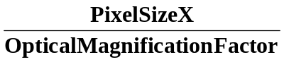 (resp. by 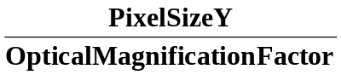)

A variance in X direction (resp. in the Y direction, resp. a covariance) is multiplied by 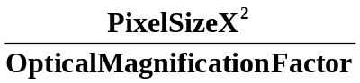 (resp. by 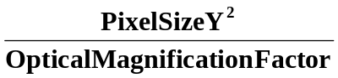, resp. by 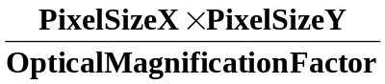)
The equivalent multiplications are done for the third order moments.

The following attributes are scaled with respect to these 3 configuration attributes:
- CentroidX, CentroidY expressed in µm
- VarianceX, VarianceY, CovarianceXY expressed in µm²
- SkewX3, SkewY3, SkewX2Y, SkewXY2 expressed in µm³
- ProfileCenter, ProfileSigma, ProfileFWHM expressed in µm
- GaussianFitCenterX, GaussianFitCenterY expressed in µm
- GaussianFitVarianceX, GaussianFitVarianceY, GaussianFitCovarianceXY expressed in µm²
- GaussianFitMajorAxisFWHM, GaussianFitMinorAxisFWHM expressed in µm (warning : they make sense only if PixelSizeX and PixelSizeY are equal)

TANGO software interfaces

Properties
There are two kinds of properties for the device:
- Setup properties: defines the functioning mode of the device.
- Initialization values of attributes

    - Setup Properties
ImageDevice | The name of the device providing the image attribute
ImageAttributeName | The name of the image attribute inside the device
Mode | CONTINUOUS or ONESHOT (see §2.1)
AutoStart | [used only if CONTINUOUS mode is chosen] true to automatically start the analysis at device initialisation
AutoROIMethod | PROFILES or THRESHOLD (see §2.2.3.2)

    - Initialization of attributes
It concerns all the configurable (Read/Write) attributes of the device:
AutoROIMagFactorX, AutoROIMagFactorY, BitsPerPixel, ComputationPeriod, Enbale2DGaussianFit, EnableAutoROI, EnableHistogram, EnableImageStats, EnableProfiles, EnableUserROI, GammaCorrection, HistogramNbBins, HistogramRangeMax, HistogramRangeMin, HorizontalFlip, OpticalMagnification, PixelSizeX, PixelSizeY, Rotation.
Things to know about them:
- they have exactly the same name as their corresponding attributes
- they have default values if you don’t define them
- the current runtime configuration can be saved by running the command SaveCurrentSettings, which will create those properties if they don’t exist, or override the already existing values in case they do already exist.

Attributes
The majority of the attributes have been extensively described in § 2.2. Please refer to it to have the details.
The attributes that have not yet been described are the following :
- ComputationPeriod : used only in CONTINUOUS mode, this attribute is the period at which the device will read and process a new image
- EstimComputTime : this is the time taken to process the last image

Commands
In addition to the standard State and Status command, the device proposes the following commands:
- Start : [only in CONTINUOUS mode] start the reading and processing of image
- Stop : [only in CONTINUOUS mode] stop the reading and processing of image
- Process : [only in ONESHOT mode] reads one image and process it
- SaveCurrentSettings : save all the configuration attributes in database (see §3.1.2)
- GetVersionNumber : return the version number of the current release of the device

Software Setup

When declaring a ImgBeamAnalyzer device in the database, it is mandatory to set some setup properties. See §3.1.1 for their list.

After that, you can run the device, and execute the SaveCurrentSettings method to create all the properties corresponding to the initialization values of attributes (see §3.1.2).

Note : the device uses a library that is single-threaded, so you MUST declare each ImgBeamAnalyzer in its own instance.

Limitations and problems
As said in chapter 4, each device must be declared in its own instance, since the library it relies on is only single-threaded for the moment. Making it multithreaded is an evolution that could be done in the future but is not planned yet.

As said in §2.2.9, the GaussianFitMajorAxisFWHM and GaussianFitMinorAxisFWHM are invalid if PixelSizeX and PixelSizeY are not equal.

