**Report**

* The dashboard showcases the ongoing simulation for a given number of nodes.
* The number of nodes can be specified and when the start button is clicked, the transactions begin. When the number of nodes is not specified, it takes a default value of 10 nodes.
* The transaction count, numbers of blocks and the total amount in the chain can be seen on the dashboard.
* The line chart showcases the number of blocks in the chain for a particular time.
* The bar graph showcases the amount each node has.

This is how the dashboard looks like for 10 nodes:

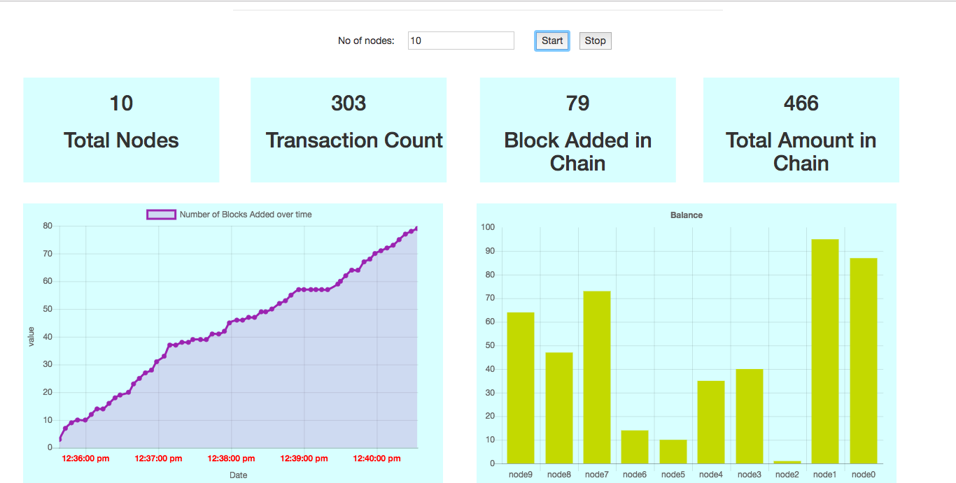

Different Types of Transaction tried:

1. All the inputs in the transaction corresponds to some outputs in the block chain. If a transaction contains an input which does no belong to any outputs we throw “{:error, :some_inputs_does_not_exist}”
2. The sum of amount in a input should be greater than or equal to the sum of outputs in transaction, if not the case we throw “{:error, :invalid_input_minus_output_sum}”
3. Each of the inputs corresponds to an output in the blockchain, but each outputs corresponding to an input should be spent only once otherwise we throw “{:error, :invalid_inputs_uniqueness}”
4. Person signing the transaction with his private key should own all the inputs. Basically, his public key should be able to very the signature on each inputs otherwise we throw {:error, :invalid_input_ownership}

As we can see from the above dashboard number of transaction is less compared to number of blocks due to invalid transaction.