**Globulator Method Description**

Purpose::

* link each crescent to its corresponding globule
* make a distribution of size and amount of globules
* make a distribution of RNA contamination among RNA present

Brief Method:

1. Using imageJ to “read” the image file and identify each globules and crescents
2. Use globulator.pl to calculate the above and produce result files

Long Method:

1. Using ImageJ.

ImageJ is an image reader and manipulator. Each pixel of any image contains, among other things, color information. The useful information is [RED, GREEN, BLUE].

ImageJ can directly identify edges of a circle if the edges have the same pixel. The globule files, however, do not have consistent edge color. The first half is black and the last half is white. Moreover, the background has the same color as the center of the globules. Therefore, imageJ cannot directly “identify” circles of the slide (globule). Therefore, to work around this, we must do threshold. Thresholding is a method to change a certain color range into a certain new color. For example, you can ask imageJ to change “all color that is dark grey into red”, and then you can ask imageJ to “group all isolated red pixels together and identify this as a circle”. Then imageJ will make a tab-delimited file that contains x, y, circularity, area among others.

Three macros have been made to automatically do this. They are called “GLOB_UNIX.ijm”, “CRES_UNIX.ijm”, “CONT_UNIX.ijm” (_WIN for windows version)” Simply copy-paste these files into ImageJ/Macos folder then you can use it. These macros are automatically doing the process below:

First, processing globule, we need DIC image file.

1. Open DIC image file
2. Image-> Adjust -> Color Threshold to open Threshold window (If the image is big, then it will take 30s-5minutes until it’s done, so wait patiently.
3. Set HUE 0-255, Saturation 0-255.
4. For brightness, get average and standard deviation of the image’s brightness, then minimum amount of brightness is set according to these values (max is 255)

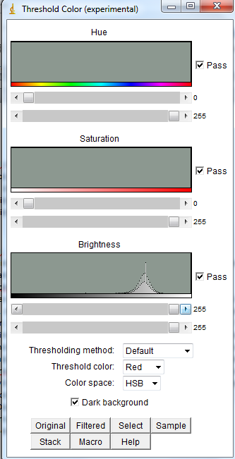

1. Thresholding Method: Default. Thresholding color: Red. Color Space: HSB. Dark background is checked.
2. To manually adjust brightness, scroll the upper part from behind the curve, then open the image file. It will be colored red. Make sure that you do not get noise (colored red, but no globule) as best as you can.
3. After you’re satisfied with the thresholding, close the Threshold window. Then go to Analyze -> Set Measurement and check everything on the upper part (until kurtosis).
4. Go to Analyze -> Analyze particles. Size is 0-Infinity, Circularity 0-1, Show nothing (or show outline if you want to see the result, but this is not needed)

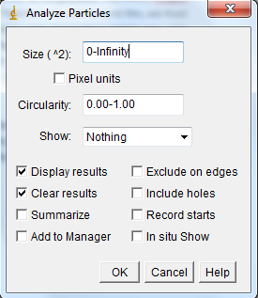

1. Click OK and this will generate Result window. CTRL+S to save, <slidename>.txt and then close everything. (I usually save it as GLOB_<filename>.txt to distinguish between globule and crescent file).

Second, process crescent file, we need R+G file

1. Similarly with globule, open RG_ file, then Threshold window.
2. Go to image -> Type -> HSB Stack
3. Go to image -> Stacks -> Stack to images. This will create three images “Hue”, “Saturation”, and “Brightness”. Select “Hue” and go to Image-> Duplicate and set name to Hue-1
4. Select Hue then go to Image-> Adjust -> Threshold and set it from 0-26, check “Dark Background”. Select Hue-1 then do the same but set Threshold from 240-255.
5. Select set Brightness to 52-255This will get only red-purple to red-orange colored crescent
6. Go to Process-> Image Calculator -> put Image1 as “Hue” and Image2 as “Hue-1” then Operation “OR” and check Create new result window. Keep the new result and close Hue and Hue-1. Go to Process-Image Calculator -> put Image1 as the first result and Image2 as “Brightness” then Operation “AND” and check Create new result window. Close the previous windows.
7. Select the newest result, then Analyze particles, save result (I usually save it as CRES_<filename>.txt)

Third, process contamination file, we need R file

1. Repeat Second process, except Hue is set to 0-52 instead of 0-26.

Picture example:

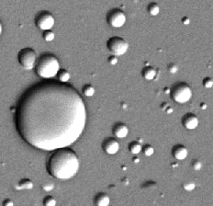

**Before thresholded**

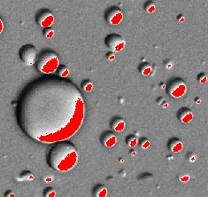

**After Thresholded “254 to 255 brightness”**

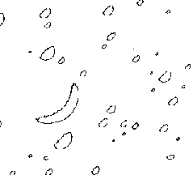

**ImageJ captures the area, location, and circularity of image**

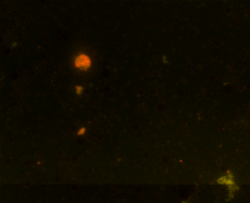

**Before Threshold**

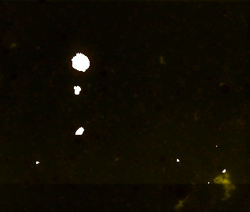

**After Threshold (0-26 Hue, 52-255 Brightness)**



ImageJ captures the area, location of the crescent.

2) Using Globulator.pl

A) Processing DIC Files



As seen above, globule captured is mostly half-circles. So we must correct the area into full circle area and x,y coordinate as well (since imageJ x,y center coordinate is off since it corresponds to the half-circle, not the full circle).

To correct area, we can use one important trend of the picture. This is due to the nature of photograph taken: Globules are flat, therefore the “white” part of the bigger globule will be more spread out. Furthermore, the “white” part of the smaller globule will be less spread out and cover the circle itself. Therefore, the circularity will be farther from 1, while the smaller globule will have circularity closer to 1.

*Circularity equation: Circularity = 4pi * Area/Perimeter^2 (taken from imageJ)*

From here on, Circle seen will be named with “o” (e.g. Ao = area of circle seen) , while real circle will be named with “t” (At). Based on observation of DIC samples, the perimeter of the circle seen (Po) consist of [half of real circle perimeter (Pt)] + [N of real circle perimeter], where 0.5 < N < 1.

N is roundness, a variable that depends on the major axis and minor axis. Major axis is the longest line from center. Minor axis is the line 90° of major axis.

*Round =Minor axis/MajorAxis (taken from imageJ)*

Example of image:

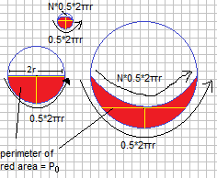

On the image above, major/minor axis is defined by the yellow line. When the shape is half-circle (as in the medium circle at picture above) axis is 2r, the minor axis is r, therefore round = r/2r = 0.5. When the shape is very crescent (biggest circle), Round is going to be less than 0.5. When the shape is almost round (smallest circle), Round is going to be more than 0.5.

Therefore, the equations are:

**First, perimeter of circle seen (Po) = 0.5*(2πRt ) + N*(2πRt) = (0.5+N)(2πRt)**

If the circle is perfectly half-circle, N will be 2r/2πr = 1/π

If the circle is perfectly round, N will be 0.5*2πr/2πr = 0.5

Therefore, the range of N possible is from (1/ π) to (0.5) => Range of N = (0.5-1/π).

The amount of N possible is a scale of roundness.

Therefore, N = 1/π + [abs(0.5-Round)/0.5*(0.5-1/π)].

Finally, Po = (0.5+1/ π + [(0.5-Round)/0.5*(0.5-1/π)]) (2πRt)

**Second, circularity = 4π Ao/Po2**

Circularity = 4π Ao/Po2

At * C = π Rt2 * 4π Ao/(Po2)

At  = π Rt2 * 4π Ao/(C* (0.5+1/ π + [abs(0.5-Round)/0.5*(0.5-1/π)] 2 *4π2 Rt2)

At = Ao/(C*[0.5+1/ π + (abs(0.5-Round)/0.5*(0.5-1/π))]^2) if

**At = Ao/(C*(0.5+1/ π + (abs(0.5-Round)/0.5*(0.5-1/π))))**

This equation gives ~10% variations in area.

However, if the circularity is too low (<0.1) which often happens on very large circle (or circle with very long and very slender white crescent-shaped but) , the circularity tends to be overemphasized because the area is very, very low while the perimeter is still very long. In this case, the Area is divided by lowering the circularity, which is [1/(Po^2) * C] instead of [Po^*C]

2) Correcting x and y coordinate

To correct x and y coordinate, we use another important trend. The globule white areas are always 315 degree tilted down (C°, below, is ~ 45°). Therefore, if we know the Radius and the minor axis, we will be able to correct the X and Y coordinate.

Note: minor is the yellow line

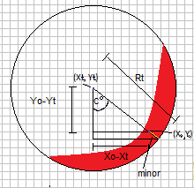

Using simple trigonometry we can calculate Xt and Yt:

(Rt-minor)cos(C°) = Xo-Xt => Xt = Xo-(Rt-minor)cos(C°)

(Rt-minor)sin(C°) = Yo-Yt => Yt = Yo-(Rt-minor)sin(C°)

B) Linking Globule with their crescents

Globule and crescent are linked by their distance

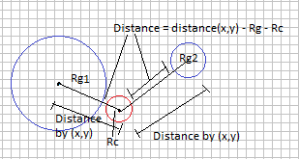

Distance is simply their x,y distance minus Rg and Rc.

Distance can’t be too far, and the limit is the diameter of each crescent. The limit is set as such because smaller crescent won’t be separated very far from their globules. This result in some crescents having no globule linked to them, which has been confirmed to be true by eye. These crescents will be called ambiguous crescent.