Sarah Bakker

8/13/2020

FDNProgramming

Module 5

**Module 5**

**Introduction:**

For this document I read through the chapter, watched the videos, and completed the FDN_py_Module_05 document.

**Writing my code:**

Loading Existing Data

Deleting an Entry

I started this section out with a basic idea of what I needed. I needed to ask the user which ID they wanted to delete and then delete that ID. I was unsure of how to incorporate this so I started looking online. The most common suggestion I found was to make a script that opens and reads the files. Then reopen the file in write mode and write my lines back (except for the lines I want to delete). I used this method for the assignment but worry how scalable this method is. I could see it causing issues if you have a huge database. Next I moved on to writing the code. I knew I had to

1. #------------------------------------------#
2. # Title: CDInventory.py
3. # Desc: Script CDINventory to store CD Inventory data
4. # Change Log: (Who, When, What)
5. # SBakker, 2020-Aug-3, Created File
6. #------------------------------------------#
8. # 1. Display menu allowing the user to choose: 'Add CD', 'Display Current Inventory', 'Save Inventory to file' and 'exit'
9. **import** sys
11. #def main_menu():
12. **print**("Please select one of the below options \nAdd CD \nDisplay Current Inventry \nSave Inventory to File \nExit")
13. menuchoice = input()
15. row1 = [1, 'The Big Wheel', 'Runrig']
16. row2 = [2, 'Bad', 'Michael Jackson']
17. tbl1 = [row1, row2]
19. # 2. Add data to the table (2d-list) each time the user wants to add data
21. **if** menuchoice == ('Add CD'):
22. **while** True:
23. **print**('enter ID (type \'exit\' to quit!)')
24. input1 = input()
25. **if** input1.lower() == 'exit': **break**
26. **print**('enter song title')
27. input2 = input()
28. **print**('please enter artist')
29. input3 = input()
30. row3 = [int(input1), input2, input3]
31. tbl1.insert(3, row3)
32. **print**('\n2D List:')
33. **for** row **in** tbl1:
34. **print**(row)
35. #print('press enter to add another row or type menu to return to menu')
36. #input4 = input()
37. #main_menu()

40. # 3. Display the current data to the user each time the user wants to display the data
42. **if** menuchoice == ('Display Current Inventory'):
44. tpldata01 = ('1', 'The Big Wheel', 'Runrig')
45. tpldata02 = ('2', 'Bad', 'Michael Jackson')
46. **print**('ID, CD, Artist')
47. **for** item **in** tpldata01:
48. **print**(item, end='|')
49. **print**()
50. intID, strCD, strArtist = tpldata02
51. **print**(intID, strCD, strArtist, sep='|')
53. # 4. Save the data to a text file CDInventory.txt if the user chooses so
55. **if** menuchoice == ('Save Inventory to File'):
56. objF = open('CDInventory_starter.txt', 'w')
57. strRow = ''
58. **for** item **in** row1:
59. strRow += str(item) + ','
61. strRow = strRow[:-1] + '\n'
62. objF.write(strRow)
63. objF.close()
65. #5. Exit the program if the user chooses so.
67. **if** menuchoice == ('Exit'):
68. sys.exit(menuchoice)

Figure 1. Code as seen in planetb.com

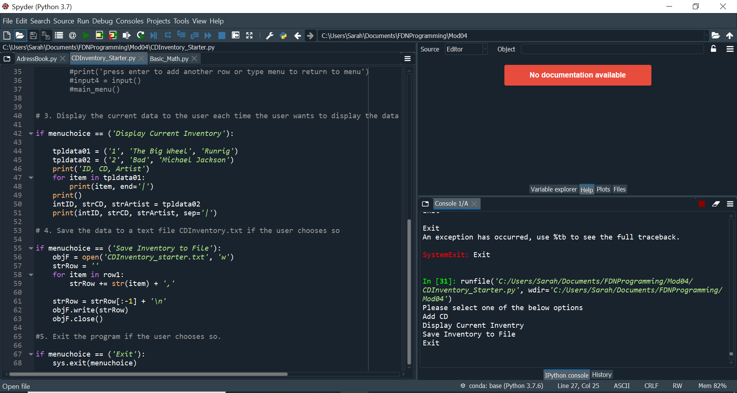

Figure 2. Image of my code working in Spyder

**Summary:**

The further I get in this class the more I am struggling. I probably spent around 6 hours on the homework assignment alone and even more time reviewing the module doc, watching the videos, and reading the book. It is frustrating because I still don’t understand some of the code I am creating and often times just feel like I am copying it off a website. I know it is acceptable to be looking up solutions on the internet but I want to be understanding these solutions. If I am not understanding the solutions how can I expect to ever be able to create my own Python files?

**Appendix:**

1. Dawson, Michael. Python Programming for Absolute Beginners. 3rd ed., Cengage Learning, 2010.