Electricity Generation and Environmental Justice Communities in North Carolina

Fiona Price, Summer Heschong, and Asreeta Ushasri

2024-12-12

## Reading layer `nc_plants' from data source   
## `/home/guest/UshasriPriceHeschong_ENV872_EDE_FinalProject/Data/Processed/nc_plants_EJ.gpkg'   
## using driver `GPKG'  
## Simple feature collection with 875 features and 139 fields  
## Geometry type: POINT  
## Dimension: XY  
## Bounding box: xmin: -84.17753 ymin: 33.9397 xmax: -75.53472 ymax: 36.533  
## Geodetic CRS: NAD83

## Reading layer `NC_Env_Justice' from data source   
## `/home/guest/UshasriPriceHeschong_ENV872_EDE_FinalProject/Data/Processed/NC_Env_Justice.gpkg'   
## using driver `GPKG'  
## Simple feature collection with 2672 features and 135 fields  
## Geometry type: MULTIPOLYGON  
## Dimension: XY  
## Bounding box: xmin: -84.32182 ymin: 33.75288 xmax: -75.40012 ymax: 36.58814  
## Geodetic CRS: NAD83

## Reading layer `North_Carolina_State_and_County_Boundary_Polygons' from data source `/home/guest/UshasriPriceHeschong_ENV872_EDE_FinalProject/Data/Spatial/North_Carolina_State_and_County_Boundary_Polygons.shp'   
## using driver `ESRI Shapefile'  
## Simple feature collection with 100 features and 9 fields  
## Geometry type: POLYGON  
## Dimension: XY  
## Bounding box: xmin: 406832.6 ymin: 34987.93 xmax: 3052480 ymax: 1043624  
## Projected CRS: NAD83(2011) / North Carolina (ftUS)

# Rationale and Research Questions

1. What is the distribution and capacity of power plants generating electricity in North Carolina?
2. Does electricity generation impact air quality through criteria air pollutant emissions in North Carolina?
3. What are the Environmental Justice implications of electricity power generation in North Carolina? Are power plants primarily located in low-income and disadvantaged communities?

# Dataset Information

The eGRID 2022 data set provides information on electricity generation in the United States. The U.S. EPA publishes this data to describe capacity and geographic distribution of different energy resources. The 2022 data is the most recent data (published in 2024), because it requires time to process and compile this national data into a workbook.

This project utilizes the Plant 2022 and the Generator 2022 data sheets. The Plant 2022 data sheet describes the capacity, location, and primary fuel source of every power plant in the United States. The Generator 2022 worksheet focuses on individual generators. Power plants often have multiple generators of various fuel types, (such as natural gas combined cycle plants). For this reason, the U.S. EPA includes a separate worksheet for generators specifically.

To understand the impact of electricity generation on environmental justice, this project includes the Climate and Economic Justice Screening Tool. The U.S. Council on Environmental Quality developed this tool to highlight communities that face unprecedented impact from environmental issues.

Lastly, this project incorporates spatial data to understand the geographic relation between plants, as well as between plants and environmental justice (EJ) communities. The spatial data is from NC OneMap; it includes a vector polygon dataset delineating official boundaries of the North Carolina counties (in addition to the North Carolina state boundary as well).

# Exploratory Analysis

As shown in @ref(fig:), natural gas generates the largest capacity of electricity power in North Carolina. The sum of natural gas power plants’ nameplate capacities outranks solar, nuclear and coal. This follows broader trends in the United States. After technological advances in horizontal drilling and shale fracking in the 2010s, natural gas became economically more efficient to process (Rapier, 2024). Natural gas has therefore transformed into a primary fuel source for electricity generation in the United States.

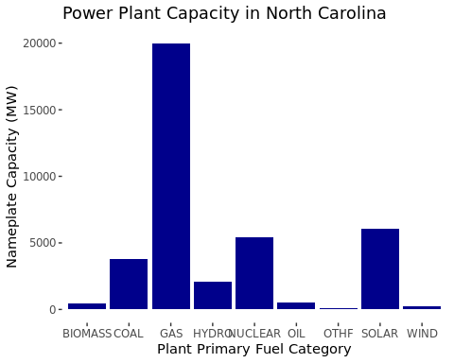

Total capacity (in MW) by Power Plant

Although natural gas contributes the most to electricity capacity in North Carolina, the number of solar power plants in the state is notably high, displayed in Figure @ref(fig:fig2). This indicates that North Carolina likely hosts numerous, small solar power plants across the state. Solar power plants are small in capacity, but remain the most popular renewable resource in the state.

Solar power plants are evenly throughout the state of North Carolina, depicted in Figure @ref(fig:), except in Western North Carolina along the Appalachian range. In this mountainous region, hydro power plants are more common than solar power plants.

In North Carolina, natural gas power plants are absent from the atlantic coast area. For the most part, natural gas power plants are instead located slightly inland (though spread across counties).

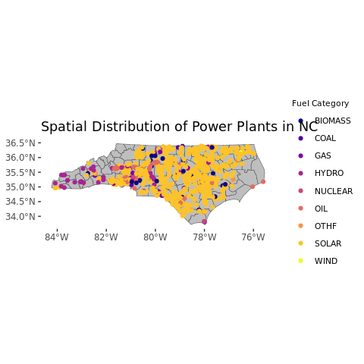

Power Plant Locations in North Carolina

While the number of solar power plants is large, Figure @ref(fig:) showcases that each solar plant contains a relatively small electricity generation capacity. The natural gas and coal power plants, though lower in number, producer a larger share of electric power in the state.

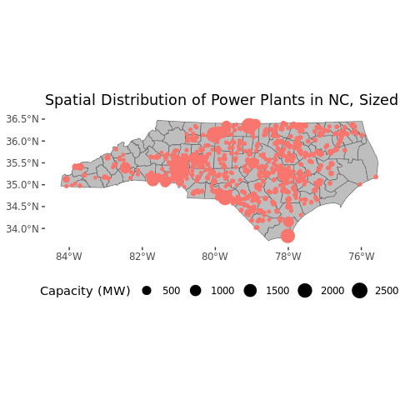

Power Plant Nameplate Capacity (MW) by Location in North Carolina

Figure @ref(fig:fig5) maps census tract disadvantaged status, while Figure @ref(fig:fig6) maps census tract disadvantaged status and power plant location. A few disadvantaged counties have a concentration of power plants in the Southern area of the state. However, the Raleigh metropolitan area is not classified as disadvantaged, but also has a notable concentration of power plants. Therefore, further investigation is required to understand if any correlation exists between census tract status and power plant locations.

The fuel type of the power plant also impacts front-line communities. Coal and natural gas power plants influence air quality due to the release of criteria air pollutants such as NOx. There are a handful of natural gas and oil power plants located around Robeson and Scotland county, but there are also many solar power plants in these areas. The Raleigh metropolitan area also has a couple of natural gas power plants.

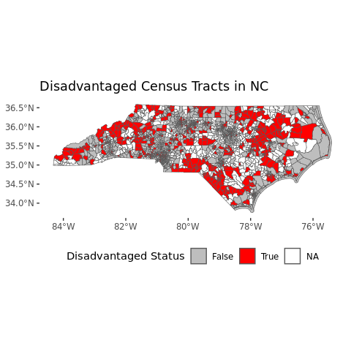

Disadvantaged Census Tracts in North Carolina

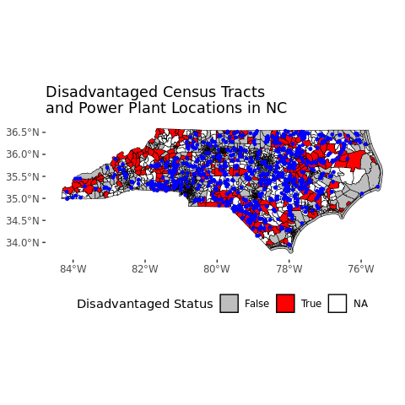

Disadvantaged Census Tracts and Power Plant Locations in North Carolina

This project aims to explore primary fuel type of electricity generation along with environmental justice to determine if any spatial patterns or injustices exist regarding electricity generation in North Carolina.

# Analysis

## Question 1: What is the distribution and capacity of power plants generating electricity in North Carolina?

### Question 1a: Which type of plant has the highest capacity?

The exploratory analysis above investigates which plant fuel category has the highest capacity. In total, gas, solar, nuclear, and coal have the highest generation capacities. However, this does not reflect the average capacity for each fuel type, as shown in figure below. As displayed in this graph, nuclear has the highest average capacity, followed by coal, gas, wind, hydro, other, biomass, oil, and solar. Although natural gas has the highest total capacity, each individual plant has a lower average capacity than nuclear and coal. This suggests there is a greater quantity of natural gas plants than nuclear or coal.

### Question 1b: Which type of plant is the most common?

Although natural gas contributes the most to electricity capacity in North Carolina, the number of solar power plants in the state is notably high, displayed below in Figure @ref(fig:fig7). This graph shows the number of each type of plant. Solar is by far the most common, followed by oil, hydro, biomass, and gas. The reason solar does not have the highest total capacity in MW for NC (despite being the most common) is that it has the lowest average capacity for each plant. This indicates that North Carolina likely hosts numerous, small solar power plants across the state. Solar power plants are small in capacity, but remain the most popular renewable resource in the state.

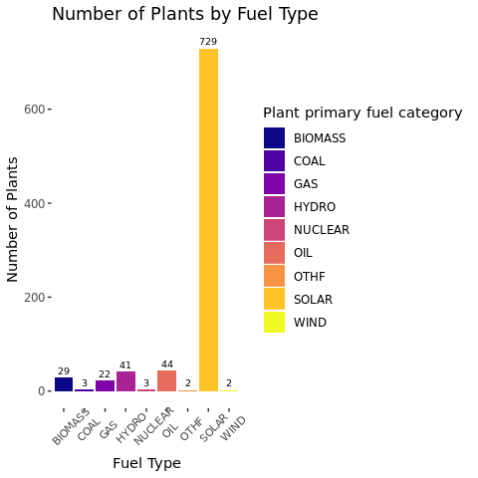

Number of Power Plants by Fuel Type in North Carolina

### Question 1c: Where are most plants located?

As depicted in Figure @ref(fig:fig8), the ten counties with the most power plants are, in order, Robseon, Duplin, Wayne, Nash, Cleveland and Johnston (tied at 29), and Bladen, Catawba, Halifax, and Randolph (all tied at 17). To understand the breakdown of power plants by fuel type in the county with the most plants (Robeson), this county was isolated for analysis (Figure @ref(fig:fig9)). The primary power plant type in Robeson County was solar (41 plants, versus biomass (2) and oil (1)).

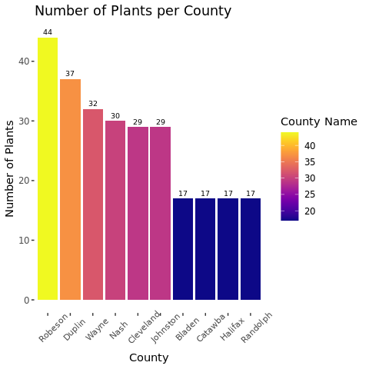

Top Ten Counties with Power Plant Sites

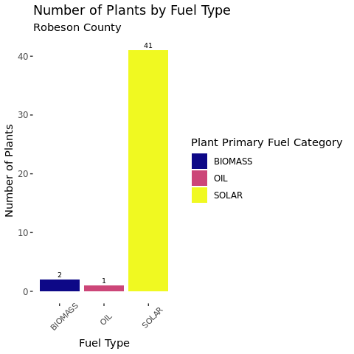

Primary Fuel Category of Robeson County Power Plants

## Question 2: Does electricity generation impact air quality through criteria air pollutant emissions in North Carolina?

### Question 2a: How do power plants contribute to carbon dioxide equivalent emissions in North Carolina?

As shown in the bar chart on CO2 Equivalent Emissions (Figure @ref(fig:fig10)), only natural gas and coal-fired power plants release large quantities of carbon emissions when generating electricity.

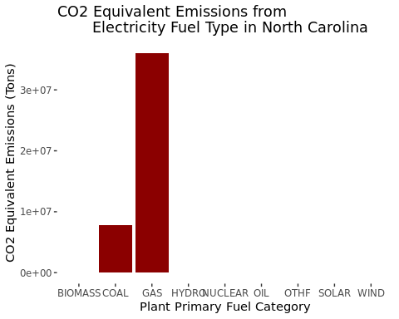

CO2 Equivalent Emissions from Electricity Generation in North Carolina

Analyzing this spatially (Figure @ref(fig:fig11)), coal and natural gas power plants release more carbon dioxide equivalent emissions than renewable resources. This impacts counties with and without the disadvantaged status. Emissions from natural gas power plants in particular border disadvantaged communities, even when the power plant itself is not located in a disadvantaged community.

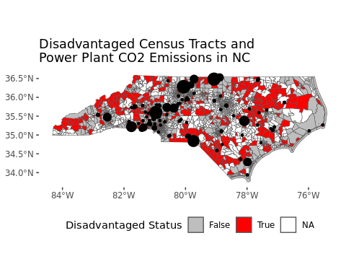

CO2 Equivalent Emissions from Power Plants (in tons) and Disadvantaged Communities in North Carolina

This influences the cumulative environmental justice impacts in a community. Cumulative impacts is the combination of chemical and environmental stressors from multiple pathways which influence the health and well-being of a community (Bakkensen et al., 2024). In essence, cumulative impacts account for different sectors of the environment, such as air quality and water quality, which are typically management by different public departments. Because air quality and water quality are monitored separately, recognizing the overlapping effect that two separate environmental stressors have on a community is crucial to creating equitable environmental policies. Therefore, exposure to air pollutants on top of economic disadvantage harms the larger health outcomes of North Carolina counties.

### Question 2b: What is the distribution of NOx emissions from power plants in North Carolina?

NOx is listed as one of the six criteria air pollutants by the U.S. EPA (Suh et al., 2000). Nitric oxides react with volatile organic compounds and sunlight to produce ground-level ozone (Suh et al., 2000). Ground-level ozone reacts negatively with lung tissue, causing burning in the lungs and breathing difficulties for vulnerable populations such as young kids, elderly adults, and individuals with disabilities or asthma (Suh et al., 2000).

Mapping NOx emissions along with counties reveals that counties with and without disadvantaged status face NOx emissions when located close to fossil fuel power plants. In the map below (Figure @ref(fig:fig12)), the dark circles represent NOx emissions from power plant sites. Larger circles indicate a greater amount of NOx emissions in tons. Examining correlation between census tract disadvantaged status and power plant location will reveal if power plants are disproportionately located close to disadvantaged communities. Given that natural gas and coal plants release high levels of NOx and carbon emissions, proximity to these power plants could impact public health outcomes.

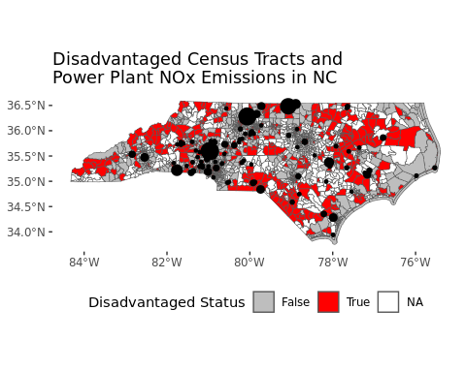

NOx Emissions from Power Plants (in tons) and Disadvantaged Communities in North Carolina

### Question 2c: What is the distribution of SO2 emissions from power plants in North Carolina?

SO2 is another criteria air pollutant tracked by the U.S. EPA (Saxena, 2019). Sulfur dioxide contributes to acid rain, which deteriorates building materials and plant life. Acid rain does not directly impact human health, but indigesting and inhaling acidic compounds formed from sulfur is dangerous for humans (Saxena, 2019). This can also impact pulmonary issues (Saxena, 2019).

As depicted in the map of SO2 emissions below (Figure @ref(fig:fig13)), coal power plants contribute the most to sulfur dioxide. The black circles represent emissions; the larger the circle, the greater the power plant’s emissions. A reduction in sulfur dioxide emissions is one of the advantages to natural gas over coal. Natural gas does not release as much sulfur as coal combustion. The nation-wide trend of shifting from coal to natural gas reduces the sulfur released in the air. Determining the impact of power plant proximity on disadvantaged communities requires further investigation into the correlation between location and environmental justice communities.

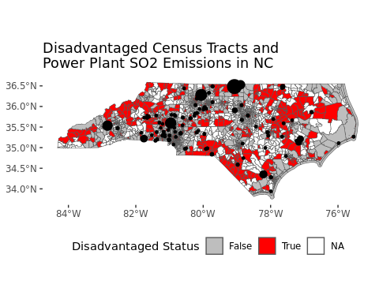

SO2 Emissions from Power Plants (in tons) and Disadvantaged Communities in North Carolina

## Question 3: What are the Environmental Justice implications of electricity power generation in North Carolina?

### Question 3a: Are power plants primarily located in low-income and disadvantaged communities?

In order to determine whether power plants are disproportionately located in disadvantaged counties a chi-squared test was conducted comparing observed and expected counts of power plants in disadvantaged vs. non-disadvantaged counties. The results showed a statistically significant difference, with disadvantaged counties hosting more power plants than would be expected by chance. This suggests a potential inequity in the distribution of power plants, raising environmental justice concerns.

As mentioned earlier, fossil fuel-based power plants, particularly coal and natural gas facilities, are significant sources of criteria air pollutants, such as NOx and SO2, which can exacerbate respiratory health issues. Disadvantaged communities near these plants may experience higher exposure to air pollution, contributing to cumulative environmental stressors that affect public health. Since the first chi-squared test took into account power plants of all fuel types, another was performed only taking into consideration power plants that are the worst for public health. The results of this test also showed a statistically significant difference.

##   
## Chi-squared test for given probabilities  
##   
## data: observed  
## X-squared = 6.673, df = 1, p-value = 0.009789

##   
## Chi-squared test for given probabilities  
##   
## data: observed  
## X-squared = 12.482, df = 1, p-value = 0.0004108

# Summary and Conclusions

This project examined the distribution and capacity of power plants in NC, the impact of power plants on air pollution, and the Environmental Justice implications of these plants in NC using data from eGRID 2022, CEJST, and NC OneMap.

The analysis explored three primary research questions. First, the capacity and distribution of power plants in NC was examined. It revealed that natural gas is the largest contributor to electric capacity, while nuclear and coal plants have the highest average capacities. Solar power plants are the most numerous though they have the lowest average capacity. Additionaly, the most plants were located in Robeson County.

Next, the impact of electricity generation on air quality was examined. Natural gas and coal power plants are both significant sources of carbon emissions, fossil fuel produces NOx emissions, and coal contributes the most to SO2 emissions. Because all three of these are significantly harmful to public health it was important to examine their location and proximity to disadvantaged communities.

Finally, the Environmental Justice implications of electric power generation in NC were examined. A chi-squared test revealed a statistically significant over representation of power plants in disadvantaged counties which suggests an inequitable distribution of environmental burdens. However, there were several census tracts in the CEJST data that were listed as ‘no data’ for whether they are disadvantaged or not, and this may have affected the outcome of the analysis.

This project highlights the complex interplay between energy production and environmental health and equity in North Carolina. While the state’s shift toward renewable energy like solar power is a positive trend it does not erase the existing inequities in the distribution of other types of power plants and their associated impacts. It seems that disadvantaged communities bear a disproportionate amount of environmental burdens from fossil fuel power generation indicating a need for more equitable energy policies.

# References

Bakkensen, L. A., Ma, L., Muehlenbachs, L., & Benitez, L. (2024). Cumulative impacts in environmental justice: Insights from economics and policy. *Regional Science and Urban Economics, 107*, 103993. <https://doi.org/10.1016/j.regsciurbeco.2024.103993>

Rapier, R. (2024, May 20). *How Natural Gas And Renewables Dethroned Coal In America*. Forbes. <https://www.forbes.com/sites/rrapier/2024/05/20/how-natural-gas-and-renewables-dethroned-coal-in-america/>

Saxena, P., & Sonwani, S. (2019). Primary Criteria Air Pollutants: Environmental Health Effects. In Criteria Air Pollutants and their Impact on Environmental Health (pp. 49–82). *Springer Singapore*. <https://doi.org/10.1007/978-981-13-9992-3_3>

Suh, H. H., Bahadori, T., Vallarino, J., & Spengler, J. D. (2000). Criteria air pollutants and toxic air pollutants. *Environmental Health Perspectives, 108*(suppl 4), 625–633. <https://doi.org/10.1289/ehp.00108s4625>

U.S. Council on Environmental Quality. (2024). *Climate and Economic Justice Screening Tool, 2022*. <https://screeningtool.geoplatform.gov/en/>

U.S. Environmental Protection Agency. (2024). *Emissions and Generation Resource Integrated Database (eGRID), 2022*. <https://www.epa.gov/egrid/download-data>

U.S. Environmental Protection Agency. (2024). *Emissions and Generation Resource Integrated Database (eGRID), Technical Guide 2022*. <https://www.epa.gov/egrid/egrid-technicalguide>.