SIMATS ENGINEERING (SAVEETHA SCHOOL OF ENGINEERING)
Department of Computer Science and Engineering
CO3_AT3 — VISUALIZATION CRITIQUE & REDESIGN

Course Code: | DSA06 | Course Title: | Data Handling and Visualization
CO Assessed: | CO3 – Evaluation (BL5) | Assessment: | Assessment Tool 3 – Critique & Redesign
Weightage: | 20% of CIA | Total Marks: | 25 (5 Questions × 5 Marks)
CO3 Statement: | Evaluate flawed or misleading data visualizations, critique their specific shortcomings, and justify an improved redesign.(BL5)
Student Name: | s.sri mathi | Reg. No.: | 192424095
Section / Batch: | Slot c | Date: | 18-08-2026

Code of Conduct
I s.sri mathi (Name / Reg No) certify that this submission is my original work and that I have adhered to the guidelines specified for this assessment. I understand that any violation of academic integrity rules will result in disciplinary action.


Signature of the Student:

Instructions
- This test contains 5 questions, each carrying 5 marks. Total: 25 Marks.
- No negative marking. Unanswered questions carry zero marks.
- No calculators or electronic devices permitted.
- Duration: 90 minutes.
- Each answer must go beyond simply naming a flaw: explain WHY it is misleading and what a reader could wrongly conclude from it.
- Your redesign must be a specific, justified chart proposal — not just “use a different chart.”
- Diagrams may be hand-drawn or clearly described in words if drawing tools are unavailable.

Annexure A – VISUALIZATION CRITIQUE & REDESIGN

Rubrics for Calculation ASSESSMENT RUBRIC
AT3 — Visualization Critique & Redesign
CO3 · BT5: Evaluate ·
This rubric is used to assess student responses to the CO3-AT3 Visualization Critique & Redesign problems, in which students are given a flawed or misleading chart, must critique its specific shortcomings, and propose a justified redesign.

Criteria | Weightage | Level 4 – Exemplary | Level 3 – Proficient | Level 2 – Developing | Level 1 – Beginning
Understanding of Concepts | 25% | Demonstrates thorough understanding of the specific visualization principle being violated (e.g., proportional ink, axis scaling, color perception, overplotting) in the given flawed chart. | Good understanding of the relevant principle, with only minor gaps in identifying exactly what is violated. | Basic understanding, but with some misconceptions about which principle applies to the flaw shown. | Poor understanding of core principles; misidentifies the nature of the flaw entirely.
Explanation | 25% | Clearly explains why the flaw is misleading, including what a reader could wrongly conclude as a result — not just that something is 'wrong.' | Explains the flaw with adequate reasoning, covering most of why it misleads a reader. | Identifies the flaw but explanation is generic or only loosely tied to its misleading effect. | Little or no explanation of why the flaw is misleading; the critique is a bare assertion.
Application | 20% | Proposes a specific, well-justified redesign that directly resolves the identified flaw, correctly applying appropriate chart-selection and design principles. | Proposes a workable redesign that resolves the flaw, with only minor gaps in justification. | Proposes a redesign, but it only partially resolves the flaw or lacks sufficient justification. | Fails to propose a workable redesign, or the redesign does not address the identified flaw.
Organization | 15% | The response is clearly structured, addressing both the critique and the redesign in a logical sequence with coherent overall flow. | The response is organized and addresses both parts, with only minor issues in flow or clarity. | Basic structure; both parts are addressed but the response lacks clarity or a logical sequence. | Poorly organized; the response is incoherent, and one or both parts are left unaddressed.
Accuracy | 10% | Both the critique and the redesign are completely accurate and well-suited to the specific chart and data described. | Mostly accurate, with only minor omissions or a small error in the critique or redesign. | Partially correct; the critique or redesign contains notable inaccuracies or mismatches to the scenario. | Largely incorrect or inappropriate, with major gaps in both the critique and the redesign.

Scoring Guide
For each criterion, award a performance level (1–4) based on the descriptors above. Multiply the level achieved (as a percentage of 4, i.e., Level 4 = 100%, Level 3 = 75%, Level 2 = 50%, Level 1 = 25%) by the criterion's weightage, then sum across all five criteria to obtain the total score out of 100%.

Faculty In-charge | Course Coordinator | Head of Department
Signature: _______________ | Signature: _______________ | Signature: _______________
Date: ___________________ | Date: ___________________ | Date: ___________________

CO 3 AT 3
VISUALIZATION CRITIQUE & REDESIGN

NAME: S.SRI MATHI
REG.NO: 192424095
COURSE CODE: DSA0606
COURSE NAME: DATA HANDLING AND VISUALIZATION
DATE: 18.08.2026

Problem 2 (5 Marks)
Scenario: A quarterly sales report uses a 3D, tilted pie chart to compare 4 regions' revenue share.

a) Critique the visual distortion introduced by the 3D tilt.
b) Redesign: propose a flat alternative and explain why it fixes the distortion.

a) Critique the visual distortion
The 3D tilted pie chart introduces perspective distortion. Slices positioned at the front appear visually larger, while slices at the back may appear smaller, even when their actual revenue shares are similar. This makes accurate comparison between regions difficult. The 3D effect adds visual decoration without providing useful information and can mislead the viewer about the actual revenue proportions.

b) Redesign
A flat 2D bar chart should be used instead of the 3D pie chart. A bar chart represents each region using a common baseline, making differences in revenue share easier and more accurate to compare. It removes the perspective and depth distortion created by the 3D effect.
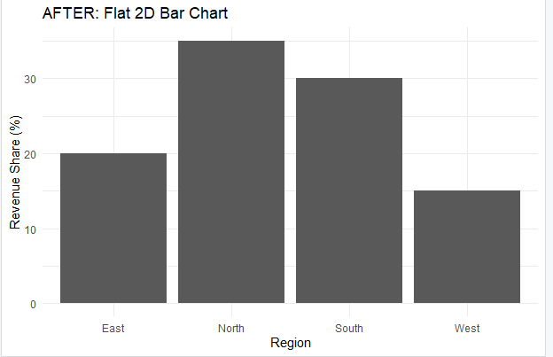
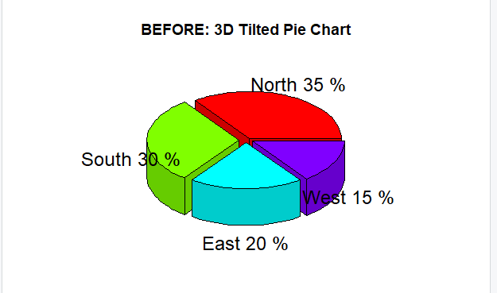

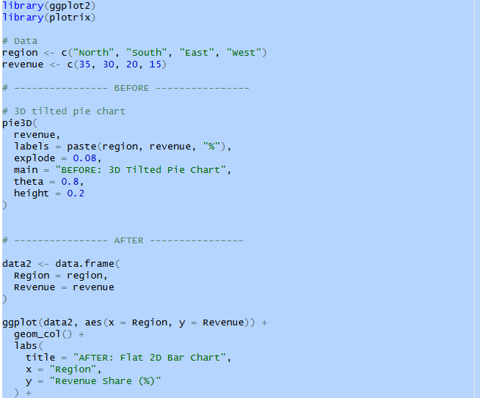
R code:

Problem 6 (5 Marks)
Scenario: A report converts department gender data into a 100% stacked bar chart without showing the total headcount of each department.

a) Critique what critical information is hidden by this design.
b) Redesign: propose how to present the data so the hidden information becomes visible.

a) Critique what information is hidden
A 100% stacked bar chart displays only the percentage distribution of male and female employees within each department. It does not show the total headcount of each department.
For example, two departments may both have 50% male and 50% female employees, but one may have 20 employees while another has 200 employees. The 100% stacked chart would make them appear identical. Therefore, the chart hides the actual workforce size and may lead to incorrect conclusions about the number of employees.

b) Redesign
A grouped bar chart showing actual headcounts should be used. Each department can have separate bars for male and female employees, with the y-axis showing the number of employees.
This allows the viewer to understand both gender distribution and department size. If percentage comparison is also important, the percentages can be displayed as labels alongside the actual counts.
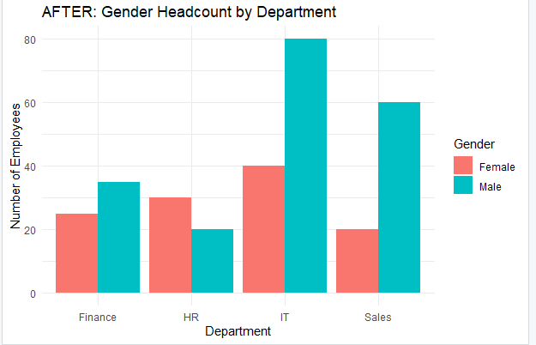
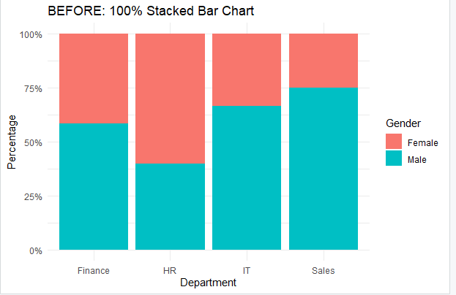

R code:
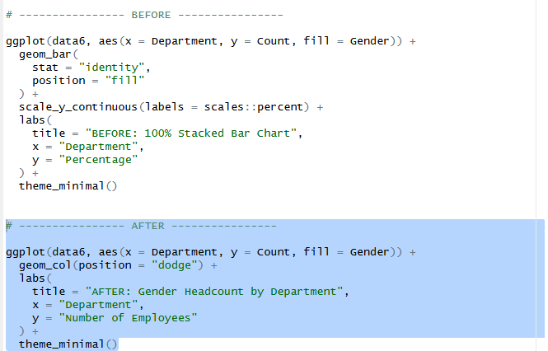
Problem 15 (5 Marks)
Scenario: A chart comparing delivery times across regions shows no indication of outliers, even though one region has a shipment that took 10 times longer than typical.

a) Critique why hiding this outlier is a problem.
b) Redesign: propose a chart type and a specific rule that would flag this outlier.

a) Critique why hiding the outlier is a problem
Hiding an extreme delivery time is misleading because the outlier is an important part of the dataset. A shipment taking 10 times longer than normal may indicate a delivery failure, logistical problem, unusual circumstance, or possible data error.
If the outlier is hidden, the distribution may appear more consistent than it actually is. This can cause management to underestimate delivery problems and make incorrect decisions about logistics performance.

b) Redesign
A box plot should be used because it displays the median, quartiles, spread, and unusual observations.
The 1.5 × IQR rule can be used to identify outliers:
IQR=Q3−Q1
An observation is considered an outlier when:
x<Q1−1.5(IQR)
The outlier will appear as a separate point outside the whiskers.
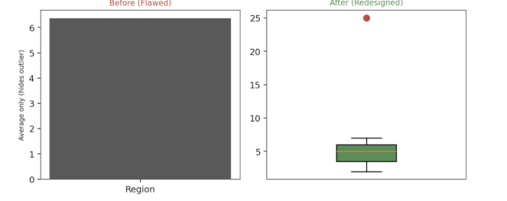

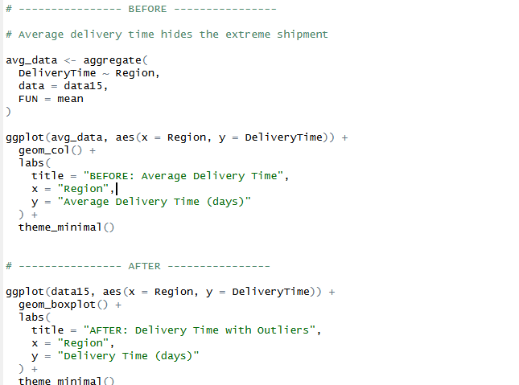
R code:

Problem 19 (5 Marks)
Scenario: A report shows 12 overlapping line charts (one per product), all drawn in similar shades of blue with no legend, comparing monthly sales trends.

a) Critique the specific problems with this chart.
b) Redesign: propose a clearer way to present 12 products' trends.

a) Critique the specific problems
The chart has several problems:
- Overplotting: Twelve lines overlap, making individual trends difficult to follow.
- Poor color differentiation: Similar shades of blue are difficult to distinguish.
- No legend: There is no clear way to identify which line belongs to which product.
- High visual complexity: Too many lines in one chart increase the viewer's cognitive load.
- Hidden trends: Important changes in individual products may be obscured by other lines.
Therefore, although the chart contains all the data, it communicates the information poorly.

b) Redesign
Use small multiples (faceted line charts), where each product is displayed in a separate panel.
The same x-axis and y-axis scales should preferably be maintained across all panels so that the trends remain comparable.
Another option is to use interactive highlighting, where the user selects one product while the others become less prominent. For a static R assignment, however, faceting is the clearer choice.

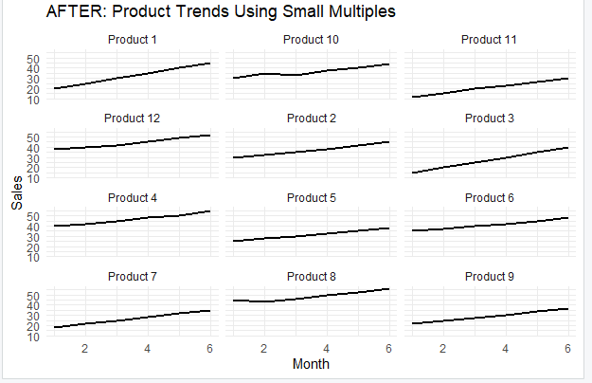
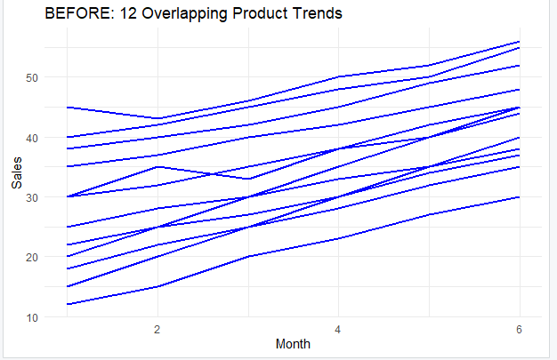
R code:
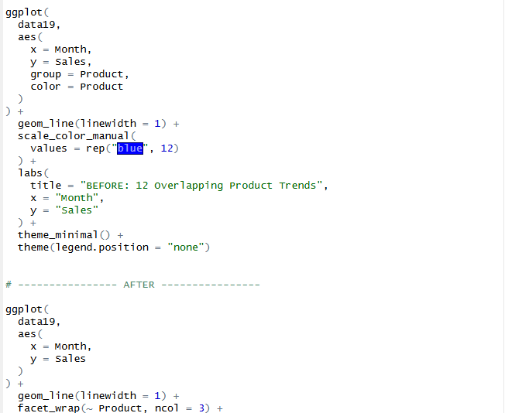

Problem 23 (5 Marks)
Scenario: A choropleth-style heatmap of sales by region uses a rainbow color scale (not perceptually ordered) to represent a continuous variable.

a) Critique this color scale choice and why it makes the map hard to read.
b) Redesign: propose an appropriate color scale and explain why it is better suited to this data.

a) Critique the color scale
The rainbow color scale is inappropriate for representing a continuous variable such as sales. Rainbow colors do not provide a consistent perceptual progression from low to high values. Changes between colors can appear larger or smaller than the actual numerical differences.
The abrupt transitions between blue, green, yellow, red, and purple can make it difficult to determine the ordering and magnitude of sales. Rainbow scales can also reduce accessibility for people with certain forms of color-vision deficiency.

b) Redesign
A sequential color scale should be used because sales values progress from low to high.
For example:
Light blue → Medium blue → Dark blue
Low sales can be represented using a light shade, while high sales can use a darker shade.
A sequential scale provides a clear visual ordering and makes it easier to understand which regions have lower or higher sales.
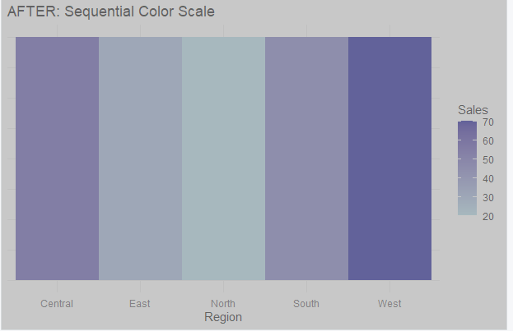
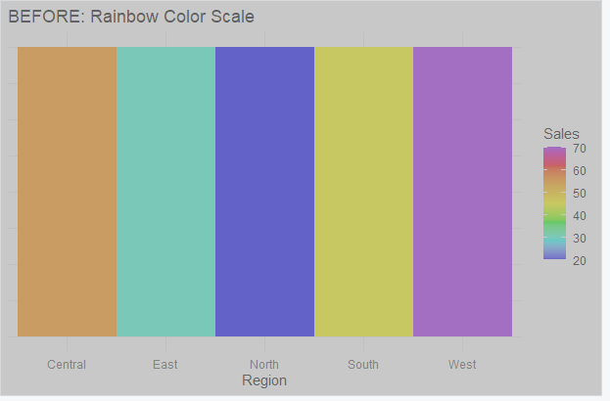
R code:
