SIMATS ENGINEERING (SAVEETHA SCHOOL OF ENGINEERING)
Department of Computer Science and Engineering
CO2_AT1 — CHART CONSTRUCTION TEST

Course Code: | DSA06 | Course Title: | Data Handling and Visualization
CO Assessed: | CO2 – Construction (BL3) | Assessment: | Assessment Tool 1 – Chart Construction
Weightage: | 20% of CIA | Total Marks: | 25 (5 Questions × 5 Marks)
CO2 Statement: | Apply appropriate chart construction techniques — correct chart type, axes, scales, and calculations — to accurately represent given data.(BL3)
Student Name: | S.SRI MATHI | Reg. No.: | 192424095
Section / Batch: | SLOT C | Date: | 30-07-2026

Code of Conduct
I S.SRI MATHI (Name / Reg No) certify that this submission is my original work and that I have adhered to the guidelines specified for this assessment. I understand that any violation of academic integrity rules will result in disciplinary action.
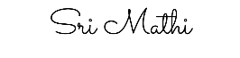
Signature of the Student:

Instructions
- This test contains 5 questions, each carrying 5 marks. Total: 25 Marks.
- No negative marking. Unanswered questions carry zero marks.
- No calculators or electronic devices permitted.
- Duration: 75 minutes.
- Graph paper or a ruler is recommended for accurate, to-scale drawing.
- Show all calculations (e.g., percentages, angles, bin ranges, five-number summaries) as part of your answer.
- Every chart must include a title, correctly labeled axes, and a legend where applicable.
Annexure A – CHART CONSTRUCTION
Problem 9 — Histogram — Binning (5 Marks)
Data: Exam scores for 20 students: 45, 52, 58, 61, 63, 65, 67, 68, 70, 72, 73, 75, 76, 78, 80, 82, 85, 88, 90,95.
Task: Construct a histogram using 5 equal-width bins spanning the full data range. Show your bin boundaries and the frequency count in each bin.
Problem 10 — Scatter Plot — Basic Construction (5 Marks)
Data: Study hours vs. exam score for 8 students: (2,50), (3,55), (4,62), (5,68), (6,74), (7,80), (8,85), (9,90).
Task: Construct a scatter plot plotting each (x, y) pair as an individual point. Label both axes with appropriate scales.
Problem 11 — Scatter Plot — With Trend (5 Marks)
Data: Advertising spend ($'000) vs. sales ($'000) for 10 companies: (5,20), (8,28), (10,35), (12,40),
(15,50), (18,55), (20,62), (22,68), (25,75), (28,82).
Task: Construct a scatter plot of this data and sketch an approximate trend line through the points, describing the relationship you observe.
Problem 12 — Area Chart — Cumulative Growth (5 Marks)
Data: Cumulative app downloads (thousands) over 6 months: Jan=5, Feb=12, Mar=22, Apr=35, May=52,
Jun=75.
Task: Construct an area chart showing the cumulative downloads over time, with the area beneath the
line shaded.
Problem 13 — Bubble Chart — Three Variables (5 Marks)
Data: Products, given as (Price $, Rating /5, Sales Volume): Product A = (20, 4.2, 500), Product B = (35,
3.8, 300), Product C = (15, 4.5, 700).
Task: Construct a bubble chart with Price on the x-axis, Rating on the y-axis, and bubble size
representing Sales Volume. Label each bubble.
Rubrics for Calculation ASSESSMENT RUBRIC
AT1 — Chart Construction Test
CO2 · BT3: Apply ·
This rubric is used to assess student responses to the CO2-AT1 Chart Construction Test, in which students are given a small dataset and must construct an accurate, correctly labeled chart of a specified type.

Criteria | Weightage | Level 4 – Exemplary | Level 3 – Proficient | Level 2 – Developing | Level 1 – Beginning
Understanding of Concepts | 25% | Demonstrates thorough, accurate understanding of the correct chart type, and the axes, scale, and elements required to construct it for the given data. | Good understanding of the required chart type and construction elements, with only minor gaps. | Basic understanding of chart construction, but with some misconceptions about the correct chart type, axes, or scale. | Poor understanding of core construction concepts; selects a chart type or elements fundamentally unsuited to the data.
Explanation | 25% | Shows detailed, clearly worked calculations (e.g., angles, bin ranges, five-number summary) and explains each construction step. | Shows clear calculations and construction steps, with adequate explanation for most parts. | Calculations or construction steps are shown but incomplete, or explanations are superficial. | Little or no working shown; calculations and construction steps are missing or unexplained.
Application | 20% | Effectively applies chart construction techniques to produce a complete, accurate chart correctly matched to the data. | Applies construction techniques to produce a correct chart, with only minor errors. | Limited application of construction techniques; the chart partially represents the data but has notable errors. | Fails to apply appropriate construction techniques; the chart does not correctly represent the data.
Organization | 15% | The chart is neatly and logically constructed, with a title, correctly labeled axes, a legend where applicable, and elements in a clear order. | The chart is well organized, with only minor issues in labeling, legend, or layout. | Basic construction; required elements (title, axes, legend) are present but poorly arranged or partly missing. | Poorly constructed; the chart is missing key elements such as a title, axis labels, or a legend.
Accuracy | 10% | The chart is completely accurate — all values, proportions, scales, and calculations correctly match the given data. | Mostly accurate, with only minor omissions or a small error in one value or calculation. | Partially correct; some plotted values, proportions, or calculations are missing or incorrect. | Largely inaccurate; major errors in plotted values, proportions, or calculations relative to the given data.

Scoring Guide
For each criterion, award a performance level (1–4) based on the descriptors above. Multiply the level achieved (as a percentage of 4, i.e., Level 4 = 100%, Level 3 = 75%, Level 2 = 50%, Level 1 = 25%) by the criterion's weightage, then sum across all five criteria to obtain the total score out of 100%.

Faculty In-charge | Course Coordinator | Head of Department
Signature: _______________ | Signature: _______________ | Signature: _______________
Date: ___________________ | Date: ___________________ | Date: ___________________

CO 2 AT 1
CHART CONSTRUCTION TEST

NAME: S.SRI MATHI
REG.NO: 192424095
COURSE CODE: DSA0606
COURSE NAME: DATA HANDLING AND VISUALIZATION
DATE: 30.07.2026

Problem 9 – Histogram – Binning
Introduction
A histogram is a graphical representation of the frequency distribution of continuous numerical data. It groups data into equal-width intervals called bins, where the height of each bar represents the number of observations within that interval. Unlike a bar chart, the bars in a histogram touch each other because the data is continuous.
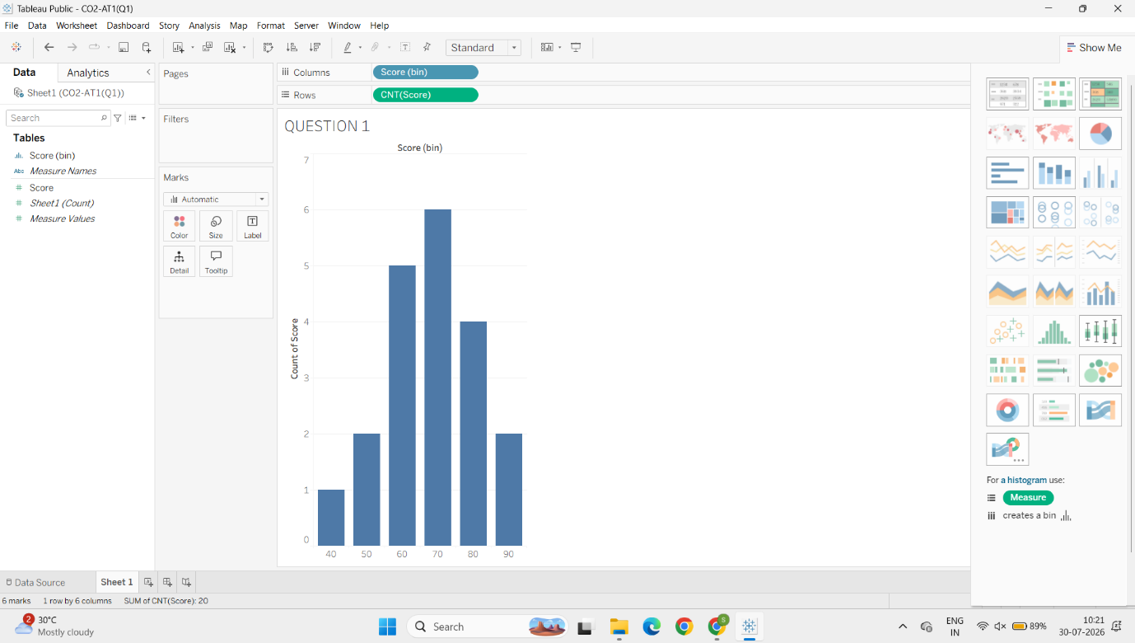Data Range
- Lowest Score = 45
- Highest Score = 95
- Range = 95 − 45 = 50
- Number of bins = 5
- Bin Width = 50 ÷ 5 = 10
Bin Boundaries and Frequencies
Bin | Scores Included | Frequency
45–54 | 45, 52 | 2
55–64 | 58, 61, 63 | 3
65–74 | 65, 67, 68, 70, 72, 73 | 6
75–84 | 75, 76, 78, 80, 82 | 5
85–95 | 85, 88, 90, 95 | 4
Evidence
The histogram shows that the highest concentration of students scored between 65 and 84 marks. Very few students scored below 55, while four students scored above 85.
Interpretation
The score distribution indicates that most students achieved average to above-average marks. There are no major gaps between score ranges, suggesting a fairly balanced distribution without extreme clustering.
Conclusion
A histogram provides a clear visualization of how numerical data is distributed. It helps identify the most common score intervals, the spread of data, and overall performance patterns.
Problem 10 – Scatter Plot
Introduction
A scatter plot is used to study the relationship between two quantitative variables. Each observation is represented by a single point whose position is determined by its x-coordinate and y-coordinate.
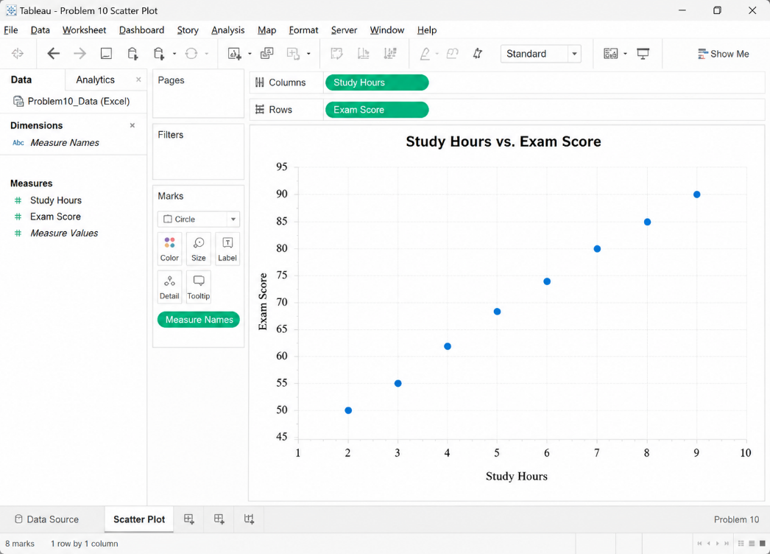
- X-axis: Study Hours
- Y-axis: Exam Score
Each student is plotted individually.
Study Hours | Exam Score
2 | 50
3 | 55
4 | 62
5 | 68
6 | 74
7 | 80
8 | 85
9 | 90
Evidence
The plotted points gradually move upward from left to right without any major outliers. Students who studied more hours generally obtained higher scores.
Interpretation
The scatter plot indicates a strong positive relationship between study hours and exam scores. As study time increases, exam performance also increases. Although the scatter plot shows correlation, it does not prove that studying is the only factor affecting scores.
Conclusion
A scatter plot is an effective visualization for identifying relationships between two numerical variables. It helps detect trends, correlations, and unusual observations in the data.
Problem 11 – Scatter Plot with Trend Line
Introduction
A scatter plot with a trend line is used to visualize both the relationship between two variables and the overall direction of that relationship. The trend line summarizes the general pattern followed by the data points.
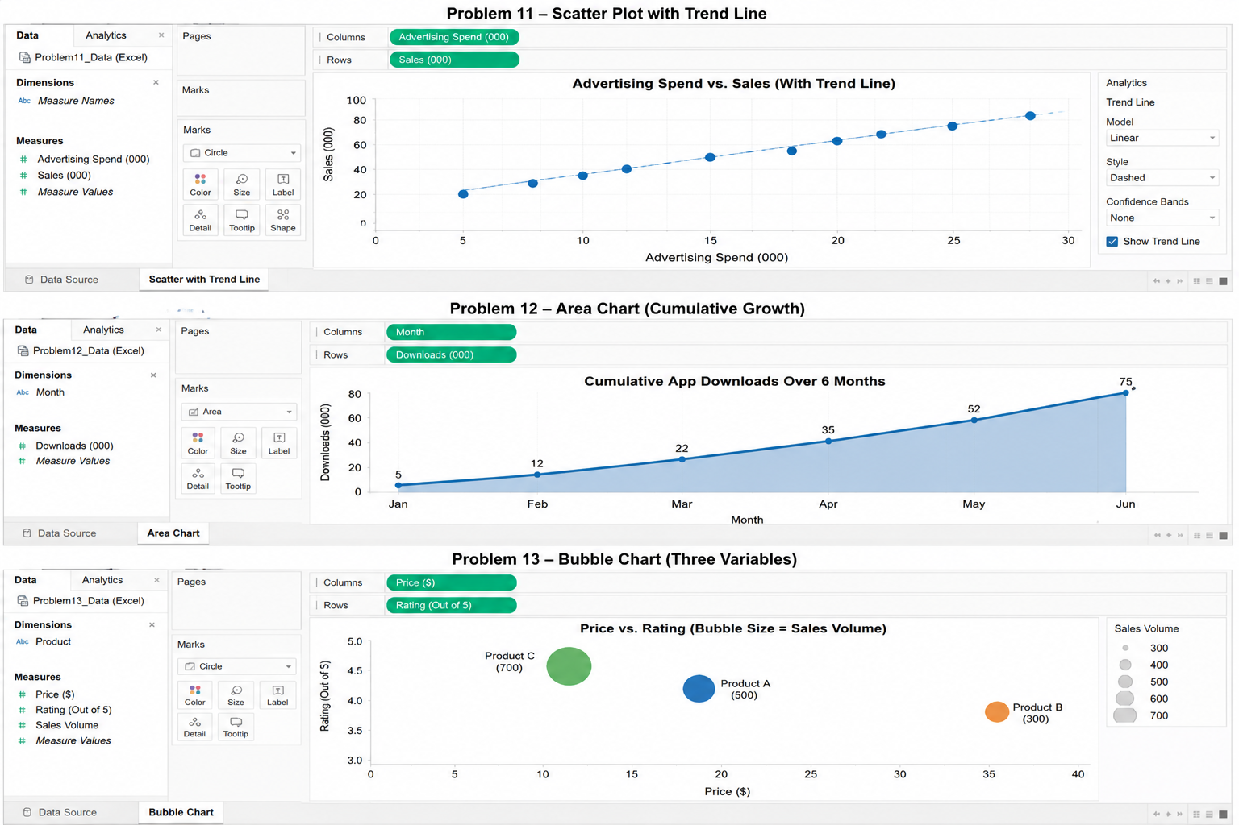
- X-axis: Advertising Spend ($'000)
- Y-axis: Sales ($'000)
- A linear trend line is drawn through the plotted points.
Evidence
Advertising Spend | Sales
5 | 20
8 | 28
10 | 35
12 | 40
15 | 50
18 | 55
20 | 62
22 | 68
25 | 75
28 | 82
The points lie close to an upward-sloping straight line.
Interpretation
The trend line indicates a strong positive linear relationship. Companies spending more on advertising generally achieve higher sales. Since the points lie close to the trend line, the relationship appears consistent with little variation.
Conclusion
A scatter plot with a trend line helps analyze the strength and direction of relationships between variables. It is widely used in business, economics, and marketing for prediction and decision-making.
Problem 12 – Area Chart – Cumulative Growth
Introduction
An area chart is a variation of a line chart in which the area beneath the line is shaded. It is commonly used to display cumulative totals and emphasize growth over time.

Month | Downloads (Thousands)
Jan | 5
Feb | 12
Mar | 22
Apr | 35
May | 52
Jun | 75
The x-axis represents months, while the y-axis represents cumulative downloads.
Evidence
The number of downloads increases every month without any decline. The largest increase occurs between May and June, where downloads rise from 52 thousand to 75 thousand.
Interpretation
The shaded area highlights the continuous accumulation of downloads over time. Since the values increase steadily, the chart indicates consistent user growth and successful adoption of the application.
Conclusion
An area chart effectively represents cumulative data and long-term growth. It allows viewers to understand both the trend and the magnitude of change over time.
Problem 13 – Bubble Chart – Three Variables
Introduction
A bubble chart is an extension of a scatter plot that displays three numerical variables simultaneously. The x-axis and y-axis represent two variables, while the size of each bubble represents a third variable.

- X-axis: Price ($)
- Y-axis: Rating (/5)
- Bubble Size: Sales Volume
Product | Price | Rating | Sales Volume
A | 20 | 4.2 | 500
B | 35 | 3.8 | 300
C | 15 | 4.5 | 700

Evidence
Product C has the highest customer rating (4.5) and the largest sales volume (700). Product B has the highest price ($35) but the lowest rating (3.8) and lowest sales volume (300).
Interpretation
The bubble chart allows all three variables to be compared simultaneously. It suggests that a lower-priced product with a higher rating can achieve greater sales than a higher-priced product. The bubble sizes make it easy to identify the best-selling product at a glance.
Conclusion
A bubble chart is useful for comparing multiple variables in a single visualization. It helps identify patterns, relationships, and high-performing products, making it valuable for business analysis and decision-making.

