SIMATS ENGINEERING (SAVEETHA SCHOOL OF ENGINEERING)
Department of Computer Science and Engineering
CO2_AT2 — VISUALIZATION DEVELOPMENT EXERCISE

Course Code: | DSA06 | Course Title: | Data Handling and Visualization
CO Assessed: | CO2 – Development (BL4) | Assessment: | Assessment Tool 2 – Visualization Development
Weightage: | 20% of CIA | Total Marks: | 25 (5 Questions × 5 Marks)
CO2 Statement: | Analyze and synthesize multiple data views into a coherent, annotated dashboard that communicates a clear narrative insight.(BL4)
Student Name: | S.SRI MATHI | Reg. No.: | 192424095
Section / Batch: | SLOT C | Date: | 30-07-2026

Code of Conduct
I S.SRI MATHI (Name / Reg No) certify that this submission is my original work and that I have adhered to the guidelines specified for this assessment. I understand that any violation of academic integrity rules will result in disciplinary action.

Signature of the Student:

Instructions
- This test contains 5 questions, each carrying 5 marks. Total: 25 Marks.
- No negative marking. Unanswered questions carry zero marks.
- No calculators or electronic devices permitted.
- Duration: 90 minutes.
- Each answer must include at least two coordinated charts sharing a common axis or theme.
- Include at least one annotation calling out a key data point in your dashboard.
- Write a one-sentence narrative takeaway summarizing the insight your dashboard reveals.
Annexure A – VISUALIZATION DEVELOPMENT
Problem 9 — HR Attrition Dashboard (5 Marks)
Data: Headcount and attrition rate by department: Engineering = 120 / 8%, Sales = 80 / 15%, Support = 60 / 20%, Marketing = 40 / 10%.
Task: Build a dashboard with a bar chart of headcount and a bar chart of attrition rate for the same departments. Annotate the department needing urgent retention action, and write a one-sentence executive takeaway.
Problem 10 — Environmental Monitoring Dashboard (5 Marks)
Data: Monthly air quality index (AQI) and average temperature: Jan = 80 / 15°C, Feb = 75 / 17, Mar = 90 /
20, Apr = 110 / 24, May = 130 / 28, Jun = 100 / 30.
Task: Build a dashboard with a line chart of AQI and a line chart of temperature on the same month axis(stacked, not dual-axis). Annotate the month where AQI peaked, and write a narrative caption connecting temperature and air quality trends.
Problem 11 — Sports Team Performance Dashboard (5 Marks)
Data: Wins/losses and points scored: Team A = 18W-6L / 2,200 pts, Team B = 14W-10L / 2,100, Team C = 20W-4L / 2,400, Team D = 10W-14L / 1,900.
Task: Build a dashboard with a bar chart of win–loss record and a bar chart of points scored for the sameteams. Annotate the standout team, and write a takeaway comparing win record to points scored.
Problem 12 — Restaurant Chain Dashboard (5 Marks)
Data: Monthly revenue for 3 locations over 4 months: Downtown = 40,45,42,50; Uptown = 30,32,28,25;Suburb = 35,38,40,44 ($'000). Average satisfaction: Downtown = 4.5, Uptown = 3.2, Suburb = 4.1 (out of5).
Task: Build a dashboard with a multi-line chart of revenue for all three locations and a separate bar chartof average satisfaction per location. Annotate the location with declining revenue, and write a one-sentence narrative linking satisfaction and revenue.
Problem 13 — App Usage Dashboard (5 Marks)
Data: Daily active users and average session duration: Mon = 2,000 / 5 min, Tue = 2,200 / 4.5, Wed =
2,100 / 6, Thu = 2,500 / 5.5, Fri = 3,000 / 4, Sat = 3,500 / 7, Sun = 3,200 / 6.5.
Task: Build a dashboard combining a bar chart of daily active users and a line chart of session durationon the same day axis. Annotate the day with unusually high engagement, and add a narrativeinterpreting the weekend pattern.
Rubrics for Calculation ASSESSMENT RUBRIC
AT2 — Visualization Development Exercise
CO2 · BT4: Analyze ·
This rubric is used to assess student responses to the CO2-AT2 Visualization Development Exercise, in which students build a small multi-chart dashboard from given data, add at least one annotation, and write a narrative takeaway.

Criteria | Weightage | Level 4 – Exemplary | Level 3 – Proficient | Level 2 – Developing | Level 1 – Beginning
Understanding of Concepts | 25% | Demonstrates thorough understanding of which chart types to combine, how they relate to each other, and how annotation and narrative should be used to communicate insight. | Good understanding of chart combination and annotation/narrative technique, with only minor gaps. | Basic understanding of dashboard development, but with some misconceptions about which charts to combine or how to annotate them. | Poor understanding of core development concepts; combines charts or annotations that do not suit the data or the story being told.
Explanation | 25% | The annotation and narrative takeaway are precise, well-justified, and clearly tied to a specific, correctly identified data point or pattern. | The annotation and narrative are clear and reasonably well-justified, with adequate connection to the data. | The annotation or narrative is present but vague, generic, or weakly connected to the actual data shown. | Annotation or narrative is missing, incorrect, or unconnected to the data in the dashboard.
Application | 20% | Effectively applies multi-chart coordination, annotation, and storytelling techniques to produce a complete, cohesive dashboard for the scenario. | Applies development techniques to produce a workable dashboard, with only minor errors or missed refinements. | Limited application; the dashboard partially addresses the scenario but charts feel disconnected or the story is unclear. | Fails to apply appropriate development techniques; the charts, annotation, and narrative do not work together as a dashboard.
Organization | 15% | Charts are clearly coordinated (aligned axes or shared theme), laid out logically, with the annotation and narrative placed for maximum clarity. | Charts are organized and mostly coordinated, with only minor issues in alignment or layout. | Basic structure; charts are present but poorly aligned or the annotation/narrative feels disconnected from the layout. | Poorly organized; charts are not coordinated, and the annotation or narrative is missing or misplaced.
Accuracy | 10% | All chart values, scales, and the annotated data point are completely accurate and correctly reflect the given data. | Mostly accurate, with only minor omissions or a small error in one chart or the annotation. | Partially correct; some plotted values or the annotated point are missing or incorrect. | Largely inaccurate; major errors in plotted values, scales, or the annotated data point.

Scoring Guide
For each criterion, award a performance level (1–4) based on the descriptors above. Multiply the level achieved (as a percentage of 4, i.e., Level 4 = 100%, Level 3 = 75%, Level 2 = 50%, Level 1 = 25%) by the criterion's weightage, then sum across all five criteria to obtain the total score out of 100%.

Faculty In-charge | Course Coordinator | Head of Department
Signature: _______________ | Signature: _______________ | Signature: _______________
Date: ___________________ | Date: ___________________ | Date: ___________________

CO 2 AT 2
VISUALIZATION DEVELOPMENT EXERCISE

NAME: S.SRI MATHI
REG.NO: 192424095
COURSE CODE: DSA0606
COURSE NAME: DATA HANDLING AND VISUALIZATION
DATE: 30.07.2026

Problem 9 – HR Attrition Dashboard (5 Marks)
Introduction
A dashboard combines multiple visualizations into a single view to help managers monitor important business metrics and make quick decisions. In this dashboard, two bar charts are used to compare department headcount and attrition rate.
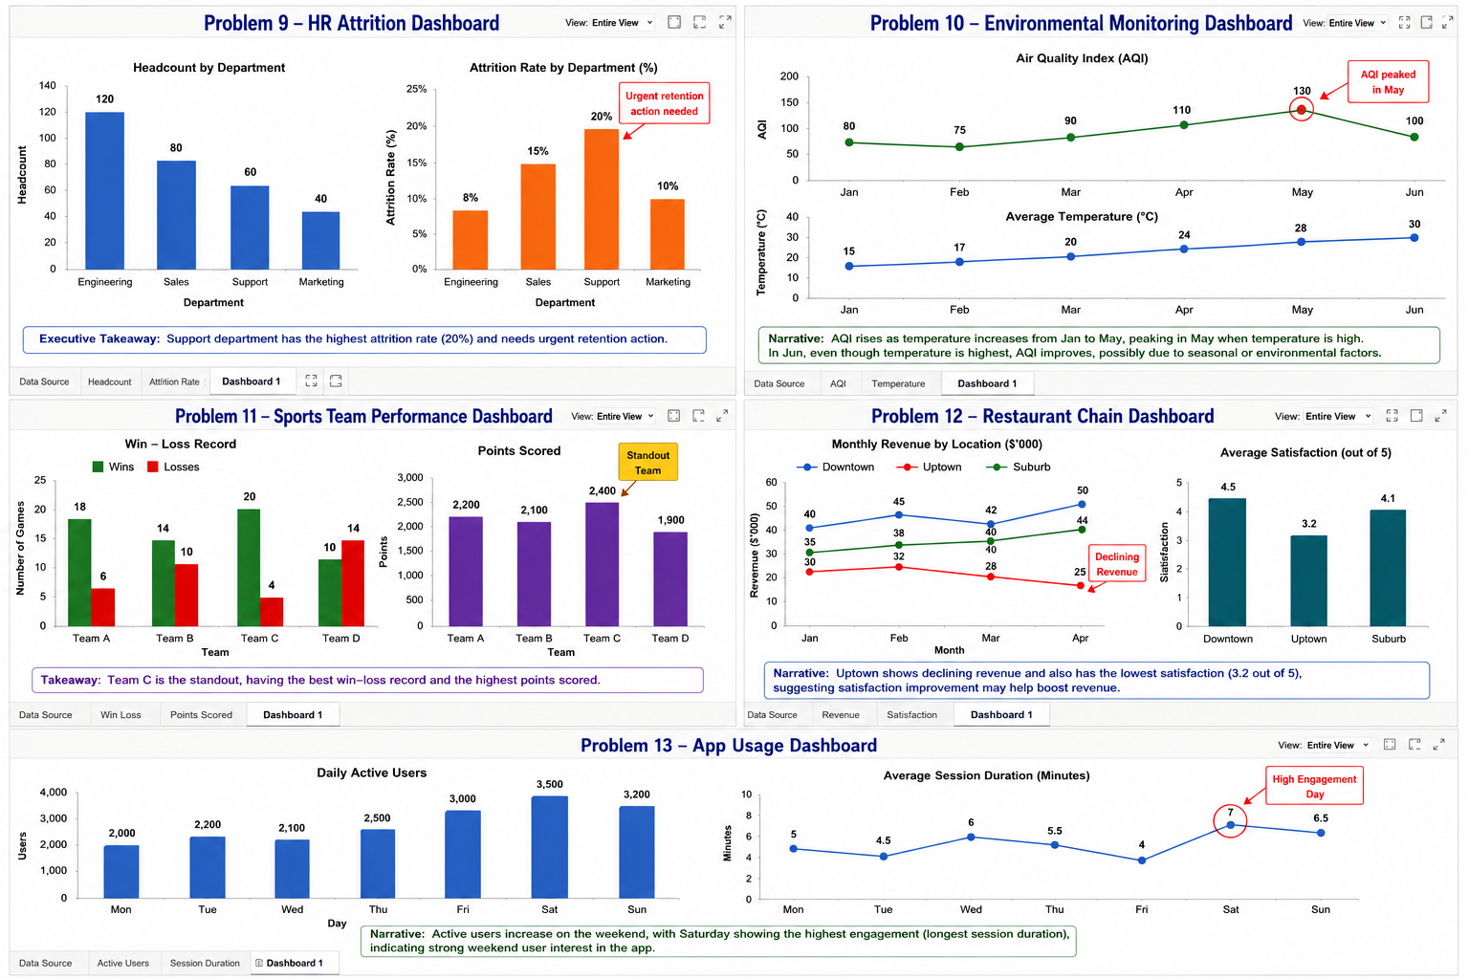

Headcount
Department | Headcount
Engineering | 120
Sales | 80
Support | 60
Marketing | 40
Attrition Rate
Department | Attrition
Engineering | 8%
Sales | 15%
Support | 20%
Marketing | 10%

The dashboard contains:
- Bar Chart 1 – Headcount by Department
- Bar Chart 2 – Attrition Rate by Department
- Annotation highlighting the Support department
- Executive takeaway below the charts
Evidence
Engineering has the largest workforce (120 employees), whereas Support has the highest attrition rate (20%). Although Support has fewer employees than Engineering, it is losing staff at the fastest rate.
Interpretation
The Support department requires immediate retention strategies because a high attrition rate can increase recruitment costs, reduce productivity, and negatively affect customer service.
Conclusion
The dashboard enables HR managers to compare workforce size and employee turnover simultaneously, helping identify departments that require immediate attention.
Problem 10 – Environmental Monitoring Dashboard (5 Marks)
Introduction
An environmental dashboard combines multiple line charts to monitor changes in environmental conditions over time. Using a common month axis makes it easier to compare trends between different variables.

The dashboard contains:
- Line Chart 1 – Air Quality Index (AQI)
- Line Chart 2 – Average Temperature
- Annotation at the highest AQI value
- Narrative caption explaining the trend
Month | AQI | Temperature (°C)
Jan | 80 | 15
Feb | 75 | 17
Mar | 90 | 20
Apr | 110 | 24
May | 130 | 28
Jun | 100 | 30
Evidence
AQI gradually increases from January to May and reaches its highest value of 130 in May. Temperature also rises steadily from 15°C to 30°C throughout the six months.
Interpretation
The dashboard suggests that increasing temperatures are associated with worsening air quality from January to May. Although temperature continues to rise in June, AQI decreases, indicating that other environmental factors may also influence air quality.
Conclusion
The dashboard effectively compares environmental indicators over time and helps identify periods of poor air quality for planning and monitoring purposes.

Problem 11 – Sports Team Performance Dashboard (5 Marks)
Introduction
A sports performance dashboard combines multiple charts to compare team performance using different metrics. This dashboard evaluates teams based on both their win–loss record and total points scored.


The dashboard contains:
- Bar Chart – Wins and Losses
- Bar Chart – Points Scored
- Annotation identifying the standout team
- Performance takeaway
Team | Wins | Losses | Points
A | 18 | 6 | 2200
B | 14 | 10 | 2100
C | 20 | 4 | 2400
D | 10 | 14 | 1900
Evidence
Team C has the highest number of wins (20), the fewest losses (4), and the highest points scored (2400).

Interpretation
The dashboard shows that Team C consistently outperforms the other teams across both performance indicators. Team D has both the weakest win–loss record and the fewest points scored, indicating poor overall performance.
Conclusion
The dashboard provides a comprehensive comparison of team performance and supports coaches and managers in evaluating strengths and weaknesses.

Problem 12 – Restaurant Chain Dashboard (5 Marks)
Introduction
A restaurant dashboard combines revenue and customer satisfaction metrics to evaluate the performance of multiple locations. Comparing these measures helps identify locations requiring operational improvements.


The dashboard contains:
- Multi-line chart showing monthly revenue for all three locations
- Bar chart showing average customer satisfaction
- Annotation highlighting declining revenue
- Narrative summary
Revenue ($'000)
Month | Downtown | Uptown | Suburb
Jan | 40 | 30 | 35
Feb | 45 | 32 | 38
Mar | 42 | 28 | 40
Apr | 50 | 25 | 44
Satisfaction
Location | Rating
Downtown | 4.5
Uptown | 3.2
Suburb | 4.1
Evidence
Uptown's revenue decreases from 32 to 28 and finally to 25, while it also has the lowest customer satisfaction score (3.2/5).
Interpretation
The declining revenue and low satisfaction suggest that customer experience may be affecting business performance. Improving service quality at Uptown could help increase customer satisfaction and revenue.
Conclusion
The dashboard enables managers to compare financial performance and customer feedback, helping prioritize improvements across restaurant locations.

Problem 13 – App Usage Dashboard
Introduction
An app usage dashboard combines user activity and engagement metrics to monitor application performance. It helps identify usage patterns across different days of the week.

The dashboard contains:
- Bar chart showing Daily Active Users (DAU)
- Line chart showing Average Session Duration
- Annotation highlighting the highest engagement day
- Narrative explaining weekend behavior
Day | Active Users | Session Duration (min)
Mon | 2000 | 5
Tue | 2200 | 4.5
Wed | 2100 | 6
Thu | 2500 | 5.5
Fri | 3000 | 4
Sat | 3500 | 7
Sun | 3200 | 6.5

Evidence
Saturday records the highest number of active users (3500) and the longest average session duration (7 minutes). Sunday also shows strong engagement with 3200 users and 6.5 minutes.

Interpretation
User engagement increases toward the weekend, indicating that users spend more time on the app when they have more free time. Weekend usage is significantly higher than weekday usage.
Conclusion
The dashboard helps monitor user behavior, identify peak engagement periods, and supports decisions on scheduling promotions, updates, or feature releases during high-traffic days.

