SIMATS ENGINEERING (SAVEETHA SCHOOL OF ENGINEERING)
Department of Computer Science and Engineering
C01_AT2 — DATA INTERPRETATION EXERCISE

Course Code: | DSA06 | Course Title: | Data Handling and Visualization
CO Assessed: | CO1 –Apply (BL3) | Assessment: | Assessment Tool 2 – Data Interpretation
Weightage: | 20% of CIA | Total Marks: | 20(2 Questions × 20 Marks)
CO1 Statement: | Understand the fundamental concepts, principles, and techniques of data visualization.(BL2)
Student Name: | S.SRI MATHI | Reg. No.: | 192424095
Section / Batch: | SLOT C | Date: | 28-07-2026

Code of Conduct
I S.SRI MATHI(Name / Reg No) certify that this submission is my original work and that I have adhered to the guidelines specified for this assessment. I understand that any violation of academic integrity rules will result in disciplinary action.
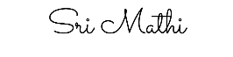
Signature of the Student:

Instructions
- This test contains 2 questions, each carrying 10 marks. Total: 20 Marks.
- No negative marking. Unanswered questions carry zero marks.

Annexure A – DATA INTERPRETATION

1.Scenario: A bar chart of 12 months& revenue is colored entirely in gray except for the single highest-

revenue month, which is colored bright red.

a) What purpose does color serve in this chart — distinguishing, representing value, or highlighting? Justify.

b) Would this technique still be effective if three months were colored red instead of one? Explain why or why

not.

c) What is the risk of using this same red highlight color elsewhere in a company& charts inconsistently?
2.Scenario: A bar chart of 12 months&; revenue is colored entirely in gray except for the single highest-
revenue month, which is colored bright red.
a) What purpose does color serve in this chart — distinguishing, representing value, or highlighting? Justify.
b) Would this technique still be effective if three months were colored red instead of one? Explain why or why
not.
c) What is the risk of using this same red highlight color elsewhere in a company charts inconsistently?
Rubrics for Calculation ASSESSMENT RUBRIC
AT2 — Data Interpretation Exercise
CO1 · BT3: Apply ·
This rubric is used to assess student responses to the AT2 Data Interpretation Exercise problems, in which students interpret a described data visualization (data types, aesthetic mappings, scales, coordinate systems, and color scales) and answer accompanying sub-questions.

Criteria | Weightage | Level 4 – Exemplary | Level 3 – Proficient | Level 2 – Developing | Level 1 – Beginning
Understanding of Concepts | 25% | Demonstrates thorough, accurate understanding of data types (nominal, ordinal, numerical), aesthetic mappings, scales, coordinate systems, and color scales as they apply to the given visualization scenario. | Good understanding of the relevant visualization concepts, with only minor gaps in identifying data types, aesthetic mappings, or scale choices. | Basic understanding of visualization concepts, but with some misconceptions about data types, aesthetics, coordinate systems, or color scales. | Poor understanding of core visualization concepts; major misconceptions about data types, aesthetics, coordinate systems, or color scales.
Explanation | 25% | Provides detailed, well-reasoned explanations for each sub-question, using specific details from the scenario and correct visualization terminology. | Provides clear explanations with adequate justification, referencing the scenario appropriately for most sub-questions. | Explanations are limited or superficial; lacks depth or fails to consistently connect reasoning to the given scenario. | Explanations are poor, unclear, or missing; answers are unsupported assertions with no reasoning shown.
Application | 20% | Effectively applies visualization concepts to interpret the specific scenario, drawing accurate, well-reasoned conclusions from the described chart or data pattern. | Applies concepts to interpret the scenario correctly, with only minor errors in reasoning or in the conclusions drawn. | Limited application of concepts to the scenario; conclusions are weakly supported or only partially correct. | Fails to apply concepts to the scenario, or the conclusions drawn are incorrect or irrelevant to the data shown.
Organization | 15% | Answers are well-structured, addressing each sub-question (a, b, c) in a clear, logical sequence with coherent flow throughout. | Answers are organized and address each sub-question, with only minor issues in flow or clarity. | Basic structure; sub-questions are addressed but answers lack clarity or a logical sequence. | Poorly organized; answers are incoherent, and sub-questions are left unaddressed or answered out of order.
Accuracy | 10% | All parts of the answer — data type identification, aesthetic/scale justification, and final interpretation — are completely accurate. | Mostly accurate, with only minor omissions or a small error in one part of the answer. | Partially correct; some key points (e.g., data type, aesthetic justification, or interpretation) are missing or incorrect. | Answers are largely incorrect, with major gaps in identifying data types, aesthetics, scales, or drawing conclusions.

Scoring Guide
For each criterion, award a performance level (1–4) based on the descriptors above. Multiply the level achieved (as a percentage of 4, i.e., Level 4 = 100%, Level 3 = 75%, Level 2 = 50%, Level 1 = 25%) by the criterion's weightage, then sum across all five criteria to obtain the total score out of 100%.

Faculty In-charge | Course Coordinator | Head of Department
Signature: _______________ | Signature: _______________ | Signature: _______________
Date: ___________________ | Date: ___________________ | Date: ___________________

CO 1 AT 2
DATA INTERPRETATION EXERCISE

NAME: S.SRI MATHI
REG.NO: 192424095
COURSE CODE: DSA0606
COURSE NAME: DATA HANDLING AND VISUALIZATION
DATE: 28.07.2026

1.Scenario: A bar chart of 12 months& revenue is colored entirely in gray except for the single highest-

revenue month, which is colored bright red.

a) What purpose does color serve in this chart — distinguishing, representing value, or highlighting? Justify.

b) Would this technique still be effective if three months were colored red instead of one? Explain why or why

not.

c) What is the risk of using this same red highlight color elsewhere in a company& charts inconsistently?

Introduction
This bar chart uses color as a visual aesthetic to emphasize important information. All 12 months' revenue is displayed in gray, while the highest-revenue month is highlighted in bright red. This helps viewers quickly identify the most significant data point.
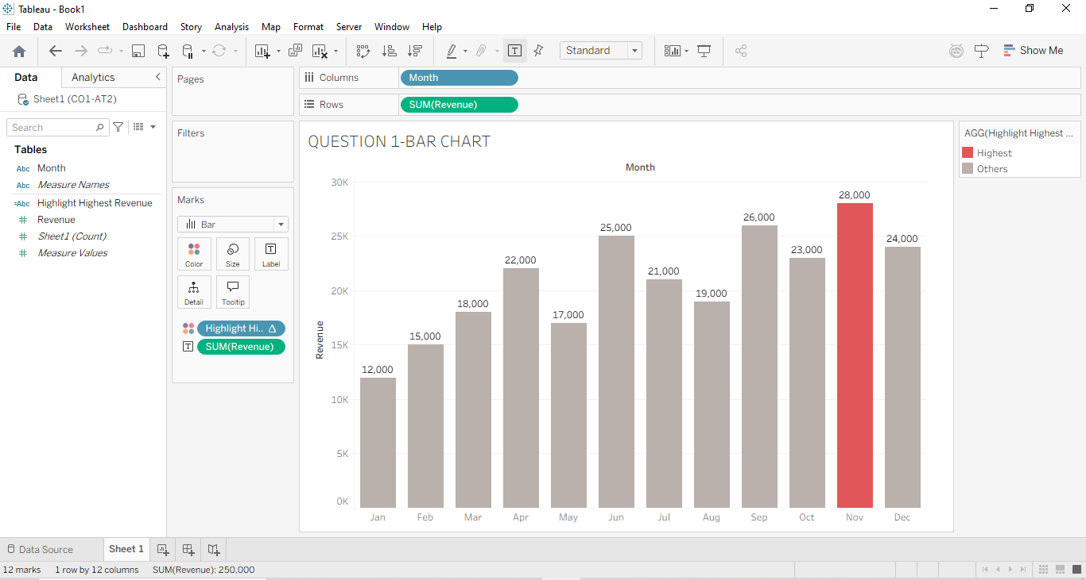

Evidence
The chart contains one red bar representing the highest revenue month, whereas the remaining eleven bars are gray. The use of a contrasting color makes the highlighted month immediately noticeable.

Interpretation
The red color is used for highlighting, not for representing revenue values or distinguishing categories. Highlighting only one bar effectively attracts attention to the highest-performing month. However, if multiple bars were colored red or if red were used inconsistently across different charts, it could confuse viewers and reduce the effectiveness of the visualization.

a) What purpose does color serve in this chart — distinguishing, representing value, or highlighting? Justify.

Introduction
Color is a visual aesthetic used to emphasize or communicate information in a chart.

Evidence
The bar chart shows all 12 months in gray, while only the highest-revenue month is colored bright red.

Interpretation
The red color is used for highlighting because it immediately draws attention to the highest-revenue month. It is not used to represent different revenue values or different categories.

b) Would this technique still be effective if three months were colored red instead of one? Explain why or why not.

Introduction
Highlighting is most effective when used on a limited number of important data points.

Evidence
If three months are colored red instead of one, multiple bars receive the same emphasis.

Interpretation
The viewer's attention is divided among the three months, making it difficult to identify the single highest-revenue month. The visual impact of highlighting is reduced.

c) What is the risk of using this same red highlight color elsewhere in a company's charts inconsistently?

Introduction
Consistent color usage is important for clear and accurate data interpretation.

Evidence
Suppose red indicates highest revenue in one chart but represents loss or warning in another chart.

Interpretation
Different meanings for the same color can confuse viewers and lead to incorrect interpretation of the data.

Conclusion
The chart demonstrates that color is a powerful tool for emphasizing key information when used consistently and sparingly. Proper use of highlighting improves readability and helps users interpret the data accurately.

2.Scenario: A fitness-tracking app records daily step counts and sleep hours for a user over 30 days, mapped as a scatter plot with Steps on the x-axis, Sleep Hours on the y-axis, and each point sized according to Calories Burned.

Introduction
A scatter plot is used to study the relationship between two numerical variables by plotting data points on the x-axis and y-axis. In this scenario, the fitness-tracking app records daily step counts, sleep hours, and calories burned over 30 days. The x-axis represents Steps, the y-axis represents Sleep Hours, and the size of each point represents Calories Burned. This visualization helps identify trends, patterns, and possible relationships among these variables.
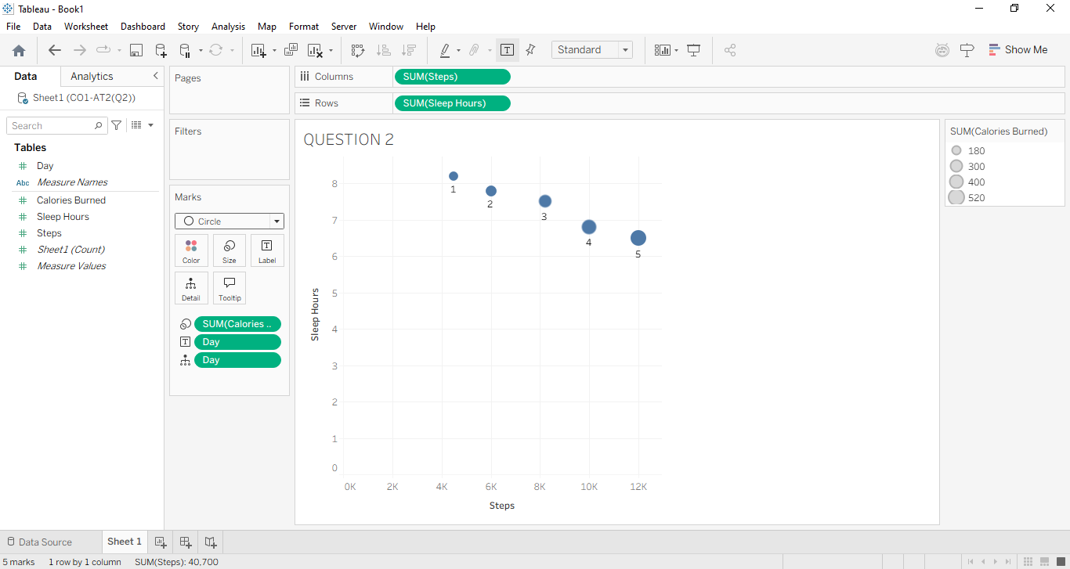
Observation
- X-axis: Daily Steps
- Y-axis: Sleep Hours
- Point Size: Calories Burned
- Each Point: One day's fitness data
The chart simultaneously displays three variables:
- Steps using horizontal position.
- Sleep hours using vertical position.
- Calories burned using the size of each point.
Larger circles indicate more calories burned, while smaller circles indicate fewer calories burned.

Evidence
From the scatter plot, it is observed that:
- Larger circles are mostly located at higher step counts.
- These larger circles also appear at lower sleep hours.
- Smaller circles are generally found at lower step counts with relatively higher sleep hours.
This pattern suggests that days with greater physical activity resulted in higher calorie expenditure.

Interpretation
The visualization indicates a positive relationship between steps and calories burned, meaning that as the number of steps increases, the calories burned also increase.
It also suggests a negative relationship between steps and sleep hours, as higher step counts tend to coincide with lower sleep durations.
However, this is only an observed trend from the data and does not prove a cause-and-effect relationship. Other factors such as exercise intensity, diet, age, or daily routine may also influence calories burned and sleep hours.
a) How many variables are being visually encoded in this chart, and through which aesthetics?
Introduction:
The scatter plot represents multiple variables using different visual aesthetics.
Content:
- Steps → X-axis (Position)
- Sleep Hours → Y-axis (Position)
- Calories Burned → Size of the points
Interpretation:
The chart encodes 3 variables using position (x and y) and size, allowing multiple data values to be viewed in one chart.

b) Is size an appropriate aesthetic for representing Calories Burned here? What is a limitation of using size?
Introduction:
Size is commonly used to represent quantitative values in scatter plots.
Content:
- Yes, size is appropriate because larger points indicate more calories burned.
- Limitation: It is difficult to accurately compare circle sizes, and large points may overlap smaller ones.
Interpretation:
Size helps identify higher calorie values quickly but is less precise than position.

c) If larger points (higher calories burned) tend to appear at higher step counts but lower sleep hours, what relationship can you infer?
Introduction:
The scatter plot helps identify relationships between variables.
Content:
- More Steps → More Calories Burned (positive relationship).
- More Steps → Less Sleep Hours (negative relationship).
Interpretation:
Higher physical activity is associated with increased calorie burning and lower sleep duration.

Conclusion
The scatter plot effectively represents three variables in a single visualization by using position and size as visual aesthetics. It helps users quickly identify relationships between daily steps, sleep hours, and calories burned. The chart suggests that increased physical activity is associated with higher calorie expenditure and relatively lower sleep duration, making it a useful tool for analyzing personal fitness trends and supporting health-related decisions.

