SIMATS ENGINEERING (SAVEETHA SCHOOL OF ENGINEERING)
Department of Computer Science and Engineering
CO1_AT3 — VISUALIZATION DESIGN EXERCISE

Course Code: | DSA06 | Course Title: | Data Handling and Visualization
CO Assessed: | CO1 – Precision (BL2) | Assessment: | Assessment Tool 3 – Visualization Design
Weightage: | 40% of CIA | Total Marks: | 20 (2 Questions × 10 Marks)
CO1 Statement: | Understand the fundamental concepts, principles, and techniques of data visualization.(BL2)
Student Name: | S.SRI MATHI | Reg. No.: | 192424095
Section / Batch: | SLOT C | Date: | 30-07-2026

Code of Conduct
I S.SRI MATHI (Name / Reg No) certify that this submission is my original work and that I have adhered to the guidelines specified for this assessment. I understand that any violation of academic integrity rules will result in disciplinary action.

Signature of the Student:

Instructions
- This assessment contains 2 questions, each carrying 10 marks. Total: 20 Marks.
- No negative marking. Unanswered questions carry zero marks.
- No calculators or electronic devices permitted.
- Duration: 60 minutes.
Annexure A – VISUALIZATION DESIGN
1. Scenario: A logistics company tracks Delivery Time in hours (numeric) for shipments across 6 shipping methods (nominal).
a) Design a chart that allows viewers to compare the distribution of delivery times across shipping methods, not just the average.
b) Which aesthetic would you use to distinguish the shipping methods, and why?
c) Justify why a chart showing the full distribution (not just an average bar) is more appropriate here.
2. Scenario: A dashboard needs to show 7 distinct customer segments (no natural order) in a single chart.
a) Design an appropriate color scale for distinguishing the 7 segments. What type of scale is this?
b) What specific guideline would you follow to ensure the 7 colors remain distinguishable to most viewers, including those with color-vision deficiencies?
c) If an 8th segment is added later, how would you adapt your color design to accommodate it?
ASSESSMENT RUBRIC
AT3 — Visualization Design Exercise
CO1 · BT3: Apply ·
This rubric is used to assess student responses to the AT3 Visualization Design Exercise problems, in which students design and justify a complete visualization (chart type, aesthetic mappings, scales, coordinate systems, and/or color scheme) for a given dataset or design brief.

Criteria | Weightage | Level 4 – Exemplary | Level 3 – Proficient | Level 2 – Developing | Level 1 – Beginning
Understanding of Concepts | 25% | Demonstrates thorough, accurate understanding of chart types, aesthetic mappings, scales, coordinate systems, and color scales, and correctly identifies which apply to the given design scenario. | Good understanding of the relevant design concepts, with only minor gaps in selecting appropriate chart types, aesthetic mappings, or scales. | Basic understanding of design concepts, but with some misconceptions about appropriate chart types, aesthetics, or scales for the scenario. | Poor understanding of core design concepts; proposes chart types or mappings that are fundamentally unsuited to the data.
Explanation | 25% | Provides detailed, well-reasoned justification for every design decision, explicitly connecting each choice to the properties of the data and the scenario. | Provides clear justification for design decisions, with adequate reasoning for most sub-questions. | Justification is limited or superficial; design choices are stated without sufficient reasoning. | Little or no justification provided; design choices appear arbitrary or unexplained.
Application | 20% | Effectively applies visualization design principles to produce a complete, appropriate, and well-reasoned design solution for the specific scenario. | Applies design principles to produce an appropriate solution, with only minor errors or missed refinements. | Limited application of design principles; the proposed design partially addresses the scenario but has notable weaknesses. | Fails to apply appropriate design principles; the proposed design does not suit the scenario or data.
Organization | 15% | The design proposal is clearly structured, addressing each sub-question (a, b, c) in a logical sequence with coherent flow throughout. | The proposal is organized and addresses each sub-question, with only minor issues in flow or clarity. | Basic structure; sub-questions are addressed but the proposal lacks clarity or a logical sequence. | Poorly organized; the proposal is incoherent, and sub-questions are left unaddressed or answered out of order.
Accuracy | 10% | All design choices — chart type, aesthetic mapping, scale, coordinate system, and/or color scheme — are completely accurate and well-suited to the data. | Mostly accurate design choices, with only minor omissions or a small error in one part of the proposal. | Partially correct; some design elements are missing, mismatched to the data, or incorrect. | Design choices are largely incorrect or inappropriate, with major gaps in matching the visualization to the data.

Scoring Guide
For each criterion, award a performance level (1–4) based on the descriptors above. Multiply the level achieved (as a percentage of 4, i.e., Level 4 = 100%, Level 3 = 75%, Level 2 = 50%, Level 1 = 25%) by the criterion's weightage, then sum across all five criteria to obtain the total score out of 100%.

Faculty In-charge | Course Coordinator | Head of Department
Signature: _______________ | Signature: _______________ | Signature: _______________
Date: ___________________ | Date: ___________________ | Date: ___________________

CO 1 AT 1
VISUALIZATION DESIGN EXERCISE

NAME: S.SRI MATHI
REG.NO: 192424095
COURSE CODE: DSA0606
COURSE NAME: DATA HANDLING AND VISUALIZATION
DATE: 30.07.2026

7. Scenario: A logistics company tracks Delivery Time in hours (numeric) for shipments across 6 shipping methods (nominal).
a) Design a chart that allows viewers to compare the distribution of delivery times across shipping methods, not just the average.
b) Which aesthetic would you use to distinguish the shipping methods, and why?
c) Justify why a chart showing the full distribution (not just an average bar) is more appropriate here.
Introduction
Data visualization helps compare and analyze delivery performance across different shipping methods. Since delivery time is a numerical variable and shipping method is a categorical variable, the chart should display not only the average delivery time but also the variation and consistency of deliveries. A visualization showing the complete distribution provides more meaningful insights for decision-making.
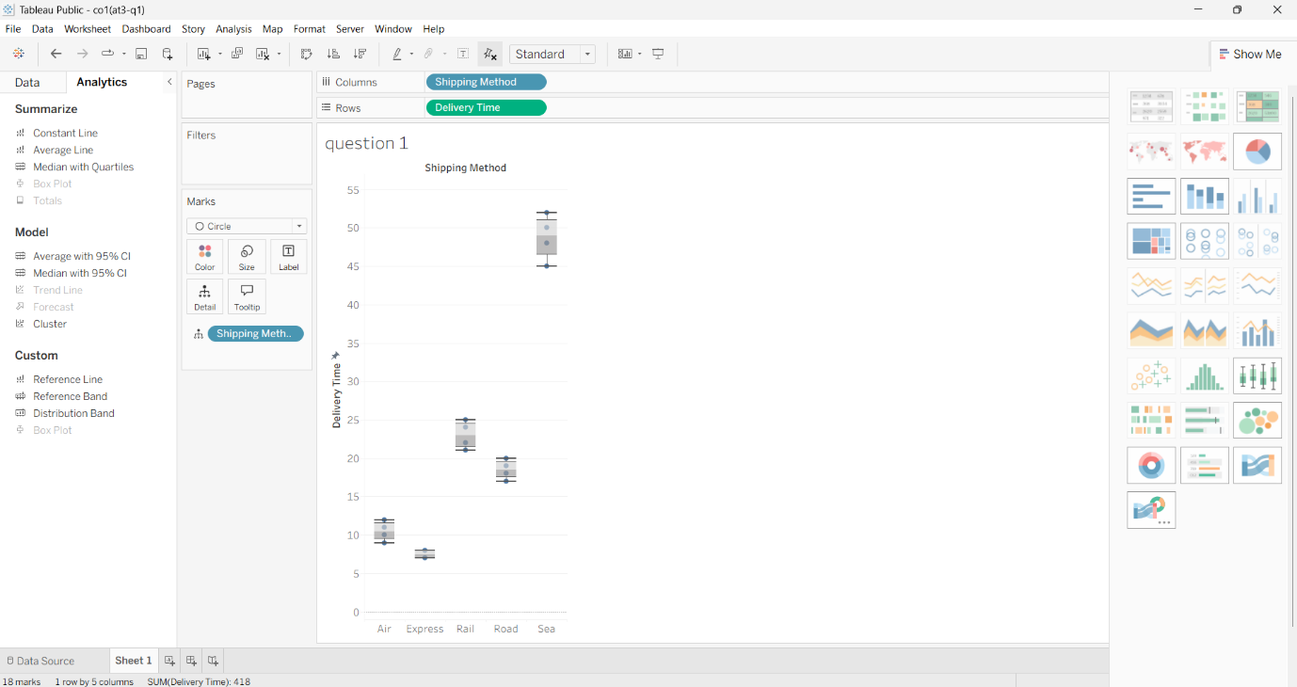
Evidence
The dataset contains:
- Numerical variable: Delivery Time (hours)
- Categorical variable: Shipping Method (Air, Road, Rail, Sea, Express, etc.)
- Multiple delivery time observations are available for each shipping method, making it possible to analyze the distribution of values.
Interpretation
a) Design an appropriate chart
A Box-and-Whisker Plot (Box Plot) is the most appropriate chart because it displays:
- Minimum value
- Maximum value
- Median
- First Quartile (Q1)
- Third Quartile (Q3)
- Outliers
This allows viewers to compare the complete distribution of delivery times for each shipping method.
b) Which aesthetic would you use?
The Color aesthetic should be used to distinguish the shipping methods because they are nominal (categorical) data with no natural order. Different colors help viewers identify and compare each shipping method easily.
c) Why show the full distribution?
A bar chart displaying only the average delivery time hides important information such as:
- Variation in delivery times
- Consistency of deliveries
- Presence of unusually slow or fast deliveries (outliers)
A box plot reveals these characteristics, making it easier to evaluate the reliability and performance of each shipping method.
Conclusion
A Box-and-Whisker Plot is the most suitable visualization because it presents the complete distribution of delivery times rather than only the average. Using different colors for each shipping method improves readability and enables accurate comparison of delivery performance.
17.Scenario: A dashboard needs to show 7 distinct customer segments (no natural order) in a single chart.
a) Design an appropriate color scale for distinguishing the 7 segments. What type of scale is this?
b) What specific guideline would you follow to ensure the 7 colors remain distinguishable to most viewers, including those with color-vision deficiencies?
c) If an 8th segment is added later, how would you adapt your color design to accommodate it?
Scenario:
Introduction
Color is an important visual aesthetic used to distinguish different categories in a dashboard. When the data consists of independent categories with no ranking or numerical relationship, a qualitative (categorical) color scale is the most appropriate choice. It helps users quickly recognize and differentiate customer segments.
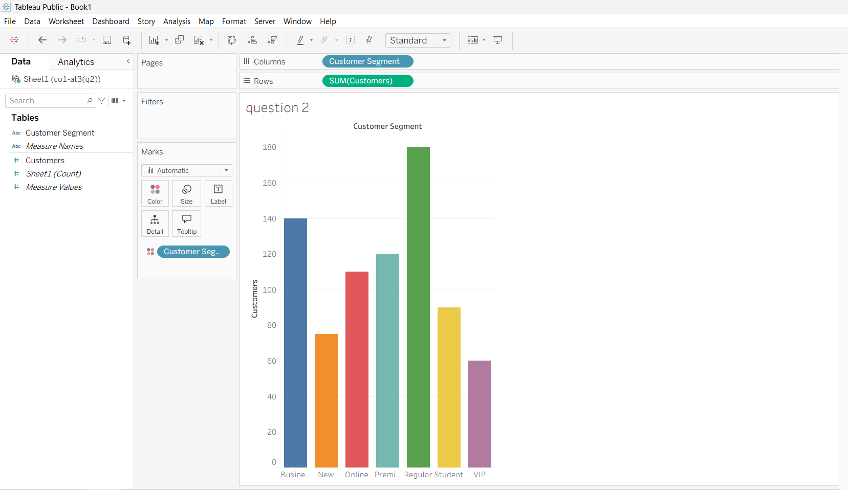
Evidence
The dashboard contains 7 customer segments, and none of them has a higher or lower order than the others. Since the segments are categorical, each should be represented using a unique color rather than a gradient or sequential scale.
Interpretation
a) Design an appropriate color scale
A Qualitative (Categorical) Color Scale should be used.
Example:
- Premium – Blue
- Regular – Green
- Student – Orange
- Business – Purple
- VIP – Red
- Online – Teal
- New – Brown
Each color uniquely identifies one customer segment without implying any ranking.
b) Guideline for distinguishable colors
To ensure the colors are distinguishable:
- Use a color-blind-friendly palette.
- Choose colors with high contrast.
- Avoid using similar shades that are difficult to differentiate.
- Do not rely only on red and green, as many users with color-vision deficiencies cannot distinguish them clearly.
These guidelines improve accessibility and ensure that all users can correctly interpret the dashboard.
c) Adding an 8th segment
If an eighth customer segment is introduced:
- Assign another unique color from the same qualitative palette.
- Maintain consistency with the existing color scheme.
- If the number of categories continues to increase, combine color with labels, shapes, or grouping to prevent confusion and maintain readability.
Conclusion
A qualitative color scale is the best choice for displaying customer segments because it clearly distinguishes categories without suggesting any order. Using accessible, high-contrast colors and adapting the palette carefully when new segments are added ensures the dashboard remains clear, consistent, and easy to interpret.

