SIMATS ENGINEERING (SAVEETHA SCHOOL OF ENGINEERING)
Department of Computer Science and Engineering
CO2_AT3 — CASE STUDY

Course Code: | DSA06 | Course Title: | Data Handling and Visualization
CO Assessed: | CO2 – Evaluation (BL5) | Assessment: | Assessment Tool 3 – Case Study
Weightage: | 20% of CIA | Total Marks: | 20 (2 Questions × 10 Marks)
CO2 Statement: | Analyze real-world data scenarios and evaluate/justify the most appropriate chart types, coordinate systems, color scales, and dashboard designs to represent them.(BL5)
Student Name: | S.SRI MATHI | Reg. No.: | 192424095
Section / Batch: | SLOT C | Date: | 01-08-2026

Code of Conduct
I S.SRI MATHI (Name / Reg No) certify that this submission is my original work and that I have adhered to the guidelines specified for this assessment. I understand that any violation of academic integrity rules will result in disciplinary action.

Signature of the Student:

Instructions
- This test contains 2 case-study questions, each carrying 10 marks. Total: 20 Marks.
- No negative marking. Unanswered questions carry zero marks.
- No calculators or electronic devices permitted.
- Duration: 90 minutes.
- Each case study has four sub-parts (a–d); answer all parts for full marks.
- Support your answers with brief calculations or justifications where relevant.
- Diagrams may be hand-drawn or clearly described in words if drawing tools are unavailable.

Annexure A – CASE STUDY
1. a) Which chart would best reveal the shape and outliers of the wait-time distribution across 20 departments?
Justify your answer.
b) Propose a chart for the 3-year admission trend, including your choice of axis and scale.
c) Design a two-chart dashboard combining department wait times and satisfaction, including one annotation
flagging the department needing urgent attention.
d) A colleague suggests a 20-slice pie chart to show each department&#39;s share of total wait time. Critique this
choice and suggest a better alternative.
2. a) Which chart correctly preserves the order of the Low/Medium/High graduation categories? Justify your
answer.
b) Propose a chart for the 6-year enrollment trend across all 8 departments without creating excessive visual
clutter.
c) Which chart type best compares the 5 satisfaction aspects for a single department all at once?
d) Combine two of the above into a coordinated dashboard, and identify one potential misinterpretation risk in
your design.

Rubrics for Calculation ASSESSMENT RUBRIC
AT3 — Case Study
CO2 · BT5: Evaluate ·
This rubric is used to assess student responses to the CO2-AT3 Case Study questions, in which students analyze a realistic multi-part scenario and select, justify, design, and critique appropriate visualizations across chart types, coordinate systems, color scales, and dashboard development.

Criteria | Weightage | Level 4 – Exemplary | Level 3 – Proficient | Level 2 – Developing | Level 1 – Beginning
Understanding of Concepts | 25% | Demonstrates thorough understanding of the full range of chart types, coordinate systems, and color scales relevant to the case, and correctly identifies which apply to each sub-part. | Good understanding of the relevant concepts, with only minor gaps in identifying appropriate chart types, scales, or color choices. | Basic understanding, but with some misconceptions about which visualization techniques suit the scenario's data. | Poor understanding of core concepts; proposes techniques fundamentally unsuited to the case study's data.
Explanation | 25% | Provides detailed, well-reasoned justification for every design decision and critique, explicitly tied to specific details of the case. | Provides clear justification for most decisions and critiques, with adequate reasoning. | Justification is limited or generic; decisions are stated without sufficient reasoning tied to the case. | Little or no justification provided; answers are unsupported assertions.
Application | 20% | Effectively applies visualization concepts to analyze and solve every sub-part of the case, including any calculations, with well-reasoned conclusions. | Applies concepts correctly to most sub-parts, with only minor errors. | Limited application; some sub-parts are weakly addressed or only partially correct. | Fails to apply appropriate concepts; sub-parts are left unaddressed or answered incorrectly.
Organization | 15% | The response is clearly structured, addressing every sub-part (a–d) in a logical sequence with coherent overall flow. | The response is organized and addresses each sub-part, with only minor issues in flow or clarity. | Basic structure; sub-parts are addressed but the response lacks clarity or a logical sequence. | Poorly organized; the response is incoherent, and sub-parts are left unaddressed or answered out of order.
Accuracy | 10% | All parts of the answer — chart choices, calculations, critiques, and dashboard design — are completely accurate and well-suited to the case. | Mostly accurate, with only minor omissions or a small error in one sub-part. | Partially correct; some elements are missing, mismatched to the case, or incorrect. | Largely incorrect or inappropriate, with major gaps across multiple sub-parts.

Scoring Guide
For each criterion, award a performance level (1–4) based on the descriptors above. Multiply the level achieved (as a percentage of 4, i.e., Level 4 = 100%, Level 3 = 75%, Level 2 = 50%, Level 1 = 25%) by the criterion's weightage, then sum across all five criteria to obtain the total score out of 100%.

Faculty In-charge | Course Coordinator | Head of Department
Signature: _______________ | Signature: _______________ | Signature: _______________
Date: ___________________ | Date: ___________________ | Date: ___________________

1. Hospital Wait-Time and Admission Trend Visualization

(a) Which chart would best reveal the shape and outliers of the wait-time distribution across 20 departments? Justify your answer.

Answer
The Box Plot (Box-and-Whisker Plot) is the most suitable chart for revealing the shape and outliers of the wait-time distribution across 20 hospital departments.
A box plot summarizes the distribution of data by displaying the minimum value, first quartile (Q1), median, third quartile (Q3), and maximum value. It also identifies outliers, which are displayed as individual points beyond the whiskers. Since hospital wait times may vary considerably between departments, the box plot makes it easy to compare the spread and variability of waiting times across all departments. It helps hospital administrators quickly identify departments with unusually high or low waiting times and supports better operational decision-making.
Justification:
- Displays the overall distribution of wait times.
- Shows the median and quartiles clearly.
- Identifies outliers effectively.
- Enables easy comparison of variability among departments.
- Suitable for analyzing large sets of numerical data.
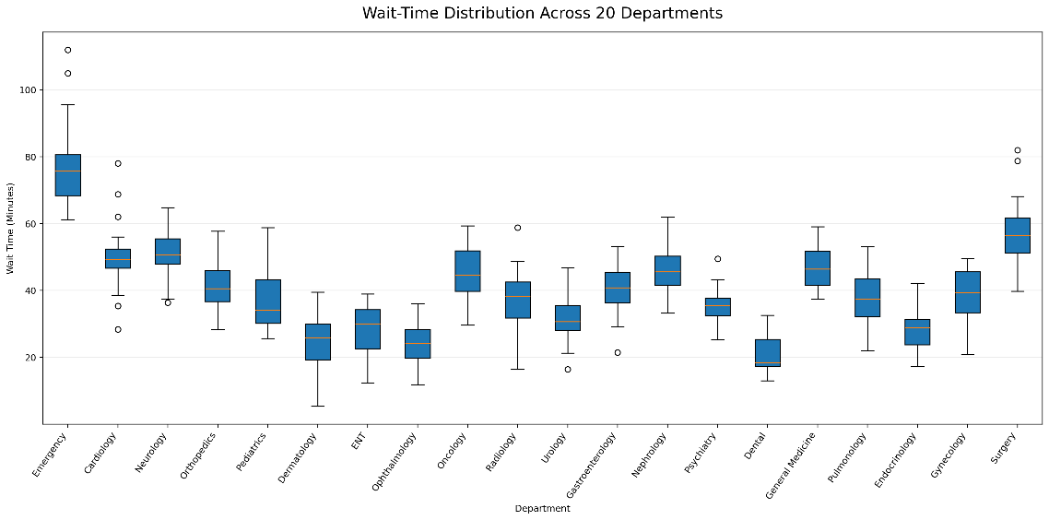

(b) Propose a chart for the 3-year admission trend, including your choice of axis and scale.

Answer
A Line Chart is the most appropriate visualization for representing the hospital admission trend over a period of three years.
A line chart is designed to display changes in data over time. By connecting admission values for each year with a continuous line, it becomes easy to observe whether admissions are increasing, decreasing, or remaining stable. This allows hospital management to identify growth patterns and make informed planning decisions.
Axis Selection:
- X-axis: Year (Year 1, Year 2, Year 3)
- Y-axis: Number of Admissions
Scale Selection:
A linear scale should be used because admission counts are numerical values and can be compared directly without requiring logarithmic scaling.
Justification:
- Clearly displays trends over time.
- Makes year-to-year comparisons simple.
- Easy to interpret and understand.
- Suitable for continuous time-series data.
- increasing or decreasing admission patterns.
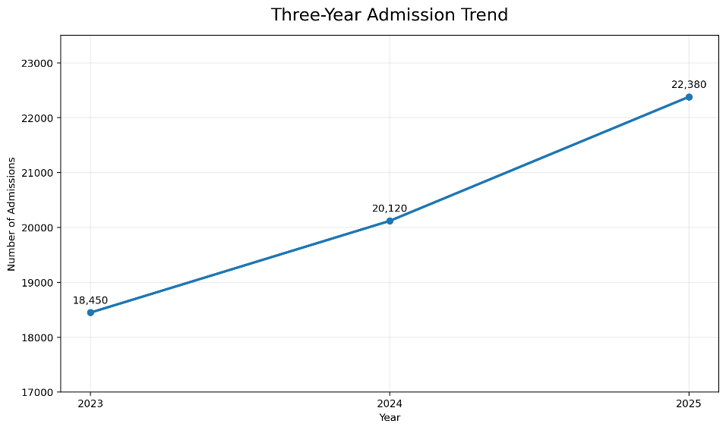

(c) Design a two-chart dashboard combining department wait times and satisfaction, including one annotation flagging the department needing urgent attention.

Answer
The dashboard should consist of two visualizations that provide a comprehensive overview of hospital performance.

Chart 1
Horizontal Bar Chart
- Displays the average wait time for each department.
- Enables quick comparison of waiting times across departments.

Chart 2
Horizontal Bar Chart
- Displays the patient satisfaction score for each department.
- Allows comparison of satisfaction levels among departments.
Both charts should be placed side by side in the dashboard to enable simultaneous comparison of operational performance and patient experience.

Dashboard Annotation
Emergency Department
The Emergency Department has the highest average waiting time and the lowest patient satisfaction score. Immediate attention is recommended to improve service efficiency, reduce waiting time, and enhance patient experience.
Justification:
- Combines operational and patient satisfaction metrics.
- Facilitates quick identification of underperforming departments.
- Supports management decision-making.
- Improves monitoring of hospital performance.
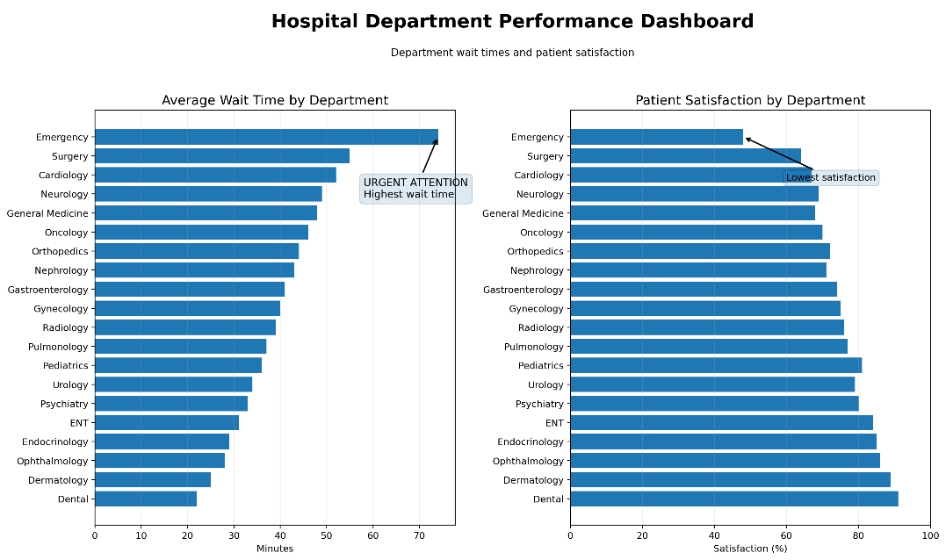
- Highlights departments requiring immediate corrective action.

(d) A colleague suggests a 20-slice pie chart to show each department's share of total wait time. Critique this choice and suggest a better alternative.

Answer
A 20-slice pie chart is not an appropriate visualization for representing departmental wait times because it contains too many categories. As the number of slices increases, it becomes difficult to distinguish between similar-sized segments, compare values accurately, and read labels clearly. This reduces the overall readability and effectiveness of the visualization.
A Horizontal Bar Chart is a much better alternative because it allows direct comparison of all departments. The departments can be sorted in descending order based on wait time, making it easier to identify those with the longest waiting periods. Long department names are also displayed more clearly in a horizontal layout.
Critique of the Pie Chart:
- Too many slices reduce readability.
- Difficult to compare similar values.
- Labels become crowded and overlap.
- Small differences between departments are hard to identify.
- Not suitable for displaying many categories.
Suggested Alternative: Horizontal Bar Chart
Advantages of the Horizontal Bar Chart:
- Easy comparison between departments.
- Supports sorting from highest to lowest wait time.
- Clearly displays department names.
- Improves readability and interpretation.
- Helps identify departments requiring immediate attention.

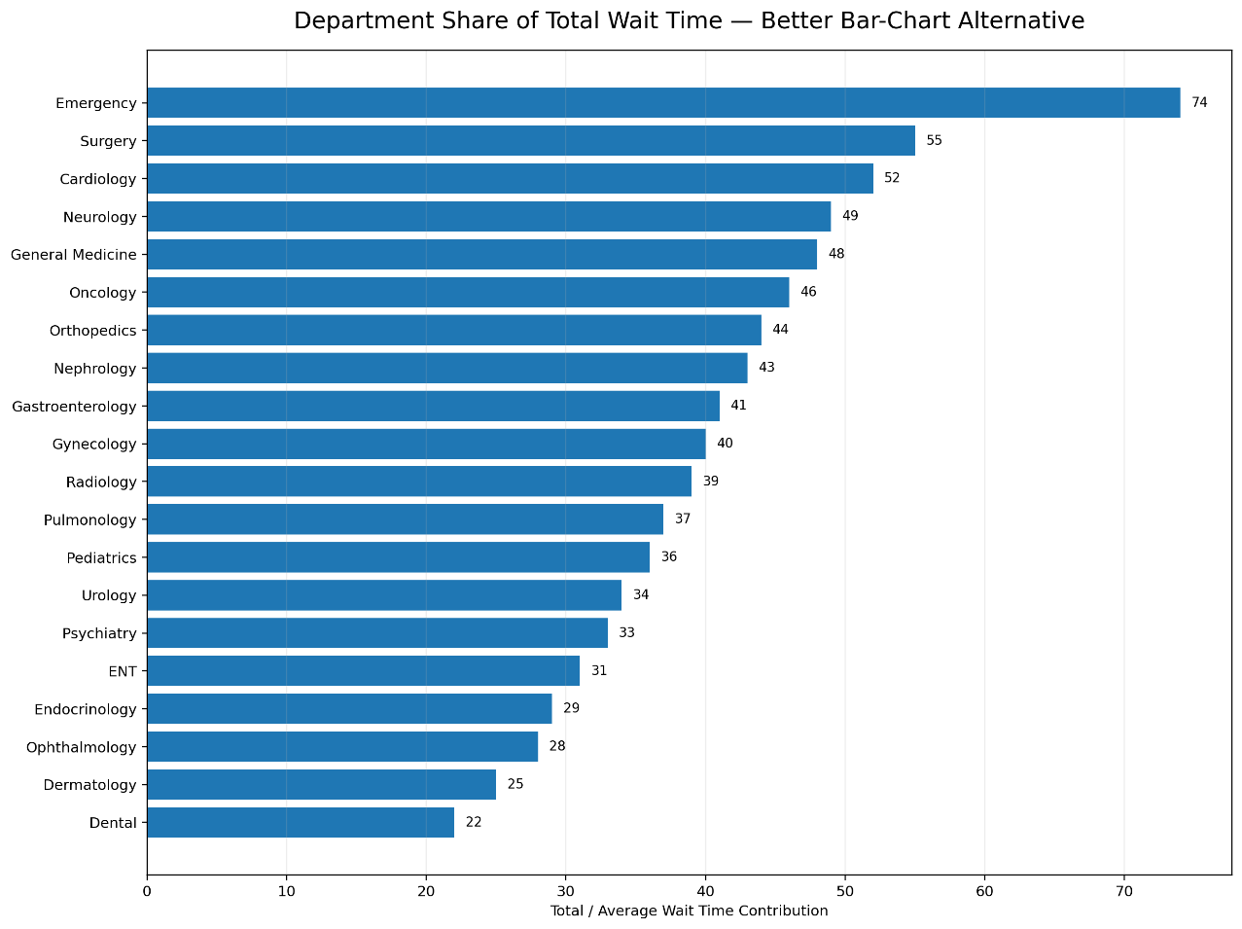

Conclusion
Appropriate data visualization techniques enable hospitals to analyze operational performance effectively. A Box Plot is best suited for identifying the distribution and outliers of wait times, while a Line Chart effectively represents admission trends over multiple years. A dashboard combining Wait Time and Patient Satisfaction charts provides a comprehensive view of hospital performance and supports timely decision-making. Compared to a pie chart with many categories, a Horizontal Bar Chart offers superior readability, accurate comparison, and clearer communication of departmental performance.
2. HR Analytics

(a) Propose a chart combining headcount and attrition rate for the 6 departments, with an annotation on the department needing urgent retention action.
A dashboard containing two horizontal bar charts is the most suitable visualization.
- Chart 1: Department vs Headcount
- Chart 2: Department vs Attrition Rate (%)
Displaying both charts side by side enables easy comparison between workforce size and employee attrition.
Support Department
The Support Department has the highest attrition rate (22%) despite having a moderate workforce. Immediate retention measures such as employee engagement, training, and career development are recommended.

Justification
- Compares workforce size across departments.
- Identifies departments with high attrition.
- Helps HR prioritize retention strategies.
- Improves management decision-making.
- Presents multiple performance indicators in a single dashboard.
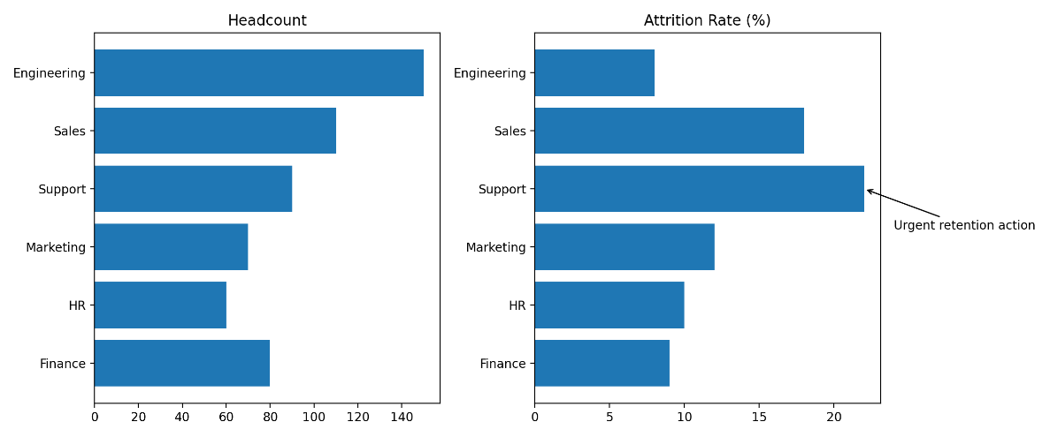

(b) Which chart best reveals the shape, median, and outliers of the company-wide salary distribution?

Answer
A Box Plot (Box-and-Whisker Plot) is the most appropriate chart for visualizing company-wide salary distribution.
The box plot summarizes salary data by displaying the minimum value, first quartile (Q1), median, third quartile (Q3), and maximum value. It also highlights salary outliers that differ significantly from the majority of employees.

Justification
- Shows salary distribution clearly.
- Displays the median salary.
- Detects unusually high or low salaries.
- Summarizes the spread of salary values.
- Useful for identifying pay variations within the organization.

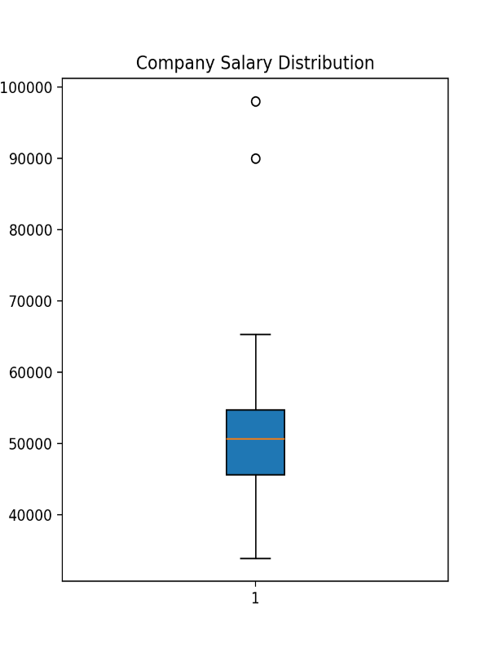

(c) Which coordinate system and chart type is most natural for the fixed-total, 40-hour workweek time allocation? Justify your answer with an angle calculation for an 8-hour component.

Answer
A Polar Coordinate System with a Pie Chart is the most appropriate visualization because the workweek is divided into parts of a fixed total (40 hours). A pie chart effectively represents each activity as a proportion of the whole.

Angle Calculation
Formula:
Angle = (Component Hours / Total Hours) × 360°
For an 8-hour activity:
Angle = (8 / 40) × 360°
Angle = 72°
Therefore, the 8-hour component occupies 72° of the pie chart.

Justification
- Represents part-to-whole relationships.
- Easy to understand percentage allocation.
- Suitable for fixed totals such as a 40-hour workweek.
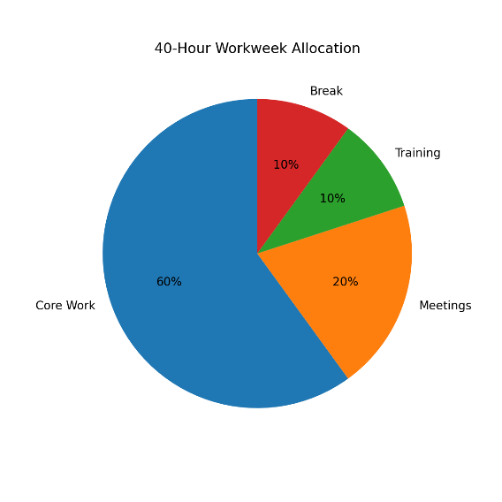
- Clearly shows the contribution of each activity.

(d) A manager wants to use 3D pie charts for the dashboard "because they look more impressive." Explain the visualization problems this introduces.

Answer
Although 3D pie charts appear visually attractive, they reduce the accuracy and readability of the data.

Problems Introduced
- Perspective distortion makes front slices appear larger than they actually are.
- Difficult to compare slice sizes accurately.
- Small slices may become hidden behind larger slices.
- Labels overlap and reduce readability.
- Users may misinterpret the proportions due to the 3D effect.

Better Alternative
A 2D Pie Chart (for a small number of categories) or a Bar Chart (for many categories) provides more accurate comparisons and improves readability.

Conclusion
A 3D pie chart should be avoided in professional dashboards because it emphasizes visual appearance over accurate data interpretation. Simpler 2D charts provide clearer and more reliable insights.

