SIMATS ENGINEERING (SAVEETHA SCHOOL OF ENGINEERING)
Department of Computer Science and Engineering
CO3_AT2 — DATA ANALYSIS PROJECT

Course Code: | DSA06 | Course Title: | Data Handling and Visualization
CO Assessed: | CO3 – Analysis (BL4) | Assessment: | Assessment Tool 2 – Data Analysis Project
Weightage: | 40% of CIA | Total Marks: | 25 (5 Questions × 5 Marks)
CO3 Statement: | Analyze real datasets using ECDFs, skewed-distribution techniques, Q–Q plots, multi-distribution comparisons, and proportion visualizations to identify patterns and justify conclusions.(BL4)
Student Name: | S.SRI MATHI | Reg. No.: | 192424095
Section / Batch: | SLOT C | Date: | 13-08-2026

Code of Conduct
I S.SRI MATHI (Name / Reg No) certify that this submission is my original work and that I have adhered to the guidelines specified for this assessment. I understand that any violation of academic integrity rules will result in disciplinary action.

Signature of the Student:

Instructions
- This test contains 5 questions, each carrying 5 marks. Total: 25 Marks.
- No negative marking. Unanswered questions carry zero marks.
- No calculators or electronic devices permitted.
- Duration: 90 minutes.
- Each answer must go beyond construction: analyze the given data, identify the relevant pattern, and justify your conclusion.
- Show all supporting calculations (e.g., IQR, percentiles, angle calculations) where relevant.
- Where a question asks you to compare or recommend, state your reasoning explicitly — a correct chart choice without justification will not receive full marks.

Annexure A – DATA ANALYSIS PROJECT

Rubrics for Calculation ASSESSMENT RUBRIC
AT2 — Data Analysis Project
CO3 · BT4: Analyze ·
This rubric is used to assess student responses to the CO3-AT2 Data Analysis Project, in which students analyze a given dataset using ECDF, skewed-distribution, Q–Q plot, multi-distribution, or proportion-visualization techniques and justify their conclusions.

Criteria | Weightage | Level 4 – Exemplary | Level 3 – Proficient | Level 2 – Developing | Level 1 – Beginning
Understanding of Concepts | 25% | Demonstrates thorough understanding of the relevant technique (ECDF, skewed-distribution/log transform, Q–Q plot, multi-distribution comparison, or proportion visualization) and correctly identifies which pattern applies to the given data. | Good understanding of the relevant technique, with only minor gaps in identifying the correct pattern. | Basic understanding, but with some misconceptions about which technique or pattern applies to the data. | Poor understanding of core concepts; misidentifies the pattern or technique required by the data.
Explanation | 25% | Provides detailed, well-reasoned analysis explicitly tied to the specific values in the dataset, going beyond description to explain why the pattern occurs or what it implies. | Provides clear analysis with adequate reasoning tied to the data, for most parts. | Analysis is present but generic or only loosely connected to the specific dataset given. | Little or no analytical reasoning provided; answers restate the data without interpretation.
Application | 20% | Effectively applies analytical techniques to compare, justify, or recommend a conclusion that is well-supported by the data and any calculations shown. | Applies analytical techniques correctly, with only minor errors in reasoning or calculation. | Limited application; conclusions are only partially supported by the data or calculations. | Fails to apply appropriate analytical techniques; conclusions are unsupported or incorrect.
Organization | 15% | The response is clearly structured, addressing every sub-part (a–b) in a logical sequence with coherent overall flow. | The response is organized and addresses each sub-part, with only minor issues in flow or clarity. | Basic structure; sub-parts are addressed but the response lacks clarity or a logical sequence. | Poorly organized; the response is incoherent, and sub-parts are left unaddressed or answered out of order.
Accuracy | 10% | All parts of the answer — pattern identification, calculations, and conclusions — are completely accurate and well-suited to the data. | Mostly accurate, with only minor omissions or a small error in one sub-part. | Partially correct; some elements are missing, mismatched to the data, or incorrect. | Largely incorrect or inappropriate, with major gaps across multiple sub-parts.

Scoring Guide
For each criterion, award a performance level (1–4) based on the descriptors above. Multiply the level achieved (as a percentage of 4, i.e., Level 4 = 100%, Level 3 = 75%, Level 2 = 50%, Level 1 = 25%) by the criterion's weightage, then sum across all five criteria to obtain the total score out of 100%.

Faculty In-charge | Course Coordinator | Head of Department
Signature: _______________ | Signature: _______________ | Signature: _______________
Date: ___________________ | Date: ___________________ | Date: ___________________

CO 3 AT 1
DATA ANALYSIS PROJECT

NAME: S.SRI MATHI
REG.NO: 192424095
COURSE CODE: DSA0606
COURSE NAME: DATA HANDLING AND VISUALIZATION
DATE: 13.02.2026

QUESTION 1 — Comparing Sales Performance of Two Stores

Dataset:
Monthly sales of two stores in ₹ thousands:
Month | Store A | Store B
1 | 42 | 35
2 | 45 | 38
3 | 48 | 40
4 | 50 | 42
5 | 52 | 44
6 | 55 | 46
7 | 58 | 48
8 | 60 | 50
9 | 65 | 54
10 | 70 | 58

1(a) Analyze what this positional difference tells you about the two stores' sales performance.
The ECDF represents the cumulative proportion of observations that are less than or equal to a particular sales value. When comparing the two stores, Store A's ECDF is positioned to the right of Store B's ECDF.
For example, the median sales of Store A are approximately:
252+55​=53.5

The median sales of Store B are:
244+46​=45
Therefore, the median sales of Store A are approximately ₹53.5 thousand, compared with ₹45 thousand for Store B.
At higher sales levels, Store A also maintains larger values. For example, its upper sales observations reach ₹65–₹70 thousand, while Store B reaches only ₹54–₹58 thousand.

Interpretation
This positional difference indicates that Store A generally performs better than Store B across the sales distribution, not just at one particular month. Store A has higher typical sales as well as higher upper-range sales.
Therefore, the ECDF comparison suggests that Store A has a stronger overall sales performance.

1(b) Would you say one store's sales distribution "dominates" the other?
Dominance means that Store A generally produces higher sales at comparable cumulative probabilities.
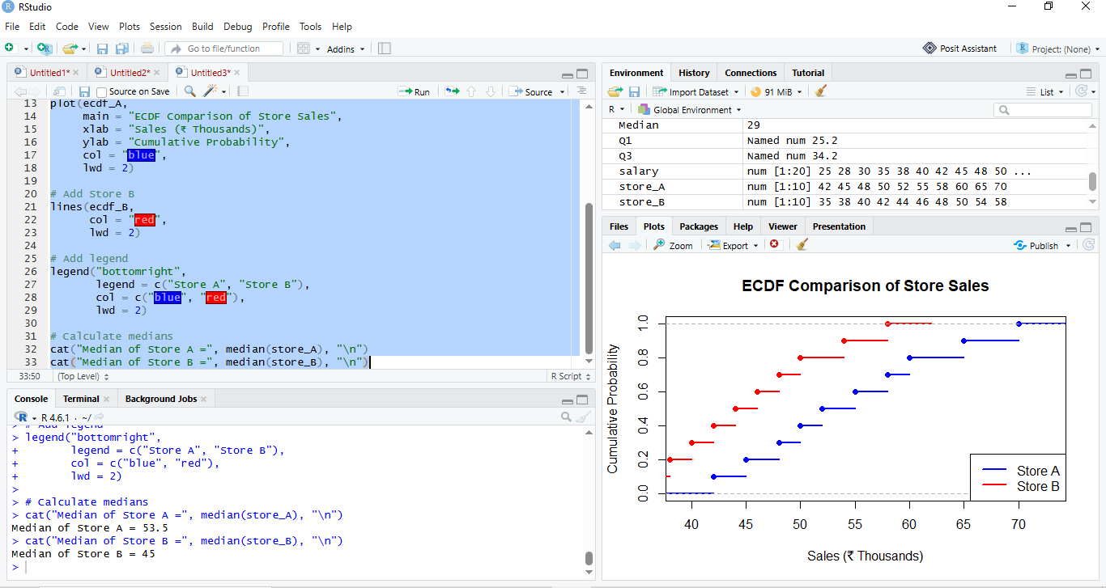
If the ECDF of Store A remains below the ECDF of Store B across the range, it means that for a given sales level, a smaller proportion of Store A's observations are below that level. Equivalently, Store A tends to have higher sales values.

Conclusion
Store A can be considered to first-order stochastically dominate Store B because its sales distribution is consistently shifted toward higher values.This suggests that Store A is performing better overall and not merely because of one unusually successful month.

QUESTION 2 — Analysis of a Right-Skewed Sales Distribution

Dataset
Daily sales in ₹ thousands:
20, 22, 23, 25, 26, 27, 28, 30, 32, 35, 40, 50, 75, 100
Most observations are between ₹20,000 and ₹40,000, while a few observations are much larger.

2(a) Analyze the shape of this distribution.
The distribution is right-skewed (positively skewed).
Most of the sales values are concentrated between ₹20,000 and ₹40,000. However, a few unusually large sales values such as ₹75,000 and ₹100,000 extend the distribution toward the right.
The approximate median is:
There are 14 observations, so:
Median=230+32​=31
The mean is:
1420+22+23+25+26+27+28+30+32+35+40+50+75+100​ Mean≈36.64
Therefore:
Mean>Median
This is a common characteristic of a right-skewed distribution because the large sales values pull the mean toward the right.

2(b) Why would a log transformation be appropriate?
A log transformation is appropriate because sales data can contain very large values compared with ordinary sales.
For example:
- ₹20,000
- ₹30,000
- ₹100,000
The difference between ₹30,000 and ₹100,000 is very large on the original scale.
A logarithmic transformation compresses large values more strongly than small values.
For example:
log(20),log(30),log(100)
The large value becomes much less extreme after transformation.

Effect on the distribution
The log transformation would:
- Compress extremely large sales values.
- Reduce the influence of the right tail.
- Reduce positive skewness.
- Make the distribution more approximately symmetric.
- Make statistical analysis easier when methods assume approximate normality.
Conclusion
A log transformation is suitable because it reduces right-skewness and makes extreme high sales less influential while retaining all observations.

QUESTION 3 — Q–Q Plot and Heavy Tails

Dataset
Suppose the daily sales data are:
10, 12, 13, 14, 15, 16, 17, 18, 19, 20, 21, 22, 25, 30, 45
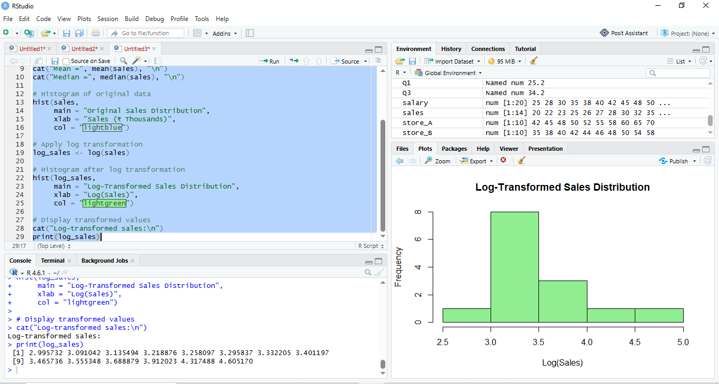
A Normal Q–Q plot is constructed to compare these observations with what would be expected from a Normal distribution.

3(a) Analyze what this specific S-shape indicates about the tails.
The S-shaped pattern in the Normal Q–Q plot indicates that the sales distribution does not follow a Normal distribution exactly.
The important feature is the deviation of the points from the straight reference line at the two ends.
The observations in the middle may follow the reference line reasonably well, but the points at the lower and upper extremes move away from the line.
This indicates that the distribution has heavier tails than a Normal distribution.

What does "heavier tails" mean?
A Normal distribution predicts relatively few extreme observations.
A heavy-tailed sales distribution contains more unusually high or low values than the Normal distribution would predict.
For example, the value 45 is considerably larger than most observations in the dummy dataset. Such extreme observations contribute to the tail behavior.

3(b) Give one plausible business reason for heavier tails.
One realistic business reason is occasional promotional or seasonal events.
For example, a company may normally sell between ₹10,000 and ₹25,000 per day. However, during:
- Festival sales
- Diwali promotions
- Black Friday-type campaigns
- Clearance sales
- Major product launches
- Bulk corporate orders
sales may suddenly increase to ₹40,000, ₹50,000 or even more.
These occasional extreme sales values create heavier tails than a Normal distribution would predict.
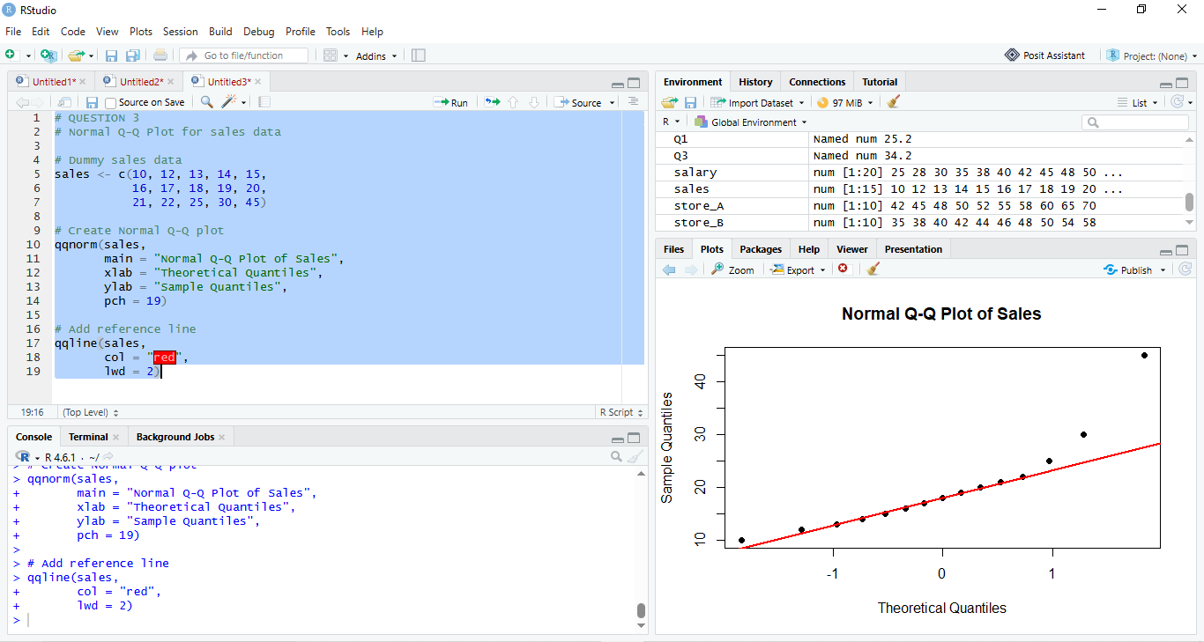

Conclusion
Therefore, heavy tails may represent genuine business behavior rather than an error in the data. Special events, promotions and bulk purchases can naturally create extreme sales observations.

QUESTION 4 — Outlier Detection Using the 1.5 × IQR Rule

Dataset
Daily delivery times in minutes:
10, 12, 13, 14, 15, 16, 17, 18, 19, 20, 21, 22, 23, 25, 60
We will identify whether 60 minutes is an outlier.

4(a) Analyze the dataset for outliers using the 1.5 × IQR rule.

Step 1: Find Q1
There are 15 observations.
The lower half is:
10, 12, 13, 14, 15, 16, 17

The middle value is:
Q1=14

Step 2: Find Q3
The upper half is:
19, 20, 21, 22, 23, 25, 60
The middle value is:
Q3=22

Step 3: Calculate IQR
IQR=Q3−Q1IQR=22−14IQR=8

Step 4: Calculate 1.5 × IQR
1.5×IQR=1.5×8=12

Step 5: Calculate lower fence
Q1−1.5(IQR)=14−12=2

Step 6: Calculate upper fence
Q3+1.5(IQR)=22+12=34
Therefore:
- Lower fence = 2 minutes
- Upper fence = 34 minutes
Any observation below 2 or above 34 is an outlier.
The value:
60>34
Therefore, 60 minutes is an outlier.

4(b) How would this outlier affect a violin plot compared with a box plot?
The outlier would have different effects on the two visualizations.

Box plot
In a box plot:
- Q1 = 14
- Median = 17
- Q3 = 22
- IQR = 8
- Upper fence = 34
The 60-minute observation would normally appear as a separate point beyond the upper whisker.
The box itself mainly represents the middle 50% of the observations, so the outlier does not become part of the central box.

Violin plot
A violin plot represents the density of the distribution.
Most delivery times are between approximately 10 and 25 minutes. The 60-minute observation can create a thin extension or tail toward 60, depending on the smoothing method used.
Therefore, the violin plot may show a long thin tail, while the box plot makes the outlier easier to identify explicitly.
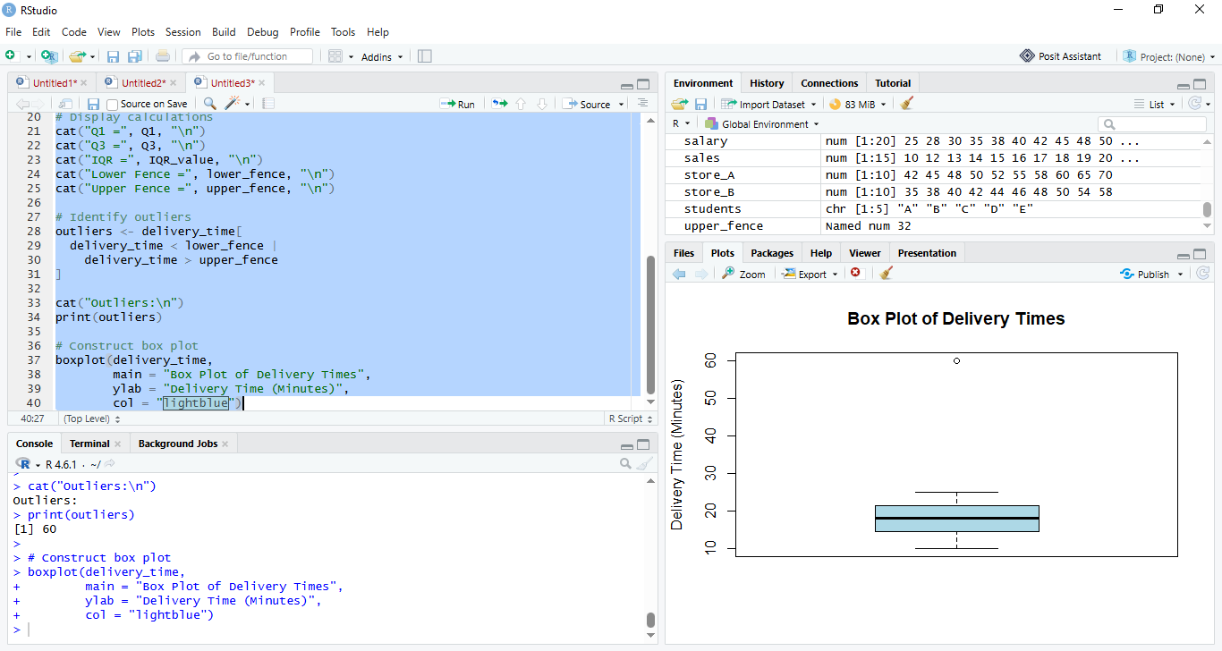

Conclusion
The box plot clearly identifies 60 as an outlier, whereas the violin plot emphasizes the overall density and long tail created by the extreme observation.

QUESTION 5 — School-to-College Student Flow

Dummy Dataset
Suppose students from four schools are admitted to three colleges.
School | College 1 | College 2 | College 3
School A | 35 | 20 | 15
School B | 50 | 25 | 10
School C | 25 | 30 | 20
School D | 15 | 10 | 25

5(a) Which school contributes the most students to College 1?
To answer this, we only need to compare the College 1 column.
School | Students to College 1
School A | 35
School B | 50
School C | 25
School D | 15
The largest value is:
50
Therefore, School B contributes the most students to College 1.

5(b) Why is a Sankey diagram or parallel sets chart better than a simple table?
A simple table provides exact numbers, but it requires the reader to manually compare rows and columns.
For example, from the table we can see:
School B → College 1 = 50 students
However, when there are many schools and colleges, identifying the overall flow becomes difficult.

Sankey diagram
A Sankey diagram represents:
School → College
as a flow.
The width of each flow is proportional to the number of students.
Therefore:
School B → College 1 = 50
would have a wider flow than:
School D → College 1 = 15
This makes the dominant relationship immediately visible.

Parallel sets chart
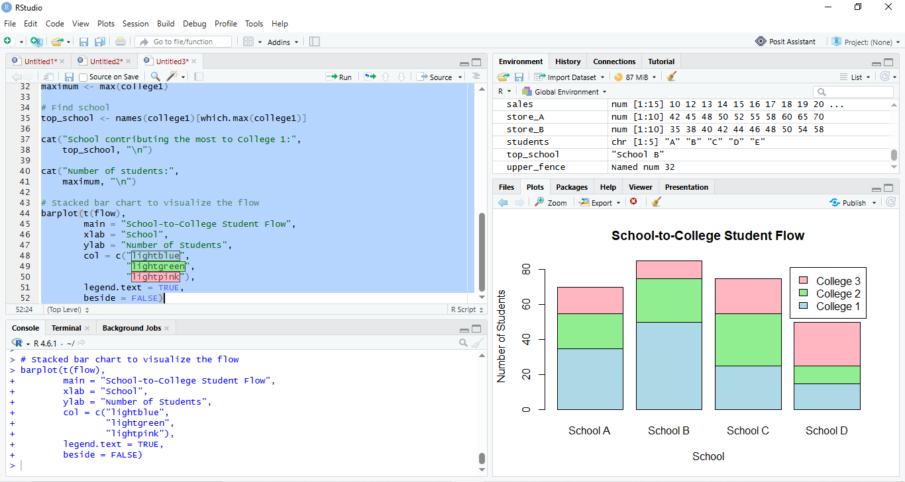
A parallel sets chart similarly shows categorical relationships between multiple groups. The thickness of each connecting band represents the number of students following that path.

Conclusion
A Sankey diagram or parallel sets chart is more effective because it allows us to:
- Identify the largest student flows quickly.
- Compare schools and colleges visually.
- See the overall distribution of students.
- Identify dominant pathways.
- Understand many-to-many relationships more easily than from a table.
Therefore, these visualizations are better suited for proportion and flow analysis.

