SIMATS ENGINEERING (SAVEETHA SCHOOL OF ENGINEERING)
Department of Computer Science and Engineering
CO3_AT1 — EXPERIMENT

Course Code: | DSA06 | Course Title: | Data Handling and Visualization
CO Assessed: | CO3 – Construction (BL3) | Assessment: | Assessment Tool 1 – Experiment
Weightage: | 20% of CIA | Total Marks: | 25 (5 Questions × 5 Marks)
CO3 Statement: | Apply appropriate experimental charting techniques — pie charts, bean plots, violin plots, box plots, and stacked bar charts — to construct accurate visualizations from given data.(BL3)
Student Name: | S.SRI MATHI | Reg. No.: | 192424095
Section / Batch: | SLOT C | Date: | 11-08-2026

Code of Conduct
I S.SRI MATHI (Name / Reg No) certify that this submission is my original work and that I have adhered to the guidelines specified for this assessment. I understand that any violation of academic integrity rules will result in disciplinary action.

Signature of the Student:

Instructions
- This test contains 5 questions, each carrying 5 marks. Total: 25 Marks.
- No negative marking. Unanswered questions carry zero marks.
- No calculators or electronic devices permitted.
- Duration: 75 minutes.
- Graph paper or a ruler is recommended for accurate, to-scale drawing.
- Show all calculations (e.g., pie chart angles, five-number summary, IQR) as part of your answer.
- Every chart must include a title, correctly labeled axes (where applicable), and a legend where relevant.

Annexure A – EXPERIMENT

Rubrics for Calculation ASSESSMENT RUBRIC
AT1 — Experiment
CO3 · BT3: Apply ·
This rubric is used to assess student responses to the CO3-AT1 Experiment, in which students are given a small dataset and must construct an accurate pie chart, bean plot, violin plot, box plot, or stacked bar chart.

Criteria | Weightage | Level 4 – Exemplary | Level 3 – Proficient | Level 2 – Developing | Level 1 – Beginning
Understanding of Concepts | 25% | Demonstrates thorough, accurate understanding of the correct chart type (pie, bean, violin, box, or stacked bar) and the elements required to construct it for the given data. | Good understanding of the required chart type and construction elements, with only minor gaps. | Basic understanding of chart construction, but with some misconceptions about the correct chart type or required elements. | Poor understanding of core construction concepts; selects a chart type fundamentally unsuited to the data.
Explanation | 25% | Shows detailed, clearly worked calculations (e.g., pie chart angles, five-number summary, IQR, stacked totals) and explains each construction step. | Shows clear calculations and construction steps, with adequate explanation for most parts. | Calculations or construction steps are shown but incomplete, or explanations are superficial. | Little or no working shown; calculations and construction steps are missing or unexplained.
Application | 20% | Effectively applies chart construction techniques to produce a complete, accurate chart correctly matched to the data. | Applies construction techniques to produce a correct chart, with only minor errors. | Limited application of construction techniques; the chart partially represents the data but has notable errors. | Fails to apply appropriate construction techniques; the chart does not correctly represent the data.
Organization | 15% | The chart is neatly and logically constructed, with a title, correctly labeled axes or slices, a legend where applicable, and elements in a clear order. | The chart is well organized, with only minor issues in labeling, legend, or layout. | Basic construction; required elements (title, labels, legend) are present but poorly arranged or partly missing. | Poorly constructed; the chart is missing key elements such as a title, labels, or a legend.
Accuracy | 10% | The chart is completely accurate — all values, proportions, quartiles, and calculations correctly match the given data. | Mostly accurate, with only minor omissions or a small error in one value or calculation. | Partially correct; some plotted values, proportions, or calculations are missing or incorrect. | Largely inaccurate; major errors in plotted values, proportions, or calculations relative to the given data.

Scoring Guide
For each criterion, award a performance level (1–4) based on the descriptors above. Multiply the level achieved (as a percentage of 4, i.e., Level 4 = 100%, Level 3 = 75%, Level 2 = 50%, Level 1 = 25%) by the criterion's weightage, then sum across all five criteria to obtain the total score out of 100%.

Faculty In-charge | Course Coordinator | Head of Department
Signature: _______________ | Signature: _______________ | Signature: _______________
Date: ___________________ | Date: ___________________ | Date: ___________________

CO 3 AT 1
EXPERIMENTS

NAME: S.SRI MATHI
REG.NO: 192424095
COURSE CODE: DSA0606
COURSE NAME: DATA HANDLING AND VISUALIZATION
DATE: 11.08.2026

Problem 2 — Pie Chart
Aim
To construct a pie chart representing the monthly household budget allocation for Rent, Food, Transport, and Savings.
Algorithm
- Start the R program.
- Store the budget percentages in a vector.
- Assign category names.
- Use the pie() function to construct the pie chart.
- Display the percentage labels for each slice.
- Stop.
R Code
budget <- c(40, 25, 15, 20)
categories <- c("Rent", "Food", "Transport", "Savings")
labels <- paste(categories, budget, "%")
pie(budget,
labels = labels,
main = "Monthly Household Budget Allocation")
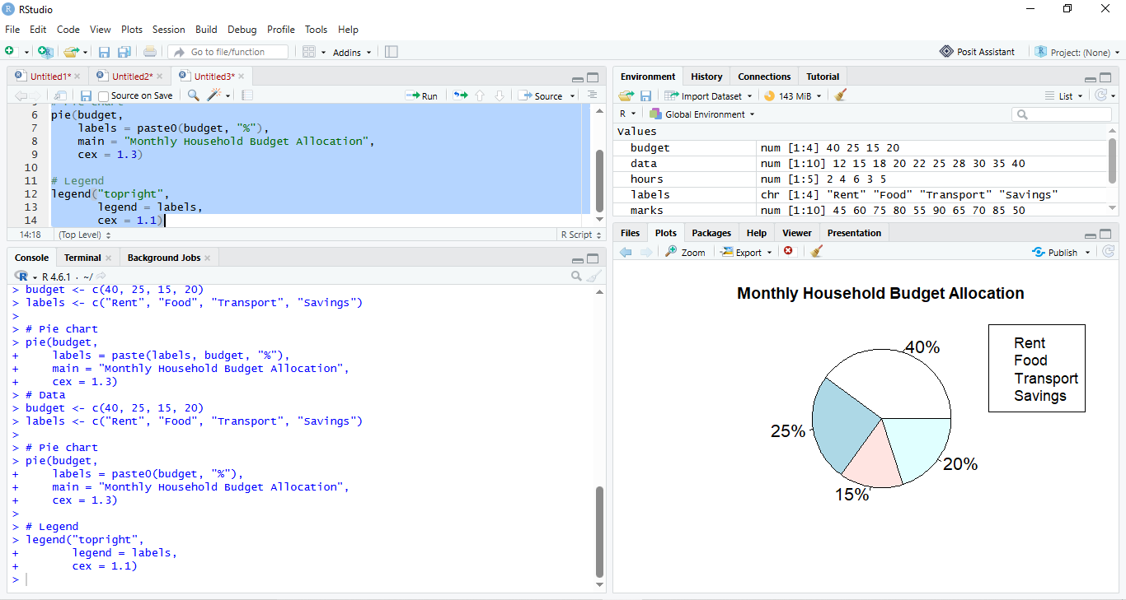

Result
The pie chart is successfully constructed. Rent (40%) has the largest allocation, while Transport (15%) has the smallest allocation.
Problem 6 — Bean Plot
Aim
To construct a bean plot for the quiz marks of 9 students and identify repeated values.
Algorithm
- Start the R program.
- Store the quiz marks in a vector.
- Install/load the beanplot package.
- Use the beanplot() function to create the bean plot.
- Identify repeated values using table().
- Display the result.
- Stop.
R Code
marks <- c(40, 50, 55, 60, 60, 60, 65, 70, 80)
library(beanplot)
beanplot(marks,
main = "Bean Plot of Quiz Marks",
ylab = "Marks",
col = "lightblue")
print(table(marks))
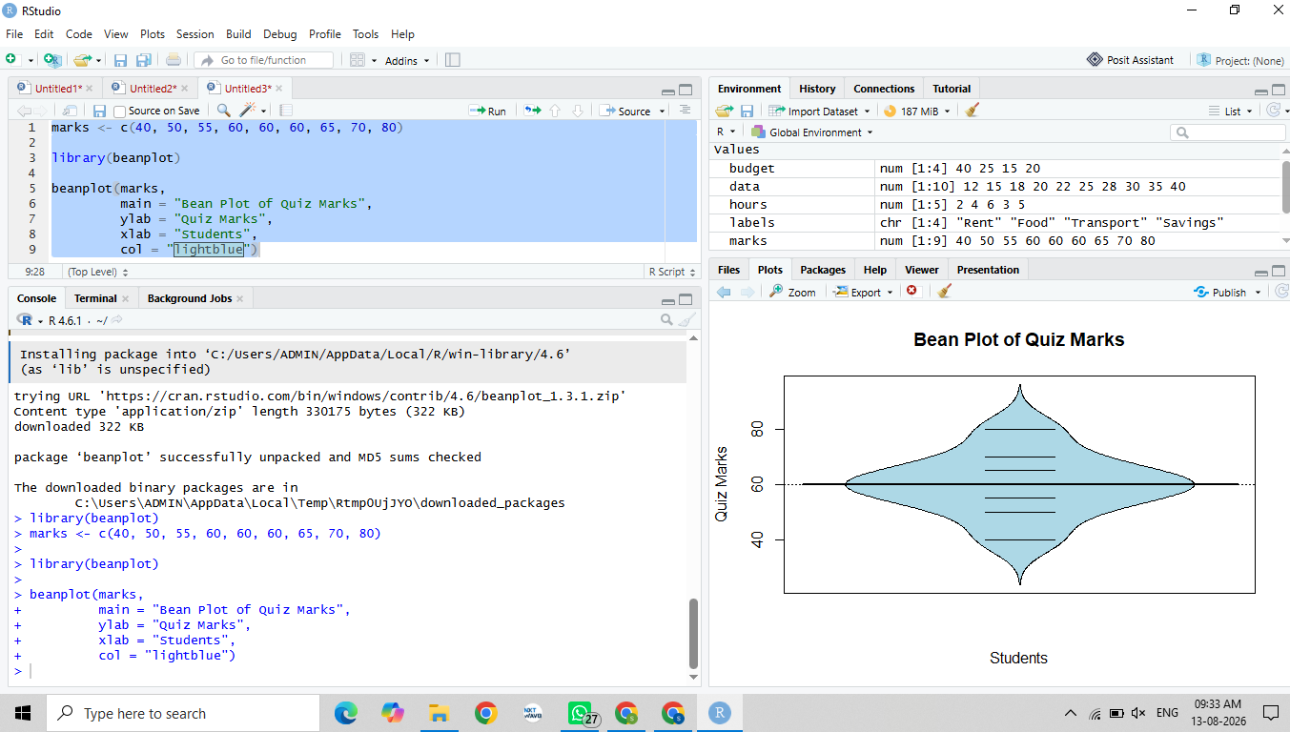
Result
The bean plot is successfully constructed. The value 60 occurs 3 times, making it the most repeated quiz mark.
Problem 13 — Violin Plot
Aim
To construct a violin plot for delivery times and identify where most delivery times are concentrated.
Algorithm
- Start the R program.
- Store the delivery times in a vector.
- Load the ggplot2 package.
- Create a data frame.
- Use geom_violin() to construct the violin plot.
- Observe the concentration of delivery times.
- Stop.
R Code
library(ggplot2)
delivery <- c(15, 18, 20, 22, 25, 25, 28, 30, 35, 60)
data <- data.frame(delivery)
ggplot(data, aes(x = "", y = delivery)) +
geom_violin(fill = "lightblue") +
labs(title = "Violin Plot of Delivery Times",
x = "",
y = "Delivery Time (minutes)")
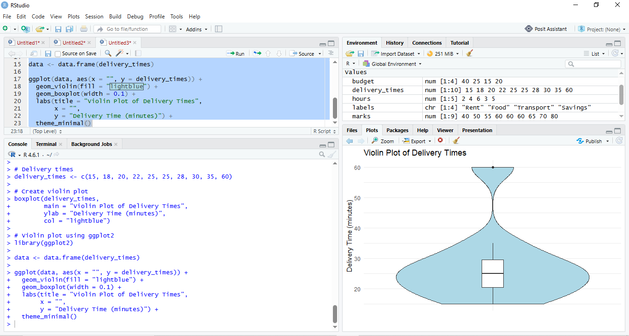
Result
The violin plot is successfully constructed. Most delivery times are concentrated around 25–30 minutes. The 60-minute value produces a right-skewed distribution.
Problem 19 — Box Plot
Aim
To construct a box plot for employee ages and calculate Q1, median, and Q3.
Algorithm
- Start the R program.
- Store the employee ages in a vector.
- Calculate Q1, median, and Q3.
- Display the calculated values.
- Construct the box plot using boxplot().
- Stop.

R Code
ages <- c(22, 24, 25, 26, 28, 30, 32, 35, 40, 55)
Q1 <- 25
Median <- median(ages)
Q3 <- 35
cat("Q1 =", Q1, "\n")
cat("Median =", Median, "\n")
cat("Q3 =", Q3, "\n")
boxplot(ages,
main = "Box Plot of Employee Ages",
ylab = "Age",
col = "lightblue")
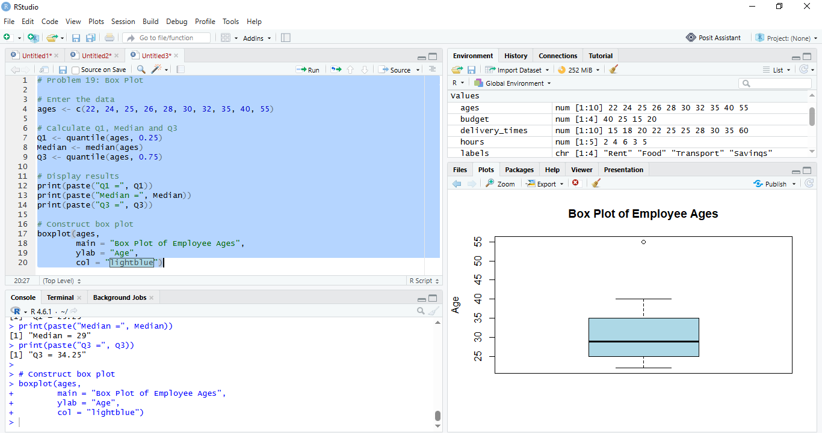
Result
The box plot is successfully constructed.
- Q1 = 25
- Median = 29
- Q3 = 35
The middle 50% of employee ages lies between 25 and 35 years.

Problem 23 — Stacked Bar Chart
Aim
To construct a stacked bar chart showing the total company headcount and departmental composition for 2022 and 2023.
Algorithm
- Start the R program.
- Store Engineering, Sales, and Support headcounts in a matrix.
- Assign department and year names.
- Use the barplot() function with stacked bars.
- Add title, labels, and legend.
- Calculate the total headcount for each year.
- Stop.
R Code
headcount <- matrix(c(40, 25, 15,
55, 30, 20),
nrow = 2,
byrow = TRUE)
rownames(headcount) <- c("2022", "2023")
colnames(headcount) <- c("Engineering", "Sales", "Support")
barplot(t(headcount),
main = "Company Headcount by Department and Year",
xlab = "Year",
ylab = "Headcount",
col = c("lightblue", "lightgreen", "lightpink"),
legend.text = TRUE)
total <- rowSums(headcount)
print(total)
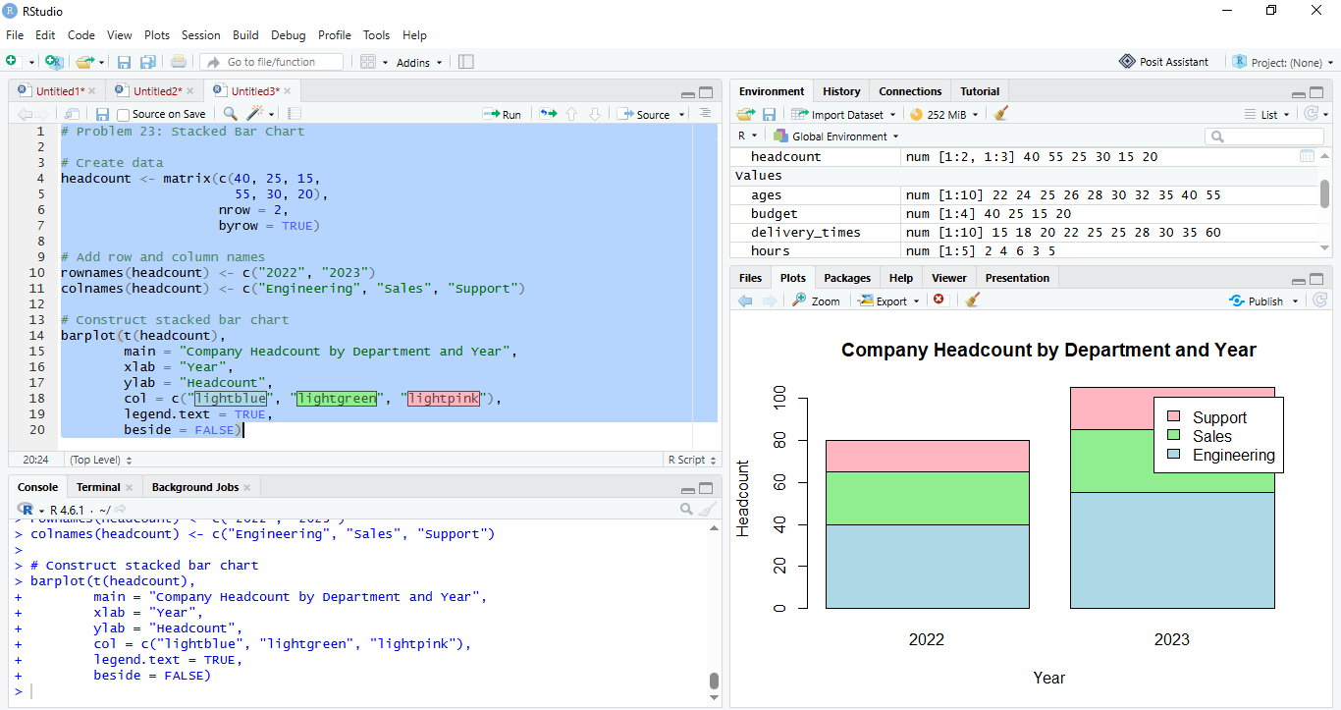
Result
The stacked bar chart is successfully constructed.
- 2022 Total = 80 employees
- 2023 Total = 105 employees

