PERSONAL EXPENSE TRACKER

A Major Project Report
Submitted in partial fulfillment of the requirements for the award of the degree of
BACHELOR OF ENGINEERING
COMPUTER SCIENCE AND ENGINEERING

Submitted By
SRINATH RAJASEKAR R
Register No.: 421224104095

Internship Organization
EDIGLOBE

Under the Guidance of
EDIGlobe

Department of Computer Science and Engineering
KARPAGA VINAYAGA COLLEGE OF ENGINEERING AND TECHNOLOGY
Anna University – R2021
2026

ACKNOWLEDGEMENT
I would like to express my sincere gratitude to Ediglobe for providing me with the opportunity to undertake this internship project and for providing a valuable environment to apply and strengthen my technical knowledge.

I am thankful to my internship coordinator and mentors at Ediglobe for their guidance, valuable suggestions, and continuous support throughout the development of the Personal Expense Tracker project. Their feedback and encouragement helped me understand the practical aspects of Python programming, application development, data handling, testing, and visualization.

I also express my sincere thanks to the Department of Computer Science and Engineering, KARPAGA VINAYAGA COLLEGE OF ENGINEERING AND TECHNOLOGY, for providing the necessary academic support and encouragement to successfully complete this internship project.

I am grateful to all the faculty members, friends, and colleagues who supported me directly or indirectly during the development and completion of this project.

Finally, I would like to thank my family for their constant encouragement, motivation, and support throughout the internship and project development.

ABSTRACT
The Personal Expense Tracker is a command-line-based Python application
developed to help users record, organize, analyze, and visualize their
daily expenses. The system provides essential expense management
operations including adding, viewing, editing, deleting, categorizing,
searching, and filtering expense records.

The application uses Python data structures such as lists and
dictionaries to manage expense records during execution. CSV file
handling is used to provide persistent storage, allowing expense data
to be loaded when the application starts and saved for future use.
Input validation and exception handling are implemented to prevent
invalid data and improve application reliability.

The system also provides analytical reports including total spending,
average expense, highest and lowest expenses, category-wise spending,
and monthly spending. Matplotlib is integrated to provide graphical
visualizations through category-wise bar charts, pie charts, and
monthly spending charts.

The project demonstrates practical implementation of Python concepts
such as functions, control flow, data structures, modular programming,
file handling, exception handling, data analysis, testing, and
visualization.

Keywords: Python, Expense Tracker, CSV, Data Visualization,
Matplotlib, File Handling, Data Analysis, Command-Line Application.

TABLE OF CONTENTS
S. No. | Contents | Page No.
0 | Acknowledgement | 1
1 | Introduction | 2
2 | Project Overview | 3
3 | Problem Statement | 4
4 | Objectives | 5
5 | Scope of the Project | 6-7
6 | System Requirements | 7
7 | System Design | 8
8 | System Architecture | 8
9 | Project Structure and Modules | 9-12
10 | Implementation | 13-14
11 | Reports and Data Analysis | 15
12 | Data Visualization | 16
13 | Error Handling and Validation | 17
14 | Testing | 18
15 | Results and Output | 19-20
16 | Conclusion | 21
17 | Future Enhancements | 22
18 | References | 23

1. INTRODUCTION
Managing personal expenses is an important part of maintaining financial awareness and understanding daily spending habits. When expenses are recorded manually, it can become difficult to maintain organized records, search for previous transactions, calculate total spending, and identify major spending categories.
The Personal Expense Tracker is a Python-based command-line application developed during the internship at Ediglobe to provide a simple and structured solution for managing personal expenses. The application allows users to record expenses by entering details such as date, category, description, and amount.
The system provides essential operations for managing expense records, including adding, viewing, editing, deleting, searching, filtering, and categorizing expenses. The application uses Python lists and dictionaries to organize expense information during execution and uses CSV file handling to maintain expense data for future use.
In addition to basic expense management, the application provides analytical features such as total spending, average expense, highest and lowest expenses, category-wise spending, and monthly spending. These features help users understand their spending patterns and obtain useful information from their expense records.
The project also incorporates Matplotlib for graphical visualization of expense data. Bar charts, pie charts, and monthly spending charts provide a visual representation of the recorded expenses.
Input validation and exception handling are implemented to ensure that incorrect or invalid information does not affect the application's operation. The project also includes automated testing using Python's unittest framework to verify the correctness of important functions and components.
Overall, the project demonstrates the practical application of Python programming, modular development, data structures, file handling, data analysis, visualization, validation, exception handling, and software testing in developing a functional real-world application.

2. PROJECT OVERVIEW
The Personal Expense Tracker is designed as a standalone command-line application that allows users to maintain and analyze their personal expense records. The project follows a modular approach in which different responsibilities are divided into separate Python modules, making the application easier to understand, maintain, test, and extend.
The application starts by loading previously stored expense records from a CSV file. Users can then interact with the system through a menu-driven interface. Depending on the selected operation, users can add new expenses, view existing records, search or filter expenses, modify records, delete unwanted records, and organize expenses according to their categories.
The project uses a structured expense record containing an identifier, date, category, description, and amount. These records are managed using Python data structures during program execution and are stored permanently in a CSV file.
The application also includes a reporting component that processes the stored expense information and generates useful statistics. Users can determine their total and average spending, identify their highest and lowest expenses, and examine spending based on categories and months.
A visualization component uses Matplotlib to represent expense information graphically. This makes it easier to understand the distribution and trends of spending rather than relying only on numerical information.

Major Components
Component | Purpose
Expense Management | Add, view, edit, delete, search, and filter expenses
Data Storage | Store expense records using CSV
Validation | Verify user inputs and prevent invalid data
Reports | Calculate and summarize expense information
Visualization | Display spending information through charts
Testing | Verify application functionality using automated tests
3. PROBLEM STATEMENT
Managing personal expenses without a structured system can make it difficult to maintain accurate records and understand spending patterns. When expenses are recorded manually, users may face difficulties in organizing transactions by category, finding specific records, calculating total spending, and comparing expenses across different periods.
Another limitation is the lack of persistent and easily manageable storage. Without proper data storage, previously recorded expenses may be difficult to retrieve and analyze. Manual calculations can also increase the possibility of errors when determining total, average, highest, or category-wise spending.
Therefore, there is a need for a simple and structured application that can manage expense records, store them for future use, validate user inputs, generate useful reports, and provide graphical representations of spending information.
The Personal Expense Tracker addresses these requirements through a Python-based command-line application. It provides centralized expense management, CSV-based persistent storage, analytical reporting, data visualization, input validation, exception handling, and automated testing.

4. OBJECTIVES
The primary objective of the Personal Expense Tracker is to develop a reliable and modular Python application for recording, managing, analyzing, and visualizing personal expenses.
The specific objectives of the project are:
- To develop an expense management system that allows users to add, view, edit, and delete expense records.
- To organize expenses into categories such as Food, Transport, Entertainment, Shopping, and other relevant categories.
- To implement persistent data storage using CSV file handling so that expense records can be retained and accessed across application sessions.
- To provide search and filtering functionality for efficiently locating specific expense records.
- To generate analytical reports including total spending, average expense, highest expense, lowest expense, category-wise spending, and monthly spending.
- To implement data visualization using Matplotlib to represent expense distributions and spending patterns through graphical charts.
- To implement input validation and exception handling to prevent invalid data and improve the reliability of the application.
- To apply modular programming principles by separating expense management, validation, file handling, reporting, and visualization into dedicated modules.
- To perform automated testing using Python's unittest framework to verify the correctness of important application components.
- To demonstrate practical Python development skills by applying data structures, functions, control flow, file handling, data analysis, visualization, and testing in a real-world application.

5. SCOPE OF THE PROJECT
The scope of the Personal Expense Tracker is to provide a simple, structured, and reliable application for managing personal expense records through a command-line interface. The project focuses on maintaining expense information, processing the stored data, and presenting useful spending insights.

5.1 Expense Management
The system allows users to:
- Add new expense records.
- View all available expenses.
- Edit existing expense records.
- Delete unwanted expense records.
- Categorize expenses based on their type.
- Search and filter expense records.
Each expense contains important information such as ID, date, category, description, and amount.

5.2 Data Storage
The project uses CSV-based file handling for persistent storage. Expense records can be saved to a CSV file and loaded when the application starts. This allows previously recorded expenses to remain available across different sessions.

5.3 Expense Analysis
The system processes stored expense records to provide useful financial summaries. The analysis includes:
- Total spending.
- Average expense.
- Highest expense.
- Lowest expense.
- Category-wise spending.
- Monthly spending.

5.4 Data Visualization
The project includes graphical visualization using Matplotlib. Expense information can be represented using charts such as category-wise bar charts, pie charts, and monthly spending charts.

5.5 Validation and Reliability
The application validates user-provided information such as expense amount, date, category, description, and menu selection. Exception handling is used to manage invalid inputs and prevent unexpected program termination.

5.6 Testing
The project includes automated unit testing using Python's unittest framework. The implemented test suite verifies important components including expense management, report calculations, and input validation.

5.7 Project Limitations
The current project is designed as a local command-line application. It does not currently include features such as user authentication, online synchronization, database connectivity, mobile support, or a graphical user interface. These features can be considered as future enhancements.

6. SYSTEM REQUIREMENTS

Software / Technology | Purpose
Python 3.x | Application development
Matplotlib | Data visualization
CSV Module | Persistent data storage
Datetime Module | Date handling
Unittest | Automated testing
VS Code / PyCharm | Development environment
Git / GitHub | Version control and project hosting

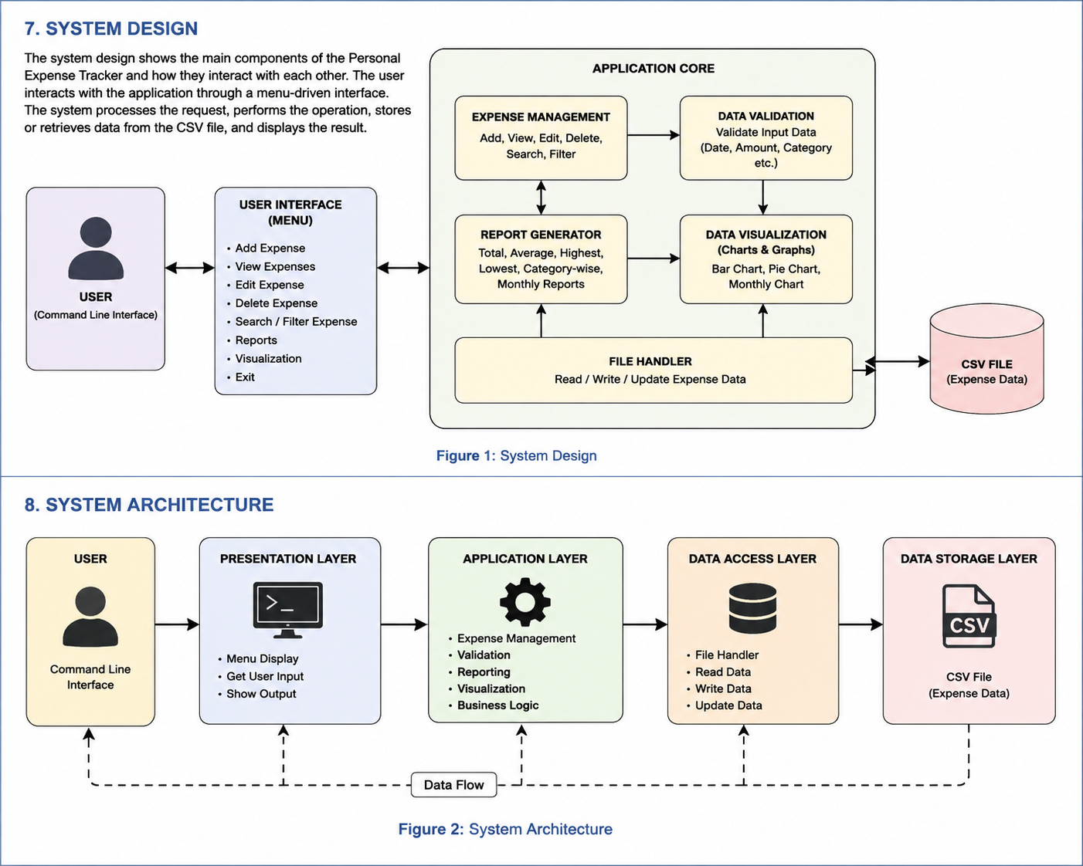
9. PROJECT STRUCTURE AND MODULES
The Personal Expense Tracker follows a modular project structure in which different functionalities are organized into separate files and directories. This structure improves code organization, readability, maintainability, and testing.

9.1 Project Structure
Personal_Expense_Tracker/
│
├── data/
│ ├── README.md
│ └── expenses.csv
│
├── docs/
│ ├── README.md
│ └── project_documentation.md
│
├── modules/
│ ├── README.md
│ ├── __init__.py
│ ├── expense_manager.py
│ ├── file_handler.py
│ ├── reports.py
│ ├── validator.py
│ └── visualization.py
│
├── tests/
│ ├── README.md
│ ├── __init__.py
│ └── test_expense_tracker.py
│
├── .gitignore
├── LICENSE
├── README.md
├── main.py
└── requirements.txt
9.2 Module Description
File / Directory | Description
main.py | Controls the main application flow and menu-driven interface.
modules/ | Contains the core functional modules of the application.
expense_manager.py | Handles adding, viewing, editing, deleting, searching, and filtering expenses.
file_handler.py | Handles reading and writing expense records to the CSV file.
validator.py | Validates amounts, dates, categories, descriptions, and menu inputs.
reports.py | Calculates total, average, highest, lowest, category-wise, and monthly spending.
visualization.py | Generates charts using Matplotlib.
data/ | Stores the application's persistent expense data.
expenses.csv | Contains the saved expense records.
tests/ | Contains automated unit tests for the application.
test_expense_tracker.py | Implements the project's automated test cases.
docs/ | Contains project-related technical documentation.
requirements.txt | Lists the external Python dependencies required by the project.
.gitignore | Specifies files and folders that should not be committed to Git.
LICENSE | Defines the terms under which the project can be used.
README.md | Provides an overview, setup instructions, features, and documentation of the project.

9.3 Modular Workflow
main.py
│
┌───────────────┼────────────────┐
↓ ↓ ↓
Expense Manager Validator File Handler
│ │ │
└───────────────────────────────┘
↓
Reports
│
↓
Visualization
│
↓
expenses.csv

10. IMPLEMENTATION
The Personal Expense Tracker is implemented using Python and follows a menu-driven command-line approach. The implementation is divided into multiple functional components to ensure that each operation can be developed and tested independently.
10.1 Expense Record
Each expense is represented using structured data containing the following fields:
Field | Description
ID | Unique identifier for the expense
Date | Date on which the expense occurred
Category | Category of the expense
Description | Short description of the transaction
Amount | Monetary value of the expense

10.2 Expense Management
The expense management component provides the core operations required to maintain records. Users can add new expenses, view existing records, modify incorrect information, delete unwanted records, and search or filter records based on relevant criteria.
10.3 Data Validation
Before an expense is stored, the provided information is validated. The system checks whether the amount is valid and positive, the date follows the required format, the category is acceptable, and the description is not empty.
10.4 File Handling
The application uses Python's csv module to maintain persistent records. Expense information can be loaded from the CSV file and saved back after changes are made.
10.5 Reporting
The reporting component processes expense records using basic calculations and logical operations. It generates summaries that help users understand their overall and category-wise spending.
10.6 Visualization
The visualization component uses Matplotlib to convert expense information into graphical representations. This provides an easier way to identify spending distribution and trends.
10.7 Menu-Driven Control Flow
The application uses loops and conditional statements to maintain the main menu until the user chooses to exit.

11. Reports and Data Analysis
The Personal Expense Tracker provides a simple reporting system to help users understand their spending habits. The stored expense data is processed and summarized based on categories, amounts, and dates.
11.1 Expense Summary
The system calculates the total amount spent by the user and provides a clear summary of the recorded expenses. This helps users quickly understand their overall spending.
The expense summary can include:
- Total number of expenses recorded
- Total amount spent
- Highest expense
- Lowest expense
- Average expense amount
- Category-wise spending
11.2 Category-wise Analysis
The system groups expenses according to their categories, such as Food, Travel, Shopping, Education, Bills, and Others. The amount spent in each category is calculated to identify areas where the user spends more money.
11.3 Monthly Expense Analysis
Expenses can also be analyzed based on the month in which they were recorded. Monthly analysis helps users compare their spending and identify changes in their expenses over time.
11.4 Data Filtering
The application allows expense records to be filtered according to relevant information such as category or date. Filtering makes it easier to find specific transactions and analyze selected expense records.
11.5 Importance of Data Analysis
Data analysis makes the expense tracker more useful than a simple record-keeping system. By analyzing the stored data, users can identify their major spending areas and make better financial decisions.
12. Data Visualization
Data visualization is used to present expense information in a simple and understandable graphical form. It helps users identify spending patterns without having to examine every individual expense record.
12.1 Purpose of Visualization
The main purpose of data visualization in the Personal Expense Tracker is to provide a quick visual understanding of the user's expenses. Graphs and charts make it easier to compare different categories and spending amounts.
12.2 Category-wise Visualization
A category-wise chart can be used to display the amount spent on different expense categories. This helps users identify which categories contribute the most to their total spending.
12.3 Monthly Visualization
A monthly expense chart can be used to compare expenses across different months. It helps users observe whether their spending is increasing, decreasing, or remaining consistent.
12.4 Benefits
The visualization feature provides the following benefits:
- Easy understanding of expense data
- Quick comparison between categories
- Identification of major spending areas
- Better understanding of monthly spending patterns
- Improved financial decision-making
Overall, data visualization improves the usability of the Personal Expense Tracker by converting numerical expense data into clear and meaningful graphical information.

13. Error Handling and Validation
Error handling and validation are important parts of the Personal Expense Tracker. They ensure that the application accepts valid information and prevents incorrect data from affecting the system.
13.1 Input Validation
The system checks the information entered by the user before processing it. Required fields such as expense amount, category, date, and description are validated to ensure that appropriate values are provided.
13.2 Amount Validation
The expense amount must contain a valid numerical value. Invalid or negative values are rejected to prevent incorrect expense records.
13.3 Empty Input Handling
The system checks for empty inputs in important fields. If a required value is missing, the user is informed and requested to enter the required information.
13.4 Invalid Operation Handling
When the user selects an unavailable menu option or performs an invalid operation, the system displays an appropriate message instead of terminating unexpectedly.
13.5 File and Data Handling
The application also handles problems related to loading or saving expense data. If the required data file is unavailable or contains invalid information, the system can notify the user and continue safely whenever possible.
13.6 Benefits
Proper error handling and validation provide the following benefits:
- Prevent incorrect data entry
- Improve application reliability
- Reduce unexpected program failures
- Provide clear messages to users
- Maintain the accuracy of stored expense data
Thus, error handling and validation make the Personal Expense Tracker more reliable, stable, and user-friendly.
14. Testing
Testing was performed to verify that the Personal Expense Tracker works correctly and produces the expected results. Different operations were checked using valid and invalid inputs.
14.1 Testing Objectives
The main objectives of testing were:
- To verify that all major functions work correctly.
- To identify and correct errors.
- To check whether user inputs are properly validated.
- To ensure that expense data is stored and retrieved correctly.
- To verify that reports and calculations produce accurate results.
14.2 Functional Testing
Each major function of the application was tested individually. Adding, viewing, updating, deleting, searching, and analyzing expense records were checked to ensure that they performed the expected operations.
14.3 Input Validation Testing
Different types of inputs were tested, including valid numbers, invalid values, empty fields, and incorrect menu selections. The system was checked to ensure that invalid inputs were handled properly.
14.4 Data Storage Testing
The save and load operations were tested to confirm that expense records were stored correctly and could be retrieved when the application was reopened.
14.5 Testing Result
The testing process confirmed that the major features of the Personal Expense Tracker functioned as expected. Errors identified during testing were corrected, resulting in a more reliable and stable application.
Overall, testing helped ensure that the system meets its functional requirements and provides accurate expense management.

15. Results and Output
The Personal Expense Tracker was successfully developed and tested as an application for managing daily expenses. The system provides the required functions for recording, managing, analyzing, and displaying expense information.
15.1 Expense Entry
The application allows users to enter expense details such as date, category, amount, and description. The entered information is stored for further processing.
15.2 Expense Management
Users can view and manage the stored expense records. The system provides operations such as adding, viewing, updating, deleting, and searching expense information.
15.3 Expense Calculation
The application calculates the total expenses and provides useful information such as category-wise and monthly spending. These calculations help users understand their overall spending.
15.4 Reports and Visualization
The system generates summarized expense information and presents the data in an understandable format. Charts or graphical representations can be used to make comparisons between different expense categories and time periods.
15.5 Output
The final output of the system includes:
- Successfully stored expense records
- Total expense calculation
- Category-wise expense summary
- Monthly expense information
- Search and filter results
- Reports and graphical analysis
- Proper validation and error messages

15.6 Overall Result
The completed application successfully meets the main objectives of the project. It provides a simple and organized way to maintain expense records and analyze spending patterns. The project also demonstrates the practical application of programming, data handling, validation, and visualization concepts.

16. Conclusion
The Personal Expense Tracker was successfully developed as an internship project at Ediglobe to provide a simple and organized solution for managing personal expenses. The system allows users to record, view, update, delete, and analyze their expense information efficiently.
The project helped in understanding the practical implementation of programming concepts, data handling, input validation, error handling, reporting, and data visualization. The analysis features also help users understand their spending patterns and identify major expense categories.
Overall, the project achieved its intended objectives and provides a useful foundation for developing a more advanced expense management application in the future. The development process also provided valuable practical experience in designing, implementing, testing, and documenting a software project.

17. Future Enhancements
Although the Personal Expense Tracker provides the basic features required for managing expenses, several improvements can be added in the future to make the application more powerful and user-friendly.
17.1 User Login and Security
A secure login system can be added to protect personal expense information and allow multiple users to maintain separate accounts.
17.2 Advanced Data Visualization
More interactive charts and dashboards can be introduced to provide detailed insights into spending patterns and financial trends.
17.3 Budget Management
A budget planning feature can be added to allow users to set spending limits for different categories and monitor their expenses against those limits.
17.4 Database Integration
The application can be connected to a database such as MySQL, PostgreSQL, or MongoDB to provide more reliable and scalable data storage.
17.5 Export and Import
Users could be provided with options to export expense reports in formats such as CSV, Excel, or PDF and import existing expense records.
17.6 Mobile and Web Application
The system can be extended into a responsive web or mobile application so that users can manage their expenses from different devices.
17.7 Automated Insights
Future versions can include intelligent analysis to identify unusual spending patterns and provide personalized expense insights.
These enhancements can make the Personal Expense Tracker more secure, flexible, and suitable for real-world use.

18. References
- Python Software Foundation, Python Documentation, Python Programming Language.
- Pandas Development Team, Pandas Documentation, Data Analysis and Manipulation Library.
- NumPy Developers, NumPy Documentation, Numerical Computing Library.
- Matplotlib Development Team, Matplotlib Documentation, Data Visualization Library.
- Scikit-learn Developers, Scikit-learn Documentation, Machine Learning and Data Analysis Library.
- Ediglobe, Internship Learning Materials and Project Guidance, Internship Program, 2026.
- W3Schools, Python Programming and Data Handling Tutorials.
- GeeksforGeeks, Python Programming, Data Analysis and Software Development Concepts.

