
CROWD-SOURCED REAL-TIME POTHOLE AND ROAD DAMAGE TRACKER FOR CORPORATION
A Mini Project work submitted in partial fulfilment of the requirements for the award of the Degree of
MASTER OF COMPUTER APPLICATIONS
Submitted By
G.SHAMEEM
Register No. : 25PCA143
Under the Guidance of
Dr. P. ANITHA, M.C.A., M.Phil., B.Ed., Ph.D.,
Assistant Professor
DEPARTMENT OF COMPUTER APPLICATION

VELLALAR COLLEGE FOR WOMEN (AUTONOMOUS)
College with Potential for Excellence
Re-accredited with ‘A+’ Grade (CYCLE IV) by NAAC &
Affiliated to Bharathiar University, Coimbatore – 641 046
Thindal, Erode – 638 012
OCTOBER – 2026

DECLARATION

DECLARATION
I hereby declare that mini project work entitled “CROWD-SOURCED REAL-TIME POTHOLE AND ROAD DAMAGE TRACKER FOR CORPORATION” submitted in partial fulfilment of the requirements for the award of the Degree of MASTER OF COMPUTER APPLICATIONS is a record of original work done by G.SHAMEEM [25PCA143] during my period of study in VELLALAR COLLEGE FOR WOMEN (AUTONOMOUS), ERODE-12 under the supervision and guidance of Dr. P. ANITHA, M.C.A., M.Phil., B.Ed., Ph.D., Assistant Professor, Department of Computer Applications, Vellalar College for Women (Autonomous), Erode-12, and it has formed the basis for the award of any Degree/Diploma/Associateship/Fellowship or similar title to any candidate of any university.

Name of the Candidate Register Number Signature of the Candidate
G.SHAMEEM 25PCA143

Place: Erode Signature of the Guide :
Date: Dr. P. ANITHA, M.C.A., M.Phil., B.Ed., Ph.D.,
Assistant Professor,
Department of Computer Applications,
Vellalar College for Women (Autonomous),
Erode – 12.

CERTIFICATE

CERTIFICATE
This is to certify that this mini project work entitled as “CROWD-SOURCED REAL-TIME POTHOLE AND ROAD DAMAGE TRACKER FOR CORPORATION” submitted to VELLALAR COLLEGE FOR WOMEN (AUTONOMOUS), ERODE-12 affiliated to Bharathiar University, Coimbatore-46 in partial fulfilment of the award of the degree of Master of Computer Applications is a record of original work done by G.SHAMEEM [25PCA143], during the period of study 2025-2027 in VELLALAR COLLEGE FOR WOMEN (AUTONOMOUS), ERODE-12, under my supervision and guidance and this project work has formed the basis for the award of any Degree/Diploma/Associateship/Fellowship or similar title to any candidate of any University.

Forwarded by Guided by
Mr. N. SENTHILKUMARAN, M.C.A., M.Phil., Dr. P. ANITHA, M.C.A., M.Phil., B.Ed.,
Ph.D.,
Director, Assistant Professor,
Department of Computer Applications, Department of Computer Applications,
Vellalar College for Women(Autonomous), Vellalar College for Women(Autonomous),
Erode-12. Erode-12.

College Seal Signature of the Principal

DR. R. PARVATHI,
Principal,
Vellalar College for Women (Autonomous),
Erode-12.

Submitted to the Mini project Viva-Voce Examination held on

Internal Examiner External Examiner

ACKNOWLEDGEMENT

ACKNOWLEDGEMENT
I praise and thank God for the love and blessings showered upon me to complete this project successfully.
I wish to express my gratitude and sincere thanks to our respected Secretary and Correspondent Thiru. S.D. CHANDRASEKAR, B.A., Vellalar College for Women (Autonomous), Erode-12, for providing the opportunity and resources required to carry out this project successfully.
I express my sincere thanks to our respected Principal Dr. R. PARVATHI, Principal, Vellalar College for Women (Autonomous), Erode-12, for the valuable support rendered throughout the project.
I record my heartfelt gratitude to Mr. N. SENTHILKUMARAN, M.C.A., M.Phil., Director and Head of the Department, Department of Computer Applications, Vellalar College for Women (Autonomous), Erode-12, for providing a supportive academic environment.
I am extremely thankful to my project guide, Dr. P. ANITHA, M.C.A., M.Phil., B.Ed., Ph.D., Assistant Professor, Department of Computer Applications, Vellalar College for Women (Autonomous), Erode-12 for initiating me right from the beginning and helping me to learn the requisites in the practical field, as well as our project internal guide for me moral support and valuable guidance and suggestion which made the project a successful one.
I place my sincere thanks to all our Teaching and Non-Teaching staff Members and Lab Assistant of Department of Computer Applications, Vellalar College for Women (Autonomous), Erode-12, for their encouragement during this project work.
I wish to thank all my Friends for their co-operation and their moral support. Words are inadequate to express deep sense of gratitude to my beloved Parents for them never ending co-operation and support.
.

s

ABSTARCT

ABSTRACT

The Crowd-Sourced Real-Time Pothole and Road Damage Tracker for Corporation is a web-based application designed to help citizens report potholes, cracks, waterlogging and other road damage directly to Corporation officials. A user can register, log in, upload a photograph, write a short description, enter an address or landmark and capture the GPS coordinates through the browser.
The application provides a My Complaints page where citizens can view the complaints they have submitted and the current status of each one. Corporation officials log in through an administrator account and reach a dashboard that shows the total number of complaints along with the counts of Pending, In Progress and Resolved complaints. Officials can filter the complaints, view the photograph and reporter details, open the complaint location in a map link and update the status.
The system improves communication between citizens and the Corporation by giving both sides a single place to report, monitor and manage road damage. The photograph and location details help officials to identify the exact problem area, and the status updates let citizens follow the progress of their complaints without visiting the office. The application is developed using Python Flask, MySQL, HTML, CSS, Bootstrap 5 and JavaScript.

CONTENTS

CONTENTS
CHAPTER NO | TITLE | PAGE NO
1 | INTRODUCTION
1 | 1.1 PROBLEM DESCRIPTION
1 | 1.2 SYSTEM SPECIFICATION
1 | 1.3 SOFTWARE DESCRIPTION
2 | SYSTEM ANALYSIS
2 | 2.1 EXSISTING SYSTEM
2 | 2.2 PROPOSED SYSTEM
2 | 2.3 MODULE DESCRIPTION
3 | SYSTEM DESIGN
3 | 3.1 DATA FLOW DIAGRAM
3 | 3.2 DATABASE DESIGN
3 | 3.3 TABLE DESIGN
3 | 3.4 INPUT DESIGN
3 | 3.5 OUTPUT DESIGN
4 | SYSTEM TESTING AND IMPLEMENTATION
4 | 4.1 SYSTEM TESTING
4 | 4.2 SYSTEM IMPLEMENTATION
5 | CONCLUSION
6 | FUTURE ENHANCEMENT
7 | BIBLIOGRAPHY
8 | APPENDICES

INTRODUCTION

CHAPTER 1

INTRODUCTION

1.1 PROBLEM DESCRIPTION
Roads are used by everyone every day, whether a person is walking, riding a two-wheeler or driving a bus. Potholes, cracks and stagnant water make a road dangerous and often lead to accidents, vehicle damage and traffic jams, especially in the rainy season when a pothole is hidden under water.
At present, a citizen who notices road damage can only phone the Corporation office, meet a ward member or send an informal message. The complaint is rarely recorded properly, and the citizen never learns what happened to it. The main problems are given below.
- Scattered complaints: Complaints arrive through calls, visits and messages, so there is no single record.
- No photo proof: Officials cannot see the actual damage before sending a repair team.
- Unclear location: A description such as "near the bus stand" is not enough to find the exact spot.
- No status information: The citizen cannot know whether the work is pending, started or completed.
- Manual record keeping: Registers are maintained by hand, which takes time and leads to mistakes.
- Difficult monitoring: It is hard to know how many complaints are still open.
Because of these problems, repair work is delayed and the public loses trust in the system. A web application in which the citizen submits a photo with the location, and the official views and updates the complaint in one place, can solve most of these issues. The Crowd-Sourced Real-Time Pothole and Road Damage Tracker has been developed with this idea.

1

1.2 SYSTEM SPECIFICATION
1.2.1 HARDWARE SPECIFICATION
Processor : 13th Gen Intel® Core™ i3-1305U
RAM : 8 GB
Storage : 477 GB of free disk space
Internet Connection : 5 Mbps or higher
1.2.2 SOFTWARE SPECIFICATION
Operating System : Windows 11
Programming Language : Python
Front End : HTML, CSS, JavaScript, Bootstrap 5
Back End : Flask 3.0.3
Database : MySQL
Database Admin Tool : phpMyAdmin (XAMPP)
Authentication : Flask Session, Werkzeug Password Hashing
File Storage : Local Server Storage (static/uploads)
Location Services : Browser Geolocation API
Web Browser : Any modern browser with location support (Google Chrome, Microsoft Edge)

2
1.3 SOFTWARE DESCRIPTION
FRONT END
HTML
HyperText Markup Language (HTML) is the standard markup language used to create web pages. It describes the structure of a page using elements and tags such as headings, paragraphs, forms, tables, images and links. The browser does not display the tags themselves but uses them to arrange and display the content. In this project, HTML is used to build all the pages of the application such as Home, Register, Login, Report Damage, My Complaints and the Admin Dashboard.
- HTML describes the structure of a web page using elements and tags.
- It provides form elements for the registration, login and complaint forms.
- It supports the file input used to upload the photograph of the road damage.
- It works together with CSS and JavaScript to build a complete web page.
- It is platform independent and supported by all web browsers.
CSS
Cascading Style Sheets (CSS) is a style sheet language used to describe how HTML elements are displayed on the screen. It separates the presentation of a page from its content, which includes the layout, colours, fonts and spacing. When many pages use the same style sheet, a change made in one place is reflected in all the pages. In this project, CSS is used along with Bootstrap to give all the pages a consistent and neat appearance.

BOOTSTRAP 5
Bootstrap is a free and open-source front-end framework that provides ready-made CSS classes and JavaScript components for building responsive web pages. It follows a mobile-first approach, so the same page adjusts itself to mobile phones, tablets and desktop screens. In this project, Bootstrap 5 is used for the responsive layout, the collapsible navigation bar, forms, complaint cards, alert messages and the coloured status badges for Pending, In Progress and Resolved complaints.

3
- Responsive grid system that adjusts the page to different screen sizes.
- Ready-made components such as navigation bar, forms, cards, buttons and alerts.
- Consistent appearance across different web browsers.
- Reduces the time and effort needed to design the user interface.

JAVASCRIPT
JavaScript is a high-level scripting language that runs inside the web browser and makes web pages interactive. It is one of the core technologies of the World Wide Web along with HTML and CSS, and all major browsers have a built-in JavaScript engine to execute it. In this project, JavaScript is used to capture the location of the user through the Geolocation API of the browser when the Capture My Location button is clicked, and to fill the latitude and longitude fields of the complaint form. It is also used to close the alert messages automatically after a few seconds.

BACK END
PYTHON
Python is a high-level, general-purpose and interpreted programming language created by Guido van Rossum and first released in 1991. It has a simple and readable syntax, a large standard library and a wide range of third-party packages. In this project, Python is used to write the server-side logic such as handling requests, validating form data, hashing passwords, saving the uploaded photographs and communicating with the database.
Advantages of Python
- Python is open-source and free of cost.
- It is easy to learn and the programs are easy to read and maintain.
- It has a large number of libraries and frameworks for web development.
- It runs on different operating systems such as Windows, Linux and macOS.
Disadvantages of Python
- It is slower than compiled languages such as C and Java.
- It is not commonly used for developing mobile applications.

4
FLASK
Flask is a lightweight web framework for Python, created by Armin Ronacher and maintained by the Pallets project. It is called a micro framework because its core is small and simple, and additional features can be added through extensions and libraries. Flask is built on the Werkzeug toolkit and the Jinja2 template engine. Flask 3.0.3 is used in this project to handle the routes of the application, such as registration, login, complaint submission, My Complaints, the Admin Dashboard and the status update.
Features of Flask
- Routing: connects each web address of the application to a Python function.
- Jinja2 templates: allows the same base layout to be reused by all the pages.
- Session management: stores the details of the logged-in user.
- File handling: receives the uploaded photographs of the road damage.
- Werkzeug utilities: provides password hashing and secure file name handling.
- Built-in development server that makes testing easy.

MYSQL
MySQL is an open-source relational database management system (RDBMS). It stores data in tables made up of rows and columns and uses Structured Query Language (SQL) to create, insert, update, delete and retrieve data. MySQL was originally developed by the Swedish company MySQL AB and is currently owned by Oracle Corporation. In this project, MySQL stores the users and complaints tables, and the mysql-connector-python library is used to connect the Flask application to the database. The queries use parameters, which protects the database from SQL injection.

FEATURES OF MYSQL
Ease of Use
MySQL is easy to install, configure and manage. Tools such as phpMyAdmin allow the database and tables to be created and viewed through a web browser.
Scalability
MySQL can be used for small applications as well as large web applications, so the complaint database can grow as the number of complaints increases.

5
Data Integrity
MySQL supports primary keys and foreign keys, which maintain the relationship between the records of different tables. In this project, every complaint is linked to the user who reported it.
Security
MySQL provides user accounts, authentication and access privileges, so that only authorized users can view or change the stored data.

OTHER TOOLS AND SERVICES
XAMPP and phpMyAdmin
XAMPP is a free software package that provides the MySQL database server on the local computer. phpMyAdmin is a web-based tool used to manage the MySQL database. In this project, they are used to create the database, run the schema file and view the stored users and complaints.
Browser Geolocation API
The Geolocation API is a feature of modern web browsers that allows a website to get the geographical position of the user after the user gives permission. It returns the latitude and longitude of the device, and it works on secure pages such as HTTPS and localhost. This is used to capture the exact location of the road damage without any external service.
Google Maps Link
The saved latitude and longitude of a complaint are used to create a Google Maps link, which opens the location of the damage on a map. This helps the administrator to find the exact place without using any API key.

6

SYSTEM ANALYSIS

CHAPTER 2
SYSTEM ANALYSIS
2.1 EXISTING SYSTEM
The existing system for reporting road damage depends mainly on traditional methods. A citizen who notices a pothole, crack or waterlogged road can phone the Corporation office, meet a ward member in person or send a message through an informal channel. This provides a basic way of bringing the problem to the notice of the authorities. However, the process is largely restricted to informing the officials and does not cover the complete sequence of activities involved in handling a complaint. Photographs of the damage, the exact location, complaint records and repair status are not managed through a unified platform. As a result, officials may need to depend on separate registers or manual procedures for recording and following up the complaints, and citizens have no way of knowing what happened to their complaints, which makes complaint tracking and record management less convenient.

Drawbacks of Existing System
- Provides only basic support for informing the Corporation about road damage through calls, visits and messages.
- Photo proof and the exact location of the damage are not available to the officials.
- Complaints are maintained manually in registers and not through a unified system.
- Citizens cannot track the status of their complaints, and officials have limited support for monitoring the open complaints.

7
2.2 PROPOSED SYSTEM
The proposed system is a web-based application designed to efficiently report, manage and monitor road damage complaints. The Crowd-Sourced Real-Time Pothole and Road Damage Tracker provides a simple platform for citizens to register, log in and report potholes, cracks and waterlogging along with a photograph, GPS location and description. It also provides an admin module for Corporation officials to manage the complaints.
A key feature of the proposed system is its centralized complaint management, which allows the administrator to view all the complaints, check the photographs, open the location through a Google Maps link and update the repair status from Pending to In Progress and Resolved. The citizen can view the updated status in the My Complaints page. This reduces manual record keeping and makes complaint tracking easier.
Features of the Proposed System
- Easy Registration and Login – Allows citizens to create an account and log in securely.
- Simple Complaint Submission – Allows citizens to submit the damage type, description and address through a single form.
- GPS Location and Photo Evidence – Captures the location automatically and allows a photograph to be uploaded.
- Complaint Status Tracking – Allows citizens to follow their complaints as Pending, In Progress or Resolved.
- Admin Dashboard – Displays all complaints with photographs, reporter details, summary counts and status filters.
- Secure and Responsive Interface – Protects passwords using hashing and works on desktop, tablet and mobile devices.

Drawbacks of Existing System
- Complaints are received through calls, visits and messages, with no single record.
- Photo proof and exact location are not available to the officials.
- Complaints are maintained manually in registers, which is slow and error-prone.
- Citizens cannot track complaint status, and officials find it hard to monitor open complaints.

8
2.3 MODULE DESCRIPTION
The Crowd-Sourced Real-Time Pothole and Road Damage Tracker is divided into several modules, where each module performs a specific function in the road damage reporting and management process. The modules work together to allow citizens to report road damage with photographs and location details, track their complaints, and help the Corporation administrator monitor and resolve the complaints efficiently.
User Authentication Module
The User Authentication Module provides secure access to the system for citizens and administrators. It manages user registration, login, role-based redirection, session handling and logout. During registration, the user provides the name, email address, password and confirm password, and the system checks that all fields are filled, the passwords match and the email address is not already registered. The password is stored as a secure hash. During login, the system verifies the entered credentials and redirects the user to the appropriate page based on the role, such as the My Complaints page for a citizen and the Admin Dashboard for an administrator. The logout function clears the session and returns the user to the home page.
Citizen Module
The Citizen Module allows a logged-in citizen to report road damage and follow the progress of the complaints. The major submodules are Complaint Submission, Image Upload and GPS Capture, and Complaint Status Tracking.
Complaint Submission
The Complaint Submission submodule allows the citizen to select the type of damage such as Pothole, Crack, Waterlogging or Other, and enter the description and the address or landmark. The complaint is stored with the status Pending and is linked to the user who reported it.

9
Image Upload and GPS Capture
This submodule allows the citizen to upload a photograph of the damage and capture the location using the Capture My Location option. The latitude and longitude are obtained through the Geolocation API of the browser. The photograph is accepted only in PNG, JPG, JPEG, GIF or WEBP format with a maximum size of 5 MB, and it is saved with a unique file name.
Complaint Status Tracking
The My Complaints page displays all the complaints submitted by the citizen, with the photograph, damage type, description, address and the current status as Pending, In Progress or Resolved. The citizen can also use the Report New Damage option to submit another complaint.
Admin Module
The Admin Module provides the Corporation administrator with facilities to view, monitor and update the complaints. Access to this module is restricted to users with the admin role. The major submodules are Admin Dashboard, Complaint Status Update and Location and Map Support.
Admin Dashboard
The Admin Dashboard displays all complaints with the photograph, damage type, description, reporter name and email address, and current status. It also shows summary cards for the total, Pending, In Progress and Resolved complaints, and the administrator can filter the complaints by status.
Complaint Status Update
This submodule allows the administrator to change the status of a complaint using a drop-down list and the Save button. The system accepts only the values Pending, In Progress and Resolved, stores the new status in the database and records the update time. A confirmation message is displayed after the update.
Location and Map Support
The saved latitude and longitude of a complaint are used to create a Google Maps link, which opens the location of the damage on a map. This helps the administrator to find the exact place of the damage.

10
Database and Security Module
The Database and Security Module stores the user details and complaint details in separate MySQL tables, and a foreign key connects every complaint with the user who reported it. Email addresses are kept unique, passwords are protected using hashing, and the database queries use parameters to prevent SQL injection. The login check and the admin check ensure that only authorized users can access the protected pages.
User Interface Module
The User Interface Module provides a simple and responsive web interface for citizens and administrators using HTML, CSS, Bootstrap 5 and JavaScript. It provides navigation for registration, login, complaint submission, complaint tracking and administration, and it displays success and error messages after every action.

11

SYSTEM DESIGN

CHAPTER 3
SYSTEM DESIGN

3.2 DATA FLOW DIAGRAM
A data flow diagram (DFD) shows how data moves between the external entities, the processes and the data stores of a system. In this project the Yourdon notation is followed, in which a rectangle is an external entity, a circle or oval is a process, an open rectangle is a data store and an arrow is a data flow.

Level 0
The Level 0 diagram, also called the context diagram, shows the whole system as a single process. There are two external entities, the Citizen and the Admin (Corporation Official). The citizen sends the registration and login details and the complaint details with photo and location, and receives the complaint status. The admin sends the login and status update and receives the complaint reports and dashboard data. The diagram is shown in Fig 3.1.

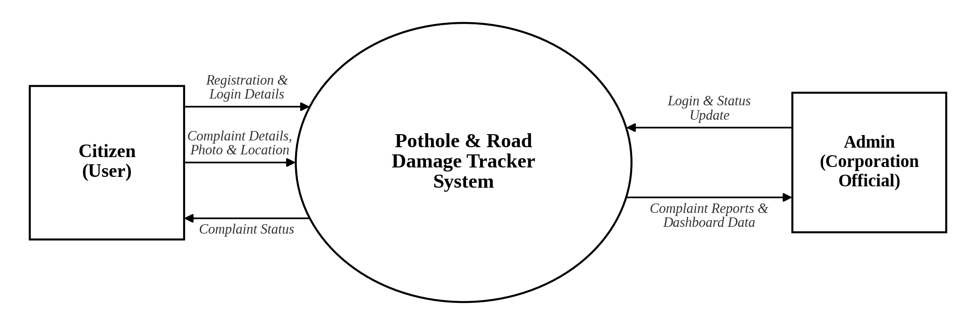
Figure 3.1 Level 0 Data Flow Diagram

12

Level 1
The Level 1 diagram breaks the system into five main processes and three data stores. It is shown in Fig 3.2.
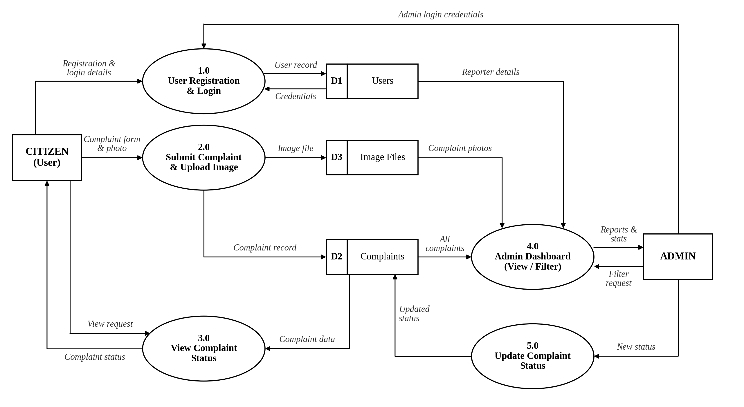
Figure 3.2 Level 1 Data Flow Diagram
4.2 DATABASE DESIGN
The main consideration in designing the database is to organize and maintain the required information in a systematic and structured manner. The database design focuses on maintaining a proper relationship between the tables, ensuring data accuracy, reducing redundancy, and supporting smooth retrieval and updating of records. The main objectives of database design are:
Data Integration
Data integration refers to combining different types of related information and maintaining them in a centralized database. The details of the users and the road damage complaints are stored in their respective tables, namely users and complaints, and are connected through the user id. The complaint table also stores the location, status and the file name of the uploaded photograph. This provides a unified view of the information and avoids maintaining the same data in multiple places. It also allows the administrator to view the complaint details together with the reporter details in the dashboard.

13
Data Integrity
Data integrity ensures that the information stored in the database remains accurate, complete, consistent and reliable throughout the operation of the system. Primary keys, a foreign key between complaints and users, a unique constraint on the email address, and suitable data types are used to maintain the correctness of the stored records. The status of a complaint is restricted to Pending, In Progress and Resolved, and every complaint is stored with its reporting user. These mechanisms help prevent duplicate, incomplete or invalid data from being entered into the database and ensure that the relationship between the users and their complaints remains valid.
Data Independence
Data independence refers to the ability to make changes to the database structure or storage method without causing major changes to the application programs. The database can be modified or extended according to future requirements while the existing functions of the application continue to operate properly. For example, new fields such as priority or repair date, or new tables such as notifications, can be added when new requirements arise without redesigning the existing system. This makes the database easier to maintain, improves flexibility and supports the future expansion of the application.
4.3 TABLE DESIGN
Table name: Users
Description: Stores the registration, login and role details of the citizens and the Corporation administrator.
Field Name | Data Type | Size | Constraints
id | INT | 11 | Primary Key, Auto Increment
name | VARCHAR | 100 | NOT NULL
email | VARCHAR | 150 | NOT NULL, UNIQUE
password | VARCHAR | 255 | NOT NULL (stored as hash)
role | ENUM | — | NOT NULL, Default 'user'
created_at | TIMESTAMP | — | Default CURRENT_TIMESTAMP
Note: The role field accepts the values user and admin.
14
Table name: Complaints
Description: Stores the road damage complaints submitted by the citizens, along with the photograph, location and repair status.
Field Name | Data Type | Size | Constraints
id | INT | 11 | Primary Key, Auto Increment
user_id | INT | 11 | Foreign Key (users.id), NOT NULL, ON DELETE CASCADE
damage_type | ENUM | — | NOT NULL
description | TEXT | — | NULL
image_filename | VARCHAR | 255 | NOT NULL
latitude | DECIMAL | 10,8 | NULL
longitude | DECIMAL | 11,8 | NULL
address | VARCHAR | 255 | NULL
status | ENUM | — | NOT NULL, Default 'Pending'
created_at | TIMESTAMP | — | Default CURRENT_TIMESTAMP
updated_at | TIMESTAMP | — | Default CURRENT_TIMESTAMP, updated automatically on every change
Note: The damage_type field accepts Pothole, Crack, Waterlogging and Other, and the status field accepts Pending, In Progress and Resolved. The user_id field connects every complaint with the user who reported it.

15
4.4 INPUT DESIGN
Input Design is the process of designing the forms and interfaces through which users enter information into the system. The input forms are designed in a simple, clear and user-friendly manner to ensure that the required information is entered accurately and efficiently. Appropriate validation is provided to reduce incorrect, incomplete or invalid data entry.
The system provides different input forms based on the user's role and the operation being performed. The main input forms include Registration, Login, Complaint Submission and Complaint Status Update. Each form collects only the information required for its particular function.
Registration
The Registration form collects the full name, email address, password and confirm password of the citizen. The system checks that all the fields are filled, the passwords match and the email address is not already registered, and then stores the details in the database with the password in hashed form.
Login
The Login form accepts the registered email address and password of the user. The system verifies the entered credentials and provides access to the appropriate page based on the role of the user, such as My Complaints for a citizen and the Admin Dashboard for an administrator.
Complaint Submission
The Complaint Submission form allows a logged-in citizen to report road damage. The citizen selects the type of damage such as Pothole, Crack, Waterlogging or Other, and enters the description and the address or landmark. The latitude and longitude are filled automatically using the Capture My Location option, and a photograph of the damage is uploaded. The entered details are validated and stored as a new complaint with the status Pending.
Complaint Status Update
The Complaint Status Update input allows the administrator to select the new status of a complaint from a drop-down list containing Pending, In Progress and Resolved, and save it. The selected status is validated and stored in the database.

16

Input Validation
Input validation is implemented throughout the system to ensure that the entered data is correct and complete. Required fields are checked before submission, the passwords are compared and stored securely, and the uploaded photographs are checked for the permitted file types (PNG, JPG, JPEG, GIF and WEBP) and the maximum size of 5 MB. The status values accepted by the server are restricted to Pending, In Progress and Resolved. These validations improve data accuracy and help prevent invalid information from being stored in the database.
4.3 OUTPUT DESIGN
Output Design is the process of presenting the information generated by the system in a clear, accurate and user-friendly format. The output screens are designed to provide users with the required information quickly and help them understand the current status of their complaints. The system displays information according to the user's role and access permissions.
Complaint Details
The Complaint Details output is displayed in the My Complaints page for the citizen. It shows the photograph of the damage, damage type, description, address or landmark and the current complaint status as a coloured badge. This output allows the citizen to view all the complaints submitted by him or her and to follow their progress.
Admin Dashboard
The Admin Dashboard output displays the summary cards for the total, Pending, In Progress and Resolved complaints. Below the cards, it lists all the complaints with the photograph, damage type, description, location, reporter name and email address, and current status. The administrator can filter the list by status.
Location Details
The location output is displayed as a Google Maps link created from the latitude and longitude of the complaint. When the link is opened, the exact location of the damage is shown on a map, which helps the administrator to find the place easily.
Confirmation Messages
The system displays success and error messages after actions such as registration, login, complaint submission and status update. These messages close automatically after a few seconds.

17
Output Format
The system presents the outputs mainly through summary cards, tables, complaint cards, status badges, alert messages and map links. The output screens are designed using a consistent layout, so that users can easily navigate between different pages and access the information required for their activities.

Functional Requirements
Functional requirements define the functions and operations that the Crowd-Sourced Real-Time Pothole and Road Damage Tracker must perform to support the activities of its users. The system is designed to provide separate functions for citizens and the Corporation administrator while maintaining the information required for complaints, photographs, locations and repair status. These requirements describe how users interact with the system and how each activity is processed through the application.
- User and Complaint Management: The system allows citizens to register and log in, submit road damage complaints with a photograph, location and description, and view the status of their own complaints.
- Admin Management: The system allows the administrator to log in, view all the complaints with the reporter details and location, filter the complaints by status, and
update the repair status of each complaint.
- Security and Access Control: The system stores the passwords as hashes and allows only the administrator to access the dashboard and change the complaint status.
Non-Functional Requirements
Non-functional requirements describe the quality attributes and operational characteristics that the Crowd-Sourced Real-Time Pothole and Road Damage Tracker should maintain while performing its functions. Unlike functional requirements, which specify what the system should do, non-functional requirements describe how efficiently, securely, reliably and conveniently the system should operate. These requirements are important for ensuring that the application provides a smooth user experience and maintains the accuracy and security of the stored information. The system should handle user activities such as registration, login, complaint submission, photograph upload, status tracking and status update in a consistent and efficient manner. The major non-functional requirements of the system are given below.
- Security: Passwords are stored as hashes, the sessions control the access to the pages, and the admin functions are available only to the administrator.
18
- Performance: The pages should load quickly and the complaints should be stored and displayed without noticeable delay.
- Usability: The interface should be simple and easy to use for citizens with basic computer or mobile knowledge.
- Reliability: The system should store the complaint data correctly and display the latest status every time.
- Maintainability: The code is divided into routes, templates and database files, so that changes can be made easily.
- Scalability: The database and the application can be extended to handle more users and complaints in future.

19

SYSTEM TESTING

AND IMPLEMENTATION

CHAPTER 5
SYSTEM TESTING AND IMPLEMENTATION
5.1 SYSTEM TESTING
Testing is the process of detecting errors and verifying whether the Crowd-Sourced Real-Time Pothole and Road Damage Tracker works according to the specified requirements. Testing plays an important role in ensuring the reliability, correctness and quality of the application. The system is tested with different inputs and user activities to identify errors and ensure that all modules function properly.
TESTING OBJECTIVES
The main objective of testing is to identify errors in the system and ensure that the developed application satisfies the requirements of citizens and the Corporation administrator.
- Testing is performed to identify errors in different modules of the system.
- Each module is tested with valid and invalid inputs.
- The interaction between different modules is verified.
- The system is checked to ensure that the expected output is produced for the given input.
- Testing ensures that the system satisfies the functional and user requirements.
TYPES OF TESTING
UNIT TESTING
Unit Testing focuses on testing each individual module of the Pothole and Road Damage Tracker separately. Each module is tested to verify whether its functions are working correctly. The User Authentication, Complaint Submission, Image Upload, Complaint Status Tracking, Admin Dashboard and Complaint Status Update modules are tested independently before integrating them with other modules.

LINK TESTING
Link Testing verifies the connections between different pages of the system. Navigation between the Home, Register, Login, Report Damage, My Complaints and Admin Dashboard pages is tested to ensure that links, buttons, forms and redirections work correctly. It also verifies that users are redirected to the appropriate pages after performing different operations, such as the My Complaints page for a citizen and the Admin Dashboard for an administrator after login.
20
INTEGRATION TESTING
The goal of Integration Testing is to verify whether the different modules of the system work together properly. The interaction between registration, login, complaint submission, image upload, GPS location capture, status tracking and status update is tested. Different combinations of inputs are provided to ensure that data is correctly transferred between the connected modules and the MySQL database, and that a status updated by the administrator is displayed correctly in the My Complaints page of the citizen.
ACCEPTANCE TESTING
Acceptance Testing is performed using realistic data to demonstrate that the system works satisfactorily according to the user requirements. The external behaviour of the system is checked without concentrating on the internal program logic. The testing verifies whether citizens can register, log in, submit a complaint with a photograph and location, and view the status of their complaints. It also verifies whether the administrator can view all the complaints, filter them by status, open the location through the map link and update the repair status. This testing ensures that the objectives of the system are achieved and the user requirements are satisfied.

VALIDATION TESTING
Validation Testing is performed to ensure that the system accepts only valid and appropriate data from users. It checks whether the entered information follows the required format, conditions and rules before being stored or processed. In the Pothole and Road Damage Tracker, validation is applied to important inputs such as registration details, login credentials, complaint details, uploaded photographs and the complaint status. The system checks the required fields, the matching of passwords, the uniqueness of the email address, the allowed image formats and the maximum image size of 5 MB, and it accepts only the status values Pending, In Progress and Resolved. It helps prevent incomplete, incorrect or invalid data from entering the system and improves the accuracy and reliability of the stored information.

21

5.2 SYSTEM IMPLEMENTATION
Implementation is the process of converting the designed Pothole and Road Damage Tracker into a working web-based application. The system is developed using Python Flask and MySQL with a user-friendly web interface built using HTML, CSS, Bootstrap 5 and JavaScript. The implementation is carried out module by module, and the individual modules are integrated to provide a complete workflow for complaint reporting, photograph upload, location capture, status tracking and complaint management.
In the Citizen Module, citizens can register and log in to the system, submit complaints by selecting the damage type and entering the description and address, upload a photograph of the damage, capture the GPS location, and view the status of their complaints in the My Complaints page.
In the Admin Module, the Corporation administrator can log in, view the summary of the total, Pending, In Progress and Resolved complaints, view all the complaints with the photograph and reporter details, filter the complaints by status, open the location through a Google Maps link, and update the repair status of each complaint. The updated status is then made available to the citizen who reported the complaint.
The Database Implementation stores and manages the information required by the system. The user details and the complaint details are maintained in the users and complaints tables of the MySQL database. The relationship between the tables through the user id helps the system retrieve, update and manage the required information efficiently. The uploaded photographs are stored in the uploads folder with unique file names, and only the file names are stored in the database.
Finally, all the implemented modules are integrated and tested together to form the complete Pothole and Road Damage Tracker. The system provides a centralized platform for complaint reporting, photograph and location capture, status tracking and complaint management for the citizens and the Corporation.

22

CONCLUSION

CHAPTER 5
CONCLUSION
The Crowd-Sourced Real-Time Pothole and Road Damage Tracker for Corporation provides a central platform for reporting road damage and following its repair. Through a simple web interface, a citizen can report a pothole, crack or waterlogged road with a photograph, a GPS location and a description. The Corporation administrator can see all the complaints in one dashboard, check the reporter details and the location, and update the status of each complaint as the work progresses.
The project combines HTML, CSS, Bootstrap 5, JavaScript, Python Flask and MySQL to build a responsive and well-organized application. The location of the damage is captured with the Geolocation API of the browser without any external service. Passwords are stored as hashes, the uploaded photos are saved with unique names, and the admin pages are protected by a role check. The status tracking feature allows citizens to follow their complaints from Pending to In Progress and then to Resolved.
The system has some limitations. It depends on the citizens to give correct information, it does not detect duplicate complaints, and it does not send any message when the status changes. These points can be taken up in the future, as given in the next chapter.
In conclusion, the project brings complaint submission, image upload, status tracking and administration into a single system. It can help the Corporation to identify road damage quickly, respond to the complaints in time and improve the communication between the officials and the citizens.

23

FUTURE ENHANCEMENTS

CHAPTER 6

FUTURE ENHANCEMENT
The present system covers the basic process of reporting and tracking road damage. The following features can be added in the future to make it more useful.

1. SMS and Email Notification
A message can be sent to the citizen by SMS or email when the complaint is received, when the repair work starts and when it is completed. This will save the citizen from logging in again and again to check the status.

2. Map View of Complaints
A map can be added to the Admin Dashboard to show the pending complaints as pins, using Leaflet or Google Maps. The saved latitude and longitude of each complaint can be used for this. It will help the officials to see the areas with more damage and plan the repair work.

3. Priority Scoring and Duplicate Detection
A priority score can be calculated for each complaint based on the number of complaints from the same location. Complaints from nearby places can be grouped to avoid duplicate entries, and the roads with more complaints can be shown first so that serious damage is repaired earlier.

4. Report Generation and Excel Export
A report section can be added to view the complaints by damage type, status, area and date. The filtered list can be downloaded as an Excel file for the records of the Corporation. The administrator can also upload a photo of the completed repair when a complaint is marked as Resolved.

5. Automatic Damage Detection
A machine learning model can be used to check the uploaded photo and confirm whether it really shows a pothole or a crack. It can also estimate the severity of the damage, which will reduce fake complaints and help in setting the priority.

24

6. Ward-wise Assignment and Local Language Support
Complaints can be assigned to the engineer or the contractor of the concerned ward, and the pages can be made available in Tamil along with English so that more citizens can use the system easily.

7. Mobile Application
A mobile application can be developed on the same Flask backend so that citizens can report road damage directly from their phones. The camera and the location of the phone can be used to capture the photo and the GPS position easily.

25

BIBLIOGRAPHY

CHAPTER 7
BIBLIOGRAPHY
BOOK REFERENCES
- "Flask Web Development: Developing Web Applications with Python" by Miguel Grinberg, 2nd Edition, O'Reilly Media, 2018.
- "Software Engineering: A Practitioner's Approach" by Roger S. Pressman and Bruce R. Maxim, 9th Edition, McGraw-Hill Education, 2019.
- "Database System Concepts" by Abraham Silberschatz, Henry F. Korth and S. Sudarshan, 7th Edition, McGraw-Hill Education, 2019.
- "Learning Python" by Mark Lutz, 5th Edition, O'Reilly Media, 2013.
- "MySQL" by Paul DuBois, 5th Edition, Addison-Wesley, 2013.
WEB REFERENCES
- flask.palletsprojects.com
- www.python.org
- www.mysql.com
- getbootstrap.com
- developer.mozilla.org
- www.w3schools.com
- www.geeksforgeeks.org
- www.apachefriends.org
- www.phpmyadmin.net

26

APPENDIX

CHAPTER 8
APPENDIX
Fig 9.1 Login Page
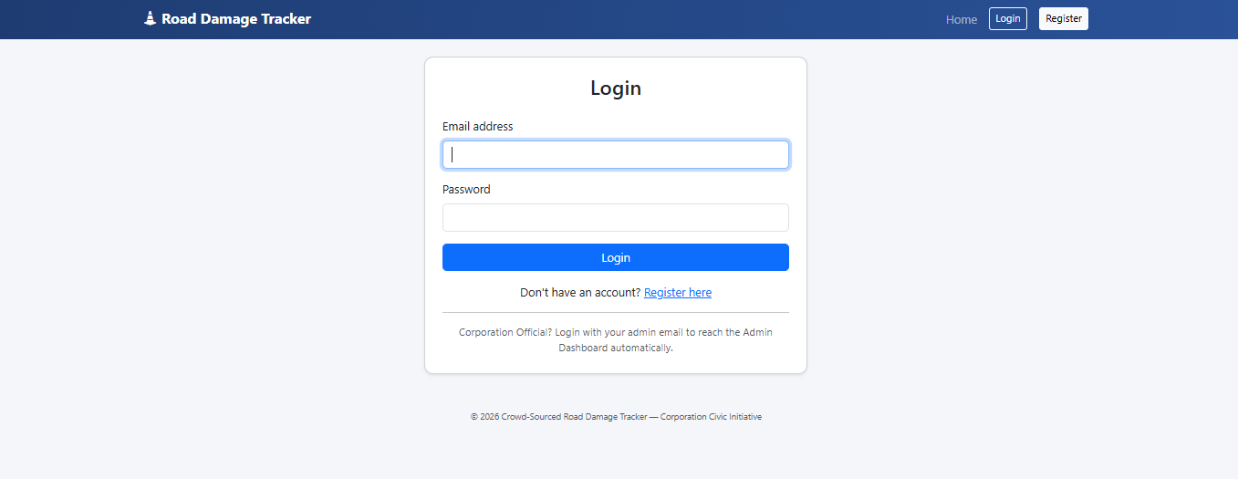

Fig 9.2 Registration Page
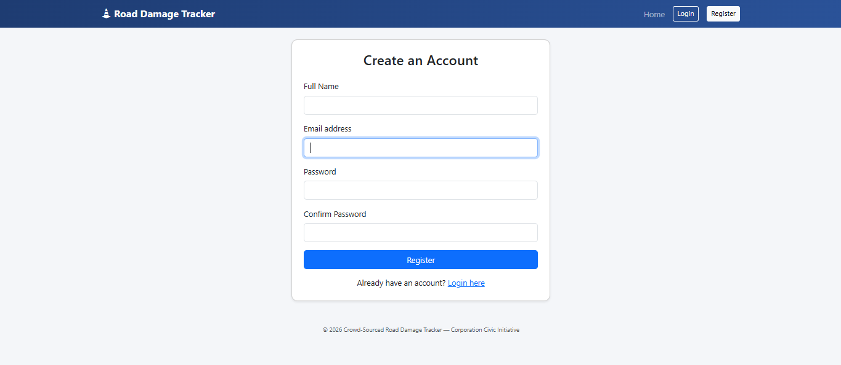

27
Fig 9.3 Home Page
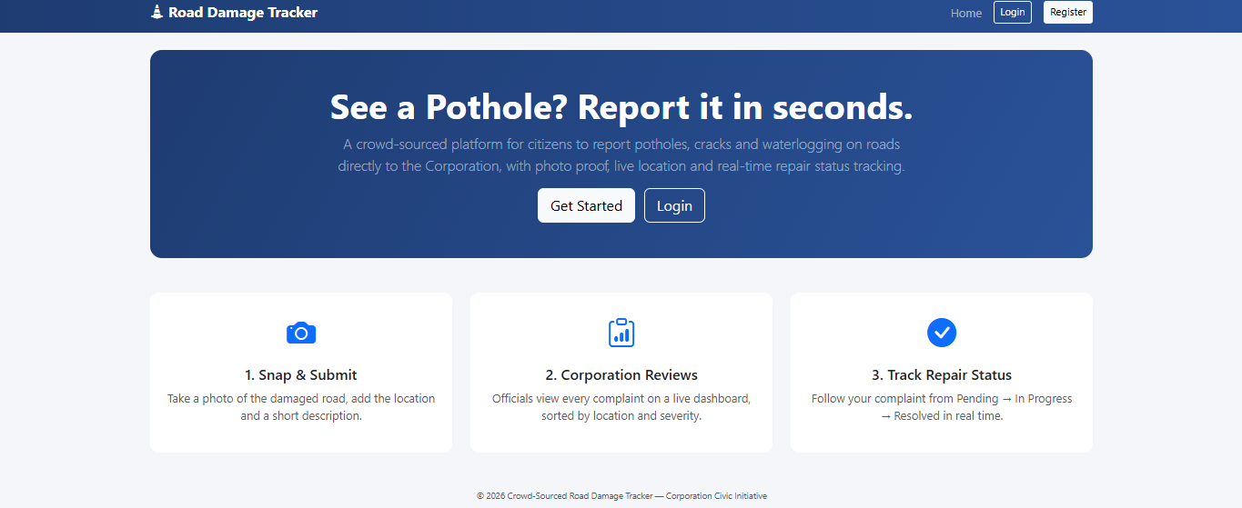

Fig 9.4 Report Road Damage Page
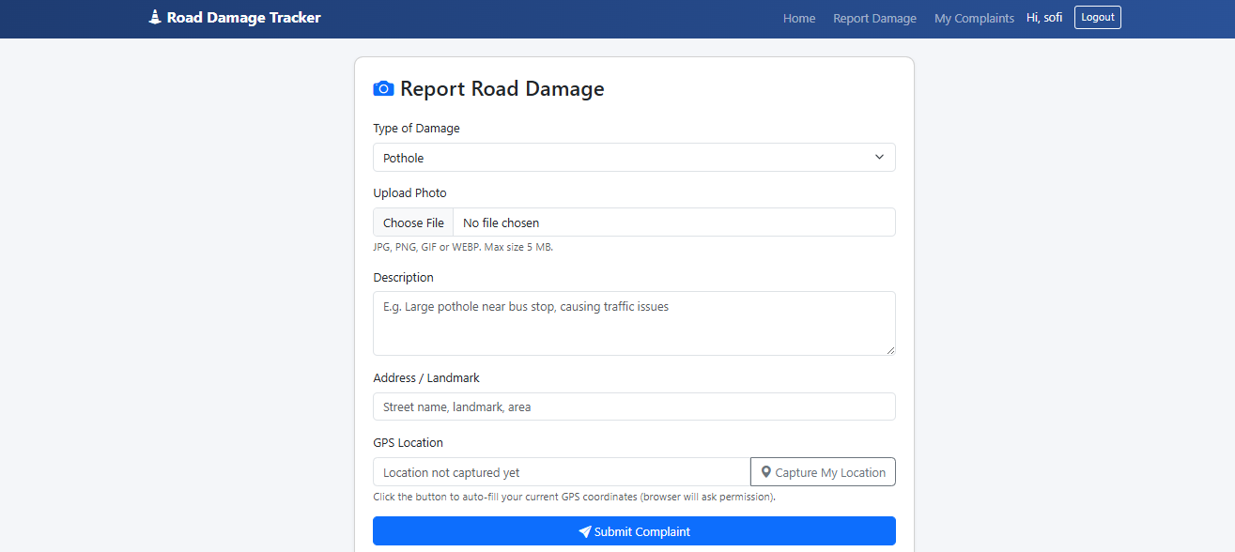

28
Fig 9.5 My Complaints Page
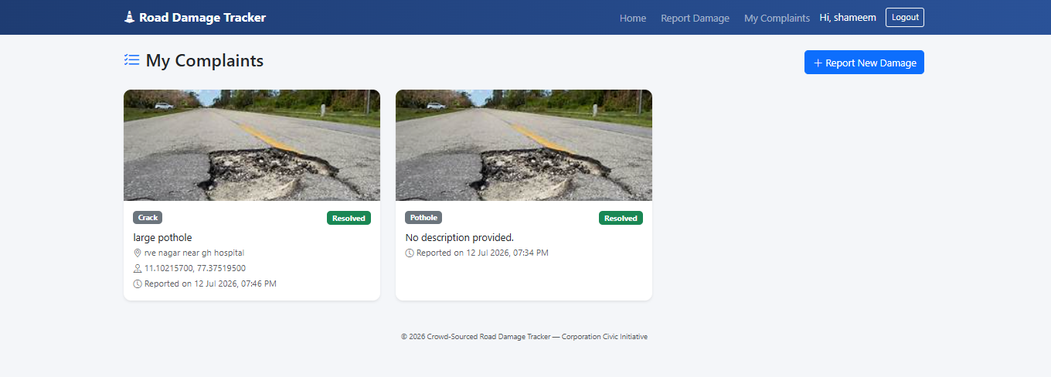

Fig 9.6 Corporation Admin Dashboard
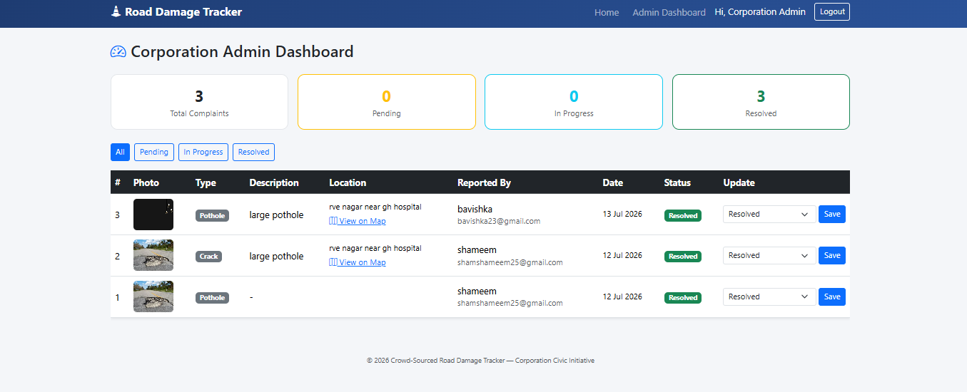

29

