369ai.biz — SEO Implementation Report
Technical SEO audit, fixes and deployment
12 September 2026 | Prepared for 369AI / Alphalize Technologies

Executive summary
The 369ai.biz website was live but completely absent from Google — a search for the exact brand name returned competitors and not the site itself. This work established why, fixed every technical cause, and registered the site with Google so indexing can begin.
Six code changes were shipped and deployed, three Cloudflare rules were configured, and Google Search Console was set up with the sitemap submitted. Page performance improved from a failing score of 36 to 91, with all five of Google's Core Web Vitals now passing.

Results at a glance
Measure | Before | After
Google Performance score | 36 (poor) | 91 (good)
Layout stability (CLS) | 0.421 — failing | 0.002 — passing
Largest Contentful Paint | 2.9 s — failing | 1.4 s — passing
Speed Index | 4.3 s — failing | 2.1 s — passing
Main-thread blocking | 400 ms — failing | 80 ms — passing
Google SEO score | 85 | 92
Pages described to Google | 2 page types | All 87 pages
Registered with Google | No | Yes — sitemap submitted

1. The core diagnosis
The site was not missing from Google because of a quality or ranking problem. It had simply never been submitted. Google does not automatically discover new domains; it has to be told they exist.
Every possible technical blocker was checked and cleared:
- No "noindex" instruction in the page code or server headers
- robots.txt does not block Google
- Googlebot and Bingbot both fetch the site successfully
- Cloudflare passes crawler traffic through
The conclusion was that no code change could fix the problem — only registration with Google Search Console would, and that required the client's Google account.

2. Code changes delivered
# | Change | Why it matters
1 | Sitemap file (87 pages, 9 languages) | Gives Google a complete list of every page instead of expecting it to find them
2 | robots.txt with crawl rules | Points crawlers at the sitemap; keeps the job-applications admin area out of search
3 | Social share image (1200x630) | Links shared on WhatsApp or LinkedIn previously showed a blank grey box
4 | Company information for Google | Name, six office addresses, phone, opening hours, social accounts — drives the Google business panel
5 | Brand name variants | Tells Google that "369 ai", "369aibiz" and "369ai.biz" all mean this company
6 | Product information on 75 pages | Product pages previously gave Google nothing. Now each describes its model, specifications and images
7 | Fixed 5 pages with wrong address tags | About, Products, Services, Solutions and Privacy were telling Google they were the homepage — a serious error that can remove pages from search
8 | Descriptive link text | Four buttons read only "Learn more". Google uses link wording to understand destinations
9 | Page-jump fix | The single biggest improvement — see section 3
10 | Removed a caching blocker | A language cookie was preventing Cloudflare from caching any page

3. The main technical finding

The page was jumping while it loaded
Google measures how much a page shifts around as it loads, and uses that measurement when ranking. The acceptable limit is 0.1. This site measured 0.421 — more than four times over.
The cause was traced to a single file. The homepage checks whether an administrator is logged in, which makes the page load in two stages: a grey placeholder appears first, the footer settles beneath it, then the real content arrives and throws the footer down the page. That one movement accounted for 99.8% of the total.
The file was safe to remove because the site already has a second loading animation that works correctly — it floats above the page rather than occupying space within it. Only the redundant one was causing harm.
Method note
The cause was identified by measurement, not assumption. The first suspect was the site's opening splash screen. Testing proved it innocent — and revealed that it actually makes the site appear a full second faster, so it was kept. Recorded in the handover notes so it is not removed later by mistake.

4. Hosting configuration (Ubuntu + Cloudflare)
Setting | Problem found | Status
HTTPS redirect | The insecure http:// version served the full site, which Google can treat as a duplicate | Fixed
www redirect | Both www and non-www served the site — a duplicate copy | Fixed
Page caching | Cloudflare was caching nothing; every visit travelled to the Ubuntu server (0.76 s delay) | Rule deployed
Deployment | The live site was running three versions behind the finished work | Deployed

How the Cloudflare rules were configured
All three rules were built from Cloudflare's own templates, which require no hand-written configuration. The screenshots below record each step as it was carried out, so the setup can be audited or repeated.
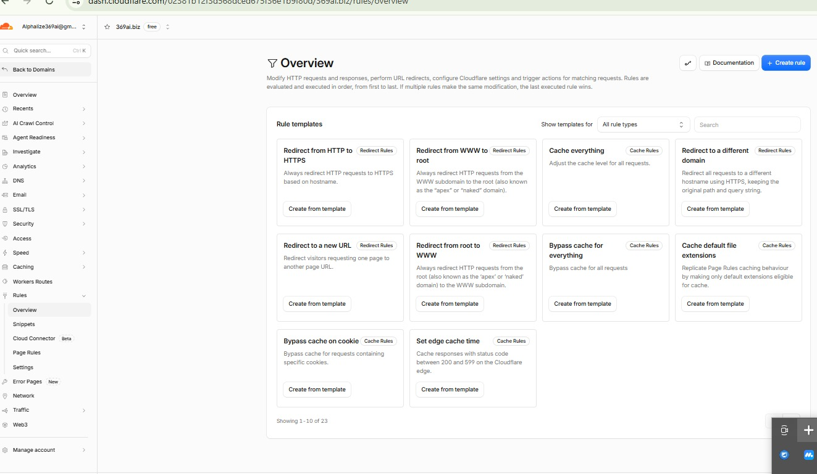
Step 1 — Rules > Overview. The template gallery. "Redirect from HTTP to HTTPS", "Redirect from WWW to root" and "Cache everything" are the three used.
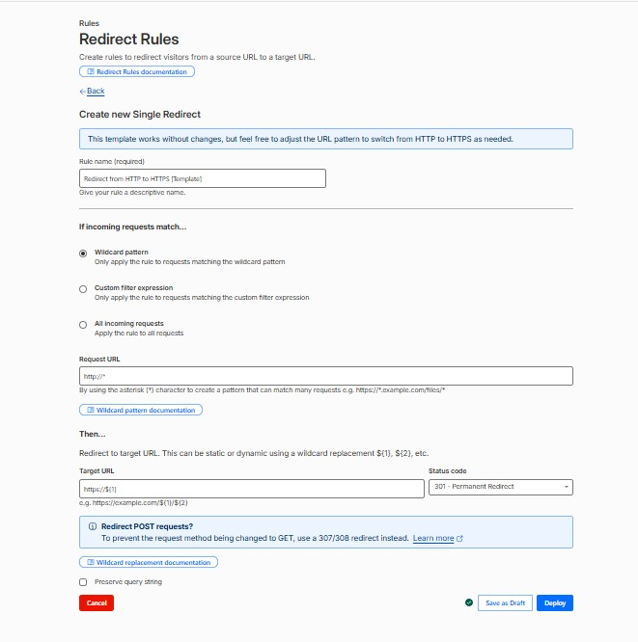
Step 2 — The HTTP to HTTPS template opens pre-filled and needs no edits. Deploy applies it immediately.
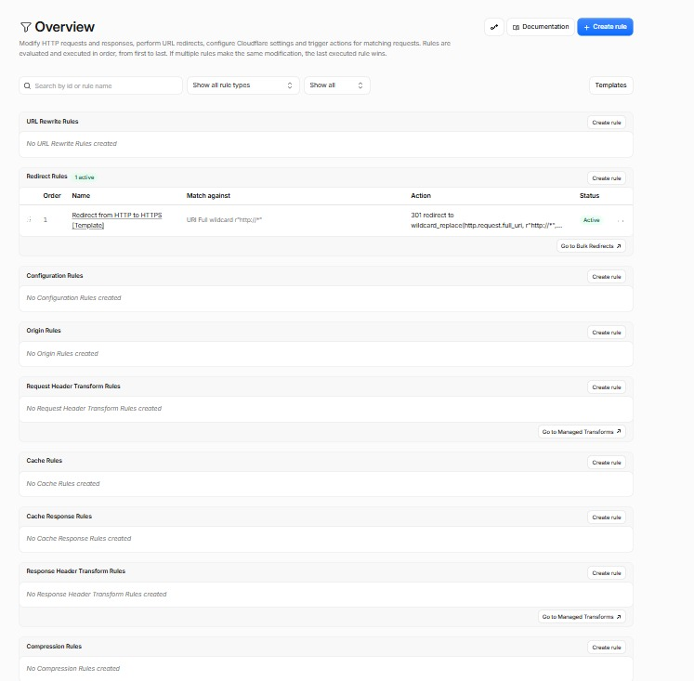
Step 3 — After deploying, Redirect Rules shows "1 active": every http:// request now returns a 301 to the secure address.
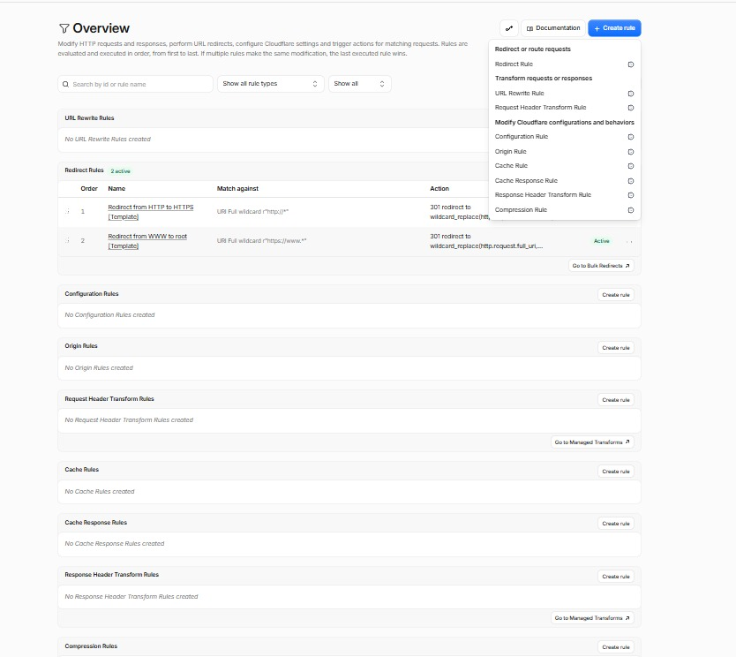
Step 4 — The WWW to root template added the same way. "2 active": the duplicate www copy of the site now redirects to the main address.
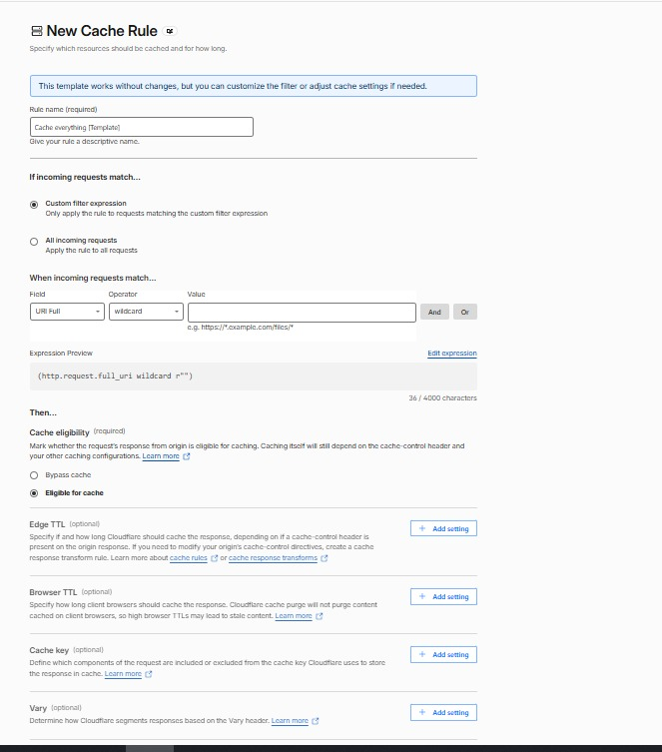
Step 5 — The Cache everything template. This is the only one needing input: a match value of https://369ai.biz/*, with Edge TTL left unset so Cloudflare follows the caching instructions the site already sends. That is what keeps the homepage uncached, since it checks the administrator login on every request.
Each rule was verified from outside the network after deployment: the insecure address returns a 301, the www address returns a 301, and the cache rule correctly leaves the homepage and the API routes uncached.

5. Google Search Console
The step that actually starts indexing. Completed:
- Domain property created for 369ai.biz and verified through DNS
- Sitemap submitted — status: Success, 87 pages discovered
- Indexing requested for six key pages
Expected timeline: first pages typically appear within a few days; most of the 87 within one to two weeks.

6. Realistic expectations
The brand name is genuinely contested. A search for "369 AI" returns at least six established companies, including 369ai.cloud whose name is almost identical.
Search term | Realistic outcome
369aibiz | Should be won — the term is distinctive and unused by others
369 ai biz | Likely over time, alongside 369ai.cloud
369 ai | Page one achievable; sole top position is not
369 | Not achievable for anyone, and not desirable — searchers are looking for the "369 manifestation method" and numerology, never a POS supplier
Product model codes (e.g. NGP-MC720-S) | The strongest opportunity — low competition, genuine buying intent

The largest remaining opportunity
Product descriptions are currently English across all nine language versions of the site — only menus and labels are translated. Google treats those as duplicates rather than ranking them separately, so the 675 product pages carry the value of roughly 75.
Translating the 75 product descriptions into the other eight languages is the single largest SEO gain still available. It is a content project rather than a technical one.

7. Outstanding items
# | Action | Owner | Time
1 | Rebuild the Ubuntu server so the final change goes live | Server admin | 5 min
2 | Add the website link to the @369AIbiz YouTube channel — currently the top Google result for the brand name and it links nowhere | Marketing | 2 min
3 | Check indexing progress in Search Console after 2-3 days | Marketing | 5 min
4 | Create a Google Business Profile for the offices | Marketing | 30 min

Full technical detail, including the exact commands for each remaining step, is kept in the project repository at docs/seo-handoff.md.

