Field Attendance | Employee Step-by-Step Guide | 369ai.Biz
3 6 9 a i . B i z
FIELD ATTENDANCE Employee Step-by-Step Guide
369ai.Biz Employee Attendance App
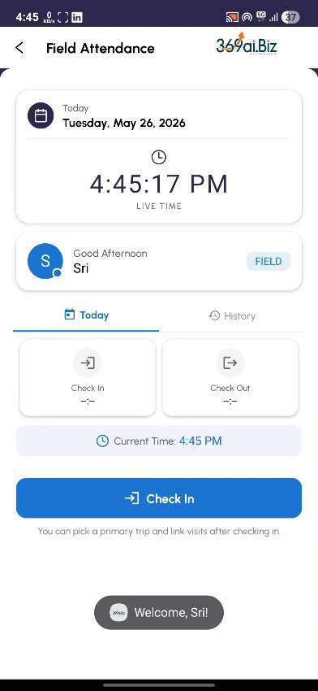
A simple guide to checking in, logging trips, recording customer visits, and checking out for the day.
Page 1 of 26

Field Attendance | Employee Step-by-Step Guide | 369ai.Biz
About Field Attendance
Field Attendance is the daily workflow for employees who work on the move — drivers, delivery staff, sales representatives, and field technicians. Instead of a single in/out punch from the office, the app lets you check in from anywhere, record every trip, log every customer visit at the actual visit location, add fuel stops, and check out at the end of the day.
This guide walks you through everything you need to do during your workday, in the order you will do it.
Your Day at a Glance
●Open the app and log in with your PIN
●Check In — capture a photo and your starting location ●Set up your Primary Trip (home to office)
●Add Secondary Trips for each customer visit
●Add fuel stops whenever you refuel
●Set up your Return Trip (visit to office, or visit to home) ●Check Out at the end of the day
Page 2 of 26

Field Attendance | Employee Step-by-Step Guide | 369ai.Biz
PART 1 Starting Your Day
Step 1Open the App
On your phone, open the Employee Attendance app. You will see the app home screen with all the
options.
Tap User Attendance to begin.
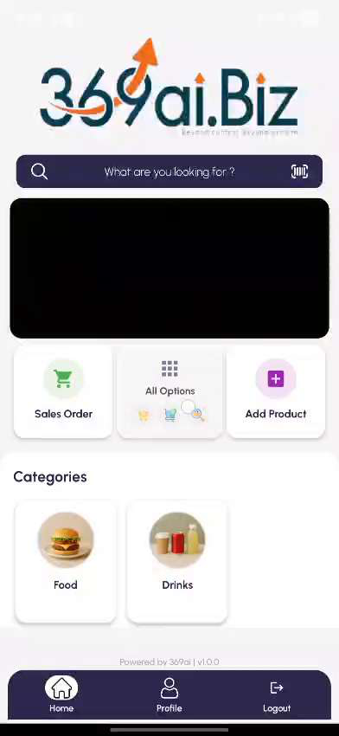
Step 2Log In with Your PIN
Enter your 4-digit PIN to verify your identity, then tap Verify PIN. The app will identify you by your Badge
ID.
Page 3 of 26

Field Attendance | Employee Step-by-Step Guide | 369ai.Biz
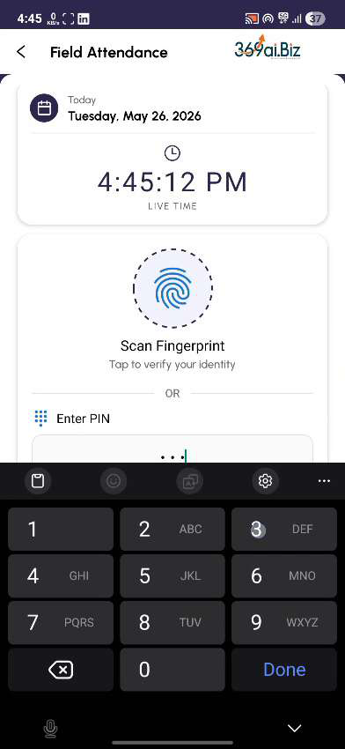
Step 3Go to Field Attendance
You will land on the Field Attendance screen. It shows today's date, the live time, and your name with a
FIELD badge. The Check In button is at the bottom.
Page 4 of 26

Field Attendance | Employee Step-by-Step Guide | 369ai.Biz

Step 4Check In
Tap the Check In button. A confirmation dialog will ask “Are you sure you want to check in?” Tap YES.
The app will then open the camera. Position your face inside the circle and wait for the countdown. The
app will automatically take your photo and capture your current GPS location.
Page 5 of 26

Field Attendance | Employee Step-by-Step Guide | 369ai.Biz

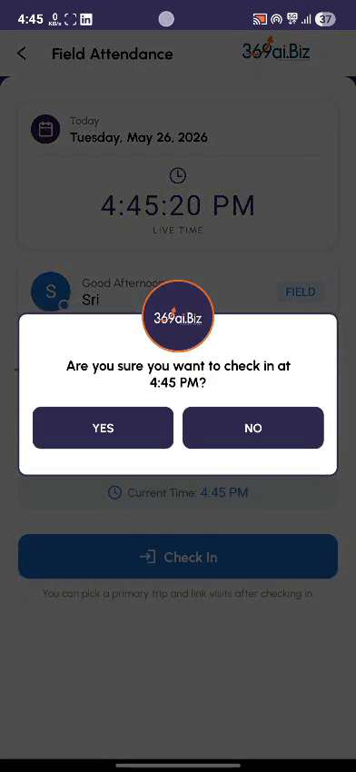

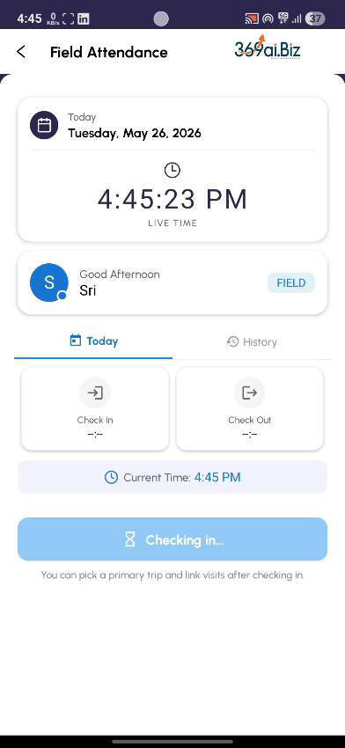

TIP Your photo and location are used as your work-start anchor. Make sure your face is clearly visible in the frame before the countdown ends.
Step 5If You Are Late — Submit a Reason
If you have checked in after your shift start time, the app will show a “You're Late” dialog. It will tell you how many hours late you are, your expected start time, and any salary deduction that applies.
Type a brief reason in the text box (for example, “Traffic”, “Personal emergency”, “Doctor visit”) and tap Submit Reason. Your reason will be logged for HR review.
Page 6 of 26

Field Attendance | Employee Step-by-Step Guide | 369ai.Biz

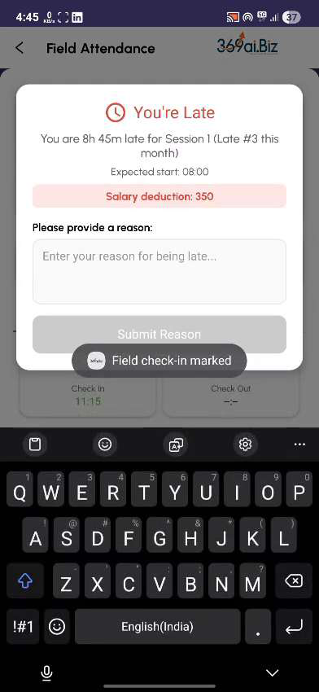

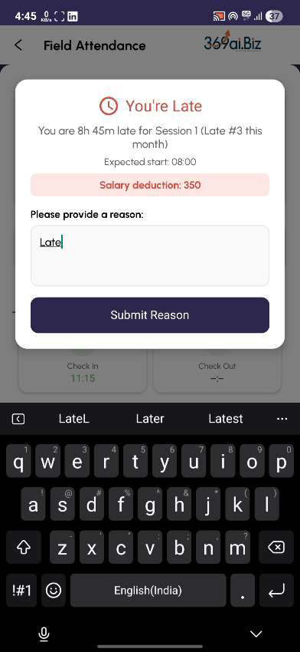

PART 2 Your Primary Trip (Home to Office)
If you drove from home to your office before starting customer visits, log that journey as your Primary Trip. If you went directly from home to a customer site, skip this part and go to Part 3.
Step 6Tap Setup Primary Trip
On the Field Attendance screen, find the blue Setup Primary Trip (Home → Office) buƩon and tap it.
Page 7 of 26

Field Attendance | Employee Step-by-Step Guide | 369ai.Biz
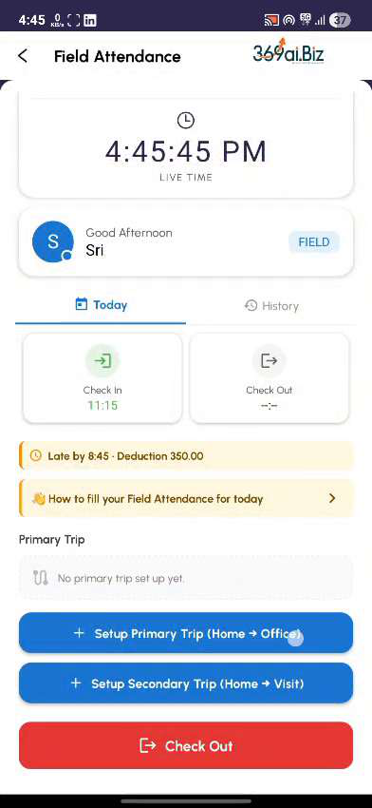
Step 7Create a New Trip
A small popup will open. Tap Create New Trip. This will open the Vehicle Tracking form, where you record
the details of your journey.
Step 8Select Your Vehicle
Tap the Vehicle dropdown and choose the vehicle you are using today. Once you select a vehicle, the
driver, plate number, and other details will fill in automatically.
Page 8 of 26

Field Attendance | Employee Step-by-Step Guide | 369ai.Biz
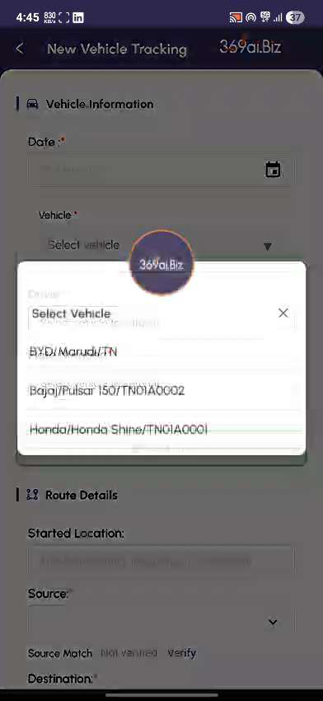
Step 9Set Source and Destination
Choose your Source (where you are starting from — usually your home address) and Destination (your
office). The app will calculate the estimated kilometres and travel time automatically.
Page 9 of 26

Field Attendance | Employee Step-by-Step Guide | 369ai.Biz
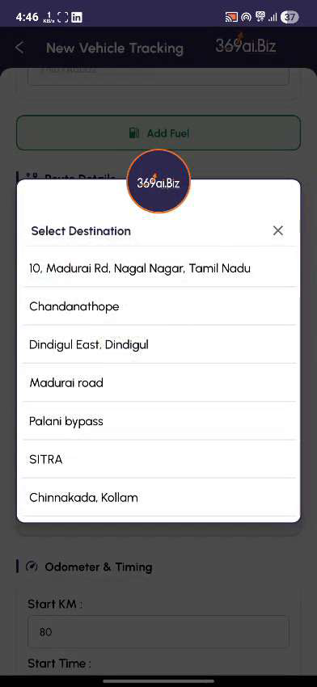
TIP If you see ‘Source Match: Not verified’, tap Verify next to it. The app will check your current GPS against the source location.
Step 10Enter Start Kilometres
Scroll down to the Odometer & Timing section. Enter your vehicle's current odometer reading in the Start
KM field.
Step 11Complete the Pre-Trip Checklist
Scroll down to the Pre-Trip Checklist. Tap each item — Coolant Water, Oil Checking, Tyre Checking, Battery
Checking, Fuel Checking, Daily Checks — to confirm your vehicle is ready.
Page 10 of 26

Field Attendance | Employee Step-by-Step Guide | 369ai.Biz
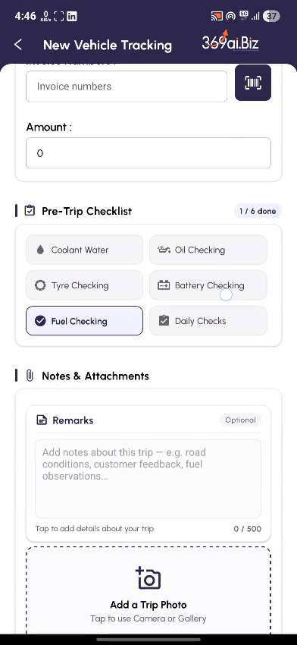
Step 12Start the Trip
Tap the Start Trip button at the bottom. You will see a “Trip started successfully!” message. The app will
return to the popup with your new trip already selected.
Tap Save. Your primary trip is now recorded for the day.
Page 11 of 26

Field Attendance | Employee Step-by-Step Guide | 369ai.Biz
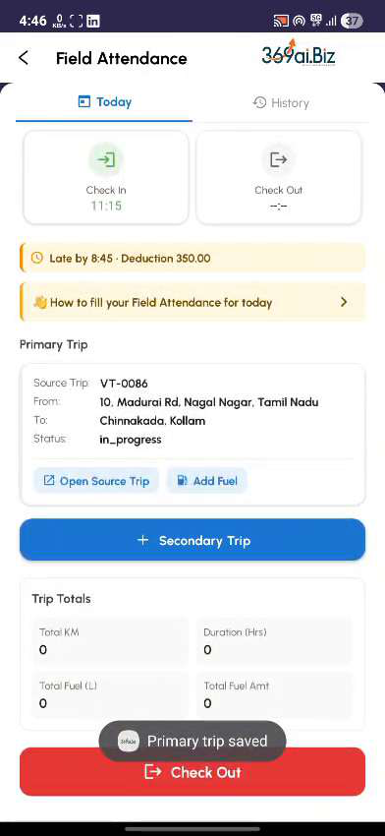
PART 3 Adding Fuel During a Trip
Any time you refuel during a trip, you can log it directly from the trip card. You can add fuel any number of times in a day.
Step 13Tap Add Fuel on the Trip Card
On the Field Attendance screen, find the trip card for your current trip. Tap the green Add Fuel chip.
Step 14Fill the Fuel Entry Form
The Add Fuel Entry form will slide up. Enter:
●Fuel Amount — how much you paid (in your currency)
●Fuel Litres — how many litres you fuelled
●Current Odometer — your vehicle's odometer reading at the fuel stop
Page 12 of 26

Field Attendance | Employee Step-by-Step Guide | 369ai.Biz
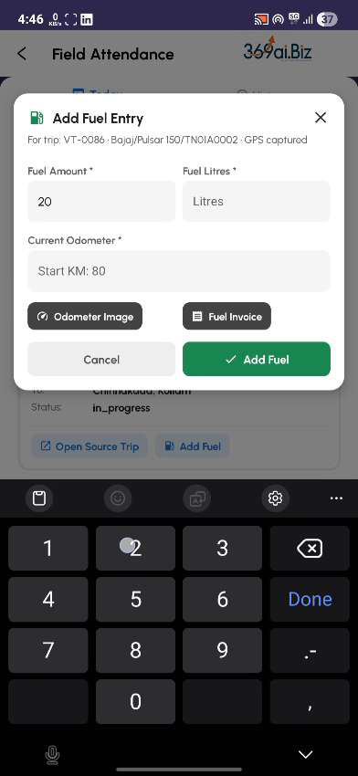
Step 15Capture the Odometer and Invoice Photos
Tap Odometer Image to take a photo of your odometer. Then tap Fuel Invoice to take a photo of the fuel receipt. Both photos are required.
TIP You can also pick photos from your gallery if you have already taken them. Tap the thumbnail to confirm the photo is clear and readable.
Step 16Save the Fuel Entry
Tap the green Add Fuel button. The fuel log is now attached to your trip, and the trip card will update to show “1 fuel log added”.
Page 13 of 26

Field Attendance | Employee Step-by-Step Guide | 369ai.Biz
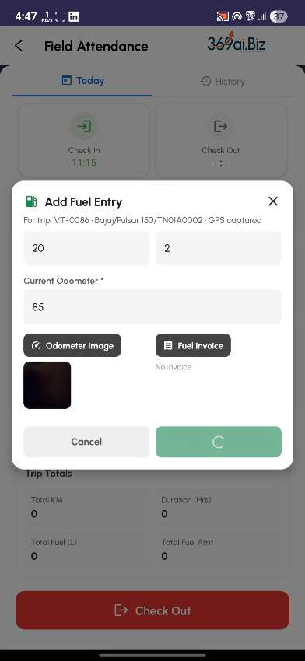
PART 4 Visiting a Customer (Secondary Trip)
When you leave the office (or your home) to visit a customer, record a Secondary Trip. This is done in two
phases:
●Phase 1 — Before you drive: Set up the trip from your current location
●Phase 2 — When you arrive at the customer: Enter the customer visit details
IMPORTANT Two phases are important! The customer visit's GPS location is captured when you fill the visit form. If you fill it at the office, the location will be wrong. Always wait until you reach the customer to tap Enter Visits.
Step 17Tap Setup Secondary Trip
On the Field Attendance screen, tap the blue Setup Secondary Trip (Home → Visit) buƩon.
Page 14 of 26

Field Attendance | Employee Step-by-Step Guide | 369ai.Biz
Step 18Close Your Previous Trip
A “Close Previous Trip” popup will appear. Enter the End KM of your previous trip — this should be your
current odometer reading. Tap Save & Exit. Your previous trip is now closed.
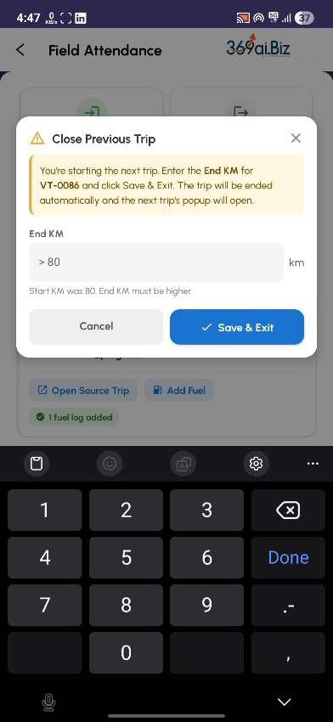
Step 19Fill the Secondary Trip Details
The Vehicle Tracking form will open for your new trip. The Source will already be set to your previous
destination (locked). Choose the customer location as your Destination.
Page 15 of 26

Field Attendance | Employee Step-by-Step Guide | 369ai.Biz
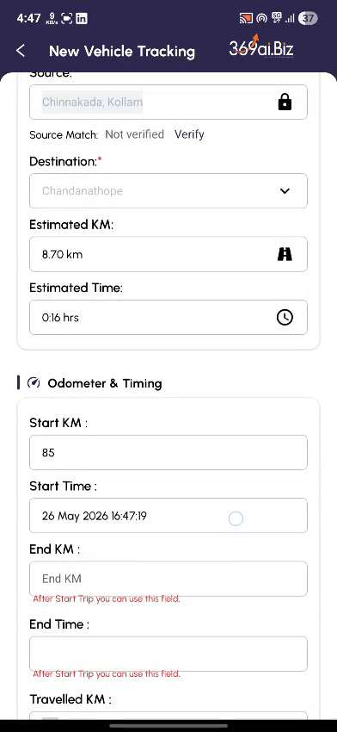
Complete the form the same way as before — Start KM, Pre-Trip Checklist, Purpose of Visit. Tap Start Trip,
then tap Save in the popup that follows.
Step 20Drive to the Customer
A yellow Pending Trip Card will appear on the Field Attendance screen, with a green Enter Visits button
on the right side. A yellow banner reminds you: “Once you reach the visit, enter the customer details.”
Page 16 of 26

Field Attendance | Employee Step-by-Step Guide | 369ai.Biz
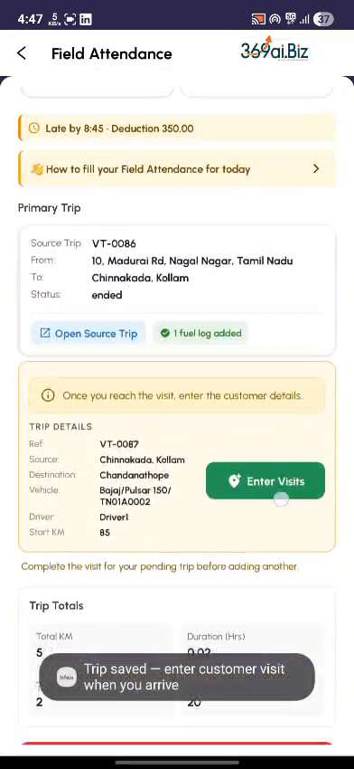
IMPORTANT Do not tap Enter Visits yet. Drive to the customer first. The button will be waiting for you when you arrive.
Step 21Tap Enter Visits When You Arrive
When you reach the customer location, open the app and tap the green Enter Visits button on the pending trip card. The New Customer Visit form will open.
Step 22Fill the Customer Visit Form
Fill in the visit details:
●Customer — pick from the customer list
●Visited By — defaults to your name
●Date and Time — defaults to now
●Visit Purpose — choose from the dropdown (Meeting, Delivery, Follow Up, etc.) ●Visit Duration — optional
●Remarks — describe what happened during the visit (minimum 25 characters)
Page 17 of 26

Field Attendance | Employee Step-by-Step Guide | 369ai.Biz
●Photos — optionally attach photos of the visit
●Voice Note — optionally record a quick voice note
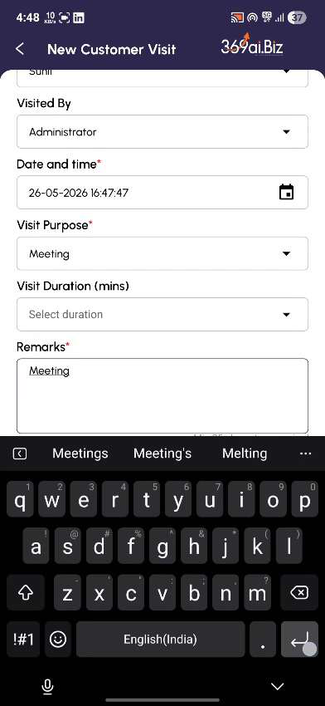
TIP Your GPS location is captured at this moment — the actual customer location. This is what makes Field Attendance accurate, so always fill this form AT the customer site.
Step 23Save the Visit
Tap the Save button at the bottom of the form. The visit is now created and linked to your trip.
Back on the Field Attendance screen, the pending card will disappear. In its place, a Secondary Trip card
will show both Trip Details (on the left) and Visit Details (on the right) side by side.
Page 18 of 26

Field Attendance | Employee Step-by-Step Guide | 369ai.Biz
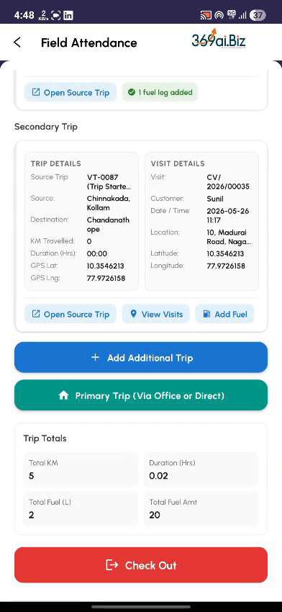
Repeat Steps 17–23 for every customer you visit during the day.
PART 5 Going Back (Return Trip)
After your last customer visit, you have two ways to head back:
●Via Office — You return to the office first, then go home ●Direct — You go straight from the last customer to home
Step 24Tap Primary Trip (Via Office or Direct)
On the Field Attendance screen, tap the green Primary Trip (Via Office or Direct) button.
Step 25Choose Your Return Route
A popup will open with two options:
●Via Office (Visit → Office) — if you are stopping at the office first ●Direct (Visit → Home) — if you are going straight home
Tap the option you want.
Page 19 of 26

Field Attendance | Employee Step-by-Step Guide | 369ai.Biz
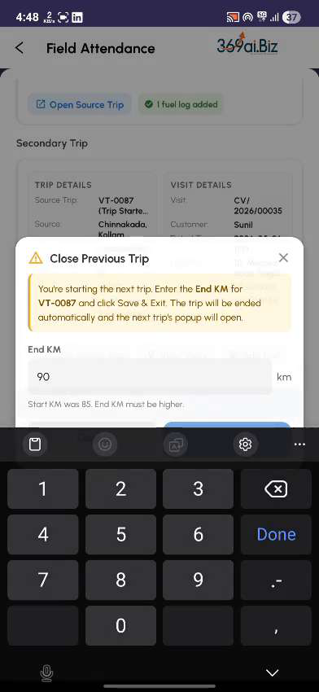
Step 26Close the Last Trip and Set Up the Return
Enter the End KM for your previous trip. Then complete the new Vehicle Tracking form — Source will be
your last visit location, Destination will be your office (Via Office) or your home (Direct). Tap Start Trip,
then Save.
A Return Home card will appear, showing the return leg details.
Page 20 of 26

Field Attendance | Employee Step-by-Step Guide | 369ai.Biz
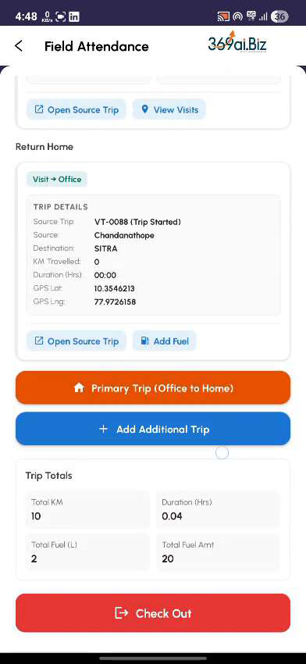
Step 27If You Stopped at the Office — Add Office to Home
If you chose Via Office, you still need to log the final leg from the office to home. Tap the orange Primary Trip (Office to Home) button.
Fill in the new Vehicle Tracking form — Source is the office, Destination is your home. Pick a Purpose of Visit from the dropdown.
Page 21 of 26

Field Attendance | Employee Step-by-Step Guide | 369ai.Biz

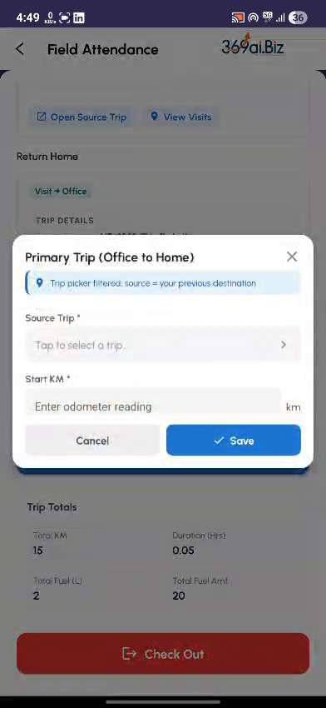

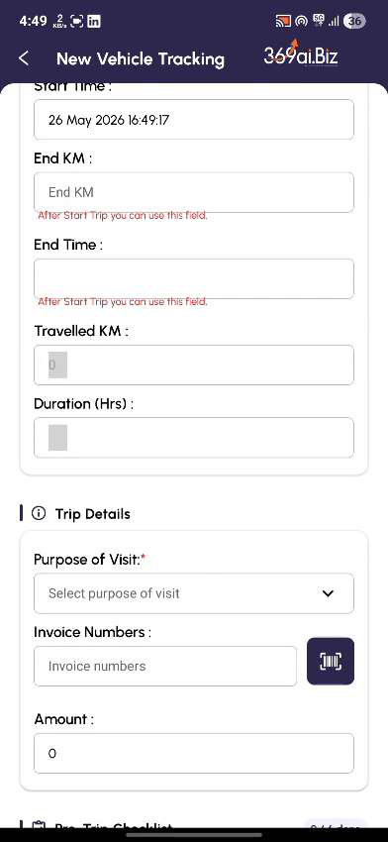

Complete the checklist, tap Start Trip, then Save. You will see “Office → Home leg added”.
PART 6 Ending Your Day (Check Out)
Step 28Tap Check Out
When you are ready to end your day, tap the red Check Out button at the bottom of the Field Attendance screen.
Step 29Close Your Last Open Trip
If your last trip is still open, an “End KM” dialog will appear. Enter the final odometer reading of your last trip and tap Save & Checkout.
Page 22 of 26

Field Attendance | Employee Step-by-Step Guide | 369ai.Biz
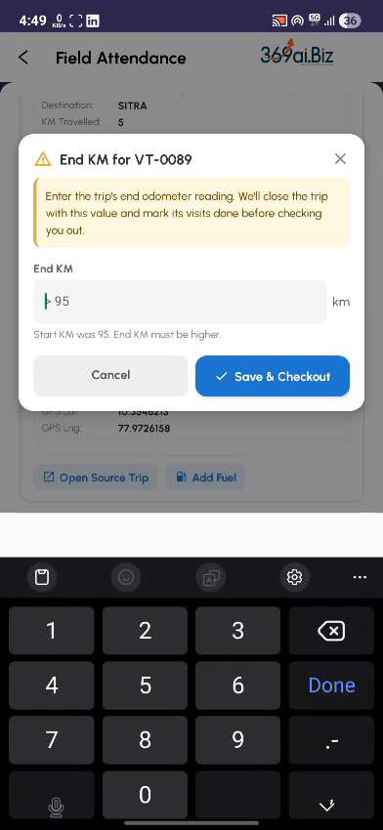
Every customer visit you made today will be automatically marked as Done.
Step 30Take Your Check Out Photo
The camera will open one last time. Position your face in the frame and wait for the countdown. The app
will take your check-out photo and capture your final GPS location.
Page 23 of 26

Field Attendance | Employee Step-by-Step Guide | 369ai.Biz
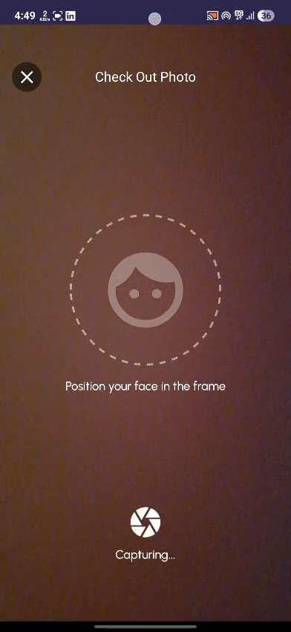
Step 31Day Complete
The Field Attendance screen will refresh and show:
●A grey “checked out, read-only” banner
●Trip Totals — Total KM, Total Fuel, Total Fuel Amount
●All your trip and visit cards in read-only form
●A green “Field attendance complete” confirmation at the bottom
Page 24 of 26

Field Attendance | Employee Step-by-Step Guide | 369ai.Biz
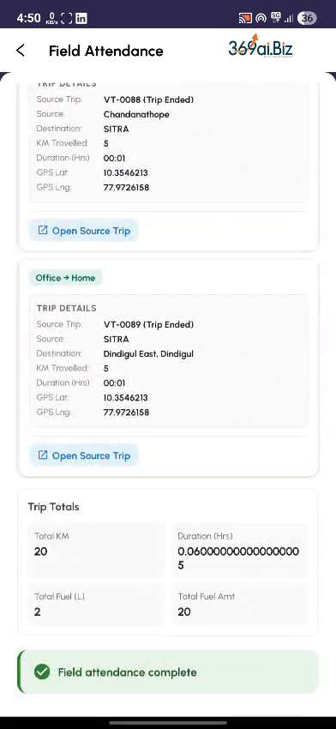
That’s it — your day is sealed. Your manager and the HR system can now review everything you did, where, and when.
Page 25 of 26

Field Attendance | Employee Step-by-Step Guide | 369ai.Biz
Quick Reference — When to Use Which Button
Use this table as a fast lookup when you are out in the field.
Button | When to use it
Check In | At the start of your workday
Setup Primary Trip | When you drove from home to the office in the morning
Setup Secondary Trip | When you are heading out to visit a customer
Enter Visits | Only after you reach the customer — never at the office
Add Fuel | Any time you refuel during a trip
Primary Trip (Via Office or Direct) | When leaving your last customer of the day
Primary Trip (Office to Home) | After returning to the office, to log the office → home leg
Check Out | At the end of your workday
Things to Remember
●Always fill the customer visit form AT the customer location, not before.
●Take clear odometer and fuel invoice photos — blurry ones may be rejected.
●Close every open trip with an End KM before starting the next one.
●If the app is closed mid-flow, your pending trip will be saved. You can pick up where you left off. ●Once you Check Out, the day is sealed. You cannot edit your trips after that.
●If you lose internet during the day, the app stores your work and uploads it when you are back online.
— End of Guide —
369ai.Biz | Field Attendance Employee Guide
Page 26 of 26

