3 6 9 a i . B i z

LATE WAIVER REQUEST

Employee Step-by-Step Guide
369ai.Biz Employee Attendance App
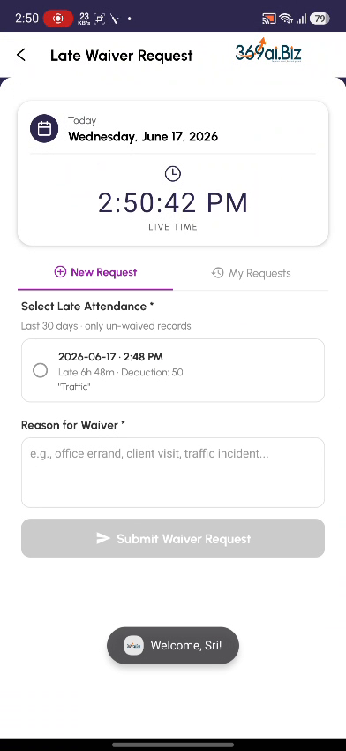
A simple guide to requesting a waiver for a late-arrival deduction, submitting it for manager approval, and tracking the result.

About Late Waiver Request
When you check in late, the app records the late time and applies a salary deduction. If you had a genuine reason for being late, you can use Late Waiver Request to ask your manager to waive (cancel) that deduction. You pick the late record, give a reason, and submit it for approval. You can track the result under My Requests.
This is the formal follow-up to the “You're Late” screen in Office Attendance. The reason you typed at check-in explains why you were late; a waiver request asks for the deduction itself to be cancelled.
This guide walks you through everything you do, in the order you will do it.
How a Waiver Works
- Open the app and go to User Attendance
- Choose Late Waiver Request and verify your identity
- Select the late attendance you want waived
- Enter a reason for the waiver
- Review and Submit for your manager's approval
- Track the result under My Requests — Pending, Approved or Rejected
PART 1 Opening Late Waiver Request
Step 1 Open the App and go to User Attendance
On your phone, open the Employee Attendance app. From the 369ai.Biz home screen, open All Options, scroll down to the HR & Tracking section, and tap User Attendance.
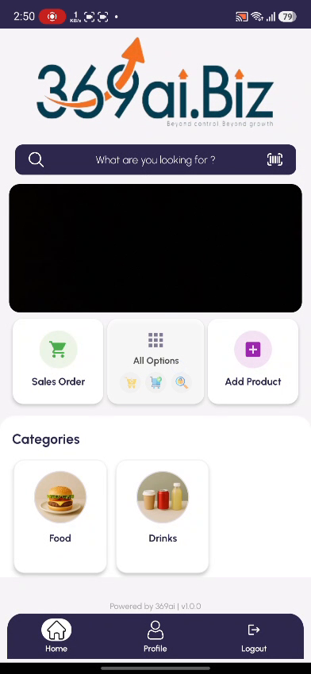 | 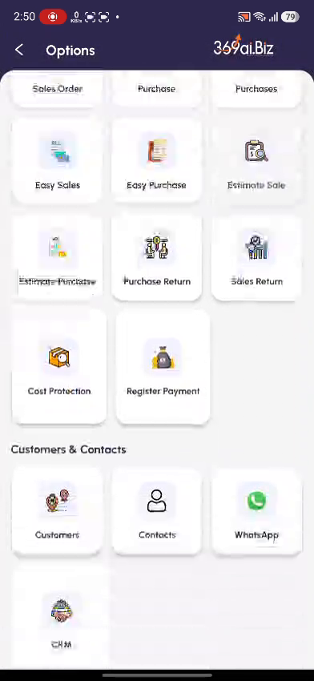 | 

Step 2 Choose Late Waiver Request
On the Select Attendance Type screen, tap Late Waiver Request (“Request waiver for a late arrival deduction”).
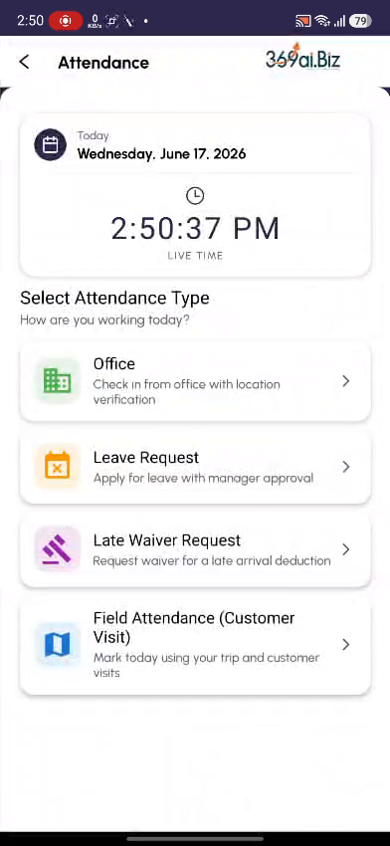
Step 3 Verify Your Identity
Confirm it is really you. Either tap Scan Fingerprint and use your enrolled finger, or type your 4-digit PIN under Enter PIN and tap Verify PIN.
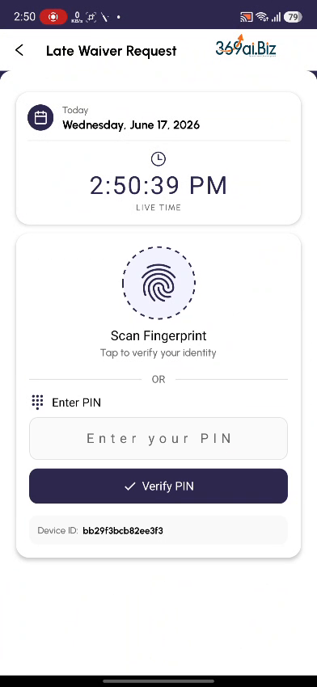
PART 2 Raising a Waiver
Step 4 Select the Late Attendance
You will land on the New Request tab. Under Select Late Attendance, the app lists your late check-ins — only un-waived records from the last 30 days. Each card shows the date and time, how late you were, the deduction amount, and the reason you gave at check-in. Tap the card to select it; the selected card is highlighted.
If you don't see a late record here, it means you have no un-waived late check-ins in the last 30 days — there is nothing to waive.
 | 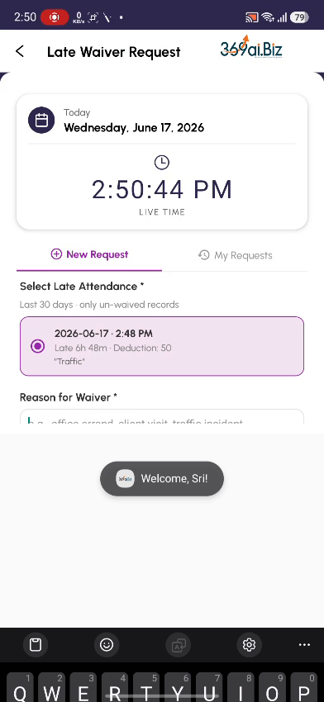

Step 5 Enter a Reason for Waiver
In the Reason for Waiver box, explain why the deduction should be cancelled (for example, “There was heavy traffic returning from hometown”). A reason is required before you can submit.
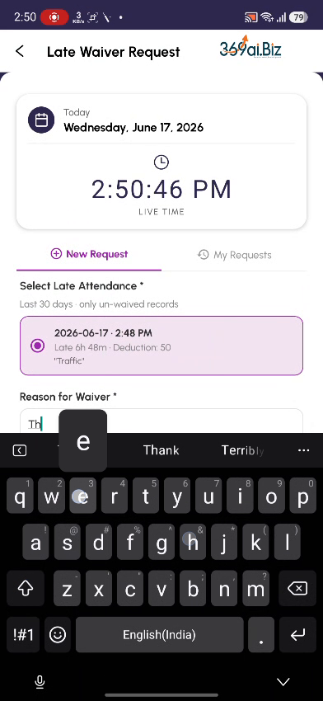
Step 6 Review and Submit
Once a late record is selected and a reason is filled in, the Submit Waiver Request button becomes active. Tap it. A confirmation dialog shows a summary — Date, Late time, Deduction, and Reason. Check the details and tap SUBMIT to send it to your manager, or CANCEL to go back and edit.
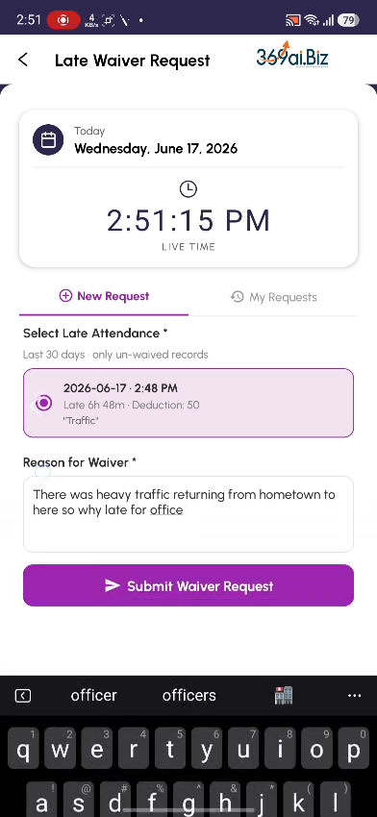 | 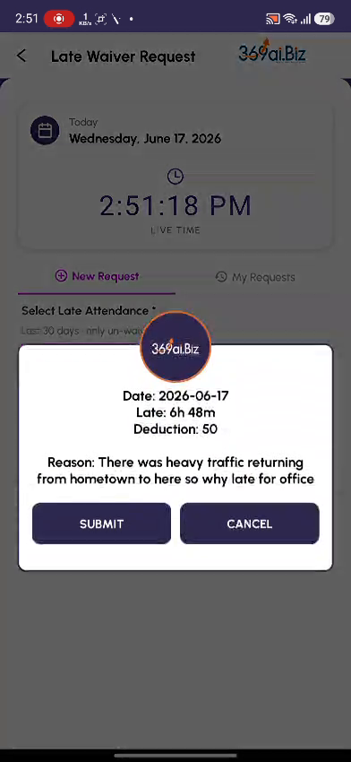

PART 3 Tracking Your Waiver
Step 7 My Requests
After you submit, a message confirms “Waiver request submitted for approval”. Tap the My Requests tab to see all the waivers you have raised. Each card shows the late date, the late time and deduction, your reason, and a status badge — Pending (awaiting your manager), Approved, or Rejected. When a waiver is Approved, the deduction is removed.
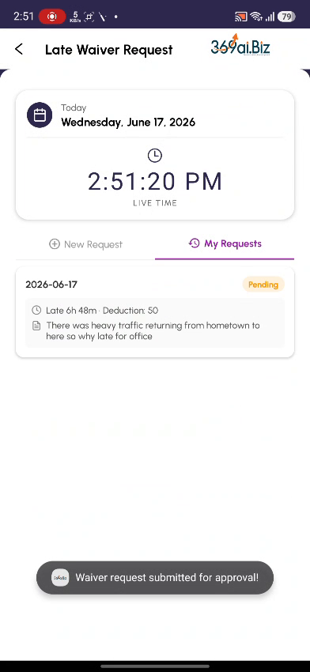 | 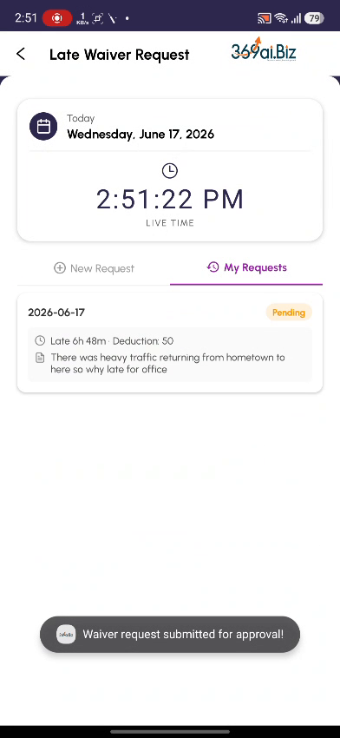

What the Late Record Shows
Each card under Select Late Attendance summarises one late check-in:
Detail | What it means
Date & time | The day and the time you checked in late.
Late duration | How long after your expected start time you checked in (e.g. Late 6h 48m).
Deduction | The salary amount currently deducted for that late arrival (e.g. 50).
Reason | The short reason you typed on the “You're Late” screen at check-in.

What Happens After You Submit
Status | What it means
Pending | Submitted and waiting for your manager to approve or reject. The deduction still stands for now.
Approved | Your manager agreed — the deduction is waived and removed from your pay.
Rejected | Your manager did not agree — the deduction stays as it was.

Quick Reference / FAQ
Question | Answer
Why is my late not in the list? | Only un-waived late records from the last 30 days appear. Older or already-waived lates are not shown.
Can I waive the same late twice? | No. Once a late is waived (or a request is raised for it) it no longer appears in the list.
Is the deduction removed straight away? | No. It is removed only after your manager approves the waiver.
How is this different from the late reason at check-in? | The check-in reason explains why you were late; the waiver formally requests that the deduction be cancelled.
What if my waiver is rejected? | The deduction stays. You cannot re-submit the same record, so make your reason clear the first time.
The Submit button is greyed out. | You must both select a late record and type a reason for waiver before you can submit.

