3 6 9 a i . B i z

LEAVE REQUEST

Employee Step-by-Step Guide
369ai.Biz Employee Attendance App
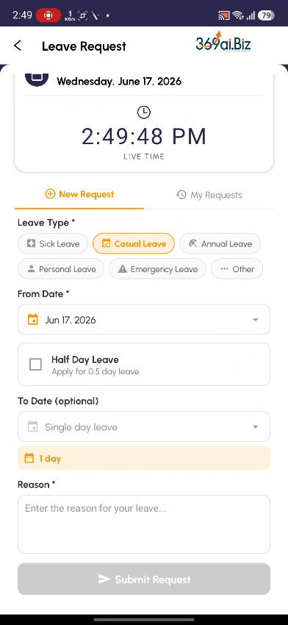
A simple guide to applying for leave, choosing your dates, submitting for manager approval, and tracking your requests.

About Leave Request
Leave Request lets you apply for time off straight from your phone. You pick a leave type, choose your dates (or mark a half day), and add a reason. Your request goes to your manager for approval. HR decides whether the leave is paid or unpaid based on your company's policy, and you can track the status of every request under My Requests.
This guide walks you through everything you do, in the order you will do it.
How Leave Requests Work
- Open the app and go to User Attendance
- Choose Leave Request and verify your identity
- Pick a Leave Type (Sick, Casual, Annual, Personal, Emergency, Other)
- Choose your dates — a single day, a date range, or a half day
- Add a reason and Submit for approval
- Track the status under My Requests — Pending, Approved or Rejected
PART 1 Opening Leave Request
Step 1 Open the App and go to User Attendance
On your phone, open the Employee Attendance app. From the 369ai.Biz home screen, open All Options, scroll down to the HR & Tracking section, and tap User Attendance.
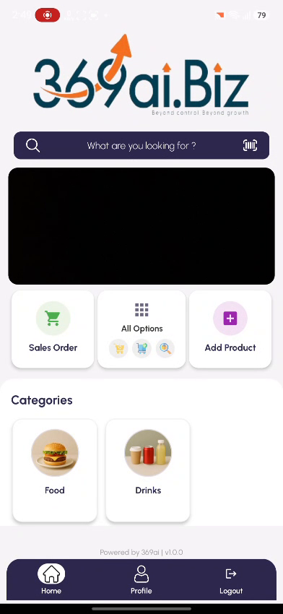 | 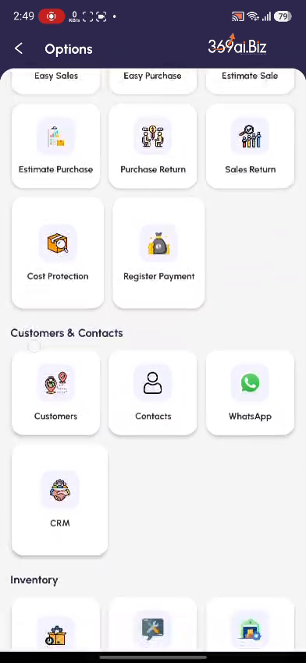 | 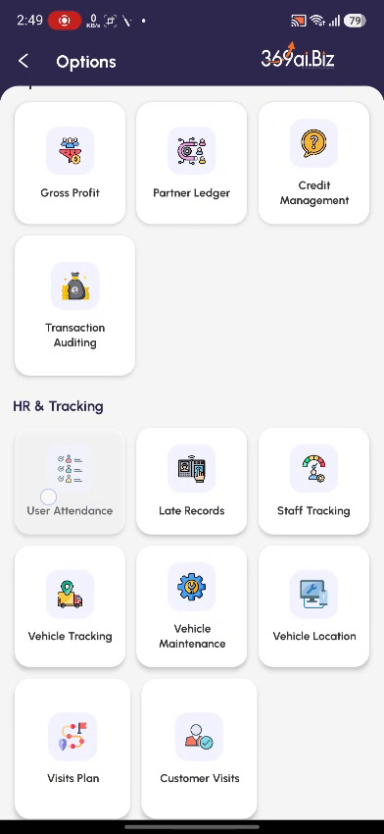

Step 2 Choose Leave Request
On the Select Attendance Type screen, tap Leave Request (“Apply for leave with manager approval”).
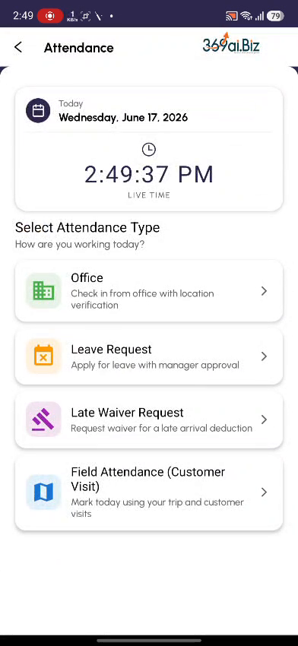
Step 3 Verify Your Identity
Confirm it is really you. Either tap Scan Fingerprint and use your enrolled finger, or type your 4-digit PIN under Enter PIN and tap Verify PIN.
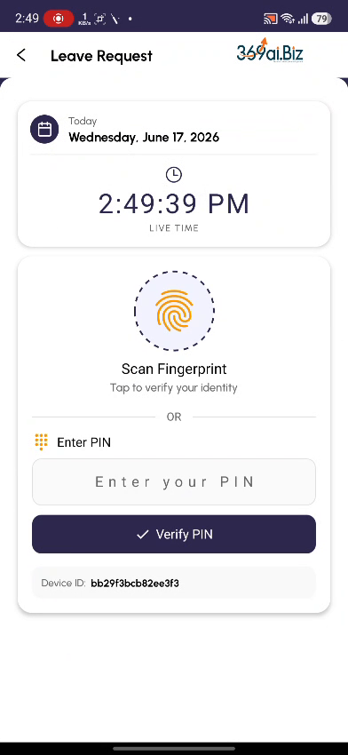 | 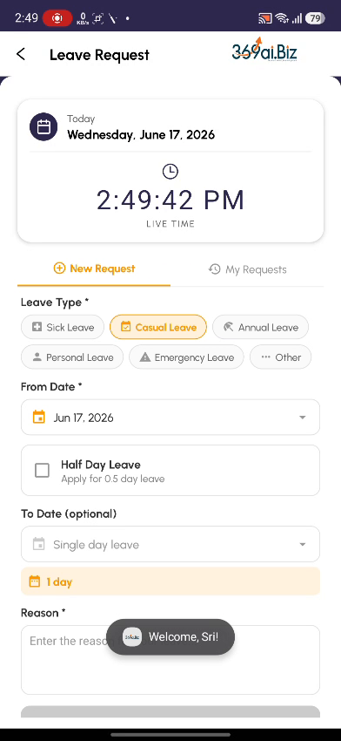

PART 2 Filling in Your Request
Step 4 Choose your Leave Type
You will land on the New Request tab of the Leave Request form. At the top, pick your Leave Type by tapping one of the chips — Sick, Casual, Annual, Personal, Emergency, or Other. The selected type is highlighted.

Step 5 Pick your dates
Tap From Date and choose the start day from the calendar, then tap OK. If your leave is more than one day, tap To Date and choose the end day. Leave To Date empty for a single-day leave. The orange N day(s) badge updates automatically to show how many days you are requesting.
For a half-day leave, switch on Half Day Leave instead of picking a To Date — it counts as 0.5 day.
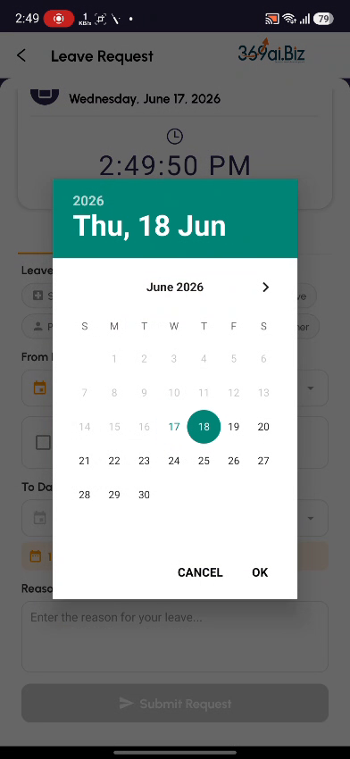 | 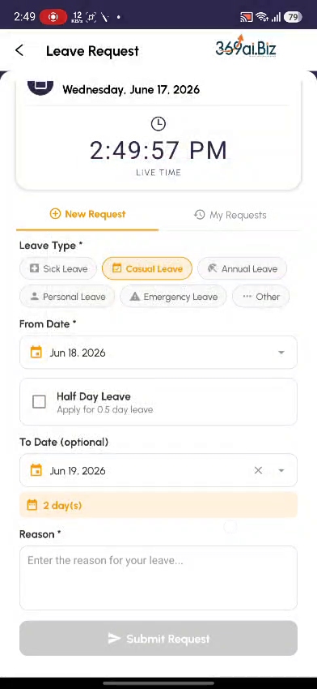

Step 6 Enter a reason
In the Reason box, type a short explanation for your leave (for example, “Going for hometown”). A reason is required before you can submit.
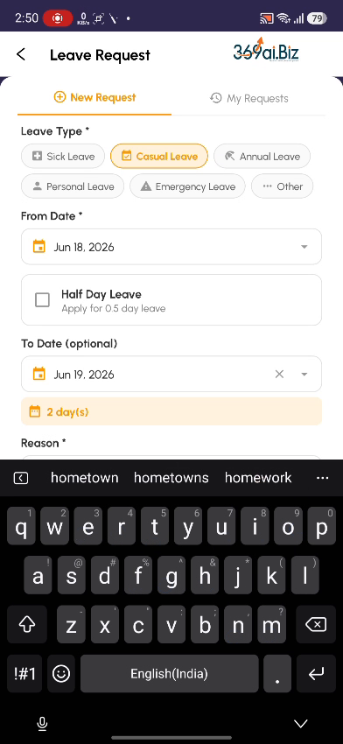
Step 7 Review and Submit
Once a type, the dates, and a reason are filled in, the Submit Request button turns orange. Tap it. A confirmation dialog shows a summary — Type, From, To, and Reason. Check the details and tap SUBMIT to send it to your manager, or CANCEL to go back and edit.
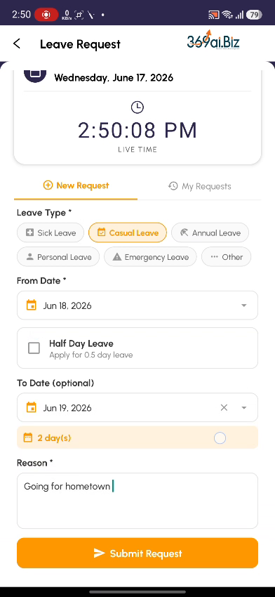 | 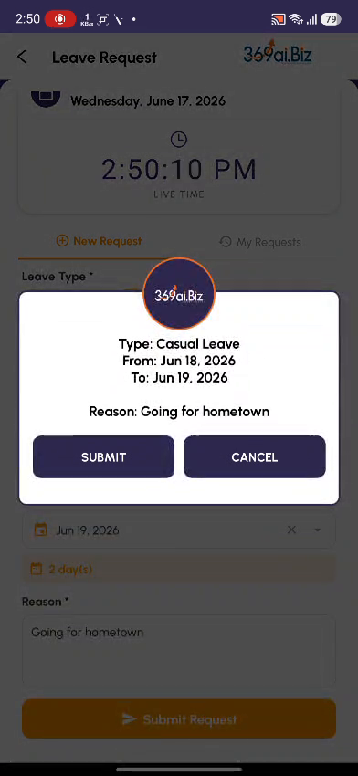

PART 3 Tracking Your Requests
Step 8 My Requests
Tap the My Requests tab to see all the leave you have applied for. Each card shows the leave type, the dates and number of days, your reason, and a status badge — Pending (awaiting your manager), Approved, or Rejected. Approved cards also show who approved them (e.g. “By: Administrator”). While a request is still Pending you can tap Cancel Request to withdraw it.
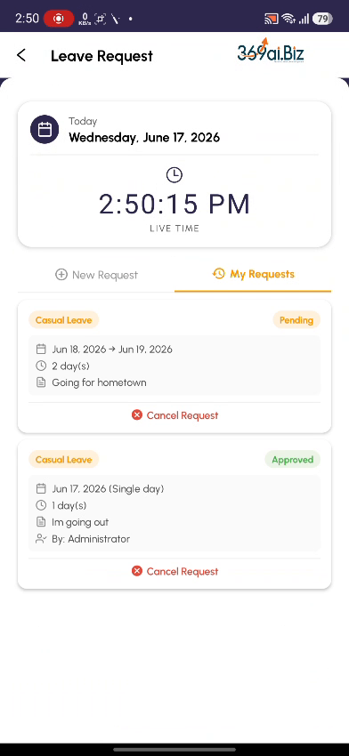
Understanding Leave Types
Pick the type that best matches your reason for taking leave:
Leave Type | When to use it
Sick Leave | You are unwell or need to recover, or for a medical appointment.
Casual Leave | Short, everyday personal time off — errands, family matters, a day out.
Annual Leave | Planned holiday or vacation taken from your yearly leave allowance.
Personal Leave | Personal commitments that don't fit the other categories.
Emergency Leave | Sudden, unplanned situations that need you to be away urgently.
Other | Anything that doesn't match the types above — explain it in the reason.

Paid vs Unpaid Leave
Your company grants a set number of paid leave days per year (and a limit per month). Leave within that allowance is paid. Once you have used up the allowance, extra days are unpaid and may carry a salary deduction. A half day counts as 0.5 day.
The exact number of paid days and how unpaid days are deducted are set by HR. Your approved request and any deduction are calculated automatically from that policy.
Request Status & Cancelling
Status | What it means
Pending | Submitted and waiting for your manager to approve or reject. You can still Cancel Request.
Approved | Your manager approved the leave. The card shows who approved it (e.g. By: Administrator).
Rejected | Your manager did not approve this request. You can submit a new one if needed.
Cancelled | You withdrew the request before it was actioned.

Quick Reference / FAQ
Question | Answer
How do I apply for a single day? | Pick the From Date and leave To Date empty — the badge will show 1 day.
How do I apply for a half day? | Switch on Half Day Leave instead of choosing a To Date. It counts as 0.5 day.
The Submit button is greyed out. | You still need to fill a required field — make sure a leave type, the From Date, and a reason are all set.
Can I edit a request after submitting? | No. Cancel the Pending request and create a new one with the correct details.
Who approves my leave? | Your manager / HR. The request stays Pending until they approve or reject it.
Will my leave be paid? | Leave within your yearly paid allowance is paid; beyond that it is unpaid and may be deducted, per your company's policy.
Can I cancel an approved leave? | Use Cancel Request on the card; if it is already approved, check with your manager / HR.

