3 6 9 a i . B i z

OFFICE ATTENDANCE

Employee Step-by-Step Guide
369ai.Biz Employee Attendance App
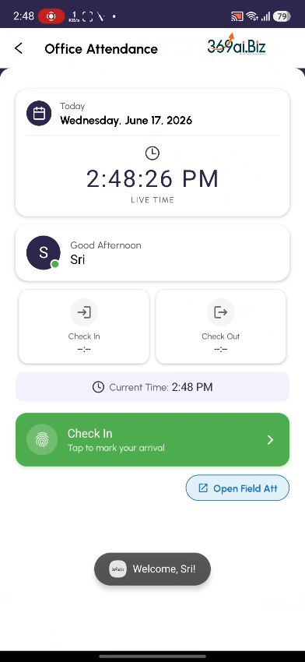
A simple guide to verifying your identity, checking in at the office, giving a late reason if needed, and checking out for the day.

About Office Attendance
Office Attendance is the daily workflow for employees who work from the office. Instead of an unverified punch, the app confirms it is really you and that you are really at the office: it takes your photo at check-in and check-out, and checks your GPS location against your company's location. It is a simple one Check In and one Check Out per day.
The app also tracks late arrivals. If you arrive after your expected start time, it shows how late you are, your late count for the month, and any salary deduction — and asks you to type a short reason.
This guide walks you through everything you do, in the order you will do it.
Your Day at a Glance
- Open the app and log in with your PIN or fingerprint
- Choose Office attendance
- Check In — confirm, then capture a photo and your office location
- If you are late, give a reason
- Work your day
- Check Out at the end of the day — confirm and capture a photo
- See All Done — your attendance for the day is complete
PART 1 Starting Your Day
Step 1 Open the App
On your phone, open the Employee Attendance app. You will see the 369ai.Biz home screen with all the options. Scroll down to the HR & Tracking section and tap User Attendance to begin.
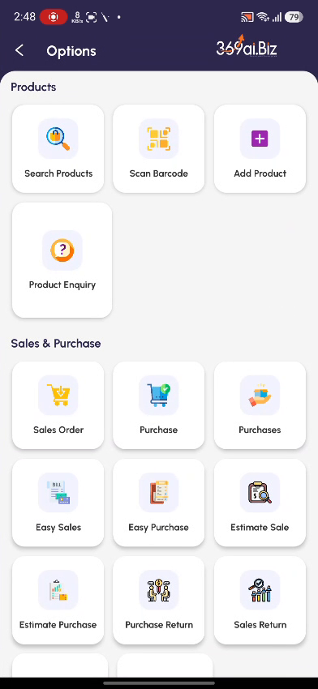 | 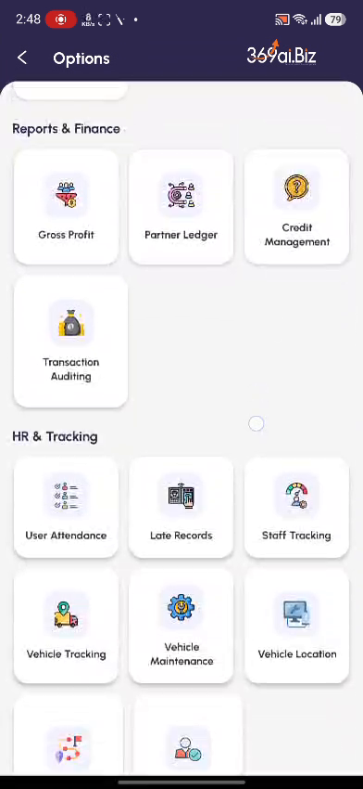

Step 2 Choose Office Attendance
On the Select Attendance Type screen, tap the first card — Office (“Check in from office with location verification”).
The other options — Leave Request, Late Waiver Request, and Field Attendance (Customer Visit) — have their own guides.
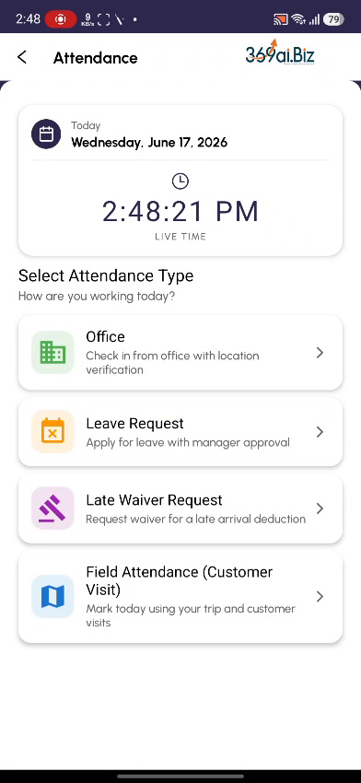
Step 3 Verify Your Identity
Confirm it is really you. Either tap Scan Fingerprint and use your enrolled finger, or type your 4-digit PIN under Enter PIN and tap Verify PIN. The Device ID shown at the bottom is your phone's registered ID — you don't need to do anything with it.
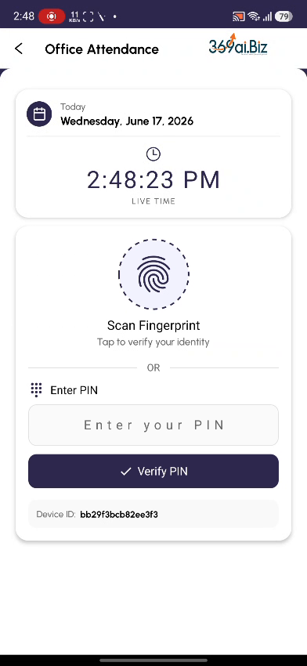 | 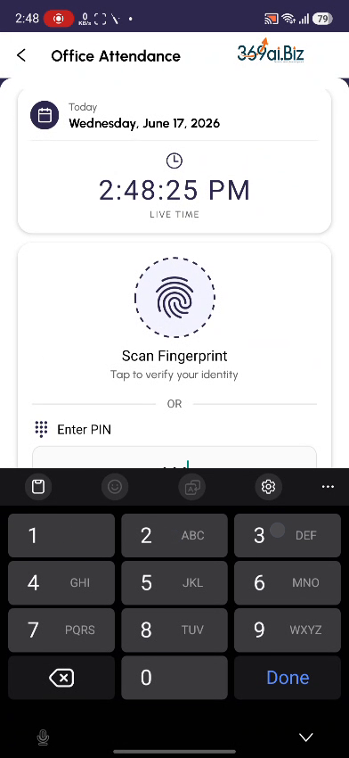

Step 4 Go to the Office Attendance Screen
You will land on the Office Attendance screen. It shows today's date, the live time, and a greeting with your name. The Check In and Check Out cards are empty until you act, and a green Check In button sits at the bottom.

PART 2 Checking In
Step 5 Tap Check In
Tap the green Check In button. A confirmation dialog asks “Are you sure you want to check in at 2:48 PM?” Tap YES.
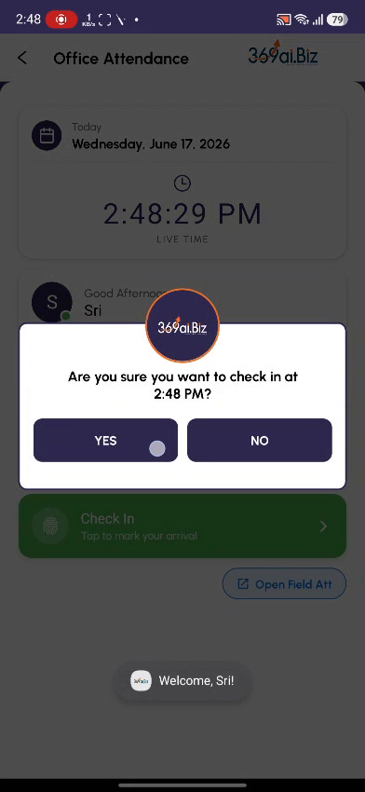
Step 6 Take Your Check-In Photo
The app opens the camera. Position your face inside the dotted circle and wait for the countdown. The app automatically takes your photo and captures your current GPS location.
Make sure your face is clearly visible and well lit — this photo is your proof of attendance.
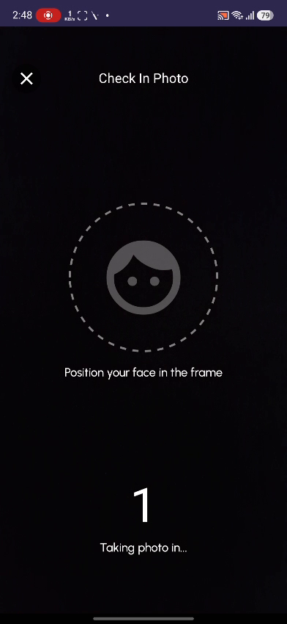
Step 7 If You're Late, Give a Reason
If you checked in after your expected start time, a You're Late notice appears. It shows how late you are (e.g. “6h 48m late for Session 1”), your late count this month, the expected start time, and any salary deduction. Type a short reason in the box (for example, “Traffic”) and tap Submit Reason.
If you believe the deduction is unfair, you can raise a Late Waiver Request separately — your manager can then approve or reject it.
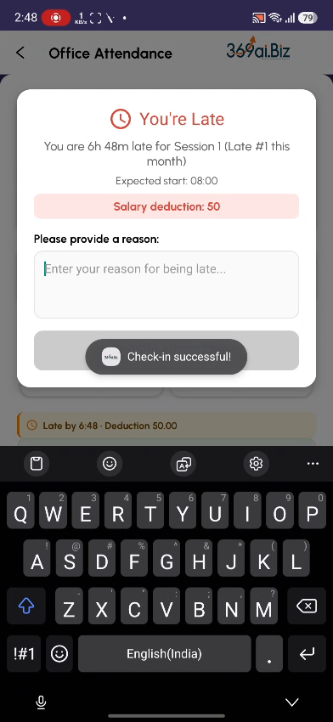 | 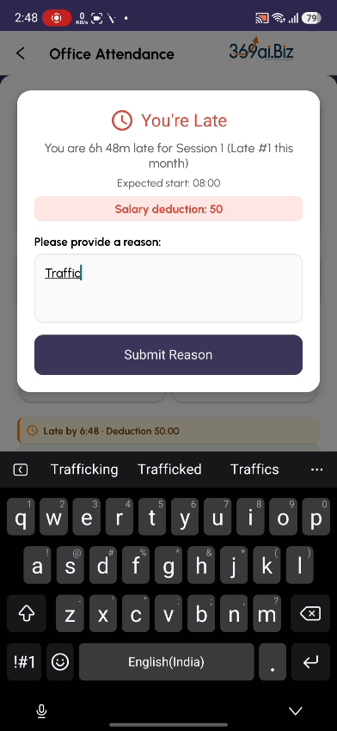

Step 8 You're Checked In
You are now checked in. The Check In time shows in green, and a green Location Verified banner confirms you were at the office (e.g. “0m from My Company”). If you were late, an amber banner shows the late time and deduction. A red Check Out button is ready for when you leave.
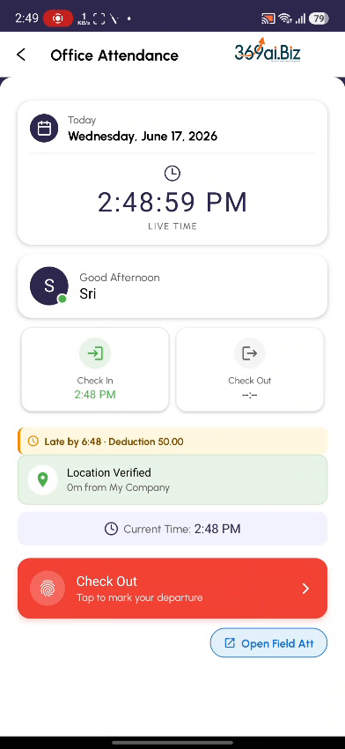
PART 3 Checking Out
Step 9 Tap Check Out
When you are ready to leave, tap the red Check Out button. The app confirms the time and warns that once you check out you cannot check in again to this session today. Tap YES, CHECK OUT to continue.
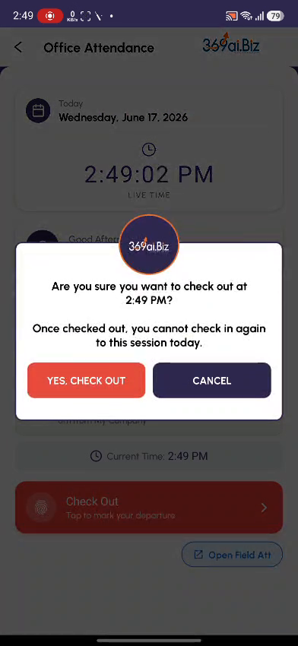
Step 10 Take Your Check-Out Photo
Just like check-in, the camera opens. Position your face in the frame and hold still while it captures the photo and your final GPS location.
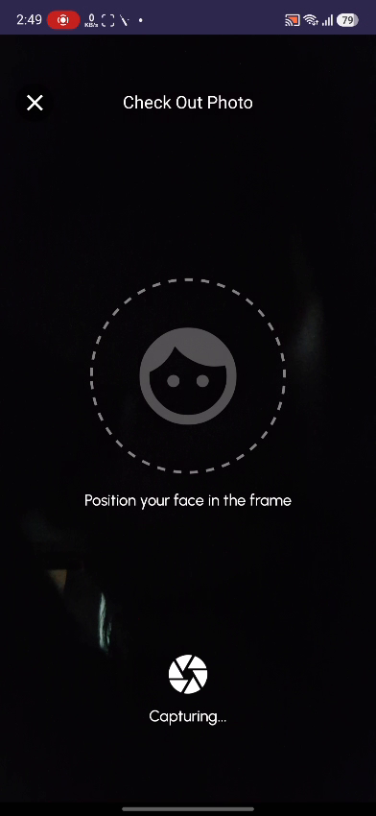
Step 11 All Done
You will see a green tick and All Done! — Your attendance is complete for today. Both the Check In and Check Out cards now show your times. You are finished for the day.
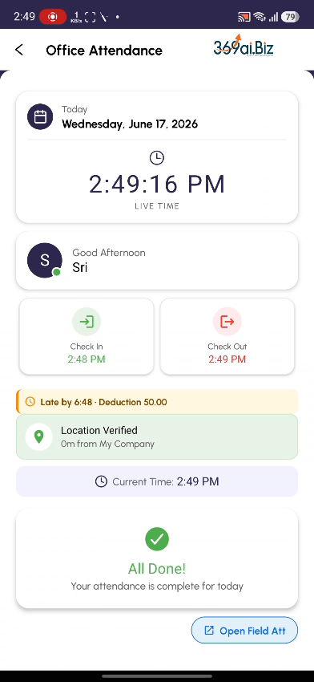
Understanding the “You're Late” Screen
The late notice can look alarming, so here is what each line means:
Term | What it means
Expected start | The official start time of your shift (e.g. 08:00). You are “late” only if you check in after this plus a short grace allowance.
Session 1 | Your work session. Most staff have a single session; split-shift staff can have Session 1 and Session 2, each tracked separately.
Late #N this month | How many times you have been marked late this month. Your company allows a few “free” late times (a grace period) before deductions begin.
Salary deduction | The amount deducted for this late arrival, based on how late you are and your company's rules. Shows 0 while you are within the grace period.
Reason | A short explanation you type (e.g. Traffic). It is stored with the record for your manager to see.

Being late and getting a deduction isn't always final — you can submit a Late Waiver Request asking your manager to waive it.
Location Verification
Office Attendance checks where you are, not just when:
- At check-in, the app compares your GPS position with your company's saved location and shows the distance, e.g. “0m from My Company.”
- If you are too far from the office, check-in can be blocked — so you can't mark office attendance from home or on the road.
- Keep your phone's Location/GPS turned on and the app's location permission allowed, or check-in may fail.
Quick Reference / FAQ
Question | Answer
I entered the wrong PIN. | Type it again and tap Verify PIN. Nothing is submitted until your PIN is accepted.
My fingerprint isn't working. | Use the Enter PIN option instead — both methods do the same thing.
Do I have to give a reason for being late? | Yes. The Submit Reason step is required before the late check-in completes.
Can I check in twice in one day? | No. Once you check out of a session you cannot check in again to that session the same day.
My check-in is blocked. | You are probably too far from the office, or GPS is off. Turn on Location, allow the permission, and try from inside the office.
The photo screen is too dark. | Move to better light and keep your face inside the dotted circle — it captures automatically.
I'm in the office but it says I'm far away. | GPS can drift indoors. Wait a few seconds for the location to settle, or step near a window, then try again.
What's the “Open Field Att” link? | It switches to Field Attendance mode for staff doing customer visits — not used for normal office days.

