3 6 9 a i . B i z

Van Sale

Everyday Guide
Open your register, sell, take the money, and hand over the receipt.

About This Guide
This is the guide for the person who uses Van Sale all day: opening a register in the morning, selling to customers, taking payment, printing receipts, handling returns, and keeping products and customers tidy.
It describes the app exactly as it behaves on the tablet. Every button name, field label and message in this guide is quoted from the app itself, so what you read here is what you will see on the screen.
If you are the person who sets the system up — connecting a new tablet, deciding who can see what, designing the receipt — that is a separate job with a separate guide. It is the second half of this document.
TIP Your Home screen may not show every tile in this guide. An administrator can hide tiles for your login, and a hidden tile does not grey out — it disappears completely, along with its section heading if nothing is left in it. Nothing is broken; ask your administrator.

Van Sale at a Glance
▪ Start of day — sign in, open your register, and enter the cash that is already in the drawer.
▪ All day — build an order, attach the customer, take the payment, hand over the receipt.
▪ When something comes back — open the original order and use Return Products.
▪ As stock moves — record what you buy in Easy Purchase, and send faulty goods back with Quick Return.
▪ End of day — close the register, and check Orders and Sales Report against your drawer.

PART 1 GETTING INTO THE APP

Step 1 Sign In
The app opens on the sign-in screen showing Welcome back and Login to continue to your store. Under the heading ACCOUNT there are just two boxes.
Type your Odoo user name into Username or Email and your password into Password, then tap Login.
There is no server address or database to choose here — the tablet was pointed at your server when it was first set up, and it stays there. If you leave a box empty the app tells you Please input user name or Please input password; if the details are wrong it says Invalid credentials.
Auto Fill Credentials remembers the user name and password for this server so they appear ready-typed next time. The first time you switch it on before ever logging in you will see No saved credentials yet — log in once to save.
What you tap | What happens
Username or Email | Your Odoo login — the same one you would use in the back office
Password | Your Odoo password
Auto Fill Credentials | Fills both boxes for you on this server from now on
Login | Signs you in and opens the Home screen

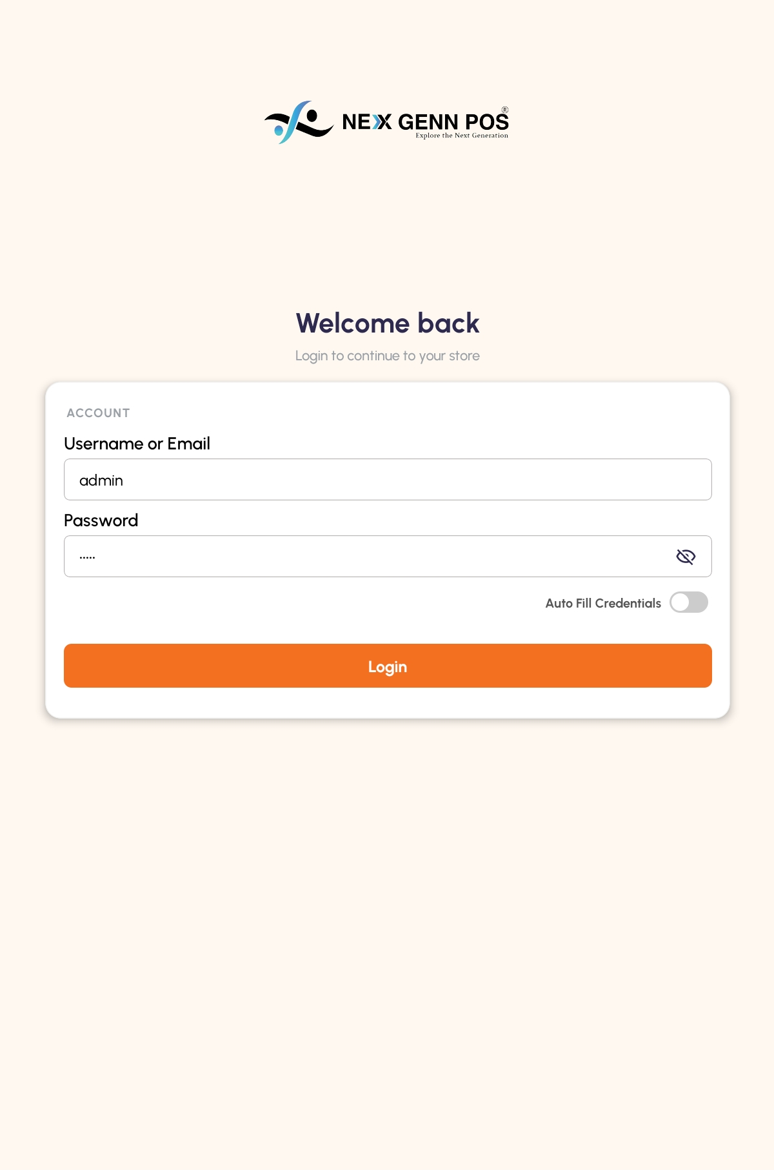
The sign-in screen — Welcome back, the ACCOUNT card and the Auto Fill Credentials switch

Step 2 Find Your Way Around Home
Home is the map of the whole app. At the top are your company logo, a banner strip, and today's date and time. Below that is a bar reading Quick Access and Manage your store, with your company name beside it.
Everything else is grouped into sections, each with a count of the tiles inside it.
Section | What lives in it
Sales & POS | POS, Orders, Sales Report
Inventory | Products, Stock
Easy Purchase | Easy Purchase, Quick Return
Contacts | Customers, Customer ID Proofs
Finance | Expenses
Accounting | Invoices, Journal Entries, Partner Ledger, Opening Balance
Administration | Users, App Banners, Apps Privileges, Invoice Settings, User Manual

The five Administration tiles are for administrators only. They stay visible to everyone, but tapping one as an ordinary user just shows Only administrators can access this feature.
Journal Entries behaves differently from every other tile: instead of opening a list it opens a small Select Journal window offering Sales, Purchases, Bank & Cash and Miscellaneous.
TIP Pressing the tablet's back button on Home shows Press back again to exit. Press it a second time within two seconds and the app closes.

[ IMAGE 2 — not captured yet ]
The Home screen — the Quick Access bar and the grouped tiles

Step 3 The Three Tabs, Your Company, and Signing Out
Along the bottom of every screen sit three tabs: Home, Profile and Logout.
Profile shows who you are signed in as — a Connected badge, then User ID, Database, Role, Login and Company. Under HELP there is User Manual (View or download the guides), which opens the guides your administrator has published. The version of the app is printed at the bottom.
Company names the company you are working in. If your login is allowed into only one company, that is all it does. If you are allowed into two or more, the row carries an arrow: tap it and Choose company opens, explaining The app shows registers, products and customers of this company. Tap the company you want.
The app checks before it changes anything — Switch company? and Change from one company to the other, with You'll see this company's registers, products and customers. Tap SWITCH, or CANCEL to stay where you are. Once switched, a message reads Switched to and the company's name.
From then on the registers, products and customers you see are that company's, and a sale is booked under the company its register belongs to. The app remembers your choice, so the next time you sign in you are still in the same company.
Logout is not really a tab. Tapping it asks Are you sure you want to log out? — tap YES to confirm. You are returned to the sign-in screen.
What you tap | What happens
Home | Back to the tile grid
Profile | Who you are, which database, and the manuals
Company | Shows your company; with more than one, lets you switch
Logout | Asks to confirm, then signs you out

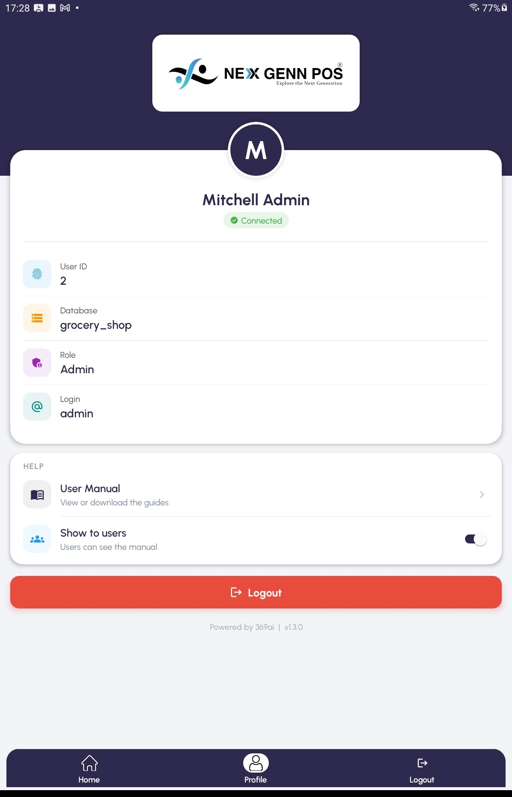
Profile — the HELP card with User Manual, and the three tabs along the bottom

PART 2 OPENING YOUR REGISTER

Step 4 Open a Register
Tap POS on Home. This does not open a till — it opens POS Register, a list of the registers in your shop split into Active Sessions and Available Registers.
A register you have not started yet shows AVAILABLE and the line Tap below to open this register and start a new session. Tap Open Register on its card.
If nothing is listed you will see No registers found. — your administrator has not set a register up for you in Odoo.
What you see | What it means
AVAILABLE | Nobody is selling on this register; you can open it
ACTIVE | A session is already running on it
OPENING | The session is being opened
Session Closed | This session has finished and cannot be sold on

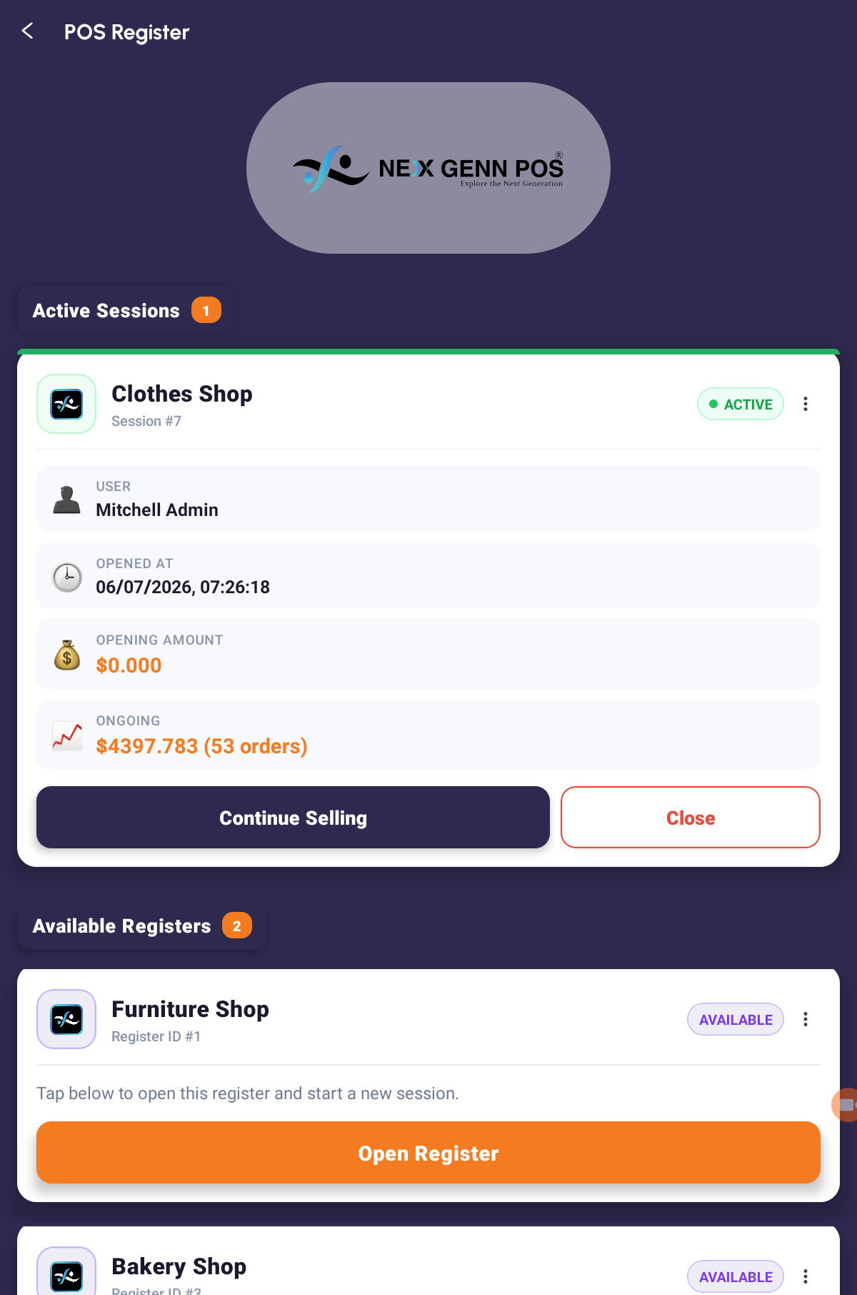
POS Register — an available register card with its Open Register button

Step 5 Count the Drawer into Opening Control
Opening a register asks one question first. The Opening Control window shows Opening cash with the note Cash currently in the drawer., and an Opening note box.
Count the money that is physically in the drawer and type it in. Add a note if you want one, then tap Open Register. If the figure is not a valid number you will be told Invalid amount — Please enter a valid opening cash amount (0 or more).
The app confirms with Register Opened and the session number.
IMPORTANT The opening figure is what your end-of-day cash count is measured against. Count the drawer properly — a guessed number here becomes a discrepancy at closing time.

[ IMAGE 5 — not captured yet ]
The Opening Control window — Opening cash and Opening note

Step 6 Carry On With a Session Already Open
If the register is already running, its card says Continue Selling. Tapping it asks how you want to carry on.
▪ New Order — Open a clean register. This is the normal choice.
▪ Existing Order — Resume a draft from this session. Use this to pick up an order somebody started and left unpaid.
The ⋮ menu on a register card also offers Sessions and Orders if you need to look back over the day.

Step 7 Close the Register at the End of the Day
Closing is offered from the register card. If unpaid drafts are still sitting in the session the app will not let them vanish quietly — it warns that a number of draft orders must be paid or cancelled before close, and offers to discard them all and retry.
When the session closes you will see Register Closed and Session closed successfully.
IMPORTANT Deal with your drafts before you close. Discarding them throws the orders away — it does not park them for tomorrow.

PART 3 BUILDING THE ORDER

Step 8 Add Products to the Order
You arrive on the Register screen with an empty basket: Cart is empty and Tap "Add Products" below to start building this order.
Tap Add Products. The product screen has a Search Products box and a row of category chips such as All (128), each showing how many products it holds.
There are three ways to add something:
▪ Tap the orange + on a product tile.
▪ Tap the tile to open it, then tap Add to POS Cart.
▪ Tap the QR button and scan the barcode.
Each addition confirms with Added and the product name. If the product is already in the basket you get Already Added instead, with the note that you should go back and increase the quantity. A barcode the till does not recognise raises Product Not Found.
When you are done, tap Go to Register.
What you tap | What happens
Search Products | Filters the list as you type
Category chip | Shows only that category
+ on a tile | Adds one of that product to the basket
Add to POS Cart | Adds the product you are looking at
Go to Register | Returns to the basket

[ IMAGE 6 — not captured yet ]
The Register screen with lines in the basket and the total beneath

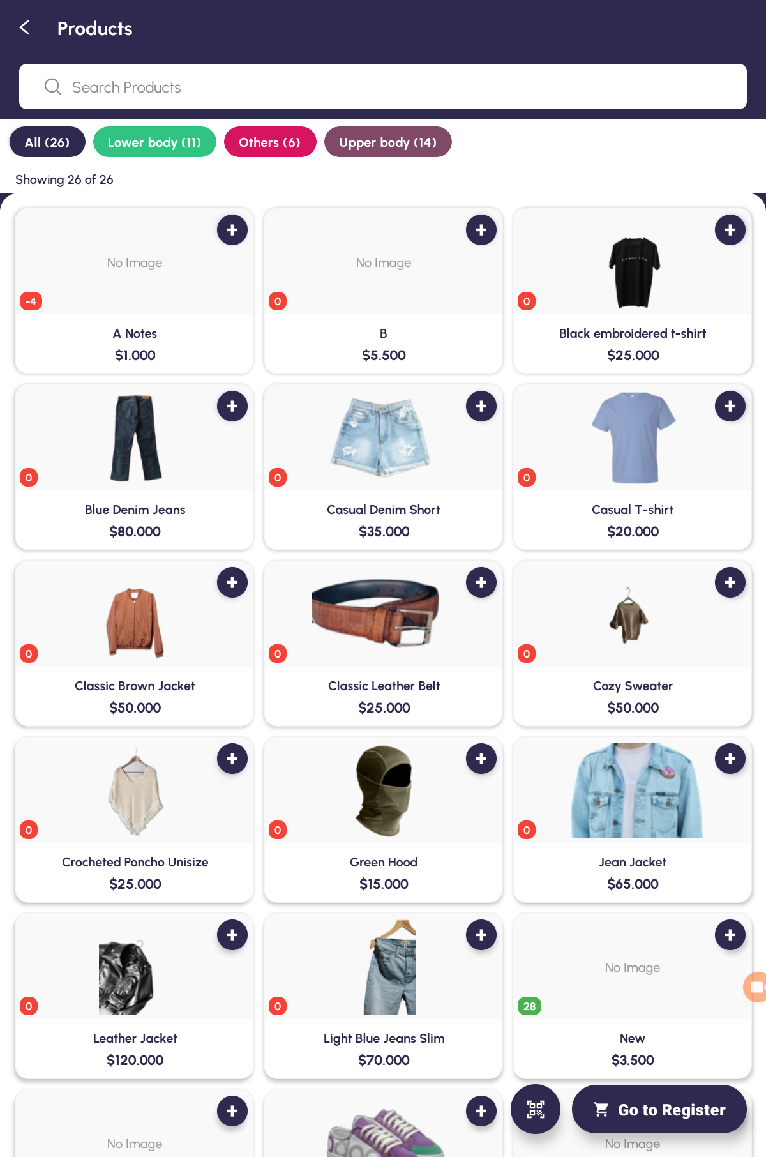
The product picker — the search box, category chips and the orange + buttons

Step 9 Change a Line
Back on Register, each line has − and + either side of its quantity.
Tap the quantity itself to open Set Quantity and type a number, then tap Set. Tap the price to open Set Unit Price the same way.
Two things about quantities are worth knowing before they surprise you. Quantities are whole numbers only — you cannot sell half of something from this screen. And − on a line showing 1 does not take it to zero, it removes the line; typing 0 into Set Quantity removes it too.
To clear several lines at once, press and hold a line to enter selection mode, tick the rest, and tap Delete.
TIP If the price is plain text rather than a tappable, dotted-underlined figure, your administrator has turned price editing off for your login. That is deliberate, not a fault.

Step 10 Give a Discount
Tap a line to select it and a Discount chip appears, along with Note for a free-text note on that line.
The Select Discount window asks two things. DISCOUNT TYPE is either Total Discount (spread across the whole basket) or Items Discount (this line only). DISCOUNT FORMAT is Percentage or Amount. Then pick one of the preset buttons or type your own figure, and tap Apply. Clear takes the discount off again.
The discount shows under the total as a line beginning with − Discount.
IMPORTANT Apply discounts here, on the Register screen. The payment screen has a discount chip too, but in the normal Place Order → Payment route it is hidden — by then the total has already been fixed.

[ IMAGE 8 — not captured yet ]
The Select Discount window — discount type, format and the preset buttons

Step 11 Attach the Customer
At the bottom of the Register screen is a chip reading Customer. Tap it, find the person in the list, and tap their row. The chip then shows their name.
What you tap | What happens
Customer chip | Opens the customer list to choose from
A customer row | Attaches them to this order and returns you here
The eye icon | Shows their details and ID proof without selecting them

IMPORTANT Every sale needs a customer, not only sales on credit. If you try to finish without one the app opens Customer Required — Please select a customer to validate the payment. Attaching the customer here saves a detour later.

When the basket is right, tap Place Order. The order is saved as a draft — you will see Draft saved and its number — and the payment screen opens. An empty basket is refused with Cart Empty — Add products before placing order.
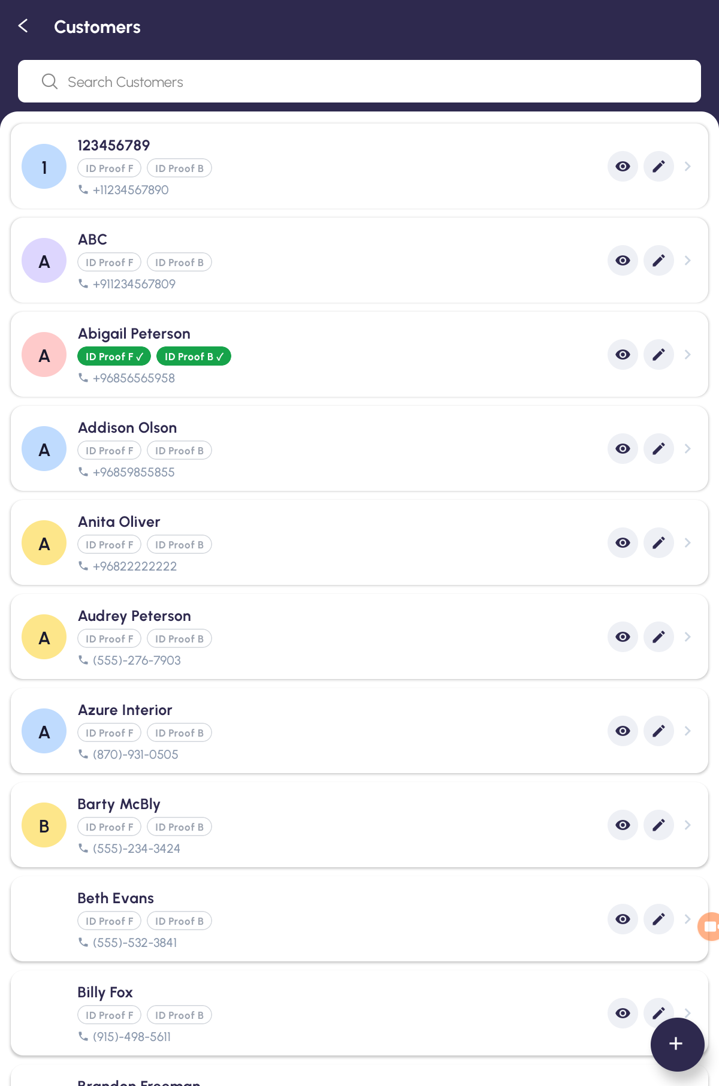
Choosing the customer from the Register screen

PART 4 TAKING THE PAYMENT

Step 12 Read the Payment Screen
The top of the Payment screen shows TOTAL. If a discount or tax applies, a breakdown appears beneath it — Subtotal, the discount line, and a Tax row you can tap to see it split line by line.
If the customer already owes money, an amber card appears under the total headed Previous Due with the amount outstanding. It is only there when there is something to show: no customer, or nothing owed, and the card stays hidden.
What you see | What it means
TOTAL | What this order comes to
Subtotal | Before discount and tax
Tax | Tap it for the line-by-line breakdown
Previous Due | What this customer owed you before today's order

[ IMAGE 10 — not captured yet ]
The Payment screen — the total, and the amber Previous Due card beneath it

Step 13 Take Cash or Card
Tap Cash or Card, then type the amount on the keypad. The keypad has +10, +20 and +50 shortcuts down the right-hand side, along with +/−, a decimal point and a backspace.
Watch the coloured pill as you type. It reads Remaining and an amount while you are short, Exact amount when it matches, and Change with an amount once you have taken more than the total.
If you try to finish while still short, the app opens Amount Required and tells you exactly how much more is needed.

Step 14 Put It on the Customer's Account
Tap Credit for CREDIT (CUSTOMER ACCOUNT). To take part of the money now, choose Pay now via: Cash or Card and type that part; the rest goes on the account. A live line shows Credit (due): with the amount and the customer's name, turning red if you have typed more than the order is worth.
IMPORTANT Credit needs a customer attached. Without one you will see the red hint Customer required for Credit and the sale cannot be validated.

Step 15 Split Between Two Methods
Split Payment takes one order across two payments. The window shows Total to collect, then Method 1 and Method 2, each offering Cash or Card.
Type an amount into each. A pill keeps score with Entered against the total, and the two figures must add up exactly before Confirm will accept them. The two methods must also be different.
TIP Credit is not offered as a split leg, and there are only ever two slots. To put part of a sale on account, use Credit with a Pay now via amount instead.

[ IMAGE 11 — not captured yet ]
The Split Payment window — two method slots and the running total

Step 16 Capture the Signatures
As soon as a customer is attached, the signature window rises by itself, headed with the customer's name and Capture the customer and cashier signatures.
There are two pads, CUSTOMER SIGNATURE and CASHIER SIGNATURE. Tap one, sign inside the box, and tap SAVE. Pen, Eraser and Clear are there if a signature needs redoing. Tap DONE when both are captured.
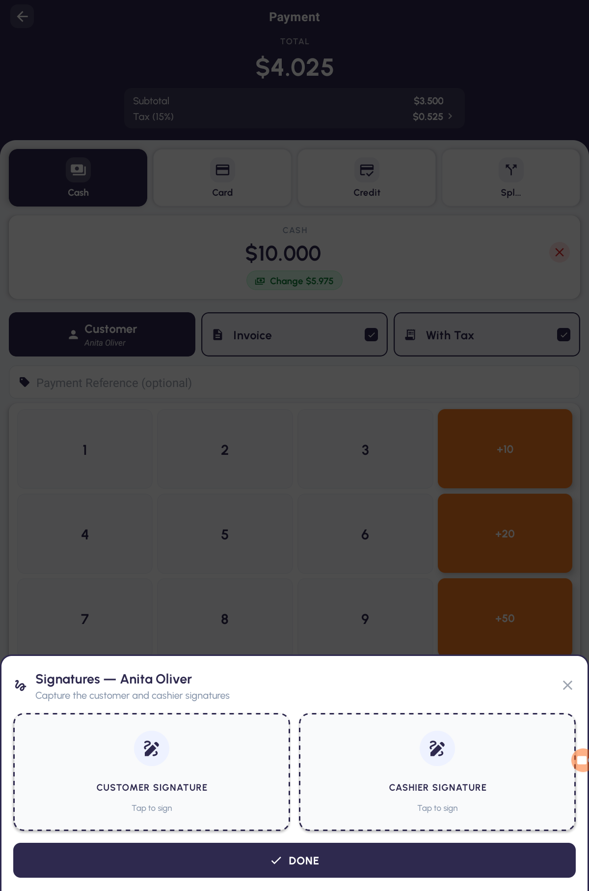
The signature capture window with the customer and cashier pads

Step 17 Validate the Payment
Check the two tick boxes above the keypad before you finish. Invoice and With Tax are both on by default.
Turning Invoice off asks you to confirm, and the warning is worth reading: without the invoice, accounting cannot reconcile the transaction and the order will not appear in monthly VAT reports. Tap Keep Invoice unless you are certain.
Then tap Validate Payment.
IMPORTANT The app records where the sale happened, and it will not finish without a location. If location services are switched off, or the app has been refused permission, payment stops and offers Open Settings — there is no way past it. If the tablet simply cannot get a fix in time you are offered Save without location instead.

What blocks you | What to do
Customer Required | Attach a customer, then validate again
Amount Required | Type the rest of the money
Turn on location | Open Settings and switch location services on
Allow location access | Open Settings and grant the app location permission
No internet connection | Reconnect and tap Retry — sales cannot be completed offline

PART 5 THE RECEIPT

Step 18 Choose the Paper Size
The receipt screen opens with a green tick and Order Placed, the order number, and a preview of the paper.
The first time you tap Preview, Download or Print, the app asks Choose receipt size — Pick a paper size. The receipt re-flows to fit the chosen size. The list runs from 2 inch (50 mm) up to A4, and one row may carry a purple Default badge. Custom width (mm) lets you type your own Width (mm) and tap Use this size.
If your administrator has switched on a default size, this window never appears — the receipt simply prints at that width.
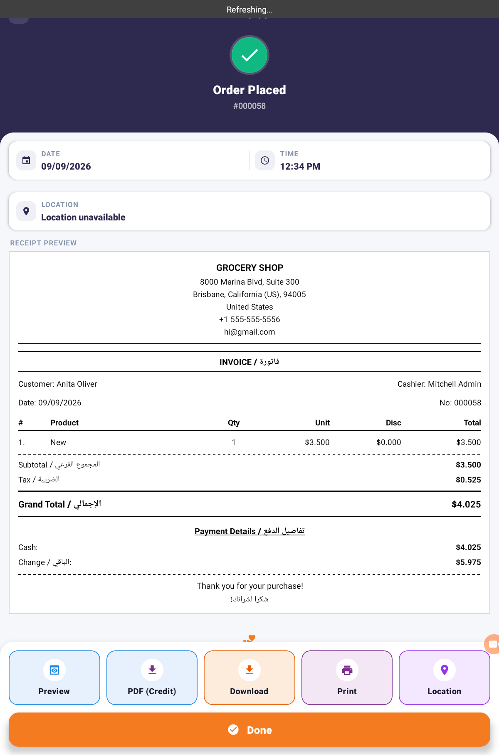
The receipt screen — Order Placed, the order number and the paper preview

[ IMAGE 14 — not captured yet ]
The Choose receipt size window, with the Default badge and Custom width

Step 19 Preview, Download or Print
Along the bottom of the receipt sit the actions.
What you tap | What happens
Preview | Opens Print Preview — the receipt exactly as it will print
Download | Saves the receipt as a PDF; you choose the folder
Print | Hands the receipt to the tablet's printing service
PDF (Credit) | Downloads the accounting invoice; only shown when the order has one
Location | Shows where the sale was made
Done | Clears the basket and returns you to Home

If the customer still owes money, the printed receipt carries three extra lines — Previous Due, This Invoice and Total Due — so they can see the whole picture.
TIP The preview drawn on the screen is always the app's own plain layout. If your shop has been set up with a branded or bilingual receipt, that design shows up in Preview, Download and Print — not in the on-screen block.

IMPORTANT Done ends the sale. You cannot go back to the payment screen afterwards, and neither can the tablet's back button. Print or download whatever you need before you tap it.

Step 20 See Where a Sale Happened
Tap Location for Order Location, showing Latitude and Longitude and an Open in Maps button. On the receipt itself the position appears under LOCATION, either as a place name or as coordinates.

PART 6 ORDERS AND RETURNS

Step 21 Find a Past Order
Tap Orders on Home. Search Orders looks in the order number, the customer and the salesperson, and four chips filter the list: All, Paid, Draft and Cancelled.
Each row shows the order number, a status badge, the amount, the customer, the receipt number and the date. Where the customer still owes money, an amber Due pill sits under the receipt number with the amount; tap it to see the whole picture. Refunds carry a red REFUND badge. An empty list says No orders found.
Badge | What it means
New | A draft — not paid yet
Paid | Payment taken
Posted | Finished and booked
Invoiced | An accounting invoice exists for it
Cancelled | Abandoned
REFUND | This order gives money back

Tapping a draft loads it back into the basket so you can finish it. Tapping any other order opens it read-only.
TIP There is no date filter on this screen. To look at a period, use Sales Report instead.

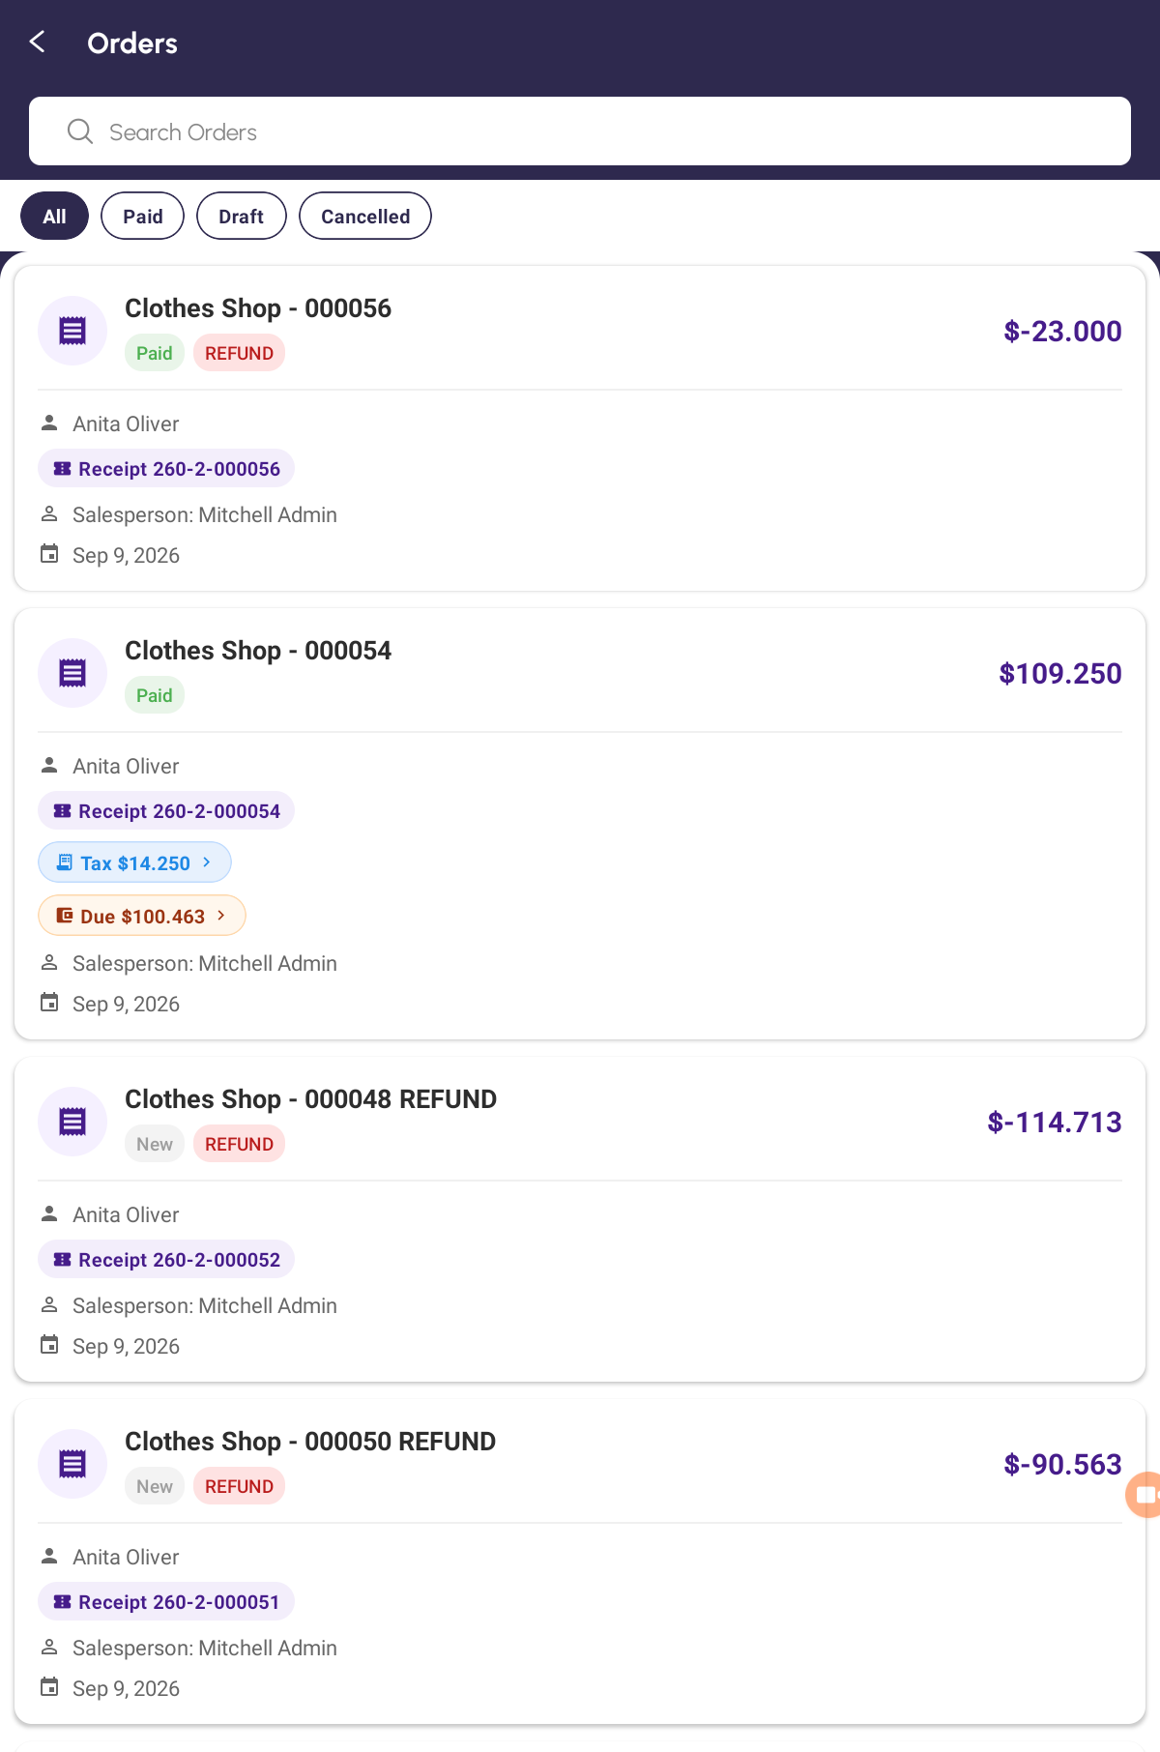
The Orders list — status badges, a REFUND row and the search box

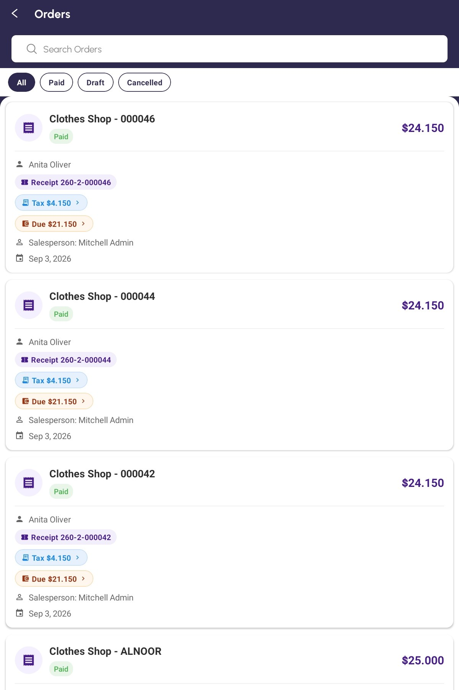
The Orders list with an amber Due pill on the rows that still owe money

Step 22 Read an Order
The order screen shows the number, the receipt reference and a status pill, then DATE, CUSTOMER, SALESPERSON and REGISTER, the ITEMS, the totals and the payments taken. If the customer owed money when this order was sold, an amber CUSTOMER DUE card sits under the totals with Previous Due, This Invoice and Total Due.
Along the bottom are Preview, Download, Print, Tax Breakdown, Due, Return Products and Location. A greyed-out Location chip means the order has no position stored; tapping it says No location.
The Due chip, and the Due pill on the Orders list, both open the same Customer Due box, which comes in two halves answering different questions. WHEN THIS ORDER WAS SOLD is history: Previous Due, This Order and Total Due are kept on the sale itself and never change, so this is always what was owed on the day. OPEN INVOICES NOW is today: every unpaid bill with its number, its date and what is still owed on it, added up as Owed now. Once everything is settled it reads No open invoices — this customer is settled up.
IMPORTANT The two halves are meant to differ. When the customer pays something the top half stays where it was, because it is the record of that sale, while the bottom half drops. That is not a mistake — it is why both are there.

On some servers the figures from the day of the sale are not kept. There the card reads CUSTOMER DUE (CURRENT) and the top half of the box reads CURRENT BALANCE instead: both show what the customer owes right now, not what they owed on the day.
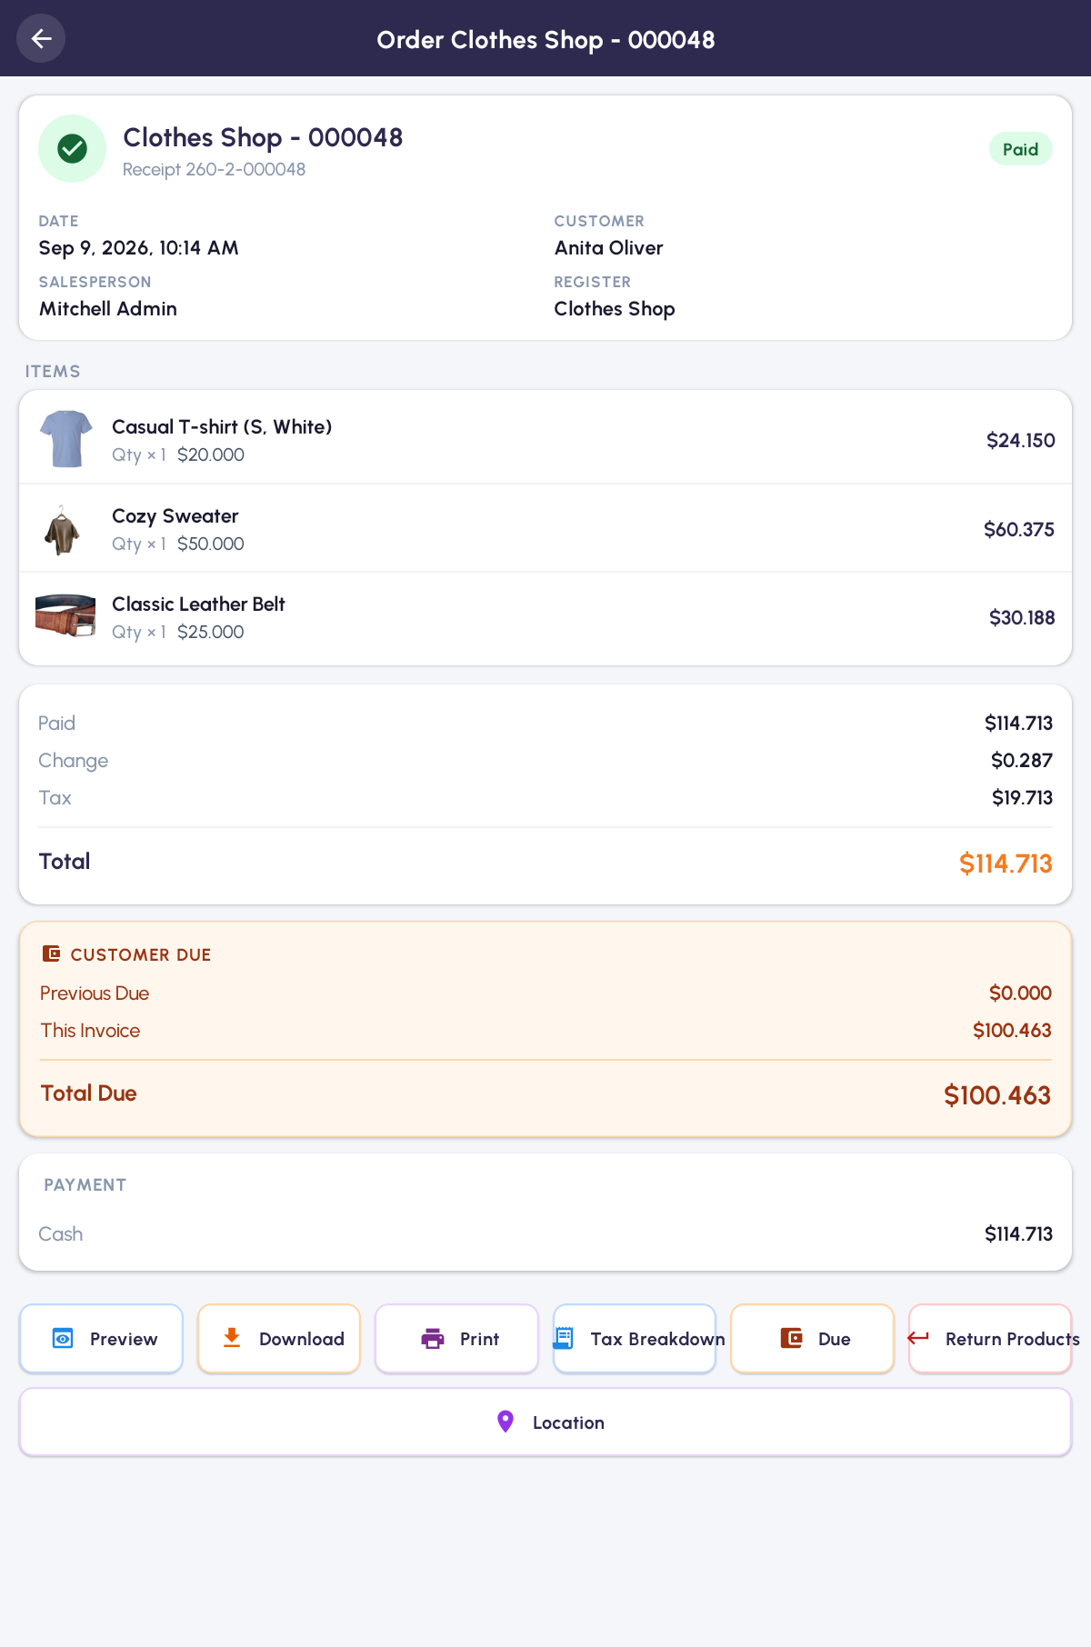
An order opened from the list, with its items, totals and action chips

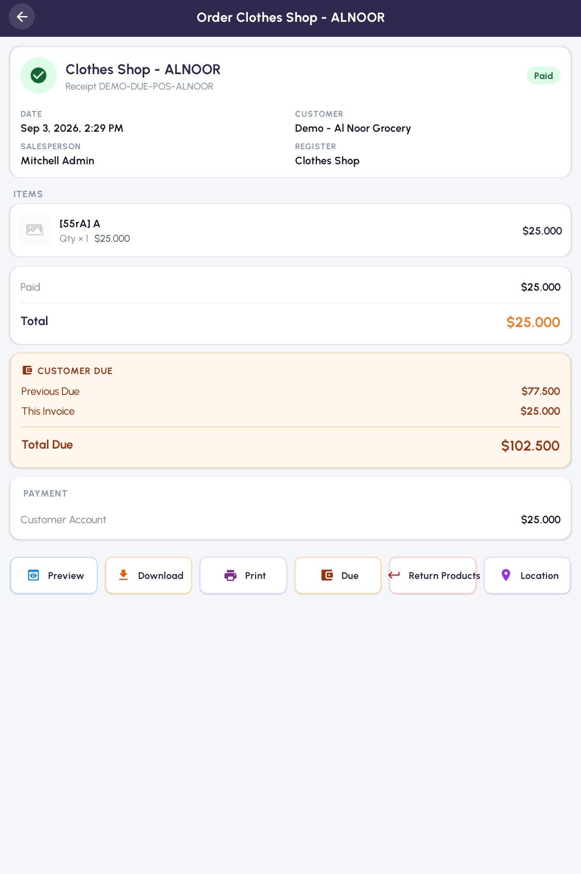
The same order showing the amber CUSTOMER DUE card and the Due chip

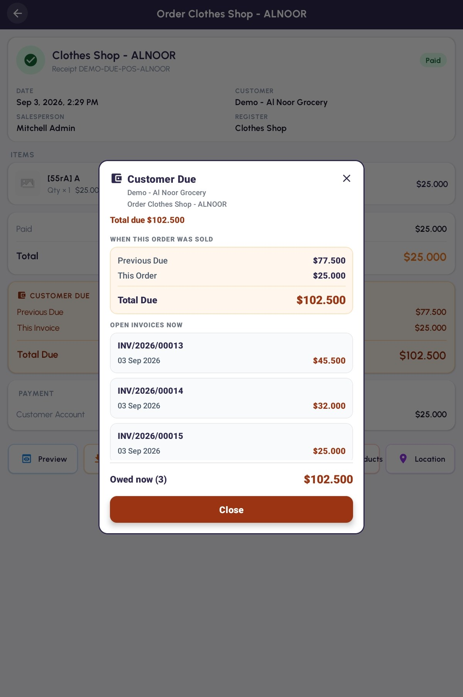
The Customer Due box — the frozen figures above, the open invoices below

Step 23 Send Products Back
Open the original paid order and tap Return Products. The app asks Return Products? and explains that a new refund order will be created with negative quantities, ready for payment. Tap RETURN.
The refund order is created — Products returned, Refund order created — ready for payment. — and loaded straight into the basket. Take the payment as usual to give the money back.
Return Products only appears when a return is actually possible. It is hidden on drafts, on cancelled orders, on refunds themselves, and on any order that has already been returned once. You also need an open session: without one you get Invalid Operation telling you to open a session on that register first.
IMPORTANT Returning brings back every line at its full quantity. To refund only part of an order, delete the lines you are not refunding — do not try to edit the quantities. On a return line − removes the line altogether and + makes the refund smaller, and a negative quantity cannot be typed in.

The refund keeps whatever tax was charged originally, scaled to what you are giving back, so a return always reverses exactly what was taken.
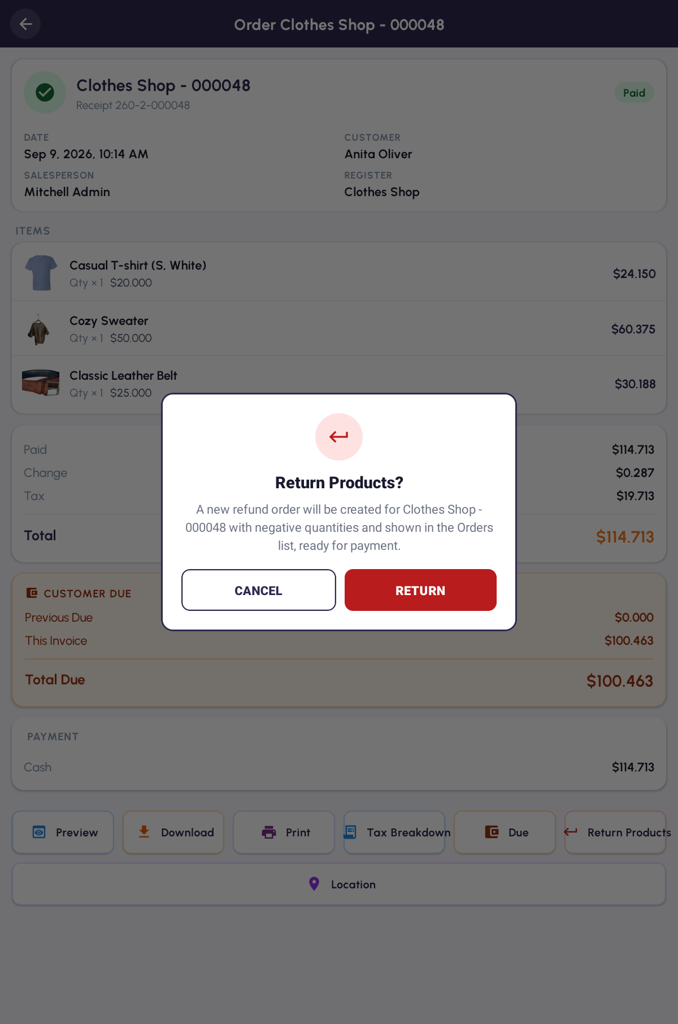
The Return Products confirmation

PART 7 CUSTOMERS

Step 24 Find a Customer
Tap Customers on Home and use Search Customers. Each row shows the name, the phone or email, and two small badges for whether their ID proof is on file — ID Proof F for the front and ID Proof B for the back, ticked when the image is there.
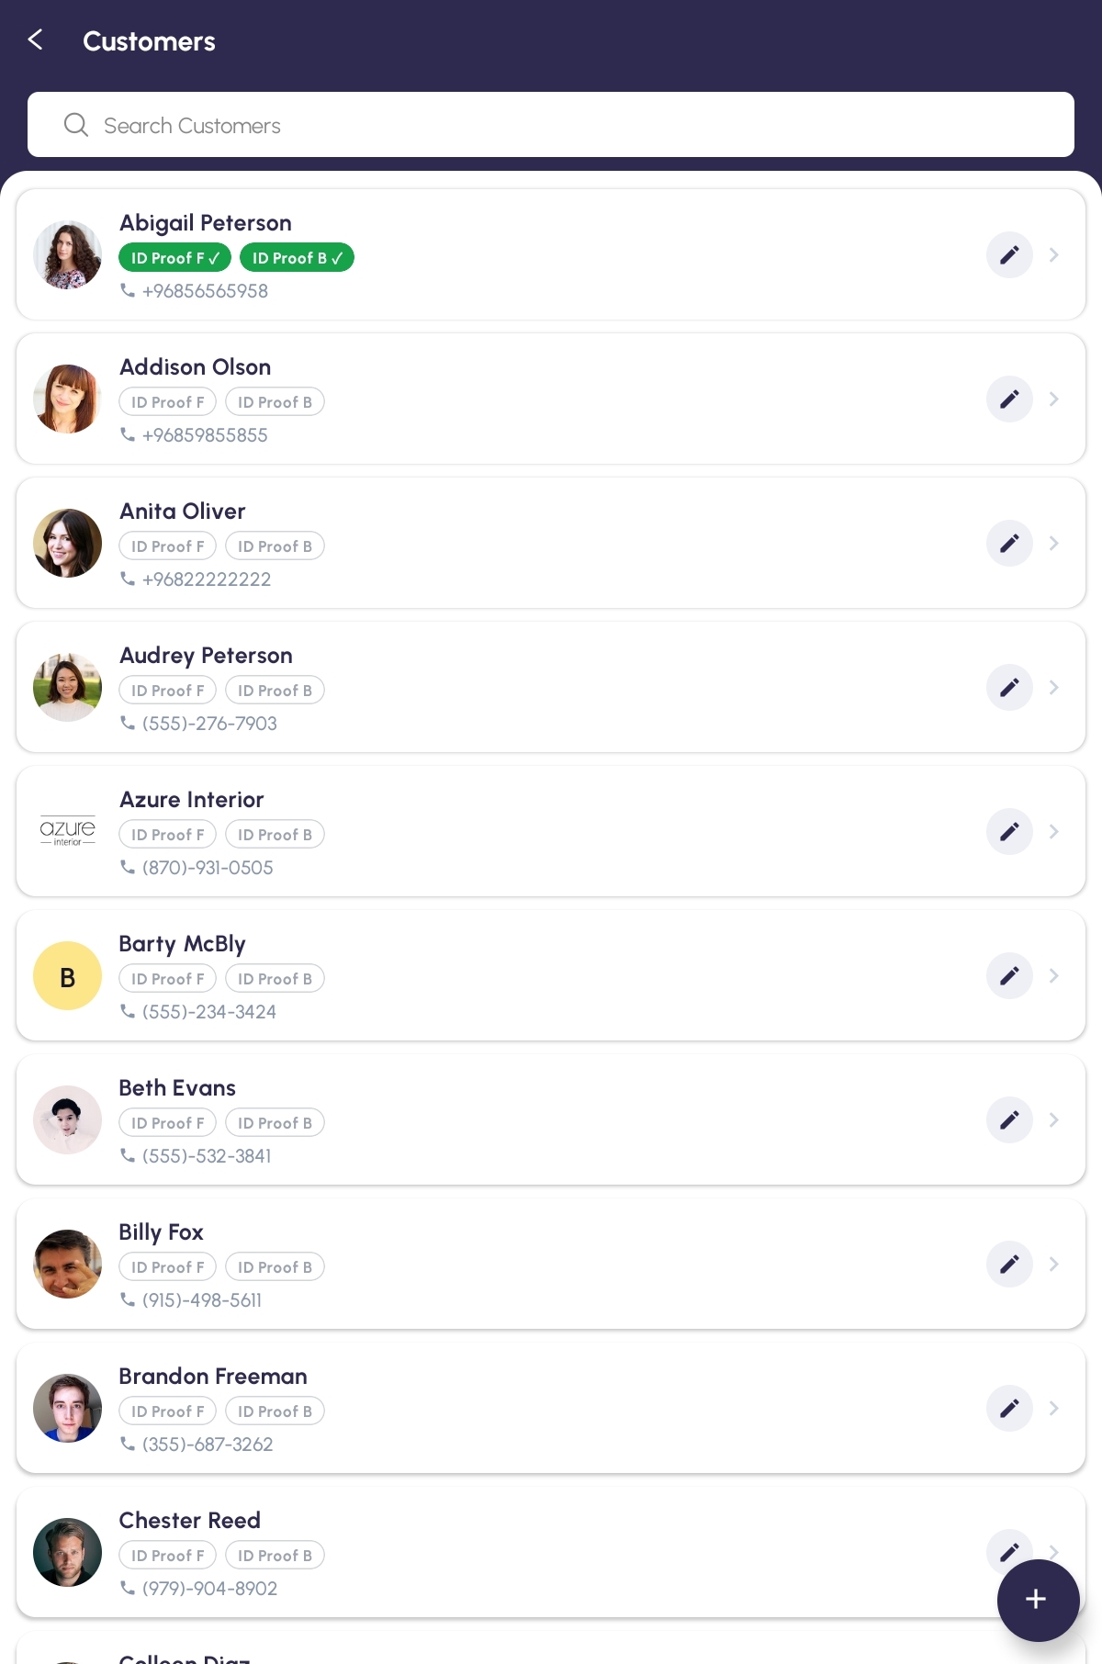
The Customers list with the ID-proof badges

Step 25 Add or Change a Customer
Tap the orange + for New Contact, or the pencil on a row for Edit Contact.
Choose Person or Company at the top, then fill in what you know. Only one field is compulsory.
Field | Do you have to fill it in?
Name * | Yes — the only required field. Leaving it empty gives Name is required
Email | No
Phone | No. The dial code button defaults to +968, and a hint shows how many digits that country expects
Company, Job Position | No — shown for a Person
Street, Street 2, City, ZIP | No — under Address
Tax ID, Website | No — under Other
ID Proof | No — front and back photos

Tap Save. You will see Contact created or Contact updated and be returned to the list.
TIP Nothing else is validated. An email with no `@`, or a phone number that is too short, will save without complaint — so it is worth reading the details back before you tap Save.

[ IMAGE 19 — not captured yet ]
The New Contact form with the mandatory Name field

Step 26 See What a Customer Owes
There is no balance on the customer record itself. What a customer owes shows up in five places instead:
Where | What it tells you
The amber Previous Due card at payment | What they owed before the order you are ringing up
The Previous Due / This Invoice / Total Due lines on the receipt | The whole picture, printed for the customer
The Due pill on the Orders list | What they owed when that order was sold
The CUSTOMER DUE card on the order | The same three figures, on the order itself
The Customer Due box behind either Due | Those figures, plus every unpaid bill as it stands today

Partner Ledger remains the full account, every line, in one place.
TIP The first four are all the sale’s own record and never change. Only the Customer Due box and Partner Ledger move as the customer pays.

PART 8 PRODUCTS AND STOCK

Step 27 Look Through the Products
Tap Products on Home. Search Products filters the grid, and category chips narrow it further. A line under the search box counts what you are looking at, for example Showing 40 of 128.
Each tile shows the picture (or No Image), the stock figure in a green or red badge, the name and the price.
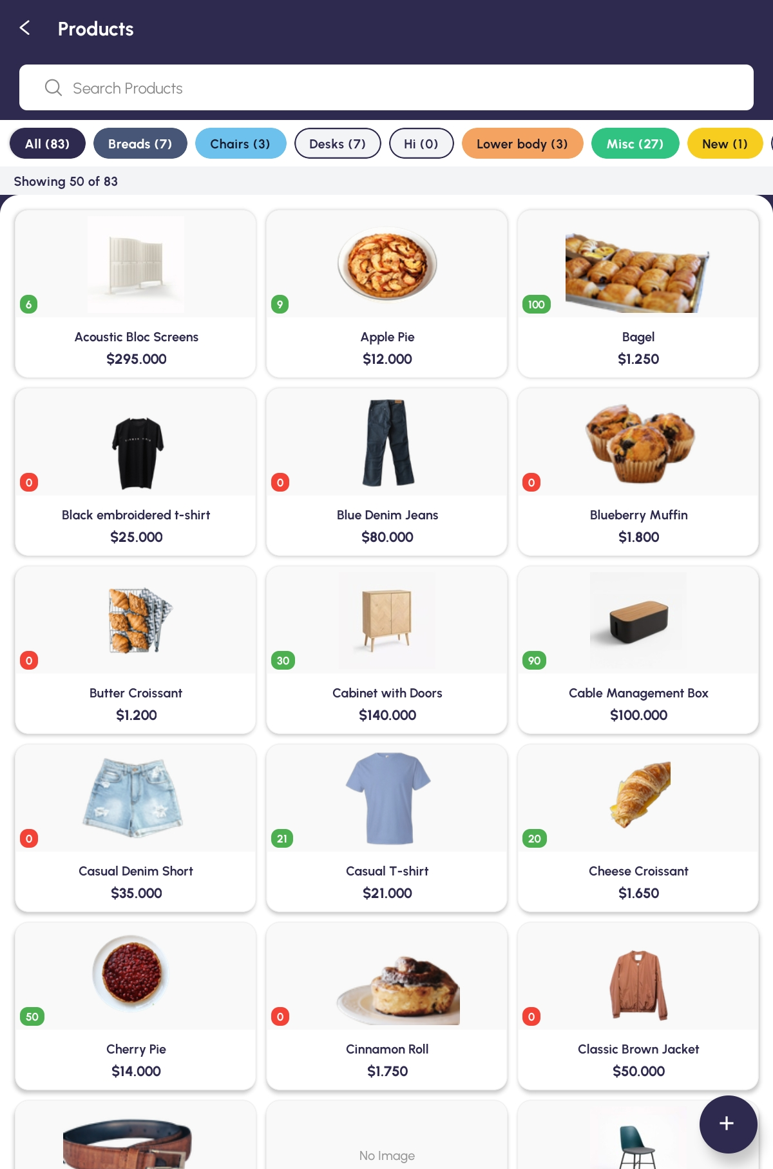
The Products list — the search box, the category chips and the count line

Step 28 Add or Change a Product
Tap the orange + for New Product, or open a product and tap Edit Product.
Field | Do you have to fill it in?
Product Name * | Yes — the only field actually enforced
Category * | Starred, but the app will save without it
Sales Price, Cost | No
Unit of Measure | No
Track Inventory | No — tick it to hold a stock figure for this product
On Hand Quantity | Only when Track Inventory is ticked
Barcode, Internal Reference | No

Tap Save Changes. If nothing has changed the button stays dimmed and will not respond — that is the app telling you there is nothing to save, not a fault.
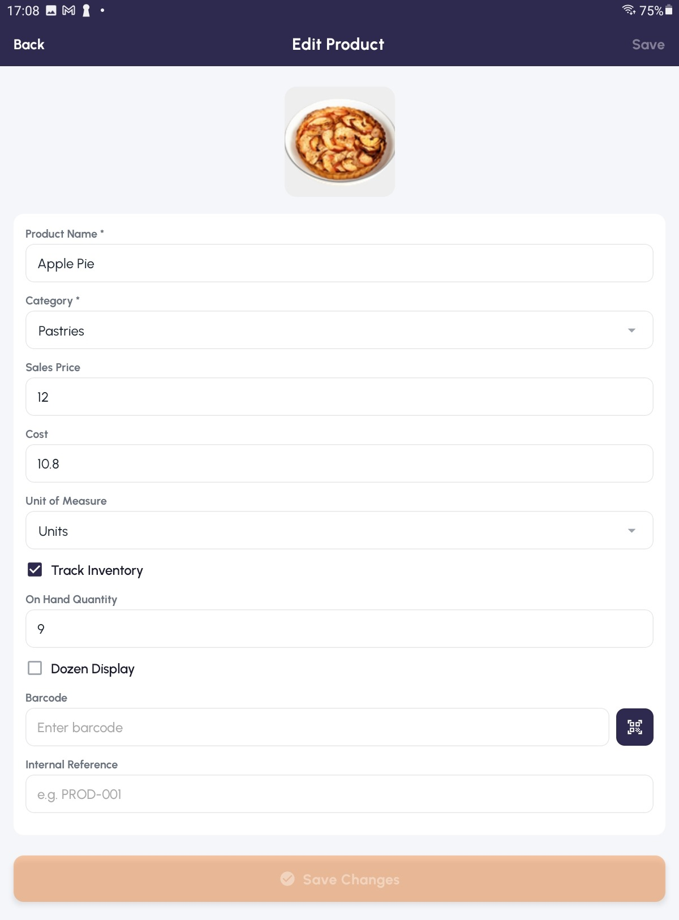
Edit Product — Track Inventory ticked, and Save Changes dimmed because nothing has changed yet

Step 29 Put a Product in Several Categories
Tap the Category * row for Select Category. The rows are tick boxes, so you can choose several and the window stays open while you do. The chosen names come back joined together in the field.
Add Category at the bottom creates a new one — Category Name * and a Colour — and whatever you typed in the search box is used as the starting name.
TIP Categories can be created and renamed here but never deleted, and this is the only place in the app where you can manage them.

[ IMAGE 22 — not captured yet ]
The Select Category picker with several categories ticked

Step 30 Sell in a Different Unit
Tap Unit of Measure, then Add Unit for New Unit of Measure.
Give it a Unit Name *, choose a Reference Unit, and say how many of that unit it Contains. A line underneath does the sum for you as you type — with a pack of twenty referencing Units it reads 1 Pack of 20 = 20 Units.
IMPORTANT Once a product with this unit has been bought or sold, Odoo will not let the ratio change. If a saved change comes back as Some changes did not save, this is usually why.

[ IMAGE 23 — not captured yet ]
The New Unit of Measure window and the line that does the sum

Step 31 Count in Dozens
Tick Dozen Display on a product you are tracking. Two boxes appear — Pieces per Dozen and On Hand (Dozens) — with a running total beneath them in the form = 9 Dozen 7 Pcs.
Typing into On Hand (Dozens) asks you to confirm the change to the piece count before it is written. The product's own screen then carries an On Hand (Dozen + Pcs) row.
[ IMAGE 24 — not captured yet ]
Dozen Display switched on, with the Dozen and Pcs readout

Step 32 Retire a Product You Cannot Delete
Open the product and tap Delete Product, then OK.
A product that has already been sold cannot be deleted. The app opens Can't Delete Product with the reason, and offers ARCHIVE INSTEAD — which hides it without destroying its history. You will see Product archived.
To find it again, tap Show Archived on the Products list; the counter changes to Archived · Showing 3 of 3. Open it and tap Restore Product to bring it back. Show Active returns to the normal list.
[ IMAGE 25 — not captured yet ]
The Can't Delete Product box, offering ARCHIVE INSTEAD

Step 33 Check Stock
Stock on Home lists what you hold, with Search Stock and the filters All, In Stock, Low Stock and Out of Stock. You can export the list as PDF or Excel. Opening a line shows ON HAND, FORECAST, Locations and Last Movement.
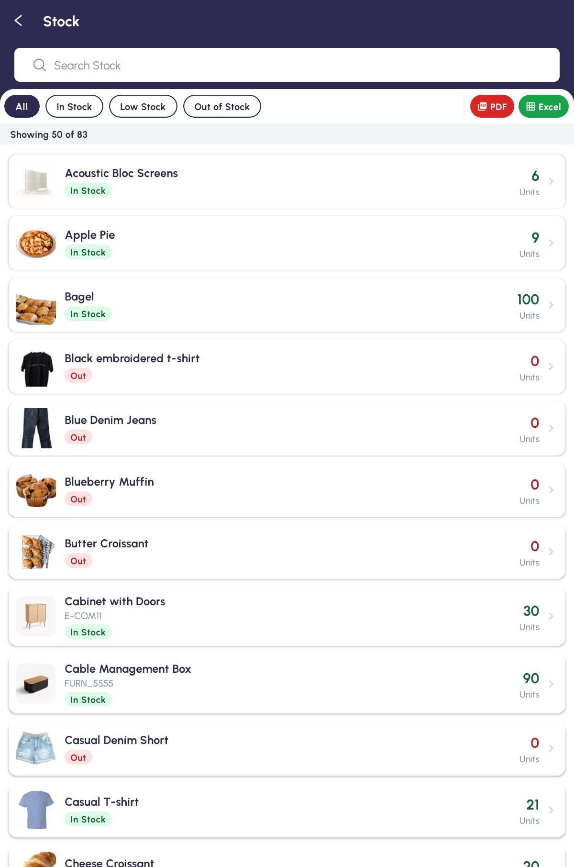
The Stock list with its filter pills

PART 9 BUYING AND RETURNING STOCK

Step 34 Record What You Buy
Tap Easy Purchase on Home, then the New Purchase button.
Fill in Purchase Header — Vendor *, Date *, an optional Vendor Reference, and the Discount Type. Then Payment & Warehouse — Payment Method * and Warehouse *.
Only then can you add goods. Until a vendor and a payment method are both set, the product area is locked and says Select a vendor and a payment method first to start adding products.
Tap Add Line for each product, giving Product *, Quantity * and Unit Price *. Then Save to keep it as a draft, or confirm it outright.
What you tap | What happens
Save | Keeps the purchase as a draft you can come back to
Confirm Order | Commits it — stock and the vendor bill follow automatically
Cancel Purchase | Abandons a draft

TIP There is no goods-receipt screen. Confirming the purchase creates and completes the stock receipt for you; the finished purchase shows it back as a read-only Receipt row under Linked Records.

[ IMAGE 27 — not captured yet ]
The Easy Purchase form — header, payment and warehouse, and the product lines

Step 35 Send Goods Back to a Vendor
Tap Quick Return on Home, then New Return.
Pick the Vendor Bill * you are returning against — Tap to pick a posted vendor bill. The lines load underneath, each showing four figures.
Column | What it tells you
Purchased | How many you bought on that bill
Already Returned | How many have gone back before
Max Returnable | The most you can still send back
Return Qty | How many you are returning now — type this in

Return all at the top of the card fills in the maximum on every line. When the figures are right, tap Confirm Return.
IMPORTANT You cannot return more than you bought. Type too much and the app says Quantity exceeds maximum, explains the limit and snaps the figure back down; while any line is over, Confirm Return stays greyed out.

Once a return has been created its source bill is locked and shows a padlock — you cannot point it at a different bill afterwards.
[ IMAGE 28 — not captured yet ]
Quick Return — Purchased, Already Returned, Max Returnable and Return Qty

PART 10 MONEY

Step 36 Look at Invoices
Invoices on Home lists your customer invoices. Search by invoice # or customer finds one, the tabs All, Posted, Draft and Cancelled narrow the list, and Filters and Group By refine it further.
Opening an invoice shows Total Amount, then Customer, Invoice Date, Due Date, Journal and the rest, the Amounts block ending in Amount Due, a Payment Status badge, and the Invoice Lines.
Two buttons produce a PDF and they are not the same:
Button | What you get
Download PDF | Odoo's own invoice document, as the back office would print it
Print PDF | The same invoice through your shop's receipt design and paper size

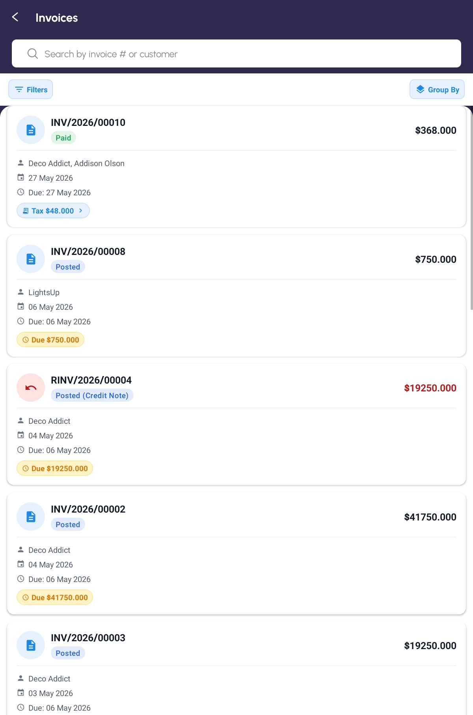
The Invoices list with the Filters and Group By pills

Step 37 Read the Partner Ledger
Partner Ledger shows every posted movement per customer or supplier, in columns from Date through Debit, Credit and Balance. A Total row is pinned at the bottom and sums whatever you are currently looking at.
Filters opens the full set — Posting Status, To Review, Reconciliation, Journal, Accounts, and a Date section offering periods against either Date or Invoice Date. Each filter you pick appears as a chip above the table; tap a chip to remove just that one.
Tapping any row opens the invoice behind it.
[ IMAGE 30 — not captured yet ]
Partner Ledger with the Filters box open and chips above the table

Step 38 Record an Expense, and Check the Day
Expenses on Home records money going out. Sales Report builds a report over a period you choose and is the place to look at a date range — the Orders list has no date filter.
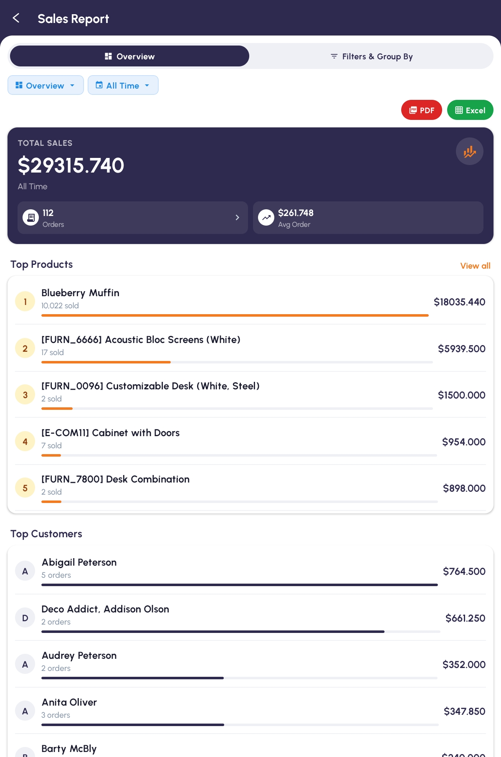
The Sales Report screen

Step 39 Enter Opening Balances from the Paper Records
When you start using the app, your customers may already owe you money from before — written in a ledger book, not in the system. Opening Balance is where you type those old amounts in, once, so they show up against each customer from then on.
Tap Opening Balance on Home, in the Accounting section. At the top, Balance as on shows the date the amounts are counted up to; tap it to change it (it cannot be a future date). Below that, a dark strip shows how many Customers are on the list and their Total. An empty list says No customers yet. Tap “Add” to enter a balance from the paper records.
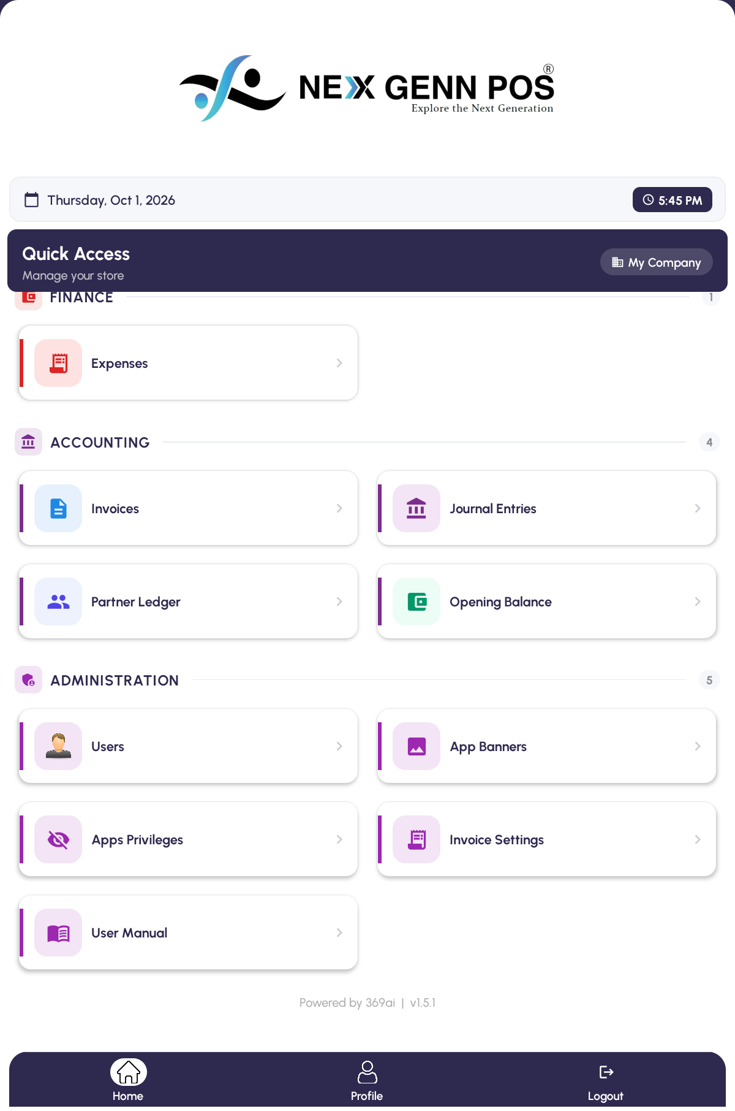
The Opening Balance tile in the Accounting section of Home

Tap the orange Add button. The Add Opening Balance window opens. Under Customer, type a name or a phone number into Type customer name or phone and tap the right person in the list. If they are not in the system yet, tap Create with the typed name beside it — the customer form opens, and when you save it you come straight back with that customer already chosen.
Under Outstanding by age (days) there are five boxes: 0–30, 31–60, 61–90, 91–120 and >120 days. Put each amount in the box for how old it is, in whole numbers. The Total adds them up as you type. Tap Add to put the customer on the list.
IMPORTANT As soon as you type an amount, a yellow note appears: ⚠️ Check every amount twice. Once published, opening balances can't be changed or published again. Each box with an amount in it gets a yellow border. Check them against the paper before you tap Add.

What you see | What it means
Add greyed out | Pick a customer and enter at least one amount first
Already in the list — you are editing that entry. | That customer is on the list already; you are changing their amounts, not adding them twice
No customer found. | Nothing matches what you typed — check the spelling, or create the customer
Search failed — check the connection. | The app could not reach the server to search

Each customer on the list shows their total and a chip for every age that has an amount. The pencil opens the entry again (the button now reads Update); the red bin asks Remove that customer from the list? — tap Remove or Cancel.
The list is kept on this tablet as you go, so you can close the app and come back to it later. Nothing reaches the accounts until you publish.
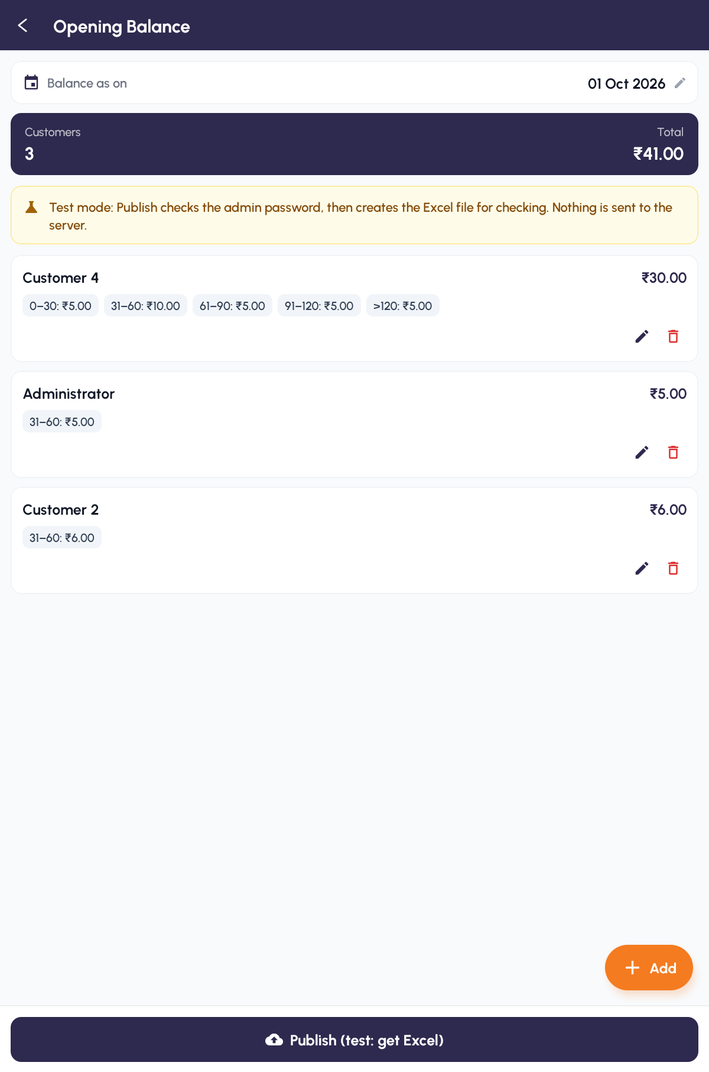
The Opening Balance list — the date, the Customers and Total strip, and one card per customer

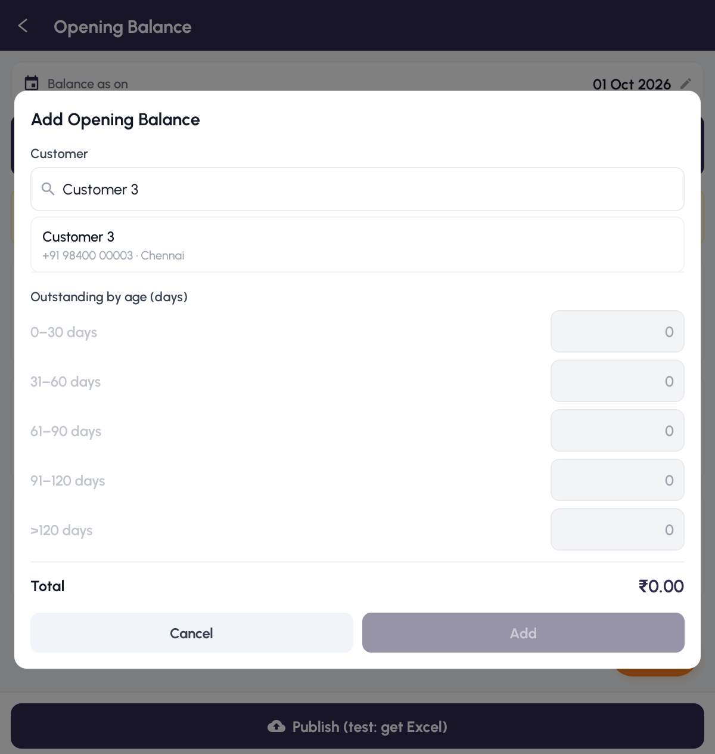
Picking the customer — type a name or phone and tap the match

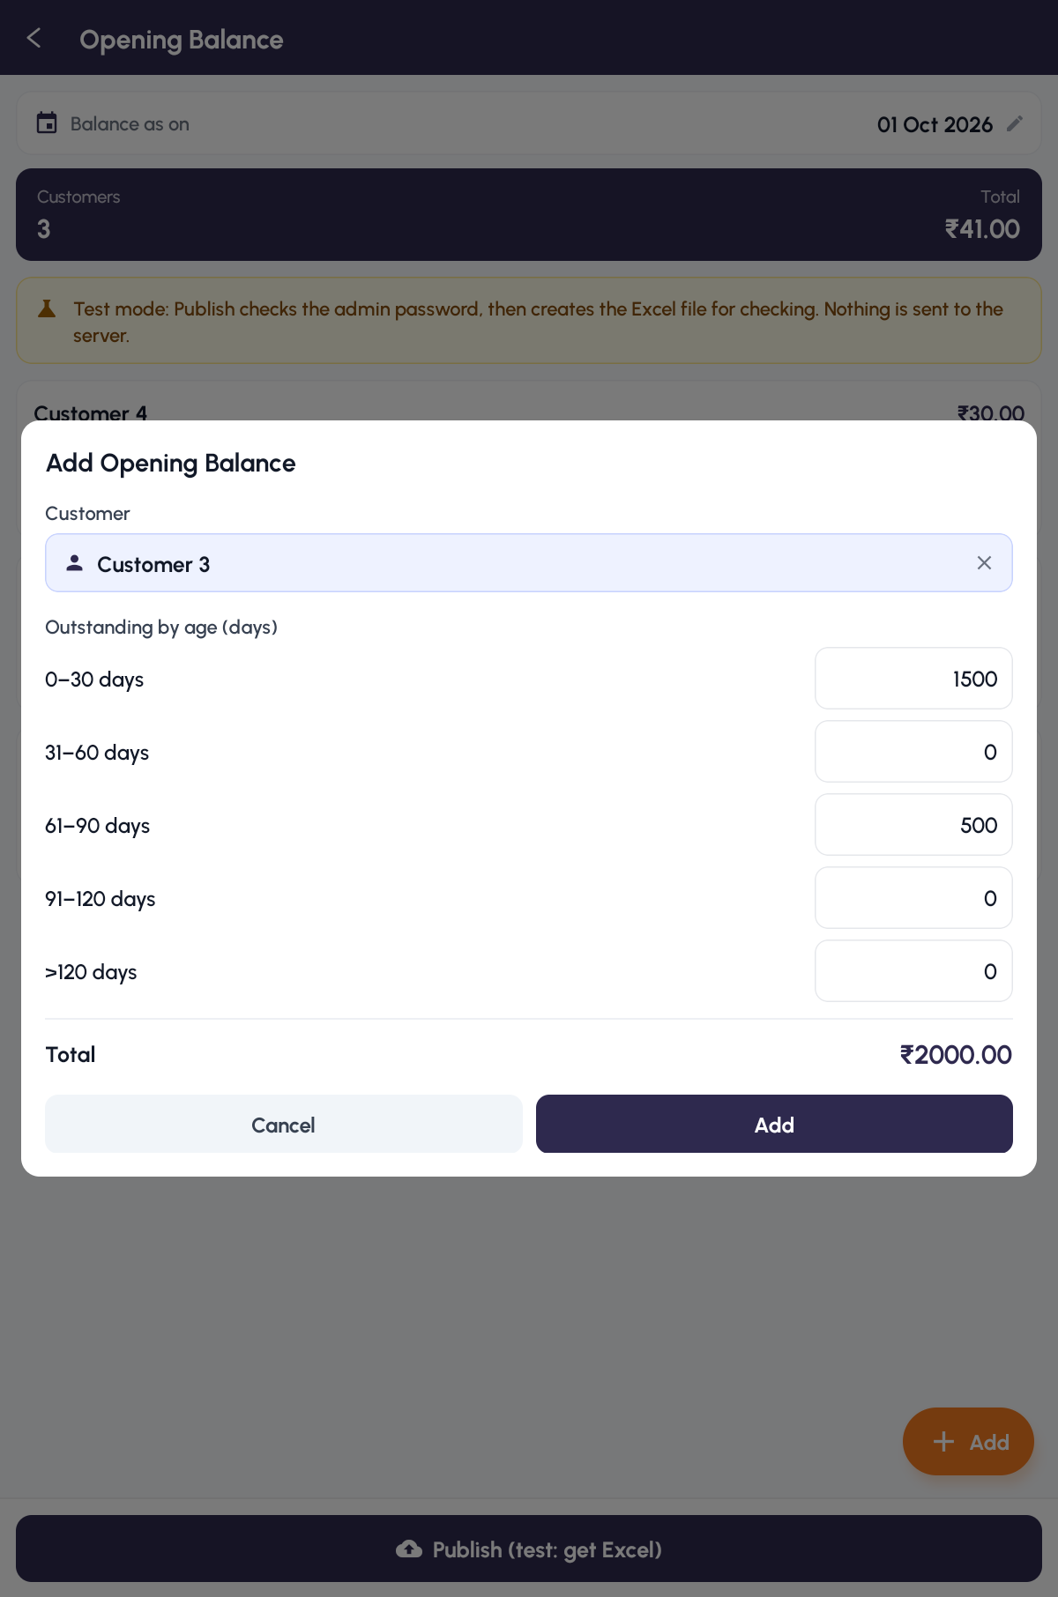
The Add Opening Balance window with amounts in the age boxes and the Total beneath

When every amount has been checked, tap Publish at the bottom. An Admin password window asks for an administrator's password. It tells you how many customer balances will be posted and their total, and warns ⚠️ This can't be undone. Check all amounts — they can't be published again. It signs in as the main administrator; tap Different admin? to type another administrator's login. Type the password and tap Verify.
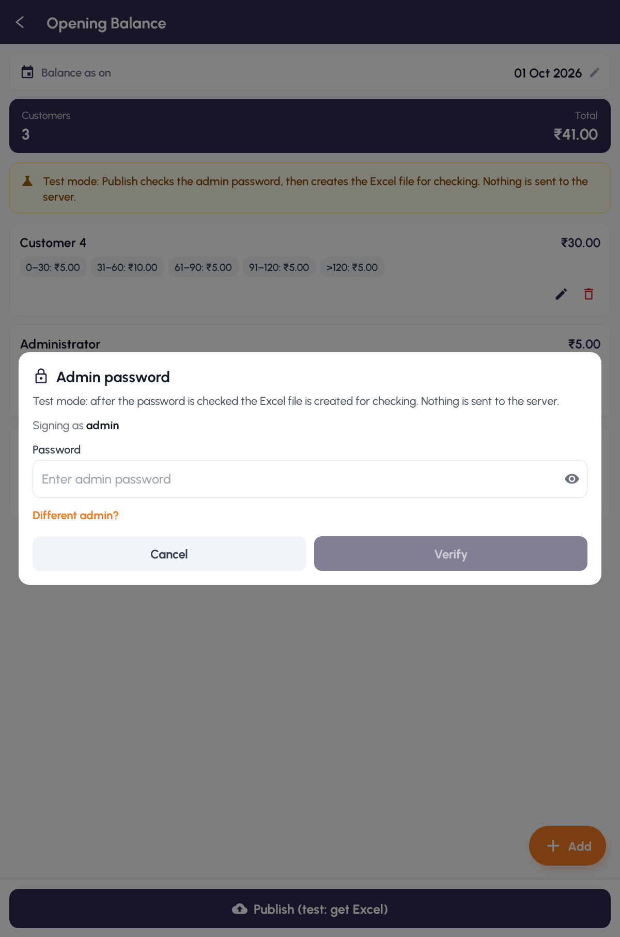
The Admin password window that guards Publish

The app then works through the steps one by one — Checking existing balances…, Preparing opening balance batch…, Generating Excel file…, Uploading…, Verifying customers and amounts…, Importing lines… and Posting journal entry… — with Don't close the app or go back until this finishes. underneath. When it is done you see Opening balances posted with the number of customers and the total. Tap Done; the list is cleared.
If you see | Do this
Already has an opening balance | Some of these customers have one in the system already. Cancel to check, or Post anyway to add another on top
Publish failed | Read the reason, fix it, and tap Retry. Your entries are kept.
No answer from the server | Tap Retry. It checks the server first and only finishes what is missing — it never posts twice
Wrong password. | Try again. After three wrong tries the window locks for a minute
The last publish didn't finish. | The list is locked. Tap Resume publish, or Start over instead (needs the admin password) to cancel the unfinished upload and edit the list again

If the server does not have the Opening Balance feature installed, a blue note says Publishing isn't available yet. and the button reads Publish unavailable. You can still enter and keep balances on the tablet; ask your administrator to install it, then come back and publish.
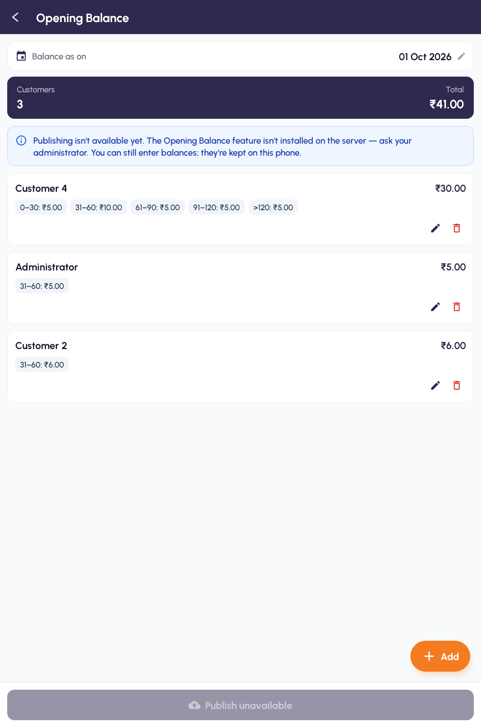
Publish unavailable — the server does not have the Opening Balance feature yet

TIP Do this once, when you first move a customer's old balance into the app. Once a balance has been published it cannot be edited or published again from here.

QUICK REFERENCE

Where Things Live
To do this | Go here
Sell something | POS → open a register → Add Products → Place Order
Find a past sale | Orders
Refund a sale | Orders → open the paid order → Return Products
Look at a period | Sales Report
Add or edit a customer | Customers
See what a customer owes | Partner Ledger, the Due pill on Orders, or the Previous Due card at payment
Add or edit a product | Products
Bring an archived product back | Products → Show Archived → Restore Product
Check what you hold | Stock
Record a purchase | Easy Purchase
Send goods back to a vendor | Quick Return
Enter old balances from paper | Opening Balance → Add → Publish
Work in another company | Profile → Company
Read the manuals | Profile → User Manual

Things to Remember
▪ Every sale needs a customer. Attach them on the Register screen and save yourself the detour.
▪ Location must be available. With location switched off or refused, payment simply will not complete.
▪ There is no offline mode. Lose the network and selling stops until it comes back.
▪ The basket does not survive a restart. Finish or discard an order before closing the app.
▪ Apply discounts on the Register screen, not at payment.
▪ Returns bring back every line. Delete what you are not refunding rather than editing quantities.
▪ An order can only be returned once, and only while the register's session is open.
▪ Count the drawer honestly at opening. Everything at closing is measured against that number.
▪ Clear your drafts before closing the register, or they will have to be discarded.
▪ Done ends the sale. Print or download before you tap it.
▪ A missing tile is usually a privilege, not a fault. Ask your administrator.
▪ Opening balances go in once. Check every amount twice — after publishing they cannot be changed or published again.
▪ The company you pick on Profile sticks. Registers, products and customers follow it until you switch back.
Open the register, sell, take the money, hand over the receipt. Everything else in this guide hangs off those four things.

— End of Guide —
369ai.Biz | Van Sale Everyday Guide

3 6 9 a i . B i z

Van Sale

Administrator Guide
Connect the tablets, decide who sees what, and design the receipt your shop prints.

About This Guide
This is the second half of the document, for whoever owns the system: connecting tablets to your server, deciding which parts of the app each person can see, and designing the receipt and invoice your shop hands out.
It assumes you have an Odoo administrator login, and that somebody has installed the custom modules listed in PART 6 — without those, several screens in this guide either do not appear or refuse to work.
IMPORTANT Most of this only works if your Odoo user's role is Administrator. The five Administration tiles check for it and refuse with Only administrators can access this feature otherwise.

The Administrator's Job at a Glance
▪ Once per tablet — connect it to the server and register it against a QR code.
▪ Once per person — create their Odoo login, then hide whatever they should not see.
▪ Once per company — choose the invoice template, set up paper sizes, and design the layout.
▪ Whenever you like — change the Home banners and publish the manuals.

PART 1 CONNECTING A DEVICE

Step 1 Set the Server and Database
A tablet that has never been configured opens on Device Setup rather than the sign-in screen.
Work down the three steps. Server URL takes the address of your Odoo server — Enter the URL (http:// or https://). Leave the box and the app fetches the databases from it, which you then choose under Database. Finally give Admin Credentials — a Username and Password with administrator rights.
Tap Configure Device.
If you see this | What is wrong
Could not fetch databases — check the URL and try again | The address is wrong or unreachable
Connection timed out — is the server running? | The server is not answering
Cannot reach server — check the IP address and port | Wrong host or port
Server found but database listing is disabled or module not installed | Odoo is not exposing its database list
Invalid username or password | The administrator credentials are wrong
Device Module Not Installed | `device_login_config` is missing on the server

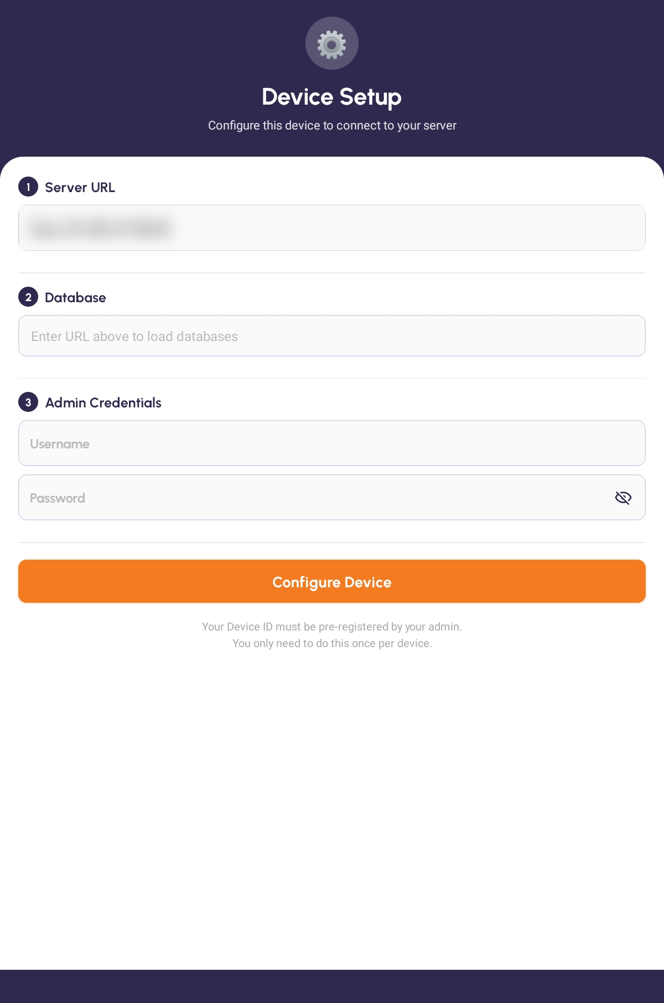
Device Setup — Server URL, Database and Admin Credentials

Step 2 Register the Tablet by QR
After the details are accepted the app asks Ready to scan?. Tap Scan QR and point the camera at the registration code generated in Odoo for this device. The status line reads Point camera at the QR code on the admin screen, then QR detected — registering device…, then Device registered! Redirecting…, and the tablet lands on the sign-in screen.
If you see this | What it means
Invalid QR | That code is not a device registration code
Wrong Database | The code was generated for a different database than the one you chose
QR Already Used | Another tablet has claimed this code
Device Blocked | The device is blocked in Odoo
Cannot Reach Server | The server did not answer during registration

IMPORTANT The QR code is tied to one database. If you picked the wrong database on the previous screen, either go back and change it or ask for a new code generated from the right one.

[ IMAGE 33 — not captured yet ]
The QR scanner registering a device

Step 3 Get Back to Device Setup Later
Once a tablet is registered there is no menu item that returns you to Device Setup — the screen is deliberately hard to reach so a cashier cannot wander into it.
The way back is a hidden gesture: on the sign-in screen, tap the words Welcome back seven times. A gear appears in the top-right corner; tapping it returns you to Device Setup, where you can repoint the tablet at a different server or database without wiping the app.

Step 4 Know When a Device Gets Thrown Out
The app re-checks its registration every few seconds and whenever it comes back to the foreground. If you block or deactivate the device in Odoo while somebody is using it, they are signed out on the spot and returned to Device Setup with either Device blocked (Serial …). Contact your administrator. or This device's session ended. Please reconnect by scanning the QR.
This is how you retire a lost or stolen tablet: block it in Odoo and it locks itself within seconds.

PART 2 PEOPLE AND WHAT THEY SEE

Step 5 Create the People
Users on Home lists everyone, split into ADMINISTRATORS and USERS, with Search by name or login. New User creates one; tapping a row edits it.
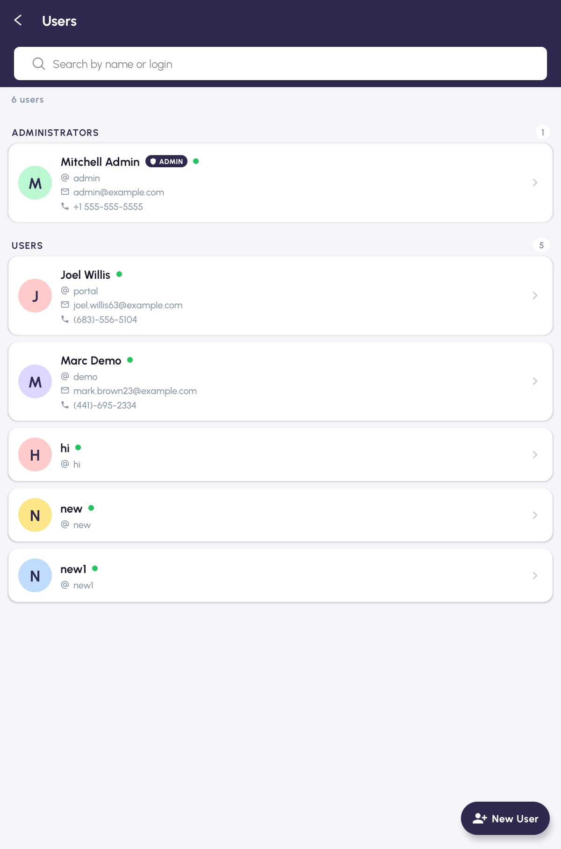
The Users list, split into administrators and users

Step 6 Hide What People Should Not See
Apps Privileges is where you decide what each person's app looks like. Choose somebody under Pick a user — Choose whose visibility you want to manage — and you get the whole catalogue of features, grouped into headings such as Home Tiles and Accounting Invoices.
Each row is a switch between Visible and Hidden. Hide All and Reset All do the obvious thing to everything at once. Tap Save when you are done.
Two things about this screen matter more than anything else on it.
IMPORTANT This is a hide list, not a permission list. Everything is visible by default; you are switching things off. And a hidden feature does not grey out — it disappears entirely, taking its section heading with it if nothing else is left in that section. Tell your staff, or you will field bug reports about missing buttons.

IMPORTANT Hiding has no effect at all on an Odoo administrator. The screen warns you: This user is an administrator — privilege rules will NOT apply. To make privileges bite, open Odoo, go to Settings → Users & Companies, and change that person's role from Administrator to User.

Changes are not instant either. The banner on the screen says it plainly: Visibility changes apply on the user's next login. The person has to sign out and back in.
What you can hide | Examples
Home tiles | POS Tile, Products Tile, Invoices Tile, Partner Ledger Tile
Actions | Add, Edit, Change Password, Resume Draft, Export PDF
POS controls | Open Register, Close Register, POS - Edit Line Price
Invoice actions | Invoice - Pay, Invoice - Confirm & Post, Invoice - Cancel
Journals | Journals - Sales, Journals - Purchases, Journals - Bank & Cash
Whose data they see | See All Users' Data

See All Users' Data deserves singling out. Switch it off for somebody and they stop seeing everyone else's records in Orders, Invoices, Journal Entries and Partner Ledger — they see only what they created themselves. It is the closest thing the app has to a data-level role.
TIP Hiding all four journal types leaves the Journal Entries tile in place but its Select Journal window opens empty. Hide the Journal Entries Tile itself instead.

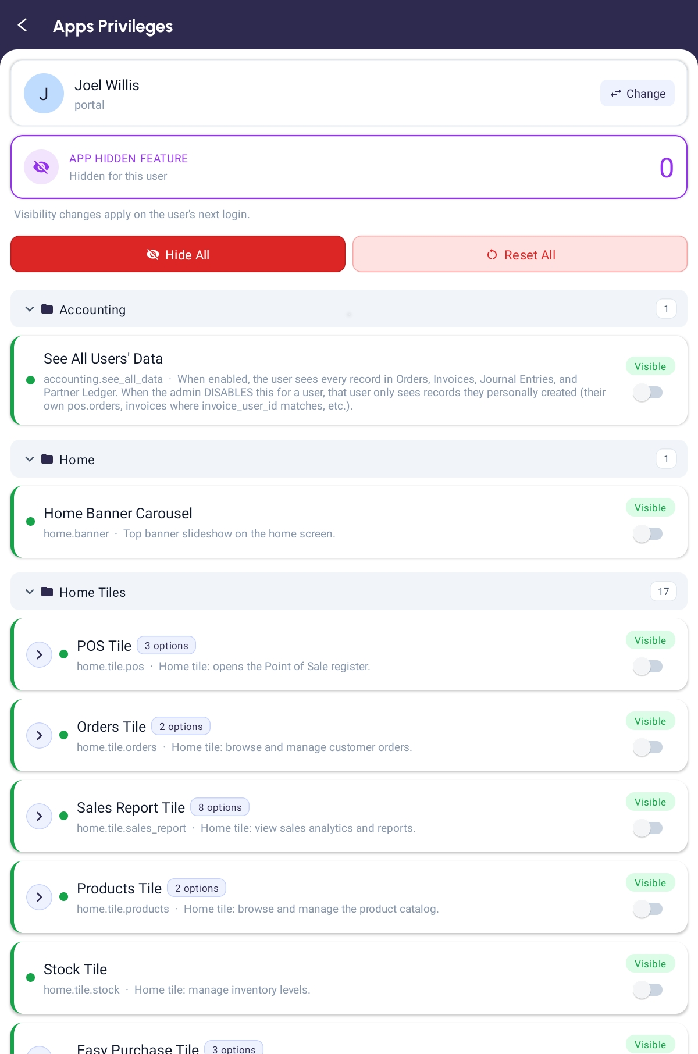
Apps Privileges — a user chosen, and features switched between Visible and Hidden

PART 3 INVOICE SETTINGS

Step 7 Open the Settings for a Company
Invoice Settings on Home lists one entry per company. Open one and you reach a hub of three cards.
Card | What it covers
General Settings | Invoice template, branding, logo, toggles and the default receipt size
Receipt Paper Sizes | Add, edit and reorder the paper sizes your shop prints on
Invoice Layouts | Preview each size's custom block layout

IMPORTANT All of this is provided by the `pos_dynamic_invoice` module. Without it the list refuses to open and tells you Dynamic Invoice module is not installed on the server.

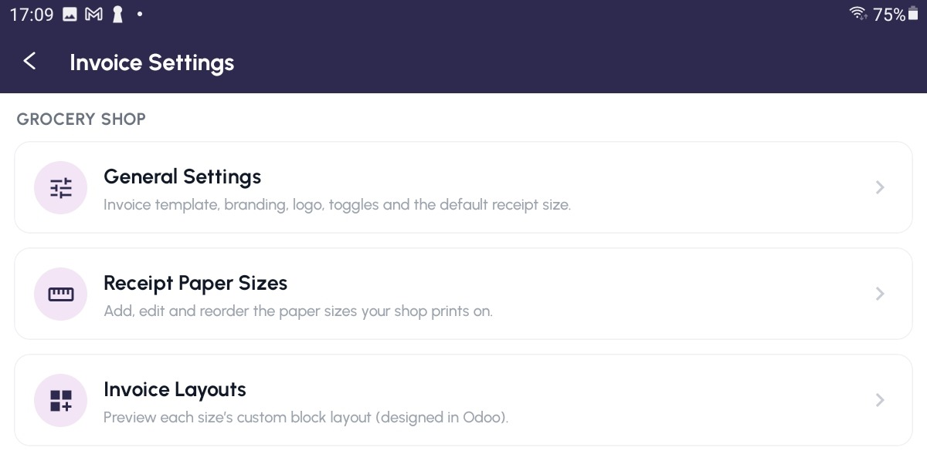
The Invoice Settings hub — General Settings, Receipt Paper Sizes and Invoice Layouts

Step 8 Choose the Invoice Template
General Settings opens with Invoice Template — Choose which receipt the app shows. There are four.
Template | What it gives you
Standard | The app's built-in receipt — nothing to configure
Dynamic | Branded receipt with logo, VAT number and custom header and footer
Cash Memo | Bilingual English/Arabic invoice, sized for A4 or A5
Custom Layout (editable) | A drag-and-drop block layout, designed per paper size

Preview renders the chosen template against your most recent order. It is not offered for Standard, which has nothing to preview.
TIP Whichever template you pick, the block the cashier sees on the receipt screen is always the plain built-in layout. Your design shows up in Preview, Download and Print. That is expected — do not chase it as a fault.

[ IMAGE 37 — not captured yet ]
General Settings — the Invoice Template choices

Step 9 Fill In the Branding
For Dynamic, the Branding card carries Address, Phone, Email and VAT / GST Number, each falling back to the company's own details when left blank. Header & Footer sets the Header Title and Footer Text. Show / Hide on Receipt switches the Tax row, Customer signature, Cashier signature and Footer on and off. Logo uploads the image and decides whether it appears on the invoice, the receipt, or both.
For Cash Memo, the Cash Memo Header card drives the bilingual header — These appear on the bilingual invoice header. Leave blank to hide a line.
Field | Its switch
Company Name (English) and Company Name (Arabic) | Show Company Name
C.R. Number | Show C.R. Number
GSM / Mobile | Show GSM / Mobile
— | Show Sultanate of Oman
VAT Number | Show VAT Number

Tap Save Settings when you are done.
[ IMAGE 38 — not captured yet ]
The Cash Memo Header card with its show and hide switches

Step 10 Decide Whether Cashiers Get Asked About Size
Use Default Receipt Size controls one thing: whether the cashier sees the size window on every print. The screen explains it exactly — on, and Preview, Download and Print use the size below without asking each time; off, and the app asks for a size each time.
Switch it on and pick a Default Size.
TIP Turning this on is the single biggest speed-up you can give a busy till. Leave it off only if the shop genuinely prints on more than one paper size during the day.

PART 4 PAPER SIZES AND LAYOUTS

Step 11 Set Up the Paper Sizes
Receipt Paper Sizes lists the widths your shop prints on. The screen tells you how it works: enter the size in inches and the width in millimetres fills in automatically, and a height of 0 means one continuous page.
Tap New for New Paper Size, give it a Size (inch), adjust Width (mm) — auto from inch if you must, and set Height (mm) — 0 = auto. The chevrons on the left reorder the list — that order is what cashiers see in their size window.
IMPORTANT One entry per company is marked Custom and shows a padlock instead of the edit and delete buttons. It cannot be renamed, edited or deleted — only moved up and down. It is what backs the Custom width (mm) option on the cashier's size window.

A size that is in use as a default cannot be removed; the app says Delete failed (it may be in use as a default).
[ IMAGE 39 — not captured yet ]
Receipt Paper Sizes, with the locked Custom entry

Step 12 Design a Layout
Invoice Layouts lists one layout per paper size, each tagged Grid or Flow. Open one to see its blocks and Open Visual Editor.
IMPORTANT Layouts only reach the printed receipt when Invoice Template is set to Custom Layout (editable) in General Settings. Designing one and leaving the template on Standard changes nothing.

[ IMAGE 40 — not captured yet ]
The Invoice Layouts list, with each size tagged Grid or Flow

Step 13 Use the Visual Editor
The editor is a landscape screen in three panels: Design on the left, Options in the middle and Live Preview on the right. Tap a block in Design and its settings appear in Options — Tap a section to edit it. until you do.
The toolbar carries Save, Undo, Redo, a Grid/List switch, Add and Reset.
Every block has Visible, Align and Direction. In grid mode you position it with X (cm), Y (cm), Width (cm) and Height (cm); in list mode you only set Width %. Text blocks add Label (English) and Label (Arabic); the barcode block asks what it should encode.
The blocks available are the parts of a receipt: Logo, Company Name (English), Company Name (Arabic), Company Header, Title, Order Fields (No / Date / Customer), Items Table, Totals, Payments, Signatures, Footer, Barcode, QR Code and Custom Text.
IMPORTANT Two blocks are shared. The editor warns you with Company-wide — shared by every layout. and Company Header rows — shared by every layout. Editing them in the A4 layout changes them in the 3-inch layout too.

TIP Your edits are written as you make them — there is no save-or-lose-it moment. The Save button refreshes the preview and confirms with Saved. In grid mode the banner reminds you that Grid = fixed positions; use List for print-exact.

[ IMAGE 41 — not captured yet ]
The Visual Editor in landscape — Design, Options and Live Preview

PART 5 BANNERS AND THE MANUAL

Step 14 Change the Home Banners
App Banners manages the carousel across the top of everybody's Home screen. Each banner shows as Active or Inactive.
New Banner opens a form with a Name, an Active switch, and Pick from gallery for the image. Delete banner asks Delete banner? and warns that it permanently removes the banner from the carousel.
[ IMAGE 42 — not captured yet ]
The App Banners list

Step 15 Publish the Manuals
User Manual holds the guides your staff can read on the tablet. Tap Add for Add Document, give it a Title, tap Choose PDF, and save. Tapping any document offers View (Open it in your PDF app) or Download (Save a copy to your device).
If the screen says The manual feature is not set up on this server yet. the `app_user_manual` module is missing.
[ IMAGE 43 — not captured yet ]
The User Manual screen with its document list

Step 16 Decide Whether Staff See the Manual
On Profile, under HELP, administrators get a second row: Show to users. Switched on it reads Users can see the manual; switched off, Hidden for users (you always see it).
IMPORTANT This switch is stored on the tablet, not on the server and not against a person. Turning it off on one tablet hides the manual for everybody who uses that tablet, and leaves every other tablet untouched. Administrators always see the manual whatever the switch says.

PART 6 WHAT IS SET UP IN ODOO

Step 17 Install the Modules
The app leans on twelve custom Odoo modules. Some are optional; two of them the app cannot start without.
Module | What it turns on in the app
`device_login_config` | Device Setup and QR registration. Without it no tablet can be configured at all
`user_privilege_manager_apps` | The whole Apps Privileges system and the feature catalogue
`pos_dynamic_invoice` | Invoice Settings, receipt paper sizes and invoice layouts
`app_banner` | The Home banner carousel and the App Banners screen
`app_user_manual` | The User Manual screen and the HELP card on Profile
`easy_purchase_apps` | The Easy Purchase tile and its screens
`quick_purchase_return_apps` | The Quick Return tile
`pos_order_location` | Recording where each sale happened, and the receipt's location line
`pos_total_discount` | The whole-order discount button in POS
`product_dozen_display` | The Dozen Display fields and the Dozen + Pcs readout
`hr_expense_payment_method` | The payment-method field on Expenses
`opening_balance_customer_supplier` | Publishing on the Opening Balance screen. Without it the screen still takes entries but shows Publish unavailable

Step 18 Do the Things the App Cannot Do for You
Some setup has no in-app equivalent at all.
In Odoo you must | Or else
Pre-register each device and generate its QR code | The tablet cannot be configured
Expose the database list | Device Setup cannot fetch the databases
Load the feature catalogue into Privilege Manager | Apps Privileges shows No features defined yet
Change a person's role from Administrator to User | Their privilege switches are silently ignored
Create an invoice settings record per company | Invoice Settings has nothing to open
Set up POS payment methods on each register | Payment fails — the register has no method configured
Upload the manual PDFs | The User Manual screen is empty

TIP When a cashier reports that something has vanished, work down three things in order: is the tile hidden for their login, is their Odoo role still Administrator (which ignores privileges entirely), and have they signed out and back in since you changed anything.

QUICK REFERENCE

Where Things Live
To do this | Go here
Connect a new tablet | Device Setup — first run, or seven taps on Welcome back
Retire a lost tablet | Block the device in Odoo; it locks itself within seconds
Create a login | Users → New User
Hide something from somebody | Apps Privileges
Limit somebody to their own records | Apps Privileges → See All Users' Data → off
Choose the receipt design | Invoice Settings → General Settings → Invoice Template
Stop cashiers being asked about paper size | General Settings → Use Default Receipt Size
Add a paper size | Invoice Settings → Receipt Paper Sizes → New
Design a receipt | Invoice Layouts → Open Visual Editor
Change the Home carousel | App Banners
Publish a guide | User Manual → Add

Things to Remember
▪ Privileges hide, they do not grant. Everything is visible until you switch it off.
▪ Privileges do not apply to administrators. Demote the person to User in Odoo first.
▪ Changes take effect at next login, not immediately.
▪ A hidden tile disappears silently, along with its section if nothing is left.
▪ The QR code is tied to one database. A code from the wrong database will be refused.
▪ Blocking a device in Odoo throws its user out within seconds. That is your remote wipe.
▪ The locked Custom paper size cannot be edited or deleted, only reordered.
▪ Layouts only print when the template is Custom Layout (editable).
▪ The company header blocks are shared by every layout. Editing one edits all.
▪ Show to users lives on the tablet, not on the person or the server.
▪ Missing module, missing screen. Every "not installed" message means exactly what it says.
Connect the tablet, decide what each person sees, design the receipt once. After that the shop runs itself.

— End of Guide —
369ai.Biz | Van Sale Administrator Guide

