KRA / KPI — User Guide
Start your workday, work your tasks on the Action Board, and end your day.

About This Guide
The KRA / KPI app is where you pick up your work, record the time you spend on it, and hand it back when it is done. Everything you do sits on one screen — the KPI Action Board.
There is one rule that explains almost everything in this app: you must start your workday before you can touch a task. Until you tap Start Workday, the app is read-only. Once you tap End Workday, it is read-only again until tomorrow. Everything in between is your working day, and the app measures it for you.
This guide walks you through everything you do, in the order you will do it.

Your Day at a Glance
- Open the app and log in with your mobile number and password
- Tap Start Workday — nothing else works until you do
- Open the KPI Action Board and find your task
- Tap Start on the task you are working on
- Tap Pause for breaks, lunch and meetings
- Tap Complete when the task is finished
- Tap End Workday and send your day summary
IMPORTANT The app measures your day from the moment you tap Start Workday to the moment you tap End Workday. If you forget to start, your day is not recorded — and you will not be able to work on anything.

PART 1 GETTING INTO THE APP

Step 1 Open the App
On your phone, open the KRA KPI app. You will see a short animation, then a welcome card. Tap Tap to Enter Login Page.

Step 2 Enter Your Mobile Number
The sign-in screen greets you with Welcome back. Your country dial code is already filled in — type the rest of your mobile number and tap Continue.
Use the same number your admin registered you with. If you see “This number is not registered. Please contact your admin to register this number,” your number has not been added yet — ask your admin.
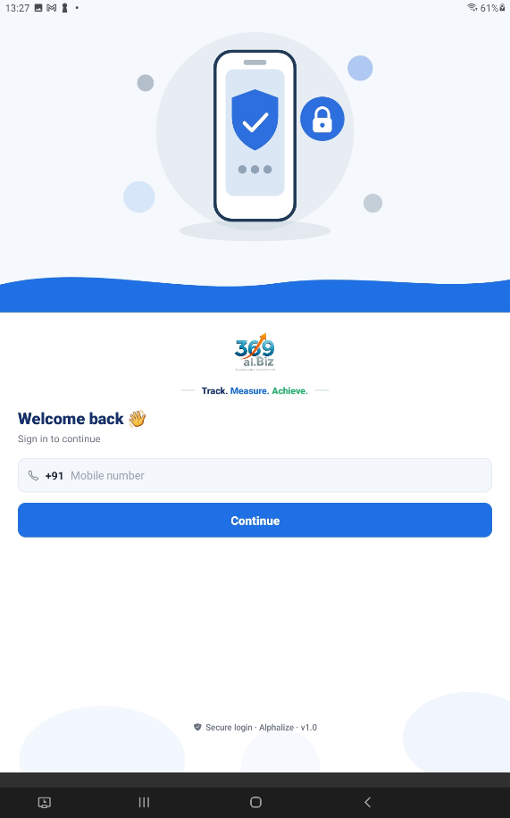
Sign-in screen — mobile number field with the dial code and the Continue button

Step 3 Enter Your Password
Type your password and tap Log In.
The first time you ever log in, your password is 1111. The app will show a red warning telling you so, and asking you to change it. Do that straight away — tap Forgot password? and follow Step 4.
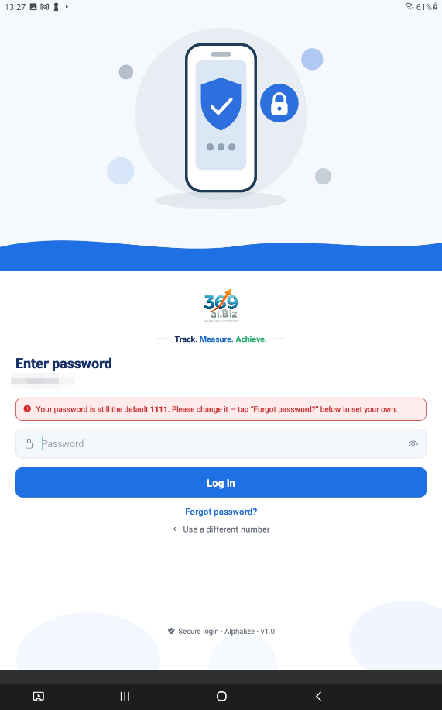
Password screen showing the red “your password is still the default 1111” warning

Step 4 Set Your Own Password
Tap Forgot password?. A 4-digit code is sent to you on WhatsApp. Type the code, type your new password twice, then tap Verify & Set Password.
If the code does not arrive, tap Resend code — there is a short wait before you can ask again, shown as “Resend in 8s”.
TIP You can change your password at any time later from the Profile tab, using the same WhatsApp code. You do not need your admin.

Step 5 Find Your Way Around Home
You land on the Home screen. From the top down:
- The ☰ menu button on the left opens the full menu.
- The bell on the right opens your notifications. A number on the bell means you have unread ones.
- Hello, <your name> — and under it, Your Tasks: a row of counters showing how many tasks you have In Progress, On Hold, Pending Review and Completed. Tap any counter to jump straight to those tasks.
- Quick Actions — the tiles you use most, grouped under KRA / KPI, Reports and Settings.
- At the very bottom: Home, Profile and Logout.
As a User you have four tiles: KPI Action Board, My Workday, My Snapshots and User Manual.
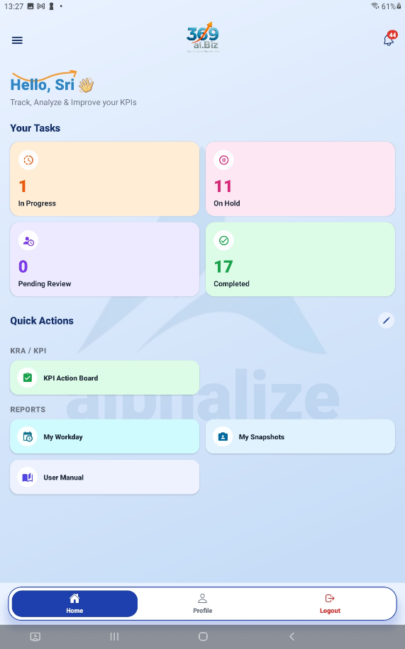
Home screen — greeting, Your Tasks counters, and the Quick Actions tiles

TIP You can choose which tiles appear on Home, and drag the menu items into the order you like. Use Edit Quick Actions on the Home grid, or the pencil in the side menu. The menu always lists every tile you are allowed to see, so hiding one from Home never loses it.

PART 2 STARTING YOUR WORKDAY

Step 6 Why Everything Looks Locked
Before you start your day, a red bar sits at the top of Home:
“Read-only — everything except Profile. Start your workday to work on tasks.”
This is not a fault. You can look at anything, but you cannot start, pause or complete a task until your day is running. The action buttons on your task cards are hidden entirely while you are in read-only.

Step 7 Tap Start Workday
Tap Start Workday. The red bar disappears, your task buttons appear, and the app begins measuring your day.
The button changes as your day goes on:
Button says | What it means
Start Workday | Your day has not begun. Tap it to begin.
End Workday | Your day is running. Tap it when you are finished for the day.
Workday ended for today | Greyed out. You have already ended today. You get one start and one end per day.

Step 8 Read the Live Strip
Once your day is running, a LIVE strip appears at the top of the Action Board. It tells you, second by second, what the app thinks you are doing:
What you see | What it means
Working: “task name” with a running clock | This task is active and its time is counting up.
Multi-tasking 3 tasks | You have more than one task running at once. Time counts on all of them.
Pause all (3) | One tap to pause every running task — useful when you step away.
A break pill (for example Break or Lunch) | You are on a recorded break. No task time is counting.
Presence 04:12:30 · Productive 03:20:05 | Presence is your time at work — the clock since you started your day, minus any time you paused it. Productive is the part of that you spent on tasks.

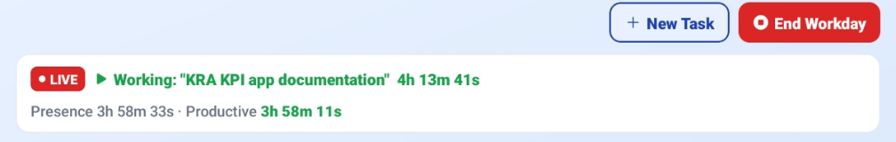
The LIVE strip on the Action Board — running task, timer, Presence and Productive

PART 3 WORKING YOUR TASKS

Step 9 Open the KPI Action Board
From Home, tap KPI Action Board. Your tasks are grouped into columns called lanes. Every task sits in exactly one lane, and a task moves between lanes on its own as you work on it.
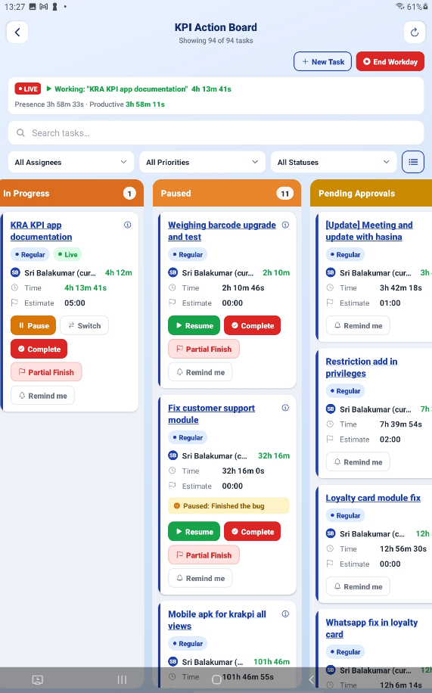
KPI Action Board — the lanes with task cards, and the status filter at the top

The Ten Lanes
Lane | What it means for you
🕔 Today | What you have worked on today, most time first. It is indigo because it is not a stage work moves through — it is a shortcut for finding a task again. A task you touched today appears here as well as in its own status lane, so seeing the same card twice is correct, not a fault. The lane empties itself at midnight.
Pending Review | A task you created yourself that an admin has not yet accepted. You can still work on it.
Regular | Not started yet, normal priority.
Important | Not started yet, marked important.
Urgent | Not started yet, marked urgent. Do these first.
In Progress | Running right now. Time is counting.
Paused | You stopped the clock. Tap Resume to pick it back up.
Pending Approvals | You finished it and an admin is checking it. Nothing for you to do unless it comes back.
Awaiting Client | The admin approved it and the client is signing off. Nothing for you to do.
Completed | Finished and signed off. Done.
Use the filter at the top of the board to show one lane at a time — choose All Statuses to see everything again.

Step 10 Start a Task
Find your task card and tap Start. The card moves to In Progress and its clock begins. Tap the card itself at any time to open KPI Details and read the full description, estimate and history.
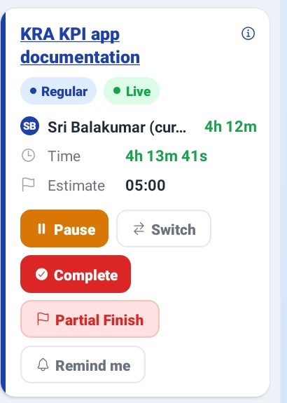
A task card with its buttons — Start, Remind me

Step 10a Add Time to the Estimate
If a task is going to take longer than its estimate, do not just run over it — say so. Open the task and tap + Add time to the estimate, enter how much longer you need and why. The extension is recorded against the task with your name on it.
The card then explains its own overrun: it shows the reason you gave, how many times the estimate has been extended, and who extended it last. Nobody has to go digging through an audit log to find out why a task ran long.

Step 11 Pause a Task
When you stop working — a break, lunch, a meeting, anything — tap Pause and pick the reason. This is how your day adds up correctly at the end.
Reason | Use it when
☕ Break | You are stepping away briefly.
🍽 Lunch | You are on your lunch break.
👥 Meeting | You are in a meeting.
🌙 Day End | You are stopping for the day. This labels the pause only — your workday stays open until you tap End Workday.
Another Priority Task | Something more urgent came up.
Waiting for Approval | You cannot go further until someone approves something.
Technical Issue | A blocker is stopping you — a broken build, no access, a server down.
Leave | You are going on leave.
✍ Other | Anything else. You must type a short note.
🚨 Urgent | An emergency pulled you off. You must type a short note, and your admins are told immediately.

TIP Keep pause notes short — they are printed on your Workday Map at the end of the day.

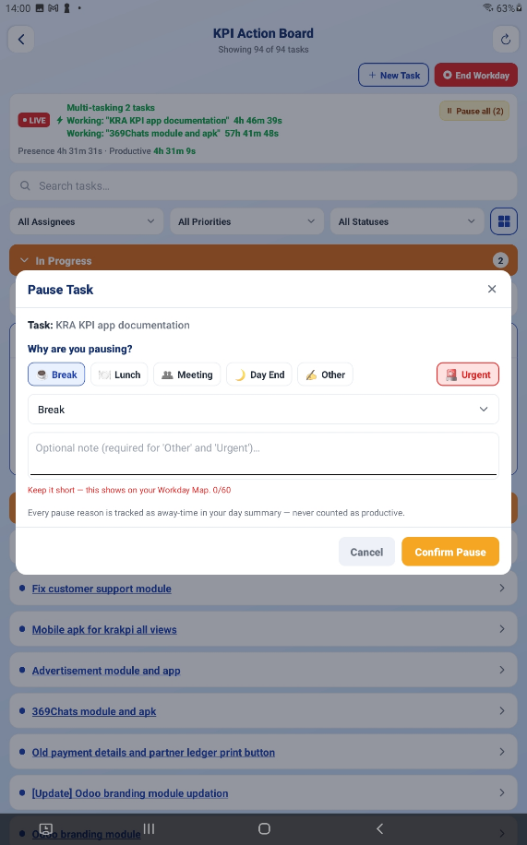
The Pause reason picker with the emoji quick-pick buttons and the note box

Step 12 Switch to Another Task
If you are moving straight from one task to another, tap Switch instead of Pause. It stops this task and records what you moved to, in one step. If you have several tasks running at once, Switch only stops this one — the others keep counting.

Step 13 Complete a Task
When the work is genuinely finished, tap Complete. A checklist appears. Tick each item honestly — this is what the admin reviews:
- Verified GitHub URL
- Deployed the task
- User manual uploaded
- Documentation submitted
- Manually tested the code
The task moves to Pending Approvals, where an admin checks it. If they approve, it goes to the client for sign-off. If they send it back, it returns to you with a reason.
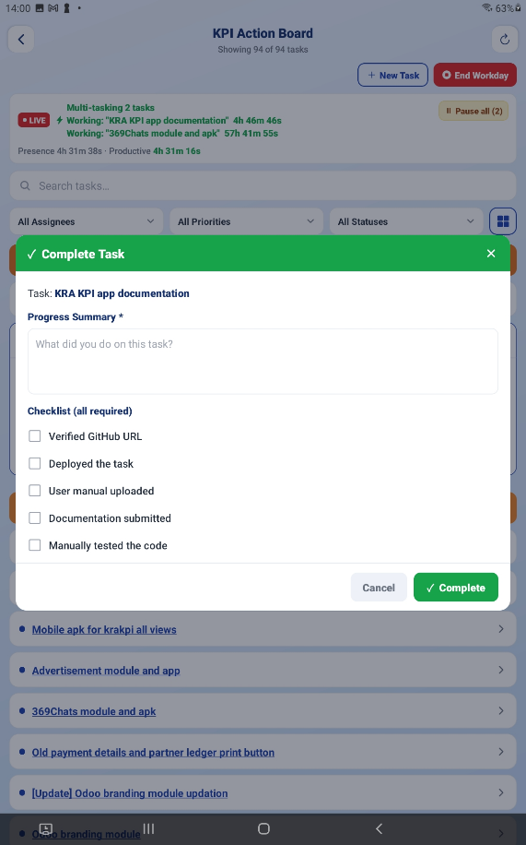
The Complete checklist with its five tick items

Step 14 Partial Finish
Use Partial Finish when you have done as much as you can but the task is not fully closed — you are waiting on someone else, or only part of the scope is deliverable now.
IMPORTANT On the board, a partially finished task shows as Verification Pending. That is the same thing — do not go looking for a lane called “Partial”.

Why Is My Button Greyed Out?
A dimmed button is still tappable. Tap it and the app tells you exactly what it is waiting for. It is never broken — it is always waiting for something:
Message | What to do
Start your workday to work on tasks | Tap Start Workday on Home.
Resume your workday to work on tasks | Your day is paused. Tap Resume.
Waiting on admin — accepts automatically at 14:35 | Nothing. It unlocks itself at that time, or sooner if an admin accepts it.
Waiting for an admin to accept this task | Nothing. Ask an admin if it is urgent.
Client put approval on hold | The client paused the decision. Your admin can chase it.
Waiting on client — releases at 16:00 | Nothing. It unlocks itself at that time.
Waiting for the client to approve | The client has not decided yet.

PART 4 CREATING YOUR OWN TASK

Step 15 Tap New Task
If you are doing work that nobody has raised a task for, create one yourself. Tap New Task on the Action Board and fill in:
- Task name — what needs doing
- Client, then Project
- Estimate — hours and minutes
- Priority
- Description

Step 16 What Happens Next
Your task lands in Pending Review. You can start working on it immediately — you do not have to wait. But an admin still has to accept it before it counts as billable work.
If the admin sends it back, you get a note explaining why, for example “Wrong project — move it under Alphalize > Phase 2.” Fix it and it goes round again.

PART 5 REMINDERS AND ALARMS

Step 17 Set a Reminder on a Task
Tap Remind me on a task card to open Remind me about this task. You can:
- Pick a Quick timer chip — 15 min, 30 min, 1 hr, 1 hr 30 min, 2 hr. You can edit these to suit you.
- Or choose remind me at estimate, so it rings when you reach the task's estimated time.
- Type a short reason. It is optional, but it is shown when the alarm goes off — “Reason (optional) — shows when it rings”.
Tap Set. To cancel it later, open the same sheet and tap Clear reminder.
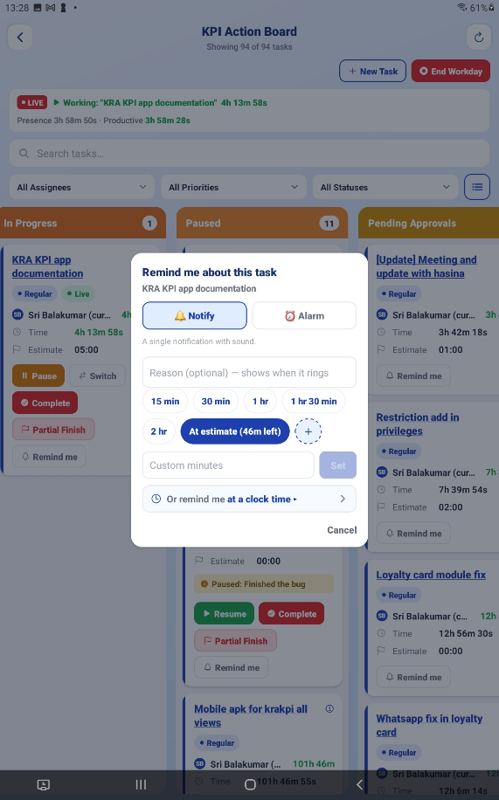
The “Remind me about this task” sheet — Quick timers chips, reason box, Set button

Step 18 When the Alarm Rings
The alarm takes over your whole screen — even on the lock screen — with the title ⏰ Time to wrap up and the line “Your set time for this task is up.” Your reason is shown under REASON.
Tap ■ STOP to silence it and open the task, or Snooze to be reminded again in a few minutes.

What the Reminder Button Tells You
Button says | What it means
Remind me | No reminder set on this task.
🔔 3:05 PM | A quiet notification reminder is set for 3:05 PM.
⏰ 3:05 PM | A full alarm is set for 3:05 PM — it will ring out loud.
😴 Snoozed 3:05 PM | The alarm already rang and you snoozed it until 3:05 PM.

TIP Alarms use your phone's own alarm sound and volume, so they are heard even when your phone is on silent. You can choose the sound from your phone's ringtone picker.

PART 6 WHEN YOU ARE NOT ON A TASK

Step 19 Answer the “Not on a task?” Popup
If your workday is running but no task is active, the app asks Not on a task? — tell it what you are doing so the time is recorded properly instead of counting as unexplained idle time:
- 👥 In a meeting
- ☕ On a break
- 🍽 Lunch
- 📬 I have no tasks
The popup gives you the same advice: “Meeting before your task? Tap In a meeting. Nothing assigned yet? Tap I have no tasks.”
IMPORTANT Choosing I have no tasks tells your admins immediately — the popup says so: “Your admins will be told straight away.” That is the point. It is how you get work assigned, not something to avoid.

Step 20 Pause Your Whole Workday
Pause Workday freezes your entire day without ending it. Use it when you leave for a long stretch but will be back.
WHERE IS IT? Pause lives inside the End Workday popup, not on the board. Tap End Workday and look at the amber strip near the bottom: “Coming back later today? Pause instead.” It sits next to End on purpose, because that is the moment you are choosing between stopping for now and stopping for good.
A banner then explains what is happening:
“Your workday is paused. Tasks can't be started, and paused time won't count as worked time. Tap Resume when you're back.”
While you are paused, a green Resume button appears in the header beside End Workday. The Pause offer itself disappears from the End Workday popup for as long as the day is frozen — there is nothing left to pause — and comes back when you resume.
IMPORTANT Pause Workday can be undone. End Workday cannot. If you are coming back today, always pause — never end.

PART 7 ENDING YOUR DAY

Step 21 Tap End Workday
When you are finished for the day, tap End Workday. The app shows you a full summary of your day before anything is sent.

Step 22 Check Your Day Summary
At the top are the day’s tiles:
Tile | What it means
Presence (at work) | Your time at work: the clock from when you started your day, minus any time you paused it. Pausing stops this figure — that is the whole point of pausing.
Productive | The part you spent actually working on tasks.
Accounted | Everything the app can explain — task time, plus recorded breaks, plus paused time.
Workday paused | Time your whole day was paused. It sits outside Presence and inside Accounted, which makes it exactly the gap between those two. It only appears on a day you actually paused.

NOTE Accounted can read higher than Presence, and that is correct. Presence is the time you were working; Accounted is your whole day explained, pause included. The difference between the two is exactly your paused time.
Below the tiles you get:
- ☕ Away time — your breaks broken down: Break, Lunch, Meeting, No tasks, Other, Away (system). This time sits inside Presence and is never counted as Productive.
- 🗺 Workday Map — your day in order, start to finish: start, task, break, task, end.
- Tasks worked today — every task you touched, with the time on each.
- An optional note box for your owner or coordinator.
You will also see the reminder: “⚠ Use Complete for finished tasks — Pause is only for breaks/interruptions.”
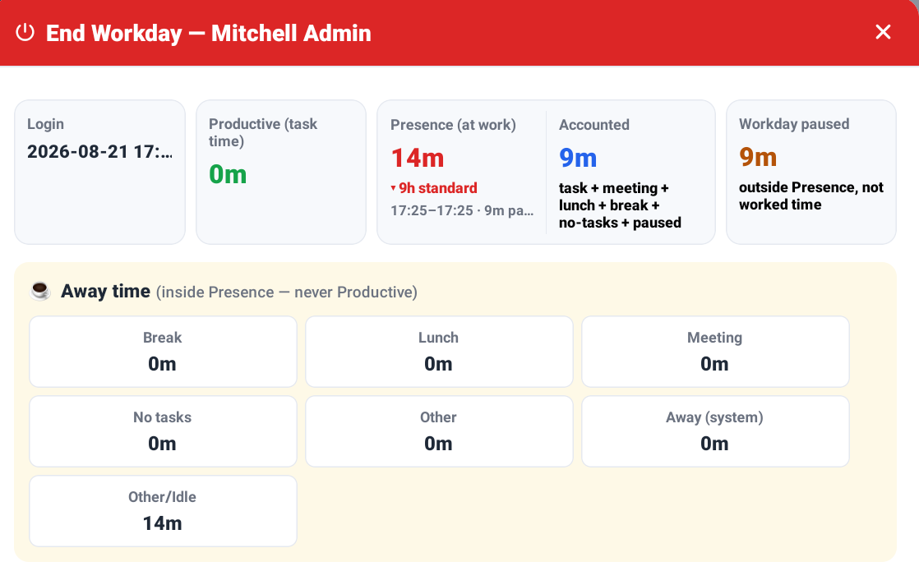
The End Workday summary — Presence and Accounted paired in one box, the Workday paused tile beside them, and the Away time breakdown

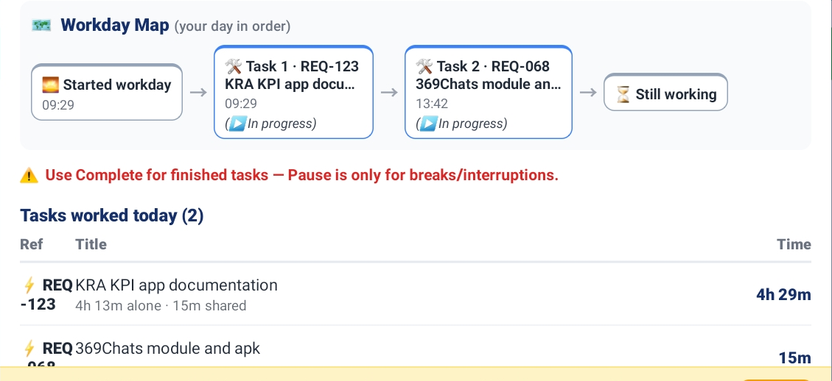
The Workday Map and the “Tasks worked today” table

Step 23 Send It
If something looks wrong — a task you forgot to complete, a break you forgot to record — tap ← Continue Working, fix it, and come back.
When you are happy, tap Logout & Send Summary. Your day is sealed, a snapshot image of the summary is saved, and you are logged out.
IMPORTANT You get one start and one end per day. Once you tap End Workday, you cannot start again today — the button reads “Workday ended for today” and is greyed out. Logging out and back in does not give you a second day.

PART 8 YOUR OWN RECORDS

My Workday
Your last 30 days: how long you were present, how much was productive, how much was paused, and which tasks you worked on each day.
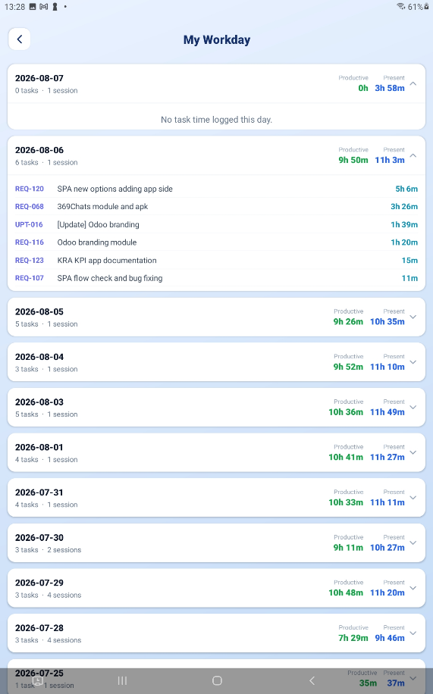
My Workday — the day list with Present / Productive / Paused figures

My Snapshots
A saved picture of every End Workday summary you have sent. Tap one to view it full size, download it, or share it.
The note you typed when you ended the day is saved with the snapshot and shown here, so you can read back what you said you worked on. If an admin reopened that day, the reason they gave is shown too.
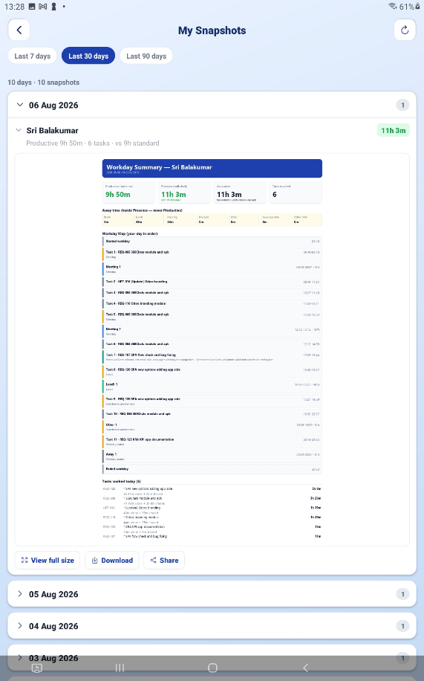
My Snapshots — the list of saved end-of-day summary images

Task Documents
Everything attached to the work in one place: the client’s requirement files, progress updates, user manuals and linked GitHub branches. Open a repository to jump straight to the branch, or tap a file to open it.
Filter by assignee to see only your own tasks’ documents — on a busy project that is the difference between a usable list and a very long one.

Notifications
Tap the bell on Home. Three tabs sort everything for you:
- All — everything.
- Unread — what you have not opened yet.
- Action needed — the ones that need you to do something.
Items are grouped into Today, Yesterday and Earlier. Anything critical carries a red URGENT badge. Tap a notification to open the task it is about, or use Mark all read to clear the badge. Pull down to refresh.
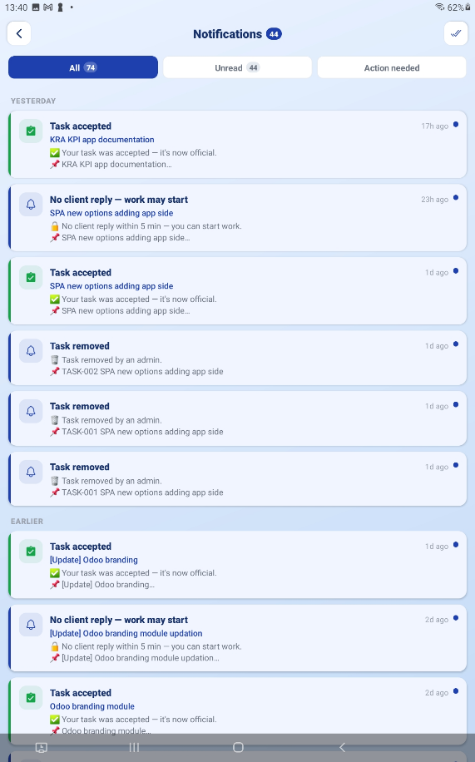
Notifications — the All / Unread / Action needed tabs with an URGENT item

Profile
Tap Profile at the bottom of Home. Here you can:
- Set your photo — Camera, Gallery, File manager, or Remove Photo.
- See your role badge (yours reads User) and whether you are Connected or Offline.
- Open Connection Details — your name, username, mobile, database, server and user ID. Useful when asking for help.
- Change your password with Forgot Password.
- Log Out.
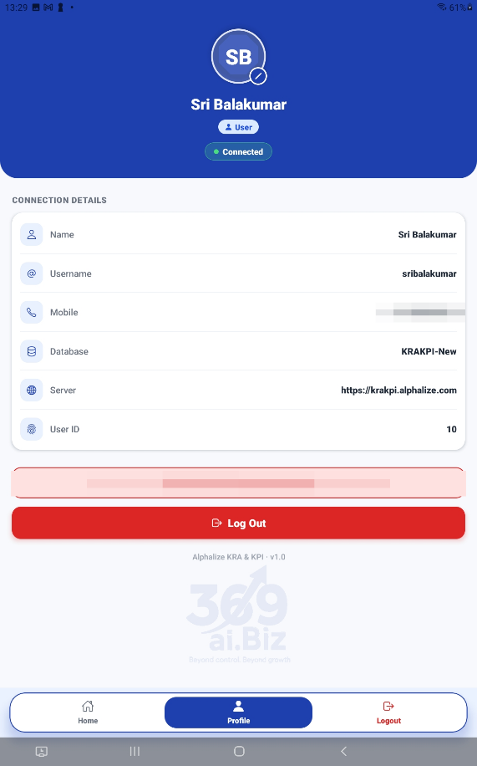
The Profile tab — avatar, role badge, connection pill and the buttons

TIP Logging out while your workday is still running does not end your day — but the app will warn you, because your day stays open and will be closed automatically at midnight. End your day properly whenever you can.

QUICK REFERENCE

Which Button, When
Button | Tap it when
Start Workday | At the beginning of your working day, before anything else.
Start | You are beginning work on a task.
Pause | You are stopping work on a task — break, lunch, meeting, blocker.
Resume | You are picking a paused task back up.
Switch | You are going straight from this task to a different one.
Complete | The task is genuinely finished.
Partial Finish | You have done all you can, but it is not fully closed.
New Task | You are doing work that has no task raised for it.
Remind me | You want the app to nudge you before you overrun.
Pause Workday | You are away for a while but coming back today.
End Workday | You are finished for the day. This cannot be undone.

Things to Remember
- Nothing works until you tap Start Workday. That is the first thing you do every morning.
- A greyed-out button is not broken. Tap it and it tells you what it is waiting for.
- Use Complete for finished work and Pause for interruptions. They are not interchangeable.
- A task showing Verification Pending is one you marked as a Partial Finish.
- Always record your breaks. Unrecorded time shows as unexplained idle time on your day summary.
- Pause Workday is reversible. End Workday is not — one start and one end per day.
- If a screen looks out of date, pull down to refresh, or go back to Home and open it again.
- Change your password away from 1111 the first time you log in.
That's your day — start it, work it, and end it. Everything else the app does for you.
— End of Guide —
Alphalize | KRA / KPI User Guide

