1. Introduction to the Linux Terminal

solution:- in this question i went through various command like ls,cd ,mkdir,touch,rm,rmdir and man commands. I provided a picture of above commands below to it.

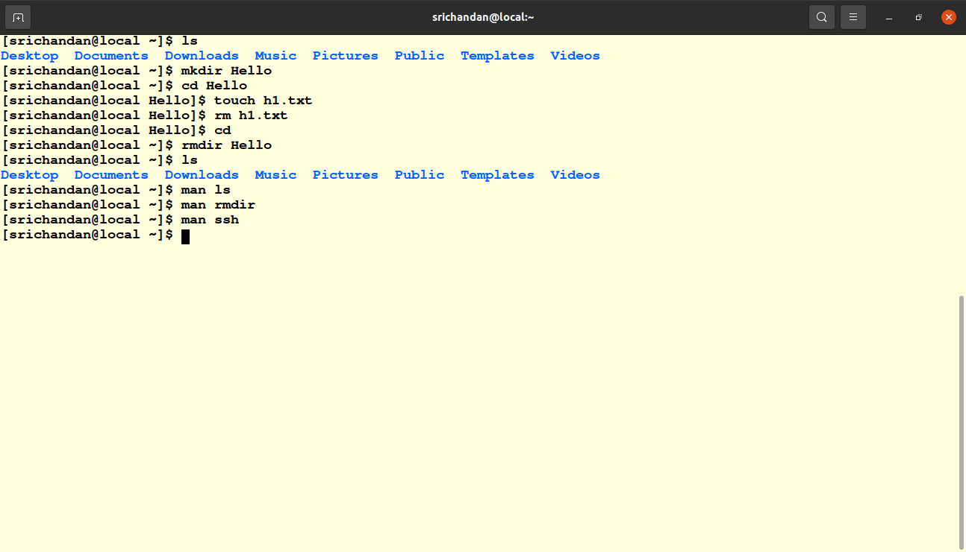
Pic-1.1

2. File management
In this task i practised mkdir,ls,mv,rm cp and cat commands.
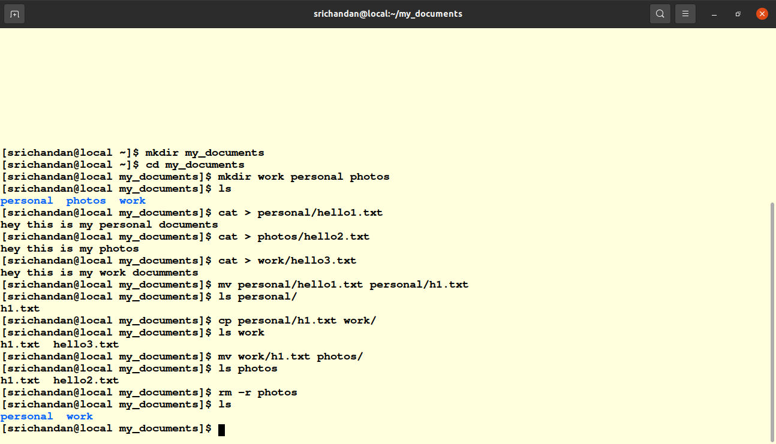
Pic1.2

3. File Permissions
In this section i practised mkdir,cd,useradd,ls-l,chmod.chown.groupadd and chgrp commands. These commands are given below in the pic 1.3
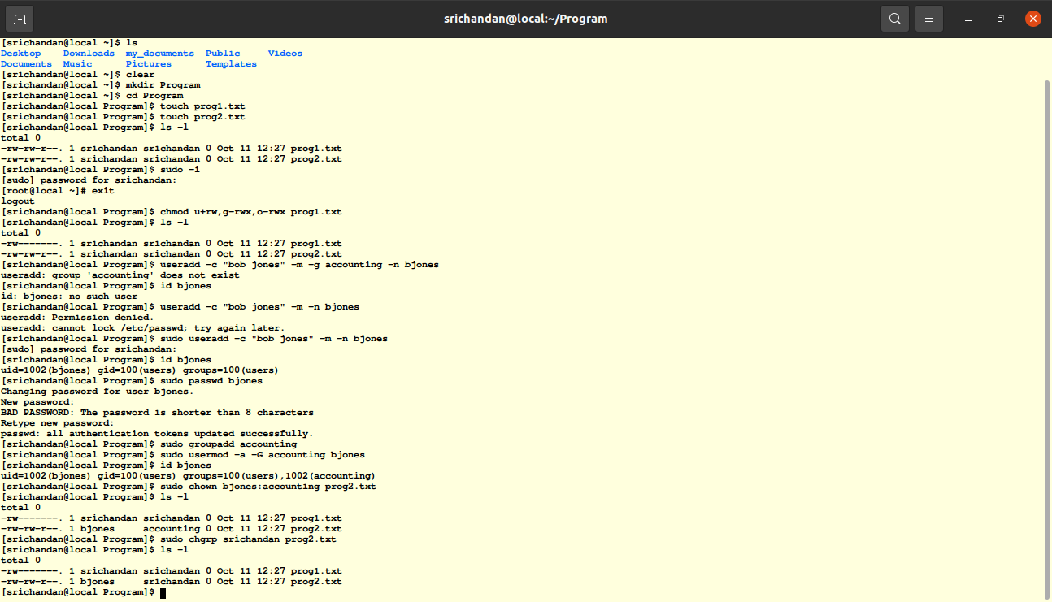
pic1.3

4. Process and system monitoring
Here i practised ps,nohup,tree,top,kill commands which is given bellow picture.
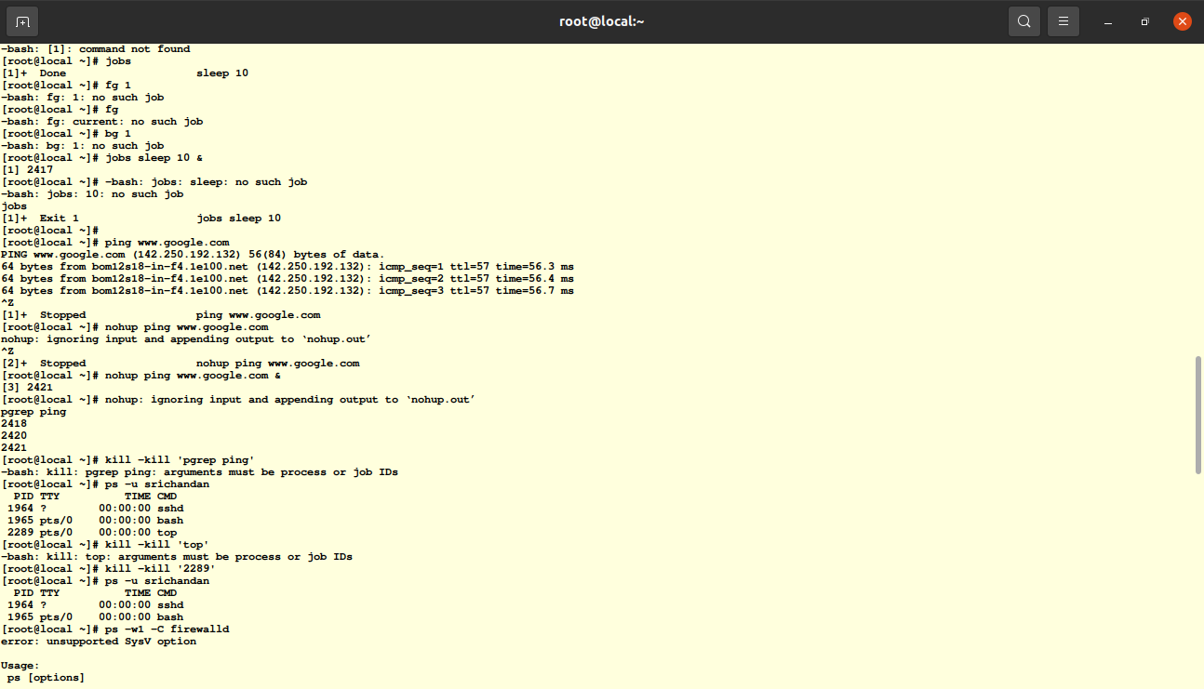
Pic1.4
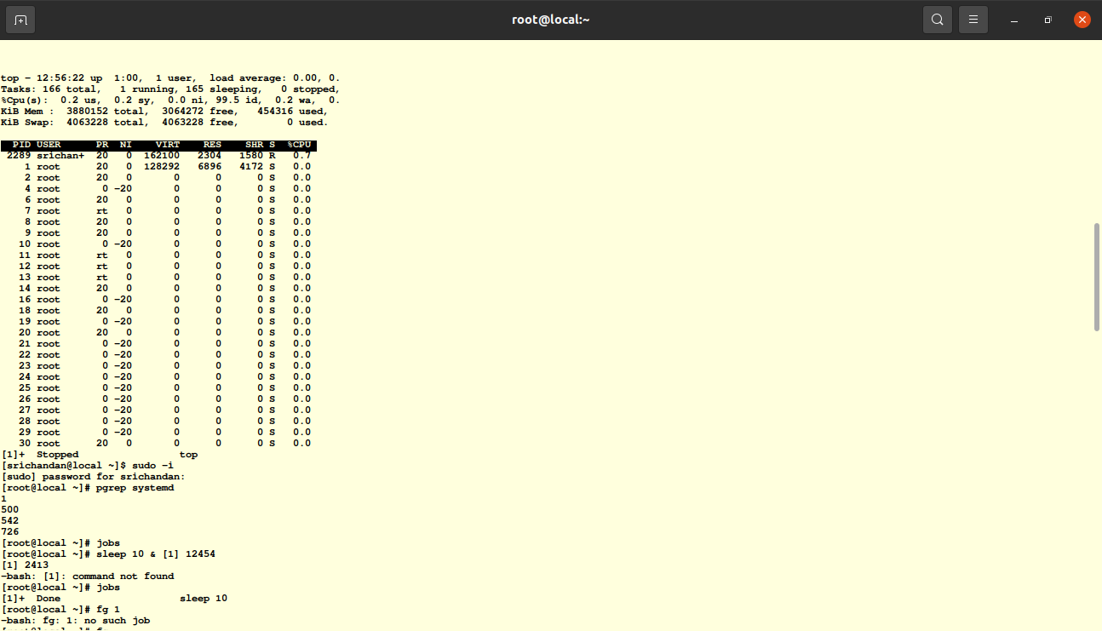
pic1.4

5.package Management
In this section i used commands like “yum install”, “yum update”, “yum search” and “yum remove”

6. User and group Management
Here i used commands like “user add”, “sudo usermod -a -G groupname username’’, “sudo groupadd groupname”, “sudo usermod -a -G groupname username”, “sudo userdel username” and “sudo groupdel groupname” .

