Exploring Linux Package Management

Task 1 :
In this task i have used Centos machine,and i used “sudo yum update” command . Below is the screenshot of this task.
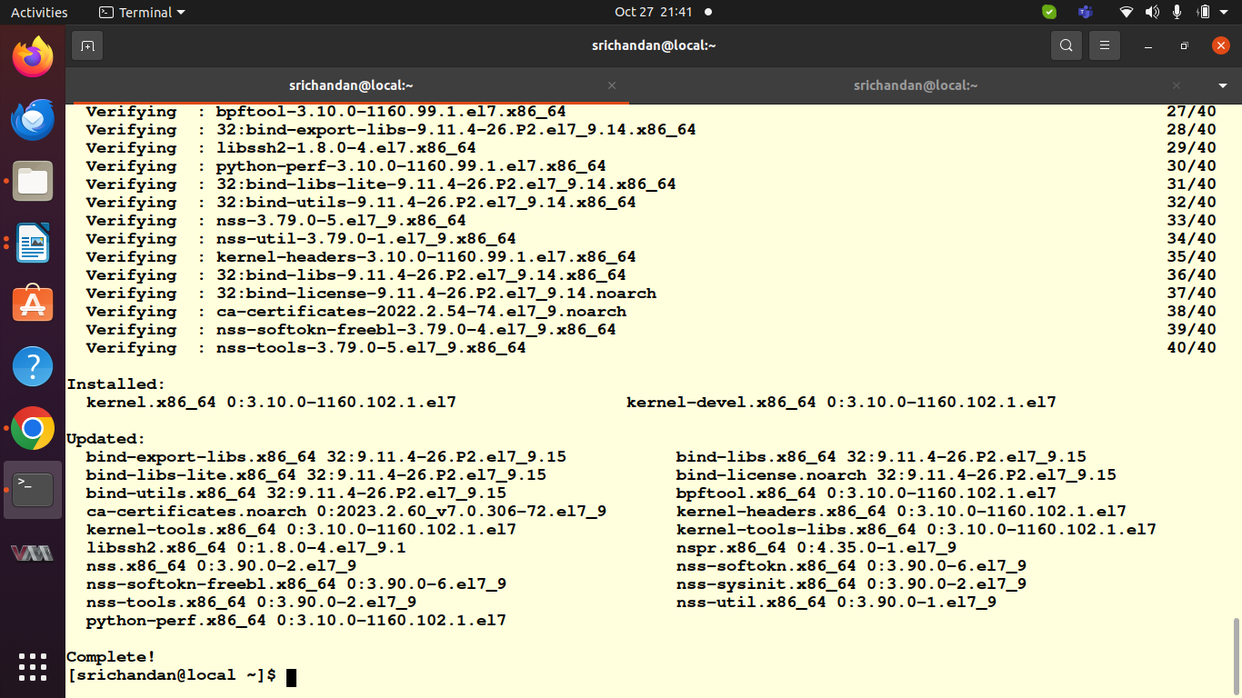
Pic 10.1

Task 2:
In this task i use nginx package and centos machine.
- For install nginx on Centos i used “sudo yum install nginx” command.
- For update package list i used “sudo yum check-update” command.
- For upgrade all installed package “sudo yum update” command.
- For remove nginx package i used “sudo yum remove nginx”
Below i attached screenshot of above task
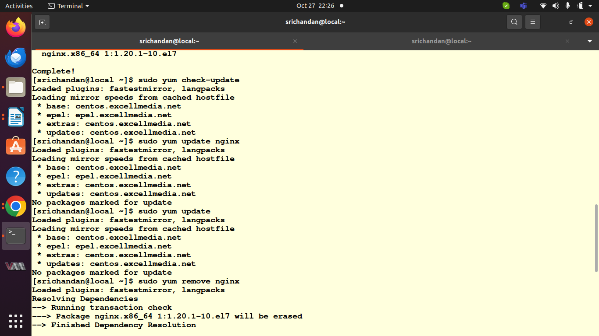
pic10.2
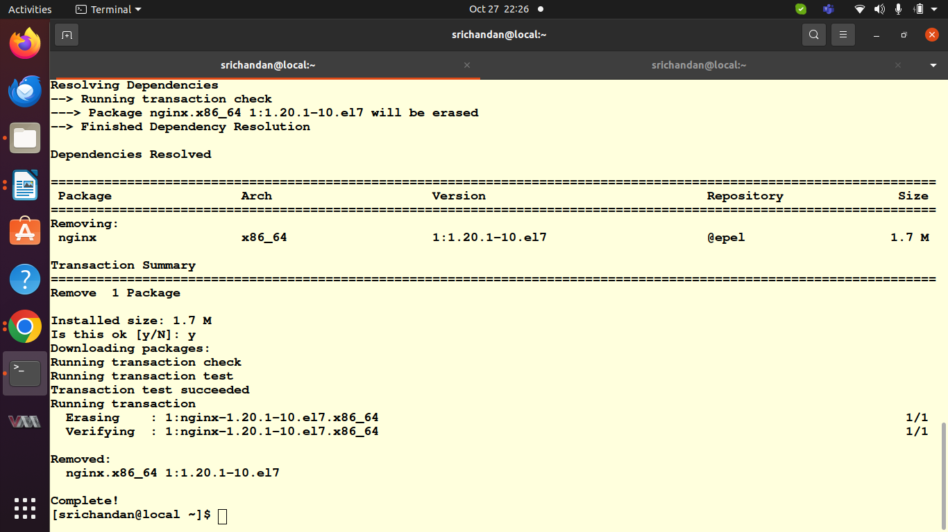
pic 10.3

Task 3:
In this task i tried to include dnf on ubuntu and apt on centos in both i got error .The error is no package available.Ubuntu primarily uses APT for package management, and DNF is designed for RPM-based distributions like Fedora and CentOS.
The screenshot of above task i attached below.
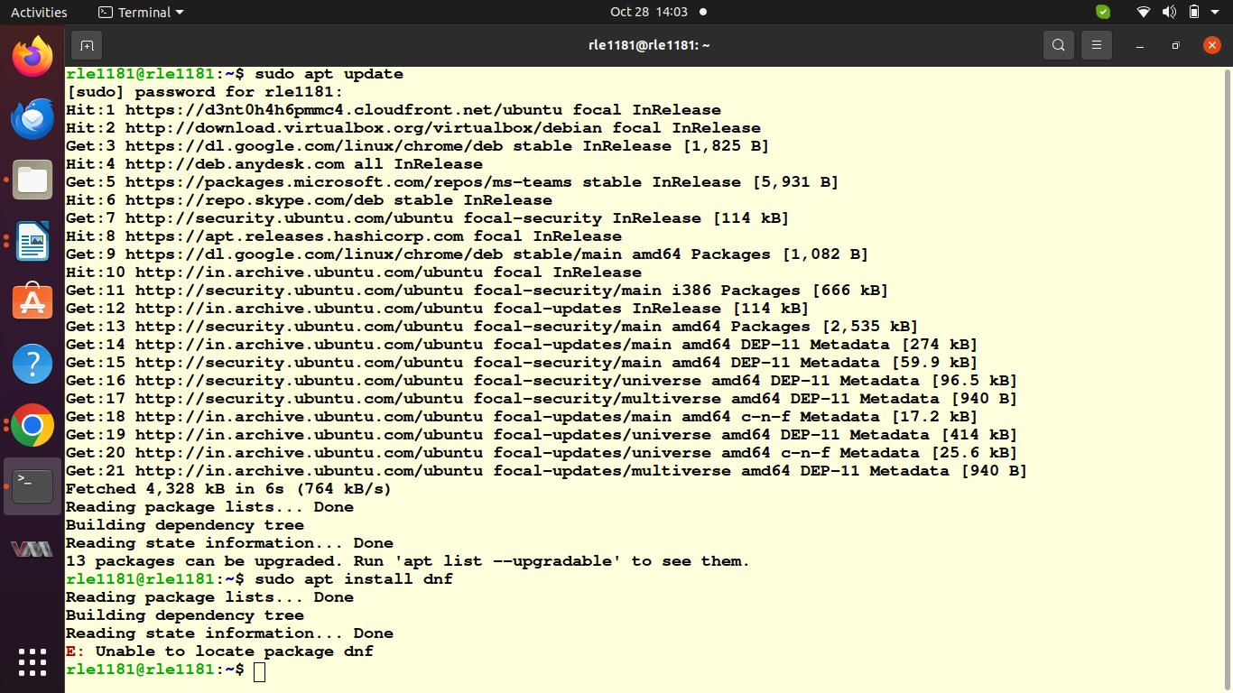
Pic 10.4
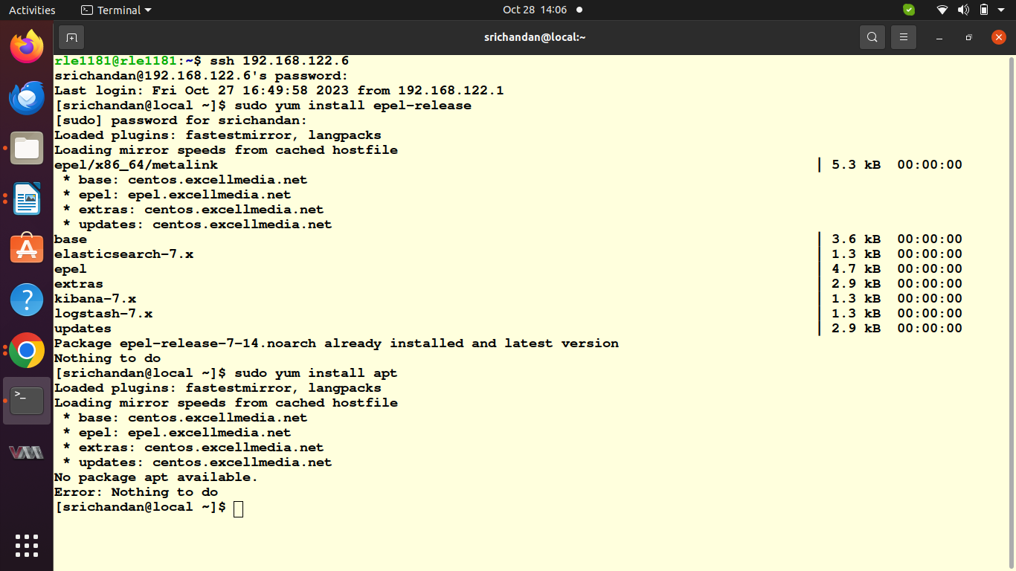
pic 10.5

Task 4 :
In this task i used “sudo yum search nginx” commnad and it gave me output which is i attched bellow.
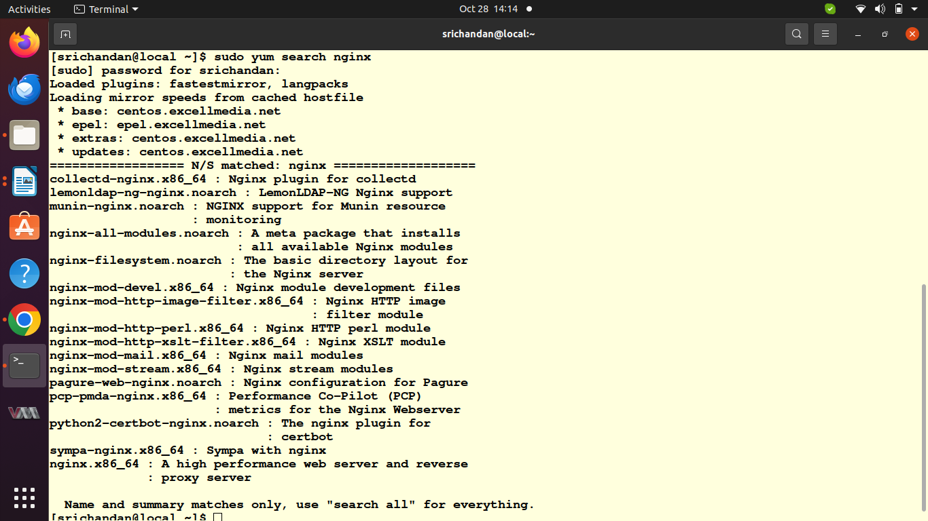
10.6

Task 6:
To explore the documentation for my distribution pacakge manager i used “man “ command . Exploring these manual pages we can get more details about additional options,flags and configuration files for package manager.

Attempt to trobuleshoot common package management issues :
- Dependency confilcts :
If you encounter dependency conflicts, try using the dnf or apt commands to resolve them. For example, we can use:
  - dnf install package_name –allowerasing on centos or fedora
  - apt –fix-broken install on debian/ubuntu
- Missing keys(GPG key issues):
If you face issues related to missing GPG keys, we can import the key using the apt-key command for APT-based systems:
sudo apt-key adv --keyserver keyserver.ubuntu.com --recv-keys KEY_ID
- Broken packages :
To fix broken packages, we can use the apt or dnf commands to repair and configure the package system. For instance:
  - For apt based system we can use
sudo dpkg --configure -a
sudo apt install -f
  - For dnf based on centos or fedora
sudo dnf clean all
Bellow i attached screensot of man commnad
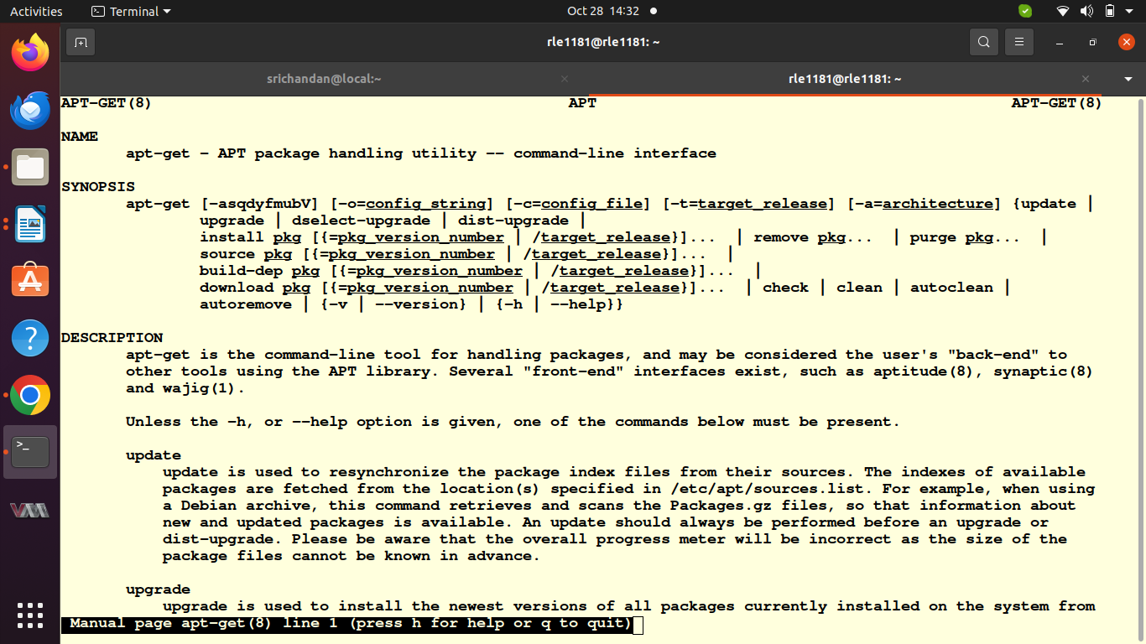
pic 4.7

