Exploring Linux SSL Certificates

Task 1 :
SSL (Secure Sockets Layer) certificates play a vital role in ensuring the security of data transmitted over the internet. These certificates are a fundamental component of online security, safeguarding sensitive information, and establishing trust between users and websites. This report provides an overview of what SSL certificates are, their importance for online security, and the different types of SSL certificates available.

SSL certificates are small data files that encrypt data transfers between a user's web browser and a web server. This encryption ensures that the data exchanged remains confidential and secure. SSL certificates create a secure connection by binding a cryptographic key to the details of an organization. These keys and the certificate enable encrypted communication, preventing eavesdropping, data tampering, and man-in-the-middle attacks.

Importance of SSL Certificates for Online Security:
- Data Encryption: SSL certificates encrypt data as it moves between a user's browser and the web server. This encryption makes it extremely difficult for cybercriminals to intercept and decipher the information, ensuring the privacy and integrity of sensitive data, such as login credentials, credit card information, and personal details.
- Authentication: SSL certificates also serve as a means of authenticating the identity of a website. They confirm that the website is owned and operated by a legitimate entity. This authentication helps users trust the site and reduces the risk of falling victim to phishing websites that impersonate trusted brands.
- Search Engine Ranking: Search engines like Google prioritize secure websites in their rankings. Having an SSL certificate and using HTTPS in your website's URL can boost your site's visibility and credibility, ultimately increasing organic traffic.
- Regulatory Compliance: Many regulatory bodies and industry standards require websites to use SSL certificates to protect user data. This includes regulations like the GDPR in Europe and the Payment Card Industry Data Security Standard (PCI DSS) for handling payment card information.
Types of SSL Certificates:
- Domain Validation (DV) SSL Certificates: These are the most basic SSL certificates and only confirm the ownership of the domain. They are quick to obtain and are suitable for personal websites and blogs where only basic encryption is needed.
- Organization Validation (OV) SSL Certificates: OV certificates not only validate the domain but also the legitimacy of the organization behind the website. They provide a higher level of trust and are suitable for small to medium-sized businesses and e-commerce sites.
- Extended Validation (EV) SSL Certificates: EV certificates offer the highest level of trust and security. Websites with EV certificates undergo a rigorous validation process, resulting in the green address bar in most browsers, signaling the highest level of security. EV certificates are typically used by banks, financial institutions, and e-commerce giants.
- Wildcard SSL Certificates: Wildcard certificates protect a domain and all its subdomains with a single certificate. This is a cost-effective solution for businesses that have multiple subdomains, like mail.domain.com, shop.domain.com, etc.
- Multi-Domain (SAN) SSL Certificates: Multi-Domain certificates secure multiple domains and subdomains under a single certificate. This is convenient for businesses that have various web properties.

Task 2:
In this task i am using nginx web server software.For this task nginx installation is required, and root access to the server also required.
In this task a registered domain also required but as i dont have any domain so for this iam using a self signed certificate.
Steps are given below fo this task
- Create a self-signed ssl certificate : in this i used ‘openssl’ command to generate a self-signed ssl certificate and private key. The command is -
“sudo openssl req -x509 -nodes -days 365 -newkey rsa:2048 -keyout /etc/nginx/ssl/self-signed.key -out /etc/nginx/ssl/self-signed.crt “
- Create an nginx configuration file :i created an nginx config file in the ‘/etc/nginx/conf.d’ directory.
“sudo nano /etc/nginx/conf.d/self-signed.conf”

- Test nginx configuration :
To verify the nginx configuration is correct or not for this the command is
“ sudo nginx -t”
- Reload Nginx :
Restart the nginx to apply the changes by using “sudo systemctl reload nginx” command.

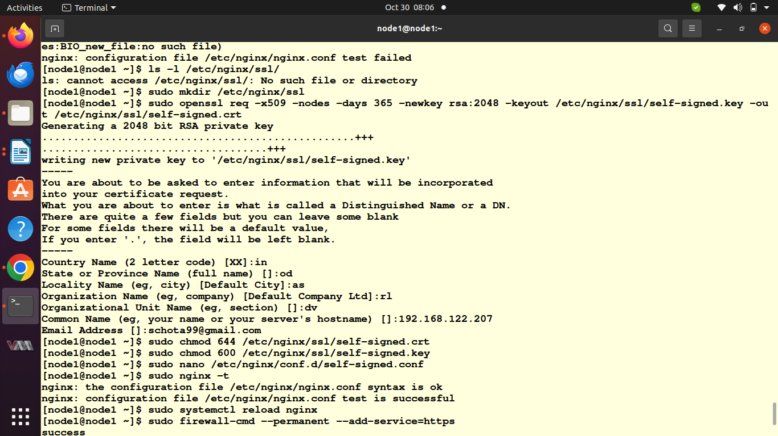
pic 11.1

Task 3 :
A self-signed SSL certificate is a certificate that is signed by the same entity that it identifies. These certificates are commonly used for testing and development purposes or in closed environments where there is no need for a certificate issued by a trusted Certificate Authority (CA).
At first we need to install OpenSSL using “sudo yum install openssl” command
To generate a self signed certificate and private key i used
“openssl req -x509 -nodes -days 365 -newkey rsa:2048 -keyout example.com.key -out example.com.crt” command
A self-signed SSL certificate is a certificate that is not signed by a trusted third-party Certificate Authority (CA). Instead, it is signed by the entity that is using the certificate, effectively "vouching" for its own authenticity. Self-signed certificates have several use cases:
- Devlopment and Testing : Self-signed certificates are commonly used during the development and testing of web applications. They allow developers to enable SSL encryption for their applications without the cost or complexity of obtaining a certificate from a trusted CA.
- Internal Services : Self-signed certificates are suitable for securing internal services, such as intranet websites, databases, or email servers, where there is no need for public trust. They provide encryption and authentication within a closed or controlled environment.
- Temporary Solutions : Self-signed certificates can be used as temporary solutions while waiting for a CA-issued certificate to be obtained or during a migration process.
Task 4 :
Discuss the security implication of self-signed certificates
Using self-signed certificates in a production environment has several security implications:
- Lack of Trust : Self-signed certificates are not issued by a trusted third-party Certificate Authority (CA). This means that web browsers and other client applications will not inherently trust your certificate. Users will typically see security warnings when accessing your site, which can erode trust.
- Vulnerability to Man-in-the-middle Attacks : Since self-signed certificates are not signed by a trusted CA, they are vulnerable to man-in-the-middle (MITM) attacks. Attackers can intercept traffic between the client and server, potentially compromising data confidentiality and integrity.
- Inadequaate for e-commarce and public sites : Self-signed certificates are unsuitable for public-facing websites, especially those that involve e-commerce or the exchange of sensitive information. Visitors may be deterred by security warnings, and your site may not meet legal or compliance requirements.
- Limited Scope : Self-signed certificates are best suited for internal or controlled environments, such as testing, development, or securing internal services. They provide encryption and authentication but are not suitable for external audiences.

